ONLINE SUPPLEMENT
Figure S1. Distribution of female and male age before (A, C) and after (B, D) matching.
SMF, severe male factor infertility.

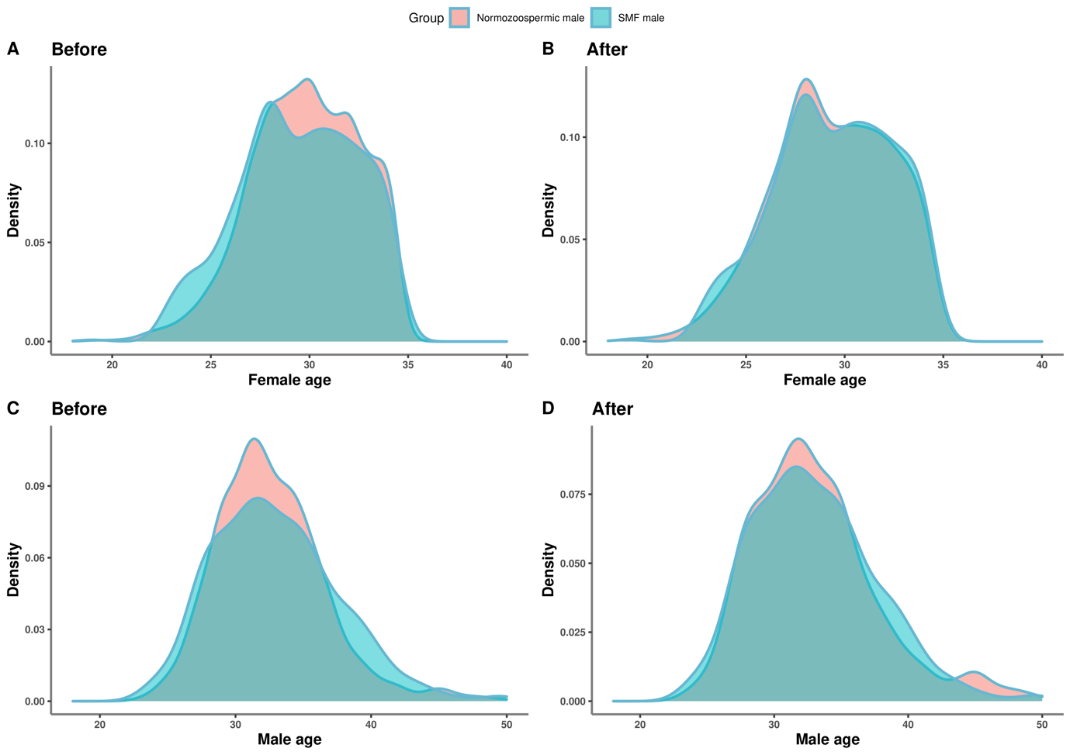

Table S1. Patient characteristic at baseline, before matching
 | Normospermia (n=1426) | Severe male factor infertility (n=648) | p-value
Age, years
Female | 29.8 ± 2.72 | 29.4 ± 2.97 | 0.004
Male | 32.7 ± 4.22 | 33.5 ± 5.94 | 0.001
Body mass index, kg/m²
Female | 21.3 ± 2.82 | 21.0 ± 2.45 | 0.02
Male | 23.9 ± 3.06 | 24.1 ± 3.28 | 0.43
Anti-Müllerian hormone, ng/mL | 3.70 [2.22; 6.10] | 3.56 [2.11; 5.65] | 0.06
Total FSH dose, IU | 2175 [1800; 2700] | 2250 [1781; 2700] | 0.81
Type of infertility, n (%)
Primary | 755 (52.9) | 457 (70.5) | <0.001
Secondary | 671 (47.1) | 191 (29.5) | <0.001
Values are mean ± standard deviation, median [interquartile range], or number of patients (%).
FSH, follicle-stimulating hormone

