Table S1. Details of Foc protein targets associated with pathogenicity and virulence selected for molecular docking studies
SL NO: | NAME OF THE PROTEIN TARGET | ROLE OF THE PROTEIN TARGET | UNIPROT ID | REFERENCE
1 | G-protein-β-subunit 1 (FGB1) | Regulation of development and pathogenicity in Fusarium | Q96VA6 | Soundararajan et al. (2011)
2 | GTPase activating protein (RHO1) | essential role in maintaining the hyphal architecture and virulence | N1RDR2 | Omar et al. (2021)
3 | 5´ → 3´ Exoribonuclease 2 (XRN2) | RNA degradation | A0A559KT57 | Bonilla LD et al. (2018)
4 | Sterol C-methyltransferase-(ERG6) | Required for the formation of fungal plasma membranes, with an essential role in membrane stabilization and signaling | A0A559KN81 | Deng et al. (2015)
5 | (Fusarium transcription factor 1) Ftf1 | Development, growth and pathogenesis | Q2V9X3 | Ghag et al. (2014)
6 | Velvet | Development, growth, and pathogenesis | W0G578 | Ghag et al. (2014)
7 | Resistance to lethality of MKK1P386  (Rlm1) | Regulation of fungal hyphal growth, antioxidation mechanisms, cell wall biosynthesis, transcription of mycotoxin biosynthetic genes | A0A559LE75 | Ding et al. (2020)
8 | MAP kinase kinase 2 (Mkk2) | Growth and differentiation | A0A559LXN6 | Ding et al. (2014)

SL NO: | NAME OF THE PROTEIN TARGET | ROLE OF THE PROTEIN TARGET | UNIPROT ID | REFERENCE
9 | C-4 sterol methyl oxidase  (ERG25) | Ergosterol biosynthesis, conideal germination | A0A559LEQ5_FUSOX | Deng et. al. (2015)
10 | Secreted in xylem 1  (SIX 1) | Effector protein of Fusarium and favor of colonization by the pathogen and disease progression. | A0A240FGL3_FUSOX | Carvalhais et al., (2019)
11 | Secreted in xylem 6  (SIX 6) | Effector protein of Fusarium and favor of colonization by the pathogen and disease progression | A0A240FGL6_FUSOX | Carvalhais et al., (2019)
12 | Secreted in xylem 8  (SIX 8) | Effector protein of Fusarium and favor of colonization by the pathogen and disease progression | A0A240FGM3_FUSOX | Carvalhais et al., (2019)
13 | Secreted in xylem 10  (SIX 10) | Effector protein of Fusarium and favor of colonization by the pathogen and disease progression | A0A240FGM6_FUSOX | Carvalhais et al., (2019)
14 | Secreted in xylem 13  (SIX 13) | Effector protein of Fusarium and favor of colonization by the pathogen and disease progression | A0A0S3CVC0_FUSOX | Carvalhais et al., (2019)
15 | Six Gene Expression 1 (SGE1) | Regulating the expression of effector genes | A0A559L303_FUSOX | Gurdaswani et al., 2020

Table S2. Details of protein targets of Foc modelled through SWISS server
S.NO. | UNIPROT ID | PROTEIN TARGET NAME & LENGTH | TEMPLATE PROTEIN PDB IDAND PROTEIN NAME | SEQUENCE IDENTITY  % | SEQUENCE SIMILARITY  % | COVERAGE  % | GMQE
1 | A0A559KT57 | XRN2  988 | 3fqd  Saccharomyces pombe Rat1-Rai1 Complex | 51.57 | 44 | 84 | 0.62
2 | Q96VA6 | FGB  394 | 7cx2  PGE2-bound EP2-Gs complex | 54.96 | 52 | 94 | 0.83

Table S3. Details of protein targets of Foc modeled through ROBETTA
Sl No. | UNIPROT ID | PROTEIN TARGET NAME & LENGTH | CONFIDENCE SCORE %
1 | A0A559LE75 | Rlm1  652 | 0.19
2 | Q2V9X3 | Ftf1  1079 | 0.36
3 | A0A559KN81 | ERG6  382 | 0.79
4 | N1RDR2 | RHO1  1154 | 0.09
5 | A0A559LEQ5 | ERG25  305 | 0.77

Sl No. | UNIPROT ID | PROTEIN TARGET NAME & LENGTH | CONFIDENCE SCORE %
6 | A0A240FGL3 | Secreted In Xylem-1 SIX-1  279 | 0.60
7 | A0A240FGL7 | Secreted in Xylem 6  217 | 0.54
8 | A0A240FGM3 | Secreted in Xylem 8  141 | 0.43
9 | A0A240FGM6 | Secreted in Xylem 10  149 | 0.46
10 | A0A240FGN1 | Secreted in Xylem 13  293 | 0.59

Table S4. Details of protein targets of Foc modeled through PHYRE 2
Sl, No. | UNIPROT ID | PROTEIN TARGET NAME & LENGTH | TEMPLATE PROTEIN PDB ID & PROTEIN NAME | CONFIDENCE SCORE % | COVERAGE  %
1 | A0A559L303 | SGE 1  330 | 4m8b  Fungal Protein-S. cerevisiae | 100 | 52
2 | W0G578 | Velvet  123 | 4n6r  VosA-VelB-complex | 100 | 98
3 | A0A559LXN6 | Mkk 2 | 1s9j  Human mitogen-activated protein kinase kinase 1 (MEK1) in a complex 4with ligand and MgATP | 100 | 52

Fig. S1. Ramachandran plot for the protein targets associated with virulence and pathogenicity of F. oxysporum f. sp. cubense
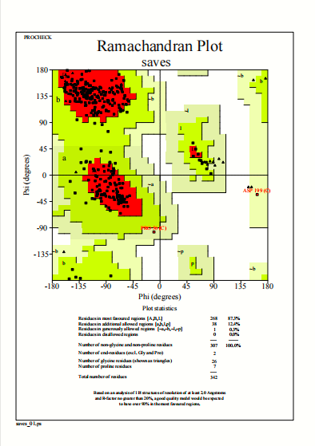
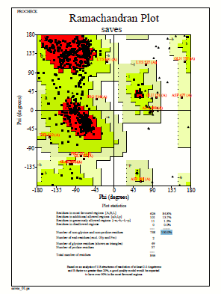

FGB1 XRN2

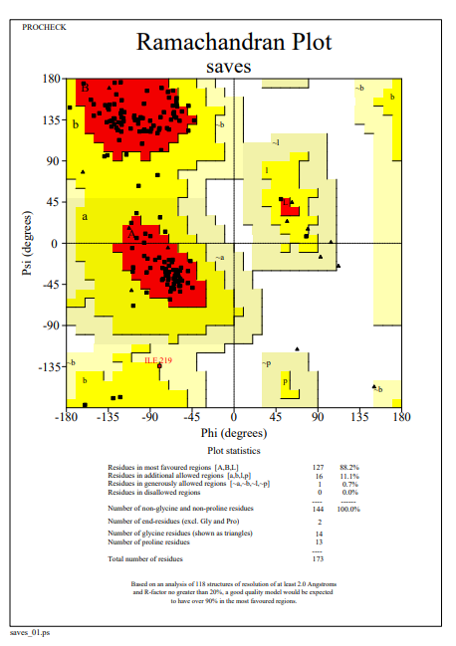
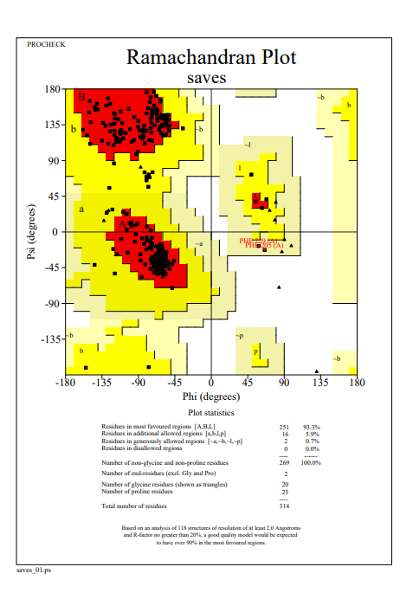

SGE1 RHO1

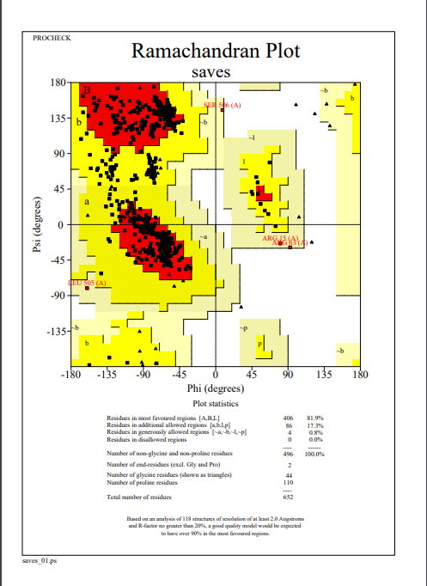
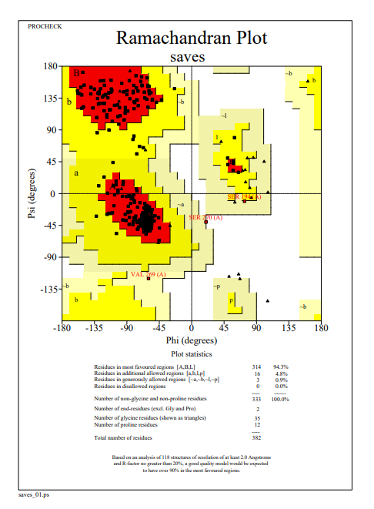

Rlm1 ERG6

Rlm1 ERG6
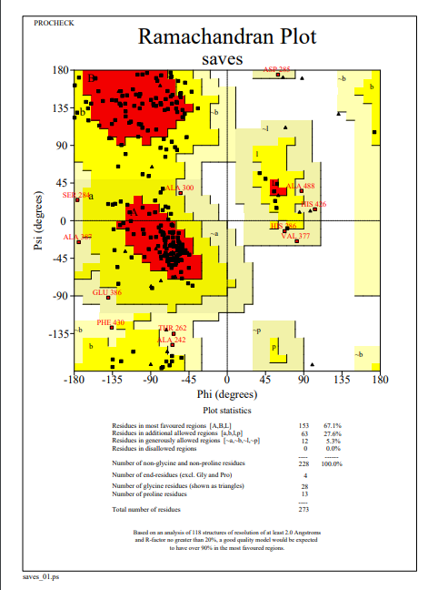
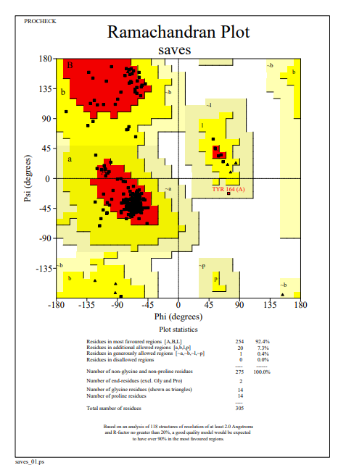
ERG25 Mkk2

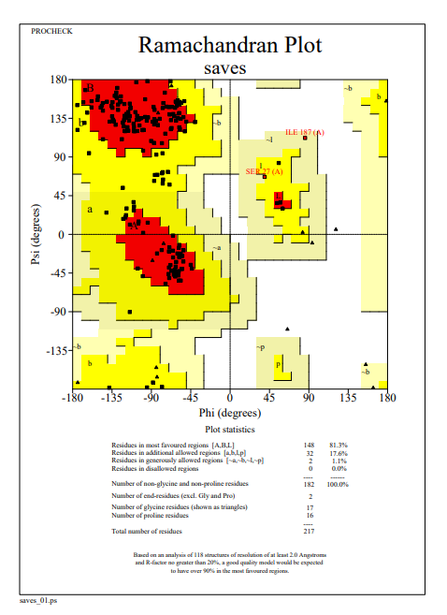
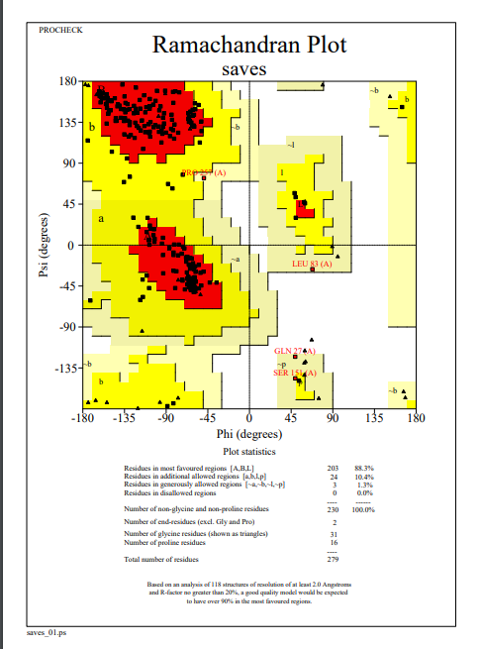
SIX1 SIX6

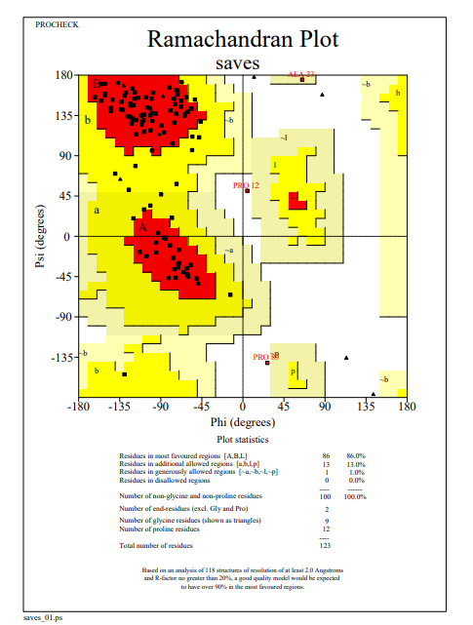
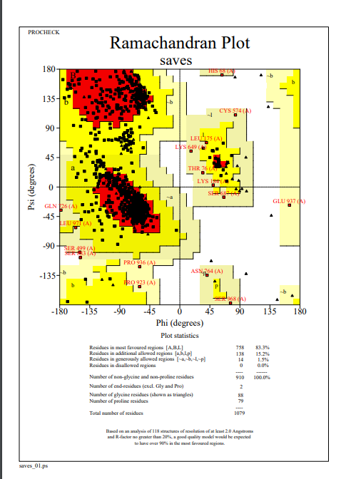
FTF1 Velvet

SIX8 SIX10
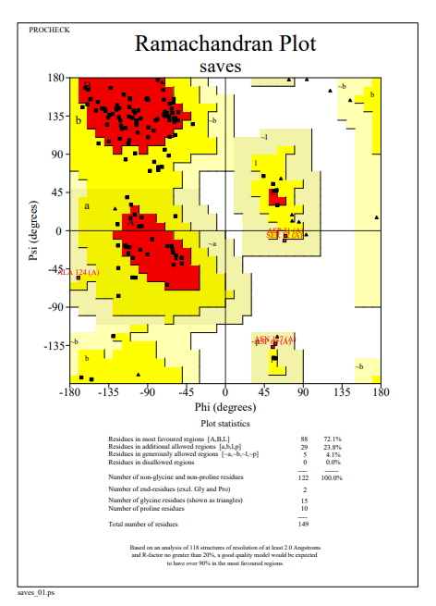
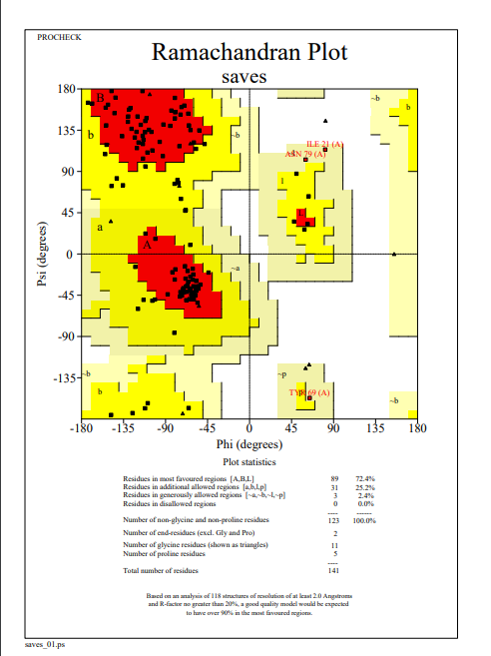

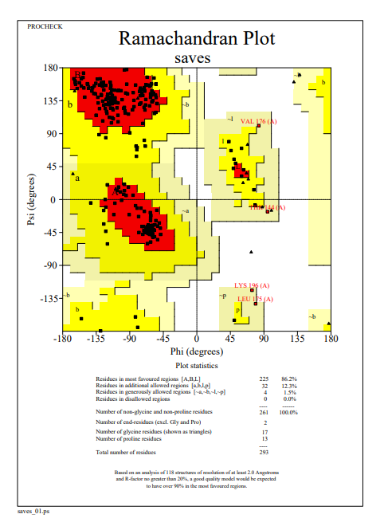

SIX13

