Table 1 Classification of Industries in India
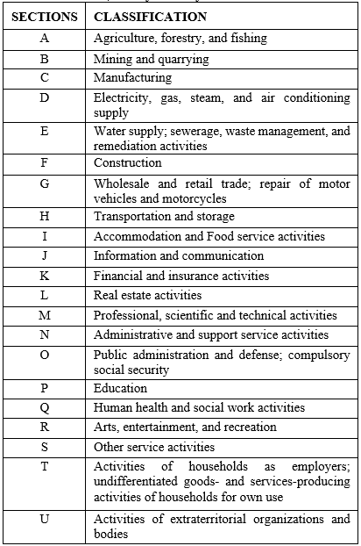

Table 3 Select Location Theories and Models
S.No. | Location Theories and Models | Highlights | Industrial Location
1. | Bid Rent Curve  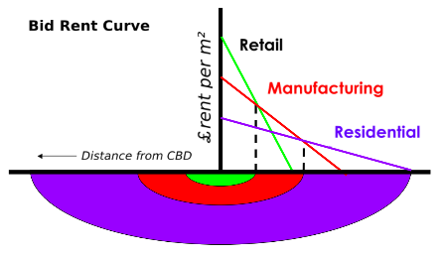 | - Based on Von Thunen’s Regional Land Use model  - Model compares relationship between production cost, market price and the transport cost of an agricultural commodity (Ikehara, 1966).  R = Y (P - C) - Yfm  R; Rent per Unit Land  Y; Yield per Unit Land  P; Market price per Unit of yield  C: Av. Production cost per unit of yield  m; Distance from Market  f; Freight rate per unit Land | - Specified manufacturing as industrial zone which lays in proximity with retail and residential.  - Transportation costs is considered as a major factor in locating industries
2. | Concentric Zone Model or The Burgess Model  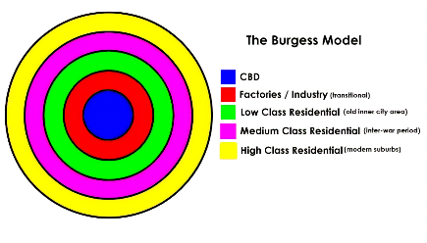 | - Stated the location of different social groups in an urban area by classifying the residential areas into low class (residing in old inner-city area), medium class and high class (modern suburbs).  - The city of Chicago was studied for which Burgess provided empirical evidence (Schwirian, 2007). | - Characterized factories and industries as transitional and located along the Central Business District.  - The residential density is utmost near the industrial area with low working class residing nearby, decreasing towards the outer areas.
3. | 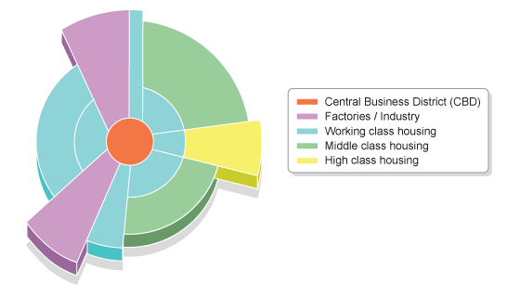  Wedge or Hoyt Model or Sector Model | - Improved version of Burgess Model differentiating the zones in the form of sectors and not rings.  - Based on the factor that the city radiates out along main travel links and corridors (Schwirian, 2007). | - Central Business District remains the nucleus for growth.  - Specified the working class residing along factories and industries and radiating outwards.
4. | Harris and Ullman’s Multiple Nuclei Model  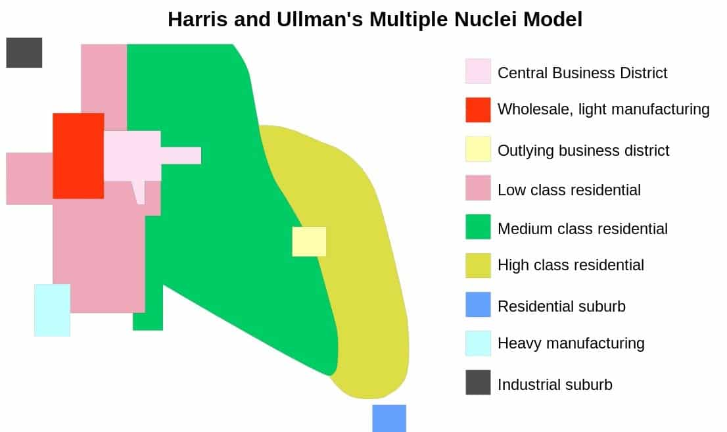 | - The model is based on the structure of Chicago.  - Cities have multiple growth points i.e., nuclei; around which growth takes place.  - Over the time the activities scatter and get modified from the CBD.  - Scattered activities act as smaller nuclei in themselves influencing the growth of industries and factories near them (Schwirian, 2007). | - The model first time classifies industrial areas into heavy manufacturing, light manufacturing and wholesale.  - Central Business District and light manufacturing is located in proximity with low class residential.
5. | 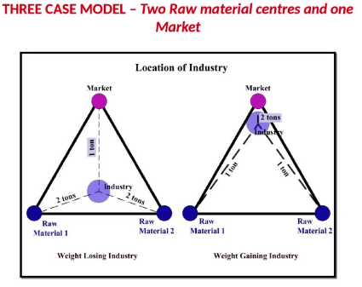  Weber’s Theory of Location | - Alfred Weber attempted an analytical approach to the problem of industrial location for the first time (Weber, n.d.).  - Weber classified causes which influences the location of an industry into tow broad categories.  - Primary Factors/Regional Factors  - Secondary Factors/ Agglomerative and Deliberative Factors  - According to the theory Transport costs are influenced by three base elements  - The weight to be transported  - The distance to be covered  - The nature of Commodity | - Analytically focused on industrial location and factors influencing it.  - Major factors included, distance to be traveled, nature of raw material or commodity.  - Also focused on regional factors affecting the location of industrial location.
6. | Growth Pole Theory  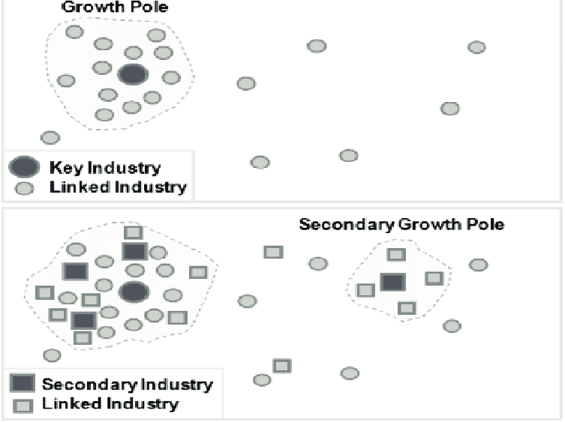 | - The concept of growth pole was first used by Franci Peroux in 1949.  - States that any growth basically occurs towards a specific location which is a result of discontinuous growth and location.  - There are core or key industries which leads to the accumulation of linked industries, which later can develop as secondary industries having its own linked industries. | - Key industries lead to occurrence of clusters of linked industries.  - Focused on emergence of multiple growth nodes of industries.

Table 5 MSME Clusters in Jaipur (MSME Development Institute & Ministry of MSME, n.d.)
