Supplemental Materials

Moral Foundations Elicit Shared and Dissociable Cortical Activation Modulated by Political Ideology

Frederic R. Hopp¹, Ori Amir², Jacob T. Fisher³,
Scott Grafton⁴, Walter Sinnott-Armstrong⁵, & René Weber^{4,6,7,*}

¹ Amsterdam School of Communication Research, University of Amsterdam
² Pomona College, Claremont, CA, USA
³ College of Media, University of Illinois Urbana-Champaign, Urbana, IL, USA
⁴Psychological & Brain Sciences, University of California, Santa Barbara, CA, USA
⁵Department of Philosophy, Duke University, NC, USA
⁶Department of Communication, University of California, Santa Barbara, CA, USA
⁷Department of Communication and Media, Ewha Womans University, Seoul, South Korea
* Corresponding Author

Table of Contents
Table 1. Cluster Peaks for General Linear Model (GLM) 2
Figure 1. Dissociable neural activation across moral foundations 8
Figure 2. A-priori ROIs 9
Table 2. A-priori ROI labels and index 10
Table 3. Cluster Peaks for Group × Condition F-test 11

Table 1. Cluster Peaks for General Linear Model (GLM)
 | MNI Coordinates
Region name | x | y | z | T value | Volume (mm)
Physical Care > Social
Temporal_Mid_L | -54.5 | -60.5 | 13.5 | 11.1517 | 15936
Frontal_Sup_2_L | -30.5 | -6.5 | 65.5 | 7.36766 | 9792
Precuneus_L | -0.5 | -62.5 | 33.5 | 7.94683 | 9488
Lingual_R | 11.5 | -84.5 | -4.5 | 10.1473 | 7808
Supp_Motor_Area_R | 1.5 | 11.5 | 51.5 | 6.539 | 5384
Temporal_Mid_R | 51.5 | -56.5 | 15.5 | 6.9509 | 4552
Postcentral_L | -44.5 | -28.5 | 57.5 | 5.74049 | 3440
Frontal_Mid_2_L | -46.5 | 35.5 | 33.5 | 5.75007 | 2648
no_label | -66.5 | -36.5 | 31.5 | 5.17662 | 2432
Frontal_Sup_Medial_R | 7.5 | 53.5 | 21.5 | 5.45034 | 2216
Temporal_Inf_L | -44.5 | -34.5 | -18.5 | 7.64062 | 2200
Frontal_Inf_Tri_L | -38.5 | 27.5 | 3.5 | 5.87796 | 2016
Frontal_Inf_Oper_L | -56.5 | 7.5 | 19.5 | 5.76394 | 1904
Occipital_Mid_L | -12.5 | -96.5 | 1.5 | 6.6718 | 1224
no_label | -0.5 | -34.5 | -2.5 | 5.91979 | 1008
Psychological Care > Social
Precuneus_L | -0.5 | -60.5 | 31.5 | 11.2789 | 17840
Frontal_Sup_Medial_R | 3.5 | 57.5 | 31.5 | 7.55842 | 7552
Lingual_R | 11.5 | -82.5 | -8.5 | 7.8122 | 6368
Supp_Motor_Area_R | 1.5 | 13.5 | 51.5 | 7.58207 | 6232
Temporal_Mid_L | -44.5 | -58.5 | 21.5 | 6.20284 | 5320
Temporal_Mid_L | -58.5 | -12.5 | -6.5 | 5.73592 | 3896
Precentral_L | -34.5 | -2.5 | 63.5 | 6.15018 | 3560
Temporal_Mid_L | -54.5 | -46.5 | 3.5 | 6.10059 | 2608
Temporal_Mid_R | 47.5 | -60.5 | 21.5 | 5.59042 | 2504
Frontal_Inf_Tri_L | -50.5 | 19.5 | 19.5 | 5.22933 | 2416
Postcentral_L | -44.5 | -26.5 | 59.5 | 5.04315 | 2064
Frontal_Inf_Tri_L | -36.5 | 29.5 | 1.5 | 5.11225 | 1496
Cerebelum_6_R | 33.5 | -60.5 | -30.5 | 5.23735 | 1472
Occipital_Mid_L | -12.5 | -96.5 | 1.5 | 6.41054 | 1408
Frontal_Sup_2_L | -30.5 | 51.5 | 17.5 | 4.26597 | 1104
Cerebelum_9_R | 7.5 | -62.5 | -46.5 | 4.9893 | 1056
Temporal_Inf_L | -48.5 | -4.5 | -30.5 | 3.70312 | 120
Fairness > Social
Precuneus_L | -0.5 | -56.5 | 31.5 | 11.8739 | 18896
Frontal_Sup_2_L | -22.5 | 27.5 | 55.5 | 6.74128 | 12568
Angular_L | -46.5 | -64.5 | 27.5 | 9.66402 | 12568
Lingual_R | 9.5 | -84.5 | -4.5 | 10.1797 | 7600
Temporal_Mid_L | -62.5 | -10.5 | -18.5 | 6.96846 | 6528
Angular_R | 49.5 | -60.5 | 27.5 | 7.75405 | 5288
Supp_Motor_Area_L | -4.5 | 5.5 | 53.5 | 7.28861 | 4400
Frontal_Sup_Medial_L | -6.5 | 65.5 | 17.5 | 5.46019 | 3712
Postcentral_L | -46.5 | -28.5 | 63.5 | 5.31842 | 3320
Temporal_Mid_R | 65.5 | -10.5 | -22.5 | 5.37338 | 2304
no_label | 3.5 | -66.5 | -50.5 | 5.26552 | 1432
no_label | 23.5 | 35.5 | 55.5 | 5.24655 | 1128
Cerebelum_6_R | 31.5 | -62.5 | -30.5 | 4.99144 | 1096
Frontal_Sup_Medial_L | -8.5 | 47.5 | 45.5 | 4.29395 | 944
Occipital_Sup_L | -12.5 | -96.5 | 3.5 | 6.30078 | 856
Liberty > Social
Precuneus_L | -0.5 | -56.5 | 31.5 | 13.7876 | 25888
Precentral_L | -30.5 | -4.5 | 61.5 | 8.36459 | 12104
Angular_L | -46.5 | -64.5 | 25.5 | 8.81123 | 9256
Lingual_R | 11.5 | -82.5 | -10.5 | 9.39426 | 9032
Supp_Motor_Area_R | 1.5 | 11.5 | 51.5 | 8.08985 | 6904
Frontal_Med_Orb_L | -8.5 | 69.5 | -6.5 | 6.55174 | 5912
Calcarine_L | -14.5 | -96.5 | -2.5 | 7.55017 | 4928
Temporal_Mid_L | -64.5 | -10.5 | -18.5 | 6.69444 | 4384
Postcentral_L | -44.5 | -26.5 | 61.5 | 5.25508 | 2736
Angular_R | 47.5 | -60.5 | 27.5 | 5.80818 | 2632
Cerebelum_9_R | 5.5 | -58.5 | -44.5 | 5.89726 | 1640
Parietal_Sup_L | -16.5 | -66.5 | 57.5 | 4.63681 | 1592
Temporal_Mid_R | 63.5 | -6.5 | -18.5 | 4.84726 | 1016
Insula_L | -30.5 | 27.5 | 1.5 | 4.81888 | 960
Cerebelum_Crus1_R | 33.5 | -60.5 | -32.5 | 5.29119 | 928
Frontal_Inf_Oper_L | -36.5 | 13.5 | 31.5 | 4.07212 | 784
Supp_Motor_Area_L | -14.5 | 11.5 | 63.5 | 4.22351 | 272
Cerebelum_Crus1_R | 23.5 | -82.5 | -24.5 | 3.33484 | 16
Cerebelum_Crus1_R | 25.5 | -84.5 | -26.5 | 3.27466 | 8
Loyalty > Social
Cingulate_Post_R | 1.5 | -54.5 | 29.5 | 19.2393 | 53832
Angular_L | -46.5 | -64.5 | 25.5 | 12.3086 | 45560
Precentral_L | -36.5 | 1.5 | 59.5 | 8.49765 | 44320
Lingual_R | 13.5 | -84.5 | -4.5 | 9.35428 | 15520
Temporal_Mid_R | 61.5 | -4.5 | -14.5 | 10.7063 | 13992
Occipital_Mid_L | -12.5 | -94.5 | -0.5 | 8.37329 | 11656
Supp_Motor_Area_R | 3.5 | 13.5 | 49.5 | 9.27276 | 8816
Frontal_Sup_2_R | 25.5 | 29.5 | 55.5 | 7.91586 | 7832
Cerebelum_9_R | 3.5 | -60.5 | -46.5 | 10.1742 | 7464
Cerebelum_6_R | 33.5 | -60.5 | -30.5 | 6.5833 | 1920
Frontal_Mid_2_R | 53.5 | 23.5 | 35.5 | 4.20373 | 1448
Cerebelum_Crus1_L | -38.5 | -62.5 | -30.5 | 5.39765 | 1200
Olfactory_L | -4.5 | 23.5 | -12.5 | 5.471 | 1112
no_label | -26.5 | 29.5 | -0.5 | 6.9515 | 944
Precentral_L | -34.5 | -8.5 | 43.5 | 3.80295 | 72
no_label | -32.5 | -10.5 | 39.5 | 3.29361 | 8
Authority > Social
Precuneus_L | -0.5 | -56.5 | 31.5 | 16.5473 | 34776
Angular_L | -50.5 | -66.5 | 23.5 | 8.61064 | 15656
Temporal_Mid_R | 47.5 | -62.5 | 21.5 | 11.0935 | 11800
Precentral_L | -32.5 | -4.5 | 57.5 | 7.3004 | 7888
Temporal_Mid_R | 53.5 | -8.5 | -16.5 | 8.15859 | 7264
Lingual_R | 11.5 | -84.5 | -6.5 | 8.69036 | 6648
Temporal_Sup_L | -54.5 | -8.5 | -10.5 | 8.64399 | 6624
Supp_Motor_Area_L | 1.5 | 13.5 | 49.5 | 8.48009 | 5352
Postcentral_L | -44.5 | -24.5 | 59.5 | 5.51249 | 5112
Frontal_Sup_Medial_R | 5.5 | 55.5 | 25.5 | 5.41108 | 4360
Cerebelum_9_L | -2.5 | -56.5 | -48.5 | 5.96227 | 3448
Frontal_Med_Orb_L | -6.5 | 65.5 | -8.5 | 6.81871 | 1976
Frontal_Inf_Tri_L | -46.5 | 17.5 | 23.5 | 5.13724 | 1824
Frontal_Sup_2_R | 29.5 | 1.5 | 61.5 | 5.07087 | 1704
Occipital_Sup_L | -12.5 | -94.5 | 3.5 | 7.4811 | 1632
Frontal_Sup_2_R | 25.5 | 31.5 | 51.5 | 4.93387 | 1552
Cerebelum_6_R | 31.5 | -60.5 | -30.5 | 5.45406 | 936
no_label | 25.5 | -76.5 | -0.5 | 3.4917 | 8
Purity > Social
Frontal_Sup_Medial_L | 1.5 | 57.5 | 29.5 | 10.2331 | 103776
no_label | -2.5 | -30.5 | -0.5 | 8.46787 | 29336
Lingual_R | 11.5 | -84.5 | -6.5 | 9.62853 | 25520
Angular_L | -48.5 | -66.5 | 23.5 | 9.6839 | 23208
Precuneus_L | -0.5 | -58.5 | 31.5 | 14.2734 | 14016
Temporal_Mid_L | -60.5 | -8.5 | -8.5 | 8.09726 | 10000
Calcarine_L | -12.5 | -98.5 | -2.5 | 7.73158 | 8776
Cerebelum_9_R | 5.5 | -58.5 | -46.5 | 11.1673 | 7544
Temporal_Pole_Sup_R | 29.5 | 23.5 | -32.5 | 9.09049 | 7512
Angular_R | 43.5 | -60.5 | 27.5 | 7.47362 | 4600
Frontal_Med_Orb_L | -6.5 | 67.5 | -6.5 | 8.06702 | 4080
Cerebelum_6_L | -30.5 | -62.5 | -30.5 | 7.63375 | 4064
Temporal_Mid_R | 61.5 | -4.5 | -16.5 | 6.72357 | 4040
Parietal_Sup_L | -26.5 | -52.5 | 49.5 | 5.18521 | 1160
no_label | 7.5 | 13.5 | 71.5 | 3.34294 | 8
Pallidum_L | -18.5 | 1.5 | 1.5 | 3.23606 | 8
Binding > Individualizing
Precuneus_R | 1.5 | -60.5 | 35.5 | 14.2034 | 96680
Temporal_Mid_L | -58.5 | -6.5 | -14.5 | 8.87132 | 79424
Angular_L | -48.5 | -66.5 | 25.5 | 8.92967 | 20776
Angular_R | 51.5 | -64.5 | 29.5 | 10.4741 | 19248
Temporal_Mid_R | 59.5 | -4.5 | -14.5 | 10.1223 | 18032
Frontal_Inf_Tri_R | 51.5 | 25.5 | 23.5 | 6.60416 | 8984
Cerebelum_9_R | 1.5 | -60.5 | -46.5 | 9.08727 | 7664
Frontal_Sup_2_R | 25.5 | 27.5 | 51.5 | 7.45254 | 7120
Supp_Motor_Area_L | -4.5 | 11.5 | 53.5 | 6.38476 | 5712
OFClat_R | 45.5 | 31.5 | -14.5 | 6.42607 | 3024
no_label | -0.5 | 7.5 | -12.5 | 5.66509 | 1840
ParaHippocampal_R | 19.5 | -22.5 | -18.5 | 4.81768 | 1000
Precuneus_R | 11.5 | -76.5 | 57.5 | 3.47626 | 16
no_label | 31.5 | 9.5 | -48.5 | 3.29324 | 8
no_label | -14.5 | -78.5 | 59.5 | 3.31335 | 8
Moral > Social
Precuneus_L | -0.5 | -58.5 | 31.5 | 16.0107 | 25632
Angular_L | -46.5 | -64.5 | 25.5 | 10.4954 | 19056
Precentral_L | -30.5 | -4.5 | 61.5 | 8.12919 | 17576
Frontal_Med_Orb_L | -4.5 | 67.5 | -6.5 | 7.64185 | 14032
Lingual_R | 11.5 | -84.5 | -4.5 | 10.6102 | 13608
Supp_Motor_Area_R | 3.5 | 13.5 | 49.5 | 9.59883 | 9312
Temporal_Mid_L | -56.5 | -10.5 | -8.5 | 8.80379 | 7064
Angular_R | 47.5 | -62.5 | 27.5 | 9.23744 | 6928
Cerebelum_9_R | 3.5 | -60.5 | -48.5 | 8.08167 | 5080
Temporal_Mid_R | 63.5 | -4.5 | -16.5 | 7.40962 | 4544
Frontal_Inf_Tri_L | -48.5 | 19.5 | 19.5 | 5.71011 | 4456
Postcentral_L | -44.5 | -26.5 | 59.5 | 5.46691 | 3592
Frontal_Inf_Tri_L | -38.5 | 27.5 | 3.5 | 5.96579 | 3224
Occipital_Mid_L | -12.5 | -96.5 | 1.5 | 7.82711 | 3192
no_label | -20.5 | -76.5 | 57.5 | 5.16684 | 2064
Thalamus_L | -8.5 | -8.5 | 3.5 | 5.14263 | 1832
Cerebelum_Crus1_L | -38.5 | -62.5 | -30.5 | 6.04268 | 1328
Frontal_Sup_2_R | 23.5 | 33.5 | 55.5 | 5.17786 | 1112
no_label | 41.5 | 5.5 | -30.5 | 5.56857 | 1048
Frontal_Sup_2_R | 29.5 | 1.5 | 61.5 | 4.78753 | 1032
Cerebelum_Crus2_R | 11.5 | -88.5 | -40.5 | 6.05015 | 944
no_label | -0.5 | -34.5 | -2.5 | 5.61872 | 928
Occipital_Inf_L | -36.5 | -78.5 | -12.5 | 4.36208 | 840
Caudate_L | -12.5 | 13.5 | 3.5 | 4.66589 | 744
Rectus_R | 3.5 | 57.5 | -20.5 | 3.27807 | 56
no_label | -24.5 | 13.5 | 67.5 | 3.28198 | 16
no_label | -24.5 | -80.5 | 51.5 | 3.26956 | 8

Figure 1. Dissociable neural activation across moral foundations

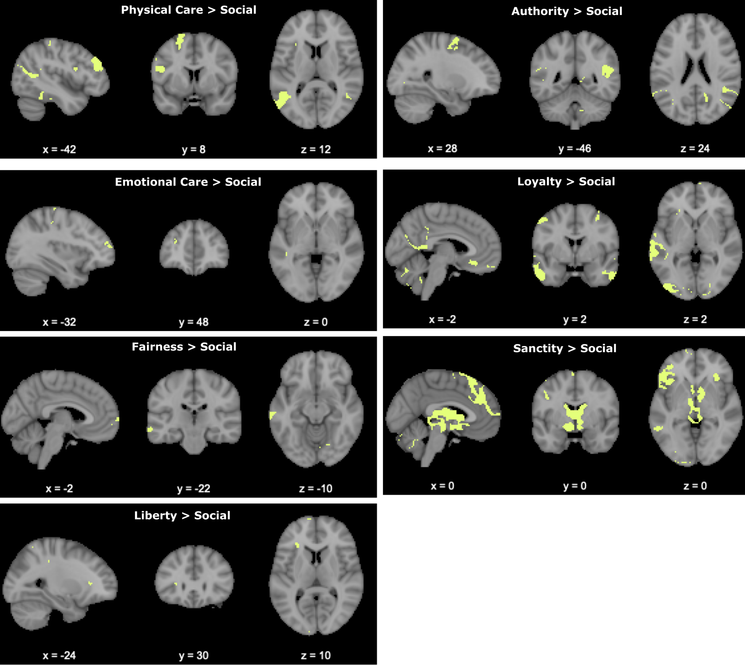
Voxels that preferentially respond to a single moral foundation versus social norms are outlined in yellow. In order to be considered, a voxel must first survive the corresponding group-level contrast with voxel-wise threshold of p < 0.001 (uncorrected) and a cluster extent threshold ensuring q < 0.01 (false discovery rate (FDR)-corrected) and only be significant for the corresponding contrast (see title) and nonsignificant for the other six moral foundation versus social norm contrasts.

Figure 2. A-priori ROIs
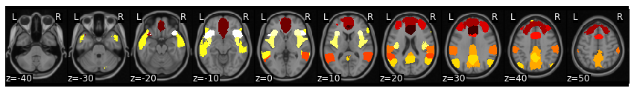

13 parcels were selected from a 50 parcel whole-brain parcellation based on meta-analytic functional coactivation of the Neurosynth database (parcellation available at https://neurovault.org/images/395092/).

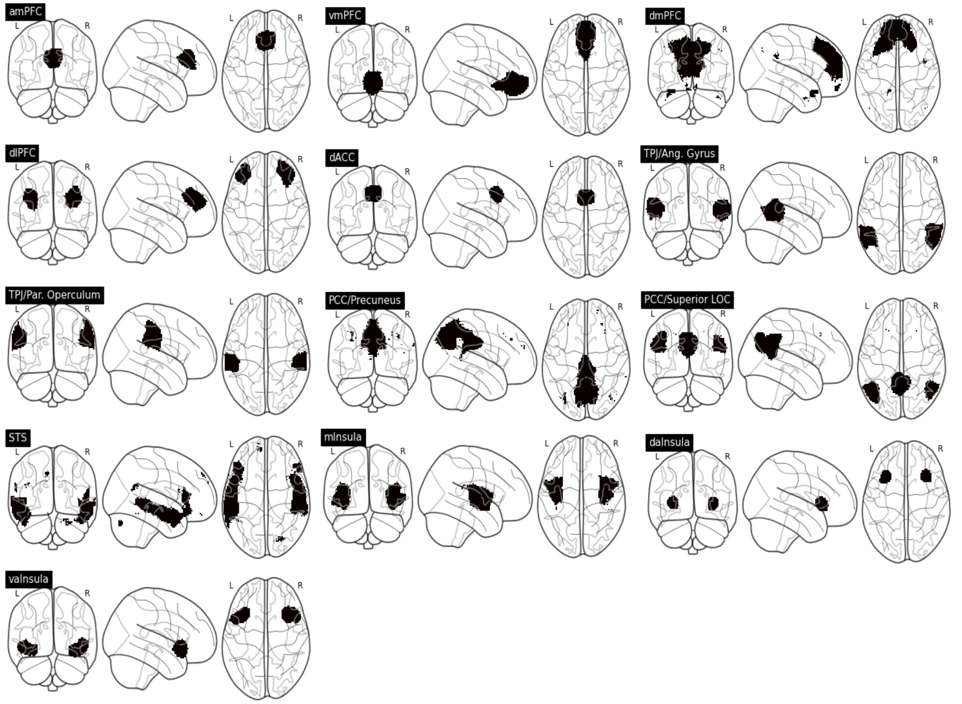

Table 2. A-priori ROI labels and index
ROI Index | Label
0 | anterior mPFC
32 | vmPFC
2 | dmPFC
44 | dlPFC
22 | dACC
5 | TPJ posterior supra marginal/angular gyrus
15 | TPJ anterior supra marginal gyrus/Parietal operculum
6 | PCC/Precuneus
19 | PCC/Superior LOC
49 | STS
16 | mid Insula
18 | dorsal anterior insula
37 | ventral anterior insula

Table 3. Cluster Peaks for Group × Condition F-test
 | MNI Coordinates
Region name | x | y | z | F value | Volume (mm)
Lingual_L | -10.5 | -78.5 | -8.5 | 26.5381 | 4168
Occipital_Mid_R | 31.5 | -88.5 | 7.5 | 15.6522 | 2176
Cuneus_R | 11.5 | -98.5 | 7.5 | 17.9493 | 1344
Frontal_Sup_2_R | 15.5 | 49.5 | 45.5 | 20.9476 | 1288
Frontal_Inf_Tri_L | -38.5 | 21.5 | 15.5 | 15.9409 | 1264
Frontal_Inf_Orb_2_L | -46.5 | 23.5 | -10.5 | 18.204 | 920
Temporal_Pole_Mid_R | 37.5 | 11.5 | -42.5 | 19.5881 | 912
Precuneus_R | 9.5 | -52.5 | 15.5 | 13.4049 | 576
Occipital_Inf_R | 47.5 | -74.5 | -12.5 | 12.8446 | 432
no_label | -62.5 | 7.5 | -8.5 | 16.171 | 432
Frontal_Mid_2_L | -24.5 | 17.5 | 41.5 | 13.9903 | 432
Angular_R | 45.5 | -66.5 | 33.5 | 11.0749 | 352
no_label | -6.5 | -16.5 | -10.5 | 16.4161 | 328
Occipital_Mid_L | -28.5 | -80.5 | 19.5 | 11.3625 | 320
Temporal_Inf_R | 53.5 | 3.5 | -36.5 | 10.5831 | 312
Fusiform_R | 41.5 | -58.5 | -14.5 | 13.6831 | 288
Temporal_Mid_L | -58.5 | -4.5 | -26.5 | 11.4734 | 248
no_label | -46.5 | -46.5 | 61.5 | 13.8815 | 232
SupraMarginal_R | 61.5 | -24.5 | 33.5 | 12.5001 | 216
Frontal_Inf_Orb_2_R | 37.5 | 27.5 | -12.5 | 13.0919 | 216
Caudate_L | -10.5 | -2.5 | 15.5 | 11.261 | 200
Cerebelum_8_L | -34.5 | -44.5 | -50.5 | 14.1627 | 168
Insula_R | 29.5 | 17.5 | -14.5 | 12.033 | 160
Temporal_Mid_L | -64.5 | -4.5 | -8.5 | 10.465 | 144
Supp_Motor_Area_L | -10.5 | 13.5 | 65.5 | 9.84386 | 144
no_label | -64.5 | -46.5 | 39.5 | 10.0575 | 144
no_label | -18.5 | -34.5 | 11.5 | 12.274 | 136
Fusiform_R | 41.5 | -14.5 | -38.5 | 12.7005 | 128
Cingulate_Ant_R | 13.5 | 47.5 | 7.5 | 11.3646 | 120
no_label | -10.5 | -12.5 | -28.5 | 11.8179 | 120
Cerebelum_3_L | -4.5 | -40.5 | -16.5 | 11.8055 | 112
Frontal_Sup_2_R | 21.5 | 35.5 | 53.5 | 9.73477 | 96
no_label | -28.5 | 11.5 | 5.5 | 9.86392 | 96
Calcarine_R | 27.5 | -70.5 | 3.5 | 12.0045 | 96
Fusiform_L | -36.5 | -56.5 | -12.5 | 12.9829 | 88
Precuneus_R | 25.5 | -46.5 | 5.5 | 9.88798 | 80
Parietal_Sup_L | -22.5 | -64.5 | 69.5 | 10.1481 | 80
Caudate_L | -16.5 | 13.5 | 13.5 | 10.075 | 80
Temporal_Inf_R | 37.5 | -2.5 | -38.5 | 8.88569 | 16
no_label | 1.5 | -22.5 | -8.5 | 8.15294 | 8
no_label | 23.5 | -42.5 | 3.5 | 8.10091 | 8
no_label | -66.5 | -46.5 | 35.5 | 8.38669 | 8

