Table 2: Summary statistics of continuous variables
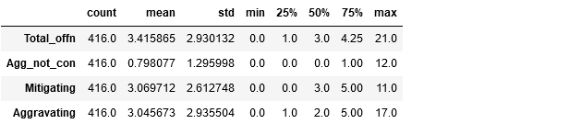
Table 3: Summary statistics of categorical variables
