Supplementary file
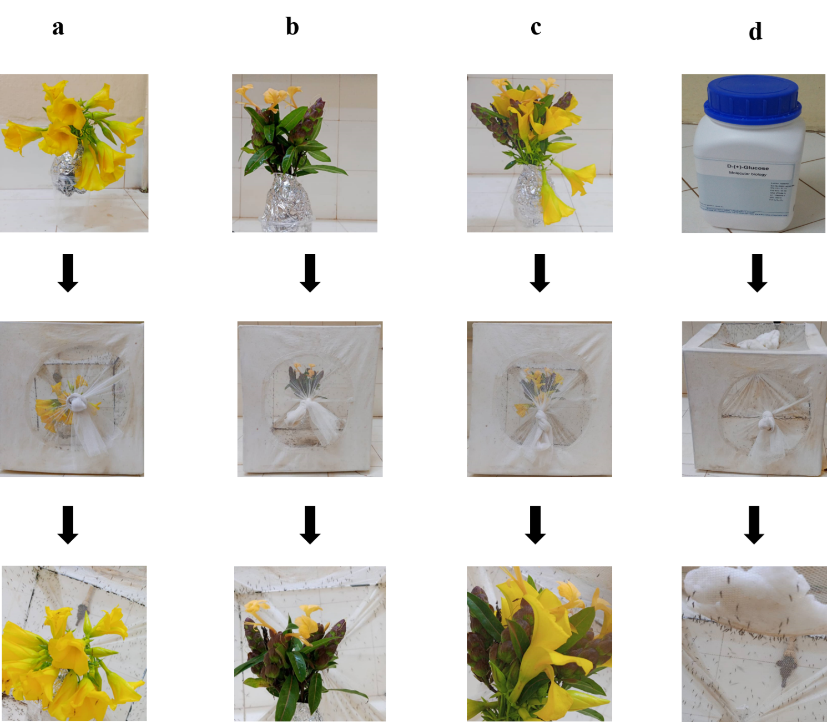

Supplementary Figure S1: Experimental setup of mosquito plant feeding experiment. Bundle of flowers of Cascabela thevetia (a), Barleria lupulina (b), Barleria lupulina + Cascabela thevetia (c) and, 5% glucose solution on cotton pad (d) and their introduction into the cages for mosquito feeding.

Supplementary Figure S2: Effect of plant diet on mosquito knock down rate (KD) following exposure to 0.05% deltamethrin (a) or 0.5% deltamethrin (b) over time for each replicate. The lines represent best-fit logistic growth curves for each plant treatment.

Supplementary Figure S3: Effect of plant diet and insecticide dose on the proportion of dead mosquitoes after 24 h of exposure to (a) 0.05% deltamethrin (a) and to (b) 0.5% deltamethrin for each replicate. The numbers above the barplots represent the sample size of each level of the plant diet variable. The error bars represent the variability of data with 95% confidence interval (±95% CI).
Supplementary Figure S4: Relationship between proportion of KD and 24 h mosquito mortality. (a) KD 60 min with the 0.05% deltamethrin and (b) KD 20 min with the 0.5% deltamethrin. The lines represent best-fit logistic growth curves for each plant treatment and the dots represent the number of WHO tubes used in the bioassays.

Supplementary Figure S5: Effect of insecticide exposure, mosquito species, plant diet, and kdr resistance gene on the proportion of dead mosquitoes exposed to (a) 0.05% deltamethin, or (b) 0.5% deltamethrin over two replicates. The numbers above the barplots represent the sample size for each plant treatment. The error bars represent the variability of data with 95% confidence interval (±95% CI). The letters on the x-axis correspond to the different genotypes of the kdr resistance gene with SS designating homozygous susceptible mosquitoes, RS heterozygous mosquitoes and RR homozygous resistant mosquitoes.

