Supplementary Figures

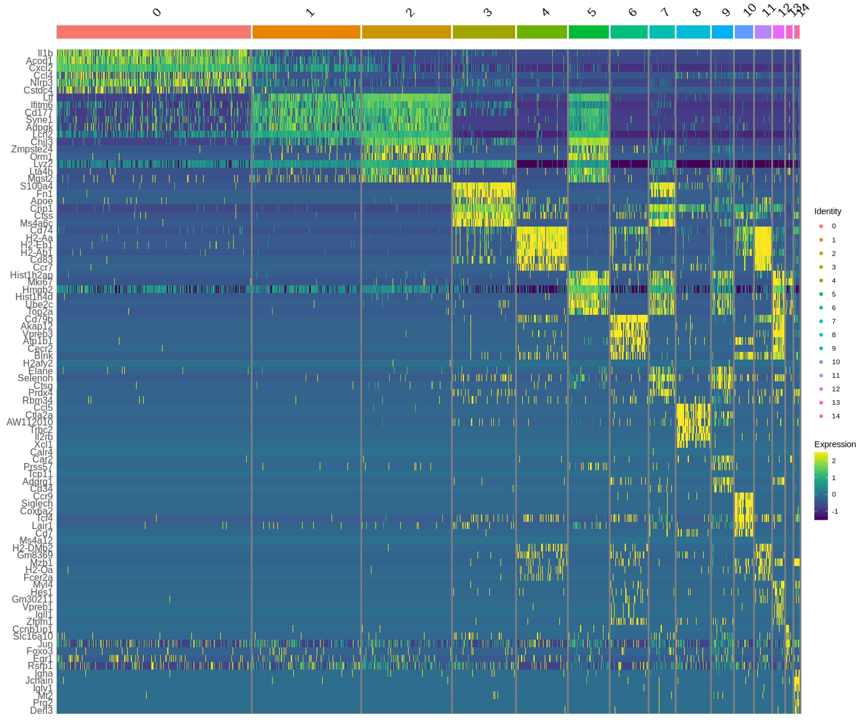
Supplementary Figure 1. Heatmap of cell-type-specific gene signatures of total BM cells.

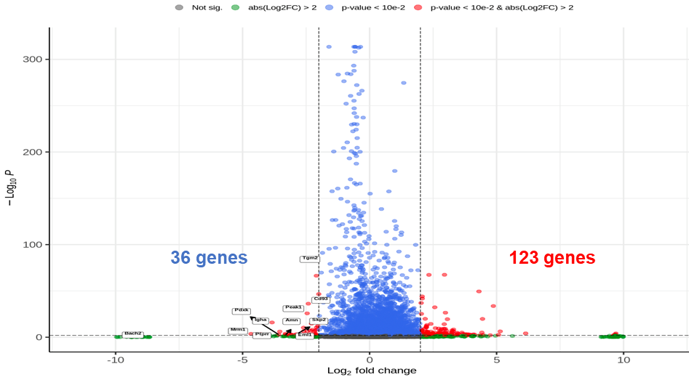
Supplementary Figure 2. Differential gene expression profile of old versus young BM.

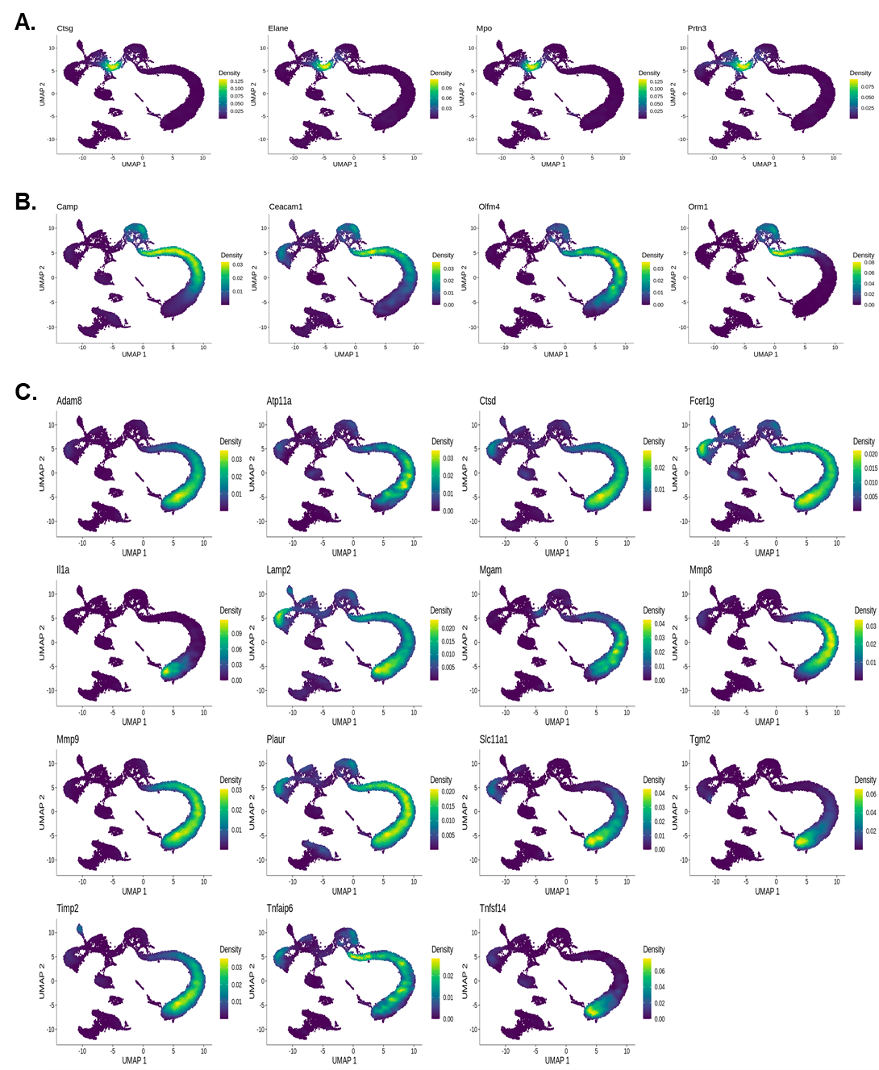
Supplementary Figure 3. Density plot of CMP-, MM- and BSN-specific markers.

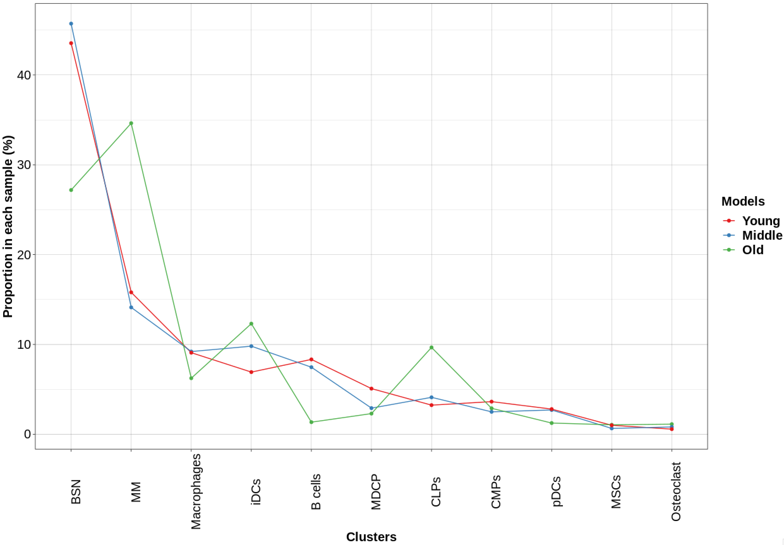
Supplementary Figure 4. Age-associated cell-type population changes.

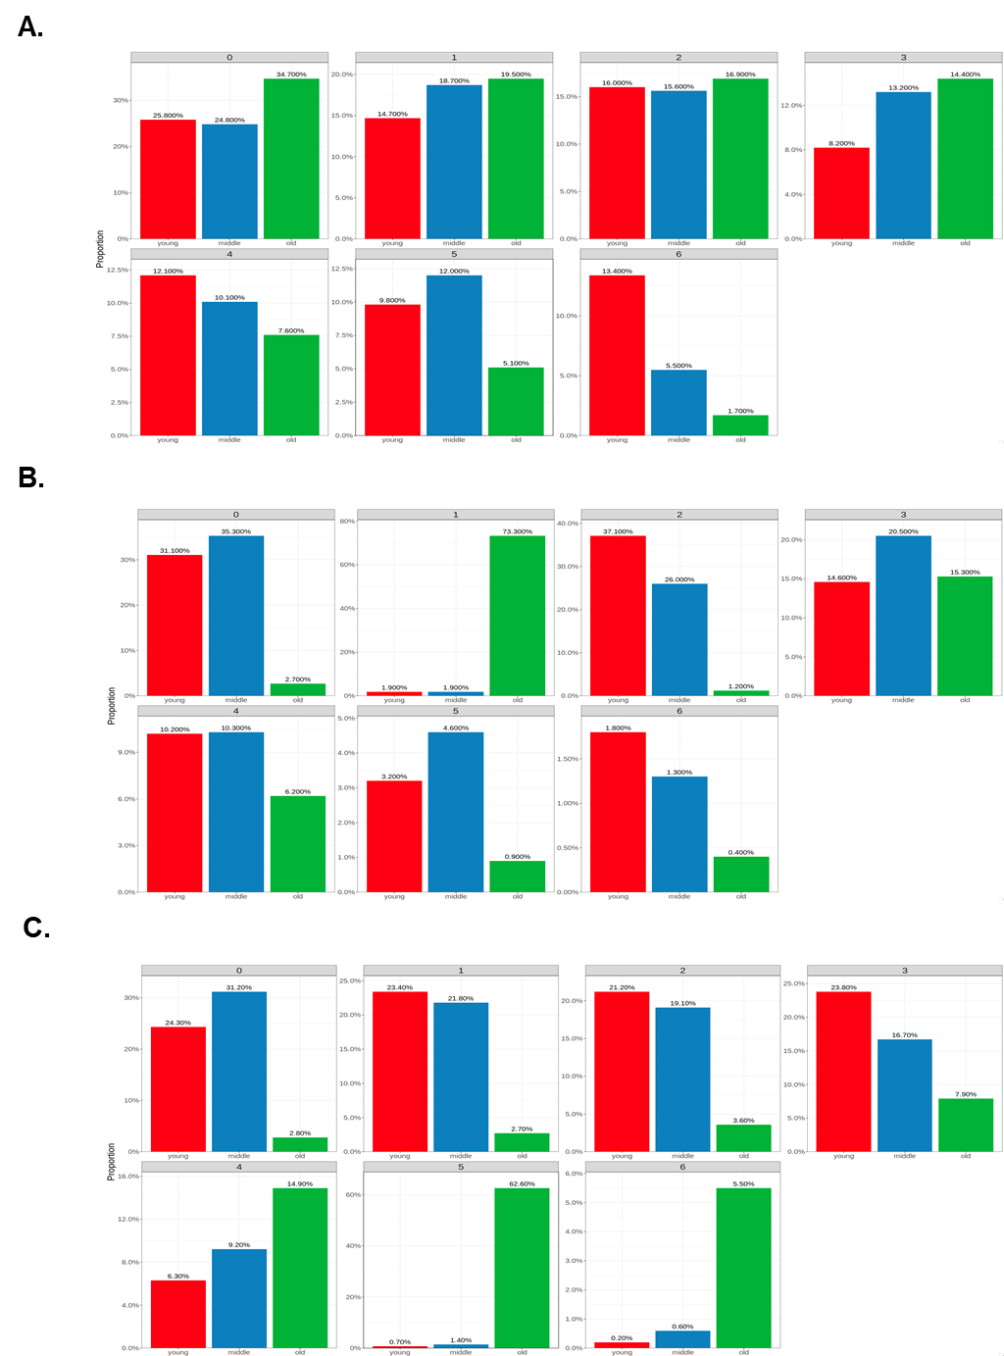
Supplementary Figure 5. Age-associated population changes of CMP, MM and BSN subclusters. Red bar indicate young, blue bar means middle and green bar indicate old group.

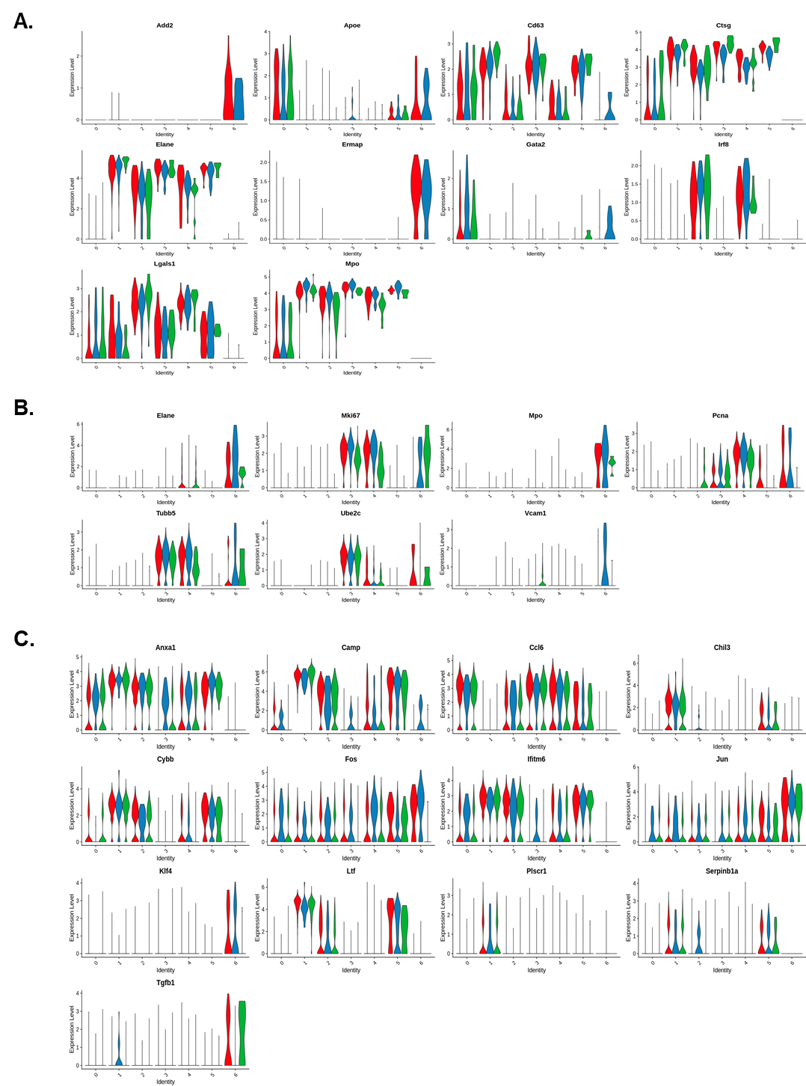
Supplementary Figure 6. Violin plot of subcluster-specific gene expression. Red indicate young, blue indicate middle and green indicate old group.

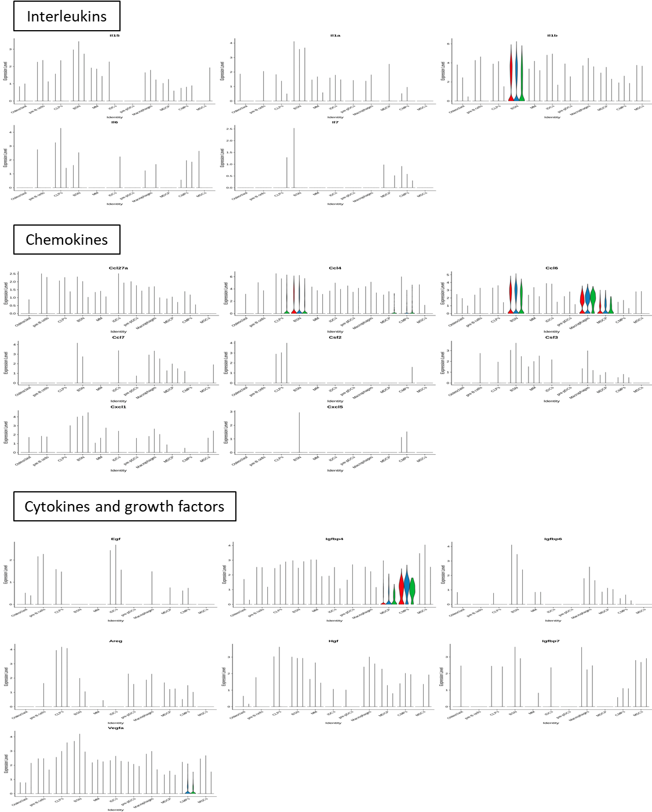
Supplementary Figure 7. Cell type-specific secretory protein expression. Red indicate young, blue indicate middle and green indicate old group.

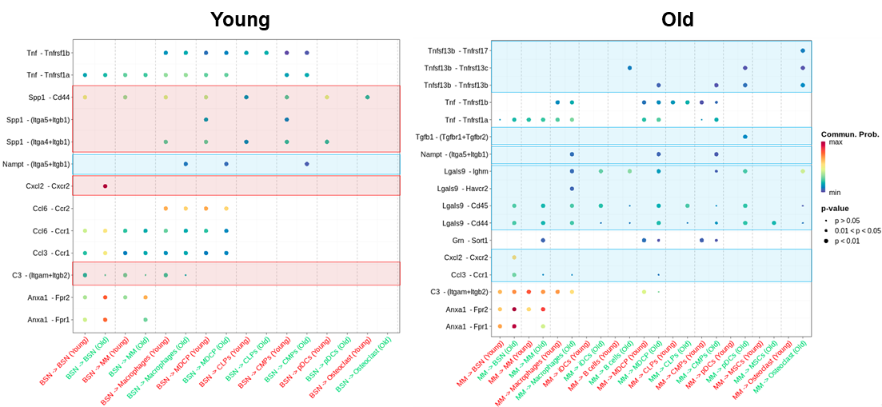
Supplementary Figure 8. Age-associated ligand‒receptor interactions in BSNs and MMs predicted by CellChat. The increased outgoing interactions from young BSNs to other cells marked red boxes and decreased interaction marked blue box (Young). The increased outgoing interaction from old MMs to other cells marked blue boxes (Old).

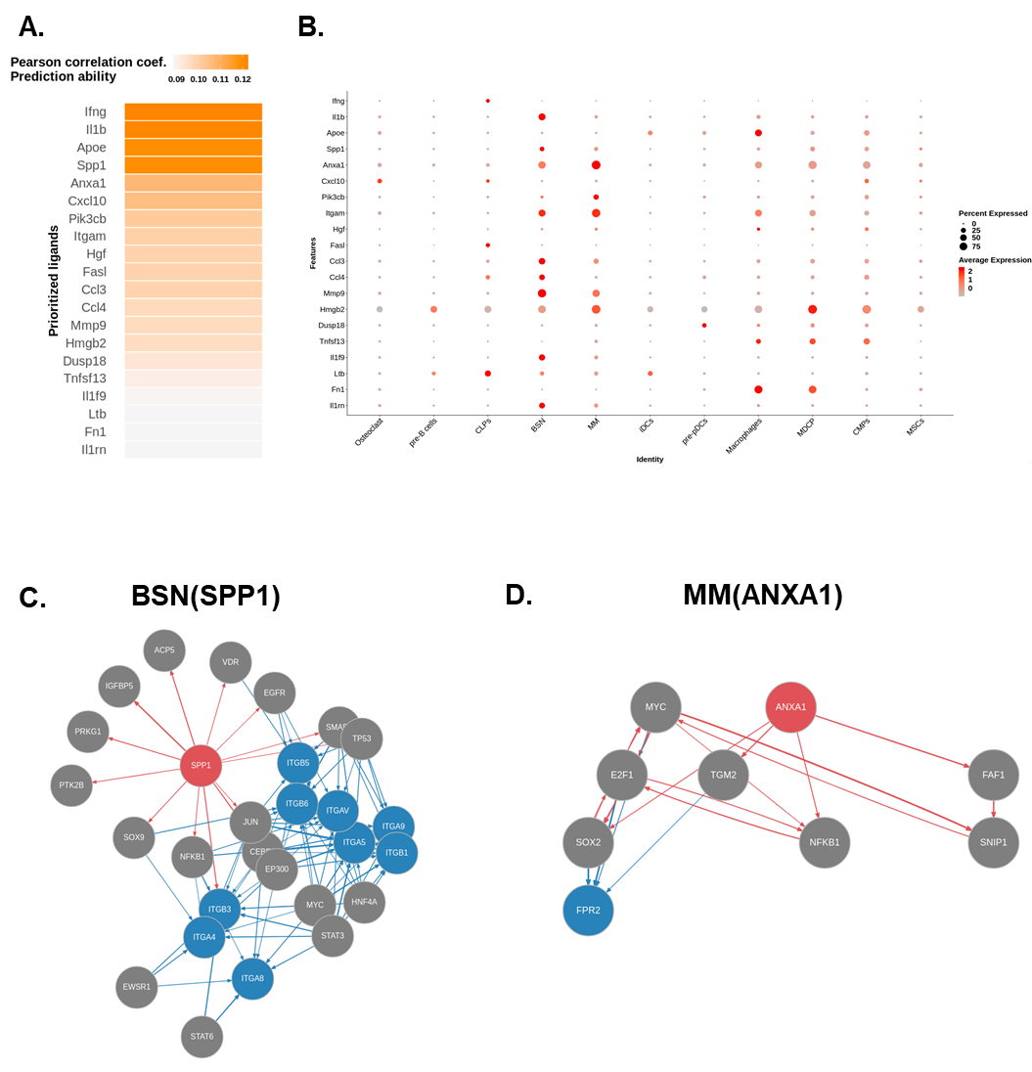
Supplementary Figure 9. Significantly altered PPI in NicheNet analysis.

