Supplementary Information to accompany
TriMaster: randomised double-blind crossover study of a DPP4-inhibitor, SGLT2 inhibitor and thiazolidinedione showing differential response to therapy based on obesity and renal function.
BM Shields, JM Dennis, CD Angwin, F Warren, WE Henley, N Britten, AJ Farmer, N Sattar, RR Holman, AG Jones, ER Pearson, AT Hattersley on behalf of the TriMaster Study group
Table of Contents
Protocol and Statistical Analysis Plan 4
Link to Trimaster Statistical Analysis Plan 4
Link to Trimaster Study Protocol 4
Supplementary Results 5
Supplementary Tables 6
Supplementary Table 1: Analysis of period and carryover effects 6
Supplementary Table 2: Participant Characteristics Hypothesis 1 7
Supplementary Table 3: Primary Analysis Hypothesis 1 full mixed effects model 7
Supplementary Table 4: Participant Characteristics Hypothesis 2 8
Supplementary Table 5: Primary Analysis Hypothesis 2 full mixed effects model 8
Supplementary Table 6: Sensitivity analysis 1. 9
Supplementary Table 7: Sensitivity analysis 2 9
Supplementary Table 8: Sensitivity analysis 3. 9
Supplementary Table 9 – Tolerability & BMI Strata full mixed effects model 10
Supplementary Table 10: Tolerability sensitivity analysis 10
Supplementary Table 11 – Tolerability & eGFR Strata full mixed effects model 11
Supplementary Table 12: Side effects by BMI Strata – mixed effects models 11
Supplementary Table 13: Side effects by eGFR Strata – mixed effects models 12
Supplementary Table 14: Assessment of period and carryover effect for weight 12
Supplementary Table 15: Hypoglycaemia by BMI strata – mixed effects models 13
Supplementary Table 16: Hypoglycaemia by eGFR strata – mixed effects models 13
Supplementary Table 17: Adverse events 14
Supplementary Table 18: Eligibility Criteria for the TriMaster Randomised Crossover Trial 15
Supplementary Table 19: Protocol Amendments in the Trimaster randomised three way crossover trial. 16
Supplementary Figures 17
Supplementary Figure 1: Participant flow through the Trimaster trial 17
Supplementary Figure 2: 18
Supplementary Methods 19
Supplementary Methods 1: The 24 recruiting centres participating in TriMaster 19
Supplementary Methods 2: Measurement of adherence to study medications 19
Supplementary Methods 3: Side effects in Trimaster 20
Supplementary Methods 4: Side effects 20
Supplementary Methods 5: Rationale for a per-protocol approach (completers only analysis): 20
Supplementary Methods 6: Assessment of carryover effect: 21
Supplementary Information - Acknowledgements 22

Protocol and Statistical Analysis Plan

Link to Trimaster Statistical Analysis Plan

The full Trimaster Statistical Analysis Plan is freely available and can be downloaded from
https://ore.exeter.ac.uk/repository/handle/10871/125162

Link to Trimaster Study Protocol

The Trimaster Study Protocol is freely available as a publication and can be downloaded from
https://bmjopen.bmj.com/content/10/12/e042784

Supplementary Results
Between November 2016 and January 2020 742 patients were screened for eligibility. 210 did not meet eligibility criteria and 7 patients withdrew before being randomised. Overall, 525 participants were randomised to one of the six sequences of drug allocations (see Table 1 for participant characteristics). Of these, 20 withdrew prior to the baseline visit (4 health reasons, 10 changed mind, 2 ineligible, 1 moved out of area and 3 unable to contact) and two withdrew at the baseline visit due to difficulties taking blood, leaving 503 receiving their first study drug. Overall, there were 45 participants who subsequently withdrew (Figure 3; Supplementary Figure 1) leading to 458 participants (87% of those randomised) who completed all 3 study periods. On therapy HbA1c results meeting analysis inclusion criteria (>=80% adherence, >12 weeks therapy duration) were available for 421 (pioglitazone), 391 (sitagliptin), and 408 (canagliflozin) (Figure 3; Supplementary Figure 1).

Supplementary Tables
Supplementary Table 1: Analysis of period and carryover effects
Output from mixed effects analysis assessing period and carryover effects. Coef represents the coefficient (difference in HbA1c (mmol/mol) between the category and reference category (‘ref’)), 95% CI is the corresponding 95% confidence interval, z is the z statistic and p is p the value. The global p is the overall p value for comparing across all 3 groups.
 | Coef | 95% CI | z | p | Global p
Period  (ref=1)  2  3 | -1.38  -0.28 | -2.54, -0.23  -1.46, 0.90 | -2.35  -0.47 | 0.02  0.6 | 0.02
Carryover (ref=A)  B  C | 0.98  0.13 | -0.32, 2.29  -1.19, 1.44 | 1.47  0.19 | 0.14  0.9 | 0.3

Supplementary Table 2: Participant Characteristics Hypothesis 1
Comparison of characteristics between participants with and without valid HbA1cs eligible for hypothesis 1. Data presented as mean +/-SD or n(%). *HbA1c heavily skewed at baseline due to lower limit of inclusion criteria so median and inter-quartile range presented an p value calculated by Mann-Whitney.
Variable | Eligible for Hypothesis 1  (n=356) | Not eligible for hypothesis 1  (n=169) | p
Male | 251 (73.3%) | 122 (72.2%) | 0.07
Age at screening (y) | 62.5 +/- 9.1 | 60.0 +/- 10.2 | 0.03
Age at diagnosis (y) | 53.3 +/-8.9 | 52.6 +/- 9.4 | 0.4
Treatment:  Metformin only  Metformin + SU | 162 (45.5%)  194 (54.5%) | 92 (54.4%)  77 (45.6%) | 0.056
White ethnicity | 339 (95.2%) | 156 (92.3%) | 0.2
BMI (kg/m²)  Obese (BMI>30) n (%) | 31.8 +/- 5.3  215 (60.4%) | 31.5 +/- 5.9  92 (54.4%) | 0.7  0.2
eGFR (mls/min/1.73m²)  eGFR>90 n(%) | 89.2 +/- 13.6  91 (53.9%) | 90.8 +/- 14.2  184 (51.7%) | 0.2
HbA1c at screening visit (mmol/mol)* | 69 (63, 77) | 70 (64, 80) | 0.04

Supplementary Table 3: Primary Analysis Hypothesis 1 full mixed effects model
 | Coef | 95% CI | z | p
Drug (ref=Pioglitazone)  Sitagliptin | -1.46 | -2.94, 0.02 | -1.9 | 0.05
Period (ref=1)  2  3 | -1.50  -0.07 | -2.77, -0.22  -1.32, 1.18 | -2.30  -0.11 | 0.02  0.9
BMI>30kg/m² | -0.68 | -2.93, 1.57 | -0.6 | 0.6
Sitagliptin*BMI>30  interaction | 2.88 | 0.98, 4.79 | 3.0 | 0.003

Supplementary Table 4: Participant Characteristics Hypothesis 2
Comparison of characteristics between participants with and without valid HbA1cs eligible for hypothesis 2. Data presented as mean +/-SD or n(%). *HbA1c heavily skewed at baseline due to lower limit of inclusion criteria so median and inter-quartile range presented an p value calculated by Mann-Whitney.
Variable | Eligible for Hypothesis 1  (n=342) | Not eligible for hypothesis 1  (n=183) | p
Male | 252 (73.7%) | 131 (71.6%) | 0.3
Age at screening (y) | 62.3 +/- 9.4 | 61.2 +/- 9.7 | 0.2
Age at diagnosis (y) | 53.2 +/- 9.1 | 52.7 +/- 9.1 | 0.6
Treatment:  Metformin only  Metformin + SU | 162 (47.4%)  180 (52.6%) | 92 (50.3%)  91 (49.7%) | 0.4
White ethnicity | 326 (95.3%) | 169 (92.4%) | 0.2
BMI (kg/m²)  Obese (BMI>30) n (%) | 31.7 +/- 5.5  205 (59.9%) | 31.6 +/- 5.7  102 (55.7%) | 0.7  0.9
eGFR (mls/min/1.73m2)  eGFR>90 n(%) | 89.7 +/- 13.9  179 (53.3%) | 89.8 +/- 13.5  96 (52.5%) | 0.9  0.98
HbA1c at screening visit (mmol/mol)* | 69 (63, 77) | 70 (64, 79) | 0.3

Supplementary Table 5: Primary Analysis Hypothesis 2 full mixed effects model
 | Coef | 95% CI | z | P
Drug (ref=Sitagliptin)  Canagliflozin | 1.79 | 0.55, 3.03 | 2.8 | 0.005
Period (ref=1)  2  3 | -1.16  -0.15 | -2.33, 0.02  -1.33, 1.02 | -1.9  -0.3 | 0.053  0.8
eGFR >90 | 1.69 | -0.41, 3.79 | 1.6 | 0.12
Canagliflozin*eGFR>90 interaction | -2.90 | -4.61, -1.19 | -3.3 | 0.001

Supplementary Table 6: Sensitivity analysis 1. Coefficients for mixed effects models for each of the drug comparisons for hypothesis 1 and hypothesis 2 adjusted for study epoch (before/after inclusion criteria change to allow metformin only as well as metformin plus SU). Epoch coefficient represents the difference in HbA1c before and after the change in inclusion criteria. Effect size represents the drug*strata interaction from mixed effects models.
 |  | Epoch coef in model  [95% CI]  (p value) | Main primary analysis effect size [95% CI] | Epoch adjusted analysis effect size [95% CI]
Hypothesis 1 (BMI strata) | Pio v Sit | -2.30 [-5.01, 0.41] (p=0.10) | 2.88 [0.98, 4.79] | 2.89 [0.98, 4.79]
Hypothesis 2 (eGFR strata) | Sit v Can | -0.87 [-3.47, 1.72] (p=0.5) | -2.90 [-4.61, -1.19] | -2.90 [-4.61, -1.19]

Supplementary Table 7: Sensitivity analysis 2 – comparison of the main effect sizes from a sensitivity analysis including only those who were on therapy for at least 15 weeks and from the main primary analysis. Effect size represents the drug*strata interaction from mixed effects models.
 | N | Main primary analysis:  Effect size [95% CI] (p) | N | Sensitivity analysis:  Effect size [95% CI] (p)
Hypothesis 1 (BMI strata) Pio v Sit | 356 | 2.88 [0.98, 4.79]; p=0.003 | 323 | 2.74 [0.73, 4.76]; p=0.008
Hypothesis 2 (eGFR strata) Sit v Can | 342 | -2.90 [-4.61, -1.19]; p=0.001 | 307 | -3.13 [-4.96, -1.31]; p=0.001

Supplementary Table 8: Sensitivity analysis 3. Results from mixed effects models of an analysis examining the impact of being on the study drug for >18 weeks (protocol change in light of COVID-19 pandemic). Column 2 is the coefficient representing the difference in HbA1c between those who had >18 weeks between study visits and those who did not. Effect size represents the drug*strata interaction from mixed effects models.
Comparison | “>18 weeks” coef in model [95% CI];  p value | Main primary analysis effect size [95% CI] | “>18wk” adjusted sensitivity analysis effect size [95% CI]
Hypothesis 1 (BMI strata)  Pio v Sit | -0.84 [-4.56, 2.87]; p=0.7 | 2.88 [0.98, 4.79] | 2.90 [1.00, 4.81]
Hypothesis 2 (eGFR strata)  Sit v Can | 0.72 [-2.99, 4.43]; p=0.7 | -2.90 [-4.61, -1.19] | -2.86 [-4.58, -1.14]

Supplementary Table 9 – Tolerability & BMI Strata full mixed effects model
Results from mixed effects logistic regression for tolerability comparing pioglitazone and sitagliptin across BMI strata. Data presented as odds ratio (OR) for tolerating therapy and 95% confidence intervals for drug (reference category pioglitazone) and period (reference category 1). (n=943 observations for 480 individuals). As in primary analysis, the key coefficient of interest in each analysis is the drug*strata interaction, representing the difference in odds ratio for tolerating therapy in one drug compared with another for obese v non-obese individuals.
 | OR | 95% CI | z | p
Drug (ref=sitagliptin)  Pioglitazone | 1.403 | 0.634, 3.105 | 0.84 | 0.4
Period (ref=1)  2  3 | 0.652  0.505 | 0.306, 1.390  0.239, 1.070 | -1.11  -1.78 | 0.3  0.08
BMI>30kg/m² | 1.382 | 0.613, 3.115 | 0.78 | 0.4
Pioglitazone*BMI>30 interaction | 2.11 | 0.657, 6.761 | 1.25 | 0.2

Supplementary Table 10: Tolerability sensitivity analysis
Comparison of the effect size (drug*strata interaction terms) from mixed effects models examining tolerability for the two strata for each of the drug pairwise comparisons for the main analysis with tolerability defined as being on therapy for at least 12 weeks, and the sensitivity analysis where tolerhability was defined as being on therapy for at least 15 weeks.
 | Main analysis effect size (tolerability >=12wks):  OR for tolerability [95% CI] (p) | Sensitivity analysis effect size:  (tolerability >=15wks)  OR for tolerability [95% CI] (p)
Pio v Sit by  BMI strata  (Hypothesis 1) | 0.47 [0.15, 1.52] (p=0.2) | 0.95 [0.42, 2.20] (p=0.9)
Sit v Can by  eGFR strata  (Hypothesis 2) | 0.42 [0.16, 1.14] (p=0.09) | 0.38 [0.18, 0.80] (p=0.01)

Supplementary Table 11 – Tolerability & eGFR Strata full mixed effects model
Results from mixed effects logistic regression for tolerability comparing pioglitazone and sitagliptin across eGFR strata. Data presented as odds ratio (OR) for tolerating therapy and 95% confidence intervals for drug (reference category sitagliptin) and period (reference category 1). (n=948 observations for 487 individuals). As in primary analysis, the key coefficient of interest in each analysis is the drug*strata interaction, representing the difference in odds ratio for tolerating therapy in one drug compared with another for eGFR60-90 v eGFR>90 individuals.
 | OR | 95% CI | z | p
Drug (ref=sitagliptin)  C | 1.755 | 0.849, 3.629 | 1.5 | 0.13
Period (ref=1)  2  3 | 0.716  1.060 | 0.392, 1.308  0.563, 1.995 | -1.09  0.18 | 0.3  0.9
eGFR>90 | 1.408 | 0.685, 2.900 | 0.93 | 0.35
Canagliflozin*eGFR>90 interaction | 0.424 | 0.158, 1.135 | -1.71 | 0.09

Supplementary Table 12: Side effects by BMI Strata – mixed effects models
Mixed effects logisitic regression model for the odds of experiencing at least one side effect for hypothesis 1 (pioglitazone v sitagliptin by BMI strata). Data presented as odds ratio (OR) for experiencing at least one side effect and 95% confidence intervals for drug (reference category pioglitazone) and period (reference category 1). (n=943 observations for 480 individuals). As in primary analysis, the key coefficient of interest is the drug*strata interaction
 | OR | 95% CI | z | p
Drug (ref=pioglitazone)  Sitagliptin | 0.719 | 0.408, 1.266 | -1.14 | 0.3
Period (ref=1)  2  3 | 1.578  1.231 | 0.963, 2.587  0.765, 1.981 | 1.81  0.86 | 0.07  0.4
BMI>30kg/m² | 1.882 | 0.973, 3.640 | 1.88 | 0.06
Sitagliptin*BMI>30 interaction | 0.676 | 0.313, 1.454 | -1.0 | 0.3

Supplementary Table 13: Side effects by eGFR Strata – mixed effects models
Mixed effects logistic regression model for the odds of experiencing at least one side effect for hypothesis 2 (sitagliptin v canagliflozin by eGFR strata). Data presented as odds ratio (OR) for experiencing at least one side effect and 95% confidence intervals for drug (reference category sitagliptin) and period (reference category 1). (n=943 observations for 480 individuals). As in primary analysis, the key coefficient of interest is the drug*strata interaction
 | OR | 95% CI | z | p
Drug (ref=sitagliptin)  Canagliflozin | 1.328 | 0.791, 2.230 | 1.1 | 0.3
Period (ref=1)  2  3 | 1.188  0.742 | 0.738, 1.911  0.469, 1.175 | 0.7  -1.3 | 0.5  0.2
eGFR>90 | 1.038 | 0.600, 1.807 | 0.1 | 0.9
Canagliflozin*eGFR>90 interaction | 1.461 | 0.702, 3.040 | 1.0 | 0.3

Supplementary Table 14: Assessment of period and carryover effect for weight
Variable | Coef (95% CI) | Z | P
Drug:  Pioglitazone (ref)  Sitagliptin  Canagliflozin | -1.86 (-2.15, -1.57)  -4.23 (-4.52, -3.94) | -12.6  -28.5 | <0.001  <0.001
Period:  1 (ref)  2  3 | 0.94 (0.60, 1.28)  1.03 (0.68, 1.37) | 5.4  5.8 | <0.001  <0.001
Carryover (drug in previous period)  Pioglitazone (ref)  Sitagliptin  Canagliflozin | -0.94 (-1.33, -0.55)  -1.37 (-1.75, -0.98) | -4.7  -6.9 | <0.001  <0.001

Supplementary Table 15: Hypoglycaemia by BMI strata – mixed effects models
Mixed effects logistic regression model for the odds of experiencing hypoglycaemia for hypothesis 1 (pioglitazone v sitagliptin by BMI strata). Data presented as odds ratio (OR) for experiencing at hypoglycaemia and 95% confidence intervals for drug (reference category pioglitazone) and period (reference category 1). (n=902 observations for 480 individuals). As in primary analysis, the key coefficient of interest is the drug*strata interaction
 | OR | 95% CI | z | p
Drug (ref=pioglitazone)  Sitagliptin | 0.992 | 0.413, 2.379 | -0.02 | 0.99
Period (ref=1)  2  3 | 0.817  0.465 | 0.428, 1.560  0.232, 0.931 | -0.6  -2.2 | 0.5  0.03
BMI>30kg/m² | 1.71 | 0.698, 4.185 | 1.17 | 0.2
Sitagliptin*BMI>30 interaction | 0.744 | 0.249, 2.216 | -0.5 | 0.6

Supplementary Table 16: Hypoglycaemia by eGFR strata – mixed effects models
Mixed effects logistic regression model for the odds of experiencing hypoglycaemia for hypothesis 2 (sitagliptin v canagliflozin by eGFR strata). Data presented as odds ratio (OR) for experiencing at hypoglycaemia and 95% confidence intervals for drug (reference category sitagliptin ) and period (reference category 1). (n=921 observations for 485 individuals). As in primary analysis, the key coefficient of interest is the drug*strata interaction
 | OR | 95% CI | z | p
Drug (ref=sitagliptin)  Canagliflozin | 0.522 | 0.192, 1.420 | -1.3 | 0.2
Period (ref=1)  2  3 | 0.482  0.725 | 0.200, 1.162  0.318, 1.652 | -1.6  -0.8 | 0.1  0.4
eGFR>90 | 2.164 | 0.745, 6.286 | 1.4 | 0.2
Canagliflozin*eGFR>90 interaction | 0.730 | 0.199, 2.672 | -0.5 | 0.6

Supplementary Table 17: Adverse events
Adverse events (AEs) on each of the three study drugs. ªParticipants experiencing at least one event in that category, regardless of drug. ^{b}Related defined as “Definitely”, “Probably” or “Possibly” related to the drug. Unrelated defined as “Unrelated” or “Not likely” related. NB participants may have more than one AE spanning across more than one category so may be included in multiple categories.
 | Pioglitazone  (n=487; 18 withdrew) |  | Sitagliptin  (n=486; 15 withdrew) |  | Canagliflozin  (n=489; 12 withdrew) |  | Total
 | Participants | Events | Participants | Events | Participants | Events | Participantsª | Events
Any adverse event | 282 | 686 | 265 | 697 | 299 | 761 | 447 | 2144
Severity of Adverse event  Mild  Moderate  Severe | 231  81  18 | 532  125  29 | 214  77  11 | 530  156  11 | 256  91  11 | 578  169  14 | 403  193  38 | 1640  450  54
Relatedness of Adverse Event^{b}  Related  Unrelated | 158  189 | 346  340 | 137  182 | 346  351 | 195  179 | 455  306 | 319  372 | 1147  997
Serious Adverse Event  Any Unrelated  Death Unrelated  Any Related^{b} | 18  2  0 | 20  3  0 | 13  1  0 | 13  1  0 | 11  0  0 | 12  0  0 | 41  3  0 | 45  4  0
Adverse Event associated with discontinuation of study drug within 12 weeks (non-tolerability)  Related^{b}  Unrelated | 19  15  9 | 53  37  16 | 35  25  21 | 140  93  47 | 38  28  19 | 112  75  37 | 82  54  28 | 305  205  100
Adverse Event associated with withdrawal of study  Related^{b}  Unrelated | 10  2  8 | 22  5  17 | 5  2  3 | 9  2  7 | 4  3  1 | 10  8  2 | 19  7  15 | 41  15  26

Supplementary Table 18: Eligibility Criteria for the TriMaster Randomised Crossover Trial
Inclusion criteria | Exclusion criteria
- Clinical diagnosis of T2DM  - Age ≥30 and ≤80 years  - Currently treated with one or two classes of oral glucose-lowering therapy (given either as separate or combined medications), that do not include a DPP4-inhibitor, a SGLT2-inhibitor or a thiazolidinedione  - Diabetes duration ≥12 months  - No change in diabetes treatment (new treatments or dose change) within previous 3 months  - HbA_{1c} > 58mmol/mol (>7.5%) and ≤110mmol/mol (≤12.2%)  - eGFR ≥ 60mls/min/1.73m²  - Able and willing to give informed consent | - Changes in glucose-lowering therapy or dose within last 3 months  - ALT >2.5 x upper limit of the assay normal range (ULN) or known liver disease, specifically bilirubin >30 μmol/L that is associated with other evidence of liver failure  - Insulin treated within the last 12 months  - Treated with study dugs within the last 3 months  - Limb ischaemia shown by absence of both pulses in one or both feet  - Currently treated with corticosteroids  - Currently treated with rifampicin, gemfibrozil, phenytoin and carbamazepine  - Active infection (any infection requiring antibiotics)  - Foot ulcer requiring antibiotics within previous three months  - Recent (within 3 months) significant surgery or planned surgery (excluding minor procedures)  - Acute cardiovascular episode (angina, myocardial infarction, stroke, transient ischemic episode) occurring within the previous 3 months  - History of heart failure  - Current use of loop diuretic therapy (Furosemide or Bumetanide)  - History of bladder carcinoma  - Current/ongoing investigation for macroscopic haematuria  - History of diabetic ketoacidosis  - History of pancreatitis  - Pregnant, breastfeeding or planning a pregnancy over the study period  - Concurrent participation on another Clinical Trial of an Investigational Medicinal Product (CTIMP) where the IMP is currently being taken, or without sufficient washout period (five times the longest half-life of the study IMPs) and without consultation with the CTIMP research team  - Unable or unwilling to give informed consent  - Females of childbearing potential must be willing to use an effective method of contraception from the time consent is signed until seven days after treatment discontinuation. A negative pregnancy test is required within seven days prior to treatment initiation and will be required for continuation at each study visit

Supplementary Table 19: Protocol Amendments in the Trimaster randomised three way crossover trial.

SA stands for substantial amendment. All other amendments did not relate to the protocol.
Amend-ment no., protocol version, and date | Description
SA1  v3 06.07.16 | Amendment to randomisation process to allocate individual bottles rather than ‘packs’ of 3 bottles to allow for shorter expiry dates, and clarification of safety reporting procedures
SA4  v4 20.03.17 | Amendment to exclusion criteria to allow patients who have previously tried the study drugs to be included, as long as this has not been in the previous 3 months. The original criteria was unnecessarily strict and did not reflect real-world prescribing habits. The amendment also removed the blanket exclusion for patients in concurrent clinical trials, providing sufficient washout period between IMPs.
SA6  v5 01.08.17 | Amendment to eligibility criteria to include patients taking metformin-only, or metformin and a sulfonylurea. This was adjusted due to the change in guidelines and prescribing trends leading to decline in use of sulfonylureas. At the time of study design sulfonylureas were the most commonly prescribed second line therapy(4) in the UK. Subsequent decline in their use in favour of DPP4-inhibitors and SGLT2 inhibitors (2), resulted in the inclusion of patients currently treated with either metformin and sulfonylureas or metformin only. We will perform a sensitivity analysis to determine if the difference in study “epoch” (before/after this amendment) has any impact on the main study outcomes.  Altered exclusion criteria also added ‘limb ischaemia’ due to updated safety information for Canagliflozin, and an upper limit of HbA1c >110mmol/mol.
SA9  v6 15.05.18 | Amendment to sample size due to over-cautious sample calculations (alpha changed to 0.05), extension to recruitment period due to delays in regulatory approvals at study set-up and slow early recruitment, and additional secondary analysis included on the advice of the Data Monitoring Committee.
SA10  v7 22.02.19 | Amendment to study analysis plan. Following advice from the Trial Steering Committee statistician, the protocol was amended to analyse only those completing at least 12 weeks on therapy, as this will determine whether the strata result in differences in response (we cannot adequately measure glycaemic response by HbA_{1c} if the patient has been on the drug for less than 12 weeks). A separate analysis will be performed to determine whether the strata influence tolerability by assessing whether the proportion completing at least 12 weeks on therapy differs by drug and strata.
SA12  v8 20.03.20 | Amendment to ensure ongoing participant safety and study integrity during Covid-19 pandemic. Urgent safety measures included (i) extension of visit windows to 14-18 weeks to allow greater flexibility for participants who are unwell/isolating, (ii) provision for remote visits with sample collection outside the usual research setting, (iii) ensuring participants remained on study therapy when only a remote visit is possible, by allowing an additional ‘continuation’ bottle of the same IMP to be issued, or when no other option, transfer to the next IMP without collection of blood samples.

Supplementary Figures

Supplementary Figure 1: Participant flow through the Trimaster trial
Numbers on each drug at each stage and exclusions. P=pioglitazone, S=sitagliptin, C=canagliflozin.

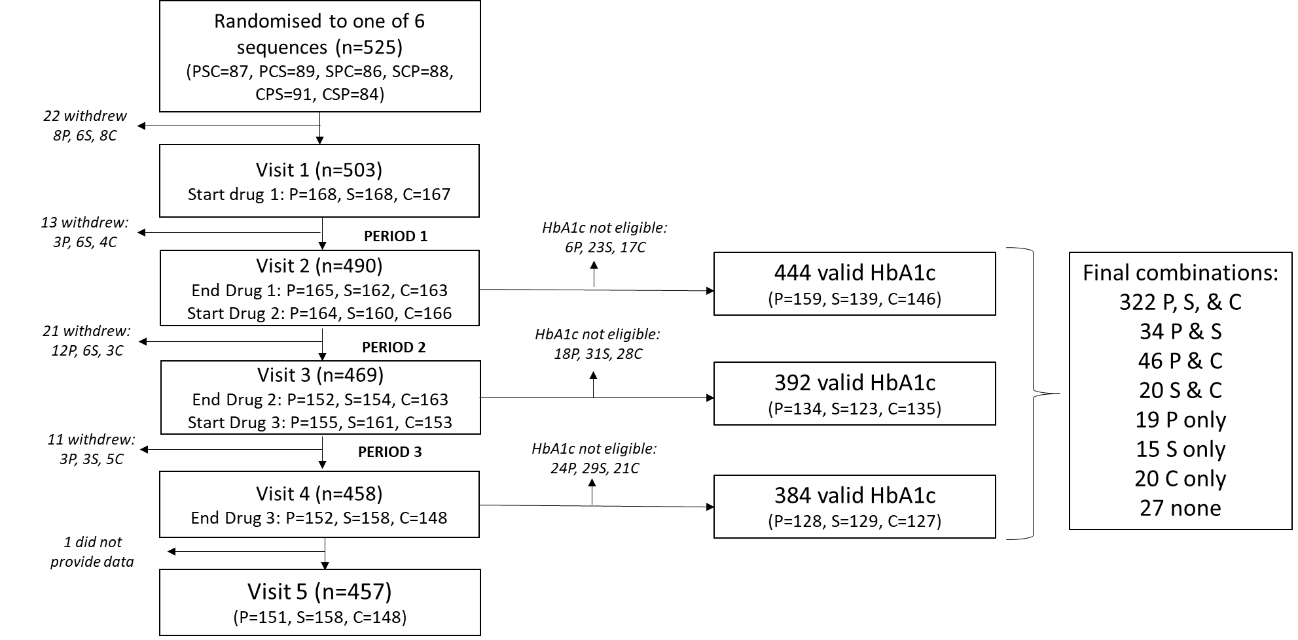

Supplementary Figure 2:

Scatterplots showing a) difference in on-treatment HbA1c between pioglitazone and sitagliptin (negative values favour pioglitazone, positive values favour sitagliptin) against BMI, and b) difference in on-treatment HbA1c between sitagliptin and canagliflozin (negative values favour sitagliptin, positive values favour canagliflozin) against eGFR. Line of best fit shown for each plot.
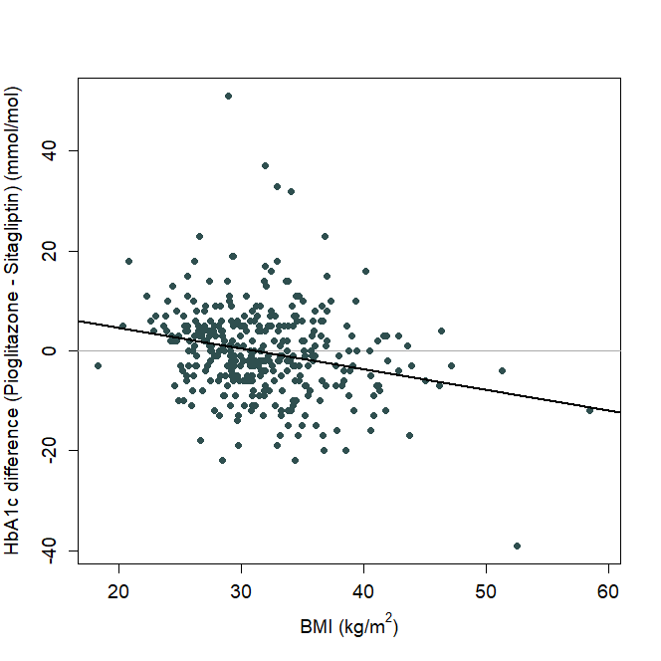  r=-0.238  a) | 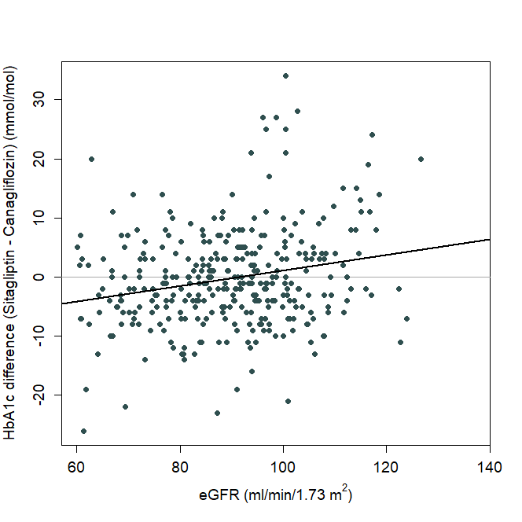  r=0.222  b)

Supplementary Methods

Supplementary Methods 1: The 24 recruiting centres participating in TriMaster
- Royal Devon and Exeter NHS Foundation Trust - RD&E Wonford Hospital
- NHS Tayside - Ninewells Hospital & Medical School
- Greater Glasgow & Clyde Health Board - BHF Glasgow Cardiovascular Research Centre
- Taunton and Somerset NHS Foundation Trust - Musgrove Park Hospital
- Brighton and Sussex University Hospitals NHS Trust - Royal Sussex County Hospital
- Cumbria Partnership NHS Foundation Trust - Cumberland Infirmary
- Oxford University Hospitals - Churchill Hospital
- Sheffield Teaching Hospitals NHS Foundation Trust - Northern General Hospital
- The Newcastle Upon Tyne Hospitals NHS Foundation Trust - Royal Victoria Infirmary
- Barnsley Hospital NHS Foundation Trust - Barnsley Hospital
- North Bristol NHS Trust - Southmead Hospital
- Plymouth Hospitals NHS Trust - Derriford Hospital
- Hywel Dda University Health Board - Prince Philip Hospital
- Abertawe Bro Morgannwg University Health Board – Morriston Hospital
- Royal Cornwall Hospitals NHS Trust - Royal Cornwall Hospital
- Cardiff and Vale University Health Board - University Hospital of Wales
- Guy's and St Thomas' NHS Foundation Trust - Guy's Hospital
- Surrey and Sussex Healthcare NHS Trust - East Surrey Hospital
- East Kent Hospitals University NHS Foundation Trust - QETQM Hospital
- Harrogate and District NHS Foundation Trust - Harrogate District Hospital
- Buckinghamshire Healthcare NHS Trust - Wycombe General Hospital
- East Suffolk and North Essex NHS Foundation Trust - Ipswich Hospital
- Royal Berkshire NHS Foundation Trust - Royal Berkshire Hospital
- Portsmouth Hospitals NHS Trust - Queen Alexandra Hospital

Supplementary Methods 2: Measurement of adherence to study medications
Participants were asked to return their medication bottle and all unused capsules at the end of the study, with adherence in each treatment period expressed as a percentage calculated as number of tablets taken divided by the expected number of tablets to be taken (number of days between study visits). Where pill count was not available, adherence was based on 4 questions around self-reported compliance (if the patient ever forgot to take their medicine, if they were careless about taking their medicine, if they stopped taking their medicine if they felt unwell, if they stopped taking their medicine if they felt better). Participants were considered to be non-adherent if they answered yes to at least three out of the four questions.

Supplementary Methods 3: Side effects in Trimaster
List of side effects asked about at baseline and follow-up study visits:
Swollen ankles/legs
Weight gain
Broken bones
Low blood sugar
Headache
Increased thirst
Passing more urine
Feeling dehydrated
Tiredness
Difficulty sleeping
Rashes
Change in appetite with weight change
Feeling or being sick
Constipation / diarrhoea
Urine infection
Thrush / Rash or redness of foreskin

Supplementary Methods 4: Side effects
We defined side effects as any experienced in the treatment periods. This is in contrast to the SAP where we stated we would examine only new side effects (nor previously experienced). We made this decision following discussion of presentation of findings. By only examining new side effects, this did not allow us to show change in side effects from baseline. It was apparent that the proportion experiencing some side effects went down on treatments compared with baseline, whereas some went up. By allowing analysis of all we were able to demonstrate this. It also meant participants could record the same side effect on two different drugs, which would not be possible otherwise. As this was not a main outcome and largely descriptive, we felt this minor change to the definition could be justified. We added in an analysis of “any v none” as a way of capturing the overall burden of side effects that we could examine by strata. A strata specific analysis for each side effect would entail multiple testing without prior hypotheses and increased likelihood of type 1 errors, so this was deemed inappropriate.

Supplementary Methods 5: Rationale for a per-protocol approach (completers only analysis):
For a participant to be included in primary analysis, it was necessary to have a valid HbA1c. For intention to treat analysis, in the absence of a valid HbA1c, some form of imputation of missing values would be required. This is more challenging in a crossover setting, as parallel group approaches such as imputing with the baseline are not valid as the pre-treatment baseline is only an appropriate baseline for the first period. However, we recognise the missing data could be informative. Therefore, to address this issue, we proposed two further analyses to explore the extent to which the missing HbA1cs could affect the final results: a tipping point analysis (see sensitivity analysis) and a secondary analysis of tolerability.

Supplementary Methods 6: Assessment of carryover effect:
In line with the Statistical Analysis Plan, we examined first order carryover effects (i.e. carryover from the preceding period only) using mixed effects models with drug, period, and a carryover variable (i.e. drug in previous period) as fixed effects, participant as a random effect, and HbA1c as the outcome. The carryover variable used the same coding as the drug variable, or a 0 if in the first period (adjustment for period removes this part of the carryover term in analysis).

Supplementary Information - Acknowledgements

TriMaster Central Coordinating Team: Catherine Angwin, Dr Caroline Jenkinson, Nina Rickards, Claire Thorne
TriMaster Study Group: Andrew Hattersley (PI), Catherine Angwin, Claire Ball, Anna Barnes, Tamika Chapter, Daniela Carmona, Tim Cranston, Clare Davidson, Mary Davis, Evan Davy, Tim Eames, Joanne Findlay, Diane Jarvis, Caroline Jenkinson, Angus Jones, John Kirkwood, Bethan Knight, Bridget Knight, James Leavy, Pattie Liakos, Kelly Littlewood, Timothy McDonald, Dionne McGill, Richard Oram, Nicola Pamphilon, Kashap Patel, Andrew Pitt, Lynne Quinn, Shelley Rhodes, Nina Rickards, Emma Robjohns, Kim Rowden, Sofia Sanabria, Beverley Shields, Steven Spaull, Sarah Statton, Anna Steele, Nick Thomas, Claire Thorne, Shirley Todd, Harry Tripp, Robert Wells, Luke Weymouth, Fiona Walters, Ewan Pearson (PI), Gill Reekie, Charlene Wong, Naveed Sattar (PI), Josephine Conney, Robert Lyndsay, Kirsty McLeish, Janice Richardson, Rob Andrews (PI), Ian Bodger, Richard Burgess, Sue Crouch, Isy Douek, Amanda Groves, Catherine Lane, Claire Lorimer, Joy Rowe, Lyndsay Stone, Ali Chakera (PI), Zdenka Cipinova, Zhengmai He, Allison Leslis, Dominika Wlazly, Louise Overend (PI), Sushil Kumar, Joanne Rafferty, Gillian Webster, Rustam Rea (PI), Lia Anguelova Karyna Gibbons, Nicky McRobert, Ursula Taylor, Simon Heller (PI), Mark Davy, Jackie Elliot, Rajiv Ghandi, Sue Hudson, Linda Greaves, Chloe Husband, Peter Novodorsky, Helena Renberg-Fawcet, Kim Ryalls, Lisa Zeidan, Mark Walker (PI), Ahmad AbuSaleh, Jade Davison, Margaret Fearby, Louise Finlay, Donna McEvoy, Ian McVittie, Bijal Patel, Geraldine Richel,l Rebecca Wilson, Thomas Hugh Jones (PI), Mishell Cunningham, Allison Daniels, Laura Walker, Lisa Zeidan, Andrew Johnson (PI), Georgina Russell (PI), Jade Bennett, Shenede Coppin, Joanne Davies, Sharon Hook, Abby Hookey, Jade King, Sharon Merritt, Helen Pearson, Sharon Tovey, Jill Townley, Patrick English (PI), Migaila Aldred, Emma Bishop, Emma Storr, Sam Rice (PI), Kim Davies, Rachel Davies, Linda O’Brien, Zohra Omar, Stephen Bain (PI), Lucy Barlow, Steven Creely (PI), Duncan Browne, Terri Chant, Helen Chenoweth, Kelly Hutchins, Laura Jones, Haider Khan, Emily Laity, Hemanth Bolusani (PI), Adele Farrugia, Grace Hopkins, Emma Norling, Caroline Robinson, Kennedy Cruickshank (PI), Krzystof Rutkowski, Benjamin Field (PI), James Clark, Ed Combes, Ruth Habibi, Stonny Joseph (PI), Louise Allen, Tracy Hazleton, Alicia Knight, Janine Musselwhite, Sutapa Ray (PI), Amanda Gillespie, Christine Cassidy, Peter Hammond, Tahir Idrees, Sam Jackson Neil Lauber, Deirdre Maguire, Ayeaye Min, Simon Trickett, Taryn Ward, Annie Williamson, Chitrabhanu Ballav (PI), Nicola Bowers, Sonia Dayal, Flavio Gil Lopes de Sousa, Lisa Jones, Mari Kononen, Ruth Penn, Fabiana Saraiva, El Muhtadi Saeed (PI), Julie Sutton, Gerry Rayman (PI), Helen Atkins, Emma Galloway, Jo Rosier, Debbie Simmonds, Michael Cummings (PI), Katherine Alington Sharon Allard, Sophie Daltry, Christine Hall, Victoria Hunter, Kate Millar.
MASTERMIND Consortium (additional members): Prof Michael Weedon, Dr Robert Lindsay, Prof Christopher Jennison, Prof Mark Walker, Prof Kennedy Cruickshank, Dr Salim Janmohamed, Prof Christopher Hyde, Prof Alastair Gray, Prof Stephen Gough, Dr Lauren Rodgers, Prof Timothy McDonald, Dr Olorunsola Agbaje
TriMaster Data Monitoring Committee: Prof David Owens (Chair), Prof Kamlesh Khunti and Prof Christopher Weir
TriMaster Trial Steering Committee: Prof Edwin Gale (Chair), Prof Polly Bingley, Caroline Padget, Prof David Russell-Jones, and Prof Stephen Senn

