Supplementary Information for
Molecular single crystals induce chain alignment in a semiconducting polymer
Ruixin Dai,ª Changshuai Ding,ª Xiangyuan Li,ª Naiying Fan,ª Takeo Minari,^{b} Xuying Liuª and Qingqing Sun^{*a}
ª School of Materials Science and Engineering, The Key Laboratory of Material Processing and Mold of Ministry of Education, Henan Key Laboratory of Advanced Nylon Materials and Application, Zhengzhou University, Zhengzhou 450001, Henan, P. R. China.
^{b} Printed Electronics Group, Research Center for Functional Materials, National Institute for Materials Science (NIMS), Tsukuba, Ibaraki 305-0044, Japan.
* Address correspondence to E-mail: sunqingqing@zzu.edu.cn (Q. Sun)

Table of Contents:
1. UV-Vis absorption spectra
2. XRD profiles
3. FWHM analysis
4. AFM morphology images
5. Electrical characteristics
6. References

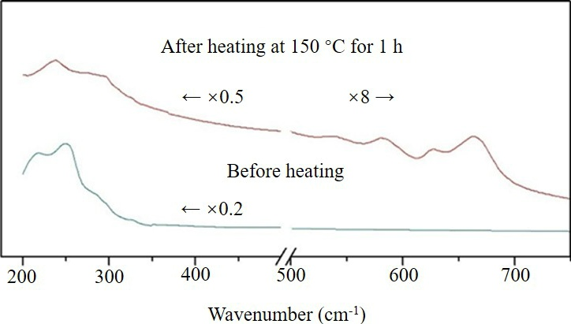
Fig. S1 UV-Vis absorption spectra of the pentacene precursor after heating at 150°C for 1 h (red line) and before heating (blue line).

The chemical structures of the pentacene precursor after and before heating are confirmed by UV-Vis absorption spectra as illustrated in Fig. S1. In order to clearly compare the characteristic peaks, the peak intensity of the pentacene precursor was subjected to a weakening and augmenting treatment in the range of 200 to 500 cm⁻¹ and 500 to 750 cm⁻¹ in wavenumber respectively. Only two clear absorption peaks at 217 nm and 252 nm of the precursor can be observed, and there is almost no obvious absorption peak above 400 nm before heating. Apparent absorption peaks appeared at 232 nm, 276 nm and in the range of 500-700 nm after heat treatment, which is consistent with the standard UV-Vis absorption spectra of pentacene, revealing the precursor was converted to pentacene as expected.

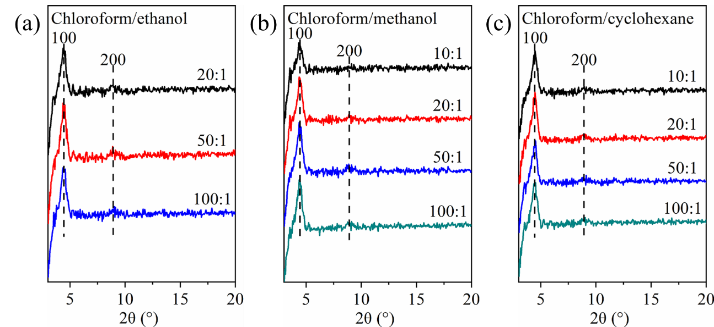
Fig. S2 XRD profiles of PDPP2T-TT-OD/pentacene (mass blending ratio of 15:1) composite thin films, treated separately in the various volume mixing ratios of chloroform/anti-solvent: (a) ethanol, (b) methanol, and (c) cyclohexane.

To delve the effect of various volume mixing ratios in chloroform/anti-solvents on the crystallization of PDPP2T-TT-OD/pentacene composite thin films, the XRD profiles are represented in Fig. S2. We found that the composite thin films exhibit the plane diffraction peaks alike belonging to the (100) and (200) lattice planes separately no matter which type of anti-solvent used, consisting with the previous research reports.^{1,2} However, different kinds of anti-solvents impact on the diffraction peak intensities, that is changes in crystallinity.³⁻⁵ The full width at half maxima (FWHM) of the (100) lattice plane from the composite thin films is calculated as shown in Table S1, to quantitively analyze the crystallinity via Scherrer Equation as follow:
D = Kλ/(βcosθ)
Where D is the mean size of the ordered (crystalline) domains, which may be smaller or equal to the grain size. K is a dimensionless shape factor with a typical value of about 0.9, varying with the actual shape of the crystallite. λ is the X-ray wavelength with a value of about 0.15443 nm. β is the line broadening at half the maximum intensity (FWHM), after subtracting the instrumental line broadening, in radians. θ is the Bragg angle.

Table S1 FWHM in the (100) lattice plane from composite thin films treated in the various volume mixing ratios of chloroform/anti-solvent
 | Mixing ratio | FWHM (Å⁻¹)
Chloroform/ethanol | 20/1 | 0.559
Chloroform/ethanol | 50/1 | 0.539
Chloroform/ethanol | 100/1 | 0.602
Chloroform/methanol | 10/1 | 0.619
Chloroform/methanol | 20/1 | 0.506
Chloroform/methanol | 50/1 | 0.608
Chloroform/methanol | 100/1 | 0.530
Chloroform/cyclohexane | 10/1 | 0.534
Chloroform/cyclohexane | 20/1 | 0.520
Chloroform/cyclohexane | 50/1 | 0.572
Chloroform/cyclohexane | 100/1 | 0.597

Evidently, the inversely proportional function relationship between grain size and FWHM is inferred from Scherrer Equation. As shown in Table S1, the FWHM value reaches the minimum at 0.539 when the volume ratio of chloroform/ethanol is 50/1, indicating the maximization in crystallinity. Besides, the FWHM peaks at 0.619 and minimizes at 0.506 with the proportion of chloroform/methanol (10/1 and 20/1) respectively. Moreover, as the content of cyclohexane keeps decreasing, the FWHM drops first and then start to augment, signifying there is an optimal volume mixing ratio in chloroform/cyclohexane (20/1) with the least FWHM value 0.520. We found that the lesser anti-solvent hardly promotes the polymer crystallization. Whereas, the polymer rapidly nucleate with excessive antisolvent during spin-coating, leading to the smaller grain size.⁶ Thus, we consider that regulating and controlling the crystallinity via tuning the volume mixing ratio of the anti-solvents and polymer good solvents, probably exhibits a positive effect on improving device performance in conjugated polymer-based composites for OTFT applications.
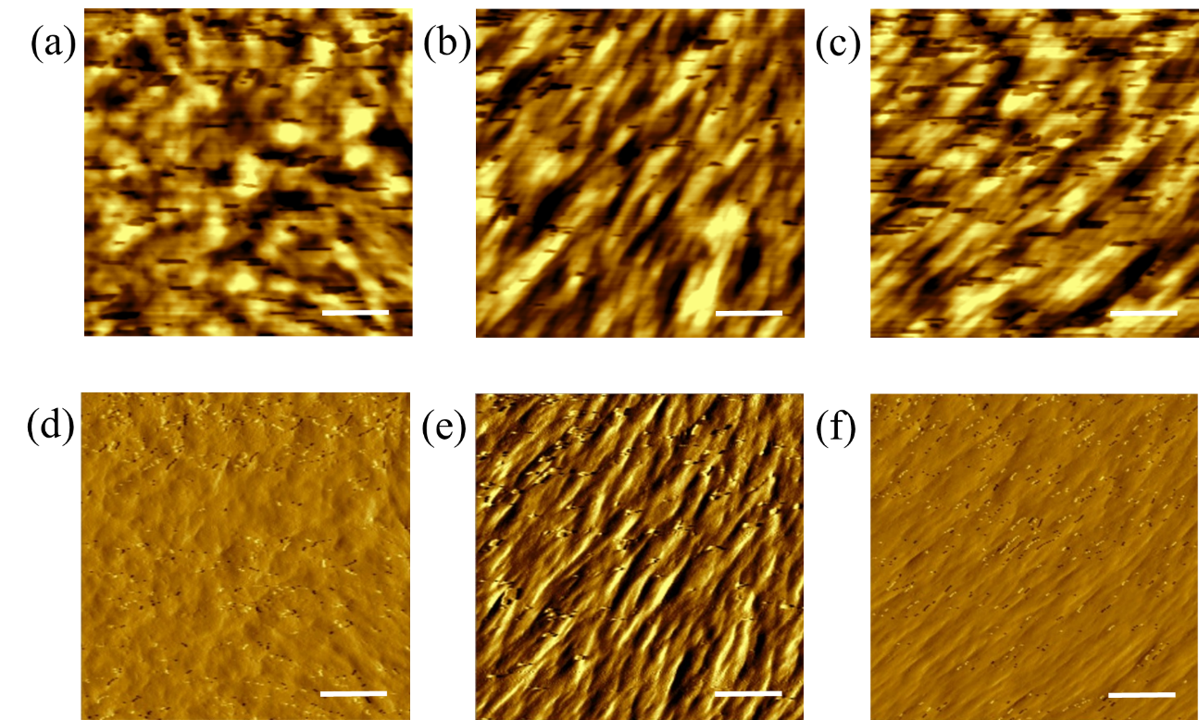
Fig. S3 AFM morphological height (up) and magnitude (down) images of PDPP2T-TT-OD/pentacene (mass blending ratio of 15:1) composite thin films, treated respectively in the volume mixing ratios of solvent/anti-solvent: (a, d) chloroform/ethanol = 50/1, (b, e) chloroform/methanol = 20/1, and (c, f) chloroform/cyclohexane = 20/1. Scale bars of (a-f) are 200 nm.

The anti-solvent treatment has a notable impact on surface morphology, roughness and grain size of composite thin film. The selected composite thin film with the optimal volume mixing ratio of chloroform/anti-solvents are characterized via AFM measurement in tapping mode as illustrated in Fig. S3. It is remarkable that the composite thin film treated by ethanol anti-solvent reveals large continuous crystalline grains with a minimum roughness about 2.47 nm, and the attained crystalline morphology is conducive to charge transport.⁷⁻⁹ Furthermore, the composite thin films treated by methanol and cyclohexane display the similar surface topography, while the gullies of the thin film treated by methanol are deeper than cyclohexane, resulting in a higher surface roughness. In brief, the nonuniformity of thin film with micropores will affect negatively on contact between film surface and electrode, leading to a decrease on device performance.

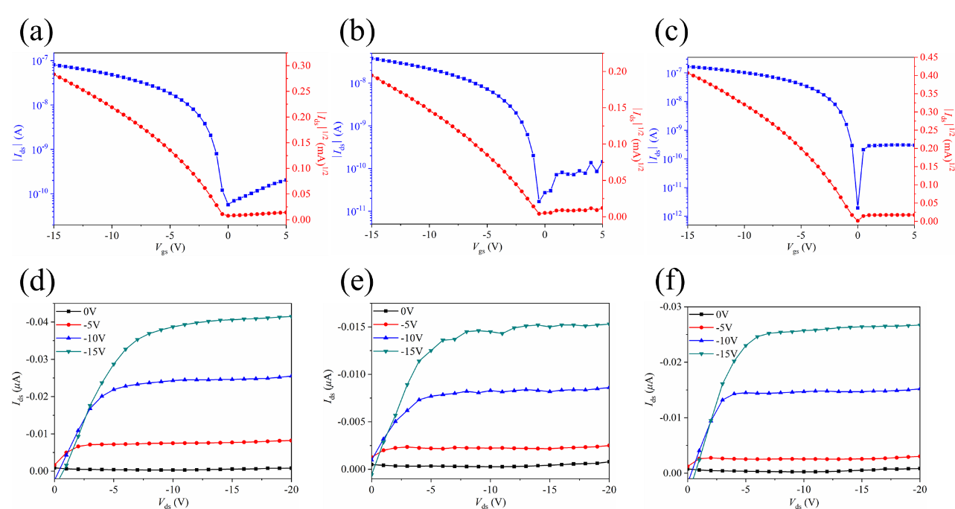
Fig. S4 Transfer characteristics (up) with the V_{ds} at -20 V and output characteristics (down) with the gate voltage steps of 0, −5, −10, −15 V. OTFT devices based on PDPP2T-TT-OD/pentacene composite thin films, prepared separately in the mass blending ratios of (a,d) 1:0, (b,e) 20:1 and (c,f) 10:1 in chloroform. The channel width/length ratio is 24.

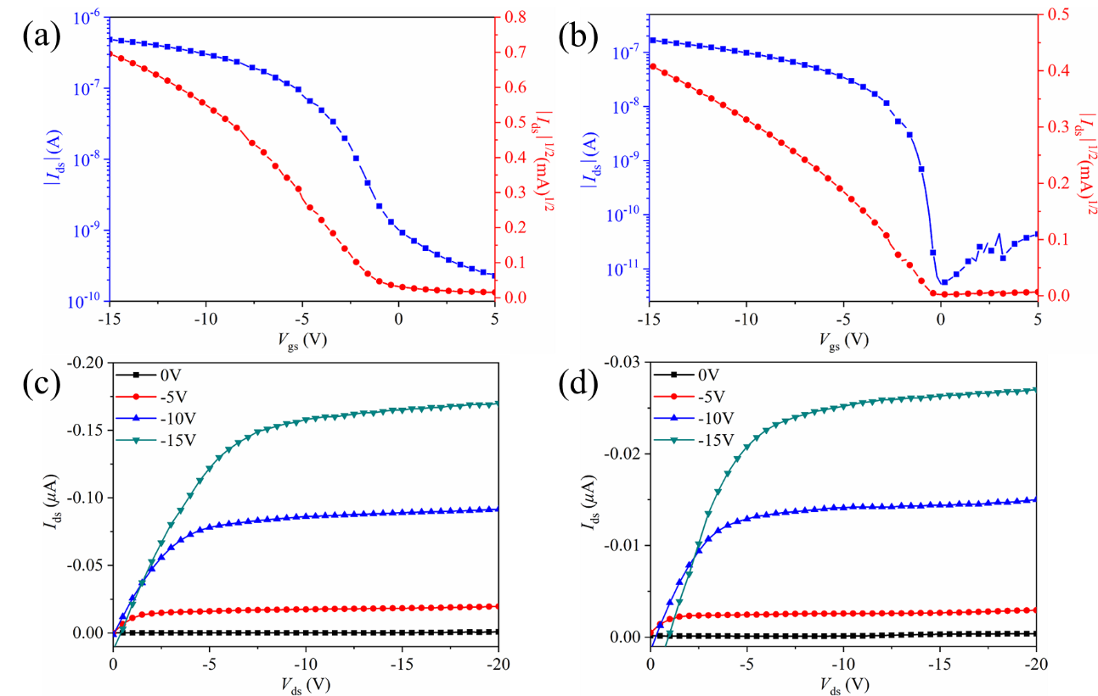
Fig. S5 Transfer characteristics (up) with the V_{ds} at -20 V and output characteristics (down) with the gate voltage steps of 0, −5, −10, −15 V. OTFT devices based on PDPP2T-TT-OD/pentacene (mass blending ratio of 15:1) composite thin films, treated in the solution of chloroform with (a,c) methanol and (b,d) cyclohexane in the volume mixing ratio of 20/1 respectively. The channel width/length ratio is 24.

References
- He Z, Li D, Hensley D K, Rondinone A J, Chen J (2013) Switching phase separation mode by varying the hydrophobicity of polymer additives in solution-processed semiconducting small-molecule/polymer blends. Appl Phys Lett 103:113301.
- Lin Z, Guo X, Zhou L, Zhang C, Chang J, Wu J, Zhang J (2018) Solution-processed high performance organic thin film transistors enabled by roll-to-roll slot die coating technique. Org Electron 54:80.
- Chen L, Zhao K, Cao X, Liu J, Yu X, Han Y (2018) Nanowires of conjugated polymer prepared by tuning the interaction between the solvent and polymer. Polymer 149:23.
- Kim N-K, Shin E-S, Noh Y-Y, Kim D-Y (2018) A selection rule of solvent for highly aligned diketopyrrolopyrrole-based conjugated polymer film for high performance organic field-effect transistors. Org Electron 55:6.
- Jo G, Cho S H, Kim H, Yoon H, Han S, Chang M. (2020) Impacts of secondary solvents on morphology and charge transport of conjugated polymer thin films. Org Electron 81:105688.
- Soeda J, Okamoto T, Mitsui C, Takeya J (2016) Stable growth of large-area single crystalline thin films from an organic semiconductor/polymer blend solution for high-mobility organic field-effect transistors. Org Electron 39:127.
- Wang L, Wang X, Deng L-L, Leng S, Guo X, Tan C-H, Choy W C H, Chen C-C (2020) The mechanism of universal green antisolvents for intermediate phase controlled high-efficiency formamidinium-based perovskite solar cells†. Mater Horiz 7:934.
- Zheng Y-Q, Yao Z-F, Lei T, Dou J-H, Yang C-Y, Zou L, Meng X, Ma W, Wang J-Y, Pei J (2017) Unraveling the Solution‐State Supramolecular Structures of Donor–Acceptor Polymers and their Influence on Solid‐State Morphology and Charge‐Transport Properties. Adv Mater 29:1701072.
- Wei S, Tian F, Ge F, Wang X, Zhang G, Lu H, Yin J, Wu Z, Qiu L, (2018) Helical Nanofibrils of Block Copolymer for High-Performance Ammonia Sensors. ACS Appl Mater Interfaces 10:22504.

