Supplementary Data
Mutagenesis and structural studies reveal the basis for the specific binding of SARS-CoV-2 SL3 RNA element with human TIA1 protein

Dong Zhang^{1,†}, Lulu Qiao^{2,†}, Zhiye Wang^{2,3,*}, and Ruhong Zhou^{1,3,*}
¹ College of Life Sciences and Institute of Quantitative Biology, Zhejiang University, Hangzhou, Zhejiang 310058, China
² State Key Laboratory of Plant Physiology and Biochemistry, College of Life Sciences, Zhejiang University, Hangzhou, Zhejiang 310058, China
³ The First Affiliated Hospital, College of Medicine, Zhejiang University, Hangzhou, Zhejiang 310058, China
† These authors contributed equally: Dong Zhang and Lulu Qiao
* To whom correspondence should be addressed: rhzhou@zju.edu.cn (R.Z.); wangzhiye1@zju.edu.cn (Z.W.)

Table S1. Sequences of primers.
Primers for pET28a-His-SUMO-TIA1 (93-274) and TIA1 (93-274)
 | 5'-3'
hTIA1-For 1 BamH1 | aaaggatccGAGGACGAGATGCCCAAGACTCT
hTIA1-For 93 BamH1 | aaaggatccAATCATTTCCATGTCTTTGTTGG
hTIA1-Rev 274 Hind3 | gtgaagcttcaTTTGCCCCAATAGCATTTCACAAC
Cy3 labelled RNA probes
U11 | Cy3-UUUUUUUUUUU
C21 | Cy3-CCCCCCCCCCCCCCCCCCCCC
SL2+SL3 | Cy3-UUUCGAUCUCUUGUAGAUCUGUUCUCUAAACGAACUUUAAAAUCU
SL2 | Cy3-UUUCGAUCUCUUGUAGAUC
SL3 | Cy3-UGUUCUCUAAACGAACUUUAA
SL3-HP3 | Cy3-UGUUCUAAGAACUUUAA
SL3-HP-C7 | Cy3-UGUUCCCCCCCCGAACUUUAA
SL3-HP-U7 | Cy3-UGUUCUUUUUUUGAACUUUAA
SL3-TL1 | Cy3-UGUUCUCUAAACGAACU
SL3-TL-C3 | Cy3-UGUUCUCUAAACGAACCCCAA
SL3-TL-G3 | Cy3-UGUUCUCUAAACGAACGGGAA
SL3-GC | Cy3-UGGGCUCUAAACGCCCUUUAA
U67C | Cy3-UGUUCUCCAAACGAACUUUAA
A68C | Cy3-UGUUCUCUCAACGAACUUUAA
A68G | Cy3-UGUUCUCUGAACGAACUUUAA
A68U | Cy3-UGUUCUCUUAACGAACUUUAA
A69G | Cy3-UGUUCUCUAGACGAACUUUAA
A69U | Cy3-UGUUCUCUAUACGAACUUUAA
U76G | Cy3-UGUUCUCUAAACGAACGUUAA
U77G | Cy3-UGUUCUCUAAACGAACUGUAA
U78C | Cy3-UGUUCUCUAAACGAACUUCAA
RousettusHKU9 SL3 | Cy3-UCACUCUUGAACGAACUUAAA
MERS SL3 | Cy3-UUUGAUUUUAACGAACUUAAA

Figure S1. Heavy-atom RMSDs as functions of simulation time for two constructed binding models (Conf1 and Conf2) of SL3 RNA element and TIA1 protein. Three independent runs (sim1, sim2, and sim3) were performed for each construction.

Figure S2. Heavy-atom RMSDs as functions of simulation time for extended MD simulations to validate the stability of the putative 3D binding model for SL3 and TIA1 complex. Three 1-μs independent simulations were run.

Figure S3. Comparison of the top 3D structures predicted by IsRNA, FARFAR2, and all-atom MD simulations for SL3 RNA element. The heavy-atom RMSDs are 1.4 (IsRNA vs. FARFAR2) and 2.4 Å (IsRNA vs. All-atom MD).

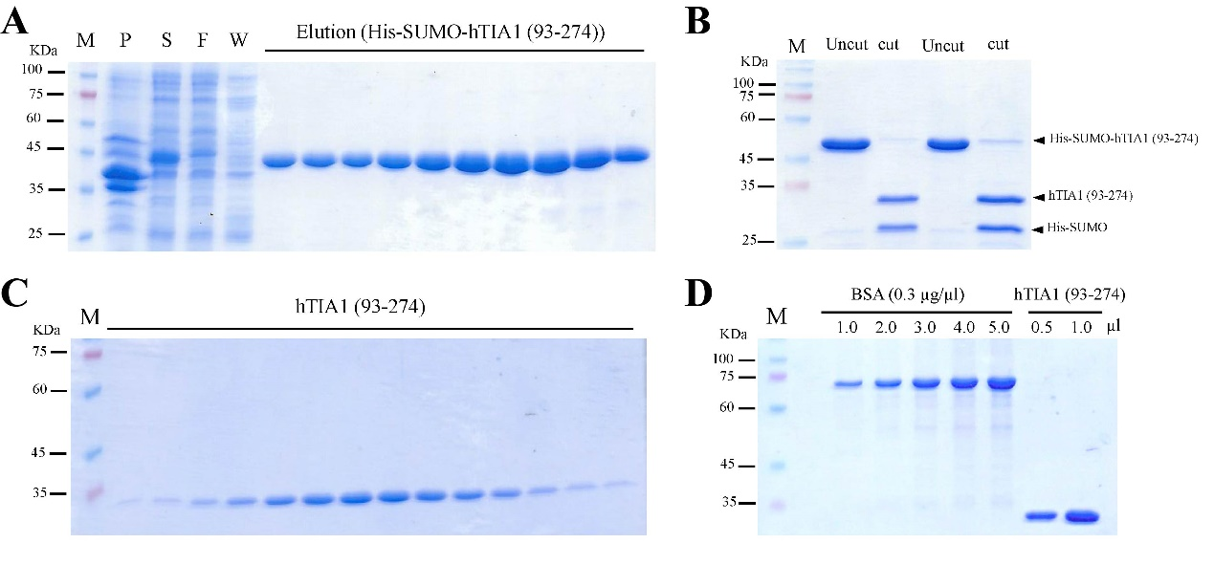
Figure S4. High purity of recombinant TIA1 proteins. (A) His-SUMO-TIA1 (93-274aa) was purified by Ni-NTA affinity chromatography. (B) His-SUMO tag was cut by SUMO proteinase. (C) TIA1 (93-274aa) was further purified through size exclusive chromatography. (D) Gel image of recombinant TIA1 (93-274aa) proteins with two-step purification.

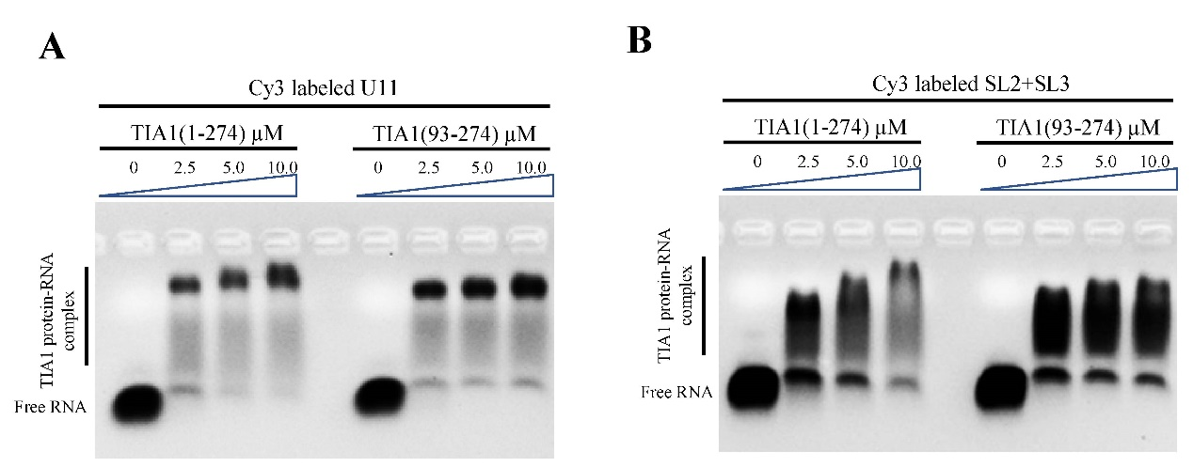
Figure S5. EMSA shows TIA1 RRM1-3 (1-274aa) and TIA1 RRM23 (93-274aa) have comparable binding affinity with 5’end Cy3-labelled (A) OligoU (U11) and (B) SL2+SL3 RNA.
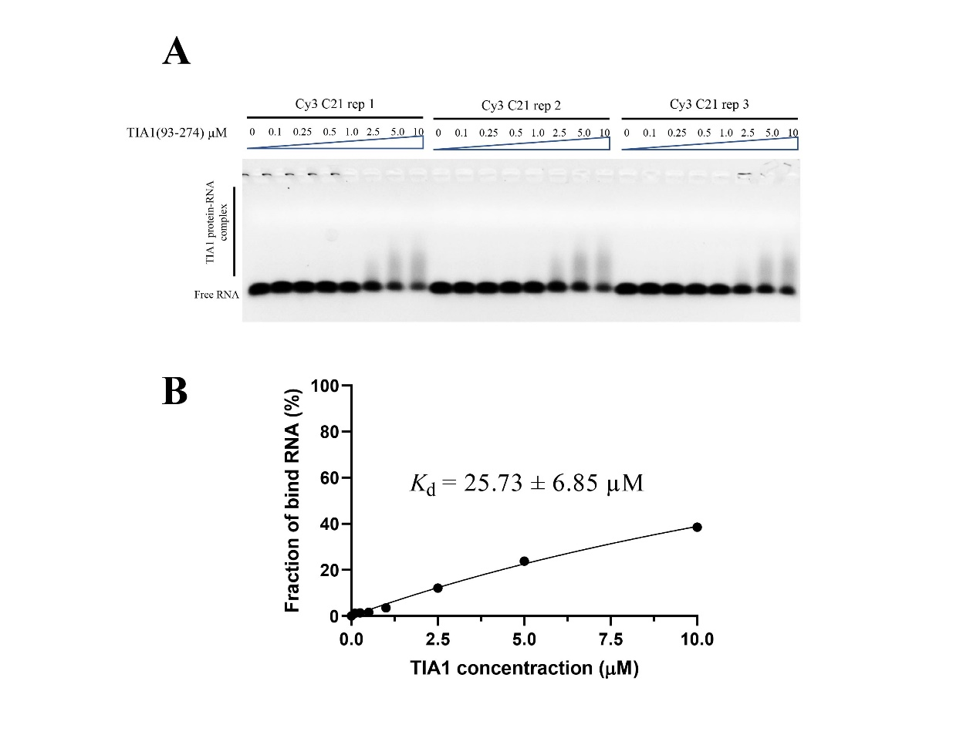
Figure S6. (A) EMSA results (three replicates) and (B) the binding curve show a faint binding of TIA1 to 5’ end Cy3-labelled OligoC (C21) RNA. The K_{d} values were calculated from the EMSA image quantification with s.d. from three experiments.
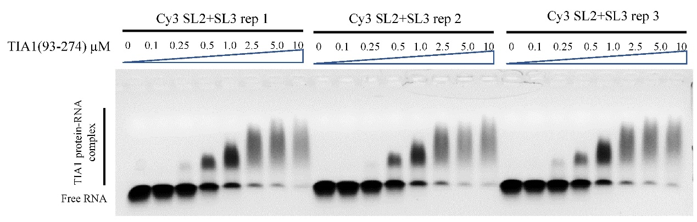
Figure S7. EMSA results (three replicates) show the mobility pattern of the TIA1-SL2+SL3 RNA complex. The gel image of the first replicate (rep 1) is also shown in Figure 1D.
Figure S8. Two possible 3D conformations for binding complex of SL3 RNA element and TIA1 protein constructed by computational modeling. TIA1 RRM2, RRM3, and flexible linker are colored by dark cyan, light green, and gray, respectively. Hairpin loop, stem, and terminal loop of SL3 are separately colored by blue, green, and orange.
Figure S9. Comparison of the putative 3D model of SL3 and TIA1 RRM23 binding complex with selected templates. (A) 66CUAA69 RNA segment of SL3 hairpin loop/TIA1 RRM3 vs. an RNA hairpin complexed with RRM of U1A spliceosomal protein (light gray, PDB id: 1urn). (B) 76UUU78 RNA segment of SL3 3’-terminal loop/TIA1 RRM2 vs. 5’-TTT-3’ oligonucleotide binding to TIA1 RRM2 (light gray, PDB id: 5ith). Atoms of phosphorus, oxygen, nitrogen, and hydrogen are colored yellow, red, purple, and white, respectively, and carbon atoms are colored according to their locations.

Figure S10. Heavy-atom RMSDs as functions of simulation time for binding model of TIA1 and SL3 all C’s variant. This all C’s variant replaces all nucleotides in the loop region of SL3 by cytosines (5’-CGUUCCCCCCCCGAACCCCCC-3’) and is thought to have a much weaker binding ability to TIA1 protein than wild-type SL3 RNA element. Three independent runs were performed.

Figure S11. Comparison of 3D structures of SL3 RNA element in the bound (complexed with TIA1) and free states. The heavy-atom RMSD between two conformations is 6.0 Å.

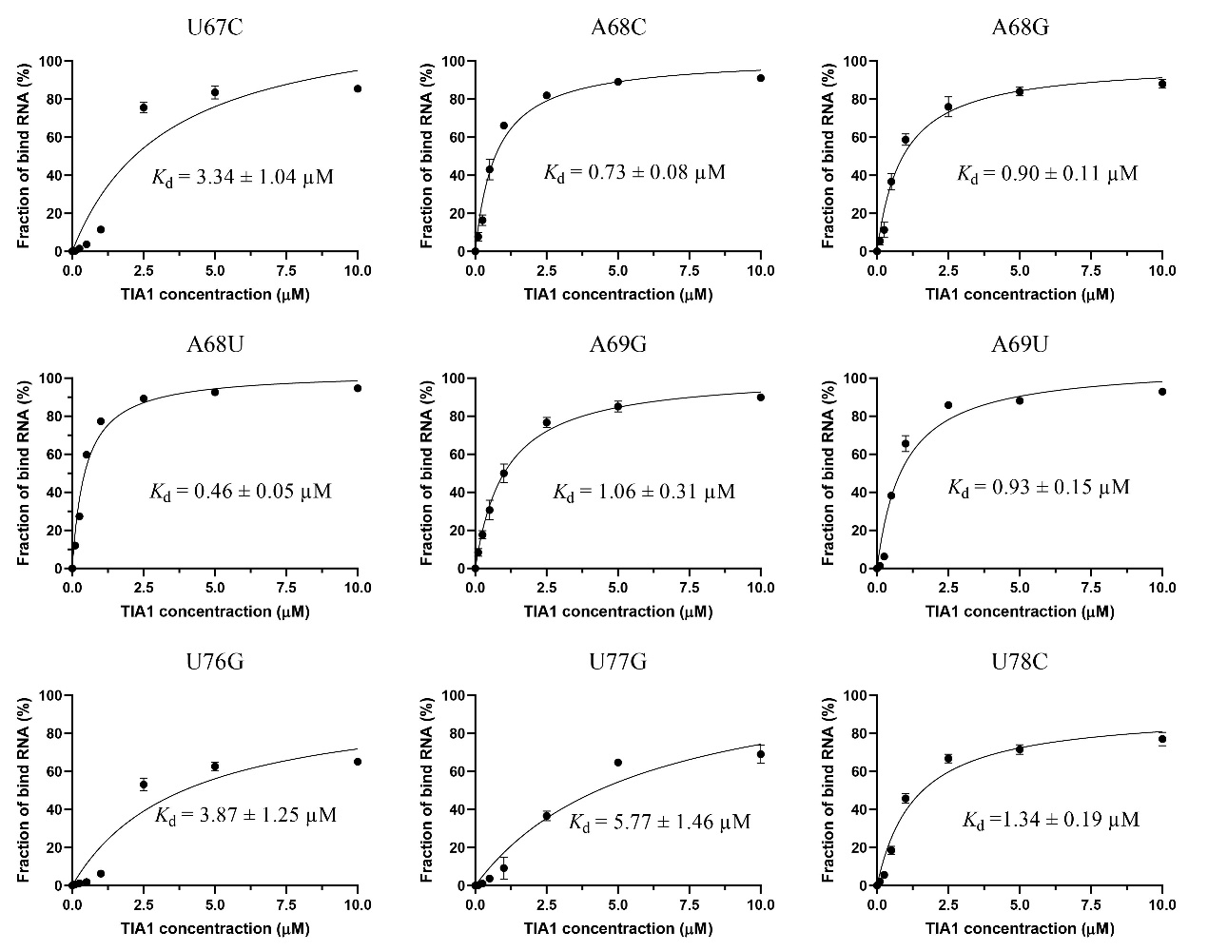
Figure S12. The binding curves of TIA1 to single-nucleotide mutated variants of SL3 RNAs. The K_{d} values were calculated from the EMSA image quantification with s.d. from three experiments.
Figure S13. Distances of listed atom pairs as functions of simulation time. A stable hydrogen bond is formed between SL3 U68 variant and TIA1 Arg233 residue, while pair distance between wild-type SL3 A68 nucleotide and TIA1 Arg233 residue is too long to form hydrogen bond.

