Supplementary Information
Ionogel-Electrode for the Study of Protein Tunnel Junctions under Physiologically Relevant Conditions
Xiyue Bai,^{1, 2} Pengfei Li,^{1, 2, 3} Wuxian Peng,¹ Ningyue Chen,¹ Jin-Liang Lin,¹ and Yuan Li^{1, *}

¹Department of Chemistry, Tsinghua University, Beijing 10084, China
²Equally contributing
³Current address: Joint School of National University of Singapore and Tianjin University, International Campus of Tianjin University, Binhai New City, Fuzhou 350207, China
*Correspondence: yuanli_thu@tsinghua.edu.cn

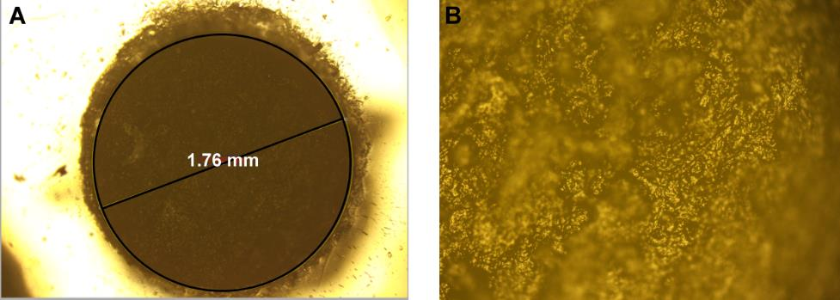
Supplementary Fig. 1 Microscopic photo of the bottom of the IG-CB top-electrodes.

Supplementary Fig. 2 The SEM images of top-electrodes. (A) Pure hydrophilic ionogel. (B) 15% hydrophilic IG-CB. (C) 20% hydrophilic IG-CB.
Supplementary Fig. 3 The histogram of log|J| at −0.5 V with Gaussian fits for Ag^{TS}-SC_{n}// hydrophilic IG-CB junction.

Supplementary Fig. 4 The influence of IG-CB top electrodes with different hole sizes on current density. (A) Plots of the <log|J(V)|> curves for Ag^{TS}-SC₁₂//hydrophobic IG-CB junctions test in solid states. (B) Corresponding log|J| at −0.5 V versus the diameter of IG-CB electrode.

The influence of the through-hole size. Here, we studied the influence of different sizes of IG-CB top electrodes on the current density. By using the IG-CB electrode with the through-holes of different sizes, we obtained top-electrodes with different contact areas with SAMs. Taking SC₁₂ as a sample, we tested it with IG-CB top-electrodes with different hole sizes. The results indicate that within the range of the selected sizes there is almost no difference in the measured current densities.
Supplementary Fig. 5 The influence of scan rates with Ag^{TS}-SC₁₀COOH//hydrophobic IG-CB junctions in solid states on current density. The numbers in legend are delay times.

Synthesis of 8-Mercaptounoctanoic acid¹: Thiourea (193 mg, 2.535 mmol, 1.50 eq.) and 8-bromounoctanoic acid (400 mg, 1.69 mmol, 1.00 eq.) were added to 30 mL ethanol in a Schlenk-tube and the solution was refluxed. After 20 hours, the ethanol was removed and NaOH solution (1.69 M, 15 mL, 25.35 mmol, 15 eq.) was added, and the solution was stirred for further 20 h at 90 °C under N₂. For the hydrolysis, the solution was cooled in an ice bath and concentrated hydrochloric acid was added until the pH is acidic. The solution was extracted with dichloromethane three times and the solvent in the combined organic layers was removed. The crude product was recrystallized with ethanol. The product was afforded (266 mg, 1.4 mmol, 83 %).
¹H NMR (400 MHz, CDCl₃) δ 11.36 (s, 1H), 2.51 (dt, J = 13.8, 7.0 Hz, 2H), 2.35 (t, J = 7.4 Hz, 2H), 1.71 – 1.50 (m, 4H), 1.43 – 1.20 (m, 10H).
¹³C NMR (100 MHz, CDCl₃) δ 180.55, 34.27, 32.35, 29.84, 29.28, 29.19, 29.14, 29.00, 24.81.
HRMS (APCI+): m/z calc for C₉H₁₈O₂S [M-H]⁺ 189.0949, found 189.0953.
Supplementary Fig. 6 The ¹H-NMR spectrum of HOOC-C₈-SH.
Supplementary Fig. 7 The ¹³C-NMR spectrum of HOOC-C₈-SH.

Synthesis of 12-Mercaptoundodecanoic acid²: Thiourea (215 mg, 2.83 mmol, 1.50 eq.) and 12-bromoundodecanoic acid (500 mg, 1.89 mmol, 1.00 eq.) were added to 30 mL ethanol in a Schlenk-tube and the solution was refluxed. After 20 hours, the ethanol was removed and NaOH solution (1.69 M, 17 mL, 28.3 mmol, 15 eq.) was added, and the solution was stirred for further 20 h at 90 °C under N₂. For the hydrolysis, the solution was cooled in an ice bath and concentrated hydrochloric acid was added until the pH is acidic. The solution was extracted with dichloromethane three times and the solvent in the combined organic layers was removed. The crude product was recrystallized with ethanol. The product was afforded (336 mg, 1,5 mmol, 80 %).
¹H NMR (400 MHz, CDCl₃) δ 2.72 – 2.64 (t, J = 8 Hz, 2H), 2.35 (t, J = 7.2 Hz, 2H), 1.71 – 1.59 (m, 4H), 1.44 – 1.21 (m, 16H).
¹³C NMR (100 MHz, CDCl₃) δ 180.00, 77.35, 77.03, 76.71, 39.44, 34.00, 29.41, 29.29, 29.16, 29.10, 28.83, 28.45, 24.63.
HRMS (APCI+): m/z calc for C₁₃H₂₆O₂S [M+H]⁺ 247.1732, found 247.1751.
Supplementary Fig. 8 The ¹H-NMR spectrum of HOOC-C₁₂-SH.
Supplementary Fig. 9 The ¹³C-NMR spectrum of HOOC-C₁₂-SH.
Preparation of 11-S-mercapto undecane sulphonate³
Synthesis of 11-bromoundecane sulphonate: 1,11-dibromoundecane (4.5 mL, 18.7 mmol) was added to 120 mL ethanol and 20 mL deionized water and the mixture was heated to 85 °C until refluxing. Sodium sulphite (0.69 g, 5.5 mmol) was solubilized in 20 mL of water and added dropwise (during 2.5 h) to the refluxing mixture. The reaction medium was refluxed for an extra 3.5 h. The mixture was transferred to a separation funnel and 30 mL of deionized water was added. The unreacted 1,11-dibromoundecane (lower phase) was separated from the mixture and the top phase was washed three times with petroleum ether. The solvent in upper phase was removed under reduced pressure and the 10 mL dichloromethane and 70 mL n-hexane was added stepwise, and the 11-bromoundecane sulphonate (52% yield) was crystallized from the solution and collected by vacuum filtration.
¹H NMR (400 MHz, DMSO) δ 3.52 (t, J = 6.6 Hz, 2H), 2.40−2.30 (m, 2H), 1.83−1.72 (m, 2H), 1.53 (br, 2H), 1.37 (br, 2H), 1.24 (br, 6H).
Supplementary Fig. 10 The ¹H-NMR spectrum of Br-C₁₁-SO₃⁻Na⁺.
Synthesis of 11-S-mercapto undecane sulphonate: 11-bromoundecane sulphonate (0.96 g, 2.86 mmol) from the previous step and thiourea (0.22 g, 2.86 mmol) were solubilized in a 1:1 mixture of water:ethanol (40 mL) and refluxed for 6h. The solvent was removed by vacuum evaporation. The white precipitate was added to an aqueous solution of sodium hydroxide (10 mL, 10% m/v). The mixture was refluxed for 3h under N₂ atmosphere and was cooled to room temperature forming a white precipitate. The mixture was neutralized with hydrochloric acid (until pH=6) and cooled in ice. The white precipitate was collected by vacuum filtration and recrystallized by ethanol. The 11-S-mercapto undecane sulphonate (37% yield) was collected after recrystallization.
¹H NMR (400 MHz, DMSO) δ 2.45 (dd, J = 14.6, 7.4 Hz, 1H), 2.41−2.31 (t, J = 8 Hz, 2H), 2.22 (t, J = 7.7 Hz, 2H), 1.59−1.45 (m, 4H), 1.36−1.17 (m, 14H).
¹³C NMR (100 MHz, DMSO) δ 51.44, 33.40, 28.98, 28.93, 28.52, 28.43, 27.76, 25.01, 23.76.
HRMS (APCI+): m/z calc for C₁₁H₂₃NaO₂₃S₂ [M-Na]⁺ 267.1089, found 267.1099.
Supplementary Fig. 11 The ¹H-NMR spectrum of HS-C₁₁-SO₃⁻Na⁺.
Supplementary Fig. 12 The ¹³C-NMR spectrum of HS-C₁₁-SO₃⁻Na⁺.
Supplementary Fig. 13 XPS spectra of Au^{TS}-SC₁₀COOH/proteins. The O_{1s} (A), S_{2p} (B) region and the XPS survey (C−F) acquired from SC₁₀COOH SAM on gold, before and after adsorption of HSA, Cyt C and HGB.
Supplementary Fig. 14 XPS spectra of Au^{TS}-SC₁₁SO₃⁻Na⁺/proteins. The O_{1s} (A), S_{2p} (B) region and the XPS survey (C−F) acquired from SC₁₁SO₃⁻Na⁺ SAM on gold, before and after adsorption of HSA, Cyt C and HGB.

Supplementary Fig. 15 The structure of HSA(A), Cyt C(B) and HGB(C). The crystal structure is obtained from an open resource of Protein Data Bank (wwPDB: Worldwide Protein Data Bank).

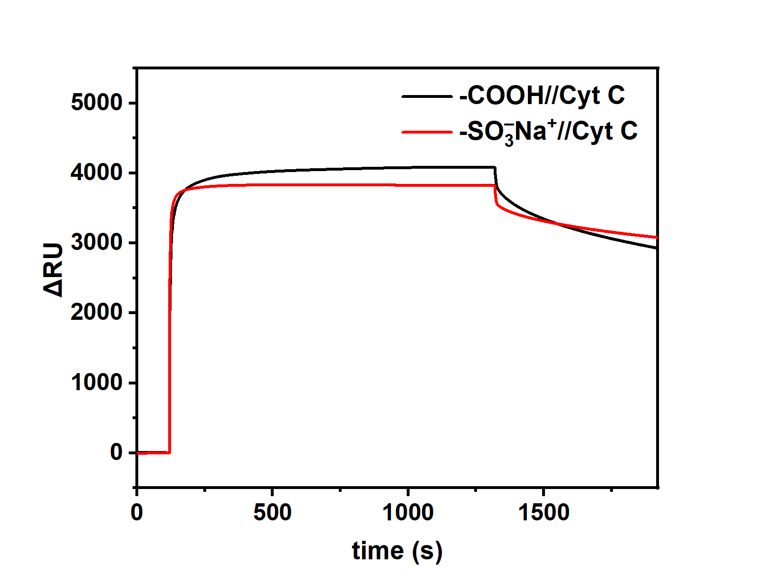
Supplementary Fig. 16 Plots of SPR response. ∆RU is as a function of time for the adsorption of Cyt C on two SAMs of SC₁₀COOH and SC₁₁SO₃⁻Na⁺.

Supplementary Fig. 17 Testing of SC_{n}COOH in pure water. The histograms of log|J| at −1.0 V with Gaussian fits for (A) Ag^{TS}-SC_{n}// hydrophobic IG-CB and (D) Ag^{TS}-SC_{n}COOH// hydrophobic IG-CB junctions. Plots of the log (average J(V)) curves for (B) Ag^{TS}-SC_{n}//hydrophobic IG-CB junctions and (E) Ag^{TS}-SC_{n}COOH//hydrophobic IG-CB test in water. Plots of log|J| at −1.0 V vs n_{C} for junctions incorporating SAMs of (C) SC_{n} and (F) SC_{n}COOH on Ag substrates.

Supplementary Fig. 18 The comparison of SC₁₀COOH and SC₁₁SO₃⁻Na⁺ SAM in solid states, water and buffer.
Supplementary Fig. 19 The histogram of protein junctions in solid states and pure water. The histograms of log|J| at −1.0 V with Gaussian fits for Ag^{TS}-SC₁₀COOH//protein//hydrophobic IG-CB junctions (A, C, E) and Ag^{TS}-SC₁₁SO₃⁻Na⁺//protein//hydrophobic IG-CB junctions (B, D, F).
Supplementary Fig. 20 Temperature-dependent measurements for SC₁₂. Temperature-dependent <log|J(V)|> data for junctions of Ag^{TS}-SC₁₂//hydrophobic IG-CB in pure water (A) and solid states (B). Corresponding plots for ln|J| at +/−0.5 V in pure water (C) and solid states (D). The dash lines are guideline to eyes.

Supplementary Fig. 21 Activation energy under different bias. Corresponding Arrhenius plots for J from –0.4 to –1.0 V for HSA (A), Cyt C (B) and HGB (C). The solid lines are fits to the Arrhenius equation.
Supplementary Fig. 22 The secondary electron cut-off of SC₁₀COOH SAM on gold before (A) and after adsorption of Cyt C (B).

Supplementary Fig. 23 The comparison of the hydrophobic and hydrophilic electrodes. (A) Plots of the log (average J(V)) curves for Ag^{TS}-SC_{n}//IG-CB junctions (n=10, 12, 14). (B) Plots of log|J| at −0.50 V vs n_{C} for junctions incorporating SAMs on Ag^{TS} substrates.

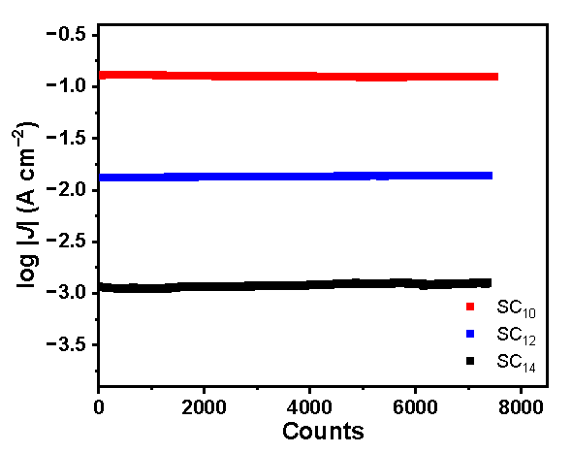
Supplementary Fig. 24 Stability measurements of hydrophobic IG-CB electrode measured with SC_{n} (n=10, 12, 14) in solid states.

Supplementary Table 1. The test result of resistivity.
Number | 1 | 2 | 3 | 4 | 5 | Avg | Error bar
15% hydrophilic IG-CB | 51.34 | 55.56 | 58.90 | 56.28 | 58.29 | 55.29 | 9.02
20% hydrophilic IG-CB | 8.98 | 9.15 | 10.51 | 10.44 | 7.94 | 9.404 | 0.97
15% hydrophobic IG-CB | 10.8 | 11.56 | 8.60 | 8.62 | 9.14 | 9.744 | 1.21

Supplementary Table 2. Statistic table of the bottom area of the IG-CB top electrodes.
Number | 1 | 2 | 3 | 4 | 5 | 6 | 7 | 8 | 9 | 10 | Avg | Error bar
A_{geo}(mm²) | 2.08 | 2.40 | 1.86 | 2.23 | 2.28 | 2.28 | 2.25 | 2.20 | 2.15 | 2.43 | 2.16 | 0.18

Supplementary Table 3. Statistic table of n-alkanethiolates SAMs test by IG-CB top electrodes we studied.
Molecule | Hydrophobicity of electrode | Environ-ment | Number  of  junctions | Number  of  shorts | Number  of  traces | Yield  (%)
SC₁₀ | hydrophilic* | air | 20 | 0 | 480 | 100
SC₁₂ | hydrophilic* | air | 20 | 0 | 480 | 100
SC₁₄ | hydrophilic* | air | 20 | 0 | 480 | 100
SC₁₆ | hydrophilic* | air | 20 | 0 | 480 | 100
SC₁₈ | hydrophilic* | air | 20 | 0 | 480 | 100
SC₂₀ | hydrophilic* | air | 20 | 0 | 480 | 100
SC₂₂ | hydrophilic* | air | 20 | 0 | 480 | 100
SC₁₀ | hydrophobic† | air | 20 | 0 | 480 | 100
SC₁₂ | hydrophobic† | air | 20 | 0 | 480 | 100
SC₁₄ | hydrophobic† | air | 20 | 0 | 480 | 100
SC₁₀ | hydrophobic† | water‡ | 20 | 0 | 480 | 100
SC₁₂ | hydrophobic† | water‡ | 20 | 0 | 480 | 100
SC₁₄ | hydrophobic† | water‡ | 20 | 0 | 480 | 100
* Hydrophilic represents using the IG-CB electrode with hydrophilic surface.
† Hydrophobic represents using the IG-CB electrode with hydrophobic surface.
‡ Water stands for the junctions formed in water.
Note: A short is defined when the value of J exceeded 10² A/cm² (the compliance value of J of our instrument) while recording 20 J(V) scans.
Supplementary Table 4. Statistic table of SAMs test in solid states and pure water by hydrophobic IG-CB top-electrodes we studied.
Molecule | Environment | Number  of  junctions | Number  of  shorts | Number of  unstable  junctions | Number  of  traces | Yield  (%)
SC₈COOH | air | 20 | 0 | 0 | 480 | 100
SC₁₀COOH | air | 20 | 0 | 0 | 480 | 100
SC₁₂COOH | air | 20 | 0 | 0 | 480 | 100
-COOH//HSA | air | 20 | 0 | 0 | 480 | 100
-COOH//Cyt C | air | 20 | 0 | 0 | 480 | 100
-COOH//HGB | air | 20 | 0 | 0 | 480 | 100
-SO₃⁻Na⁺//HSA | air | 20 | 0 | 0 | 480 | 100
-SO₃⁻Na⁺//Cyt C | air | 20 | 0 | 0 | 480 | 100
-SO₃⁻Na⁺//HGB | air | 20 | 0 | 0 | 480 | 100
SC₈COOH | water | 20 | 0 | 0 | 480 | 100
SC₁₀COOH | water | 20 | 0 | 0 | 480 | 100
SC₁₂COOH | water | 20 | 0 | 0 | 480 | 100
-COOH//HSA | water | 20 | 0 | 0 | 480 | 100
-COOH//Cyt C | water | 20 | 0 | 0 | 480 | 100
-COOH//HGB | water | 20 | 0 | 0 | 480 | 100
-SO₃⁻Na⁺//HSA | water | 20 | 0 | 0 | 480 | 100
-SO₃⁻Na⁺//Cyt C | water | 20 | 0 | 0 | 480 | 100
-SO₃⁻Na⁺//HGB | water | 20 | 0 | 0 | 480 | 100

Reference:
1. Ruhling, A., et al. Modular bidentate hybrid NHC-thioether ligands for the stabilization of palladium nanoparticles in various solvents. Angew. Chem. Int. Ed. 55, 5856–5860 (2016).
2. Yoo, D.J., Lee, K.-S., Kim, A.R., Nahm, K.S. Preparations of universal, functionalized long-chain alkylthiol linkers for self-assembled monolayers. Korean Chem. Eng. Res. 49, 330–337 (2010).
3. da Costa, D.S., Pires, R.A., Frias, A.M., Reis, R.L., Pashkuleva, I. Sulfonic groups induce formation of filopodia in mesenchymal stem cells. J. Mater. Chem. A 22, 7172–7178 (2012).

