Supplementary Information for
Machine Learning-Enabled Exploration of the Electrochemical Stability of Real-Scale Metallic Nanoparticles

Kihoon Bang,^{1,2} Doosun Hong,¹ Youngtae Park,¹ Donghun Kim,^{2,}* Sang Soo Han,^{2,}* and Hyuck Mo Lee^{1,}*

¹Department of Materials Science and Engineering, Korea Advanced Institute of Science and Technology (KAIST), Daejeon 34141, Republic of Korea
²Computational Science Research Center, Korea Institute of Science and Technology (KIST), Seoul 02792, Republic of Korea

*Correspondence to: Prof. Hyuck Mo Lee (hmlee@kaist.ac.kr), Dr. Sang Soo Han (sangsoo@kist.re.kr), Dr. Donghun Kim (donghun@kist.re.kr)

Keywords: Surface Pourbaix diagram, Machine learning, Electrocatalysis, Surface stability

Table S1. Elemental properties used for the atom feature vector $v_{i}$ in BE-CGCNN developments.
Property | Range | Unit | Category #
Group number | 1, 3 – 12, 15 |  | 12
Period number | 1 – 6 |  | 6
Electronegativity | 1.2 – 3.2 |  | 10
1st ionization energy | 6.5 – 15 | eV | 10
Electron affinity | -0.8 – 2.4 | eV | 10
Density | 0 – 23 | g/${cm}^{3}$ | 10
Weight | 1 – 240 | g/mol | 10
Radius | 0 – 1.65 | $$Å$$ | 10
Atomic volume | 6.5 – 18 | $${cm}^{3}/mol$$ | 10
Melting point | -260 – 3500 | $$℃$$ | 10
Boiling point | -274 – 5600 | $$℃$$ | 10
$$Z_{eff}$$ | 1 – 5.3 |  | 10
Heat of vaporization | 100 – 750 | kJ/mol | 10
Heat of fusion | 6 – 30 | kJ/mol | 10
Polarizability | 25 – 60 | Atomic unit | 10
Resistivity | 0 – 160 | 10⁻⁸ Ω·m | 10
Atomization energy | 250 – 750 | kJ/mol | 10
Heat capacity | 0.12 – 0.57 | J/g·K | 10
Number of valence electrons | 0 – 10 |  | 10
Number of d electrons | 0 – 10 |  | 10

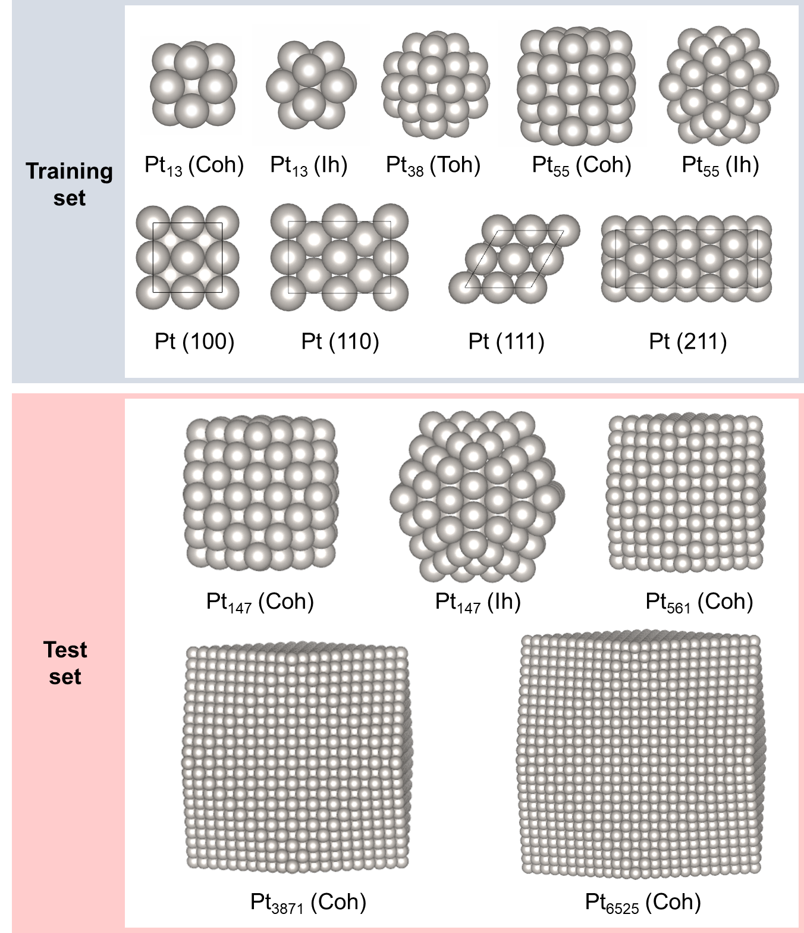
Figure S1. NPs used in constructing surface Pourbaix diagram. The NPs in training set is only used for training of BE-CGCNN model. Coh, Ih, and Toh denotes cuboctahedron, icosahedron, and truncated octahedron, respectively.

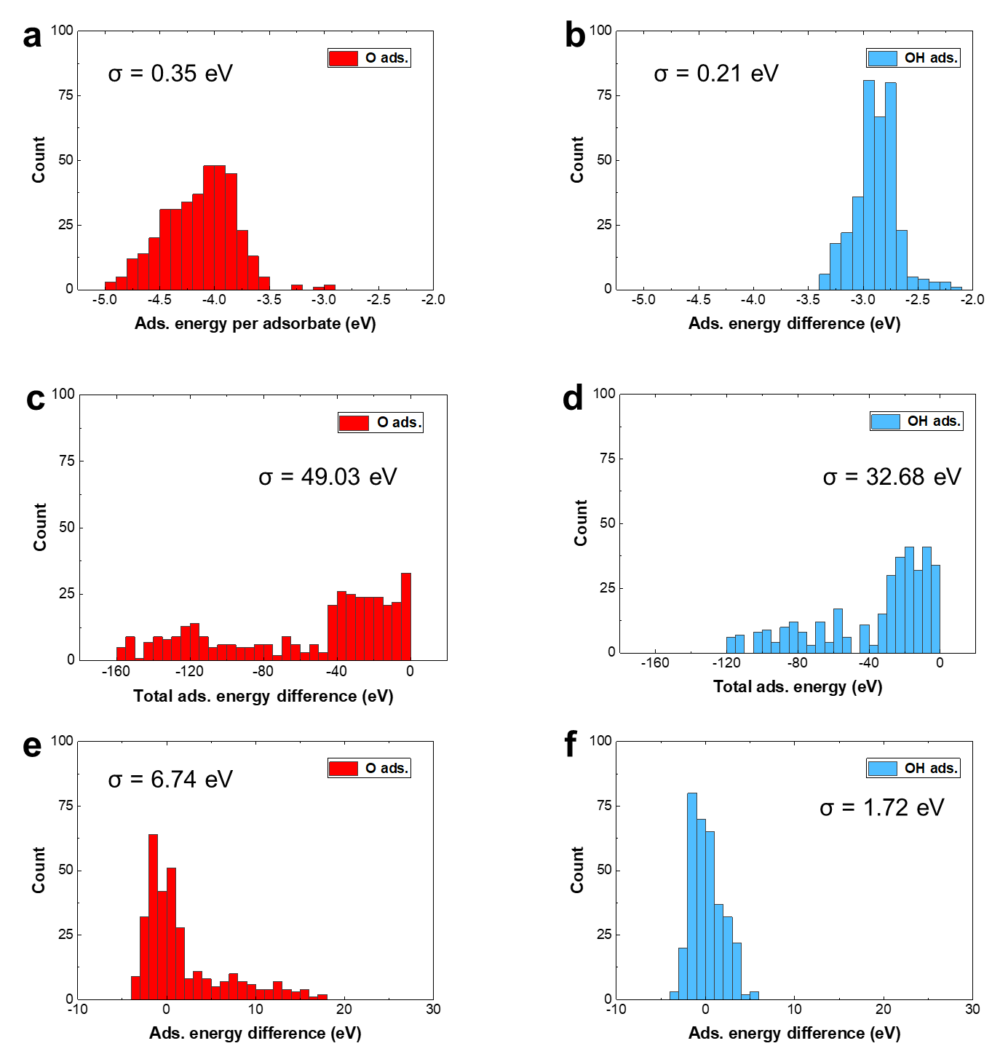
Figure S2 The data histogram of (a, b) adsorption energy per adsorbate, (c, d) total adsorption energy, and (e, f) adsorption energy difference.

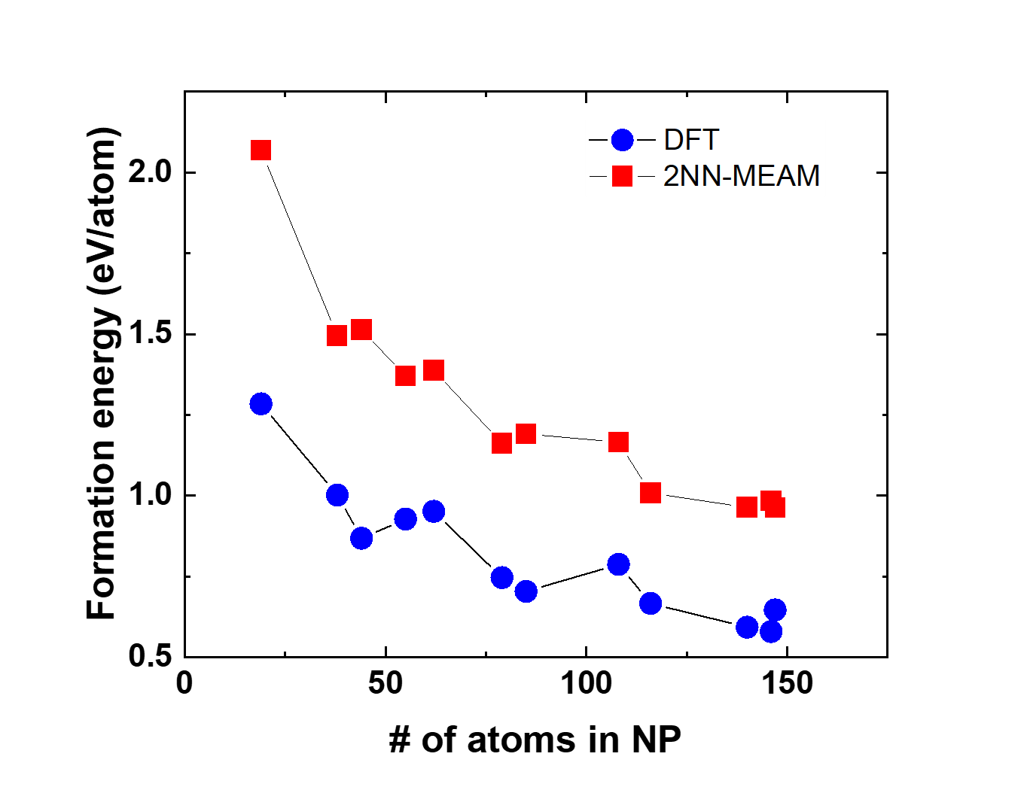
Figure S3 Formation energy of Pt NPs calculated by DFT (blue circle) and 2NN-MEAM forcefield (red square).

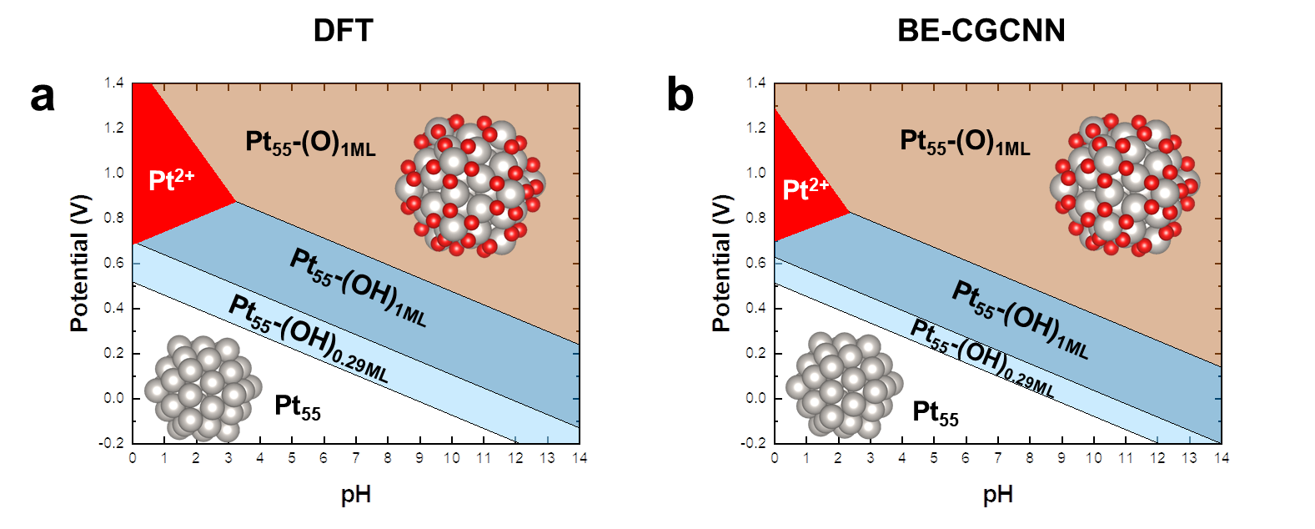
Figure S4 Pourbaix diagram of Pt₅₅ (Ih) constructed by (a) DFT calculation and (b) ML prediction trained with data of Pt slab, Pt₁₃, and Pt₃₈

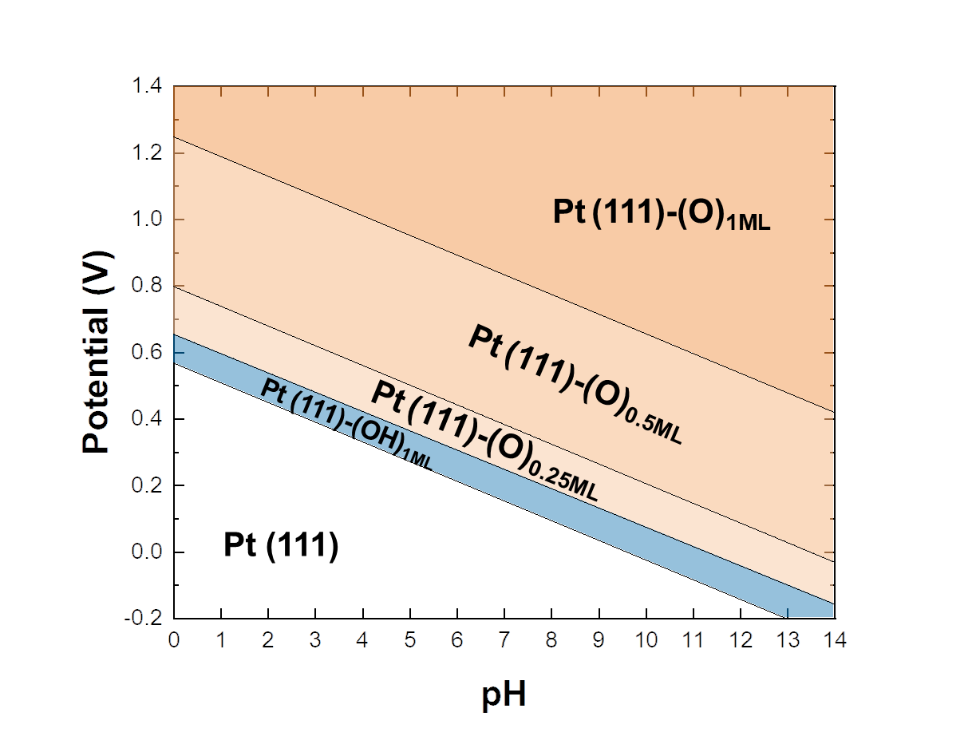
Figure S5 Pourbaix diagram of Pt (111) slab constructed by DFT calculation

