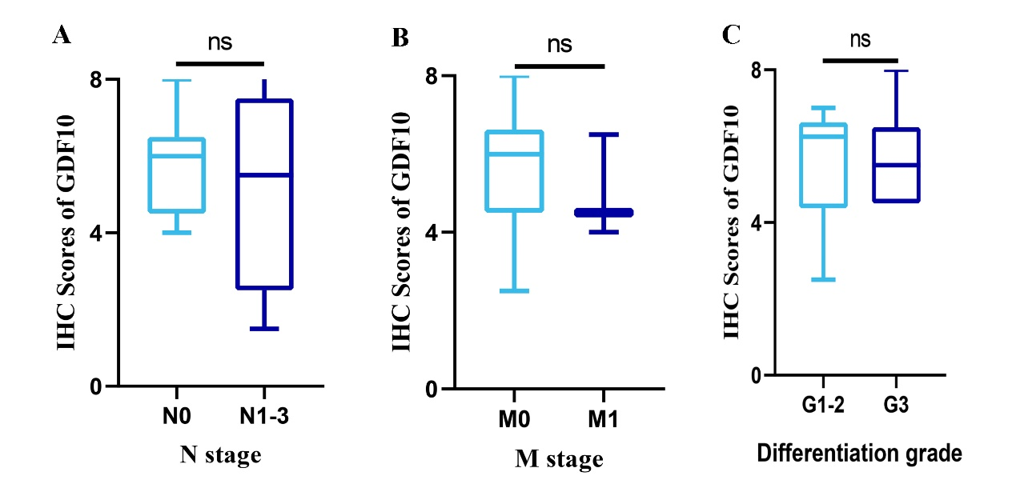
Supplementary Figure S1. Protein expression levels of GDF10 in patients with lung squamous cell carcinoma. (A) The IHC score of GDF10 in different pathological N stage (ns. no significance). (B) The IHC score of GDF10 in different pathological M stage (ns. no significance). (C) The IHC score of GDF10 in different pathological differentiation grade (ns. no significance).

