Supporting Information
Bifunctional integration of La-Ni diatomic sites with optical and catalytical activity for efficient CO₂ photoreduction
¹ State Key Laboratory of Silicate Materials for Architectures, School of Materials Science and Engineering, Wuhan University of Technology, Wuhan 430070, P. R. China.
² College of Science, Huazhong Agricultural University, Wuhan 430070, P. R. China.
³ Faculty of Materials Science and Chemistry, China University of Geosciences, Wuhan 430070, P. R. China.
⁴ Univ. Grenoble-Alpes, CEA, CNRS, IRIG/SyMMES, STEP, 38000 Grenoble, France.
⁵ Institut Européen des Membranes, IEM, UMR 5635, Université Montpellier, ENSCM, CNRS, Montpellier 34000, France.
⁶ Shanghai Synchrotron Radiation Facility (SSRF), Shanghai Institute of Applied Physics, Chinese Academy of Sciences, Shanghai 200120, P. R. China.
[*] Corresponding authors:
Prof. Yueli Liu, E-mail: lylliuwhut@whut.edu.cn
Prof. Shengyao Wang, E-mail: wangshengyao@mail.hzau.edu.cn
Prof. Keqiang Chen, E-mail: chenkeqiang@cug.edu.cn
Prof. Peter Reiss, E-mail: peter.reiss@cea.fr

[†] These authors contributed equally to this study and share the first authorship.
Supplementary Notes
Supplementary Note 1. Compared with the N 1s characteristic peaks of Phen/COF-5 (398.9 eV, C=N), a slight upshift of N 1s peaks (399.9 eV) in LaNi-Phen/COF-5 is observed (Supplementary Fig. 7)¹. The increase of the binding energy is attributed to the decrease of the electron cloud density of the Phen nitrogen, resulting from the electron transfer from nitrogen atoms in Phen to La or Ni ions. Besides, the N 1s signal of LaNi-Phen/COF-5 may be deconvoluted into two types of peaks located at 399.2 and 401.1 eV, corresponding to metal-N and C-N, respectively, which is caused by the coordination of nitrogen atoms with Ni and La ions².
Supplementary Note 2. The coordination between N atoms in Phen and La/Ni ions is also confirmed by Fourier Transform Infrared (FTIR) spectroscopy (Supplementary Figs. 8a, 8b). The FTIR spectra of COF-5 colloid indicate the typical stretching bands originating from B-O, C-O, and B-C vibrations at around 1344, 1242, and 1020 cm⁻¹, respectively, revealing the existence of boronic ester groups with the characteristic five-membered ring³. These peaks are well-matched with the FTIR spectrum of LaNi-Phen/COF-5, indicating that the loading of LaNi-Phen has a negligible effect on the molecular structure of the COF-5 colloid. Furthermore, in the FTIR spectrum of LaNi-Phen/COF-5, the C=N stretching bonds at 1602 cm⁻¹ and the C-H bands at 842 and 718 cm⁻¹ reveal a slight bathochromic shift compared with those in the starting material of Phen (1643, 854 and 740 cm⁻¹, respectively), indicating that Ni-N and La-N bonds between the LaCl₃·6H₂O and NiCl₂·6H₂O starting compounds and the Phen groups are formed⁴. As expected, La-Phen/COF-5 and Ni-Phen/COF-5 show similar characteristics of the vibrational peaks.
Supplementary Note 3. The permanent porosity of LaNi-Phen/COF-5 is investigated by N₂ adsorption isotherm measurements at 77 K (Supplementary Fig. 10), exhibiting the decrease in the Brunauer-Emmett-Teller (BET) surface area (1326 m² g⁻¹) compared to that of pure COF-5 colloid (1490 m² g⁻¹) due to the occupancy of the partial pore spaces after impregnation. As expected, the implantation of LaNi-Phen results in a decrease in porosity, which is consistent with the specific surface area shown in Supplementary Fig. 11. Although the specific surface area of LaNi-Phen/COF-5 is slightly lower than that of COF-5 colloid, it exhibits a much higher CO₂ adsorption capacity, which proves that the integration of LaNi-Phen into COF-5 colloid is conducive to improve the adsorption of CO₂ molecules (Supplementary Fig. 13).
Supplementary Note 4. The bandgap (E_{g}) of COF-5 and LaNi-Phen/COF-5 are estimated to be 3.12 and 2.86 eV, respectively, by employing Tauc plots (Supplementary Fig. 14b). The significant reduction of the bandgap facilitates the photogeneration of carriers and improves the light-harvesting properties of LaNi-Phen/COF-5. The Fermi energy level (E_{Fermi}) and the valence band maximum (VBM) of LaNi-Phen/COF-5 are determined by ultraviolet photoelectron spectroscopy (UPS)⁵. Based on the full scan UPS spectra of LaNi-Phen/COF-5 (Supplementary Fig. 16a), we infer that the cut-off edge energy and Fermi edge energy are 15.93 eV and 0.76 eV, respectively (Supplementary Fig. 16b). Accordingly, the Fermi energy level is calculated as 5.27 eV, while the top position of VB is determined to be −6.03 eV with respect to the vacuum level⁶. Combined with the bandgap (E_{g} = 2.86 eV) of LaNi-Phen/COF-5, the valence band maximum (VBM) and the conduction band minimum (CBM) of LaNi-Phen/COF-5 are calculated as 1.53 and −1.33 V versus NHE, respectively. The corresponding energy level structure and the hypothetic mechanism for the photocatalytic CO₂ reduction with LaNi-Phen/COF-5 are illustrated in Supplementary Fig. 16c. Notably, the CBM of LaNi-Phen/COF-5 is more negative than the redox potential value of −0.53 V (E⁰(CO₂/CO)) versus NHE. Electrons photoexcited from the VBM of LaNi-Phen/COF-5 to the CBM, thus enable the reduction of adsorbed CO₂ molecules to generate CO. Besides, for the oxidation half-reaction, the photoexcited holes in the VB of LaNi-Phen/COF-5 are consumed by electrons provided by BIH, in which H₂O is oxidized to O₂ or H⁺.
Supplementary Note 5. To further evaluate the stability of the as-prepared La/Ni diatomic photocatalysts, the heterogeneity experiments were performed by removing the catalyst from the reaction medium at t=4 h by centrifugation. The photocatalytic CO₂ reduction experiments were carried out with the filtrate (catalyst removed) under the same reaction conditions, which is a process of the gas-liquid phase. When the catalyst was removed, the generated gases, such as CO and H₂, were vented from the sealed system (Supplementary Fig. 22), indicating that the diatomic species of LaNi-Phen may be stably confined in the pores of COF-5 colloid without shedding during the photocatalytic CO₂ reduction process.
Supplementary Note 6. The carrier lifetime of the photogenerated charges is further evaluated by time-resolved photoluminescence (TRPL) measurements using an excitation wavelength of 365 nm, indicating charge transfer processes (Supplementary Fig. 31)⁷. The average carrier lifetime of the catalysts is summarized in Supplementary Table 6. Photoelectrochemical measurements are carried out to verify the charge carrier transfer rate of the catalysts. The response curve of LaNi-Phen/COF-5 shows the largest photocurrent density when the electrodes are illuminated with ultraviolet-visible light (λ ≥ 350 nm), indicating the enhanced electrical conductivity and prolonged carrier lifetime of the photogenerated charges (Supplementary Fig. 32). The enhancement of the photocurrent intensity contributes to the improved efficiency for the photocatalytic CO₂ reduction. Electrochemical impedance spectroscopy (EIS) is applied to determine the electron transport characteristics of the catalysts. As shown in Supplementary Fig. 33, among all the photocatalysts, a remarkably decreased radius of the Nyquist plot is observed after loading of the COF-5 colloids with the combination of La/Ni metallic complexes, demonstrating the lower resistance for charge transfer separation in the case of LaNi-Phen/COF-5. To sum up, integrating La-Ni dual-atom sites into the COF-5 colloid leads to synergistic effects, which are the origin of the observed outstanding photoelectric performance of the LaNi-Phen/COF-5 catalyst.

Supplementary Figures

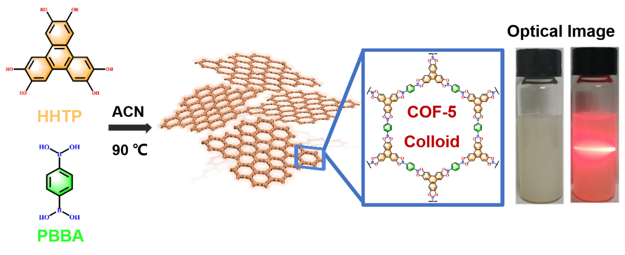
b
a
Supplementary Fig. 1 Synthesis diagram of boroxine-linked COF-5 colloid. (a) Synthesis diagram of boroxine-linked COF-5 colloid through solvothermal condensation of HHTP (5 mM) and PBBA. (b) Photograph of COF-5 colloid (left) and the corresponding Tyndall effect (right), indicating the particle size of the COF-5 colloids is within the nanoscale.

Supplementary Fig. 2 Powder XRD patterns. Powder XRD patterns of simulated COF-5, experimental COF-5 colloid, La-Phen/COF-5, Ni-Phen/COF-5 and LaNi-Phen/COF-5, demonstrating their very similar crystalline structures, indicating that the crystalline structure of the COF-5 colloid remains unchanged in LaNi-Phen/COF-5. The experimental patterns also match well the simulated one (the broad peak in the 25-30° range increases from the (001) reflection of COF-5)³.

c
b
a
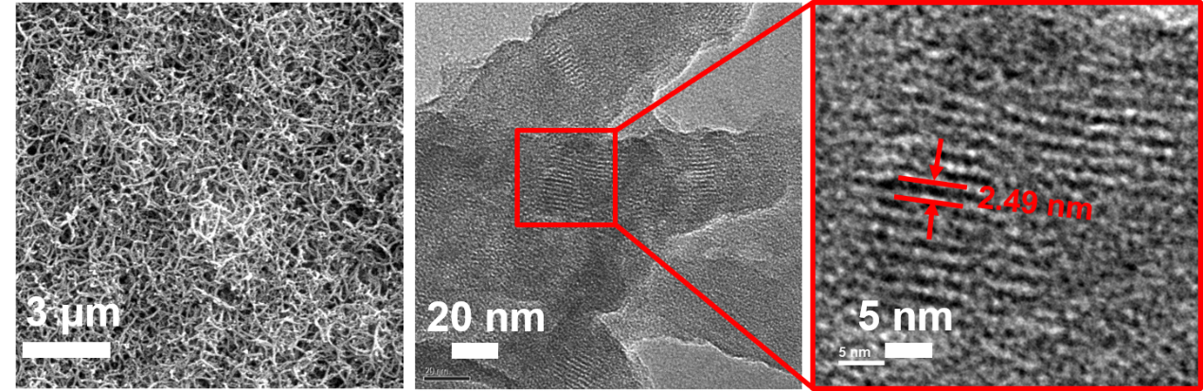
Supplementary Fig. 3 Morphology of COF-5 colloid. (a) SEM image. (b) TEM image. (c) HRTEM image of the enlarged area. Panel (a) shows its one-dimensional (1D) nanorods morphology with 70-80 nm in width. Panel (b) indicates the existence of the regular fringes corresponding to the pore size of 2.49 nm.

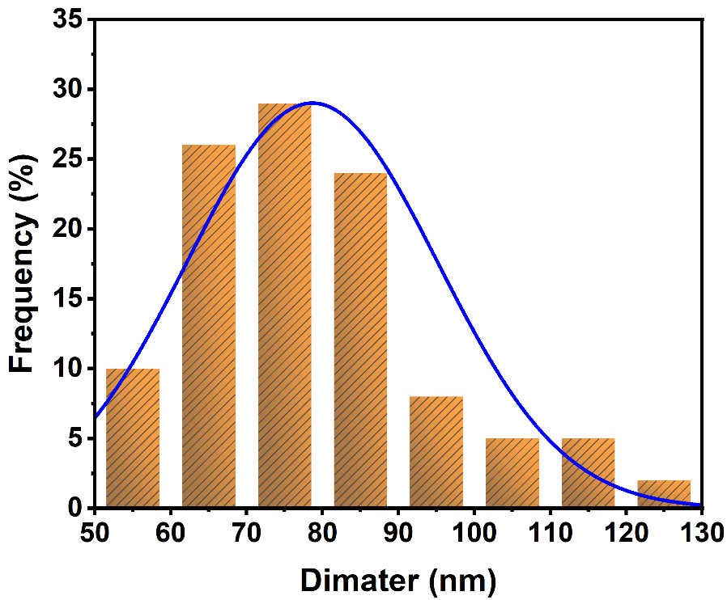
Supplementary Fig. 4 Particle width distribution. Particle width distribution of COF-5 colloid, showing the width of COF-5 colloid is mainly in the range of 70-80 nm.

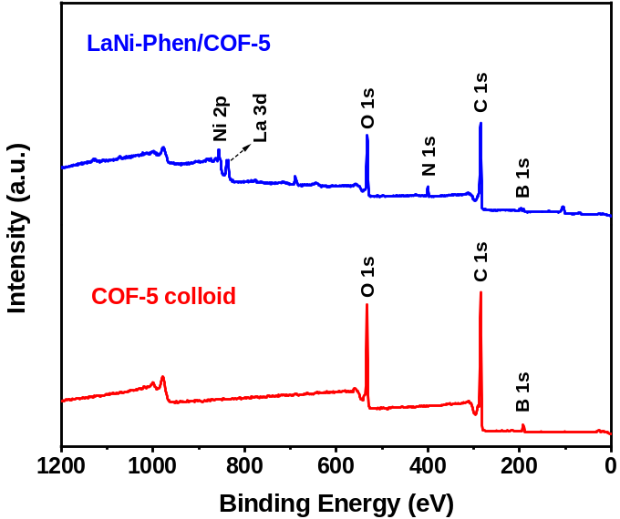
Supplementary Fig. 5 XPS full spectra. XPS spectra of COF-5 colloid and LaNi-Phen/COF-5, supporting the existence of C, N, O, La and Ni in the catalysts.
a
b
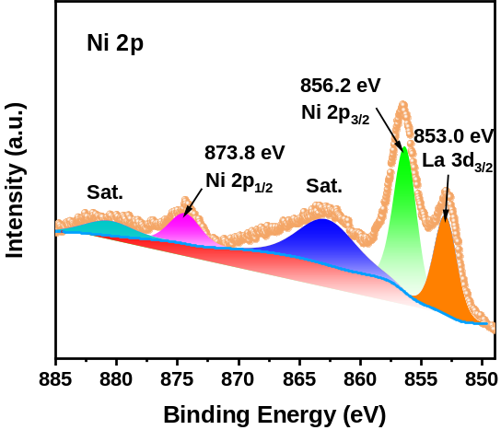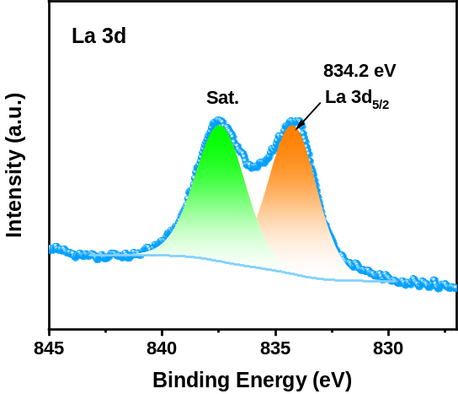
Supplementary Fig. 6 XPS spectra. XPS spectra of (a) Ni 2p and (b) La 3d in LaNi-Phen/COF-5. The high-resolution XPS spectrum of Ni 2p peaks located at 856.2 and 873.8 eV may be indexed to Ni 2p_{3/2} and Ni 2p_{1/2}, respectively, indicating the successful loading of Ni²⁺ ions into COF-5 colloid through the coordination of N atoms rather than metal cluster state⁸. And two peaks at 834.2 and 837.5 eV, which may be assigned to the signals from La 3d_{5/2} and the corresponding satellite peaks of La³⁺, respectively⁹.
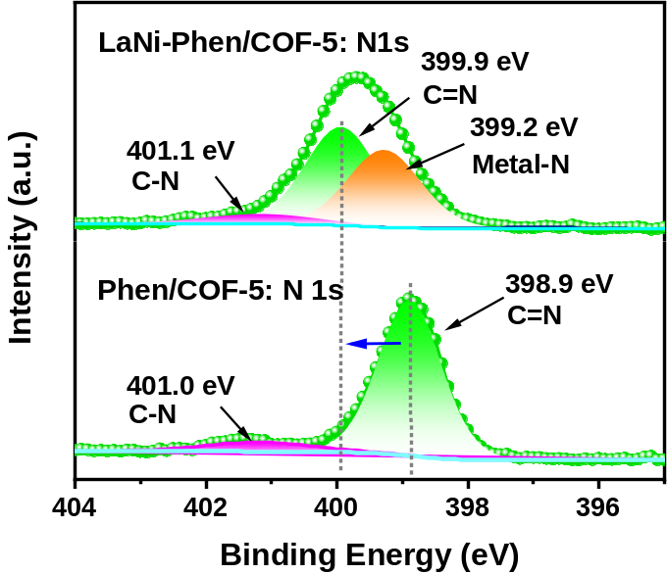
Supplementary Fig. 7 XPS spectra. XPS spectra of N 1s in COF-5 colloid and LaNi-Phen/COF-5, where the peak shift is significant, indicating strong interactions between La/Ni and the N atoms of 1,10-Phenanthroline (Phen) ligand.
b
a
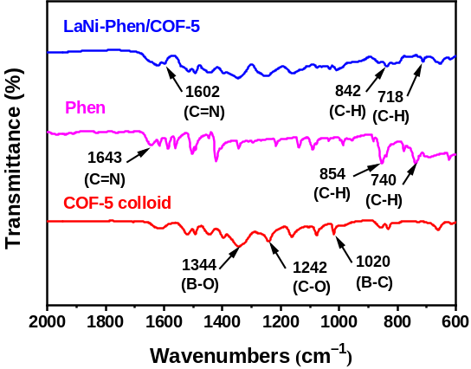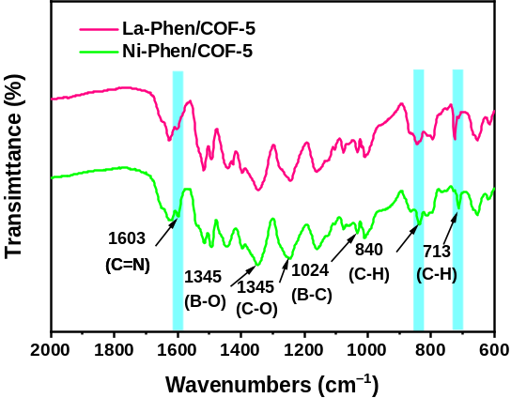
Supplementary Fig. 8 FTIR spectra. (a) FTIR spectra of COF-5 colloid, Phen and LaNi-Phen/COF-5. (b) FTIR spectra of La-Phen/COF-5 and Ni-Phen/COF-5, supporting that Ni-N and La-N bonds between LaCl₃·6H₂O/NiCl₂·6H₂O and Phen groups are formed.

a
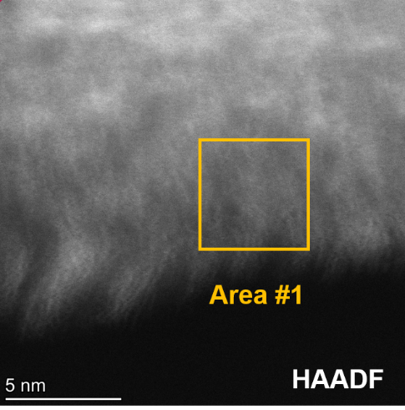
b
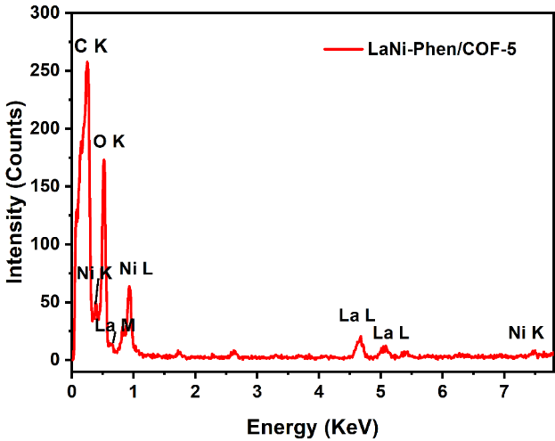
Supplementary Fig. 9 EDS spectra. (a) HAADF-STEM image of LaNi-Phen/COF-5. (b) Corresponding EDX spectrum from the region indicated in HAADF-STEM image.

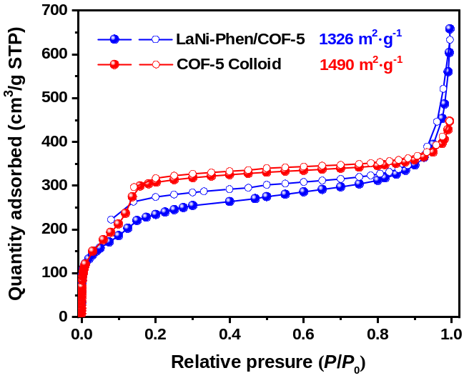
Supplementary Fig. 10 N₂ sorption isotherms. N₂ sorption isotherms of COF-5 colloid and LaNi-Phen/COF-5 at 77 K, suggesting that the incorporating of La and Ni single-sites into COF-5 colloid leads to a decreased BET surface area from 1490 to 1326 m²·g⁻¹.
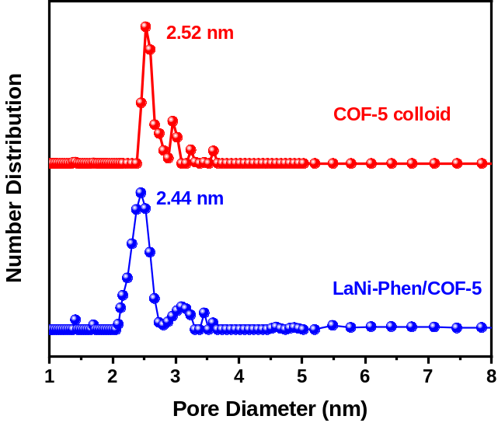
Supplementary Fig. 11 Pore size distribution. The calculated pore size distributions of COF-5 colloid and LaNi-Phen/COF-5. The pore size distributions of COF-5 colloid and LaNi-Phen/COF-5 are 25.2 Å and 24.4 Å, respectively, which are close to the theoretical pore size of 27.2 Å for the simulated AA stacking model structure.
a
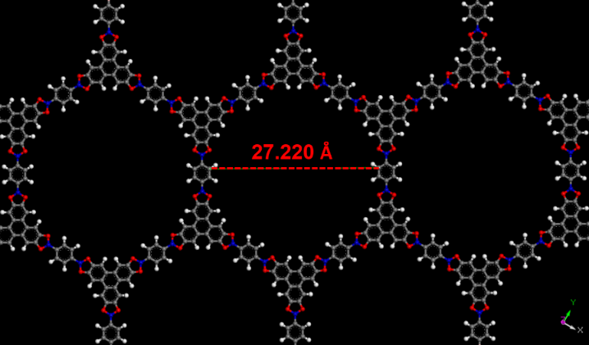
b
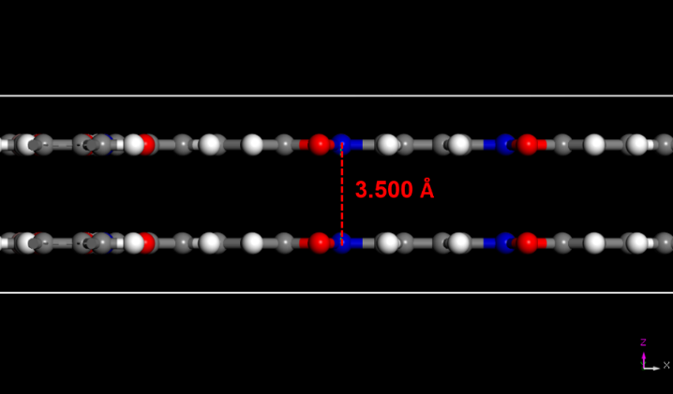
Supplementary Fig. 12 Molecular model of COF-5. (a) COF-5 view parallel to the z-axis. (b) COF-5 view parallel to the y-axis. The structural model calculated shows that the pore size and interlayer spacing of COF-5 are approximately 27.220 Å and 3.5 Å, respectively. The appropriate pore structure conduces to confine metal complexes and improve the CO₂ adsorption capacity. Carbon, oxygen, boron and hydrogen atoms are colored in grey, red, blue and white, respectively.

Supplementary Fig. 13 CO₂ adsorption curves. CO₂ adsorption isotherms of COF-5 colloid and LaNi-Phen/COF-5 at 298 K, indicating the excellent CO₂ capture capability of LaNi-Phen/COF-5 as compared to COF-5 colloid, which shows a high 2.47 mmol g⁻¹ of CO₂ uptake at 298 K and 1 bar.
a
b

a
b
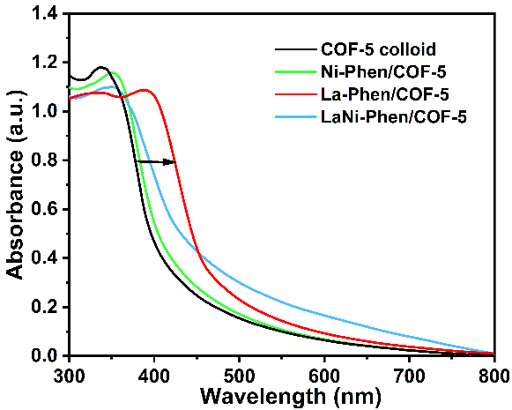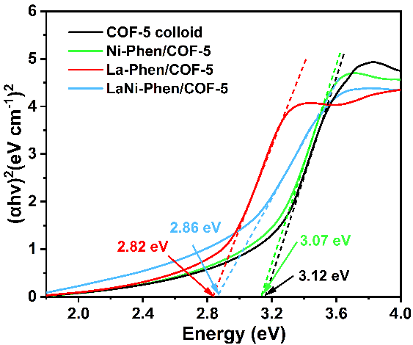
Supplementary Fig. 14 UV-vis absorption properties. (a) UV-vis diffuse reflectance spectra of COF-5 colloid, Ni-Phen/COF-5, La-Phen/COF-5 and LaNi-Phen/COF-5. (b) Tauc plots of LaNi-Phen/COF-5.
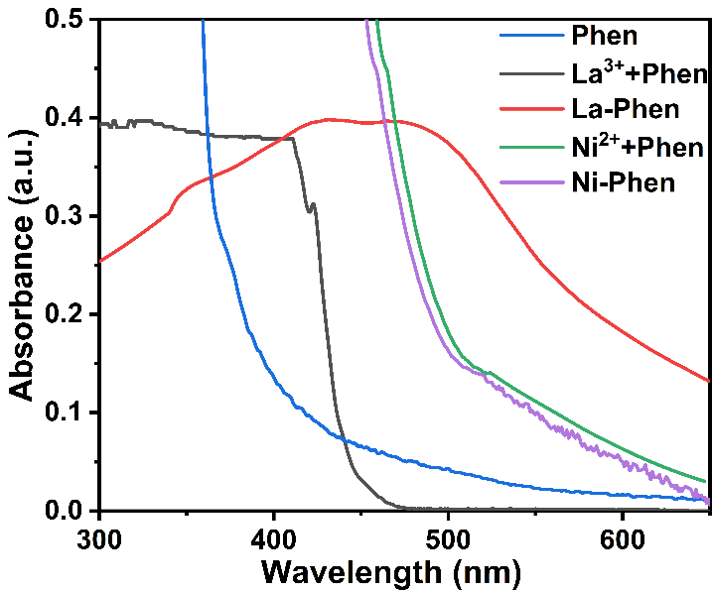
Supplementary Fig. 15 Absorption properties. UV-vis diffuse reflectance spectra of Phen, Ni²⁺+Phen (physical mixing), Ni-Phen, La³⁺+Phen (physical mixing) and La-Phen, proving that La-Phen acts as the light harvesting center determining the absorption range of the functional COF-5 colloids.

a
b
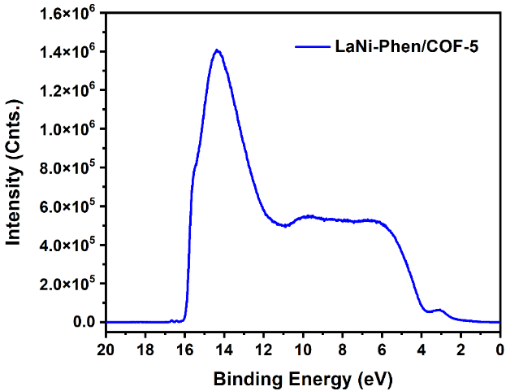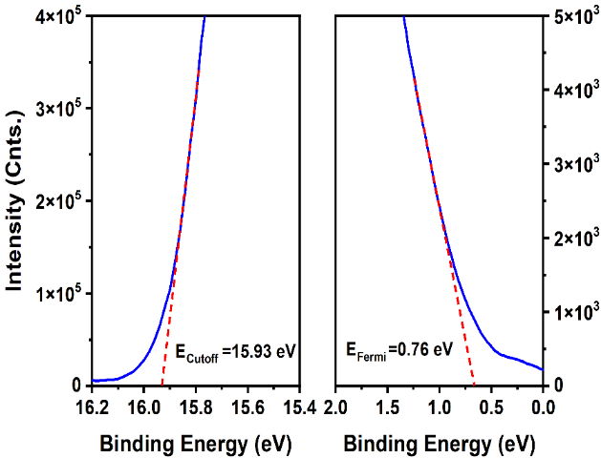
c
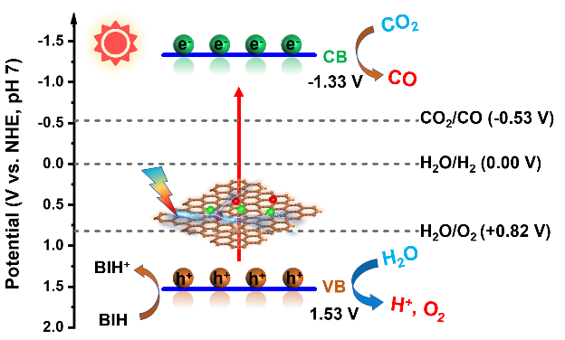
Supplementary Fig. 16 UPS spectra and electronic band structure. (a) Full scan UPS spectra of LaNi-Phen/COF-5. (b) Cutoff edge (left) and Fermi edge (right) of LaNi-Phen/COF-5. (c) Schematic energy level diagrams and possible reaction mechanism of LaNi-Phen/COF-5 at pH = 7.

a
b
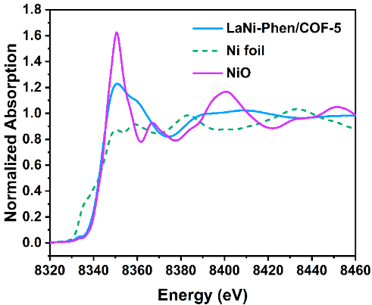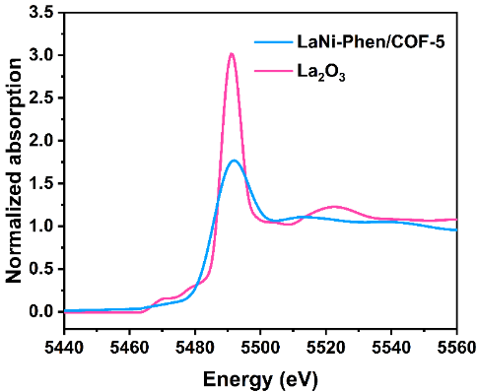
Supplementary Fig. 17 Normalized XANES spectra. (a) Experimental K-edge XANES spectra of Ni. (b) Experimental L3-edge XANES spectra of La. As highlighted with red circles and arrows, the near-edge absorption energy of La/Ni species in LaNi-Phen/COF-5 locates between that of the metal and the metal oxide, proving the positive charge of the La and Ni species.
a
b
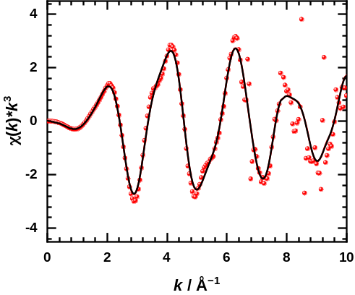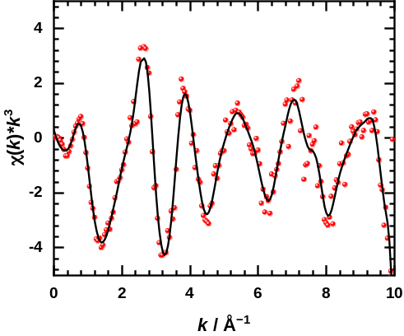
Supplementary Fig. 18 EXAFS fitting curves. Experimental EXAFS data (points) and curve fit (line) at k space of (a) Ni sites and (b) La sites.

a
b
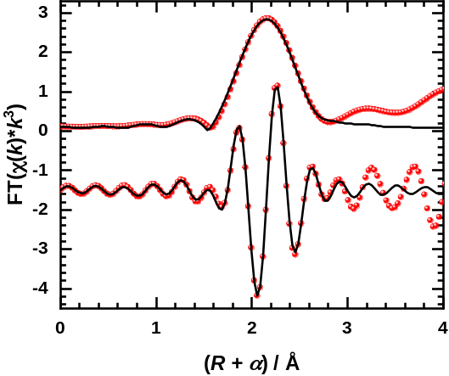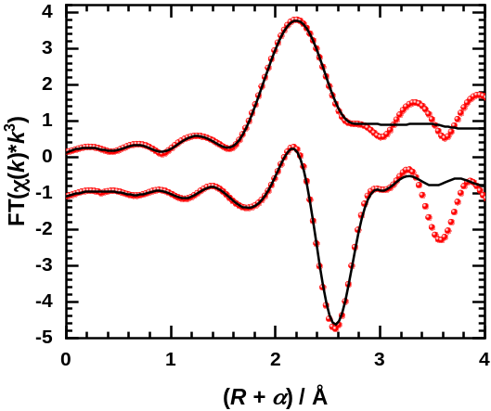
Supplementary Fig. 19 EXAFS fitting curves. Experimenetal EXAFS data (points) and curve fit (line) at R space (FT magnitude and imaginary component) of (a) Ni foil and (b) La₂O₃. The data are k³-weighted and not phase-corrected.
b
a
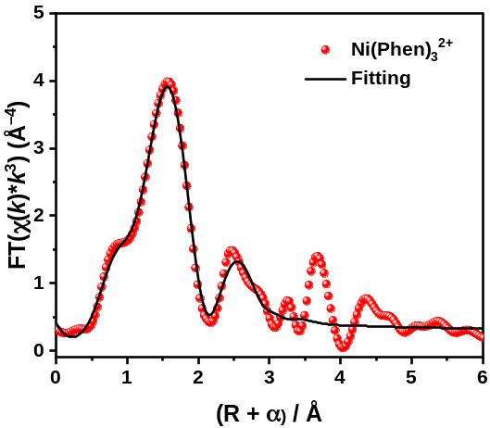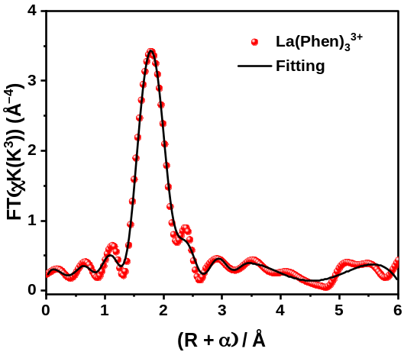
Supplementary Fig. 20 EXAFS fitting curves. Experimental EXAFS data (points) and curve fit (line) at R space (FT magnitude and imaginary component) of (a) Ni(Phen)₃²⁺ and (b) La(Phen)₃³⁺. The data are k³-weighted and not phase-corrected.

Supplementary Fig. 21 Simulated local structure of LaNi-Phen. (a) DFT-optimized structure of LaNi-Phen/COF-5, featuring that La and Ni are chelated by Phen with the coordinated structure of Ni-2N and La-4N.
Schematic diagrams of (b) d_{Ni-N}, d_{La-N} and (c) d_{La-Ni}. Color code: carbon-grey, oxygen-red, boron-pink, hydrogen-white, nitrogen-blue, nickel-light blue, lanthanum-orange.

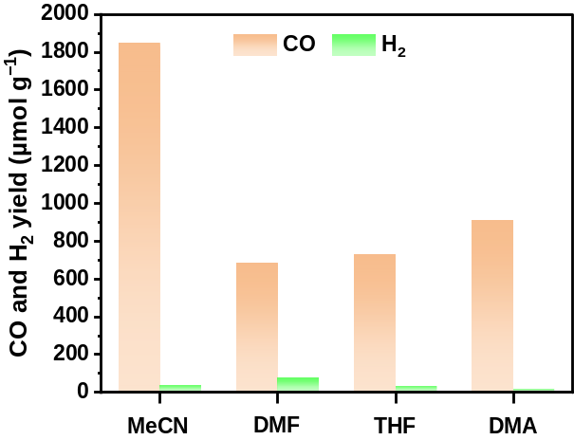
Supplementary Fig. 22 Effect of solvents in the CO₂ photoreduction. Effect of solvents in the CO₂ reduction over LaNi-Phen/COF-5 in a 3 h reaction, proving that acetonitrile is the most favorable reaction solvent with a higher activity and selectivity than the other solvents tested. (Conditions: 10 mg photocatalysts, 50 mL solvents, 2 mL H₂O, 300 W Xe lamp, 298 K).
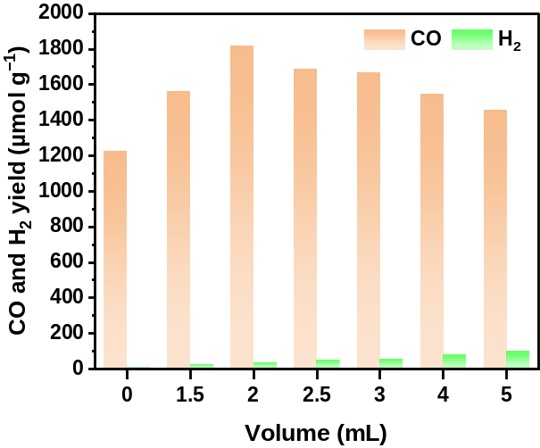
Supplementary Fig. 23 Effect of the H₂O content in the CO₂ reduction. Effect of the H₂O content in the CO₂ reduction over LaNi-Phen/COF-5 in a 3 h reaction, proving that H₂O significantly influences the catalytic activity and product selectivity. (Conditions: 10 mg photocatalysts, 50 mL MeCN, x mL H₂O, 300 W Xe lamp, 298 K).
a
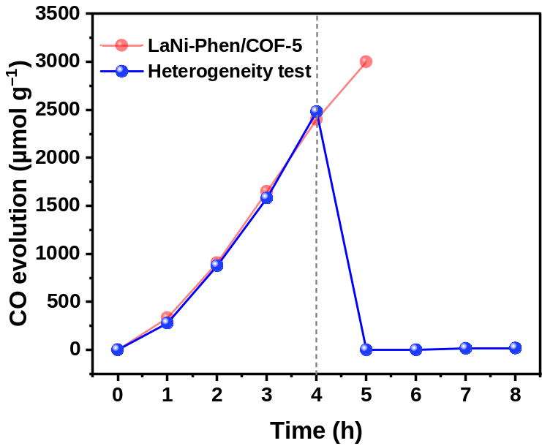
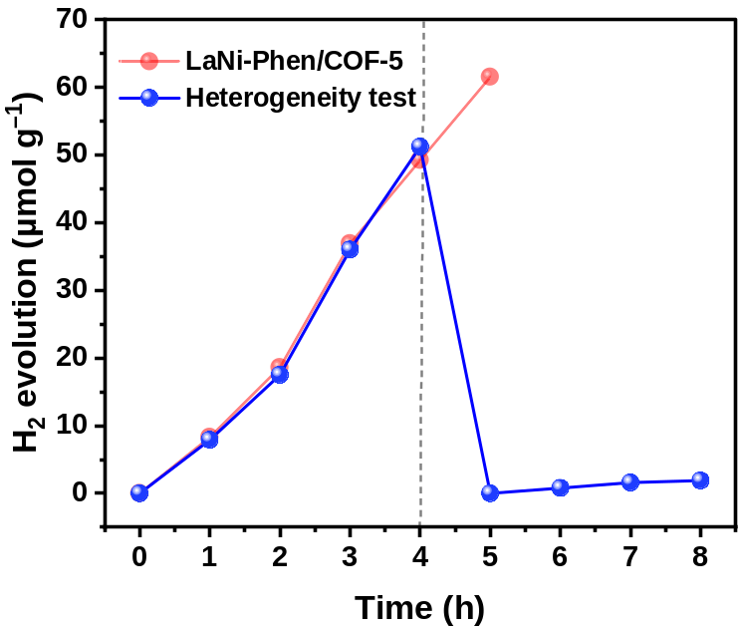
b
Supplementary Fig. 24 Heterogeneity tests. Effect of catalyst removal on the photocatalytic CO₂ reduction performance of (a) CO and (b) H₂ over LaNi-Phen/COF-5.

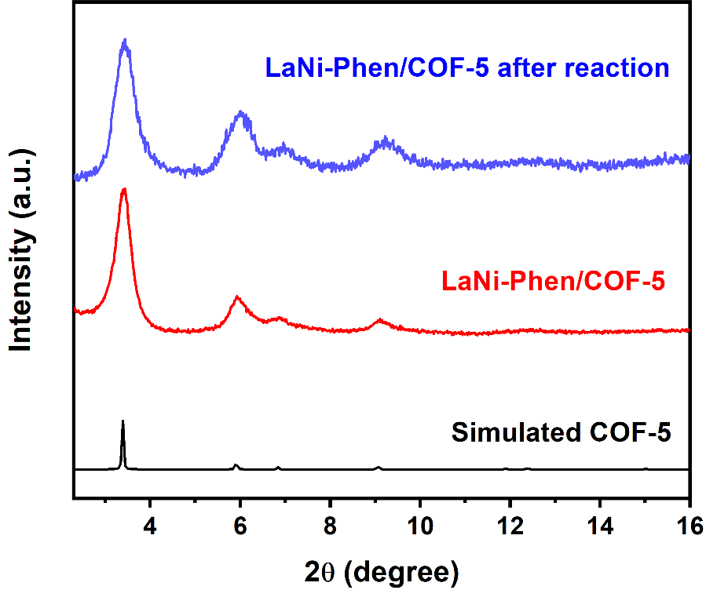
Supplementary Fig. 25 Powder XRD patterns. Powder XRD patterns of LaNi-Phen/COF-5 before and after CO₂RR reaction, evidencing the unaltered crystallinity after the CO₂RR process.

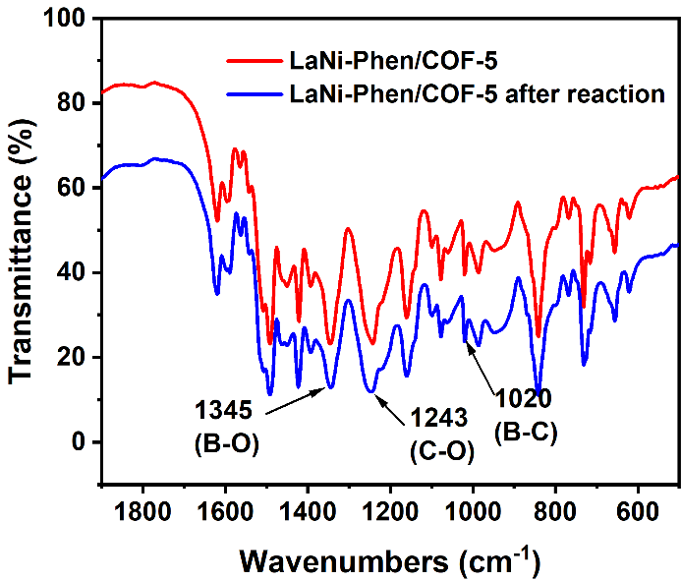
Supplementary Fig. 26 FTIR spectra. FTIR spectra of LaNi-Phen/COF-5 before and after CO₂RR reaction, showing the maintained integrity of the COF-5 colloidal framework structure after the CO₂RR process.
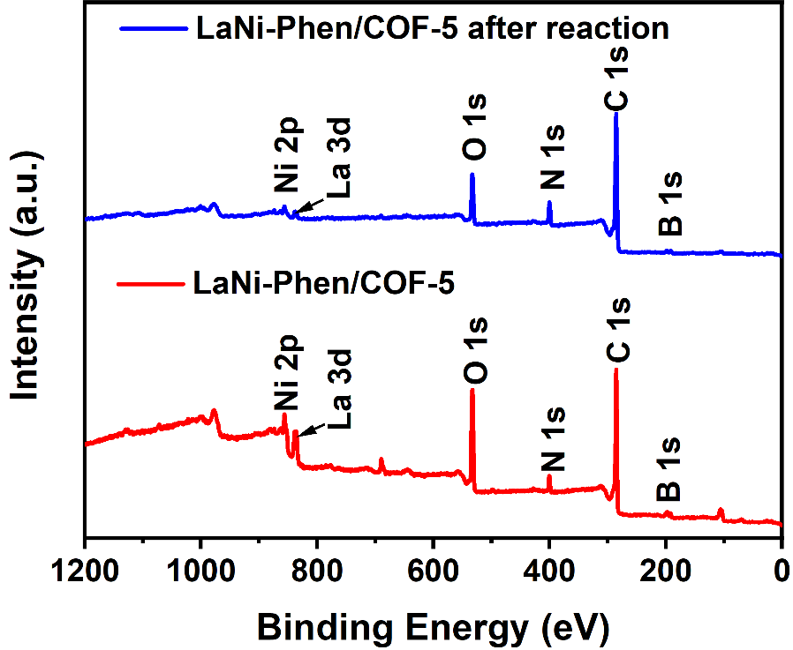
Supplementary Fig. 27 XPS spectra after CO₂RR reaction. XPS spectra of LaNi-Phen/COF-5 before and after the CO₂RR reaction (five 3h-cycles).

c
b
a
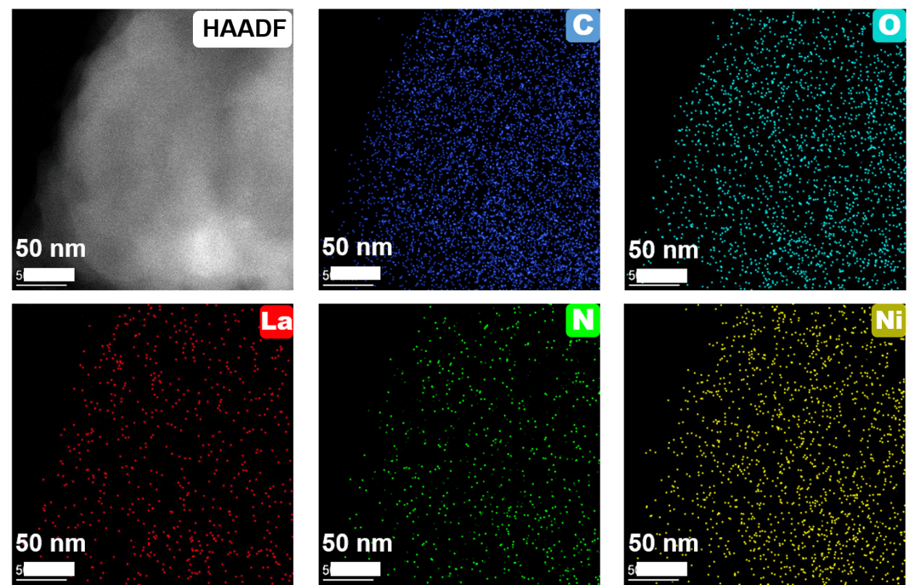
f
e
d
Supplementary Fig. 28 Morphology characterization after CO₂RR cycle experiments. (a) HAADF image, (b-f) separated elemental mapping images of LaNi-Phen/COF-5 after the CO₂RR reaction, evidencing the colocalization of the different elements without segregation or aggregation.

b
a
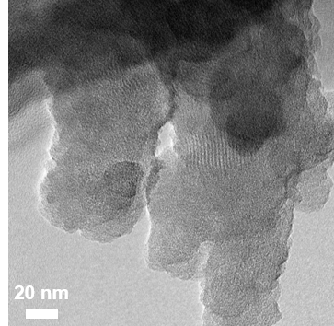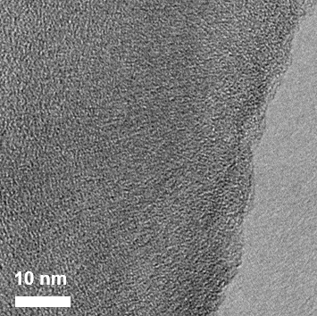
c
d
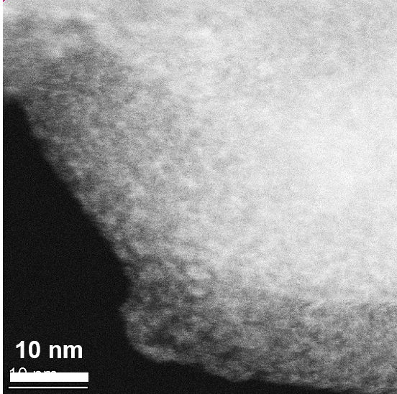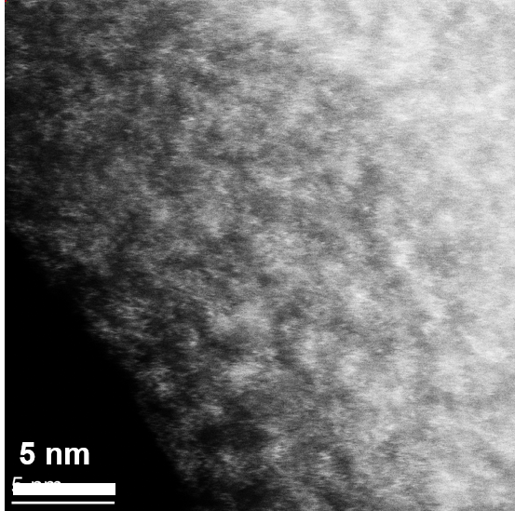
Supplementary Fig. 29 Morphology characterization after CO₂RR cycle experiments. (a)/(b) TEM images, (c)/(d) atomic-resolution ADF-STEM images of LaNi-Phen/COF-5 after CO₂RR reaction.

Supplementary Fig. 30 Steady-state PL spectra. Steady-state PL spectra of COF-5 colloid, Ni-Phen/COF-5, La-Phen/COF-5 and LaNi-Phen/COF-5 using an excitation wavelength of λ = 365 nm¹⁰. Compared with the COF-5 colloid, the PL peak position of LaNi-Phen/COF-5 is slightly red-shifted by around 26 nm (Supplementary Fig. 30), which is in accordance with the metal ion-induced reduction of the bandgap of COF-5 observed in the aforementioned UV-vis absorption studies (Supplementary Note 6). The lowest PL intensity of LaNi-Phen/COF-5 in this comparison also suggests its highest charge transport property.

Supplementary Fig. 31 Transient-state PL spectra. Transient-state PL spectra of COF-5 colloid, Ni-Phen/COF-5, La-Phen/COF-5 and LaNi-Phen/COF-5 using an excitation wavelength of λ = 365 nm.

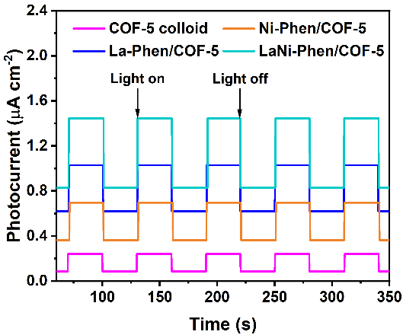
Supplementary Fig. 32 Transient photocurrent responses. Transient photocurrent responses of COF-5 colloid, Ni-Phen/COF-5, La-Phen/COF-5 and LaNi-Phen/COF-5.
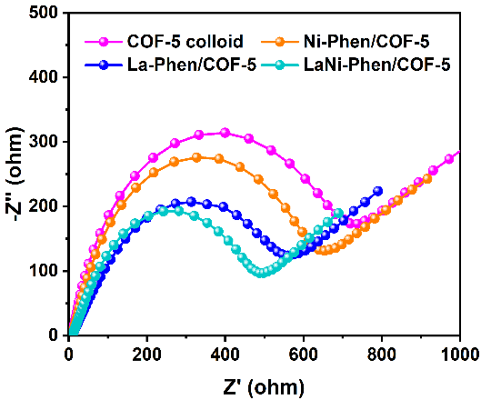
Supplementary Fig. 33 Electrochemical impedance spectra. Electrochemical impedance spectra of COF-5 colloid, Ni-Phen/COF-5, La-Phen/COF-5 and LaNi-Phen/COF-5.

a
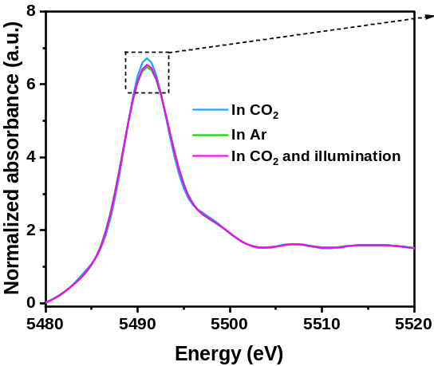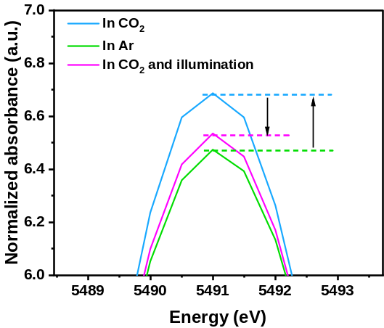
b
Supplementary Fig. 34 In situ XAFS measurements. (a) La L3-edge XANES spectra of LaNi-Phen/COF-5 during the CO₂ photoreduction reaction at room temperature, in 1 atm of Ar or CO₂-saturated aqueous solution. (b) Enlarged La L3-edge XANES spectra, demonstrating that La atoms also act as catalytic centers, and that the electronic structure is closely correlated with the processes of adsorption, activation, and the photocatalytic CO₂RR.

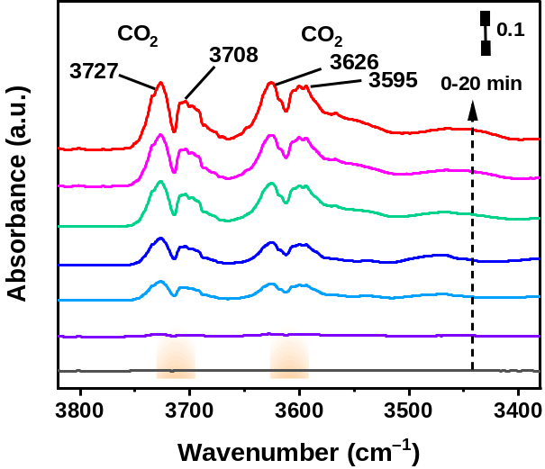
Supplementary Fig. 35 In situ DRIFTS spectra test. In-situ DRIFTS spectra of the CO₂ interaction with LaNi-Phen/COF-5 in the dark.
b
a
Supplementary Fig. 36 In-situ DRIFTS spectra test, CO₂ and H₂O interaction with LaNi-Phen/COF-5 under subsequent light irradiation. (a) Intensities of adsorbed gas-phase CO₂ at 2800-3800 cm^{–1}. (b) Intensities of ν₃(CO₂) absorption of surface CO₂ molecules at 2300-2400 cm^{–1}.

b

a
Supplementary Fig. 37 DFT simulation of CO₂ adsorption. DFT simulation of the CO₂ adsorption over the COF-5 surface (a), and LaNi-Phen (b). The O=C=O bond on the COF-5 surface was in a linear configuration, indicating that sole COF-5 cannot effectively activate the CO₂ molecule. Notably, the O=C=O bond on the LaNi-Phen coordination configuration evolves into a V-type configuration with a bond angle of 123.45°, which fully verified that the La-N₄/Ni-N₂ configuration is beneficial to the adsorption and activation of CO₂.

Supplementary Tables
Supplementary Table 1 Elemental composition of LaNi-Phen/COF-5. Elemental analysis using EDX showing the elemental contents of La and Ni in LaNi-Phen/COF-5 from (the copper signal comes from the copper grid).
Element (edge) |  | Weight% | Atomic% | Net Error%
C (K) |  | 60.56 | 74.39 | 4.85
N (K) |  | 2.56 | 2.17 | 0.59
O (K) |  | 18.54 | 16.92 | 3.43
Cl (K) |  | 1.95 | 0.91 | 0.19
Cu (K) |  | 12.20 | 3.18 | 0.18
La (L) |  | 2.58 | 1.53 | 0.21
Ni (K) |  | 1.61 | 0.90 | 0.15

Supplementary Table 2 EXAFS fitting parameters. EXAFS curve fitting parametersª for the Ni K-edge and the La L3-edge for different samples.
Sample | Path | N | R / Å | σ²/Å² | ΔE₀ (eV) | R-factor/%
Ni foil | Ni−Ni^{b} | 12.0^{f} | 2.47 | 0.006 | 2.3 | 0.5
LaNi-Phen/COF-5 | Ni−N^{c} | 2.3 | 1.91 | 0.003 | 2.3 | 0.4
La₂O₃ | La−O^{d} | 6.0^{f} | 2.57 | 0.005 | 4.5 | 0.4
LaNi-Phen/COF-5 | La−N^{e} | 4.2 | 2.54 | 0.007 | −3.1 | 0.2
[La(Phen)₃]³⁺ | La−N^{e} | 6.0 | 2.56 | 0.004 | 2.6 | 0.3
[Ni(Phen)₃]²⁺ | Ni−N^{e} | 6.0 | 2.13 | 0.005 | −2.8 | 0.5
ªN, coordination number; R, distance between absorber and backscatter atoms; σ², Debye-Waller factor to account for both thermal and structural disorders; ΔE₀, inner potential correction; R factor (%) indicates the goodness of the fit. The accuracies of the above parameters were estimated as N, ±20%; R, ±1%; σ² ±20%; ΔE₀, ±20%. For Ni foil, La₂O₃, and LaNi-Phen/COF-5 samples, S₀² was determined from Ni foil (0.875), La₂O₃ (0.907), and Porphyrin-Cu (II) (0.853) reference fitting. ^{b}Fitting range: 2.5 ≤ k ≤ 14.5 Å⁻¹, 1.0 ≤ R ≤ 3.0 Å. ^{c}Fitting range: 0 ≤ k ≤ 10 Å⁻¹, 1.0 ≤ R (Å) ≤ 3.0 Å. ^{d}Fitting range: 2.5 ≤ k ≤ 10.0 Å⁻¹, 1.0 ≤ R ≤ 3.0 Å. ^{e}Fitting range: 0 ≤ k ≤ 10.0 Å⁻¹, 1.0 ≤ R ≤ 3.0 Å. ^{f}These coordination numbers were constrained as N(Ni-Ni) = 12.0 and N(La-O) = 6.0 based on the crystal structure.

Supplementary Table 3 Photocatalytic CO₂ reduction performance over La_{x}Ni_{1−x}-Phen/COF-5 with various La-Ni metal ion doping proportions.
Entryª | Catalyst | Production rates (μmol·g⁻¹·h⁻¹) |  | S_{CO} (%)^{b}
Entryª | Catalyst | CO | H₂ | S_{CO} (%)^{b}
1 | COF-5 colloid | 39.9 | 16.5 | 70.7
2 | Ni-Phen/COF-5 | 224.4 | 21.7 | 91.2
3  4 | La_{0.1}Ni_{0.9}-Phen/COF-5 | 236.8 | 19.3 | 92.5
3  4 | La_{0.2}Ni_{0.8}-Phen/COF-5 | 299.4 | 17.9 | 94.3
5  6 | La_{0.3}Ni_{0.7}-Phen/COF-5 | 342.9 | 22.8 | 93.8
5  6 | La_{0.4}Ni_{0.6}-Phen/COF-5 | 446.5 | 17.4 | 96.2
7  8 | La_{0.5}Ni_{0.5}-Phen/COF-5 | 549.5 | 19.8 | 96.5
7  8 | La_{0.6}Ni_{0.4}-Phen/COF-5 | 605.8 | 11.3 | 98.2
9  10 | La_{0.7}Ni_{0.3}-Phen/COF-5 | 565.3 | 14.2 | 97.5
9  10 | La_{0.8}Ni_{0.2}-Phen/COF-5 | 473.7 | 16.7 | 96.6
11  12 | La_{0.9}Ni_{0.1}-Phen/COF-5 | 248.9 | 12.1 | 95.4
11  12 | La-Phen/COF-5 | 195.4 | 8.2 | 95.9
ªReaction conditions: 10 mg catalyst and 30 mg (molar concentration of 2.4 mM) BIH as a sacrificial agent; 50 mL CH₃CN and 2 mL H₂O; UV-vis light irradiation (350 W Xenon lamp, λ > 380 nm), 1 atm CO₂ and 25 °C.
^{b}Electron selectivity (Sel_{electron}) of CO: S_{CO}(%) = [2v(CO)]/[2v(CO) + 2v(H₂)] × 100%, where v(CO) and v(H₂) denote the formation rates of CO and H₂, respectively.

Supplementary Table 4 Performance comparison. LaNi-Phen/COF-5 was compared with other reported photocatalysts without the additional photosensitizers in terms of CO activity and selectivity.
Catalyst | light source | CO activity  (μmol·g⁻¹·h⁻¹) | CO selectivity | Ref
LaNi-Phen/COF-5 | 300 W Xe lamp | 605.8 | 98.2 | This work
Co₄/g-C₃N₄ | 300 W Xe lamp | 89.6 | 93.4 | 11
TAPBB-COF | 300 W Xe lamp | 24.6 | 95.6 | 12
TTCOF-Zn | 300 W Xe lamp | 2.05 | / | 13
O/La-CN | 300 W Xe lamp | 92 | 80.4 | 14
Co-ZIF-9/TiO₂ | 300 W Xe lamp | 17.58 | 90.0 | 15
NH2-UiO-66/CsPbBr₃ | 300 W Xe lamp | 8.21 | 97.0 | 16
CT-COF | 300 W Xe lamp | 102.7 | 98.0 | 17
Ni-SA-x/ZrO₂ | 300 W Xe lamp | 11.8 | 92.5 | 18
QA/10BiVO₄ | 300 W Xe lamp | 407 | 87 | 19
CN/rGO | 300 W Xe lamp | 12.63 | 87.0 | 20
WO₃/CN | UV (254 ≤ λ < 420nm) | 58.40 | / | 21
Er/g-C₃N₄ | Simulated solar irradiation | 12.75 | 87.6 | 22
CoRu-HCNp | 300 W Xe lamp | 27.3 | / | 23
LaPO₄/g-C₃N₄ | 300 W Xe lamp | 14.4 | / | 24
Ni/Mn-oxo/g-C₃N₄ | 300 W Xe lamp | 13.9 | 62.3 | 25

Supplementary Table 5 Comparison of total electron transfer in different catalysts.
Catalystª | Production rates (μmol·g⁻¹·h⁻¹) |  | Total electron transfer  (μmol·g⁻¹·h⁻¹)
Catalystª | CO | H₂ | Total electron transfer  (μmol·g⁻¹·h⁻¹)
LaNi-Phen/COF-5 | 605.8 | 11.7 | 1235.0
Ni-Phen/COF-5 | 224.4 | 21.7 | 492.2
La-Phen/COF-5 | 195.4 | 8.2 | 407.2
COF-5 colloid | 39.9 | 16.5 | 112.8
mix-LaNi-Phen/COF-5  LaNi-Phen | 115.8 | 14.6 | 260.8
mix-LaNi-Phen/COF-5  LaNi-Phen | 22.4 | 12.8 | 70.4
*Total electron transfer = 2 × CO production rate + 2 × H₂ production rate.

Supplementary Table 6 Fitted TRPL parameters of COF-5 colloid, Ni-Phen/COF-5, La-Phen/COF-5 and LaNi-Phen/COF-5.
Sample | τ₁  (ns) | A₁  (%) | τ₂  (ns) | A₂  (%) | τ₃  (ns) | A₃  (%) | τ_{ave}  (ns)
COF-5 colloid | 0.39 | 44.38 | 1.67 | 41.11 | 7.49 | 14.51 | 4.75
Ni-Phen/COF-5 | 0.21 | 47.54 | 1.0 9 | 47.17 | 3.50 | 5.39 | 1.54
La-Phen/COF-5 | 0.17 | 78.71 | 1.02 | 19.50 | 4.21 | 1.83 | 1.34
LaNi-Phen/COF-5 | 0.12 | 82.92 | 0.19 | 15.06 | 1.88 | 2.04 | 0.53
*The lifetime fitted by the following triexponential equation: y = A₁exp(−t/τ₁) + A₂exp(−t/τ₂) + A₃exp(−t/τ₃) + y₀. The average lifetime is obtained by the following equation: τ_{ave} = (A₁τ₁² + A₂τ₂² + A₃τ₃²)/(A₁τ₁ + A₂τ₂ + A₃τ₃).

Supplementary References
- Daniel, G. et al. Platinum-free electrocatalysts for oxygen reduction reaction: Fe-N_{x} modified mesoporous carbon prepared from biosources. J. Power Sources 402, 434-446 (2018).
- Serov, A., Artyushkova, K. & Atanassov, P. Fe-N-C oxygen reduction fuel cell catalyst derived from carbendazim: Synthesis, structure, and reactivity. Adv. Energy Mater. 4, 1301735 (2014).
- Cote, A. P., Benin, A. I., Ockwig, N. W., O'Keeffe, M., Matzger, A. J. & Yaghi, O. M. Porous, crystalline, covalent organic frameworks. Science 310, 1166-1170 (2005).
- Ma, X. P. et al. The intercalation of 1,10-phenanthroline into layered NiPS₃ via iron dopant seeding. Chem. Commun. 56, 4603-4606 (2020).
- Fu, J. et al. Interface engineering of Ta₃N₅ thin film photoanode for highly efficient photoelectrochemical water splitting. Nat. Commun. 13, 729 (2022).
- Gao, S. et al. Highly efficient and exceptionally durable CO₂ photoreduction to methanol over freestanding defective single-unit-cell bismuth vanadate layers. J. Am. Chem. Soc. 139, 3438-3445 (2017).
- Fang, Z. B. et al. Boosting interfacial charge-transfer kinetics for efficient overall CO₂ photoreduction via rational design of coordination spheres on metal-organic frameworks. J. Am. Chem. Soc. 142, 12515-12523 (2020).
- Zhong, W. F. et al. A covalent organic framework bearing single Ni sites as a synergistic photocatalyst for selective photoreduction of CO₂ to CO. J. Am. Chem. Soc. 141, 7615-7621 (2019).
- Liu, X. F. et al. Rare earth La single atoms supported MoO_{3-x} for efficient photocatalytic nitrogen fixation. Appl. Catal. B-Environ. 301, 120766 (2022).
- Evans, A. M. et al. Emissive single-crystalline boroxine-linked colloidal covalent organic frameworks. J. Am. Chem. Soc. 141, 19728-19735 (2019).
- Zhou, J. et al. Oxidative polyoxometalates modified graphitic carbon nitride for visible-light CO₂ reduction. ACS Appl. Mater. Interfaces 9, 11689-11695 (2017).
- Wang, L. J., Wang, R. L., Zhang, X., Mu, J. L., Zhou, Z. Y. & Su, Z. M. Improved photoreduction of CO₂ with water by tuning the valence band of covalent organic frameworks. Chemsuschem 13, 2973-2980 (2020).
- Lu, M. et al. Rational design of crystalline covalent organic frameworks for efficient CO₂ photoreduction with H₂O. Angew. Chem. Int. Edit. 58, 12392-12397 (2019).
- Chen, P. et al. Rare-earth single-atom La-N charge-transfer bridge on carbon nitride for highly efficient and selective photocatalytic CO₂ reduction. ACS Nano 14, 15841-15852 (2020).
- Yan, S. S., Ouyang, S. X., Xu, H., Zhao, M., Zhang, X. L. & Ye, J. H. Co-ZIF-9/TiO₂ nanostructure for superior CO₂ photoreduction activity. J. Mater. Chem. A 4, 15126-15133 (2016).
- Wan, S. P., Ou, M., Zhong, Q. & Wang, X. M. Perovskite-type CsPbBr₃ quantum dots/UiO-66(NH₂) nanojunction as efficient visible-light-driven photocatalyst for CO₂ reduction. Chem. Eng. J. 358, 1287-1295 (2019).
- Lei, K. et al. A metal-free donor-acceptor covalent organic framework photocatalyst for visible-light-driven reduction of CO₂ with H₂O. Chemsuschem 13, 1725-1729 (2020).
- Xiong, X. Y. et al. Photocatalytic CO₂ reduction to CO over Ni single atoms supported on defect-rich zirconia. Adv. Energy Mater. 10, 2002928 (2020).
- Yu, X. et al. Photocatalytic reduction of CO₂ to CO over quinacridone/BiVO₄ nanocomposites. Chemsuschem 13, 5565-5570 (2020).
- Xia, Y. et al. Highly selective CO₂ capture and its direct photochemical conversion on ordered 2D/1D heterojunctions. Joule 3, 2792-2805 (2019).
- Li, X. et al. Direct Z-scheme WO₃/graphitic carbon nitride nanocomposites for the photoreduction of CO₂. ACS Appl. Nano Mater. 3, 1298-1306 (2020).
- Ji, S. F. et al. Rare-earth single erbium atoms for enhanced photocatalytic CO₂ reduction. Angew. Chem. Int. Ed. 59, 10651-10657 (2020).
- Cheng, L. et al. Dual-single-atom tailoring with bifunctional integration for high-performance CO₂ photoreduction. Adv. Mater. 33, 2105135 (2021).
- Li, M. L. et al. Core-shell LaPO₄/g-C₃N₄ nanowires for highly active and selective CO₂ reduction. Appl. Catal. B-Environ. 201, 629-635 (2017).
- Hu, K. et al. Synergetic subnano Ni- and Mn-Oxo clusters anchored by chitosan oligomers on 2D g-C₃N₄ boost photocatalytic CO₂ reduction. Sol. RRL 5, 2000472 (2021).

