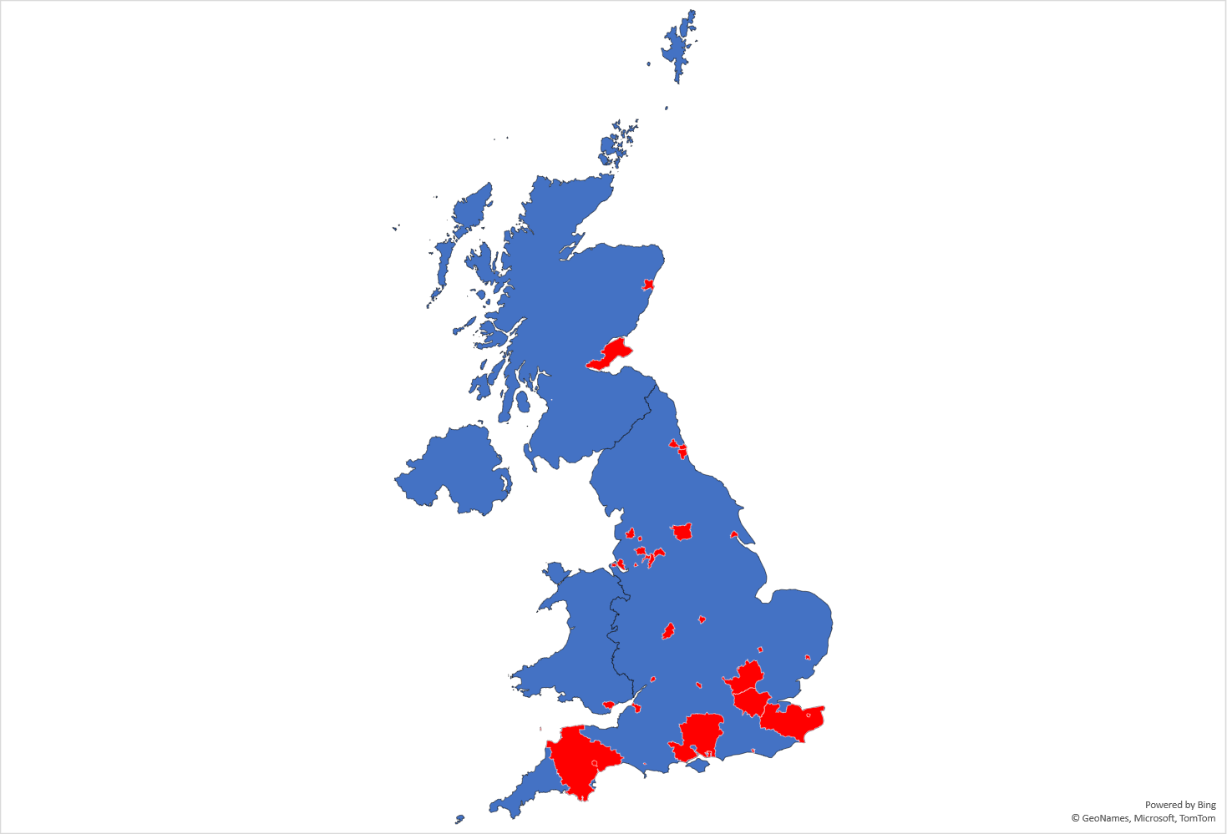
Supplementary Figure 1. Location of survey responses
Red indicates areas where responses have been received

