Supporting Information
____________________________________________________
Design, synthesis and cytotoxic evaluation in tumor cell lines of organotin(IV) complexes with heteroditopic hydroxo-carboxylato polyaromatic ligands

Tushar S. Basu Baul^{a,b,}*, Bietlaichhai Hlychhoª, Maheswara Rao Addepalli^{a,c}, Sajal Kundu^{d}, Dick de Vos^{e} and Anthony Linden^{f,*}

ª Centre for Advanced Studies in Chemistry, North-Eastern Hill University, NEHU Permanent Campus, Umshing, Shillong 793 022, India

^{b} Sophisticated Analytical Instrument Facility, North-Eastern Hill University, NEHU Permanent Campus, Umshing, Shillong 793 022, India

^{c} Department of Basic Sciences & Humanities and Social Sciences, Jawaharlal Nehru Technological University-Gurajada, Vizianagaram 535003, India

^{d} Department of Chemistry, National Institute of Technology, Barjala, Jirania, Agartala 799046, India

^{e} Teva Pharmachemie BV, PO Box 552, 2003 RN Haarlem, The Netherlands

^{f} Department of Chemistry, University of Zurich, Winterthurerstrasse 190, CH-8057 Zurich, Switzerland

CONTENTS

Sl. No. | Table of contents | Figure/ Table numbers
1. | IR spectra of compounds H′HL and 1-3 | Figs. S1-S4
2. | NMR spectra (¹H, ¹³C and ¹¹⁹Sn) of compounds H′HL and 1-3 | Figs. S5-S18
3. | ¹¹⁹Sn Mössbauer spectra of compounds 1-3 | Figs. S19-S21
4. | Crystallographic data and structure refinement details for compounds H′HL and 1-3 | Table S1

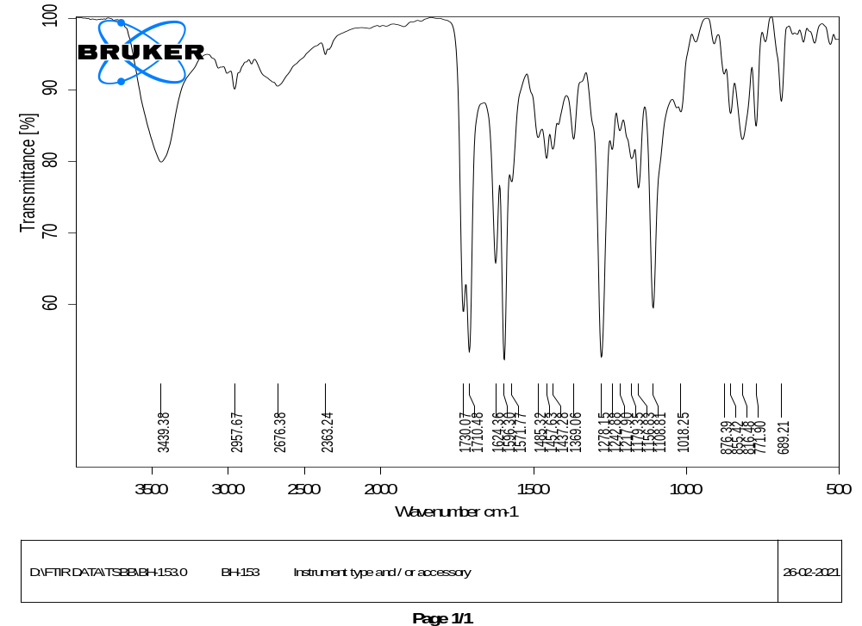
Fig. S1. IR spectrum of 2-((E)-(4-hydroxy-3-((E)-((4-(methoxycarbonyl)phenyl)imino)methyl)-phenyl)diazenyl)benzoic acid (H′HL) in KBr.
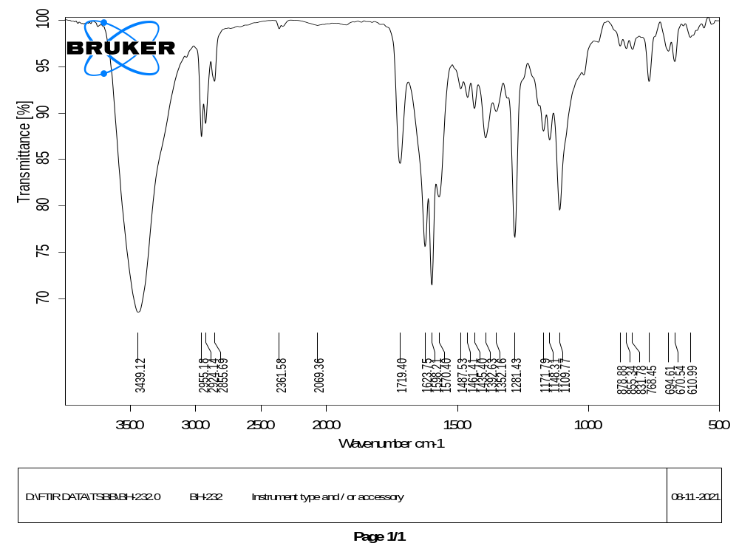
Fig. S2. IR spectrum of [n-Bu₃Sn(HL)]_{n} (1) in KBr.
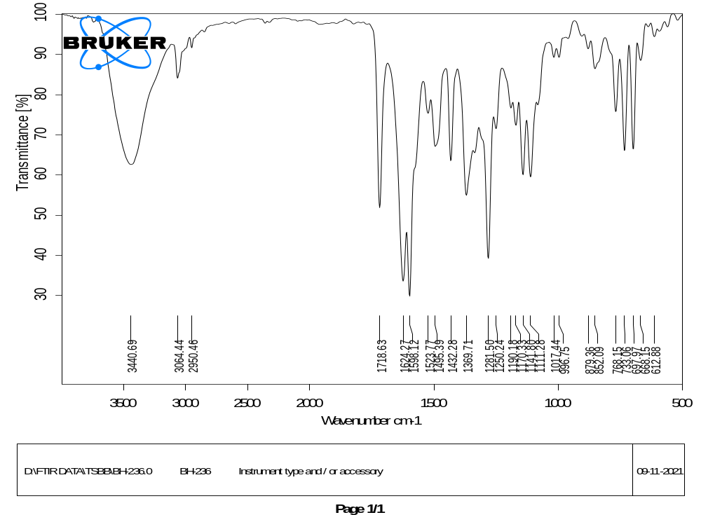
Fig. S3. IR spectrum of [Ph₃Sn(HL)]_{n} (2) in KBr.
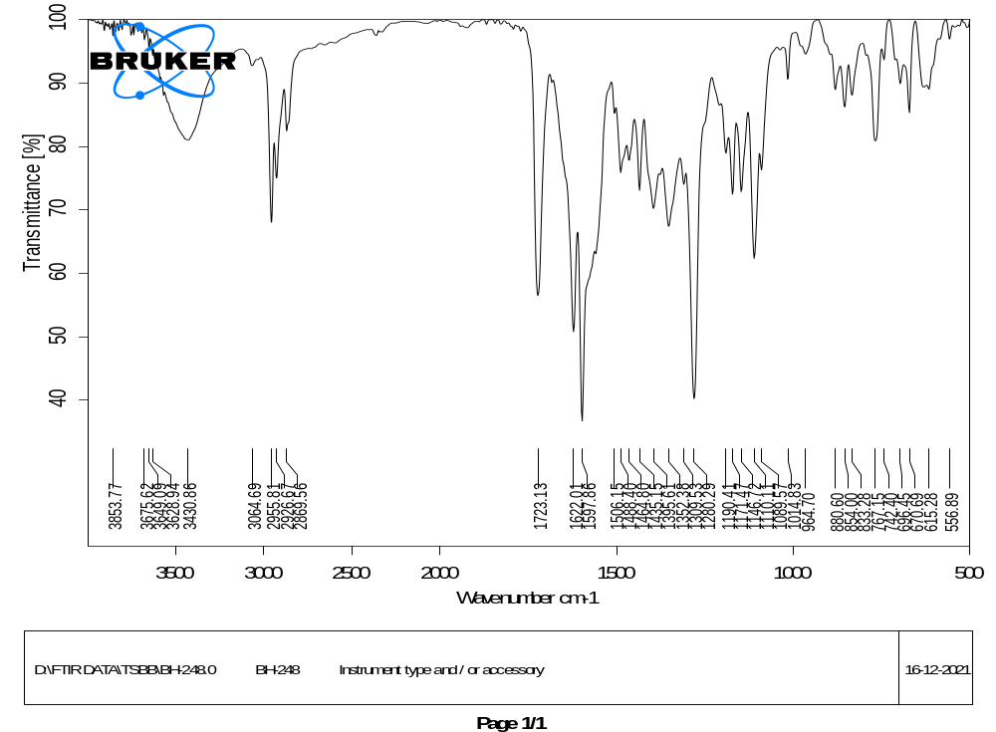
Fig. S4. IR spectrum of [n-Bu₂Sn(HL)₂]₂ (3) in KBr.

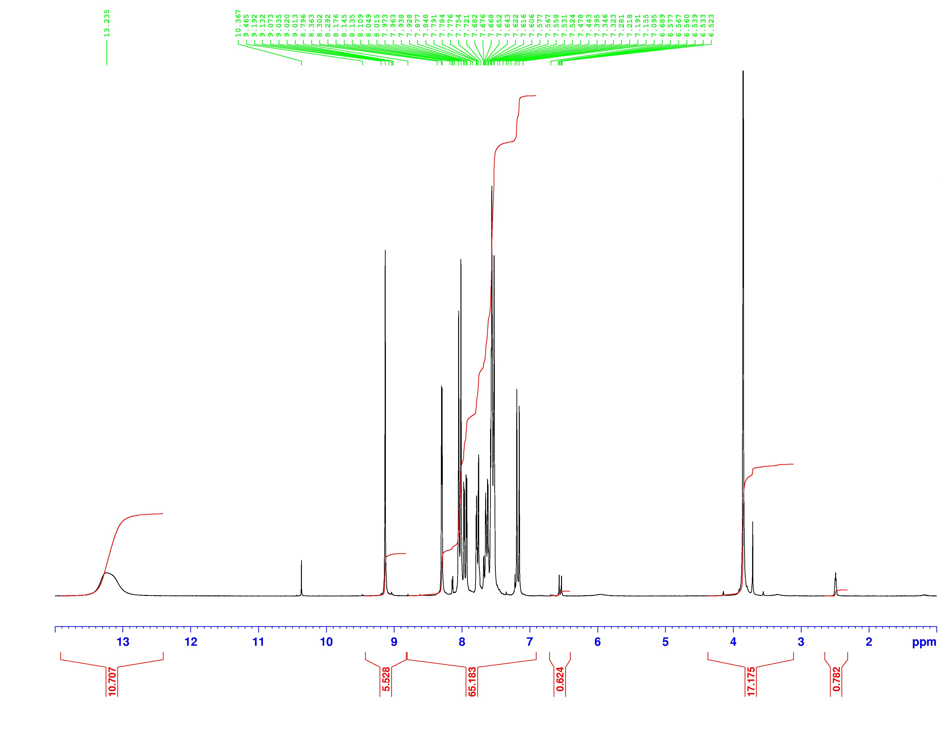
Fig. S5. ¹H NMR spectrum of H′HL in DMSO-d₆ solution.
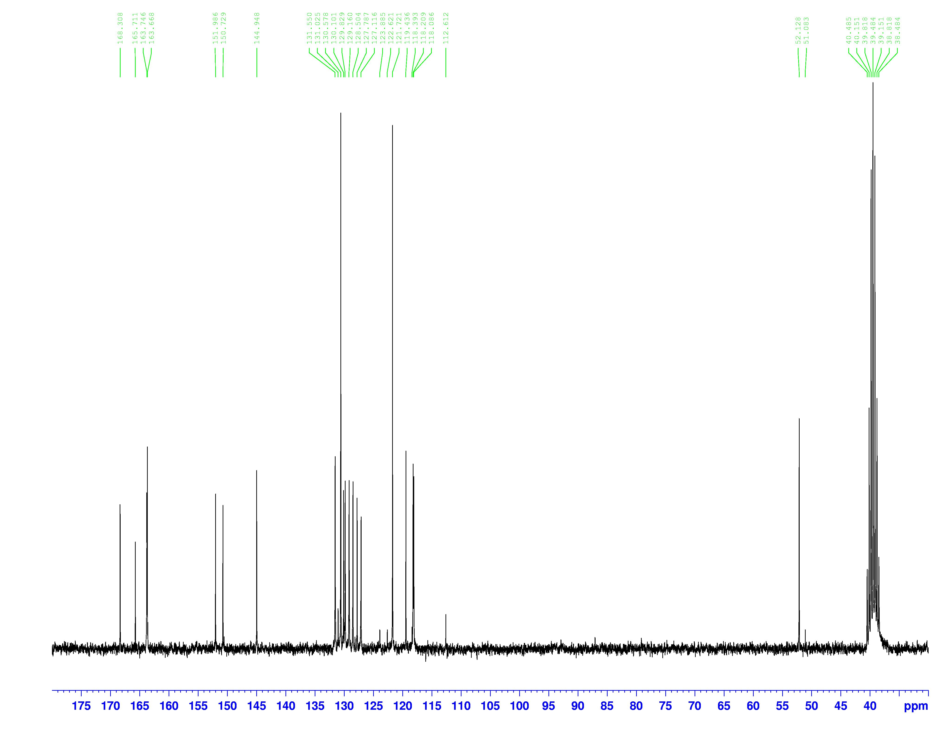
Fig. S6. ¹³C NMR spectrum of H′HL in DMSO-d₆ solution.
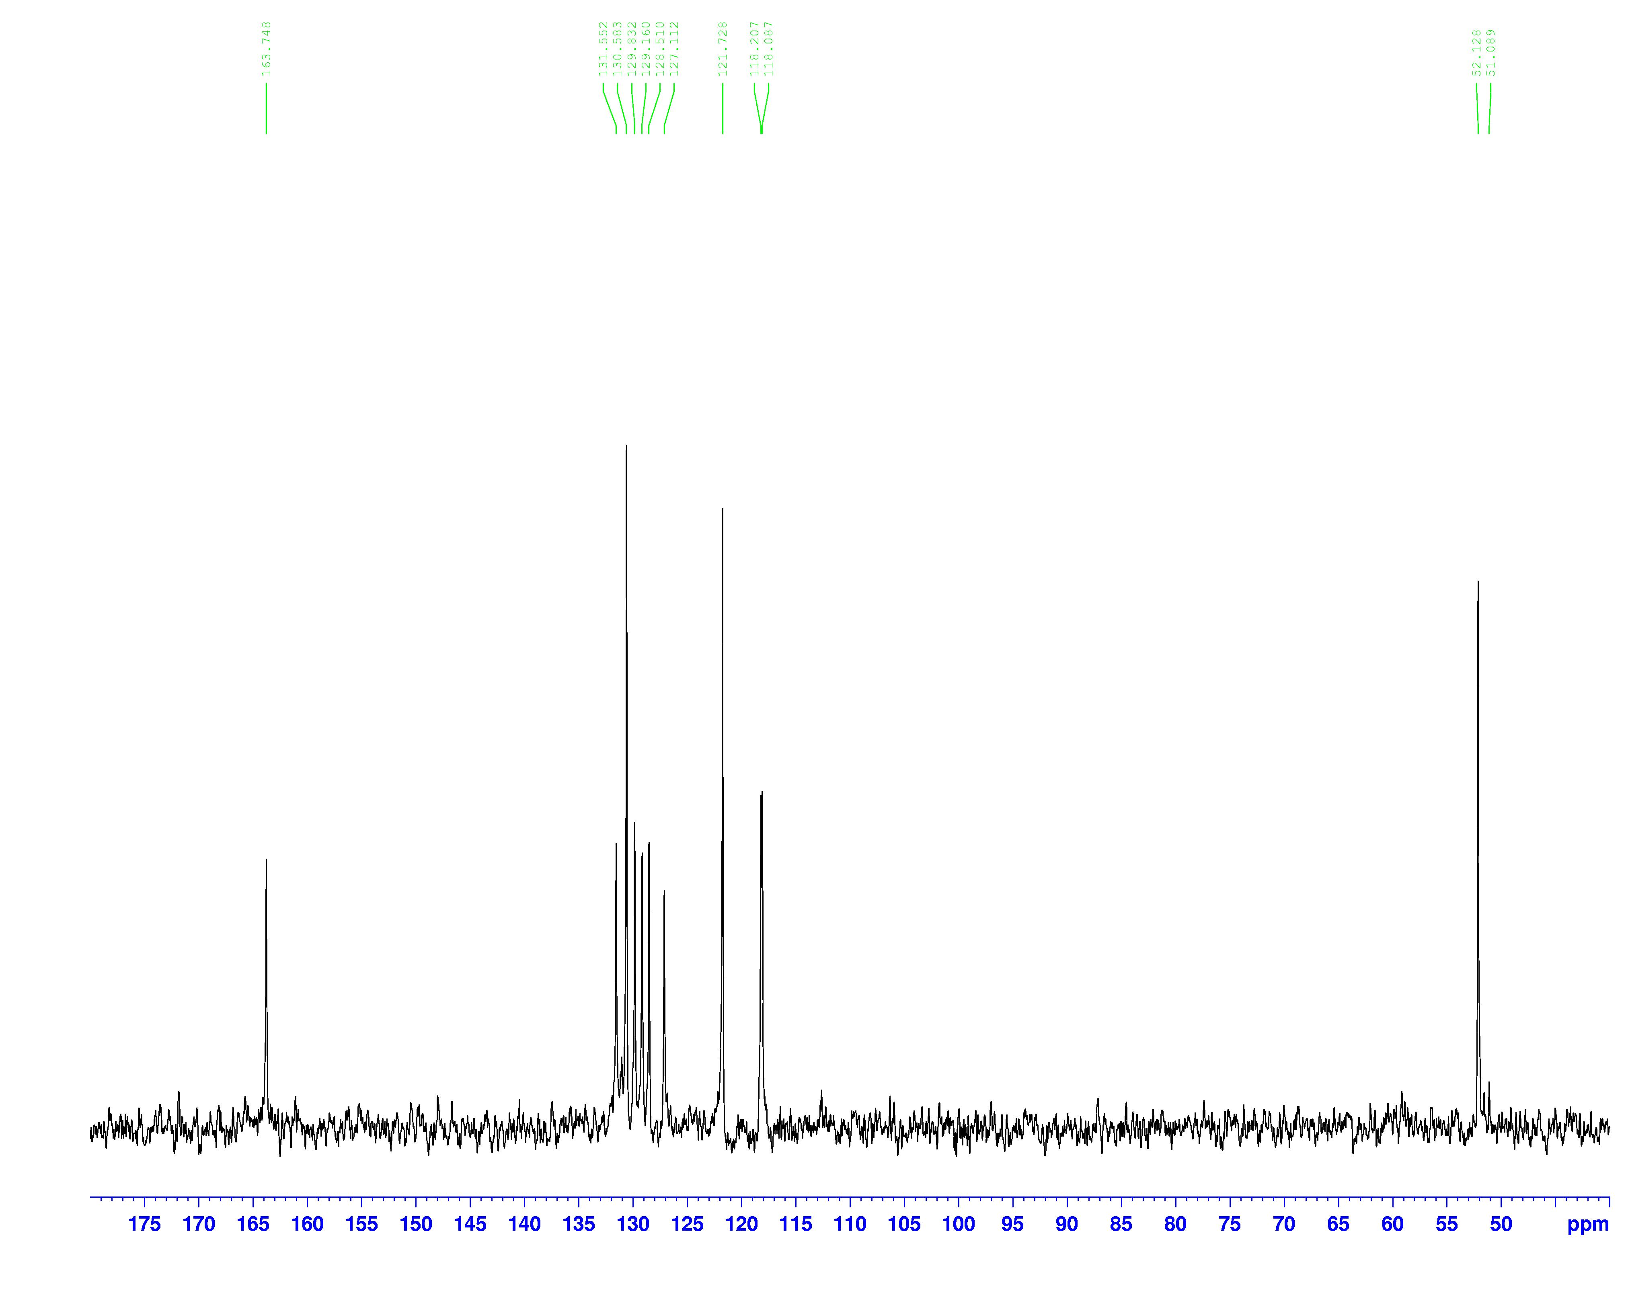
Fig. S7. ¹³C (DEPT 135) NMR spectrum of H′HL in DMSO-d₆ solution.
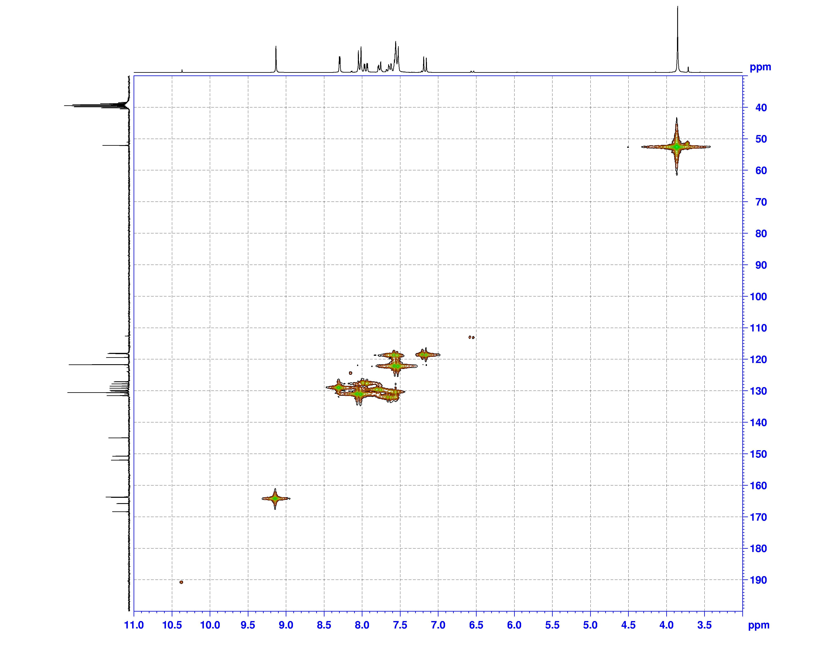
Fig. S8. ¹H-¹³C HMQC NMR spectrum of H′HL in DMSO-d₆ solution.
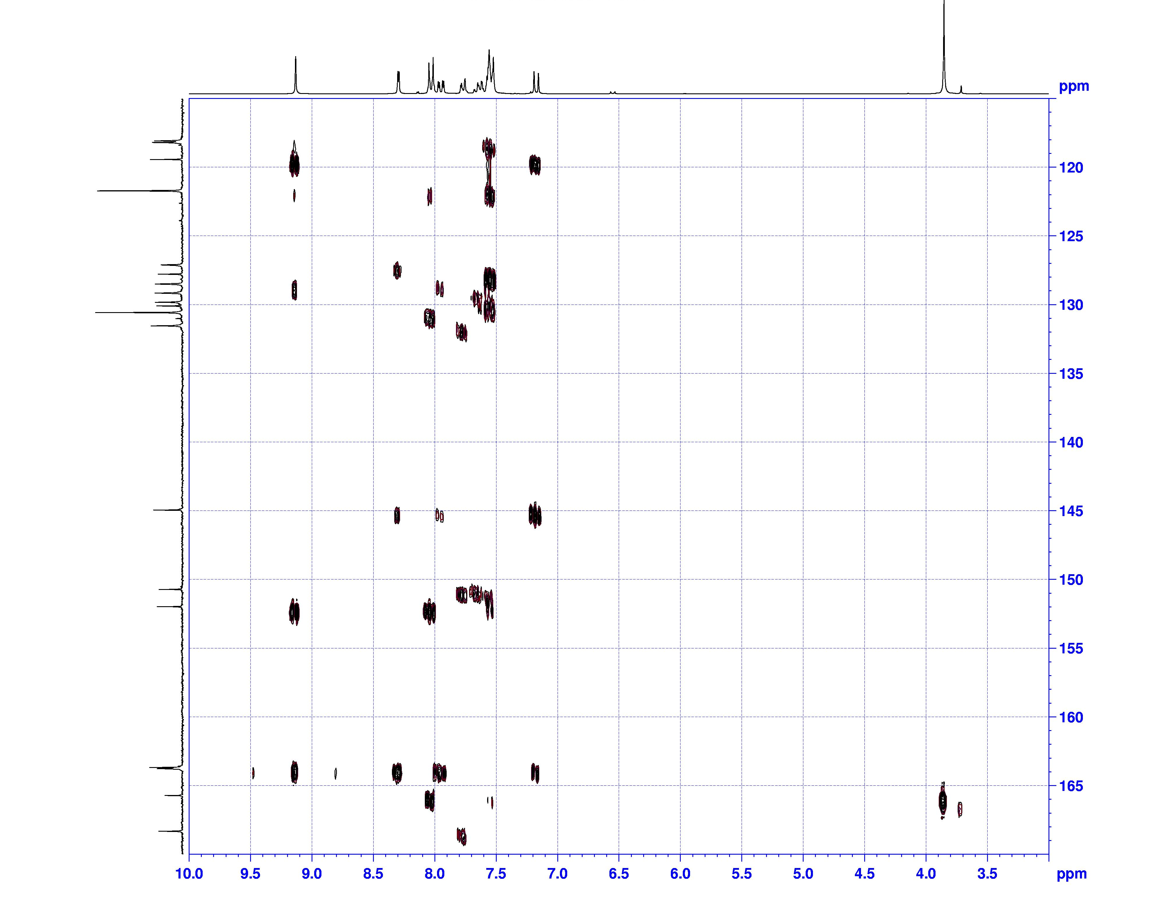
Fig. S9. ¹H-¹³C HMBC NMR spectrum of H′HL in DMSO-d₆ solution.
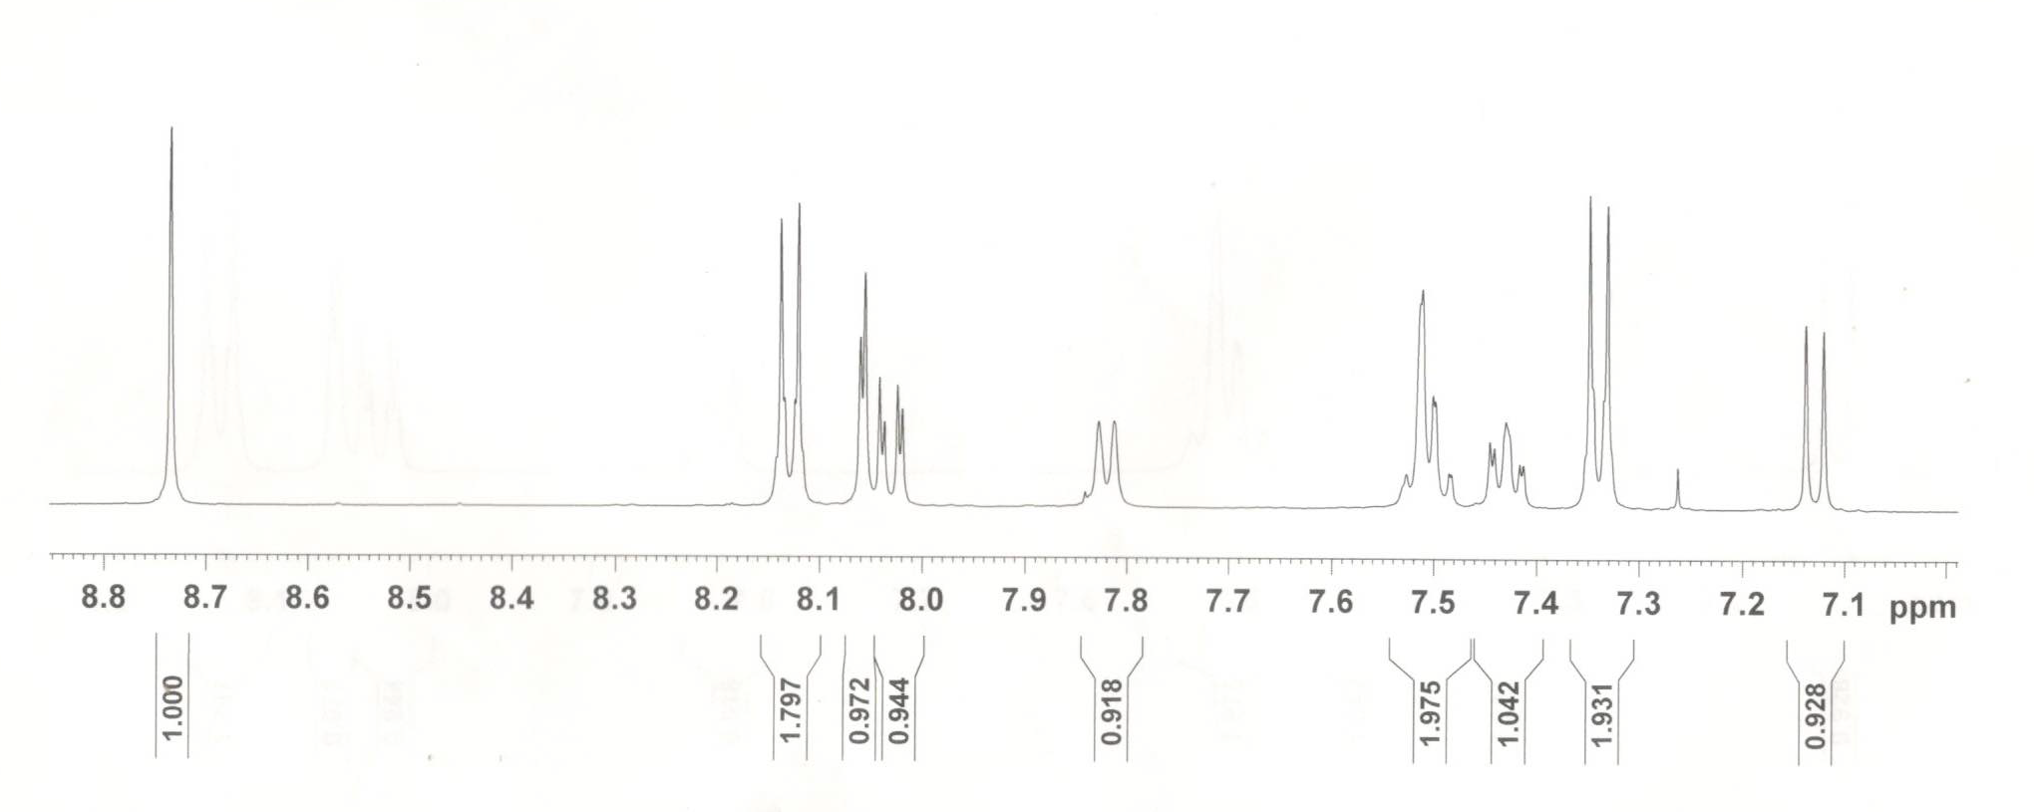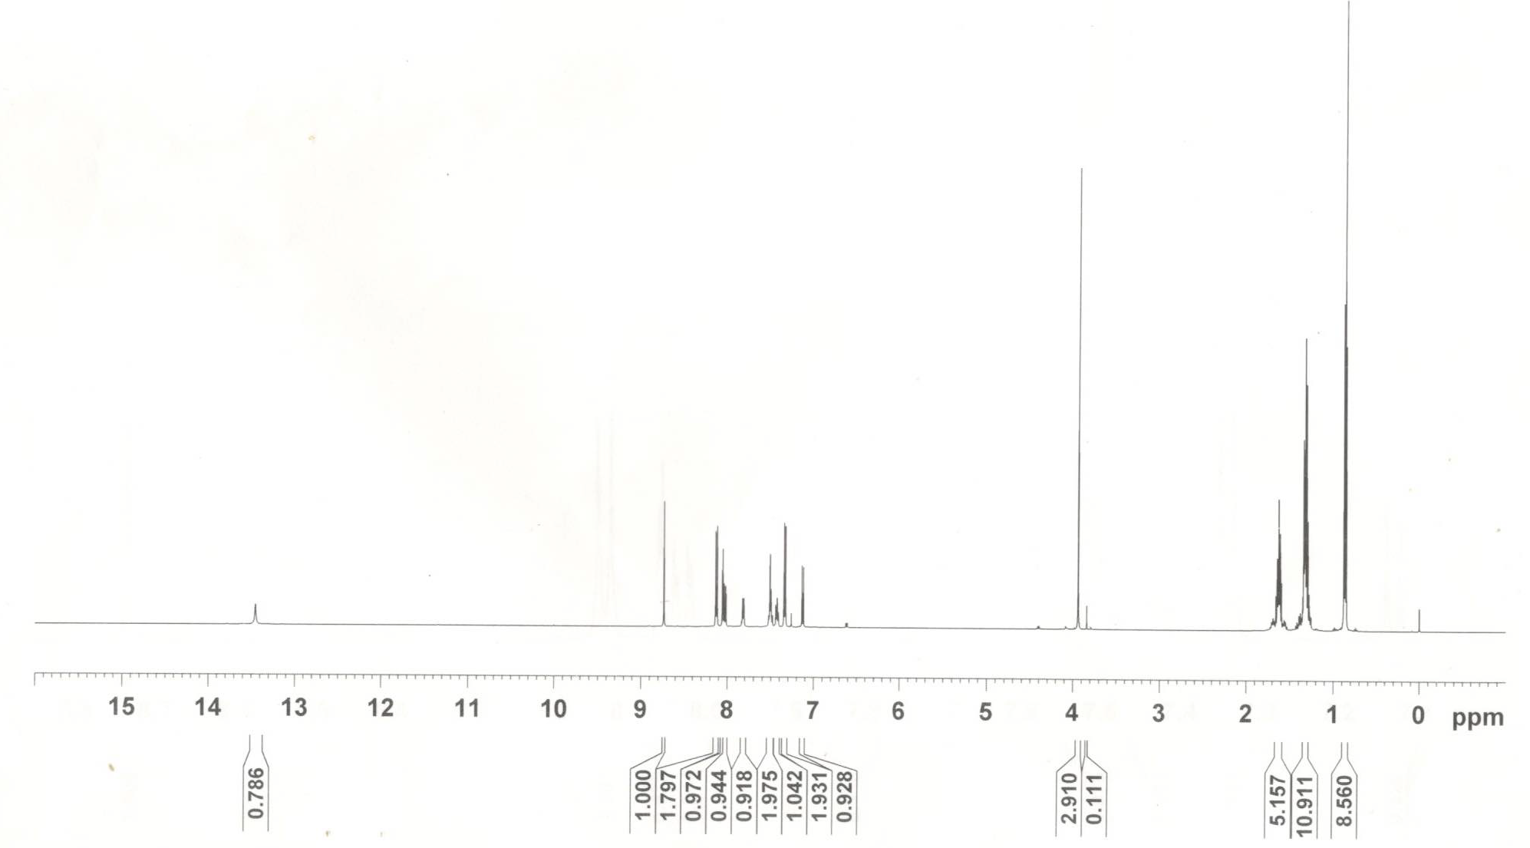
Fig. S10. ¹H NMR spectrum of [n-Bu₃Sn(HL)]_{n} (1) in CDCl₃ solution.

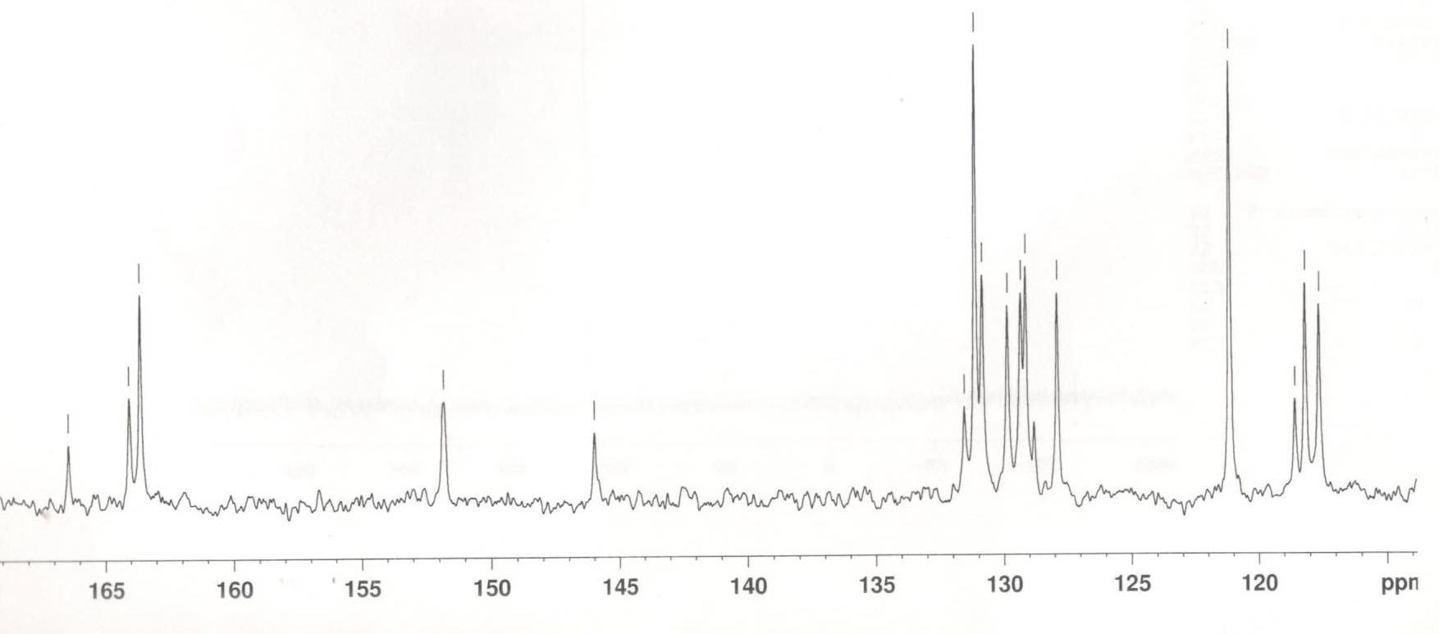

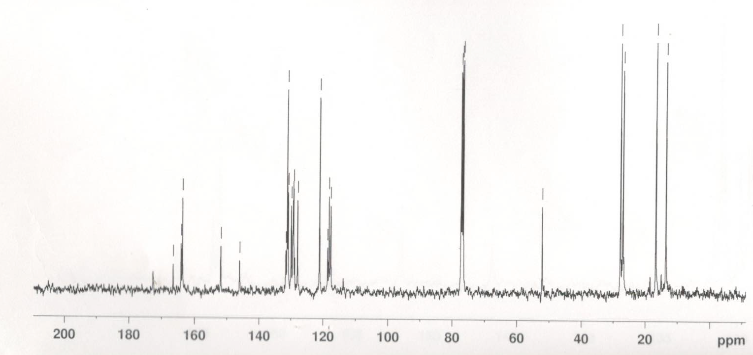
Fig. S11. ¹³C NMR spectrum of [n-Bu₃Sn(HL)]_{n} (1) in CDCl₃ solution.
.

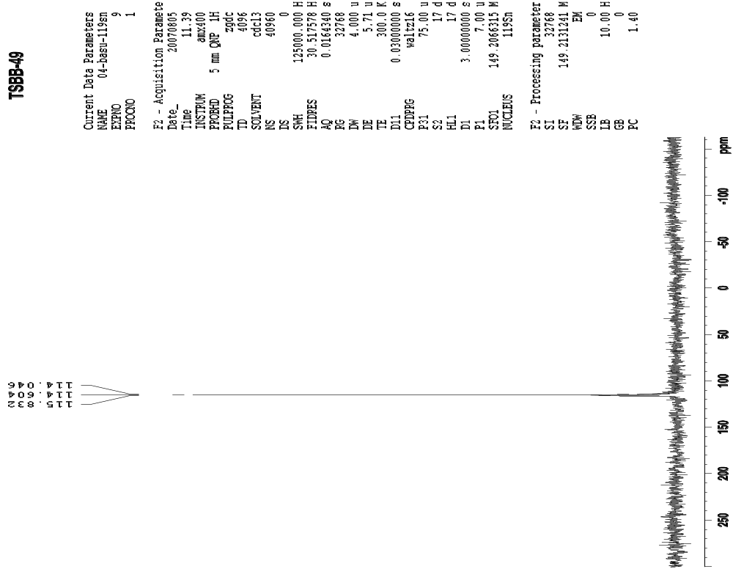
Fig. S12. ¹¹⁹Sn NMR spectrum of [n-Bu₃Sn(HL)]_{n} (1) in CDCl₃ solution.

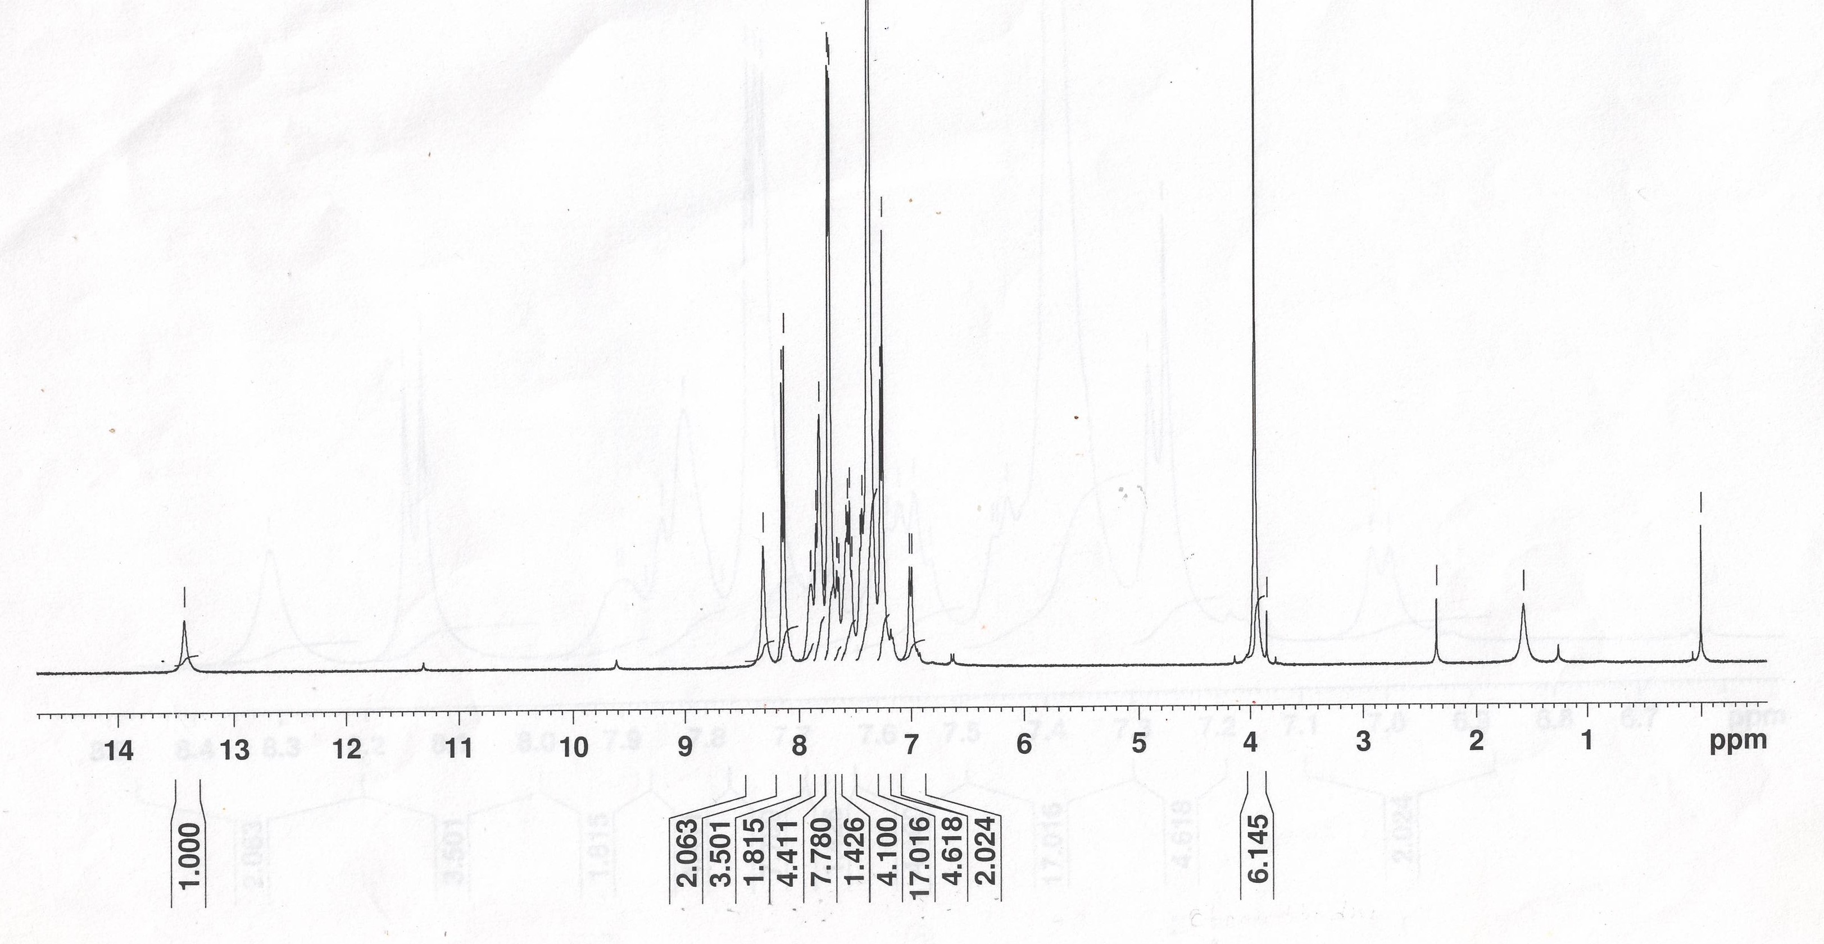
Fig. S13. ¹H NMR spectrum of [Ph₃Sn(HL)]_{n} (2) in CDCl₃ solution.

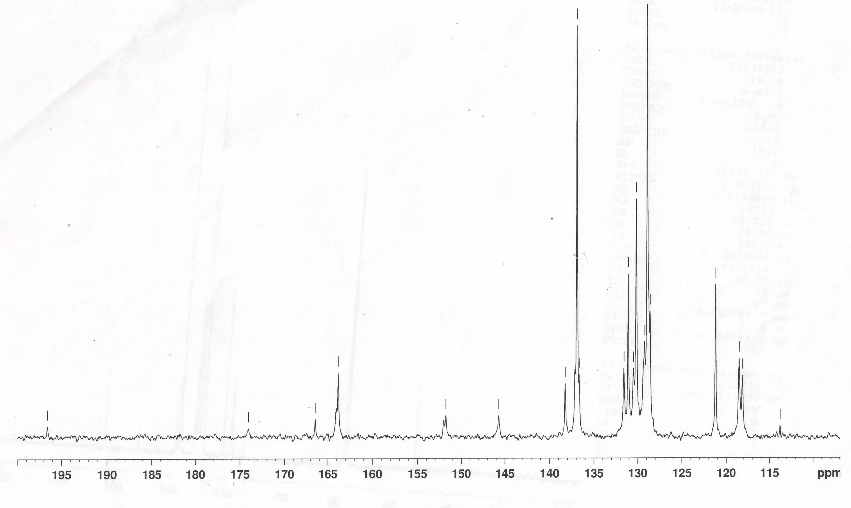
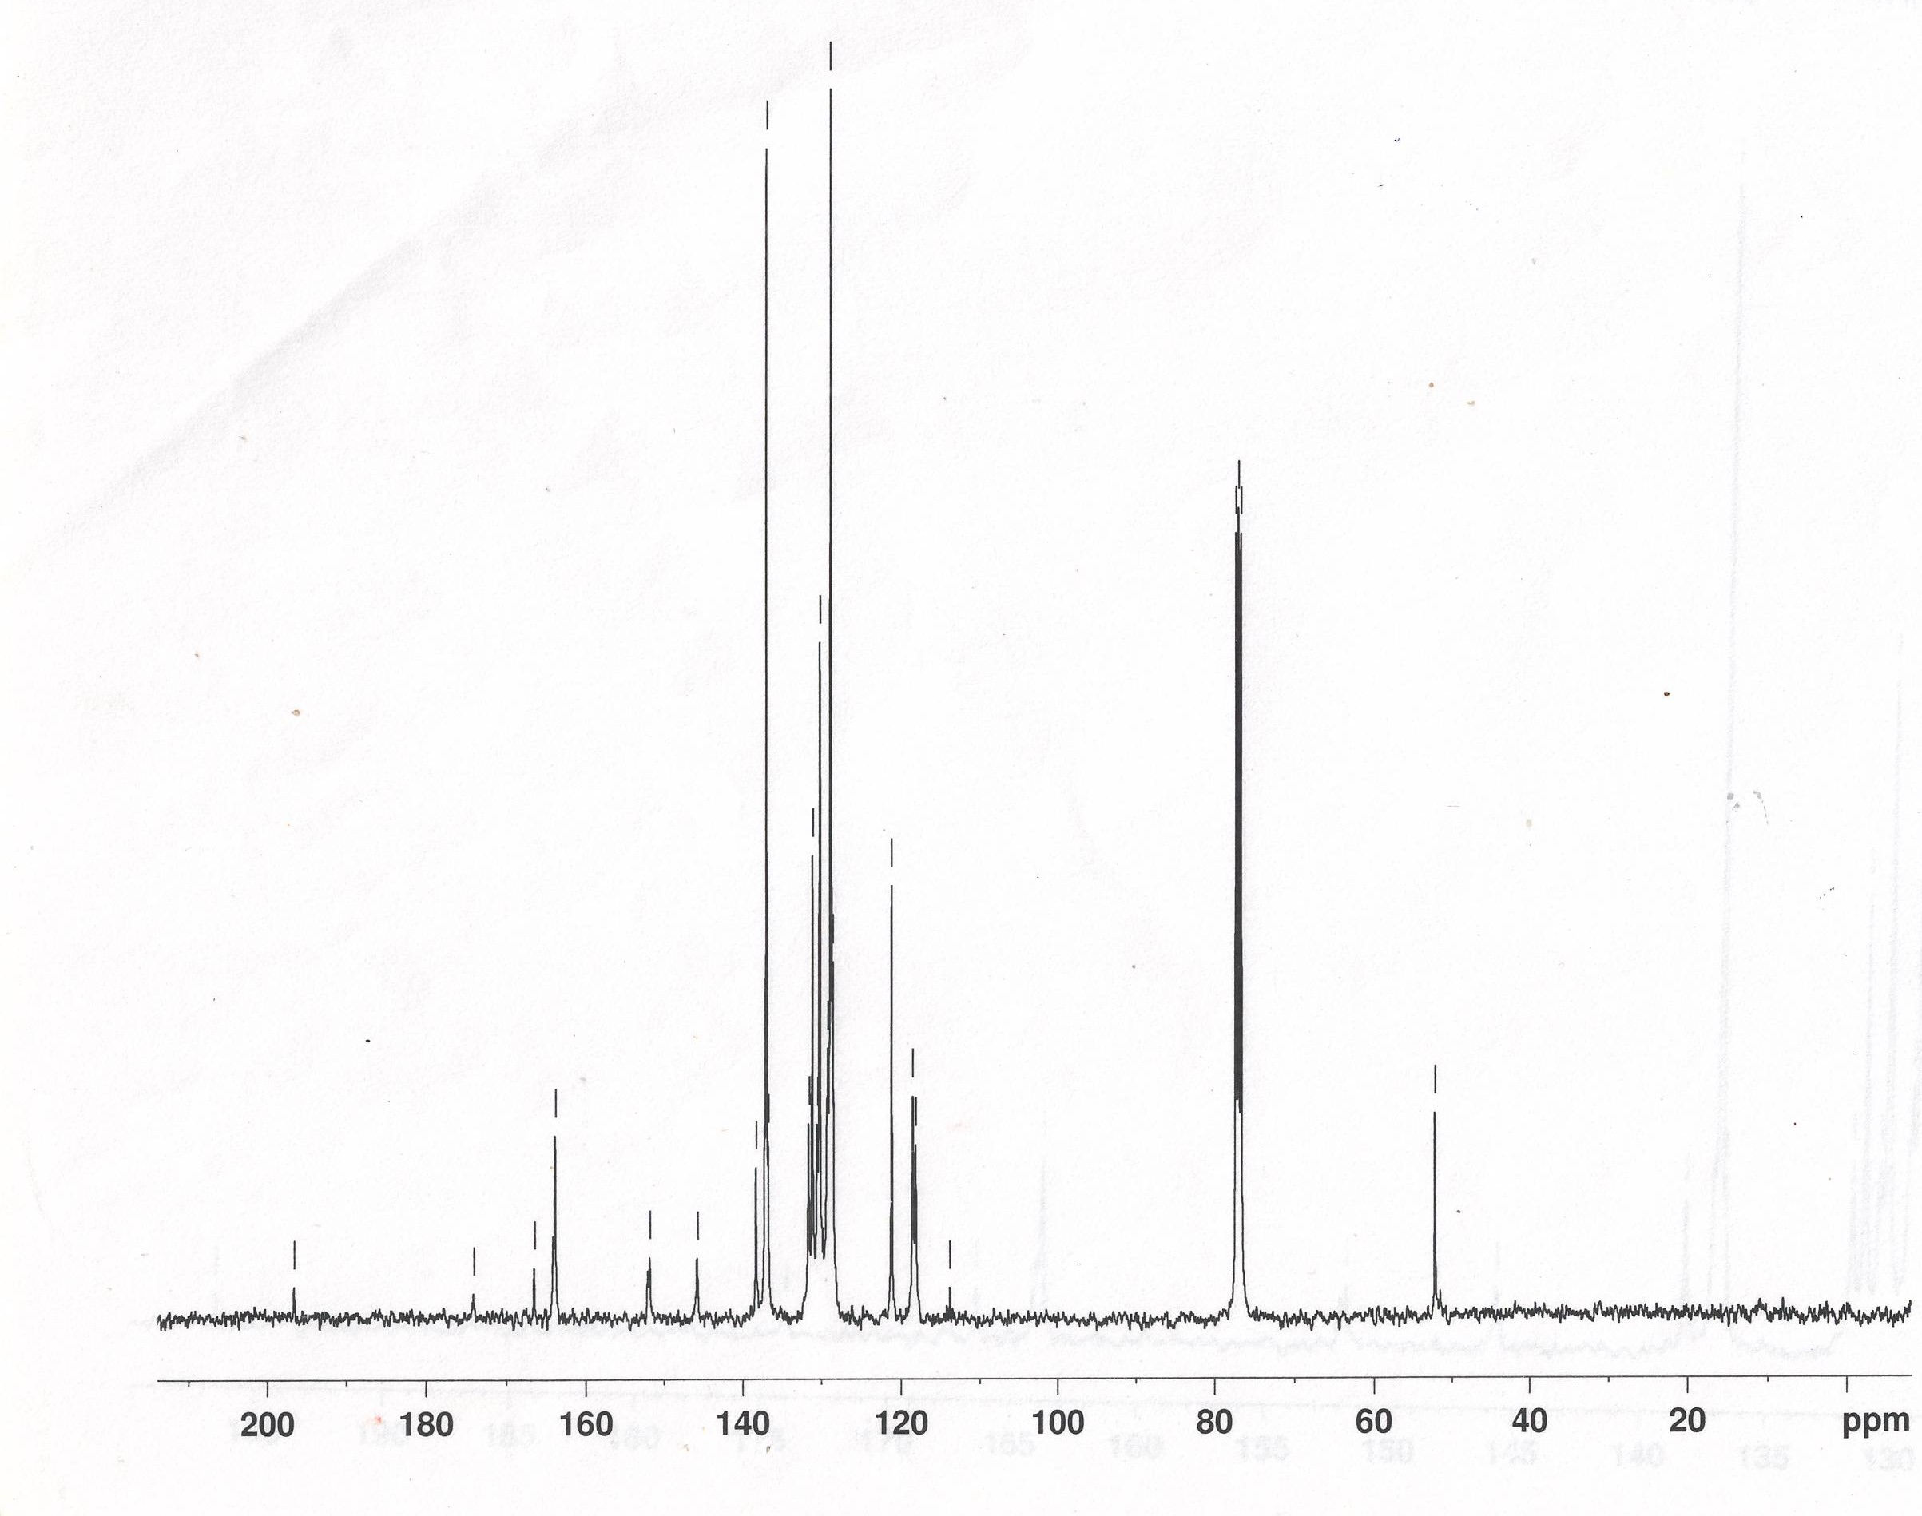
Fig. S14. ¹³C NMR spectrum of [Ph₃Sn(HL)]_{n} (2) in CDCl₃ solution.

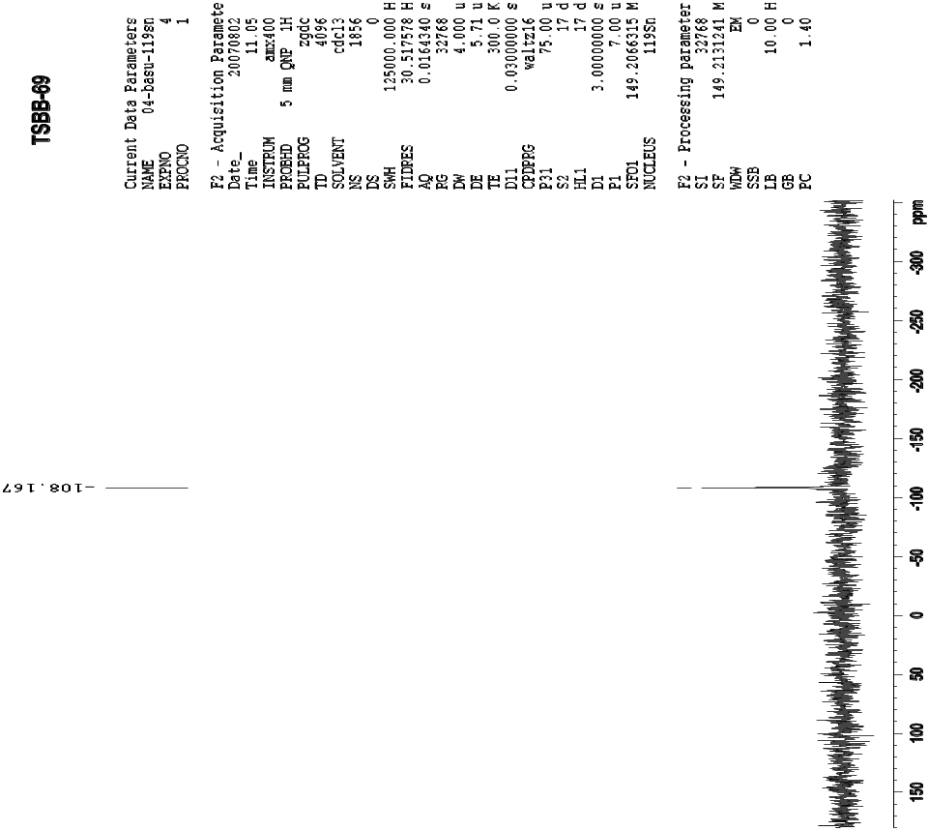
Fig. S15. ¹¹⁹Sn NMR spectrum of [Ph₃Sn(HL)]_{n} (2) in CDCl₃ solution.

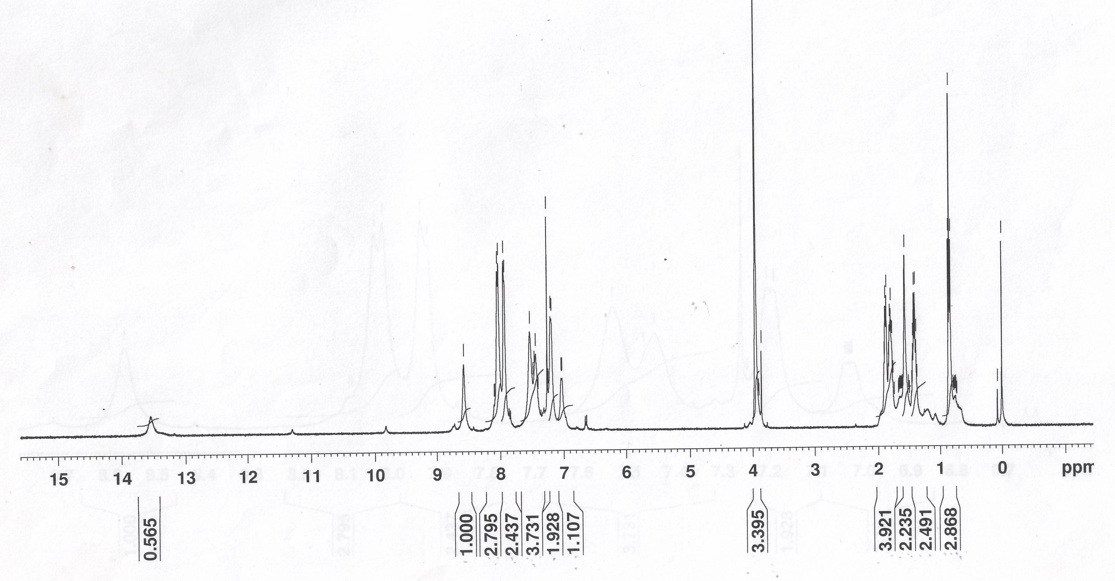
Fig. S16. ¹H NMR spectrum of [n-Bu₂Sn(HL)₂]₂ (3) in CDCl₃ solution.

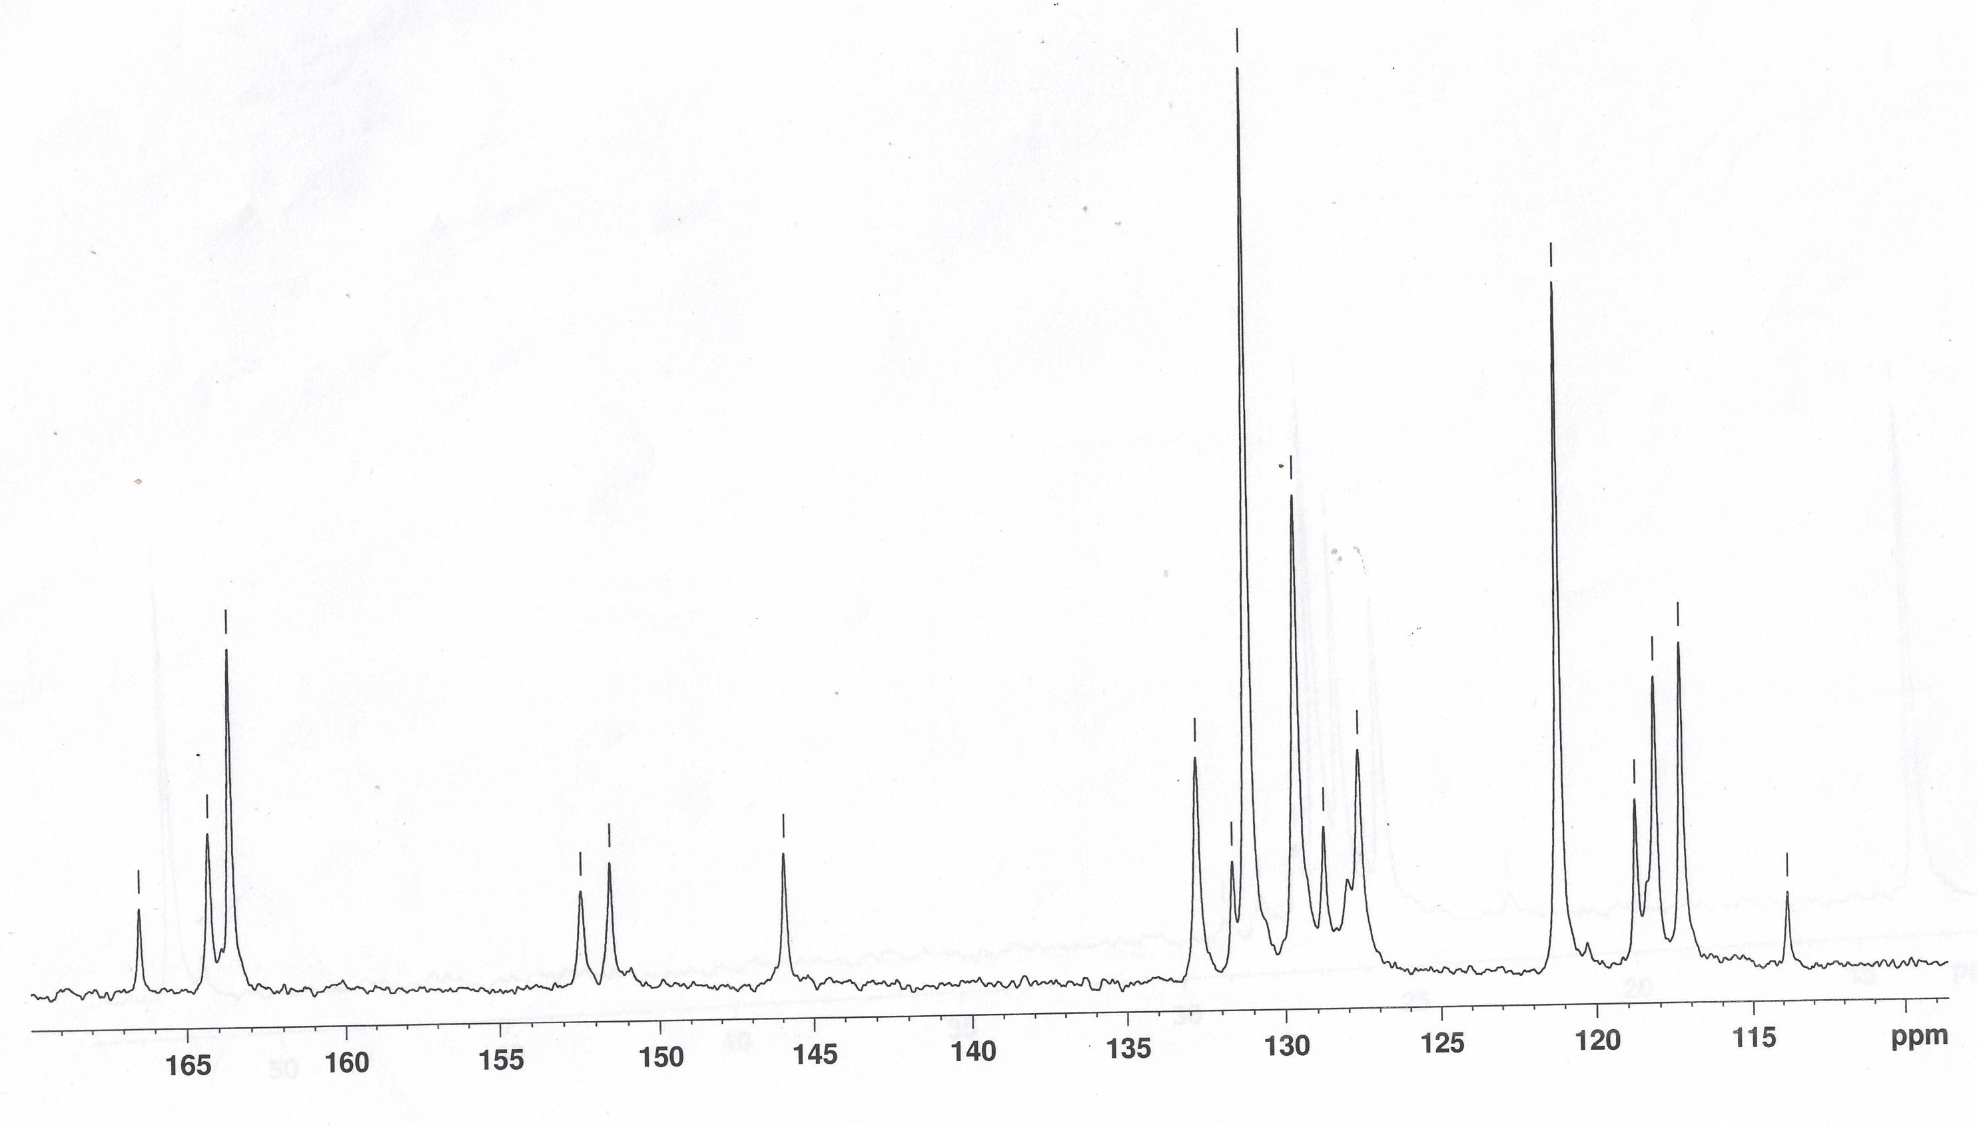
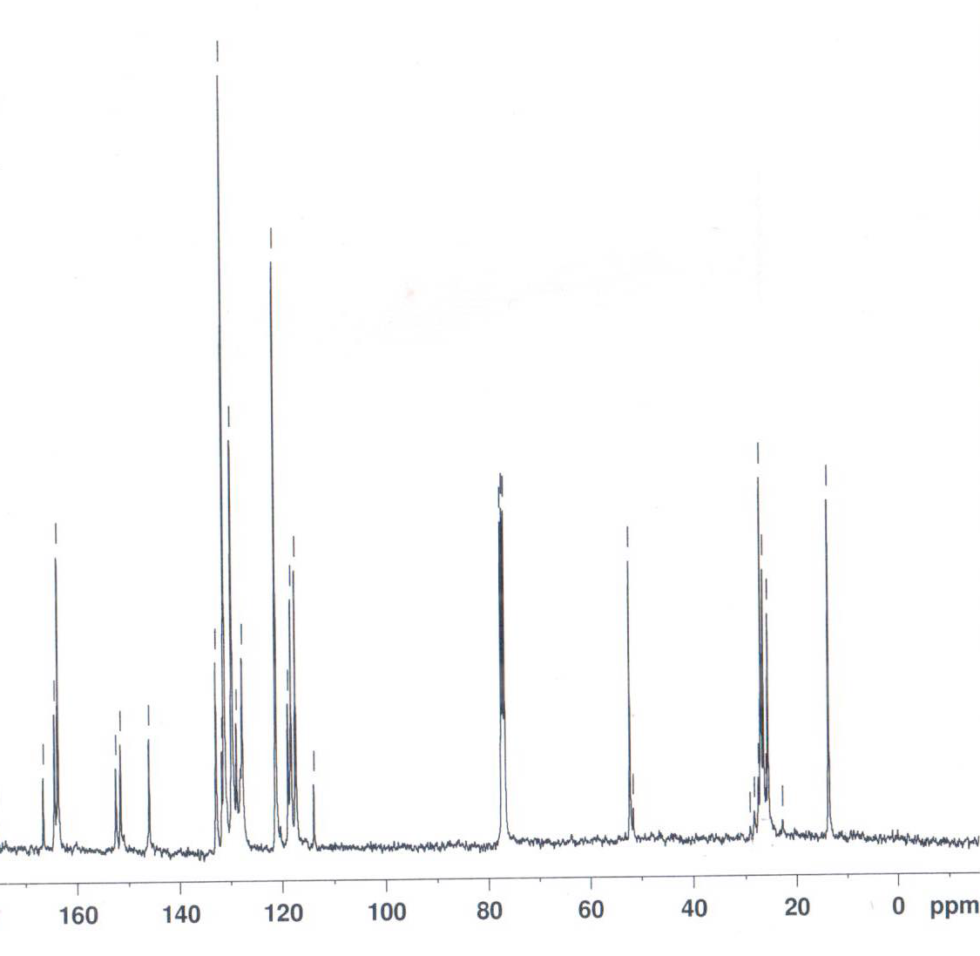
Fig. S17. ¹³C NMR spectrum of [n-Bu₂Sn(HL)₂]₂ (3) in CDCl₃ solution.

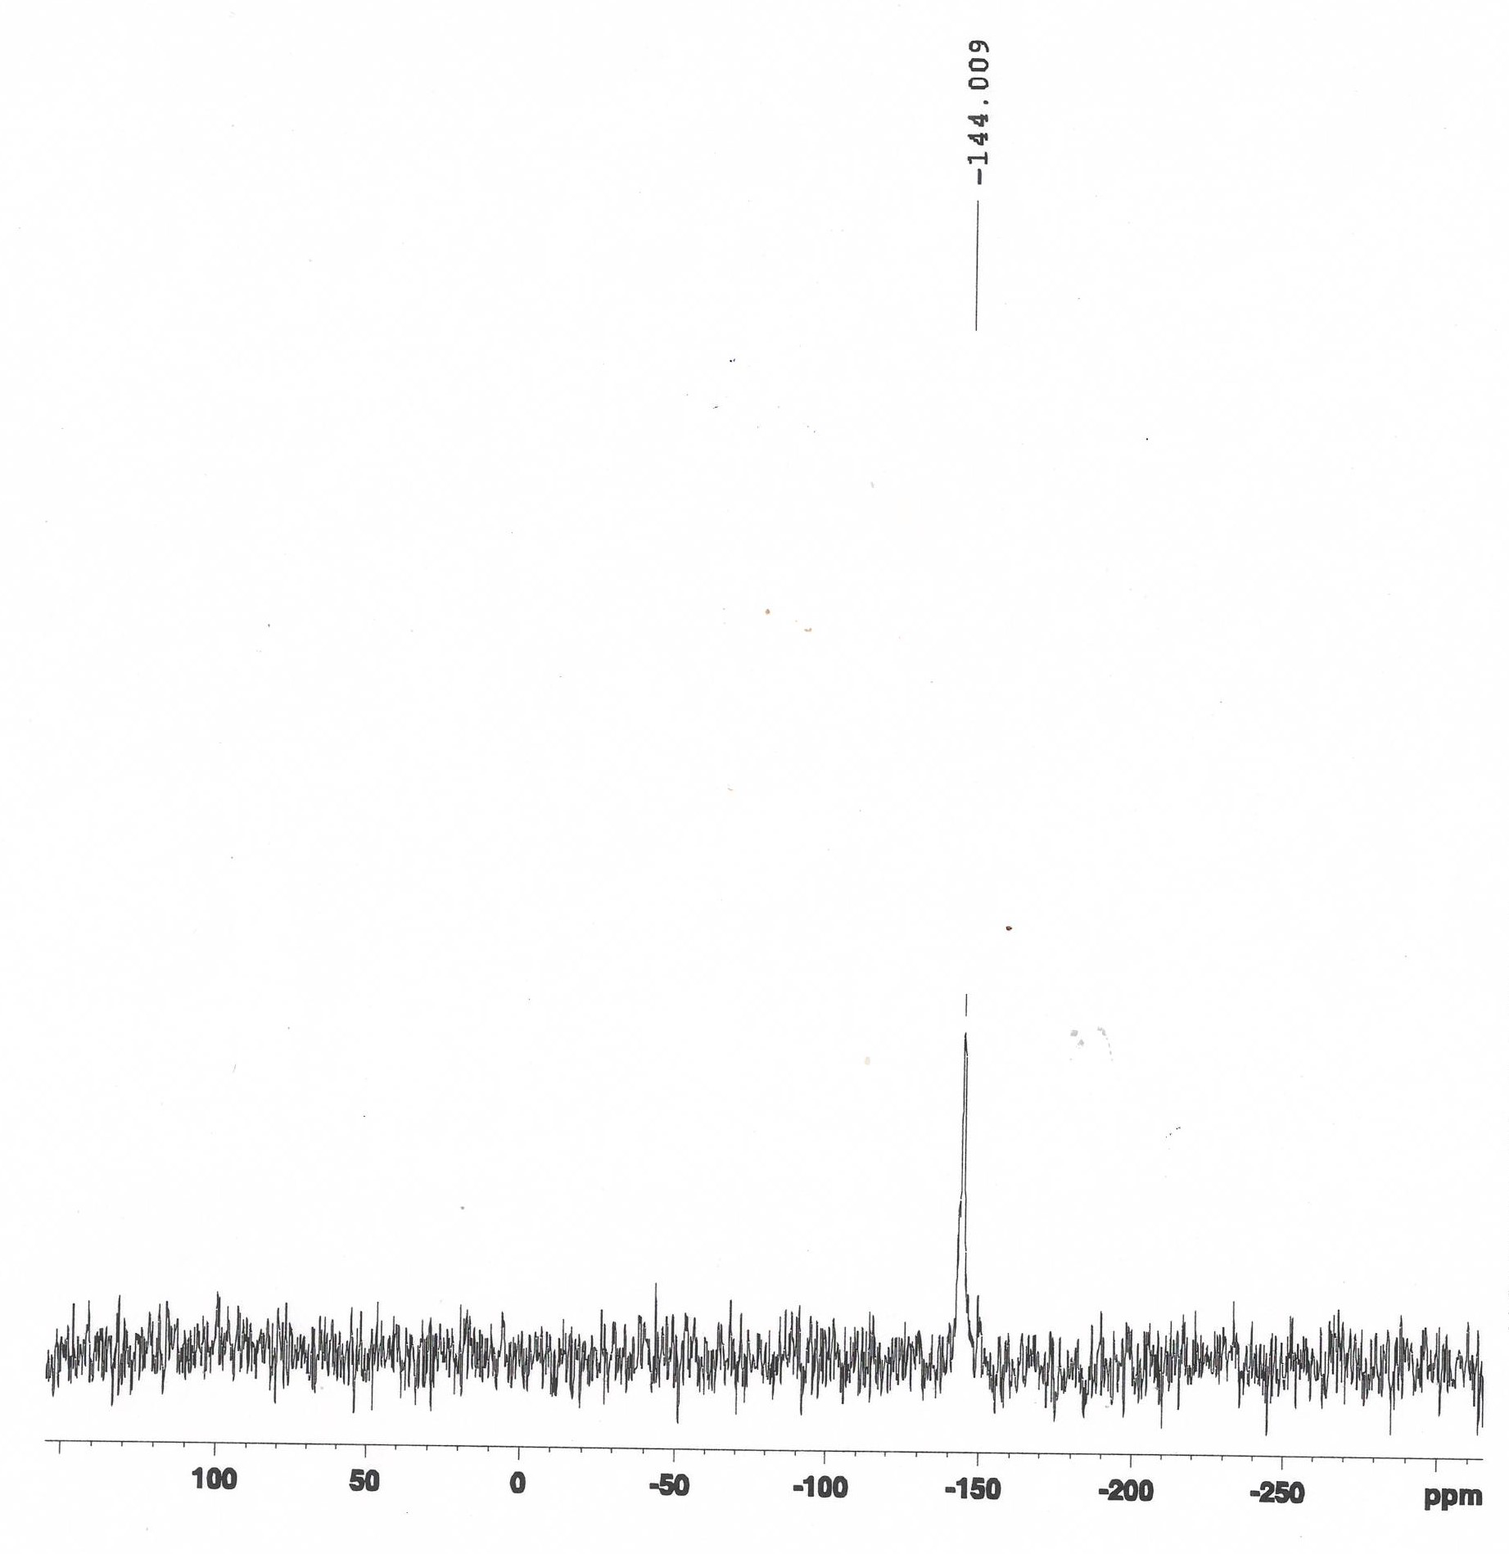
Fig. S18. ¹¹⁹Sn NMR spectrum of [n-Bu₂Sn(HL)₂]₂ (3) in CDCl₃ solution.

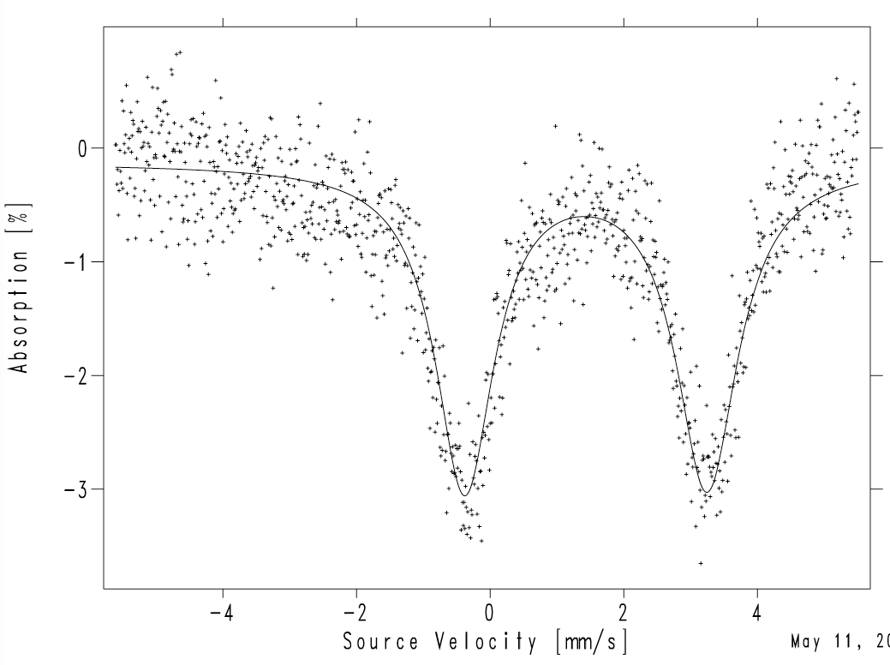
Fig. S19. ¹¹⁹Sn Mössbauer spectrum of [n-Bu₃Sn(HL)]_{n} (1).
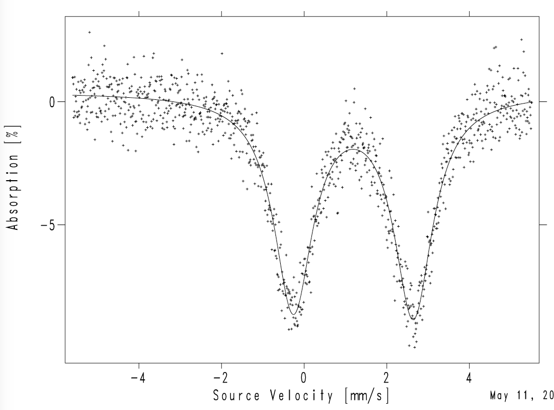
Fig. S20. ¹¹⁹Sn Mössbauer spectrum of [Ph₃Sn(HL)]_{n} (2).

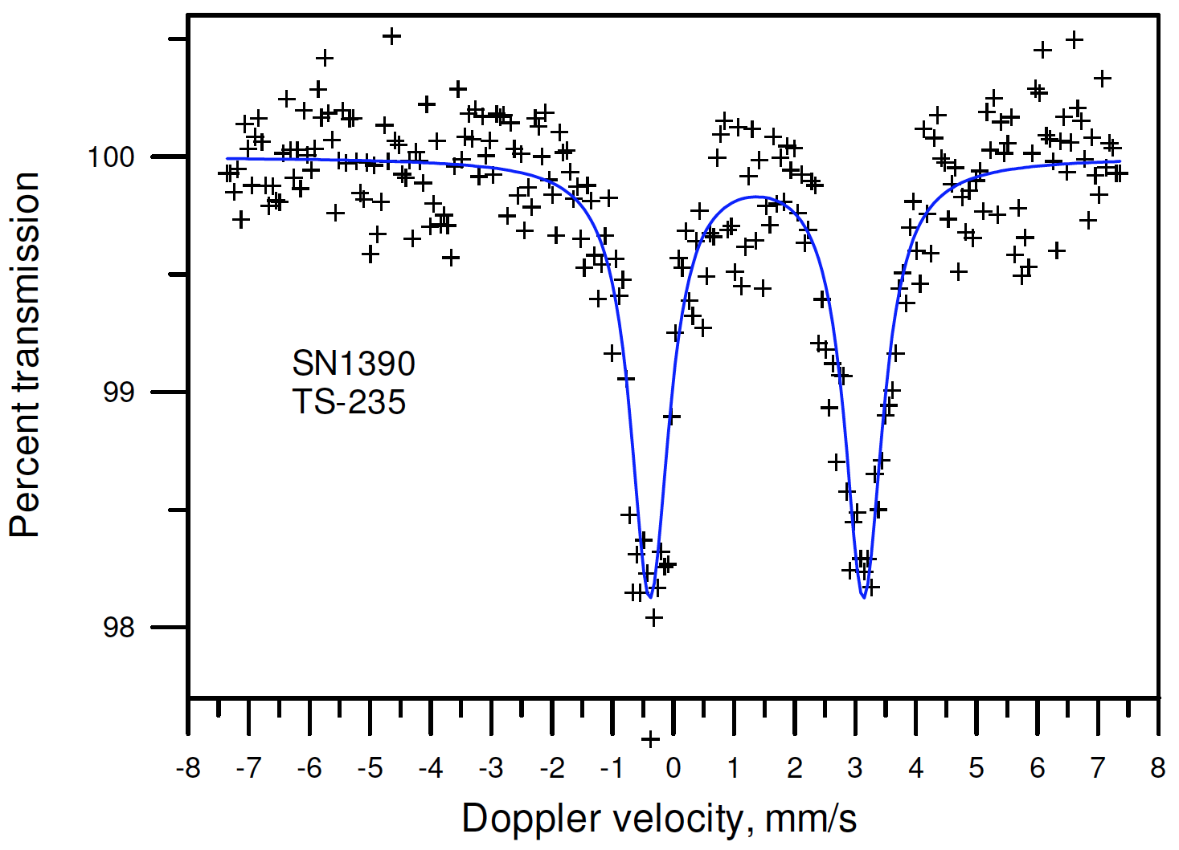
Fig. S21. ¹¹⁹Sn Mössbauer spectrum of [n-Bu₂Sn(HL)₂]₂ (3).

Table S1. Crystallographic data and structure refinement details for compounds H′HL and 1-3

H′L 2 1 3
Crystallised from CHCl₃ / MeCN CHCl₃ / toluene hexane / benzene benzene / pet. ether
Empirical formula C₂₂H₁₇N₃O₅ C₄₀H₃₁N₃O₅Sn C₃₄H₄₃N₃O₅Sn C₁₀₄H₁₀₀N₁₂O₂₀Sn₂
Formula weight [g mol⁻¹] 403.39 752.30 692.33 2075.19
Crystal colour, habit red, prism red, prism red, prism red, tablet
Crystal dimensions [mm] 0.17 × 0.25 × 0.50 0.12 × 0.25 × 0.30 0.12 × 0.25 × 0.25 0.12 × 0.15 × 0.30
Temperature [K] 160(1) 160(1) 160(1) 160(1)
Crystal system monoclinic monoclinic triclinic triclinic
Space group P2₁/n P2₁/n P P
Z 8 4 4 1
a [Å] 12.0953(2) 10.8599(4) 10.3915(3) 10.6666(3)
b [Å] 23.7493(5) 14.7608(7) 16.2347(4) 14.6047(4)
c [Å] 12.9959(3) 21.0044(7) 21.3824(5) 16.2032(4)
α [°] 90 90 82.609(2) 98.667(2)
β [°] 91.889(1) 97.854(2) 76.091(1) 102.988(2)
γ [°] 90 90 72.443(2) 98.357(2)
V [Å³] 3731.1(1) 3335.4(2) 3332.2(2) 2389.1(1)
F(000) 1680 1528 1432 1068
D_{x} [g cm⁻³] 1.436 1.498 1.380 1.442
μ(Mo Kα) [mm⁻¹] 0.104 0.816 0.809 0.601
Scan type φ and ω φ and ω ω φ and ω
θ range [°] 2.3–25.0 2.0–26.0 2.1–25.1 2.1–27.5
Transmission factors (min; max) 0.890; 1.000 0.778; 0.907 0.640; 0.920 0.811; 0.930
Total reflections measured 47833 47850 54021 52214
Symmetry independent reflections 6570 6557 11555 10827
R_{int} 0.047 0.074 0.092 0.083
Reflections with I > 2σ(I) 5111 5027 8189 8437
Reflections used in refinement 6564 6557 11553 10826
Parameters refined 559 448 852; 110 663; 51
R(F) [I > 2σ(I) reflections] 0.056 0.036 0.071 0.052
wR(F²) (all data) 0.157 0.083 0.156 0.134
Weighting parametersª (a; b) 0.0745; 1.8198 0.0272; 4.9592 0.010; 23.64 0.0666; 2.752
Goodness of fit 1.090 1.074 1.159 1.064
Secondary extinction coefficient – 0.0031(2) 0.0037(2) –
Final Δ_{max}/σ 0.000 0.002 0.000 0.002
Δρ (max; min) [e Å⁻³] 0.36; -0.29 0.85; -0.72 1.88; -1.04 0.78; -0.70
ª Weights are calculated as w = [σ²(F_{o}²) + (aP)² + bP]⁻¹ where P = (F_{o}² + 2F_{c}²)/3

