P.Senthil was born Varagubady (village) in Perambalur Dist in Tamilnadu in India in 9 May 1987.He received his B.Sc., degree in Information Technology from Bharathiyar University for coimbatore, Tamilnadu. He was received the M.Sc Information Technology and M.Phil degrees in Computer Science from Kurinji College Arts and Science, Trichy ,Tamilnadu in 2010, and 2014, respectively. In 2012, He joined in the Department of Computer Science, Kurinji College of Arts and Science in Trichy, Tamilnadu as a Lecturer and now He is working as Associate professor in the department of MCA, KCAS College of Arts and Science, Trichy Tamilnadu from June 2014 onwards. He is doing his research in Image mining & Digital Image processing at Bharathidasan University, Tamilnadu in India. He is the examination board member of various Colleges and Universities and He guided more than 6 MPhil Research scholars for various universities. universities He is editor of journal Board, WASET, IJCSE,ISR,JOC,IJMC,IJCSN and Reviewer Board IJCST, JETIR, IJEDR, IJCSN, IAENG, Elsevier, SPRINGER, IEEE, IJCSMC, IJCSR, IAAST, IJSRP.

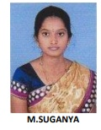
She was born on July 13, 1993 as the daughter of a family who lived in Trichy. M. Suganya better known as Sugan, is an Indian teacher and author, novelist and writer in Tamil. she has written 4 novels, 5 short stories, ten books on science and 4 volumes of poetry.Research Novel in English lecture varies college and School. She is a Professor with the National college Trichy. She is currently the Teacher of the Cyberspace Security Research Centre.

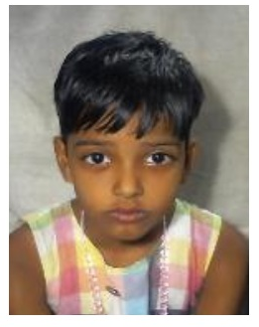

S.S.Inakshi
Department of Education,
YMCA,Trichy in Tamil Nadu
S.S. Inakshi received her current research interests include Power converters, Power systems and Control systems,Image processing.

