Supplementary Information
Unraveling the complex causality behind the Fe-N-C degradation in fuel cell
Geunsu Bae,¹ Song Jin,^{2,3} Man Ho Han,⁴ Hyung-Suk Oh,⁴ Moulay-Tahar Sougrati,⁵ Kug-Seung Lee,⁶ Min Ho Seo,*^{,7} Frédéric Jaouen,*^{,5} and Chang Hyuck Choi*^{,1}
¹Department of Chemistry, Pohang University of Science and Technology (POSTECH), Pohang 37673, Republic of Korea.
²School of Materials Science and Engineering, Gwangju Institute of Science and Technology (GIST), Gwangju 61005, Republic of Korea.
³Department of Hydrogen Energy Materials, Surface Technology Division, Korea Institute of Materials Science (KIMS), Changwon 51508, Republic of Korea.
⁴Clean Energy Research Center, Korea Institute of Science and Technology (KIST), Seoul 02792, Republic of Korea.
⁵ICGM, Univ. Montpellier, CNRS, ENSCM, 34293 Montpellier, France.
⁶Beamline Department, Pohang Accelerator Laboratory, Pohang University of Science and Technology (POSTECH), Pohang 37673, Republic of Korea.
⁷Department of Nanotechnology and Engineering, Pukyong National University, Busan 48547, Republic of Korea.
*Corresponding authors: foifrit@pknu.ac.kr (M.H.S), frederic.jaouen@umontpellier.fr (F.J.), and chchoi@postech.ac.kr (C.H.C.)

Supplementary Notes
Supplementary Note 1. Summary of previous analytical methods.
Till now, two analytical methods, ⁵⁷Fe Mössbauer spectroscopy and Fourier-transform alternating current voltammetry, have been successfully developed to understand the deactivation mechanism of Fe-N-C catalysts in PEMFCs. For the convenience of readers, we have summarized the detailed procedures of the analytical methods in Supplementary Table 1.
Supplementary Table 1. Summary of the procedure of previous diagnostic methods.
Method | Procedure | Reference
⁵⁷Fe Mössbauer spectroscopy | - In situ: acquire Mössbauer spectrum in PEMFC during a 36 h potentiostatic hold, with N₂ /H₂ feeds at anode/cathode.  - Post-mortem: acquire Mössbauer spectrum after PEMFC operation at a fixed potential with O₂/H₂ or N₂/H₂ feed. | Nat. Catal. 4,  10–19 (2021)
Fourier-transform alternating current voltammetry  (FTaCV) | - Break-in procedure.  - Polarization measurement at the beginning-of-life.  - Change cathodic gas to N₂.  - Electricity disconnection to the fuel cell station.  - Connection with the potentiostat.  - Measure CV.  - Measure EIS.  - Measure FTaCV. | Nat. Catal. 5, 163–170 (2022)

Supplementary Note 2. Physicochemical characteristics of Fe_{0.5}NC
The XRD and Raman spectrum of Fe_{0.5}NC confirmed the successful carbonization of the precursor mixture after the pyrolysis at 1323 K (Supplementary Fig. 1a and b). N_{1s} XPS revealed the functionalization of the carbon support with N moieties, which served as anchoring sites for the stabilization of isolated Fe ions (Supplementary Fig. 1c). The FT-EXAFS spectrum showed a strong Fe-N(O) interaction at R ~1.8 Å without Fe-Fe coordination at R ~2.5 Å (Supplementary Fig. 1d). Similarly, the WT-EXAFS contour map exhibited an intense peak at R ~1.9 Å and k ~6.3 Å^{–1} for the Fe–N(O) first shell and a less intense signal at R ~2.9 Å and k ~10.3 Å^{–1} for the Fe-(N)-C second shell (Supplementary Fig. 1e). No fingerprint of Fe particles in a signal from the Fe-Fe first shell at R ~2.5 Å and k ~9.7 Å^{–1} was not found (Supplementary Fig. 1f). In addition, its ⁵⁷Fe Mössbauer spectrum could be fitted with two doublets of D1 and D2 (Supplementary Fig. 1g and Supplementary Table 2), which were assigned to different types of Fe-N₄ moieties.¹ The EXAFS and ⁵⁷Fe Mössbauer spectra thus supported the predominant existence of the isolated Fe-N₄ moieties without noticeable amounts of bulk Fe species in Fe_{0.5}NC. The atomic dispersion of Fe species was further visualized by HAADF-STEM (Supplementary Fig. 1h).
Supplementary Note 3. Description of online GDE/EFC/ICP-MS system
A homemade EFC in which the GDE served as the working electrode was used for online ICP-MS measurements (Fig. 1a). Ar or O₂ gas flowed into the graphite serpentine flow channel and diffused into the catalyst-electrolyte interface through the GDE. The operating temperature was controlled using a heating pad attached to the back of graphite serpentine. To prevent the accumulation of gas bubbles in the electrolyte flow channel, which mainly resulted from gaseous CO or CO₂ evolution at the graphite counter electrode, a vacuum trap with a PTFE membrane was additionally implemented. Note that all measurements were conducted without a polymer membrane to obtain clear ICP-MS signals² and high specificity for catalytic activity without interference from other components.³
Prior to electrochemical analysis with online GDE/EFC/ICP-MS, we cleaned the graphite rod counter electrode to avoid any Fe contamination during the analysis (Supplementary Fig. 2). When the counter electrode was contacted with a 0.1 M HClO₄ electrolyte, ca. 200 ppb Fe was dissolved. However, Fe dissolution was reduced to almost zero within a few minutes. After the stabilization step, almost negligible leaching of Fe from the counter electrode was observed even under extremely harsh electrochemically conditions, CVs with an upper potential limit of 4.5 V_{RHE}. In addition, the Fe_{0.5}NC/GDE was cleaned through 200 fast CVs (200 mV s⁻¹, 1.0–0.0 V_{RHE}) at room temperature to remove any unexpected bulk Fe species (Supplementary Fig. 3). No distinct ICP-MS signal was observed from Fe leaching for Fe_{0.5}NC/GDE which was in line with our previous report.⁴
Finally, the ORR polarization curve of the Fe_{0.5}NC/GDE measured using the GDE/EFC/ICP-MS system showed a current density-potential response comparable to that measured using a conventional RDE system in the low overpotential region. However, unlike the RDE system, the GDE/EFC/ICP-MS system exhibited no mass transport-controlled region, even in the high overpotential region of 0.2 V_{RHE} (Supplementary Fig. 4). Therefore, the results confirmed that the homemade EFC successfully reflected the realistic fuel cell environment of the catalyst layer compared to the RDE system.
Supplementary Note 4. Calculation of SD and TOF losses
1. SD loss
The fraction of dissolved Fe to the total bulk Fe content of Fe_{0.5}NC was calculated using the following equation:
Dissolved Fe_{bulk} (%) = $\left(v_{Fe diss.}×s\right)÷m_{Fe}×100$ = $m_{Fe diss.}÷\left(\frac{\%_{Fe}}{100}\right)×100$ (Eq. S1)
where $v_{Fe diss.}$ is the rate of Fe dissolution, s is the operation time, $m_{Fe}$ is the bulk Fe content in the catalyst, $m_{Fe diss.}$ is the total amount of dissolved Fe, and %_{Fe} is the weight percentage of Fe in the catalyst. Similarly, the fraction of dissolved Fe to the surface Fe content of Fe_{0.5}NC (i.e., SD loss) can be expressed by the following equation:
Dissolved Fe_{surf} (%) = ${Dissolved Fe}_{bulk}÷\frac{U}{100}$ (Eq. S2)
where U is the utilization factor of Fe_{0.5}NC, which represents the electrochemically accessible active Fe-N₄ sites to the total number of Fe atoms in the catalyst (i.e., 25% as confirmed by cyanide poisoning and nitrite stripping methods).⁵
2. TOF loss
The ORR activity of Fe_{0.5}NC can be expressed in terms of the intrinsic TOF and the absolute amount (i.e., SD) of Fe-N₄ sites using the following equation:
$J [A g^{-1}]= {TOF×SD×F}/{N_{A}}$ (Eq. S3)
where J is the catalytic mass activity at a given potential, N_{A} is the Avogadro constant, and F is the Faraday constant. Similarly, the ORR activity of the deactivated Fe_{0.5}NC can be expressed by the following equation:
$J_{DEACT.} [A g^{-1}]= {{TOF}_{DEACT.}×{SD}_{DEACT.}×F}/{N_{A}}$ (Eq. S4)
where $J_{DEACT.}$, ${TOF}_{DEACT.}$, and ${SD}_{DEACT.}$ are the J, TOF, and SD values of the deactivated Fe_{0.5}NC, respectively. The relative loss in the J value for deactivated Fe_{0.5}NC can then be estimated using Eqs. S3 and S4:
$J^{'}= {(J-J_{DEACT.})}/J=1-\left({J_{DEACT.}}/J\right)=1-\left({{TOF}_{DEACT.}}/{TOF}\right)×\left({{SD}_{DEACT.}}/{SD}\right)$ (Eq. S5)
where $J^{'}$ is the relative loss of J for the deactivated Fe_{0.5}NC. Similarly, the relative losses in the SD and TOF values for the deactivated Fe_{0.5}NC can be expressed by the following equations:
${TOF}^{'}= {(TOF-{TOF}_{DEACT.})}/{TOF}=1-\left({{TOF}_{DEACT.}}/{TOF}\right)$ (Eq. S6)
${SD}^{'}= {(SD-{SD}_{DEACT.})}/{SD}=1-\left({{SD}_{DEACT.}}/{SD}\right)$ (Eq. S7)
where ${TOF}^{'}$ and ${SD}^{'}$ are the relative losses of TOF and SD for deactivated Fe_{0.5}NC, respectively. Subsequently, by substituting Eqs. S6 and S7 with Eq. S5, we can finally obtain Eq.S8 which describes the relationship between the relative losses in J, SD, and TOF values for deactivated Fe_{0.5}NC:
$J^{'}=1-\left(1-{TOF}^{'}\right)×\left(1-{SD}^{'}\right), {TOF}^{'}=1-\left\{{\left(1-J^{'}\right)}/{\left(1-{SD}^{'}\right)}\right\}$ (Eq. S8)
Supplementary Figures
Supplementary Fig. 1. Physicochemical characterizations of Fe_{0.5}NC. a, XRD pattern, b, Raman spectrum, and c, XPS-N_{1s} spectrum of Fe_{0.5}NC. The XPS peak was deconvoluted with four N-components: pyridinic-N (398.5 eV), pyrrolic-N (400.1 eV), graphitic-N (401.1 eV), and pyridinic-oxide (403.2 eV).⁶ d, k³-weighted Fe K-edge FT-EXAFS of Fe_{0.5}NC and Fe foil. e,f, k³-weighted Fe K-edge WT-EXAFS contour plots of Fe_{0.5}NC (e) and Fe foil (f). g, ⁵⁷Fe Mössbauer spectrum of Fe_{0.5}NC, which was fitted with two doublets (i.e., D1 and D2, indicating ferric and ferrous Fe-N₄ moieties of high and low/medium spins, respectively).¹ h, HAADF-STEM image of Fe_{0.5}NC (scale bar = 2 nm).

Supplementary Fig. 2. Fe dissolution from graphite rod counter electrode. a,b, Fe dissolution from graphite rod obtained after the contact with 0.1 M HClO₄ electrolyte (a) and during the CVs with various upper potential limits (b). For b, the graphite rod was used as a working electrode.

Supplementary Fig. 3. Electrochemical activation of Fe_{0.5}NC/GDE. Fe dissolution rate of Fe_{0.5}NC/GDE obtained by online GDE/EFC/ICP-MS during the CVs in a potential range of 1.0–0.0 V_{RHE} under Ar flow at 298 K.

Supplementary Fig. 4. ORR performance of Fe_{0.5}NC. a,b, ORR polarization curves of Fe_{0.5}NC fabricated on RDE or GDE (a), and corresponding Tafel plots (b). On the conventional RDE system, Fe_{0.5}NC showed a Tafel slope of 60 mV dec⁻¹. However, in the GDE/EFC/ICP-MS system, the same catalyst revealed a higher Tafel slope of 110 mV dec⁻¹ at a low overpotential region and it increased to 200 mV dec⁻¹ as the overpotential increased. This phenomenon, i.e., doubling of the Tafel slope, can be interpreted as a flooded GDE, where the measured Tafel slope is a consequence of combined O₂ diffusion outside the GDE and the ORR kinetics inside the active layer.⁷

Supplementary Fig. 5. Change in ORR activity after the CVs at various temperatures. a–d, ORR polarization curves of Fe_{0.5}NC/GDE obtained before and after the three CVs in a potential range of 1.0–0.0 V_{RHE} under Ar flow at various temperatures; 298 K (a), 313 K (b), 333 K (c), and 353 K (d).

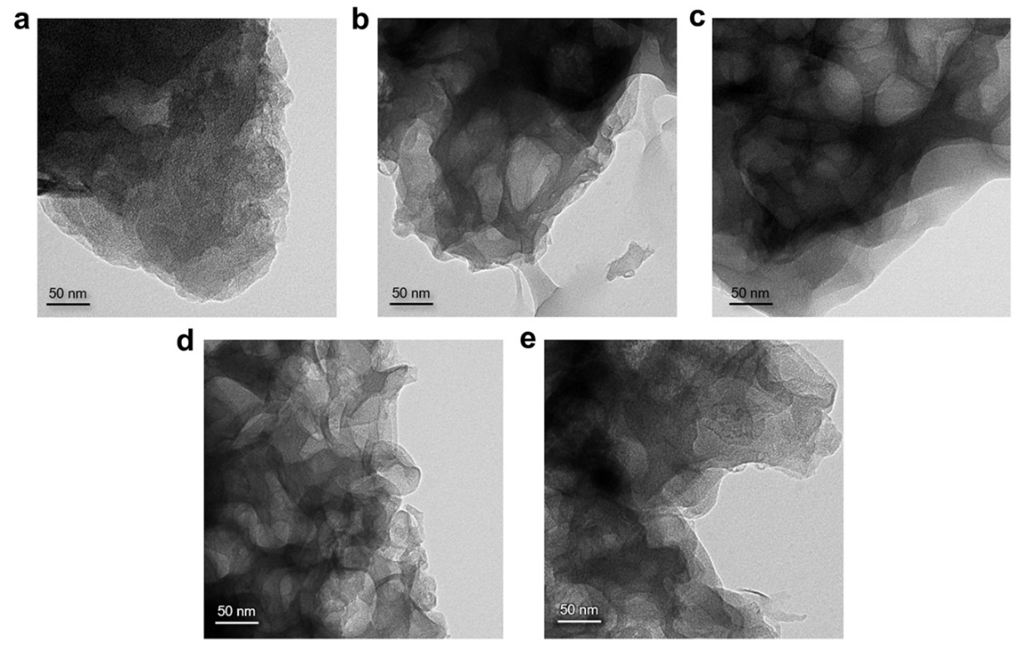
Supplementary Fig. 6. Post-mortem TEM analysis. a–e, TEM images of Fe_{0.5}NC/GDE before (a) and after (b–e) the three CVs in a potential range of 1.0–0.0 V_{RHE} under Ar flow at various temperatures; 298 K (b), 313 K (c), 333 K (d), and 353 K (e).

Supplementary Fig. 7. Change in ORR activity after the CVs under different gas atmospheres. a,b, ORR polarization curves of Fe_{0.5}NC/GDE obtained before and after the three CVs in a potential range of 1.0–0.0 V_{RHE} under Ar (a) or O₂ flow (b) at 353 K.

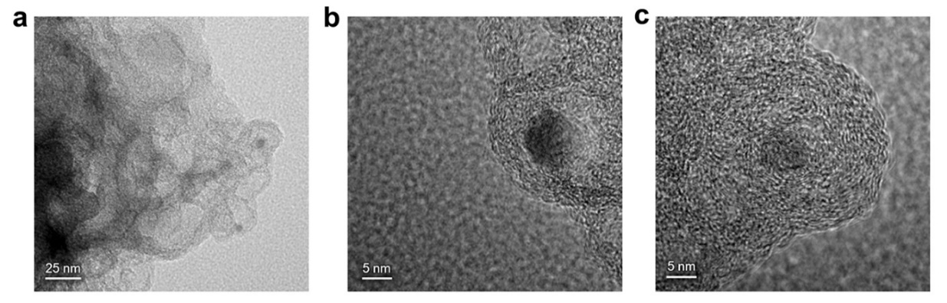
Supplementary Fig. 8. Post-mortem TEM analysis. a–c, TEM images of Fe_{0.5}NC/GDE after 2 h potential hold at 0.6 V_{RHE} and 353 K under O₂ flow.

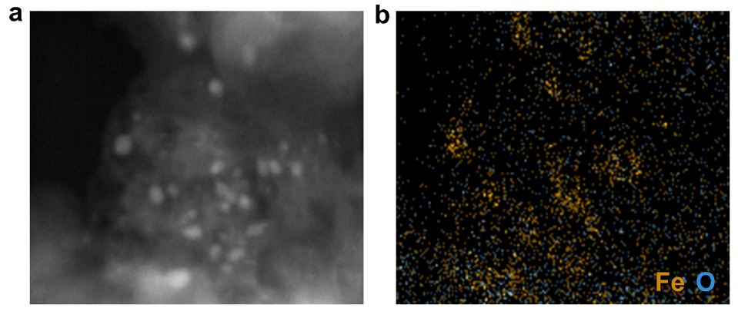
Supplementary Fig. 9. Post-mortem EDS analysis. a, TEM and b, EDS elemental mapping (Fe and O) results of Fe_{0.5}NC/GDE after 2 h potential hold at 0.6 V_{RHE} and 353 K under O₂ flow.

Supplementary Fig. 10. Selective leaching of Fe oxide. a–c, Fe dissolution of Fe_{0.5}NC and Fe₂O₃/NC in 0.5 M HClO₄ solution at various temperatures; 373 K (a), 353 K (b), and 333 K (c). For comparison, the results obtained without any catalysts (labeled ‘No Cat.’) and with Fe-free NC catalyst are also provided.
Additional discussion: To quantify the Fe oxide formed on Fe_{0.5}NC during ORR, we selectively dissolved the Fe oxides from the aged catalyst without loss of the remaining Fe-N₄ sites and measured their amount using ICP-MS. For this, we optimized the acid leaching conditions in a 0.5 M HClO₄ solution. With a pristine Fe_{0.5}NC, we prepared Fe₂O₃ nanoparticles supported on NC (labeled ‘Fe₂O₃/NC’), and the samples were acid-treated for 24 h at various leaching temperatures, one of the critical parameters determining the dissolution rate of Fe oxide.⁸ At 373 K, most of the Fe oxide was dissolved out from Fe₂O₃/NC. However, the Fe-N₄ sites from Fe_{0.5}NC were also damaged and dissolved after acid treatment at 373 K (Supplementary Fig. 10a). When leaching temperature decreased to 353 K and further to 333 K, the undesirable Fe-N₄ site loss could be avoided, and ca. 80% of Fe oxide was leached out at 333 K (Supplementary Fig. 10b and c). Hence, we chose this condition, i.e., 0.5 M HClO₄, 24 h, and 333 K, for the selective leaching of Fe oxide without undesirable loss of Fe-N₄ sites. It is of note that 80% of imperfect Fe oxide leaching under such condition was 20% post-compensated for estimating the total amount of Fe oxide formed upon Fe_{0.5}NC during ORR (see details in Supplementary Fig. 13).

Supplementary Fig. 11. Fe dissolution from Fe_{0.5}NC/GDE at a constant potential of 0.6 V_{RHE}. a–d, Real-time Fe dissolution of Fe_{0.5}NC/GDE obtained by online GDE/EFC/ICP-MS during the potential hold at 0.6 V_{RHE} and 353 K under O₂ flow with various reaction times; 30 min (a), 60 min (b), 90 min (c), and 120 min (d). The relative change in ORR current density is also shown.

Supplementary Fig. 12. Post-leaching of aged Fe_{0.5}NC/GDEs. a, ⁵⁷Fe concentration in the solution obtained after the acid-treatment of Fe_{0.5}NC/GDEs which are aged under various ORR durations. For comparison, the results obtained without any catalysts (labeled ‘No Cat.’) and with carbon paper, MPL, or pristine Fe_{0.5}NC/GDE are also shown. The ⁵⁷Fe concentration was measured using ICP-MS. The results showed non-negligible amounts of Fe dissolution from the carbon paper and MPL because Fe is typically ubiquitous. b, Fe dissolution from Fe oxides of aged Fe_{0.5}NC/GDE was thus estimated by subtracting ⁵⁷Fe concentration obtained with aged Fe_{0.5}NC/GDEs from that of pristine Fe_{0.5}NC/GDE. The sample solutions were diluted to one-tenth concentration with 0.1 M HClO₄ solution.
Supplementary Fig. 13. Cumulative amounts of dissolved Fe under O₂ flow. a, Cumulative amounts of dissolved Fe from Fe_{0.5}NC/GDEs during the potential hold at 0.6 V_{RHE} and 353 K under O₂ flow as a function of operation time, i.e., the sum of both cumulative Fe-N₄ dissolution (measured by GDE/EFC/ICP-MS) and Fe oxide amounts (measured by post-leaching). Owing to the incomplete leaching of Fe oxides under the optimized acid-leaching condition (Supplementary Fig. 10), the dissolved Fe oxide amounts was 20% post-compensated by multiplying 1.25 (i.e., the inverse of 80%). b, Comparison of cumulative amounts of dissolved Fe from Fe_{0.5}NC/GDEs under O₂ and Ar flows. Those under the Ar flow was cumulative Fe-N₄ dissolution only (measured by GDE/EFC/ICP-MS) owing to the lack of Fe oxide formation.

Supplementary Fig. 14. Change in ORR current of Fe_{0.5}NC/GDE. Change in ORR current density of Fe_{0.5}NC/GDE obtained during 2 h potential hold at 0.6 V_{RHE} and 353 K. The slope indicates the decay rate for each zone. It is of note that the decay rate obtained from the GDE/EFC/ICP-MS system was higher than that obtained during the fuel cell operation (i.e., 6.7 × 10⁻³ and 2.9 × 10⁻² mA cm⁻² min⁻¹ for 1st and 2nd zone, respectively).⁹ The faster degradation rate in the GDE/EFC/ICP-MS system is probably due to the continuous flow of electrolyte and the fast removal of dissolved Fe ions, hardly arriving at equilibrium between non-dissolved and dissolved Fe species.

Supplementary Fig. 15. Post-mortem XPS analysis. XPS O_{1s} spectra of Fe_{0.5}NC/GDE after 2 h potential hold at 0.6 V_{RHE} and 353 K under Ar or O₂ flow. For comparison, the spectra of pristine Fe_{0.5}NC/GDE were also shown. After aging Fe_{0.5}NC/GDE under O₂ flow, higher amounts of oxygen functional groups were identified compared to that aged under Ar flow.
Additional discussion: Although much larger apparent Fe dissolution was identified under Ar than that under O₂ flow during the GDE/EFC/ICP-MS operation, it was later found that the total loss of active Fe-N₄ sites was almost the same regardless of the gas flow (Supplementary Fig. 13). Despite the quantitatively similar loss of catalytic sites, the ORR activity drop after cycling was slightly larger for O₂ than for Ar (Fig. 2b), which can be attributed to the formation of ROS that modifies the carbon surface and consequently decreases the TOF of the Fe-N₄ sites.¹⁰

Supplementary Fig. 16. a, Pristine Fe-N₄ and b, Pt-N₄ were designed as reference models. Gray, blue, orange, and white balls indicate carbon, nitrogen, iron, and platinum atoms, respectively.

No. | Volume | Formation energy (eV)
1 | 71  (C₆₅Fe₁N₄Pt₁) | −1.198
2 | 71  (C₆₅Fe₁N₄Pt₁) | −1.196
3 | 71  (C₆₅Fe₁N₄Pt₁) | −1.140
4 | 71  (C₆₅Fe₁N₄Pt₁) | −1.142
5 | 71  (C₆₅Fe₁N₄Pt₁) | −1.195
6 (#1) | 70  (C₆₄Fe₁N₄Pt₁) | −1.238
7 | 70  (C₆₄Fe₁N₄Pt₁) | −1.217
8 | 70  (C₆₄Fe₁N₄Pt₁) | −1.202
9 | 70  (C₆₄Fe₁N₄Pt₁) | −1.205
10 | 70  (C₆₄Fe₁N₄Pt₁) | −1.228
11 | 70  (C₆₄Fe₁N₄Pt₁) | −1.221
12 | 70  (C₆₄Fe₁N₄Pt₁) | −1.209
13 | 70  (C₆₄Fe₁N₄Pt₁) | −1.203
14 | 70  (C₆₄Fe₁N₄Pt₁) | −1.200
15 | 70  (C₆₄Fe₁N₄Pt₁) | −1.200

Supplementary Fig. 17. Various configurations of Fe-N₄ with a single-atom Pt for searching the most stable structure. Model volumes were 71 (1–5) or 70 (6–15). Model No. 6 showed the lowest formation energy among the models, and thus, was used as the representative Fe-N₄/Pt model (#1) for the cohesive energy comparison. Gray, blue, orange, and white balls indicate carbon, nitrogen, iron, and platinum atoms, respectively.

No. | Volume | Formation energy (eV)
1 | 70  (C₆₀Fe₁N₈Pt₁) | −1.637
2 (#2) | 70  (C₆₀Fe₁N₈Pt₁) | −1.647
3 | 70  (C₆₀Fe₁N₈Pt₁) | −1.640
4 | 70  (C₆₀Fe₁N₈Pt₁) | −1.634
5 | 70  (C₆₀Fe₁N₈Pt₁) | −1.622
6 | 70  (C₆₁Fe₁N₇Pt₁) | −1.643
7 | 70  (C₆₂Fe₁N₆Pt₁) | −1.446
8 | 70  (C₆₂Fe₁N₆Pt₁) | −1.442

Supplementary Fig. 18. Various configurations of Fe-N₄ with a Pt-N₄ for searching the most stable structure. Model volume was 70. Model No. 2 showed the lowest formation energy among the models, and thus, was used as the representative Fe-N₄/Pt-N₄ model (#2) for the cohesive energy comparison. Gray, blue, orange, and white balls indicate carbon, nitrogen, iron, and platinum atoms, respectively.

No. | Volume | Formation energy (eV)
1 | 72  (C₆₂Cl₂Fe₁N₆Pt₁) | −1.858
2 | 72  (C₆₀Cl₂Fe₁N₈Pt₁) | −2.027
3 (#3) | 72  (C₆₀Cl₂Fe₁N₈Pt₁) | −2.037
4 | 72  (C₆₀Cl₂Fe₁N₈Pt₁) | −2.034
5 | 72  (C₆₀Cl₂Fe₁N₈Pt₁) | −2.029
6 | 72  (C₆₀Cl₂Fe₁N₈Pt₁) | −2.012
7 | 72  (C₆₁Cl₂Fe₁N₇Pt₁) | −1.944

Supplementary Fig. 19. a, Optimized structure of Pt-N₄Cl₂ model. b, Various configurations of Fe-N₄ with a Pt-N₄Cl₂ for searching the most stable structure. Model volume was 72. Model No. 3 showed the lowest formation energy among the models, and thus, was used as the representative Fe-N₄/Pt-N₄Cl₂ model (#3) for the cohesive energy comparison. Gray, blue, green, orange, and white balls indicate carbon, nitrogen, chlorine, iron, and platinum atoms, respectively.

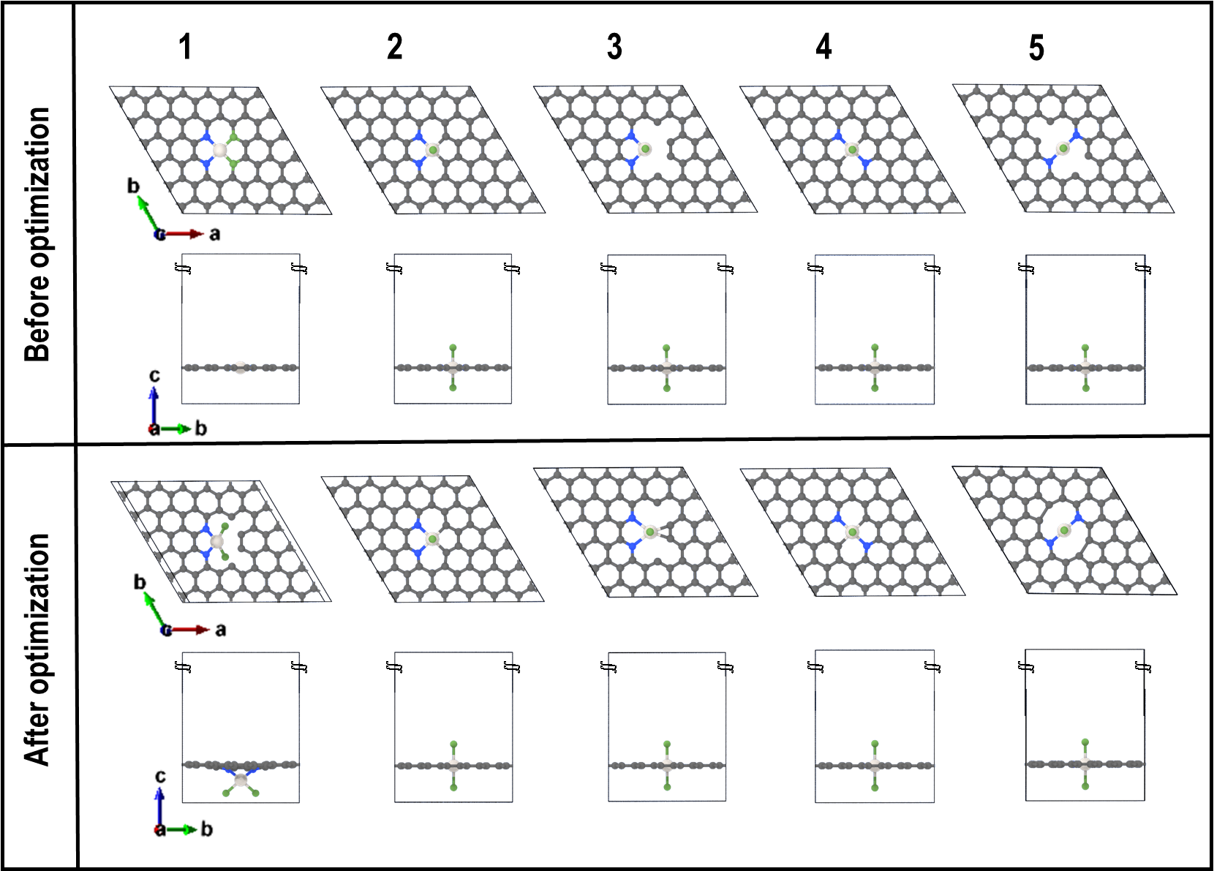
Supplementary Fig. 20. a,b, Summary of theoretically possible configurations for trans-/cis-Pt-N₂Cl₂ into graphene sheet with edge sites (a) and basal planes (b) before/after structural optimization.
Additional note: The abbreviation of carbon vacancy is “v”, and the numbering indicates that 1: trans-PtN₂Cl₂-1; 2: trans-PtN₂Cl₂-2; 3: trans-PtN₂Cl₂-v; 4: cis-PtN₂Cl₂; 5: cis-PtN₂Cl₂-v.

No. | Volume | Formation energy (eV)
1 | 70  (C₆₂Cl₂Fe₁N₄Pt₁) | −1.407
2 | 70  (C₆₀Cl₂Fe₁N₆Pt₁) | −1.600
3 (#4-1) | 70  (C₆₀Cl₂Fe₁N₆Pt₁) | −1.610
4 | 70  (C₆₀Cl₂Fe₁N₆Pt₁) | −1.588
5 | 70  (C₆₁Cl₂Fe₁N₅Pt₁) | −1.491

Supplementary Fig. 21. a, Optimized structure of the trans-Pt-N₂Cl₂-1 model. b, Various configurations of Fe-N₄ with a trans-Pt-N₂Cl₂-1 for searching the most stable structure. Model volume was 70. Model No. 3 showed the lowest formation energy among the models, and thus, was used as the representative Fe-N₄/trans-Pt-N₂Cl₂-1 model (#4-1) for the cohesive energy comparison. Gray, blue, green, orange, and white balls indicate carbon, nitrogen, chlorine, iron, and platinum atoms, respectively.

No. | Volume | Formation energy (eV)
1 | 72  (C₆₄Cl₂Fe₁N₄Pt₁) | −1.468
2 | 72  (C₆₂Cl₂Fe₁N₆Pt₁) | −1.654
3 | 72  (C₆₂Cl₂Fe₁N₆Pt₁) | −1.657
4 (#4-2) | 72  (C₆₂Cl₂Fe₁N₆Pt₁) | −1.663
5 | 72  (C₆₂Cl₂Fe₁N₆Pt₁) | −1.646
6 | 72  (C₆₂Cl₂Fe₁N₆Pt₁) | −1.657
7 | 72  (C₆₃Cl₂Fe₁N₅Pt₁) | −1.559

Supplementary Fig. 22. a, Optimized structure of the trans-Pt-N₂Cl₂-2 model. b, Various configurations of Fe-N₄ with a trans-Pt-N₂Cl₂-2 for searching the most stable structure. Model volume was 72. Model No. 4 showed the lowest formation energy among the models, and thus, was used as the representative Fe-N₄/trans-Pt-N₂Cl₂-2 model (#4-2) for the cohesive energy comparison. Gray, blue, green, orange, and white balls indicate carbon, nitrogen, chlorine, iron, and platinum atoms, respectively.

No. | Volume | Formation energy (eV)
1 | 70  (C₆₂Cl₂Fe₁N₄Pt₁) | −1.425
2 | 72  (C₆₁Cl₂Fe₁N₅Pt₁) | −1.588
3 | 72  (C₆₁Cl₂Fe₁N₅Pt₁) | −1.522
4 | 70  (C₆₀Cl₂Fe₁N₆Pt₁) | −1.623
5 | 70  (C₆₀Cl₂Fe₁N₆Pt₁) | −1.614
6 | 70  (C₆₀Cl₂Fe₁N₆Pt₁) | −1.622
7 (#4-3) | 70  (C₆₀Cl₂Fe₁N₆Pt₁) | −1.642
8 | 70  (C₆₀Cl₂Fe₁N₆Pt₁) | −1.620

Supplementary Fig. 23. a, Optimized structure of the trans-Pt-N₂Cl₂-v model. b, Various configurations of Fe-N₄ with a trans-Pt-N₂Cl₂-v for searching the most stable structure. Model volumes were 70 (1, 4–8) or 72 (2 and 3). Model No. 7 showed the lowest formation energy among the models, and thus, was used as the representative Fe-N₄/trans-Pt-N₂Cl₂-v model (#4-3) for the cohesive energy comparison. Gray, blue, green, orange, and white balls indicate carbon, nitrogen, chlorine, iron, and platinum atoms, respectively.
No. | Volume | Formation energy (eV)
1 | 72  (C₆₂Cl₂Fe₁N₆Pt₁) | −1.842
2 | 72  (C₆₂Cl₂Fe₁N₆Pt₁) | −1.843
3 | 72  (C₆₂Cl₂Fe₁N₆Pt₁) | −1.845
4 (#5-1) | 72  (C₆₂Cl₂Fe₁N₆Pt₁) | −1.848
5 | 72  (C₆₂Cl₂Fe₁N₆Pt₁) | −1.838
6 | 72  (C₆₃Cl₂Fe₁N₅Pt₁) | −1.770
7 | 72  (C₆₃Cl₂Fe₁N₅Pt₁) | −1.770

Supplementary Fig. 24. a, Optimized structure of the cis-Pt-N₂Cl₂ model. b, Various configurations of Fe-N₄ with a cis-Pt-N₂Cl₂ for searching the most stable structure. Model volume was 72. Model No. 4 showed the lowest formation energy among the models, and thus, was used as the representative Fe-N₄/cis-Pt-N₂Cl₂ model (#5-1) for the cohesive energy comparison. Gray, blue, green, orange, and white balls indicate carbon, nitrogen, chlorine, iron, and platinum atoms, respectively.
No. | Volume | Formation energy (eV)
1 | 70  (C₆₁Cl₂Fe₁N₅Pt₁) | −1.733
2 | 70  (C₆₁Cl₂Fe₁N₅Pt₁) | −1.810
3 | 70  (C₆₁Cl₂Fe₁N₅Pt₁) | −1.818
4 | 70  (C₆₁Cl₂Fe₁N₅Pt₁) | −1.811
5 | 70  (C₆₁Cl₂Fe₁N₅Pt₁) | −1.818
6 | 70  (C₆₁Cl₂Fe₁N₅Pt₁) | −1.818
7 (#5-2) | 70  (C₆₁Cl₂Fe₁N₅Pt₁) | −1.820

Supplementary Fig. 25. a, Optimized structure of the cis-Pt-N₂Cl₂-v model. b, Various configurations of Fe-N₄ with a cis-Pt-N₂Cl₂-v for searching the most stable structure. Model volume was 70. Model No. 7 showed the lowest formation energy among the models, and thus, was used as the representative Fe-N₄/cis-Pt-N₂Cl₂-v model (#5-2) for the cohesive energy comparison. Gray, blue, green, orange, and white balls indicate carbon, nitrogen, chlorine, iron, and platinum atoms, respectively.
Supplementary Fig. 26. Physical characterizations of Fe_{0.5}NC-Pt. a, XRD patterns and b, Raman spectra of Fe_{0.5}NC and Fe_{0.5}NC-Pt. The XRD patterns show (002) and (101) planes of graphite at ca. 24° and 44°, respectively. In Raman spectra, clear D- and G-band peaks appeared at ca. 1352 and 1588 cm⁻¹, respectively. The intensity ratio between the two bands (I_{D}/I_{G}), representing the degree of disorder in the carbon lattice, remained almost constant between the catalysts.

Supplementary Fig. 27. Electrochemical characterizations of Fe_{0.5}NC-Pt. a, FAOR polarization curves measured in Ar-saturated 0.1 M HClO₄ electrolyte containing 20 mM HCOOH. b, MOR experiments conducted at 0.7 V_{RHE} in O₂-saturated 0.1 M HClO₄ electrolyte. 50 mM methanol was injected into the electrolyte after 1 min. For comparison, those for Fe_{0.5}NC or Pt/C are also shown.

Supplementary Fig. 28. Electrochemical characterization of NC-Pt. a, ORR polarization curves measured in O₂-saturated 0.1 M HClO₄ electrolyte. b, PRR polarization curves measured in Ar-saturated 0.1 M HClO₄ electrolyte containing 1.3 mM H₂O₂. c, FAOR polarization curves measured in Ar-saturated 0.1 M HClO₄ electrolyte containing 20 mM HCOOH. d, MOR experiments conducted at 0.7 V_{RHE} in O₂-saturated 0.1 M HClO₄ electrolyte. 50 mM methanol was injected into the electrolyte after 1 min. For comparison, those for NC or Pt/C are also shown.

Supplementary Fig. 29. Fe and Pt dissolutions from Fe_{0.5}NC-Pt/GDE. a,b, Real-time Fe and Pt dissolutions of Fe_{0.5}NC-Pt/GDE obtained by online GDE/EFC/ICP-MS during 2 h potential hold at 0.6 V_{RHE} and 353 K under Ar (a) or O₂ flow (b). The relative change in ORR current density is also shown.

Supplementary Fig. 30. Stability diagram of Fe_{0.5}NC-Pt. Relative loss of j, SD, and TOF values of Fe_{0.5}NC-Pt as a function of operation time obtained during 2 h potential hold at 0.6 V_{RHE} and 353 K under O₂ flow. The SD change was measured under Ar flow due to qualitatively similar loss of Fe-N₄ sites regardless of gas flows.

Supplementary Fig. 31. FT-EXAFS of pristine and aged Fe_{0.5}NC-Pt. k³-weighted Pt L₃-edge FT-EXAFS spectra of Fe_{0.5}NC-Pt before and after 50 h of PEMFC operation at 0.5 V.

Supplementary Fig. 32. H₂O₂ formation profile of Fe_{0.5}NC and Fe_{0.5}NC-Pt. The Pt ring, equipped at the rotating ring-disk electrode, was polarized at a constant potential of 1.2 V_{RHE} during ORR polarization on the disk electrode. The collection efficiency of 0.42 was used after Fe^{Ⅱ}/Fe^{Ⅲ} redox calibration.

Supplementary Table 2. Parameters derived from the fittings of the ⁵⁷Fe Mössbauer spectrum of Fe_{0.5}NC: relative area (RA), isomer shift (IS), and quadrupole splitting (QS) of each fitted spectral component.
Sample | Component | RA (%) | IS (mm s⁻¹) | QS (mm s⁻¹) | Assignment
Fe_{0.5}NC powder | D1 | 59 | 0.33 | 0.88 | High spin O-Fe^{Ⅲ}-N₄
Fe_{0.5}NC powder | D2 | 41 | 0.37 | 2.73 | Low/medium spin Fe^{Ⅱ}-N₄

Supplementary Table 3. Volume and cohesive energy values of the defined model for various configurations.
Defined model | Volume | Cohesive energy (eV)
Fe-N₄ | 71 (C₆₆Fe₁N₄) | −6.503
Pt-N₄ | 71 (C₆₆Pt₁N₄) | −7.015
#1 (No.6) | 70 (C₆₄Fe₁N₄Pt₁) | −6.774
#2 (No.2) | 70 (C₆₀Fe₁N₈Pt₁) | −6.527
#3 (No.3) | 72 (C₆₀Cl₂Fe₁N₈Pt₁) | −6.553
#4-1 (No.3) | 70 (C₆₀C_{l2}Fe₁N₆Pt₁) | −6.515
#4-2 (No.4) | 72 (C₆₂C_{l2}Fe₁N₆Pt₁) | −6.923
#4-3 (No.7) | 70 (C₆₀C_{l2}Fe₁N₆Pt₁) | −7.583
#5-1 (No.4) | 72 (C₆₂C_{l2}Fe₁N₆Pt₁) | −6.849
#5-2 (No.7) | 70 (C₆₀C_{l2}Fe₁N₆Pt₁) | −6.834

Supplementary Table 4. Best-fit parameters obtained from FT-EXAFS analysis of Fe_{0.5}NC-Pt: coordination number (CN), interatomic distance (R), and Debye-Waller factor (σ²) of each path. The errors are given in the parentheses.
Sample | Path | CN | R (Å) | σ² (Å²) | R-factor
Fe_{0.5}NC-Pt powder | Pt-N | 3.44 | 2.04 (3) | 0.008 (8) | 0.011
Fe_{0.5}NC-Pt powder | Pt-Cl | 1.06 | 2.24 (4) | 0.008 (8) | 0.011

References
1 Mineva, T. et al. Understanding active sites in pyrolyzed Fe–N–C catalysts for fuel cell cathodes by bridging density functional theory calculations and ⁵⁷Fe Mössbauer spectroscopy. ACS Catal. 9, 9359-9371 (2019).
2 Ehelebe, K. et al. Platinum dissolution in realistic fuel cell catalyst layers. Angew. Chem. Int. Ed. 60, 8882-8888 (2021).
3 Martinez, U., Komini Babu, S., Holby, E. F. & Zelenay, P. Durability challenges and perspective in the development of PGM-free electrocatalysts for the oxygen reduction reaction. Curr. Opin. Electrochem. 9, 224-232 (2018).
4 Choi, C. H. et al. Minimizing operando demetallation of Fe-N-C electrocatalysts in acidic medium. ACS Catal. 6, 3136-3146 (2016).
5 Bae, G. et al. Quantification of active site density and turnover frequency: from single-atom metal to nanoparticle electrocatalysts. JACS Au 1, 586-597 (2021).
6 Guo, D. et al. Active sites of nitrogen-doped carbon materials for oxygen reduction reaction clarified using model catalysts. Science 351, 361 (2016).
7 Jaouen, F. d. r., Lindbergh, G. r. & Sundholm, G. r. Investigation of mass-transport limitations in the solid polymer fuel cell cathode. J. Electrochem. Soc. 149, A437 (2002).
8 Taxiarchou, M., Panias, D., Douni, I., Paspaliaris, I. & Kontopoulos, A. Dissolution of hematite in acidic oxalate solutions. Hydrometallurgy 44, 287-299 (1997).
9 Chenitz, R. et al. A specific demetalation of Fe–N₄ catalytic sites in the micropores of NC_Ar + NH₃ is at the origin of the initial activity loss of the highly active Fe/N/C catalyst used for the reduction of oxygen in PEM fuel cells. Energy Environ. Sci. 11, 365-382 (2018).
10 Choi, C. H. et al. The Achilles' heel of iron-based catalysts during oxygen reduction in an acidic medium. Energy Environ. Sci. 11, 3176-3182 (2018).

