TableS1. MACE risk according to baseline variables
 | HR (95%CI) | P
Age (per one year increase) | 1.031 (1.017, 1.046) | <.0001
Sex (female as reference) | 1.547 (1.115, 2.147) | 0.0091
BMI (per 1 kg/m² increase) | 1.039 (0.994, 1.086) | 0.0922
Heart rate (per 1 bpm) | 0.994 (0.981, 1.007) | 0.3793
SBP (per 1 mmHg increase) | 1.003 (0.995, 1.012) | 0.4674
LVEF (per one percentage increase) | 0.983 (0.959, 1.008) | 0.1750
BNP (per doubling increase) | 1.170 (0.939, 1.456) | 0.1611
HsCRP (per 1 mg/L increase) | 1.030 (0.991, 1.070) | 0.1328
Cr (per 1 umol/L increase) | 1.000 (0.998, 1.001) | 0.7090
D-Dimer (per 1 ug/ml increase) | 1.058 (0.927, 1.208) | 0.4018
HbA1C (per 1% increase) | 1.159 (1.041, 1.291) | 0.0069
Fasting glucose (per 1 mg/L increase) | 1.031 (0.968, 1.099) | 0.3398
TC (per 1 mmol/L increase) | 0.918 (0.803, 1.049) | 0.2106
LDL (per 1 mmol/L increase) | 0.933 (0.794, 1.096) | 0.3955
HDL (per 1 mmol/L increase) | 0.553 (0.338, 0.904) | 0.0182
Lpa (per 1 mg/L increase) | 1.000 (0.999, 1.001) | 0.9097
Diabetes (no as reference) | 1.306 (0.955, 1.786) | 0.0948
Hypertension (no as reference) | 1.276 (0.938, 1.737) | 0.1207
Hyperlipidemia (no as reference) | 1.133 (0.849, 1.512) | 0.3967
Smoke (no as reference) | 1.545 (1.168, 2.045) | 0.0023
Drink (no as reference) | 1.423 (1.075, 1.883) | 0.0136
LM (no as reference) | 1.194 (0.588, 2.424) | 0.6235
RCA (no as reference) | 1.535 (1.130, 2.086) | 0.0061
LAD (no as reference) | 0.956 (0.715, 1.277) | 0.7602
LCX (no as reference) | 1.759 (1.320, 2.343) | 0.0001
Triple-vessel disease | 2.188 (1.292, 3.705) | 0.0036
Abbreviations are the same as table 1.

TableS2. Baseline characteristics according to categories of abnormal glucose metabolism based on ADA HbA1c-based definition
Variables ± | NGT  N=225 | Pre-diabetes  N=721 | DM  N=586 | P value
Age (years) | 56.02±10.21 | 59.50±9.60 | 60.47±9.14 | <.0001
Female (%) | 55/255 (24.44) | 224/721 (31.07) | 209/586 (35.67) | 0.0074
Hypertension (%) | 137/255 (60.89) | 439/721 (60.89) | 437/586 (74.57) | <.0001
Hyperlipidemia (%) | 116/255 (51.56) | 417/721 (57.84) | 382/586 (65.19) | 0.0007
Smoke (%) | 98/255 (43.56) | 305/721 (42.30) | 265/586 (45.22) | 0.5710
Alcohol (%) | 113/255 (50.22) | 331/721 (45.91) | 252/586 (43.00) | 0.1701
BMI (kg/m²) | 25.48±2.85 | 25.41±3.12 | 26.22±3.26 | <.0001
HR (bpm) | 69.38±9.58 | 68.99±10.14 | 71.30±12.15 | 0.0005
SBP (mmHg) | 126.31±15.48 | 126.96±16.56 | 129.03±16.37 | 0.0317
LVEF (%) | 64.44±5.35 | 65.06±6.50 | 64.45±6.50 | 0.3149
NT-proBNP (pmol/L) | 537.40  (425.20, 672.80) | 544.40  (431.50, 714.00) | 547.15  (432.75, 737.35) | 0.4503
hsCRP (mg/L) | 0.93 (0.53, 1.80) | 1.19 (0.63, 2.32) | 1.56 (0.80, 3.08) | <.0001
Cr (umol/L) | 72.04  (61.38, 80.62) | 73.55  (64.28, 81.86) | 72.60  (62.62, 82.38) | 0.4844
D_Dimer (ug/ml) | 0.24 (0.18, 0.35) | 0.27 (0.19, 0.38) | 0.29 (0.20, 0.41) | 0.0039
TC (mmol/L) | 4.19 (3.57, 4.79) | 4.19 (3.50, 4.89) | 4.04 (3.38, 4.78) | 0.1972
LDL (mmol/L) | 2.49 (1.88, 3.09) | 2.43 (1.83, 3.10) | 2.32 (1.84, 3.00) | 0.1777
HDL (mmol/L) | 1.11 (0.94, 1.31) | 1.08 (0.89, 1.29) | 1.02 (0.86, 1.20) | <.0001
Lpa (mg/L) | 161.13  (64.15, 356.19) | 155.38  (64.91, 319.91) | 145.11  (53.53, 358.73) | 0.4510
Fasting glucose (mg/L) | 4.96±0.53 | 5.18±0.58 | 7.12±2.60 | <.0001
HbA1c (%) | 5.41±0.20 | 6.01±0.21 | 7.26±1.23 | <.0001
Angiographic characteristics
LM (%) | 9/255 (4.00) | 29/721 (4.02) | 15/586 (2.73) | 0.4145
RCA (%) | 48/255 (21.33) | 153/721 (21.22) | 146/586 (24.91) | 0.2492
LAD (%) | 162/255 (72.00) | 441/721 (61.17) | 388/586 (66.21) | 0.0075
LCX (%) | 45/255 (20.00) | 184/721 (25.52) | 196/586 (33.45) | 0.0001
Triple-vessel disease | 11/255 (4.89) | 21/721 (2.91) | 30/586 (5.12) | 0.1035
Abbreviations are the same as table 1.

TableS3. Baseline characteristics according to categories of abnormal glucose metabolism based on ADA FPG-based definition
Variables | NGT  N=788 | Pre-diabetes  N=158 | DM  N=586 | P value
Age (years) | 58.05±10.02 | 60.33±9.26 | 60.47±9.14 | <.0001
Female (%) | 237/788 (30.08) | 42/158 (26.58) | 209/586 (35.67) | 0.0288
Hypertension (%) | 459/788 (58.25) | 117/158 (74.05) | 437/586 (74.57) | <.0001
Hyperlipidemia (%) | 427/788 (54.19) | 106/158 (67.09) | 382/586 (65.19) | <.0001
Smoke (%) | 331/788 (42.01) | 72/158 (45.57) | 265/586 (45.22) | 0.4293
Alcohol (%) | 371/788 (47.08) | 73/158 (46.20) | 252/586 (43.00) | 0.3172
BMI (kg/m²) | 25.39±3.07 | 25.58±3.02 | 26.22±3.26 | <.0001
HR (bpm) | 6855±9.72 | 71.73±11.00 | 71.30±12.15 | <.0001
SBP (mmHg) | 125.97±15.88 | 131.01±17.74 | 129.03±16.37 | <.0001
LVEF (%) | 64.94±6.21 | 64.87±6.66 | 64.45±6.50 | 0.5020
NT-proBNP (pmol/L) | 539.75  (428.40, 703.10) | 569.50  (461.80, 683.10) | 547.15  (432.75, 737.35) | 0.3770
hsCRP (mg/L) | 1.09 (0.59, 2.17) | 1.38 (0.70, 3.04) | 1.56 (0.80, 3.08) | <.0001
Cr (umol/L) | 73.06  (63.08, 81.39) | 72.67  (64.90, 81.79) | 72.60  (62.62, 82.38) | 0.9430
D_Dimer (ug/ml) | 0.26 (0.19, 0.37) | 0.29 (0.19, 0.40) | 0.29 (0.20, 0.41) | 0.0136
TC (mmol/L) | 4.15 (3.47, 4.83) | 4.37 (3.74, 5.11) | 4.04 (3.38, 4.78) | 0.0117
LDL (mmol/L) | 2.43 (1.83, 3.06) | 2.54 (1.92, 3.26) | 2.32 (1.84, 3.00) | 0.0601
HDL (mmol/L) | 1.08 (0.89, 1.29) | 1.11 (0.95, 1.32) | 1.02 (0.86, 1.20) | <.0001
Lpa (mg/L) | 160.84  (72.11, 331.93) | 140.08  (48.76, 303.56) | 145.11  (53.53, 358.73) | 0.1232
Fasting glucose (mg/L) | 4.95±0.42 | 6.04±0.28 | 7.12±2.60 | <.0001
HbA1c (%) | 5.84±0.32 | 6.00±0.31 | 7.26±1.23 | <.0001
Angiographic characteristics
LM (%) | 33/788 (4.19) | 5/158 (3.16) | 15/586 (2.73) | 0.3385
RCA (%) | 162/788 (20.56) | 39/158 (24.68) | 146/586 (24.91) | 0.1316
LAD (%) | 503/788 (63.83) | 100/158 (63.29) | 388/586 (66.21) | 0.6117
LCX (%) | 191/788 (24.24) | 38/158 (24.05) | 196/586 (33.45) | 0.0004
Triple-vessel disease | 27/788 (3.43) | 5/158 (3.16) | 30/586 (5.12) | 0.2424
Abbreviations are the same as table 1.

TableS4. Baseline characteristics according to categories of abnormal glucose metabolism based on WHO FPG-based definition
Variables | NGT  N=886 | Pre-diabetes  N=60 | DM  N=586 | P value
Age (years) | 58.29±9.99 | 60.54±8.85 | 60.47±9.14 | <.0001
Female (%) | 266/886 (30.02) | 13/60 (21.67) | 209/586 (35.67) | 0.0169
Hypertension (%) | 529/886 (59.71) | 47/60 (78.33) | 437/586 (74.57) | <.0001
Hyperlipidemia (%) | 496/886 (55.98) | 37/60 (61.67) | 382/586 (65.19) | 0.0019
Smoke (%) | 372/886 (41.99) | 31/60 (51.67) | 265/586 (45.22) | 0.2067
Alcohol (%) | 415/886 (46.84) | 29/60 (48.33) | 252/586 (43.00) | 0.3157
BMI (kg/m²) | 25.18±3.04 | 25.92±3.32 | 26.22±3.26 | <.0001
HR (bpm) | 68.75±9.83 | 73.97±11.29 | 71.30±12.15 | <.0001
SBP (mmHg) | 126.56±16.29 | 130.48±16.09 | 129.03±16.37 | 0.0072
LVEF (%) | 64.95±6.27 | 64.56±6.54 | 64.45±6.50 | 0.4714
NT-proBNP (pmol/L) | 542.60 (431.50, 702.90) | 500.20 (411.80, 684.50) | 547.15  (432.75, 737.35) | 0.5886
hsCRP (mg/L) | 1.11 (0.60, 2.20) | 1.56 (0.74, 4.55) | 1.56 (0.80, 3.08) | <.0001
Cr (umol/L) | 74.43  (66.45, 84.55) | 73.66  (64.37, 82.78) | 72.60  (62.62, 82.38) | 0.3967
D_Dimer (ug/ml) | 0.32 (0.24, 0.45) | 0.30 (0.20, 0.45) | 0.29 (0.20, 0.41) | 0.0016
TC (mmol/L) | 4.17 (3.50, 4.85) | 4.39 (3.88, 5.24) | 4.04 (3.38, 4.78) | 0.0249
LDL (mmol/L) | 2.43 (1.83, 3.09) | 2.62 (2.08, 3.21) | 2.32 (1.84, 3.00) | 0.0578
HDL (mmol/L) | 1.09 (0.90, 1.29) | 1.14 (0.96, 1.36) | 1.02 (0.86, 1.20) | <.0001
Lpa (mg/L) | 159.18  (67.36, 330.82) | 136.32  (48.00, 292.38) | 145.11  (53.53, 358.73) | 0.4024
Fasting glucose (mg/L) | 5.05±0.49 | 6.35±0.20 | 7.12±2.60 | <.0001
HbA1c (%) | 5.86±0.33 | 6.16±0.29 | 7.26±1.23 | <.0001
Angiographic characteristics
LM (%) | 36/886 (4.06) | 2/60 (3.33) | 15/586 (2.73) | 0.3967
RCA (%) | 186/886 (20.99) | 15/60 (25.00) | 146/586 (24.91) | 0.1928
LAD (%) | 570/886 (64.33) | 33/60 (55.00) | 388/586 (66.21) | 0.2113
LCX (%) | 211/886 (23.81) | 18/60 (30.00) | 196/586 (33.45) | 0.0003
Triple-vessel disease | 30/886 (3.39) | 2/60 (3.33) | 30/586 (5.12) | 0.2452
Abbreviations are the same as table 1.

TableS5. Adjusted HR for MACE during 6-year follow-up according to baseline categories of abnormal glucose metabolism by ADA HbA1c-based definition
 | Event/Total (%) | HR (95% CI) | P value
Model 1
NGT | 16/225 (7.11) | 1 (reference) | 1 (reference)
Prediabetes | 83/721 (11.51) | 1.564 (0.916, 2.670) | 0.1017
DM | 98/586 (16.72) | 2.360 (1.391, 4.004) | 0.0015
Model 2
NGT | 16/225 (7.11) | 1 (reference) | 1 (reference)
Prediabetes | 83/721 (11.51) | 1.402 (0.818, 2.402) | 0.2189
DM | 98/586 (16.72) | 2.135 (1.253, 3.639) | 0.0053
Model 3
NGT | 16/225 (7.11) | 1 (reference) | 1 (reference)
Prediabetes | 83/721 (11.51) | 1.404 (0.816, 2.415) | 0.2201
DM | 98/586 (16.72) | 1.959 (1.135, 3.380) | 0.0157
Model 1 is univariate analysis;
Model 2 adjusted for age and sex;
Model 3 adjusted for model 2 plus medical history of hypertension, hyperlipidemia, smoking status, alcoholic consumption, body mass index, heart rate, total cholesterol, LDL, HDL, hsCRP, D-Dimer and triple vessel disease;
MACE = major adverse cardiovascular events; ADA =American Diabetes Association; HR = hazard ratio; CI =confidence interval; HbA1C = glycated haemoglobin; NGT=normal glucose tolerance; DM=diabetes mellitus

TableS6. Adjusted HR for MACE during 6-year follow-up according to baseline categories of abnormal glucose metabolism by WHO FPG-based definition
 | Event/Total (%) | HR (95% CI) | P value
Model 1
NGT | 95/886 (10.72) | 1 (reference) | 1 (reference)
Prediabetes | 4/60 (6.67) | 0.619 (0.228, 1.685) | 0.3479
DM | 98/586 (16.72) | 1.607 (1.212, 2.131) | 0.0010
Model 2
NGT | 95/886 (10.72) | 1 (reference) | 1 (reference)
Prediabetes | 4/60 (6.67) | 0.552 (0.203, 1.504) | 0.2453
DM | 98/586 (16.72) | 1.569 (1.181, 2.082) | 0.0018
Model 3
NGT | 95/886 (10.72) | 1 (reference) | 1 (reference)
Prediabetes | 4/60 (6.67) | 0.583 (0.213, 1.594) | 0.2930
DM | 98/586 (16.72) | 1.434 (1.065, 1.931) | 0.0174
Model 1 is univariate analysis;
Model 2 adjusted for age and sex;
Model 3 adjusted for model 2 plus medical history of hypertension, hyperlipidemia, smoking status, alcoholic consumption, body mass index, heart rate, total cholesterol, LDL, HDL, hsCRP, D-Dimer and triple vessel disease;
MACE = major adverse cardiovascular events; WHO = World Health Organization; FPG =fasting plasma glucose; HR = hazard ratio; CI =confidence interval; HbA1C = glycated haemoglobin; NGT=normal glucose tolerance; DM=diabetes mellitus

TableS7. Adjusted HR for MACE during 6-year follow-up according to baseline categories of abnormal glucose metabolism by ADA FPG-based definition
 | Event/Total (%) | HR (95% CI) | P value
Model 1
NGT | 79/788 (10.03) | 1 (reference) | 1 (reference)
Prediabetes | 20/158 (12.66) | 1.274 (0.780, 2.080) | 0.3339
DM | 98/586 (16.72) | 1.721 (1.280, 2.315) | 0.0003
Model 2
NGT | 79/788 (10.03) | 1 (reference) | 1 (reference)
Prediabetes | 20/158 (12.66) | 1.148 (0.702, 1.878) | 0.5818
DM | 98/586 (16.72) | 1.663 (1.235, 2.240) | 0.0008
Model 3
NGT | 79/788 (10.03) | 1 (reference) | 1 (reference)
Prediabetes | 20/158 (12.66) | 1.200 (0.729, 1.975) | 0.4730
DM | 98/586 (16.72) | 1.536 (1.124, 2.099) | 0.0071
Model 1 is univariate analysis;
Model 2 adjusted for age and sex;
Model 3 adjusted for model 2 plus medical history of hypertension, hyperlipidemia, smoking status, alcoholic consumption, body mass index, heart rate, total cholesterol, LDL, HDL, hsCRP, D-Dimer and triple vessel disease;
MACE = major adverse cardiovascular events; ADA =American Diabetes Association; HR = hazard ratio; CI =confidence interval; HbA1C = glycated haemoglobin; NGT=normal glucose tolerance; DM=diabetes mellitus

TableS8. Adjusted HR for MACE during 6-year follow-up according to baseline HbA1c level
as a continuous variable (log2 transformed)
 | Event/Total (%) | HR (95% CI) | P value
Model 1 | 197/1532 (12.86) | 2.374 (1.329, 4.240) | 0.0035
Model 2 | 197/1532 (12.86) | 2.383 (1.300, 4.366) | 0.0050
Model 3 | 197/1532 (12.86) | 2.150 (1.124, 4.115) | 0.0208
The level of fasting glucose is log2 transformed.
Model 1 is univariate analysis;
Model 2 adjusted for age and sex;
Model 3 adjusted for model 2 plus medical history of hypertension, hyperlipidemia, smoking status, alcoholic consumption, body mass index, heart rate, total cholesterol, LDL, HDL, hsCRP, D-Dimer and triple vessel disease;

TableS9. Adjusted HR for MACE during 6-year follow-up according to baseline glucose level
as a continuous variable
 | Event/Total (%) | HR (95% CI) | P value
Model 1 | 197/1532 (12.86) | 1.031 (0.968, 1.099) | 0.3398
Model 2 | 197/1532 (12.86) | 1.034 (0.969, 1.102) | 0.3119
Model 3 | 197/1532 (12.86) | 1.021 (0.952, 1.094) | 0.5592
Model 1 is univariate analysis;
Model 2 adjusted for age and sex;
Model 3 adjusted for model 2 plus medical history of hypertension, hyperlipidemia, smoking status, alcoholic consumption, body mass index, heart rate, total cholesterol, LDL, HDL, hsCRP, D-Dimer and triple vessel disease;

TableS10. Subgroup analysis of the association between categories of abnormal glucose metabolism and MACE
 | Event/Total (%) | HR (95% CI) | P value | P_{interaction}
Age ≥ 65 years (N=412) |  |  |  | 0.1867
NGT | 14/98 (14.29) | 1 (reference) | 1 (reference)
Prediabetes | 22/132 (16.67) | 1.235 (0.614, 2.487) | 0.5539
DM | 31/182 (17.03) | 1.429 (0.721, 2.834) | 0.3066
Age < 65years (N=1120)
NGT | 27/429 (6.29) | 1 (reference)
Prediabetes | 36/287 (12.54) | 1.597 (0.959, 2.658) | 0.0718
DM | 67/404 (16.58) | 2.058 (1.290, 3.283) | 0.0025
Male (N=1044) |  |  |  | 0.2244
NGT | 36/377(9.55) | 1 (reference) | 1 (reference)
Prediabetes | 47/290(16.21) | 1.597 (0.959, 2.658) | 0.0718
DM | 26/127 (20.47) | 2.058 (1.290, 3.283) | 0.0025
Female (N= 488)
NGT | 5/150 (3.33) | 1 (reference) | 1 (reference)
Prediabetes | 11/129 (8.53) | 2.213 (0.731, 6.696) | 0.1597
DM | 31/209 (14.83) | 3.921 (1.438, 10.691) | 0.0076
Smoker (N=668 ) |  |  |  | 0.0948
NGT | 19/233(8.15) | 1 (reference) | 1 (reference)
Prediabetes | 36/170(21.18) | 1.945 (1.100, 3.439) | 0.0221
DM | 51/265 (19.25) | 1.827 (1.050, 3.179) | 0.0330
Nonsmoker (N=864)
NGT | 22/294 (7.48) | 1 (reference) | 1 (reference)
Prediabetes | 22/249 (8.84) | 1.016 (0.554, 1.864) | 0.9590
DM | 47/321 (14.64) | 1.981 (1.149, 3.415) | 0.0139
Hypertension (N=1013) |  |  |  | 0.2569
NGT | 25/304 (8.22) | 1 (reference) | 1 (reference)
Prediabetes | 43/272 (15.81) | 1.597 (0.966, 2.642) | 0.0682
DM | 72/437 (16.48) | 1.626 (1.012, 2.613) | 0.0445
Non-Hypertension (N=519)
NGT | 16/223(7.17) | 1 (reference) | 1 (reference)
Prediabetes | 15/147(10.20) | 1.291 (0.615, 2.712) | 0.4991
DM | 26/149 (17.45) | 3.009 (1.558, 5.813) | 0.0010
Adjusted for age, sex, medical history of hypertension, hyperlipidemia, smoking status, alcoholic consumption, body mass index, heart rate, total cholesterol, LDL, HDL, hsCRP, D-Dimer and triple vessel disease;
MACE = major adverse cardiovascular events; HR = hazard ratio; CI = confidence interval; NGT=normal glucose tolerance; NDM=newly-diagnosed diabetes; KDM=known diabetes;

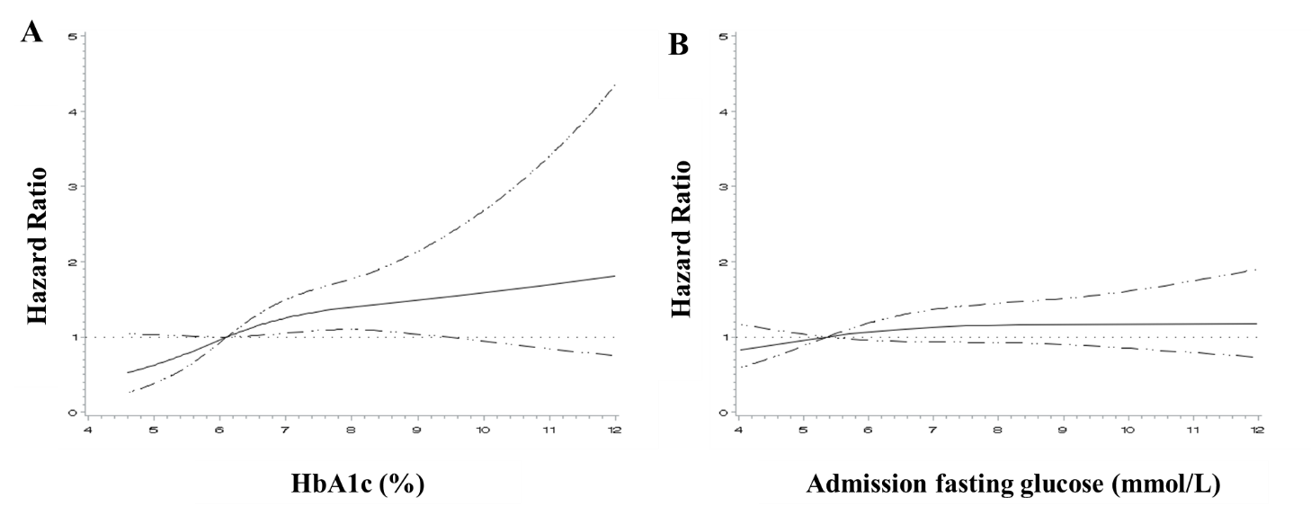

FigureS1. Restricted cubic spline analysis of the association between baseline HbA1c level (A) and admission fasting glucose (B) and major cardiovascular event (MACE) risk. Baseline HbA1c and admission fasting glucose level presented a linear relationship with the risk of MACE (p for non-linearity 0.2119 and 0.4014 respectively). The curves are presented with 95% confidence interval.

FigureS2. ROC Curve of HbA1c in Predicting MACE. The c-index on the basis of the AUC for HbA1c in predicting ischemic stroke was 0.5927. The best cutoff value of HbA1c based on the highest Youden’s index was 6% with sensitivity of 0.667 and specificity of 0.493.

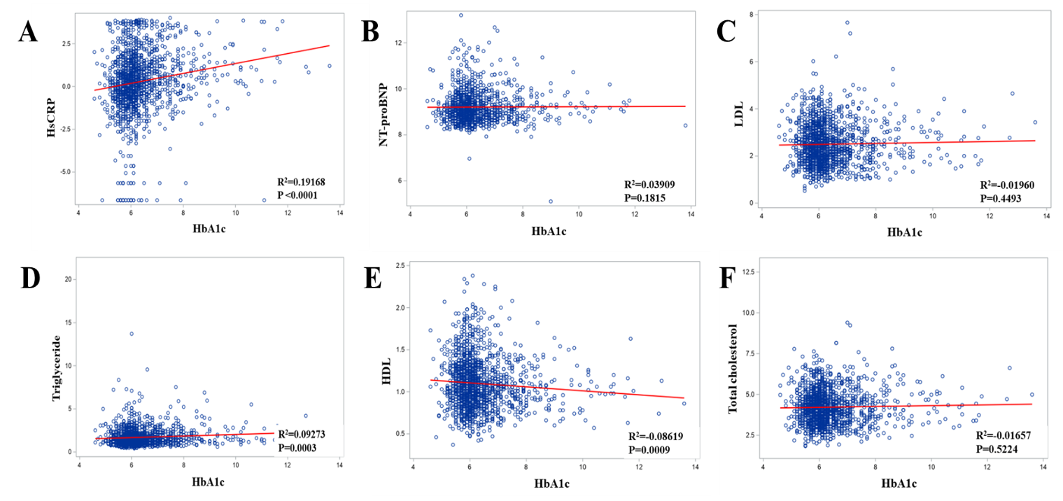
FigureS3. Correlation analysis of the relationship between HbA1c and hsCRP (A), NT-proBNP (B), LDL (C), triglyceride (D), total cholesterol (E) and HDL (F) .

