Table 3 Macro-etched cross-sections of welds with respect to HI. Fusion lines are indicated by yellow dotted lines.

Specimen  No. | Heat input per unit length  (J/mm) | Cross-section
1 | 140 | 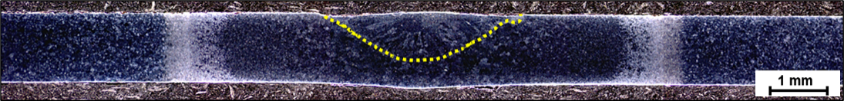
2 | 160 | 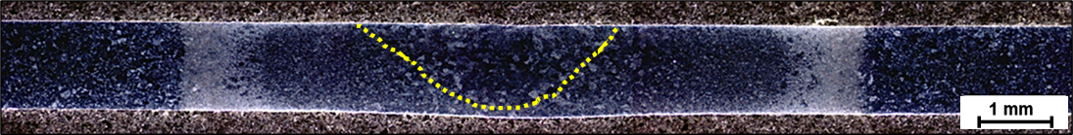
3 | 180 | 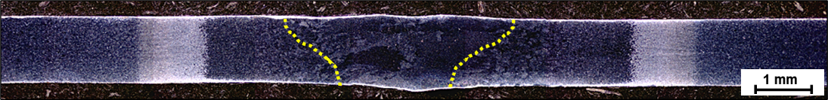
4 | 208 | 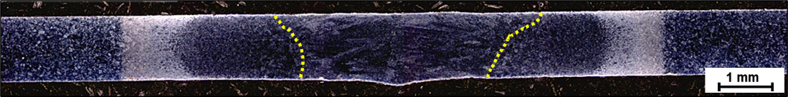
5 | 260 | 