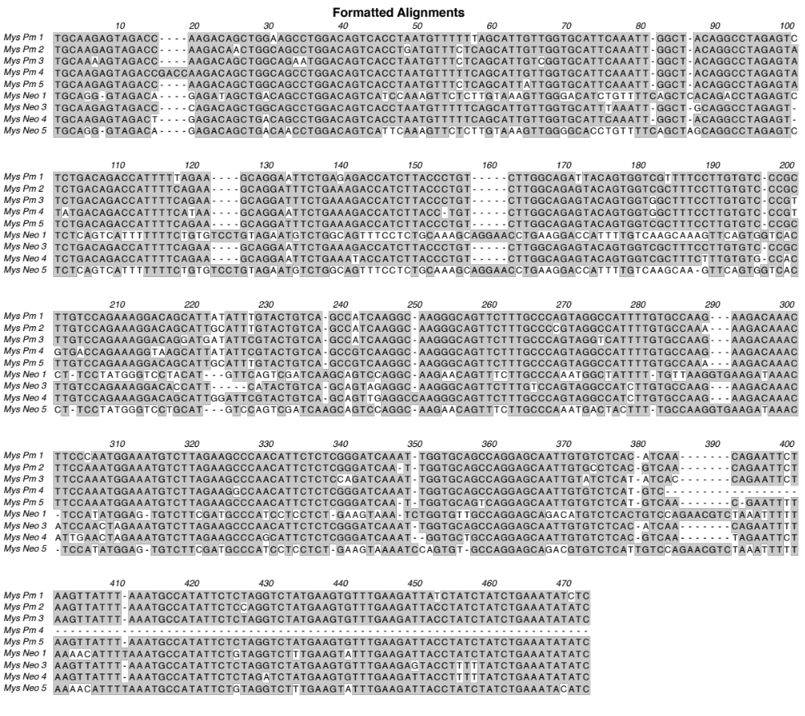

Fig. 2. Sequences of intra-ORF1 PCR DNA clones from P. maniculatus and N. alstoni. Shaded regions represent conserved nucleotides.

Fig. S1. Control dot blot to verify relative rough estimates of DNA loaded on blots using an L1 probe from guinea pig. Standards of mys ORF2 and ORF1 of mys and mysRS go up to 20K estimates. Pp = Peromyscus polionotus; Pm = P. maniculatus; Pmel = P. melanotis; Pl = P. leucopus; Pg = P. gossypinus; Pt = P. truei; Pd = P. difficilis; Pb = P. boylii; Pa = P. aztrecus; Pe = P. eremicus; Pc = P. californicus; Nals = Neotomodon alstoni; Ol = Onychomys leucogaster; Rf = Reithrodontomys fulvescens; Nalb = Neotoma albigula; Op = Oryzomys palustris; Sh = Sigmodon hispidus; Ma = Microcricetus auratus; Mu = Meriones unguiculatus; Mm = Mus musculus; Cp = Cavia porcellus

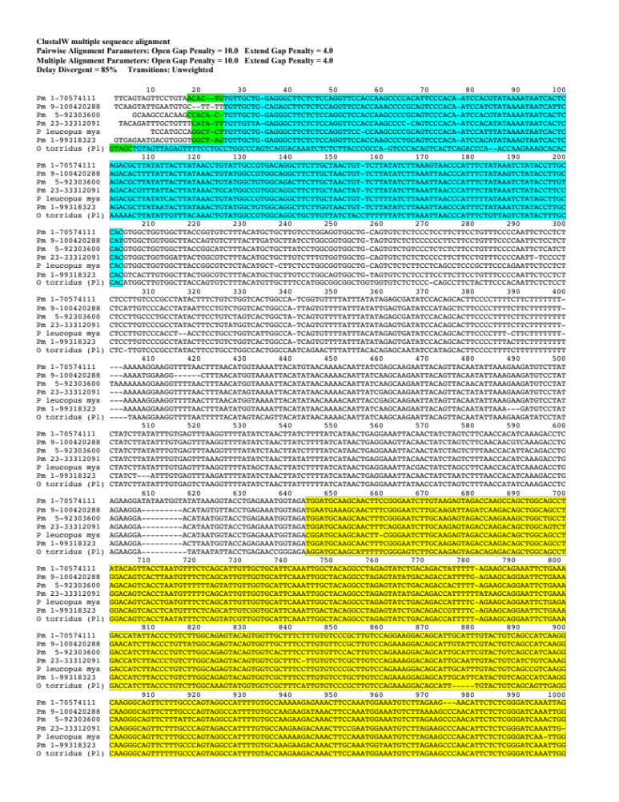

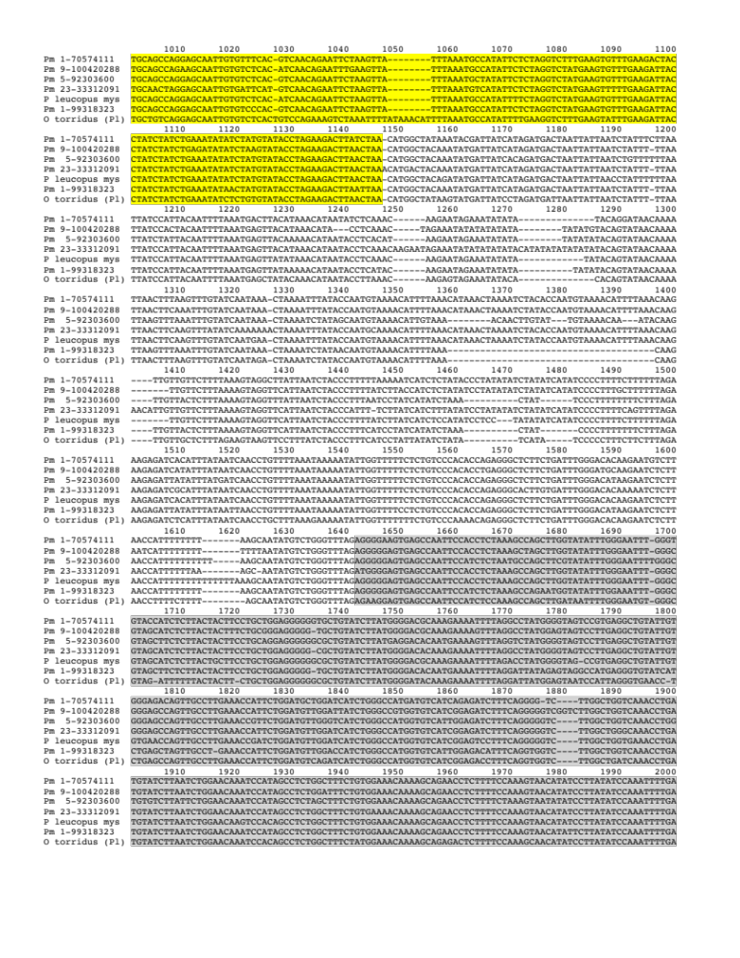

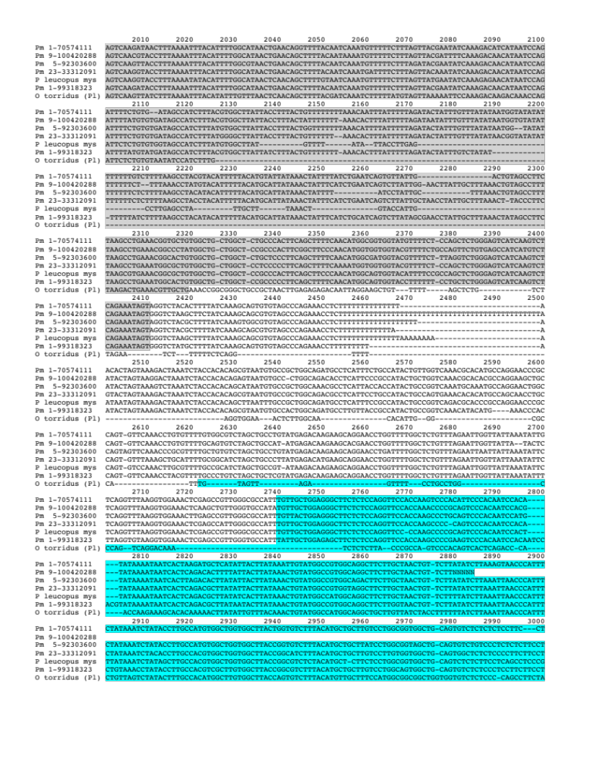
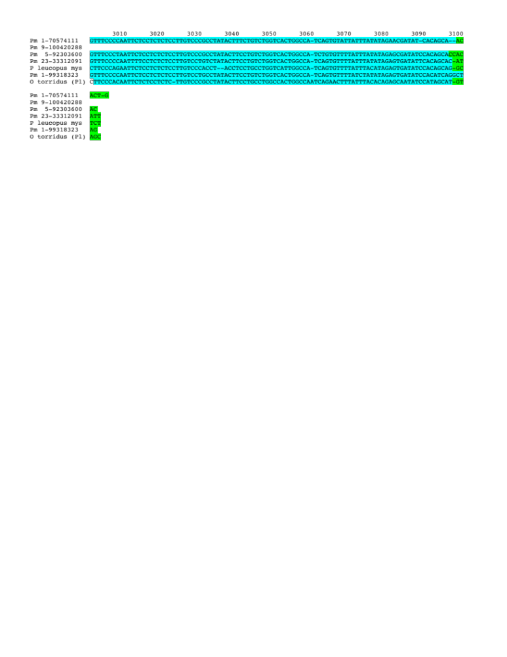

Fig. S3. mys-1 sequence alignment. P. maniculatus and O. torridus mys (Ot (pl) mys 11) elements were identified via database screening queried with the P. leucopus mys-1 element. Green highlight = FDRs, blue highlight = LTRs, yellow highlight = ORF1, grey highlight = ORF2. Labeling of Peromyscus sequences corresponds to chromosome number and approximate chromosomal location based on the Ensembl genomic database.

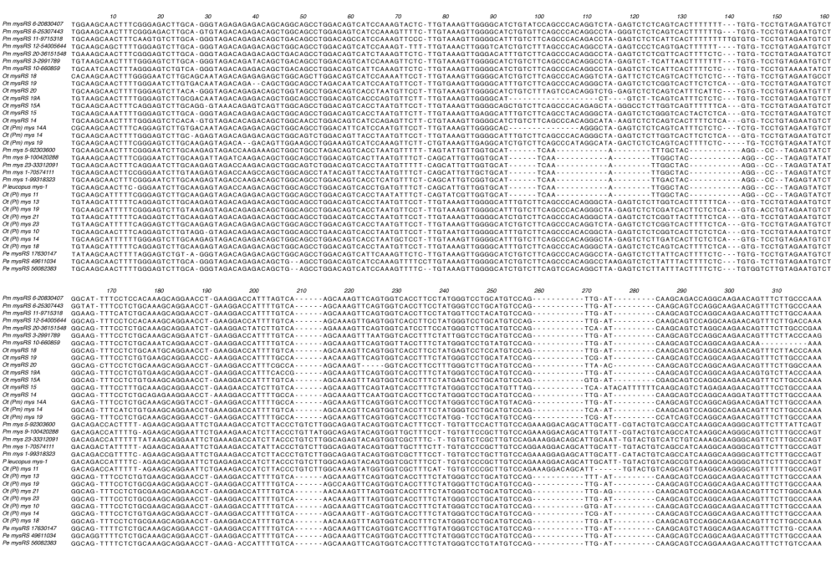

Fig. S4. Partial sequence alignment of database-isolated mys-1 and mysRS ORF1s, distinguished by regions encapsulated in blue boxes.

ClustalW multiple sequence alignment

36 Sequences Aligned Processing time: 127.1 seconds
Gaps Inserted = 5389 Conserved Identities = 556
Score = 94791288

Pairwise Alignment Mode: Slow
Pairwise Alignment Parameters:
Open Gap Penalty = 8.0 Extend Gap Penalty = 4.0

Multiple Alignment Parameters:
Open Gap Penalty = 8.0 Extend Gap Penalty = 4.0
Delay Divergent = 90% Transitions: Unweighted

10 20 30 40 50 60 70 80 90 100
Ot mysRS 18 CAAATGTAGCTA--GAGTTTTTCTCT-CCGGGTCCT--------GCCAAGC-------CCTGGCAGTTCCATAGAT---TACTTATAA---
Ot mysRS 14 AACTATAAAGTACTGTAGCTGGAGAA--CTTCTTT-ACAGCCCCT--------GCCAAGT-------CCTGTTAGTCCGAGAGCC---CACTAATAA---
Ot mysRS 19 CTAGGTGTAGCTGGAGAC--CTTCTCT-CCAGCCCCC--------ACCAAGC-------CCTGTTAGTCTGACAACC---CACTTATAA---
Ot mysRS 19A AGTTAGTGTAGCTGGAGAG--CTTTTCT-CCAGGTCCC--------ACTAAGC-------CCCAGCATTCCAGTAGCC---CACTTATAA---
Ot mysRS 15A CCATTATGTAGTTA--GAG--TTTTTCT-CTAGGTCCC--------ACTAAGC-------CCCAGCAGTCTAGTAGCC---CACTTATAA---
Ot (Pm) mys 14A ttgaatacaTGTAGCTGGAGAGCTTTTCTTT-CCAGGTGCC--------ACCAAGCC------TCTGTTAGTCCAACAGCC---CACTTATAA---
Ot (Pm) mys 14 AATACATGTATCTGGAGAG--CTTCTCT-CCAGGTGCC--------ACCAAGC-------CCCTGCAGTCTCACAACC---CACGTATAA---
Ot mysRS 15 ATGTTAATGTAGTTGGAGAG--CTTCTCT-CCAGGTCCC--------ACTAAAC-------CCCAGCAGTCCAGTAGCC---CACTTATAA---
Ot (Pm) mys 19 ACTGAGCTGTGTAGCTG--GAG-TTTTCTCT-CTGGGTCCC--------GCCAAGC-------CCTGGCAGTCCAACAACC---CACTTATAA---
Pe mysRS 17630147 CCAATAAAGTGTAGCTGGAGAA--TTTCTCT-CCAGCTCCC--GCC---ACCAAGT-------CCCGCCAGTCCCAGAGCC---CACTTATAA---
Pe mysRS 56082383 AGGGATAATGTAGCTGGAGAA--TTTT-CT-CCAGCTCCA--GCC---ACCACGT-------CCCGCCAGTCCCAGAG-C--CCACTTATAA---
Pe mysRS 4961104 GGGCTCTGTAGCTGGAGAA--TTTTTCT-CCAGCTCCC--GCC---ACCAAGT-------CCCGCCAGTCCCAGAGGC--CCACTTATAA---
Pm mysRS 11-9715318 GTAAAGTATGTTGTTGGAGAA--TTTCTCT-CCAGCTCCT--GCC---ACCAAGT-------TCCACCAGTCCCAGAGAC---CACTTATAA---
Pm mysRS 12-54005644 TGTGTGTTGCTGGAGAA--TTTCTCT-CCAGTTCCT--GCC---ACCAAGT-------CCTGCCAGTTCCAGAGCT---CACTTATAA---
Pm mysRS 6-20830407 ATATTGTAGCTGGAGAGCTTTTTTCT-CCAGGTCC-----C---TCCAAGT-------CCCGCCAGTCCCGGAA-C--CCACTCATAA---
Pm mysRS 6-253074430 ATATTGTAGCTGGAGAGCTTTTTTCT-CCAGGTCC-----C---TCCAAGT-------CCCGCCAGTCCCGGAA-C--CCACTCATAA---
Pm mysRS 20-36151548 AT-TAAATA-AGAA--TTTCTCT-CCAGCTCCC-----ACCGCCAAGT-------CCCGCCAGTCCCAGAATC---CACTTATAA---
Pm mysRS 3-2991789 AGTACATTGTTGCTGGAGAA--TTTCTCT-CCAGCTCCT--------GCCAAGT-------CTCGCCAGTCCTGGAGCC---CACTTATAA---
Pm mysRS 10-660859 AAGGACTGTTGCTGGATAA--TTTCTCT-CCAGCTCCC-----ACCGCCAAGT-------CCCGCCAGTCCCAGAGCC---CACTTATAA---
P leucopus mys1 GGCTCTTGTTGCTGGAGGG--CTTCTCT-CCAGGTTCC---------CCAAGC-------CCCG-CAGTCCCACAATC---CATTTATAA---
Pm mys 9-100420288 TGTTGCTGCAGAG--CTTCTCT-CCAGGTTCC--------ACCAAAC-------CCCG-CAGTCCCACAATC---CATGTATAA---
Pm mys 1-70574111 ACACTG-TGTTGCTGGAGGG--CTTCTCT-CCAGGTTCC--------ACCAAGC-------CCCA-CATTCCCACAATC---CACGTATAA---
Pm mys 23-33312091 CATATT--TGTTGTTAGAGGG--CTTCTCT-CCAGGTTCC--------ACCAAGC-------CCC--CAGTCCCACAATC---CACATATAA---
Pm mys 5-92303600 CCACACT---GTTGCTGGAGGG--CTTCTCT-CCAGGCTCC--------ACCAAGC-------CCCG-CAGTCCCACAATC---CACGTATAA---
Pm mys 1-99318323 GGCTAGTGTTGCTGGAGGG--CTTCTCT-CCAGGTTCC--------ACCAAGC-------CCTG-CAGTCCCACAATC---CACATATAA---
Ot (Pl) mys 11 GTAGCTGTAGTTA--GAG--TTTTCCTGCCTGGCCCA--GTCAGGACAAATCTCTCTTACCCGCCAGTCCCACAGTCACTCAGACCCAACCA
Ot (Pl) mys 13 CTAGCTGTGGTGTAGTTA--GAG--TTTTCCTGCCTGGCCCA--GTCAGGACAAATCTCTCTTACCCGCCAGGCCCATAGACGCTCAGAGCCAACCA
Ot (Pl) mys 14 CTGGAGTGTAGTTA--GAG--TTTTCCTGCCTGGCCCACAGTCAGGACAAATCTCTCTTACCCGCCAGTCCCACAGTCGCTCAGACCCAACCA
Ot (Pl) mys 19 GGCTAGTGTAGTTAA-GAG--TTTTCCTGCCTGGCCCACAGTCAGGACAAATCTCTCTCACCCGCCAGTCCCACAGTCGCTCAGACCCAACCA
Ot (Pl) mys 18 CAAGGCTGTAGTTA--GAG--TTTCCCTGCCTGGCCCA--GTCAGGACAAATCTCTCTCACCCACCAGTCCCACAGTCGCTCAGACCCAACCA
Ot (Pl) mys 21 CTCCTTTGTAGTTA--GAG--TTTCCCTGCCTGGCCCA--GTCAGGACAAATCTCTCTCACCCGCCAGTCCCACAGTCGCTCAGACCCAACCA
Ot (Pl) mys 23 TCCTTCTGTAGTTA--GAG--TTTCCCTGCCTGGCCCA--GTCAGGACAAATCTCTCTCACCCATCAGTCCCACAGTCGCTCAGACCCAACCA
Ot (Pl) mys 16 AAATGTTGTAGTTG--GAG--TTTTCCTGCCTGGCCCA--GTCAGGACAAATCTCTCTTACCCACCAGTCCCACAGTCGCTCAGACCCAACCA
Ot (Pl) mys 10 CTGCCCTGTAGTTA--GAG--TTTTCCTGCCTGGCCCA--GTCAGGACAAATCTCTCTTACCTGCCAGTCCCACAGTCGCTCAGACCCAACCA
Ot mysRS 20 TTCTGTGTAGCTA--GAGTTTTTCTTT-CCAGGTCCT--------GCCAAGC-------CCCAGCAGTCTTGTAGCC---CACTTATAA---

110 120 130 140 150 160 170 180 190 200
Ot mysRS 18 AATAAACATACAGTCACTTATATTATTT--AAAATGCTCAGCCATTAACTCAGACCTACAATTGTCTAGCTCTTAC-TCTTATACTCAGTCCATTTCT-G
Ot mysRS 14 AATAAACACACAGACAC----ATTATTT--AAACAGCTTGGCCATTAGCTCAGGCCTACCATTGTCTAGCTCTTAC-TCTTATATTTAGCCCATTTCT-A
Ot mysRS 19 AATAAACACACAGATGCTTATATTACTT--AAACTGCTTGGCCATTAGCTCAGGCCTACCATTGTCTATCTCTTAC-TCTTATATTCAGCCCATTTCT-A
Ot mysRS 19A AATGAACACACAGATACTTACATTATTT--AAACTGCTTGGCCATTAGCTCAGGCCTGCCATTGTCTAGCTCTTAC-TTTTATATTCAACCCATTTCT-A
Ot mysRS 15A AATGAACACACAGACGCTTATATTATTTC--AACTGCTTGGCCATTAGCTCAGGCCTACCACTGTCTAGCTCTTAC-TCTTATATTTAGCCCATTTCT-A
Ot (Pm) mys 14A AATAAACACACAGACACCTATATTATTT--AAACTGCTTGGCCATTAGCTCAGGCCTGTCATTGTCCA-CTC-----------ATT--------TTC--A
Ot (Pm) mys 14 AATAATCACTCAGACGCTTATATTACTTATAAACTGTATGGCCAT-GGC--ATGCTTCTTGTTATCTACTTCTTCTATCCTAAATT-AACCCATTTCT-A
Ot mysRS 15 AATGAACACACAGACACTTATATTATTT--AAACTGCTTGGCCATTAGCTCAGGCCTGTCATTGTCTAGCTCTTAC-TCTTATATTTAGCCCATTTCT-A
Ot (Pm) mys 19 AATAAACACACAGATGCTTATATTACTTATAAACTTTATAGCTGT-GGC--AGGCTTCTTGCTAACTG-TTCTTATATCTTAAATC-AACCCATTTCT-A
Pe mysRS 17630147 AATAAACACACAGACTCTTACATTATTT--AAACTGCTTGGCCATTAGCTCAGGCCTGTTATTGTCTAGCTCTTAC-TCTTATATTTAGCCCATT-CT-A
Pe mysRS 56082383 AATAAACACACAA-CTCTTATATTATTT--AAACTGCTTGGCCATTAGCTCAGGCCTGTCATTGTCTAGCTCTTAC-TCTTATATTTAGCCCATTTCT-A
Pe mysRS 4961104 AATAAACACACAAACTCTTATATTATTT--AAACTGCTTGGCCATTAGCTCAGGCCTGTCATTGTCTAGCTCTTAC-TCTTATATTTAGCCCATTTCT-A
Pm mysRS 11-9715318 AATAAACACACAGAGTCTTACATAATTT--AAACTGCTTGGCCATTAGCTCAGGACTATCATTGTCTAGCTCTTAC-TCTTATATTTAGCCCATTTCT-A
Pm mysRS 12-54005644 AATAAACACACAGATGCTTACATTATTT--AAACTGCTTAGCCATTAGCTCAGGACTATCATTGTCTAGCTCTTAC-TCTTATATT-AGCCTATTTCT-A
Pm mysRS 6-20830407 AATAAACACACAGACTCTTACATTATTT--AAACTGCTTGGCCATTAGCTTAGGCCTATCATTGCCTAGCTCTTAC-TTTTATATTTAGCCCATTTCT-A
Pm mysRS 6-25307443 AATAAACACACAGACTCTTACATTACTT--AAACTGCTTGGCCATTAGCTTAGGCCTATCATTGCCTAGCTCTTAC-TTTTATATTTAGCCCATTTCT-A
Pm mysRS 20-36151548 AATAAACACACA----CT---------------CTGCTTGGCCATTAGCTCAGGCCTATCATTGTCTAGCTTTCAC-TCTTATATT----------CT-A
Pm mysRS 3-2991789 AATAAACACACAGACTCTTACATTACTT--AAACTGCTTGGCCATTAGCTCAGGCCTATCATTGTCTAGCTCTTAC-TCTTATATTTAGCCCATTTCT-A
Pm mysRS 10-660859 AATAAACACACAGACTCTTACATTATTT--AAACTGCTTGGCCATTAGCTCAGGCCTATCATTGTCTAGCTCTTAC-TCTTATATTTAGCCCATTTTTTA
P leucopus mys1 AATAATCACTCAGACGCTTATATCACTTATAAACTGTATGGCCGT-GGC--AGGCTTCTTGCTAACTG-TTCTTTTATCTTAAATT-AACCCATTTTT-A
Pm mys 9-100420288 AATAATCATTCAGACACTTTTATTACTTATAAACTGTATGGCCGT-GGC--AGGCTTCTTGCTAACTG-TTCTTATATCTTAAATT-AACCCATTTCT-A
Pm mys 1-70574111 AATAATCACTCAGACGCTTATATTACTTATAACCTGTATTGCCGT-GAC--AGGCTTCTTGCTAACTG-TTCTTATATCTTAAAGT-AACCCATTTCT-A
Pm mys 23-33312091 AATAATCACTCAGACACGTTTATTACTTATAAACTGCATGGCCGT-GGC--AGGCTTCTTGCTAACTA-TTCTTATATCTTAAATT-AACCCATTTCT-A
Pm mys 5-92303600 AATAATCACTCAGACGCTTATATTACTTATAAACTGTATGGCTGT-GGC--AGACTTCTTGCTAACTG-TTCTTATATCTTAAATT-AACCCATTTCT-A
Pm mys 1-99318323 AGTAATCACTCAGACGCTTATAATACTTATAAACTGTATGGCTGT-GGC--AGGCTTCTTGGTAACTG-TTCTTATATCTTAAATT-AACCCATTTCT-A
Ot (Pl) mys 11 AGAAAGCACACAAAAACTTATATTGTTTACAAACTGTATGGCCGT-GGC--AGGCTGCTTGTTATCTACCTTTTTTATCTTAAATT-AACCCATTTCT-G
Ot (Pl) mys 13 AGTAAACACACAGAAACTTATATTGCTTACAAACTGTATGGCCGT-GGC--AGGCTTCTTGTTATCTAATTCTTCTATCTTAAATT-AACCCATTTCT-G
Ot (Pl) mys 14 AGAAAGCACACAGAAACTTATATTGCTTATAAACTGTATGGCCGT-GGC--AGGCTGCTTGTTATCTACCTTTTCTATCTTAAATT-AACCCATTTCT-G
Ot (Pl) mys 19 AGAAAGCACACAGAAACTTACATTGTTTACAAACTGTTTGGCTGT-GGC--AGGCTTCTTGTTATCTACTTTTTCTATCTTAAATT-AACCCATTTCT-G
Ot (Pl) mys 18 AGATAGCACACAGAAACTTATATTGCTTACAAACTGTATGGCCGT-GGC--AGGCTGCTTGTTATCTACCTTTTCTATCTTAAATT-AACCCATTTCT-G
Ot (Pl) mys 21 AGAAAGCACACAGAAACTTATATTGCTTACAAACTGTATGGCCGT-GGC--AGGCTGCTTGTTATCTACCTTTTCTATCTTAAATC-AACCCATTTCT-G
Ot (Pl) mys 23 AGAAAGCACACAGAAACTTATATTGCTTACAAACTGTATGGCCGT-GGC--AGGCTGCTTGTTATCTACCTTTTCTATCTTAAATT-AACCCATTTCT-G
Ot (Pl) mys 16 AGAAAGCACACAGAAACTTACATTGTTTACAAACTGTATGGCCGT-GGC--AGGCGTCTTGTTATCTACTTCTTCTATCTTAAATT-AACCCATTTCT-G
Ot (Pl) mys 10 AGAAAGCACACAG--ACTTACATTATTTAGAAACTGTATGGCCGT-GGC--AGGCTTCTTGTTATCTGCTTCTTCTATCTTAAATT-AACCCATTTCT-G
Ot mysRS 20 AATAAACACACAGACACTTATATTATTT--AAACTGCTCGGCCATTAGCTCAGGCCTACCATTGTCTAGCTCTTAC-TCTTATACTCAGCCCATTGTT-G

210 220 230 240 250 260 270 280 290 300
Ot mysRS 18 TTCATCTGTATGTCACCACATGTTCTGTGGCTTTACCTGCTGCTTTTACATGATGTTTCCTGCACTGCAGG-CT---GGCG----TGTCCTCCTTTCCAC
Ot mysRS 14 TTAATCTATACTTTGCCACATGGCTTGCGGCTT-ACTGG-TA-CCTTACATCTTCTTTGTTCTGGTGGCA--TT---GGCAG---TGTCTCCTTC--TCC
Ot mysRS 19 TTAATCTATACTTTGCCACATGGCTCGTGGCTT-ACCGT-CA-CCTTACATCTTCCTTGTCCTGGCGGCTG-CT---GGCCG---TGTACCCTCC--TGC
Ot mysRS 19A TTAATCTATACTTTGCCACGTGGCTCATGGTTT-ACCTG-TA-CCTTACATCTCACTTGTCATGGCGGCAG-CT--GGGTCG---TCTCTCCACCCCAGG
Ot mysRS 15A TTAATCTACACTTTGTCATGTGGCTTGTGGCTT-ACCTG-TA-TCTTACATCTCATTTGTCATGGCAGCGG-CT---GGCAGGTCTCTCCCTTCCTTCAC
Ot (Pm) mys 14A TTAATCTATACTTTGCCATGTGGCCTGTGGCTT-ACTGG-TA-CCTTACATCTTCCTTGTCCTGGTGGCCG-CT---GGCAGG--TCTCTCTCCT-CTGC
Ot (Pm) mys 14 TTAGTCTATAACTTGCCACGTGGTTTGTGGCTT-ACCTG-TA-CCTTACATCTCGCTTGTCATGGCATCGG-CT---GGCAGC--TCTCCCCCTT-CCCC
Ot mysRS 15 TTAATCTATACTTTGCCACGTGGCTCGTGGCTT-ACCTC-TA-CCTTACATGTTGTTTGTCATGGTGG----CT---GGCAGC--TCTCTCCACCTCTGC
Ot (Pm) mys 19 TTCATCTATAAGTTGCCACGTGGCTCATAGCTT-ACCAG-TA-CCTTACATCTCGCTTGTCATGGCAGCAG-CAGCCAGCAGTG-TCTCTCTGCCTCAGC
Pe mysRS 17630147 TTAATCTTTACTTTGCCACATGGCTCATGGCTT-ACTGG-TA-CCTTACATCTTCCTTGTCCTGATGGCGG-CTC---GCAG---TGTCTCTCTCTCAGC
Pe mysRS 56082383 TTAATCTT-ACTTTGCCACATGGCTCATGGCT--ACTGG-TACCTTA-CATCTTCCTTGTCCTGGCGGCAG-CTCCAGGCAG---TCTCTCTCTC--TTC
Pe mysRS 4961104 TTAATCTTTACTTTGCCACATGGCTCATGGCTT-ACTGG-TACCTTAACATCTTCCTTGTCCTGGTGGCGG-CTCCAGGCAG---TCTCCCTCT---TCC
Pm mysRS 11-9715318 TTAATCTTTACTTTGCCACGTGGCTCATGGCTT-ACCAG-TA-CTTTACATCTTCCTTGTCCTGGCAGTGG-CTCTAGGCAG---TCTCTCCTT-----C
Pm mysRS 12-54005644 TTAATCTTTACTTTGCCACCTGGTTCGTGGCGT-ACTGG-TA-CCTTACATCTTCCTTGTCCTGGTGGCGG-CTCTAGCCAG---TCTCCTCCTC--TGT
Pm mysRS 6-20830407 TTAATTGTTACTATGCCATGTGGCTCGTGGCTT-ACTGG-TACTTTA-CATCTTCTTTGTCCTGGAGGCGG-CTTCAGGCAG---TCTCTCCAT----TC
Pm mysRS 6-25307443 TTAATTTTTACTATGCCATGTGGCTCGTGGCTT-ACTGG-TACTTTA-CATCTTCCTTGTCCTGGAGGCGG-CTTCAGGCAG---TCTCTCCTT----TC
Pm mysRS 20-36151548 TTAATCTTTACTTTGCCAAGTGACTCGTGGCTT-ACCGG-TA-CTTTACATCTTCCTTGTCCTGTCAGTGG-GTCCAGGTGG---TGTCTTCTCT----C
Pm mysRS 3-2991789 TTAATCTTTACTTTGCCACATGGCTTGTGGCTT-ACTGG-TA-CTTTACATCTTCCTTGTCCTGGCGACGG-CTCCAGGCAG---TCTCTCTTTT----C
Pm mysRS 10-660859 TTAATCTTTACTTTGCCATGTGGCTTGTGGCTT-ACCAG-TA-CTTTACATCTTCCTTGTCTGGGCGGT---CT-------------CCTCTTT-----C
P leucopus mys1 TAAATCTATAGCTTGCCACGTGGCTGGTGGCTT-ACCGG-CGTCTCTACATGCT-CTTCTCCTGGCGGTGG-CT----GCAG---TCTCTCTTCCTCAGC
Pm mys 9-100420288 TAAGTCTATACCTTGCCATGTGGCTGGTGGCTT-ACCAG-TGTCTTTACTTGATGCTTATCCTGGCGGTGG-CT----GTAG---TGTCTCTCCCCCCTT
Pm mys 1-70574111 TAAATCTATACCTTGCCACGTGGCTGGTGGCTT-ACCGG-TGTCTTTACATGCTGCTTGTCCTGGAGGTGG-CT---G-CAG---TGTCTCTCCCTCCTT
Pm mys 23-33312091 TAAATCTATACCTTCCCACGTGGCTGGTGGATT-ACTGG-CGTCTTTACATGCTGCTTGTCTTTGTGGTGG-CT---G-CAG---TGTCTCTCTCCCCTT
Pm mys 5-92303600 TAAATCTATACCTTGTCACGTGGCTGGTGGCTT-ACCGG-CATCTTTACATGCTGCTTATCCTGGCGGTGG-CT---G-CAG---TGTCTGTCCCTCTCT
Pm mys 1-99318323 TAAATCTATACCTTGCCACGTCACTTGTGGCTT-ACTGG-CGTCTTTACATGCTGCTTGTCCTGGCAGTGG-CT---G-TAG---TGTCTCTCCTTCCTT
Ot (Pl) mys 11 TTAGTCTATACTTTGCCACATGGCTTGTGGCTT-ACCAG-TGTCTTTACATGTTGCTTTCCATGGCGGCGG-CT---GGTGG---TGTCTCTCCC-CAGC
Ot (Pl) mys 13 TTAGTCTATACTTTGCCACATGGCTTGTGGCTT-ACCAG-TGTCTTTACATGTTGCTTCTCATGGCGGCAG-CT---GGCGG---TGTCTCCCC--CAGT
Ot (Pl) mys 14 TAAGTCTATACTTTGCCACATGGCGTGTGGCTT-ACCAG-TGTCTTTACATGTTGCTTCTCATGGCAGCGG-CT---GGCAG---TGTCTCTCTC-CAGC
Ot (Pl) mys 19 TTAGTCTATACTTTGCCACATGGCTTGTGGCTT-ACCAG-TGTCTTTACATGTTGCTTCTCATGGCGGCGG-CT---GGCGG---TGTCTCCCCC-CAGC
Ot (Pl) mys 18 CTTATCTATACTTTGCCACATGGCTTGTGGCTT-ACCAG-TGTCTTTACATGTTGCTTCTCATGGCGGCGG-CT---GGCGG---TCTCTCTCC-----C
Ot (Pl) mys 21 CTTATCTATACTTTGCCACATGGCTTGTGGCTT-ACCAG-TGTCTTTACATGTTGCTTCTCATGGCGGCGG-CT---GGCGG---TCTCTCTCCC-CAGC
Ot (Pl) mys 23 TTAATCTATACTTTGCCACATGGCTTGTGGCTT-ACCAG-TGTCTTTACATGTTGCTTCTCATGGCGGAGG-CT---GGCGG---TCTCTCTCCC-CAGC
Ot (Pl) mys 16 TTAGTCTATACTTTGCCACATGGCTTGTGGCTT-ACCAG-TGTCTTTACACGTTGCTTCTCATGGCGGCAG-CT---GGCAG---TCTCTCTCTC-CAGC
Ot (Pl) mys 10 TTAGTCTATACTTTGCCACATGGCTTGTGGCTT-ACCAG-TGTCTTTACATGTTGCTTCTCATGGCGGCAG-CT---GGCGG---TGTCTCTC---CAGC
Ot mysRS 20 TTAATCTATATGTTGCCACGTGTTTCGTGGCTTGACCTGCTGCCTTTCCATGATGCTTCTTG-GATGGCAGACTT---GTG----TCTCCTCCTCTCTGC

310 320 330 340 350 360 370 380 390 400
Ot mysRS 18 CTTCCTGTTCTCTCAGTTCTCCTCTCTGCTAGTCCCACCTAAACTTCCTGCCTGGCTATTGGCCAATCAGTGTTTAATTT----ATCAAT-------CAA
Ot mysRS 14 CTTCCTGTTTTCTCAGT--TGCTCTCTGTTAGTCCCGCCTATACTTCCTGCCTGGCAACTGGCCAATCAGTGTTTTATTT----GT--AC-AT--AGTGG
Ot mysRS 19 CTTCTTGTTCTCCCAATTCTCCCCTCTCTTAGTCCCGCCTATACTTCCTGCCTGGCTACTGACCAATTAGTGTTTTATTT----ACCAAT-------CAA
Ot mysRS 19A CTTC-ACTTCCCAGAATTCTCTTCTCTGCTTGTCCCGCCTATACTTCCTGCCTGGCTACTGGCCAATCAGCATTTTATTT----AC--AC-AG--AGCGA
Ot mysRS 15A CTTCCACTTCCCAGAATTCTCCTCTCTCCTTGTCCCGCCTATACTTCCTGCCTGGCTACTGGCCAATCAGCA-TTTATTT----TT--AC-AG--AGCGA
Ot (Pm) mys 14A CTTCTACTTCCCAGAATTCTCTTCTCTACTTGTCCCACCTATACTTCCTGCCTGGCAACTGGCCAATCAGTATTTTATTT----AT--AC-AG--AGCAA
Ot (Pm) mys 14 ATTCCACTTTCCAGAATTCTCTTTTCTGCTTGTCCCACCTATACTTTCTGCCTGGCTACTGGCCAATCAGTGTTTTATTTT--AGCCAATCAG--AGCAA
Ot mysRS 15 CTTCTACTTCCCAGACTTCCCTTCTCTGTTTGTCCCACCTATACTTACTGCCTAACTACTGGCCAATCAGTGTTTTATTTT--AACCAATCAG--AGCAA
Ot (Pm) mys 19 CTTCCACTTCCCAGAATTCTCTTCTCTGCTTGTTCTGCCTATACTTCCTGCTTGGTTACTGGCCAATCAGTGTTTTATTTATTAACCAATCAG--AACAA
Pe mysRS 17630147 CTTCCACTTCCCAGAATTCTTTTCC----TTGTCCCACCTATACTTCCTGCCTAGCCAATGGCCAATCAGTGATTTATTT----ACTGACCAATCAGCAA
Pe mysRS 56082383 CTTCCTGTTCC-TCAGTGCTCTTCTTTGTTAGTCCCGCCTATACTTCCTGTCTGGCTATTGGCCAATCAGAG-TTTATTT----AC--AT-AT--AGCGA
Pe mysRS 4961104 CTTCCTGTTCCCTCAATTCTCTTCTCTGTTAGTCCCGCCTATACT-CCTGTCTGGCTATTGGCCAATCAGAG-TTTATTT----AC--AT-AT--AGAGA
Pm mysRS 11-9715318 CTTCCTCCT----------TCCTCTCTGTTAGTTCTACCTATACTTCTTGTCTGGCTATTGGCCAATCAGTG-TTTATTT----AC--AT-AT--AACGA
Pm mysRS 12-54005644 CTTCTTGTTCCCTCAATTCTCCTCTCTGTTAGTCCCGCCTATACTTCCAGTCTGGCTACCAGCCAATCAGTG-TTTATTT----AT--AC-AG--AGCAA
Pm mysRS 6-20830407 CTCCCTCCTTCCTCAATTCTCCCCTCTGTTAGTCCTGCCTATACTTCCTGTCTGACTATTGGCCAATCAGCA-TTTGTTT----AT--AT-AG--AGCGA
Pm mysRS 6-25307443 CTCCCTCCTTCCTCAATTCTCCCCTCTGTTAGTCCTGCCTATACTTCCTGTCTGACTATTGGCCAATCAGTA-TTTGTTT----AT--AT-AG--AGCGA
Pm mysRS 20-36151548 CTTTCTCCCTTCTTCATTCTCCTCTATGTTAGTCCCGCCTATACTTCCTGTCTGGCTATTGGCCAATCAGAG-TTTATTT----AC--AT-AT--AGCAA
Pm mysRS 3-2991789 CTTCCTCCTTCCTCAATTCTCCTCTCTGTTAGTCCCACCTATATATCCTGTCTGGCTATTGGCCAATCAGTG-TTTATTT----AC--AT-AT--AGTGA
Pm mysRS 10-660859 CTTCCTCATTCCTCAATTCTCCTCTCTCCTTGTCCCGCCTATACTTCCTGCCTGGTCATTGGCCAATCAGTGCTTTATTT----AT--AT-AG--AGCAA
P leucopus mys1 CTCCCGCTTCCCAGAATTCTCCTCTCTCCTTGTCCCACCTA--CCTCCTGCCTGGTCATTGGCCA-TCAGTGTTTTATTT----AC--AT-AG--AGTGA
Pm mys 9-100420288 CTTCCTGTTTCCCCAATTCTCCTCTCTCATTGTCCCACCTATAATTCCTGTCTGGTCACTGGCCA-TTAGTGTTTTATTT----AT--AT-TG--AGTGA
Pm mys 1-70574111 CTTCCTGTTTCCCCAATTCTCCTCTCTCCTTGTCCCGCCTATACTTTCTGTCTGGTCACTGGCCA-TCGGTGTTTTATTT----AT--AT-AG--AGCGA
Pm mys 23-33312091 CTTCCTGTTTCCCCAATT-TCCCCTCTCCTTGTCCCGCCTATACTTTCTGTATGGTCACTGGCCA-TCAGTGTTTTATTT----AT--AT-AG--AGTGA
Pm mys 5-92303600 CTTCCTGTTTCCCCAATTCTCATCTCTCCTTGCCCTGCCTATACTTCCTGTCTAGTCACTGGCTA-TCAGTGTTTTATTT----AT--AT-AG--AGCGA
Pm mys 1-99318323 CTTCCTGTTTCCCCAATTCTCCTCTCTCCTTGTCCCGCCTATACTTCCTGTCTGGTCACTGGCCA-TCAGTGTTTTATTT----AT--AT-AG--AGTGA
Ot (Pl) mys 11 CTTCTACTTCCCACAATTCTCTCCTCTC-TTGTCCCGCCTATACTTCCTGCCTGGCCACTGGCCAATCAGAACTTTATTT----AC--AC-AG--AGCAA
Ot (Pl) mys 13 CTTCTACTTCCCAGAATTCTCTTCTCTC-TTGTCCCACCTATACTTCCTGCCTGGCCACTGGCCAATCAGAACTTTATTT----AT--AC-AG--AGCGA
Ot (Pl) mys 14 CTTCTACATCCCAGAATTCTCTACTCTC-TTATCCCGCCTATACTTCCTGCCTGGCCACTGGCCAATCAGAACTTTATTT----AC--AC-AG--AGCGA
Ot (Pl) mys 19 CTTCTACTTCCCAGAATCCTCTTCTCTC-TTGTCCCGCCTATACTTCCTGCCTAGCCACTGGCCAATCAGAACTTTATTT----AC--AC-AG--AGCGA
Ot (Pl) mys 18 CTTCTACTTCCCAGAATTCTCTTCTCTC-TTGTCCCGCCTATACTTCCTGCCTGGCCACTGGCCAATCAGAATTTTATTT----AC--AC-AG--AGCGA
Ot (Pl) mys 21 CTTCTACTTCCCAGAATTCTCTTCTCTC-TTGTCCCACCTATACTTCCTGCCTGGCCACTGGCCAATCAGCATTTTATTT----GT--AC-AG--AGCGA
Ot (Pl) mys 23 CTTCTACTTCCCAGAATTCTCTTCTCTC-TTGTCCCACCTATACTTCCTGCCTGGCCACTGGCCAATCAGCATTTTATTT----GT--AC-AG--AGCGA
Ot (Pl) mys 16 CTTCTACTTCCCAGAATTCTCTTCTCTC-TTGTCCCGCCTATACTTCCTGCCTAGCCACTGGCCAATCAGAATTTTATTT----AC--AC-AG--AGCGA
Ot (Pl) mys 10 CTTCTACTTCCCAGAATTCTCTTCTCTC-TTGTCCCGCCTATACTTCCTGCCTAGCCACTGGCCAAACAGCATTTTATTT----GT--AC-AG--AGAGA
Ot mysRS 20 CTTCCTGTTTTCTCAATTCTCCTCTCTGTTAGTCCCGCCTATACTTCCTGGCTGGATACTGGCCAATCAGTGTTTTATTT----ATCAAT-------CAA

410 420 430 440 450 460 470 480 490 500
Ot mysRS 18 TCA------------------TCC-ACAGCACTTGCCCTTTTTCTTTT----------TTTTTCTTCAAAAAGGAAGGTTT-TAACTTTAAC-ATAGTAA
Ot mysRS 14 TA-------------------TCC-ACAGCACTTCTCCTTTTCTTTCTTTCTTTCTTTTTTTTTTTTTTAAAGGAAGGTTTTTAACTTTCAT-ATAGTAA
Ot mysRS 19 TCA------------------CCC-ACAGCACTTCCCCCCATTTTTTT------------TTCA----AAAACGAAGGTTTCTAACTTTAAC-ATAGTAA
Ot mysRS 19A TA-------------------TCC-ACAGCACTTCCCCTTTTCTTTTT------------TTT-------AAGGAAGGTTT-TAACTTTTGC-ATAGTAA
Ot mysRS 15A TA-------------------TCC-ACAGCACTTCCCCTTTTCTTTTT-----------TTTT-------AAGGAAGGTTT-TAACTTTCAC-ATAGTAA
Ot (Pm) mys 14A TA-------------------TCC-ATAGCACTTCCCCTTTTCTTTTT----------TTTTTTC---TAAAGTAAGGTT---AACTTTCAC-ATAGTAA
Ot (Pm) mys 14 CAAATTTGACATACTTGAACATCTCACAGCATTTCCCCTTTTCTTTTT------------TTCA----TAAAGCAAGGTTT-TAACTTTTAT-TTAGTAA
Ot mysRS 15 CACATTTGACATACTTGAACATCCCACAGCACTTGCCCTTCTCTTTTT------------TTCA----AAATGCAAGGTTT-TAACTTTTAT-AGAGTAA
Ot (Pm) mys 19 CACATTTGACATACA-GAACATCCCACAGCACTTCCCCTTTTCTTTTT------------TTCA----AAAAGGAAGATTT-TAACTTTCAC-ATAGTAA
Pe mysRS 17630147 CACACTTGACATACAGACCATCCC-ACAGCACTTCCCCTTTTCTTTTC------------TTA-----AAAAGGAAGGTTT-TAACTTTAACCATAGTAA
Pe mysRS 56082383 TAA------------------TCC-ACAGCACTTCCCCTTTTCCTTCT----------TTTTTT---TAAAAGGAAGGTTT--AACTTTAAC-ATAGTAA
Pe mysRS 4961104 TA-------------------TCC-ACAGCACTTCCCCCTTTC-TTCT----------TTTTTT---TAAAAGGAAGGTTT-TAACTTTAAC-ATAGTAA
Pm mysRS 11-9715318 TA-------------------TCC-ATAGCACTTCCCCTTTTCTTCTT-----------TTTTA----AAAAGGAAGGTTT-TAACTTTAAC-ATAGTAA
Pm mysRS 12-54005644 TA-------------------TCC-ACAGCACTTGCCCTTTTCTTCTT-----------GTTCA----AAAAGGAAGGTTT-TAACTTTAAC-ATAGTAA
Pm mysRS 6-20830407 TA-------------------TCC-ATAGCACTTCCTCTTTTC-TTCT----------TTTTTTA-AAAAAAGGAATGTTT-TAACTTTAAC-ATAGTAA
Pm mysRS 6-25307443 TA-------------------TCC-ATAGCACTTCCTCTTTTC-TTCT----------TTTTT---AAAAAAGGAATGTTT-TAACATTAAC-ATAGTAA
Pm mysRS 20-36151548 CA-------------------TCT-ACAGCACTTCCCCTTTTCTTCTT-----------TTTTA----AAAAGGAAGGTTT-TAACGTTAAC-ATAGTAA
Pm mysRS 3-2991789 TA-------------------TCC-ACAGCACTTCCCCTTTTCTTCTT-----------TTTTA----AAAAGGAAGGTTT-TAACTTTAAC-CTAGTAA
Pm mysRS 10-660859 TA-------------------TCC-ACAACACTTCCCATTTTTTCTTT------------TTCA----AAAAGGAAGGTTT-TAACTTCAAC-ATAGTAA
P leucopus mys1 TA-------------------TCC-ACAGCACTTCCCCTTT-CTTCTT----------TTTTTA----AAAAGGAAGGTTT-TAACTTTAAC-ATGGTAA
Pm mys 9-100420288 TA-------------------TCC-ATAGCTCTTCCCCTTTTCTTCTT----------TTTTTA----AAATGGAAGG-------CTTTAAC-ATGGTAA
Pm mys 1-70574111 TA-------------------TCC-ACAGCACTTCCCCTTTTCTTCTT----------TTTTT----AAAAAGGAAGGTTT-TAACTTTAAC-ATGGTAA
Pm mys 23-33312091 TA-------------------TCC-ACAGCACTTCCCCTTTTCTTCTT----------TTTTT----AAAAAGGAAGGTTT-TAACTTTAAC-ATAGTAA
Pm mys 5-92303600 TA-------------------TCC-ACAGCACTTCCCCTTTTCTTCTT----------TTTTTTTAAAAAAAGGAAGGTTT-TAACTTTAAC-ATGGTAA
Pm mys 1-99318323 TA-------------------TCC-ACAGCACTTCCCCTTTACTTCTT----------TTTTTT---AAAAAGGAAGGTTT-TAACTTTAAT-ATGGTAA
Ot (Pl) mys 11 TA-------------------TCC-ATAGCACTTCCCCTTTTCTTTTT----------TTTTTT----TAAAGGAAGGTTT-TAATTTTTAC-ATAGTAC
Ot (Pl) mys 13 TA-------------------TCC-ACAGCACTTCCCCTTTTCTTTTT----------TTTT--------AAGGAAGGTTT-TAACTTTTAC-ATAGTAC
Ot (Pl) mys 14 TA-------------------TCC-ACAGCACTTCCCCTTTTCTTTTTCTTTTT----TTTTTT----TTAAGGAAGGTTT-TAACTTTTAC-ATAGTAC
Ot (Pl) mys 19 TA-------------------TCC-ACAGCACTTCCCCTTTTCTTTTT----------TTTTTT----TAAAGGAAGGTTT-TAACTTTTAC-ATAGTAC
Ot (Pl) mys 18 TA-------------------TCC-ACAGCACTTCCCCTTTTCTTTTT----------TTTTTT----A--AGGAAGGTTT-TAACTTTTAC-ATAGTAC
Ot (Pl) mys 21 TA-------------------TCC-ACAGCACTTCCCCTTTTCTTTTT----------TGTTAA----AAAAGGAAGGTT---AACTTTCAC-ATAGTAA
Ot (Pl) mys 23 TA-------------------TCC-ACAGCACTTCCCCTTTTCTTTTT----------TGTTAA----AAAAGGAAGGTT---AACTTTCAC-ATAGTAA
Ot (Pl) mys 16 TA-------------------TCC-ACAGCACTTCCCCTTTTCTTTTT----------TTTTTT----T-AAGGAAGGTTT-TAACTTTTAC-ATAGTAC
Ot (Pl) mys 10 TA-------------------TCC-ATAGCACTTCCCCTTTTCTTTTT----------TTTTTT------AAGGAAGGTTT-TAACTTTTAC-ATAGTAC
Ot mysRS 20 TCA------------------TCC-ACAGTGTTTCCCCTTTTATTTTT----------TCTTCA----AAAAGGAAGGTTT-TAACAGTAAC-ATACTAA

510 520 530 540 550 560 570 580 590 600
Ot mysRS 18 AATTACATATAACAA---AACAGTTATCAAGCAAGAATTACAGT--TA-----------------------------------CAATATTAAAGAAATTA
Ot mysRS 14 AATTACAGATAACAA---AACAACTATCAAGCAAGAATTATAGTAATAATATATAGTCTATTTATAATAACTAGTCTATTTGGCAATATTAAAGAAGATA
Ot mysRS 19 AACTACATATAACAA---AACAATTATCAAG----AATTATAGT--TA-----------------------------------CAATATTAAGGAAGATG
Ot mysRS 19A AATTACATATAATAA---AACAATTATTAAGCAAGAATTACAGTTACAATATCTAGT-------------CTATTTGTTTTGGCAAAATTAAACAAAATA
Ot mysRS 15A AATTACATATAACAA---AACAATTATCAAGCAAGAATTACAGTTACAATATCTAGT-------------CTATTTGTTTTGGCAAAATTAAACAAAATA
Ot (Pm) mys 14A AATTACAGATAACAA---AACAATTATCAAGCAAGAATCACAGTTATAATATCTAGTCTATTTATAATAACTAGTCTATTTGACAAAATTAAAGAAGATA
Ot (Pm) mys 14 AATTACACATAAAAA----ACAATTACCAAGCAATAATTACAGT--TA-----------------------------------CAATATTAAAGAAGATA
Ot mysRS 15 AATTACAGATAACAA---AACAATTATCAAGCAAGAATTACAGT--TA-----------------------------------TAATATTAAAGAAGATA
Ot (Pm) mys 19 AATTACAGATAACAA---AACAATTATCAAGTAAGAATTACAGTTATAAAATCTTGTCTATTTATAATAACTAGTCTATTTGGAAAAATTAAAGAACATA
Pe mysRS 17630147 AATTACATATAACAA---AACAATTATCAAGCA-GAATTACAGT--TA-----------------------------------CAATATTAAAGAAGAGA
Pe mysRS 56082383 AATTACATATAACAA---A-CAATTATCAAGCAAGAATTACAGT--TA-----------------------------------CAATATTAAAGAAGAGA
Pe mysRS 4961104 A-TTACATATAACAA---A-CAATTATCAAGCAAGAATTACAGT--TA-----------------------------------TAATATAAAAGAAGAGA
Pm mysRS 11-9715318 AATTGCATATAACAA---AACAATTATCAAGCAAGAATTACAGT--TA-----------------------------------CAATACTAAAGAAGATA
Pm mysRS 12-54005644 AATTACATACAACAA---AACAATTATTAAGCAAGAATTACAGT--TA-----------------------------------CAATATTAAAGAAGATA
Pm mysRS 6-20830407 AATTATATAAAACAA---AACAATTATCAAGCAAGAATTACAGT--TA-----------------------------------CAATATTAAAGAAGATA
Pm mysRS 6-25307443 AATTATATAAAACAA---AACAATTATCAAGCAAGAATTACAGT--TA-----------------------------------CAATATTAAAGAAGATA
Pm mysRS 20-36151548 AATTACATATAACAACAAAACAATTATCAAGCAAGAATTATAGT--TA-----------------------------------CAATATTAAAGAAGATA
Pm mysRS 3-2991789 AATTACATATAACAA---AACCATTATCAAGCAAGAATTACAGT--TA-----------------------------------CAATATTAAAGAAGATA
Pm mysRS 10-660859 AATTACATATAACAA---A-CAATTATCATGTAAGAATTACAGT--TA-----------------------------------CAATATTAAAGAAGATA
P leucopus mys1 AATTACATATAACAA---AACAATTACCGAGCAAGAATTATAGT--TA-----------------------------------CAATATTAAAGAAGATG
Pm mys 9-100420288 AATTACATATAACAA---AACAATTATCAAGCAAGAATTACAGT--TA-----------------------------------CAATATTAAAGAAGATG
Pm mys 1-70574111 AATTACATGTAACAA---AACAATTATCGAGCAAGAATTACAGT--TA-----------------------------------CAATATTAAAGAAGATG
Pm mys 23-33312091 AATTACATATAACAA---AACAATTATCGAGCAAGAATTACAGT--TA-----------------------------------CTATATTAAAGAAGATG
Pm mys 5-92303600 AATTACATATAACAA---AACAATTATCAAGCAAGAATTACAGT--TA-----------------------------------CAACATTAAAGAAGATG
Pm mys 1-99318323 AATTACATATAACAA---AACAATTATCAAGCAAGAATTACAGT--TA-----------------------------------CAATATTAAA---GATG
Ot (Pl) mys 11 AGTTACATATAACAA---AACAATTATCAAGCAAGAATTACAGT--TA-----------------------------------CAATATTAAAGAAGATA
Ot (Pl) mys 13 AATTACATATAACAA---AACAATTATCAAGCAAGAATTACAGT--TA-----------------------------------CAATATTAAAGAAGATA
Ot (Pl) mys 14 AATTACATATAACAA---AACAATTATCAAGCAAGA-TTACAGT--TA-----------------------------------CAATATTAAAGAAGATA
Ot (Pl) mys 19 AATTACATATAACAA---AACAATTATCAAGCAAGAATTGCAGT--TA-----------------------------------CAATATTAAAGAAGATA
Ot (Pl) mys 18 AATTACATATAACAA---AACAATTATCAAGCAAGAATTACAGT--TA-----------------------------------CAATATTAAAGAAGATA
Ot (Pl) mys 21 AATTACAGATAACAA--------TTATCAAGCAAGAATTACAGT--TA-----------------------------------CAATATTAAAGAAGATA
Ot (Pl) mys 23 AATTACAGATAACAA--------TTATCAAGCAAGAATTACAGT--TA-----------------------------------CAATATTAAAGAAGATA
Ot (Pl) mys 16 AATTACATATAACAA---AACAATTATCAAGCAAGAATTATAGT--TA-----------------------------------CATTATTAAAGAAGATA
Ot (Pl) mys 10 AATTACATATAACAA---AACAATTATCAAGCAAGAATTACAGT--TA-----------------------------------CAATATTAAAGAAGATA
Ot mysRS 20 AATTACATATAACAA---AACAATTATCAAG----AATTACAGT--TA-----------------------------------CAATATTAAAGAAGATA

610 620 630 640 650 660 670 680 690 700
Ot mysRS 18 TACTATCTATCTTATATTTGTAAGTCTAAGGTTTT-ATATCTAACTTATCTTTTATCATAACTGAGGAAA-TTATAACTA--TCTAGTCTTTGACCACAT
Ot mysRS 14 TTTTATCTATCT-----TTGTGAGTCTAAGGTTTC-ATATCTAACTT-TCTTTTATCATAACTAAGGAAAATTATAAC----TCTAGTCTTCAACTACAT
Ot mysRS 19 TCCTATCTATCTTATATTTGTGAGTCTAAGGTTTT-ATATCTAACTTATCTTTTATCATAACTAAGGAAAATTGTAACTA--TCTAG-CTTCAACTACAT
Ot mysRS 19A T----TTTATCCTATATTTATGAGTCTAAGGTTTA-ATATCTAACTTATCTTTTATCATAACTAAGGAAAATTATACCTA--TATAGTCTTTAACTACAT
Ot mysRS 15A TTCTATCTATCCTATATTCATGAGCCTAAGGTTTC-ATATCTAACTTATCTTTTATCATAACTAAGGAAAATTATATCTA--TCTAGTCTTCAACTACAT
Ot (Pm) mys 14A TCGTATCTATCTTATATTTGTGAGTCTAAGGTTTT-ATTTCTAACTTATCTTTTATCATAACTAAGGAAAACTATAACTA--TCTAG-CTTCAACTATAT
Ot (Pm) mys 14 TCCTATCTACCTTATATTTGTGAGTCTAAGGTTTT-ATATCTAACTTATATTTTATCATAACTGAGGAAA-TTATAACGA--TCTAGTCTTCAACCACAT
Ot mysRS 15 GCCTATCTATCTTATATTTGTGAGTCTAAGGTTTT-ATATCTAACTTATCTTTTATCACAACTGAGGAAA-TTATAACTA--TCTAGTCTTCAACCACAT
Ot (Pm) mys 19 TCCTATCTATCTTATATTTGTGAGTCTAAGGTTCC-ATATCTAACTTATCTTTTATCATAACTAAGAAAAATTATAACTATCTCTGGTCTTCAACTACAT
Pe mysRS 17630147 TCCTATCTATCTTATATTTGTAAGTTTAAGGTTTT-ATATCTAACTTATCTTTTATTATAACTAAGGAAAATTGTAAGTA--TCTAGTCTTTAACCACAT
Pe mysRS 56082383 TCCTATCTATCTTATATTTGTGAGTTTAAGGTTTT-ATATCTAACTTATCTTTTATTATAACTAAGGAAAATTGTAAGTA--TCTAGTCTTCAACCACAT
Pe mysRS 4961104 TCCTATCTATCTTATATTTGTGAGTTTAAGGTTTT-ATATCTAACTTATCTTTTAT-A-AACTAAGGAAAATTGTAAGTA--TCTAGTCTTTAATCACAT
Pm mysRS 11-9715318 TC----CTATCT---ATTTGTGAGTTCAAGGTTTT-ATATCTAACTTATCTTTTATCATAACTAAGGAAAATTGTAAATA--TCGAGTCTTTAACCACAT
Pm mysRS 12-54005644 TCCTATATATCTTATATTTGTGAGTCTAATGTTTT-ATATCTAACCCATCTTTTATCATAACTGAGGAAA-TTATAACTA--TCTAGTCTTCAACCACAT
Pm mysRS 6-20830407 TACTATCTGTTTTATATTTATGAGTTTAAGGTTTT-ATATCTAACTTATCTTTTATCATAACTAAGGAAAATTGTAAGTA--TCTAGTCTTCAACCACAT
Pm mysRS 6-25307443 TACTAT--GTTTTATATTTATGAGTTTAAGGTTTT-ATATCTAACTTGTCTTTTATCATAACTAAGGAAAATTGTAAGTA--TCTAGTCTTCAACCACAT
Pm mysRS 20-36151548 TCCTATCTACCTTATATTTGTGAATTTAAGGTTTT-ATATCTAACTTATCTTTTATCATAACTAAGGAAAATTGTAAATA--TCTAGTCTTTAACCACAT
Pm mysRS 3-2991789 T----TCTATCTTATATTTGTGAGTTTAAGGTTTC-ATATCTAACATATCTTTTATCATAACTAAGGAAAATTGTAACTA--TCTAGTCTTTAACCACAT
Pm mysRS 10-660859 T-----CTATCTTATATTTGTGAGTTTAAGGTTTT-ATATCTAACTTATCTTTTATCATAACTAAGGAAAATTGTAACTA--TGTAG-CTTCAACTACAT
P leucopus mys1 TCCTATCTATCTTATATTTGTGAGTTTAAGGTTTT-ATAGCTAACTTATCTTTTATCATAACTGAGGAAA-TTACGACTA--TCTAGCCTTCAACCACAT
Pm mys 9-100420288 TCCTATCTATCTTATATTTGTGAGTTTAAGGTTTT-ATATCTAACTTATCTTTTATCATAACTGAGGAAG-TTACAACTA--TCTAGTCTTCAACAACGT
Pm mys 1-70574111 TCTTATCTATCTTATATTTGTGAGTTTAAGGTTTT-ATATCTAACTTATCTTTTATCATAACTGAGGAAA-TTACAACTA--TCTAGTCTTCAACCACAT
Pm mys 23-33312091 TCCTATCTATCTTATATTTGTGAGTTTAAAGTTTT-ATATCTAACTTATATTTTATCATAACTGAGGAAA-TTACAACTA--TCTAGTCTTTAACCACAT
Pm mys 5-92303600 TCCTATCTATCTTATATTTGTGAGTTTAAGGTTTT-ATATCTAACTTATCTTTTATCATAACTGAGGAAA-TTACAACTA--TCTAGTCTTTAACCACAT
Pm mys 1-99318323 TCCTATCTATCT---ATTTGTGAGTTTAAGATTTT-ATATCTAACTTATCTTTTATCATAACTGAGGAAA-TTACAACTA--TCTAATCTTTAACCACAT
Ot (Pl) mys 11 TCCTATCTATCTTATATTTGTGAGTCTAAGGTTTT-ATATCTAACTTATTTTTTATCATAACTGAGGAAA-TTATAACCA--TCTAGTCTTTAACCATAT
Ot (Pl) mys 13 TCTTATCTATCTTATAATTGTGAGTCTAAGGTTTT-ATATCTAACTTATCTTTTATCATAACTGAGGAAA-TTATAACTA--TCTAGTCTTCAACCACAT
Ot (Pl) mys 14 TCCTATCTATCTTATATTTGTGAGTCTAAGGTTTT-ACATCTAACTTATCTTGTATCATAACTGAGGAAA-TTATAACTA--TCTAGTCTTCAACCACAT
Ot (Pl) mys 19 TCCTATCTATCTTATATTTGTGAGTCTAAGGTTTT-ATATCTAACTTATCTTTTATCATAACTGAGGAAA-TTATAACTA--TCTAGTCTTCAATCACAT
Ot (Pl) mys 18 TCCTATCTATCTTATATTTGTGAGTCTAAGGTTTT-ATATCTAACTTATCTTTTATCATAACTGAGGAAA-TTATAACTA--TCTAATCTTTAACCACAT
Ot (Pl) mys 21 TCCTATCTATCTTATATTTGTGAGTCTAAGGTTTT-ATATCTAACTTATCTTGTATCATAACTGAGGAAA-TTATAACTA--TCTAGTCTTCAACCACAT
Ot (Pl) mys 23 TCCTATCTATCTTATATTTGTGAGTCTAAGGTTTT-ATATCTAACTTATCTTGTATCATAACTGAGGAAA-TTATAACTA--TCTAGTCTTCAACCACAT
Ot (Pl) mys 16 TACTATCTATCTTATATTTGTGAGTCCACGGTTTT-ATATCTAATTTATCTTTTATCATAACTGAGAAAA-TTATAACTA--TCTAGTCTTCAACCACAT
Ot (Pl) mys 10 TCCTATCTATCTTATATTTGTGAGTCTAAGGTTTTTATATCTAACTTATCTTGTATCATAACTGAGGAAA-TTATAACTA--TCTAGTCTTCAACCACAT
Ot mysRS 20 TTGTATCTCTCTTATATTTGTGAGTCTAAGGTTTT-ATATCTAACTTATCTTTTATCATAACTGAGGAAA-TTATAAATA--TCTAGTCTTCAACCACAT

710 720 730 740 750 760 770 780 790 800
Ot mysRS 18 CAAAGACCCCAGAAGGA----------TATACTATTATCTGAGAAA----TGGGAGAAGGACACAAGCAACTTTGGGGAATCTTGCAGCAATAGACAGAG
Ot mysRS 14 CAAAGACCTCAAAAGGA----------TATAATATTACCTGAGAAA----TGGGAGAAGGATGCAAGCAACTTTTGGGAGTCTCACA-GTGTAGACACAG
Ot mysRS 19 CAAAGACCTCAGAAGGA----------TATAATATTACTTGAGAAA----CGGGAGAAGGATGCAAGCAACTTTTGGGAATCTTGTGACAATAGAC--AG
Ot mysRS 19A CAAAGACCTCAAAAGGA----------TATAATACTACCTGAGACA----TGGGAGAAGGATGTAAGCAACTTTTGGGAGTCTTGCGACAATAGACAGAG
Ot mysRS 15A CAAAGACCTCAGAAAGA----------TATAATATTACCTGAAAAA----TGGGAGAAGGGTGCAAGCAACTTTCAGGAGTCTTGCA-GGGTAAACAGAG
Ot (Pm) mys 14A CAAAGACCTCAGAAGGA----------TATAATATTACCTGAGAAA----TGGGAGATAGACGCAAGCAACTTTCAGGAGTCTTGTGACAATAGACAGAG
Ot (Pm) mys 14 CAAAGACCTCAGAAGGA------------TA-TATTACCTGAGAAA----CAGGAGAATGATGCAAGCAACTTTTGGGAGTCTTGCA-GAGTAGACAGAG
Ot mysRS 15 CAAAGATCTCAGAAGGA----------TATAATATTACCTGAGAAC----CGGGAAAAGGATGCAAGCAAATTTTGGGAGTCTTGCA-GGGTAGACAGAG
Ot (Pm) mys 19 CAAAGACCTCAGAAGGA----------TGCAATACTACCTGAGAAA----TGGGAGAAGGATGCAAGCAACTTTCGGGAGTCTTGCAAGAGTAGAC--AG
Pe mysRS 17630147 CAAAGACCTCAGAAGGA----------TATACTACTACCTGAGAAA----TGG-AGAAGGATATAAGCAACTTTTAGGAGTCT-GTA-GGGTAGACAGAG
Pe mysRS 56082383 CAAAGACCTCAGAAGGA----------TATAATACTGCCTGAGAAA----TGGGAGAAGGATGCAAGCAACTTTTGGGAGTCTTGCA-GGGTAGACAGAG
Pe mysRS 4961104 CAAAGACCTCAGAAGGA----------TATAATACTGCCTGAGAAA----TGGGAGAAGGATGCAAGCAACTTTTGGGAGTCTTGCA-GGGTAGACAGAG
Pm mysRS 11-9715318 TAAAGACCTCAGAAGGA----------TATAATACTACCTGAGAAA----TGGGAGAAGGATGCAAGCAACTTTCAAGTGTCTTGCA-GGGTAGACAGAG
Pm mysRS 12-54005644 CAAAAACCTCAGAAGGA----------TATAATACTACCTGAGAAA----TGGGAGAAGGATGCAAGCAGCTTTTGGGAGTCTTGCA-GGGTAGACAGAG
Pm mysRS 6-20830407 CAAAGACCTCAGAAGGA----------TATAATACTACCCGAGAAA----TGGGAGAAGGATGGAAGCAACTTTCGGGAGACTTGCA-GGGTAGAGAGAG
Pm mysRS 6-25307443 CAAAGACCTCAGAAGGA----------TATAATACTACCTGAGAAA----TGGGAGAAGGATGGAAGCAACTTTCGGGAGACTTGCA-GTGTAGACAGAG
Pm mysRS 20-36151548 CGAGGACCTCAGAAGGA----------TATAATACTACCTGAGAAA----TGGGAGAAGGATGAAAGCAACTTTCGGGAGTCTTGCA-GGGTAGACAGAG
Pm mysRS 3-2991789 CAAAGACCTTAGAAGGA----------TATAATACTACCTGAGAAA----TGGGAGAAGGATGTAAGCAACTTTTGGGAGTCTTGCA-GGGTAGACAGAT
Pm mysRS 10-660859 CCAAGACCTCAGAAGGA----------TATAATACTACCTGAGAAA----TGGGAGAAGGATGCAATCAACTTTAGGGAGTCTGTCA-GGGTAGACAGAG
P leucopus mys1 CAAAGACCTGAGAAGGA---------ACATAATGGTACCTGAGAAA----TGGTAGACGGATGCAAGCAACTT-CGGGAATCTTGCAAGAGTAGACCAAG
Pm mys 9-100420288 CAAAGACCTGAGAAGGA---------ACATAGTGTTACCTGAGAAA----TGGTAGATGAATGAAAGCAACTTTCGGGAATCTTGCAAGATTAGATCAAG
Pm mys 1-70574111 CAAAGACCTCAGAAGGATATAATGGTATATAAAGGTACCTGAGAAA----TGGTAGATGGATGCAAGCAACTTCCGGGAATCTTGTAAGAGTAGACCAAG
Pm mys 23-33312091 CAAAGACCTGAGAAGGA---------ACATAATGGTACCTGAGAAA----TGGTAGATGGATGCAAGCAACTTTCAGGAATCTTGCAAGAGTAGACCAAG
Pm mys 5-92303600 TACAGACCTGAGAAGGA---------ACATAATGGTACCTGAGAAA----TGGTAGATGGATGCAAGCAACTTTCGGGAATCTTGCAAGAGTAGACCAAG
Pm mys 1-99318323 CAAAGACCTGAGAAGGA---------ACTTAATGGTACCAGAGAAA----TGGTAGATGGATGCAAGCAACTTTCGGGAATCTTGCAAGAGTAGACCAAG
Ot (Pl) mys 11 CAAAGACCTCAGAAGGA----------TATAATATTACCTGAGAAC----CGGGAGAAGGATGCAAGCATTTTTCGGGAGTCTTGCAAGAGTAGACAGAG
Ot (Pl) mys 13 CAAAGACCTCAGAAGGA----------TATAATATTACCTGAGAAC----CGGGAGAAGGATGTAAGCATTTTTCAGGAGTCTTGCAAGAGTAGACAGAG
Ot (Pl) mys 14 CAAAGACATCAGAAGGA----------TTTAATATTACATGAGAAC----CAGGAGAAGGATGCAAGCATTTTTTGGGAGTCTTGCAAGAGTAGACAGAG
Ot (Pl) mys 19 CAAAGACCTCAGAAGGA----------TATAATATTACCTGAGAAC----CGGGAGAAGGATGTAAGCATTTTTCAGGAGTCTTGCAAGAGTAGACAGAG
Ot (Pl) mys 18 CAAAGACCTCAGAAGGA----------TATAATATTACCTGAGAAC----TGGGAGAAGGATGTAAGCATTTTTCAGGAGTCTTGCAAGAGTAGACAGAG
Ot (Pl) mys 21 CAAAGACCTCAGAAGGA----------TATAATATTACCTGAAAAC----CGGGAGAAGGATGTAAGCATTTTTCAGGAGTCTTGCAAGAGTAGACAGAG
Ot (Pl) mys 23 CAAAGACCTCAGAAGGA----------TATAATATTACCTGAAAAC----CGGGAGAAGGATGTAAGCATTTTTCAGGAGTCTTGCAAGAGTAGACAGAG
Ot (Pl) mys 16 CAAAGACCTCAGAAGGA----------TATAATATTGCCTGAGAAC----TGGAAGAAGGATGCAAGCATTTTTCGGGAGTCTTGTAAGAGTAGACAGAG
Ot (Pl) mys 10 CAAAGACCTCAGAAGGA----------TATAATATTACCTGAGAAC----CAGGAGAAGGATGCAAGCAACTTTCAGGAGTCTTGTA-GGGTAGACAGAG
Ot mysRS 20 CAAAGACCCCAGAAGGA----------TATACTATTACCTGAGAAA----CAAGAGAAAGATGCAAGCAACTTTTGGGAGTCTTACA-GGGTAGACAGAG

810 820 830 840 850 860 870 880 890 900
Ot mysRS 18 AGAGCTGGCAGCTTGGACAGTCATCCAAAATTCCT-TTGTAAAGTTGGGGCATCTGTCTTCAGCCCACAGGTCTA-GATTCTCTCAGTCACTTCTCTC-T
Ot mysRS 14 ACAGCTGGCAACCTGGACAGTCATCCAGAGTTCTT-CTGTAAAGTTGGGGCATCTGTCTTCAGCCCACAGGCATA-AAGTCTCTCAGTCACTTTTCTC-A
Ot mysRS 19 ACAGCTGGCAGCCTAGACAATCATCCAATGTTCCT-TTGTGAAGTTGGGGCATTTGTCTTCAGCCCACAGGGCTA-GAGTCTCTCGGTCACTTCTCTC-A
Ot mysRS 19A ACAGCTGGCAGCCTGGACAGTCACCCAGTGTTCTT-TTGTAAAGTTGGGGCATCT-----------------------GTCT-TCAGTCATTTCTCTC-T
Ot mysRS 15A TCAGTTGGCAGCCTGGACAGTCACCTAATGTTCCT-TTGTAAAGTTGGGGCAGCTGTCTTCAGCCCACAGAGCTA-GGGCCTCTTGGTCAGTTTTTTC-A
Ot (Pm) mys 14A ACAGCTGGCAGCCTGGACATTCATCCAATGTTCCT-TTGTAAAGTTGGGGCA---------------CAGGGCTA-GAGTCTCTCAGTCATTTCTCTC-T
Ot (Pm) mys 14 ACAGCTGGCAGTCTGGACAGTTACCTAATGTTCCT-TTGTAAAGTTGGGGCATTTGTCTTCAGCCCACAGGGCTA-GAGTCTCTTGGTCACTTCTCTC-A
Ot mysRS 15 ACAGCTGGCAGCCTGGACAGTCACCTAATGTTCTT-TTGTAAAGTTGAGGCATTTGTCTTCAGCCTACAGGGCTA-GAGTCTCTGGGTCACTACTCTC-A
Ot (Pm) mys 19 ACAGTTGGAAGCCTGGAAAGTCATCCAAAGTTCTT-CTGTAAAGTTGAGGCATCTGTCTTCAGCCCATAGGCATA-GACTCTCTCAGTCACTTTTCTC--
Pe mysRS 17630147 ACAGCTGGCAGCCTGGACAGTCATTCAAAGTTCTC-TTGTAAAGTTGGGGCATCTGTCTTCAGCCCACAGGCCTA-GAGTCTCTTATTCACTTTTCTC-T
Pe mysRS 56082383 ACAGCTG--AGCCTGGACAGTCATCCAAAGTTTTC--TGTAAAGTTGGGGCATCTGTCTTCAGTCCACAGGCTTA-GAGTCTCTTATTTACTTTTCTC-T
Pe mysRS 4961104 ACAGCTG--AGCCTGGACAGTCATCCAAAGTTTTCCTTGTAAAGTTGGGGCATCTGTCTTCAGCCCACAGGCCTAAGAGTCTCTTATTTACTTTTCTC-T
Pm mysRS 11-9715318 ACAGCTGACAGCCTGGACAGCCATCCAAAGTTCCC-TTGTAAAGTTGGGGCATTTGTCTTCAGCCCACAGACCTA-GAGTCTCTCATTCACTTTTTTTTT
Pm mysRS 12-54005644 ACAGCTGGCAGCCTGGACAGTCATCCAAAGTTTTT--TGTAAACTTGGGTCATCTGTCTTTAGCCCACAGGCCTA-GAGTCCCTCAGTGACTTTTTTT--
Pm mysRS 6-20830407 ACAGCAGGCAGCCTGGACAGTCATCCAAAGTACTC-TTGTAAAGTTGGGGCATCTGTATCCAGCCCACAGGTCTA-GAGTCTCTCAGTCACTTTTTTT-T
Pm mysRS 6-25307443 ACAGCTGGCAGCCTGGAGAGTCATCCAAAGTTTTC-TTGTAAAGTTGGGGCATCTGTGTTCAGCCCACAGGCCTA-GGGTCTCTCAGTCACTTTTTTG-T
Pm mysRS 20-36151548 ACAGCTGACAGCCTGGACAGTCATCTAAAGTTCTC-TTGTAAAGTTGGGACATTTGTCTTCAGCCCACAGGCCTA-GAGTCTCTCGTTCACTTTTCTC-T
Pm mysRS 3-2991789 ACAGCTGACAGCCTGGACAGTCATCCAAAGTTCTC-TTGTAAAGTTGGGGCATCTGTCTTCAGCCCACAGGCCTA-GAGTCT-TCATTAACTTTTTTT-T
Pm mysRS 10-660859 ACAGCTGACAGCCTGGACAGTCATTCAAAGTTCTC-TTGTAAAGTTGGGGCATCTGTCTTCAGCCCACAGGCCTA-GAGTCTCTCATTCACTTTTCTC-T
P leucopus mys1 ACAGCTGGCAGCCTGGACAGTCACCTGATGTTTCT-CAGCATTGTTGGTGCATTCAAATT--GGCTACAGGCCTA-GAGTATCTGACAGACCATTTTC-A
Pm mys 9-100420288 ACAGCTGGCAGCCTGGACAGTCACTTAATGTTTCT-CAGCATTGTTGGTGCATTCAAATT--GGCTACAGGCCTA-GAGTATATGACAGACCATTTTG-A
Pm mys 1-70574111 CCAGCTGGCAGCCTATACAGTTACCTAATGTTTCT-CAGCATTGTTGCTGCATTCAAATT--GGCTACAGGCCTA-GAGTATCTGACAGACTATTTTT-A
Pm mys 23-33312091 ACAGCTGGCAGTCTGGACAGTCACCTAATGTTTTT-CAGCATTGTTGGTGCATTCAAATT--GGCTACAGGCCTA-GAGTATATGACAGACCATTTTTTA
Pm mys 5-92303600 AAAGCTGGCTGCCTAGACAGTCACCTAATGTTTTT-TAGTATTGTTGGTGCATTCAAATT--TGCTACAGGCCTA-GAGTATCTGACAGACCACTTTT-A
Pm mys 1-99318323 ACAGCTGGCAGCCTGGACAGTCACCTCATGTTTCT-CAGCATTGTCGGTGCATTCAAATT--GACTACAGGCCTA-GAGTATCTGACAGACCGTTTTC-A
Ot (Pl) mys 11 ACAGCTGGCAGCCTGGACAGTCACCTAATATTTCT-CAGTATCGTTGGTGCATTCAAATT--GGCTACAGGCCTA-GAGTATCTGACAGACCATTTTT-A
Ot (Pl) mys 13 ACAGCTGGCAGCCTGGACAGTCACCTAATGTTCCT-TTGTAAAGTTGGGGCATTTGTCTTCAGCCCACAGGGCTA-GAGTCTCTTGGTCACTTTTTTC-A
Ot (Pl) mys 14 ACAGCTGGCAGCCTGGACAGTCACCTAATGCTCCT-TTGTAAAGTTGGGGCATTTGTCTTCAGCCCACAGGGCTA-GAGTCTCTTGATCACTTCTCTC-A
Ot (Pl) mys 19 ACAGCTGGCAGCCTGGACAGTCGCCTAATGTTCCT-TTGTAAAGTTGGGGCATTTGTCTTCAGCTCACAGGGCTA-GAGTCTCTCGGTCACTTCTCTC-A
Ot (Pl) mys 18 ACAGCTGGCAGCCTGGACAGTCACCTAATGTTCCT-TTGTAAAGTTGGGGCATTTGTCTTCAGCCCACAGGGCTA-GAGTCTCTCAGTCACTTTTCTC-A
Ot (Pl) mys 21 ACAGCTGGCAGCCTGGACAGTCACCTAATGTTCCT-TTGTAAAGTTGGGGCATCTGTCTTCAGCCCACAGGGCTA-GAGTCTCTCGGTTACTTTTCTC-A
Ot (Pl) mys 23 ACAGCTGGCAGCCTGGACAGTCACCTAATGTTCCT-TTGTAAAGTTGGGGCATCTGTCTTCAGCCCACAGGTCTA-GAGTCTCTCGGTCACTTTTCTC-A
Ot (Pl) mys 16 ACAGCTGGCAGCCTGGACAGTCACCTAATGTTCCT-TTGTAAAGTTGGGGCATTTGTCTTCAGCCCACAGGGCTA-GAGTCTCTCGATCACTTCTCTC-A
Ot (Pl) mys 10 ACAGCTGGCAGCCTGAACAGTCACCTAATGTTCCT-TTGTAATGTTGGGGCATTTGTCTTCAGCCCACACGGCTA-GAGTCTCTCGGTCACTTCTCTC-A
Ot mysRS 20 ACAGCTGGTAGCCTGGACAGTCACCTAATGTTCCT-TTGTAAAGTTGGGGCATCTGTCTTTAGTCCACAGGTCTG-GAGTCTCTCAGTCATTTCATTC-T

910 920 930 940 950 960 970 980 990 1000
Ot mysRS 18 GTG--TCCTGTAGAATGCCTGGCAG-TTTCCTCTGCAATGCAGGAACCTGAA-GGACCATTTTGTCAAGCAAAGTTCAGTGGTCACCTTCCTATGAGTCC
Ot mysRS 14 GTG--TCCTGTAGAATGTCTGGCAG-TTTCCTCTGCAGAGAAGGAACCTAAA-GGACCATTTTGCCAAGCAAAGTTCAATGGTCACCTTCCTATGGGTCC
Ot mysRS 19 GTG--TCCTGTAGAATGTCTGGCAG-TTTCCTCTGTGAAGCAGGAACCCAAA-GGACCATTTTGCCAAACAAAGTTCAGTGGTCACCTTTCTATGGGTCC
Ot mysRS 19A GTG--TCCTGTAGAATGTCTGGCAG-TTTCCTCTGTGAAGCAGGAACCTGAA-GGACCATTTCACCGAGCAAAGTTCAGTGGTCACCTTTCTATGGGTCC
Ot mysRS 15A GTG--TCCTGTAGAATGTCTGGCAG-TTTCCTCTGTGAAGCAGGAACCTGAA-GGACCATTTTGTCAAGCAAAGTTTAGTGGTCACCTTTCTATGAGTCC
Ot (Pm) mys 14A CTG--TCCTGTAGAATGTCTGACAG-TTTCCTCTGCAAAGCAGGTACCTGAA-GGACCATTTTGCCAAGCAAAGTTCAGTGGTCACCTTCCTATGGGTCC
Ot (Pm) mys 14 GTG--TCCTGTAGAATGTCTGGCAG-TTTCATCTGTGAAGCAGGAACCTGAAAGGACCATTTTGTCAAGCAACGTTCAGTGGTCACCTTTCTATGGGTCC
Ot mysRS 15 GTG--TCCTGTAGAATGTCTGGCAG-TTTCCTTTGCAAAGCAGGAACCTGAA-GAACCATCTTGTCAAGCAAAGTTCAGTAGTCACCTTTCTATGGGTCC
Ot (Pm) mys 19 -TG--TCCTGTAGAATATCTGGCAG-TTTCCTCTGCAAAGCAGGAACCTGAA-GGACCATTTTGCCAAGCAAAGTTCAGTGGTCACCTTCCTATG-GTCC
Pe mysRS 17630147 GTG--TCCTGTAGAATGTCTGGCAG-TTTTCTCTGCAAAGCAGGAACCTGAA-GGACCATTTTGTCAAGCAAAGTTCAGTGGTCACCTTTGTATGGGTCC
Pe mysRS 56082383 GTGG-TCTTGTAGAATGTCTGGCAG-TTTTCTCTGCAAAGCAGGAACCTGAA-G-ACCATTTTGTCAAGCAAAGTTCAGTGGTCACCTTTCTATGGGTCC
Pe mysRS 4961104 GTG--TCTTGTAGAATGTCTGGCAGGTTTTCTCTGCAAAGCAGGAACCTGAA-GGACCATTTTGTCAAGCAAAGTTCAGTGGTCACCTTTCTATGGGTCC
Pm mysRS 11-9715318 GTGTGTCCTGTAGAATGTCTGGAAG-TTTCATCTGCAAAGCAGGAACCTGAA-GGACCATTTTGTCAAGCAAAGTTCAGTGGTCACCTTCCTATGGTTCC
Pm mysRS 12-54005644 GTG--TCCTGTAGAATGTCTGGCAG-TTTCCTCCACAAAGCAGGAACCTGAA-GGACCATTTTGTCAAGCAAAGTTGAGTGGTCACCTTCCTATGGGTCC
Pm mysRS 6-20830407 GTG--TCCTGTAGAATGTCTGGCAT-TTTCCTCCACAAAGCAGGAACCTGAA-GGACCATTTAGTCAAGCAAAGTTCAGTGGTCACCTTCCTATGGGTCC
Pm mysRS 6-25307443 GTG--TCCTGTAGAATGTCTGGTAT-TTTCCTCTGCAAAGCAGGAACCTGAA-GGACCATTTTGTCAAGCAAAGTTCAGTGGTCACCTTCCTATGGGTCC
Pm mysRS 20-36151548 GTG--TCCTGTAGAATGTCTGGCAG-TTTCCTCTGCAAAGCAGGAATCTGAA-GGACTATCTTGTCAAGAAAAGTTCAGTGGTCATCCTTCCATGGGTCT
Pm mysRS 3-2991789 GTG--TCCTGTAGAATGTCTGGAAG-TTTCCTCTGCAAAGCAGGAATCTGAA-GGACCATTTTGTCAAGCAAAGTTTAATGGTCACCTTTCTATTGGTCC
Pm mysRS 10-660859 GTG--TCCTGTAAAATATCTGGCAG-TTTCCTCTGCAAATCAGGAACCTGAA-GGACCATTTTGTCAAGCAAAGTTCAGTGGTTACCTTTCTATGGGTCC
P leucopus mys1 GAA------GCAGGAATTCTGAGAG-ACCATCTTAC----------CCTG---------TCTTG----GCAGAGTACAGTGGTCGC-TTTCCTTGTGTCC
Pm mys 9-100420288 GAA------GCAGGAATTCTGAAAG-AACATCTTAC----------CCTG---------TTATG----GCAGAGTACAGTGGTTGC-TTTCCTTGTGTTC
Pm mys 1-70574111 GAA------GCAGAAATTCTGAAAG-ACCATATTAC----------CCTG---------TCTTG----GCAGAGTACAGTGGTTGC-TTTCTTTGTGTCC
Pm mys 23-33312091 TAA------GCAGGAATTCTGAAAG-ACCATCTTAC----------CCTG---------TCTTG----GCAGAGTACAGTGGTCGC-TTTCTT-GTGTCT
Pm mys 5-92303600 GAA------GCAGGAATTCTGAAAG-ACCATCTTAC----------CCTG---------TCTTG----GCAGAGTACAGTGGTCAC-TTTCCTTGTGTTC
Pm mys 1-99318323 GAA------GCAGGAATTCTGAAAG-ACCATCTTAC----------CCTG---------TCTTG----GCAGAGTACAGTGGTCGC-TTTCCTTGTGTCC
Ot (Pl) mys 11 GAA------GCAGGAATTCTGAAAG-ACCATCTTAC----------CCTG---------TCTTG----GCAAAGTATGGTGGTCGC-TTTCATTGTGTCC
Ot (Pl) mys 13 GTG--TCCTGTAGAATGTCTGGCAG-TTTCCTCTGTGAAGCAGGAACCTGAA-GGACCATTTTGTCAAGCAAAGTTCAGTGGTCACCTTTCTATGGGTCC
Ot (Pl) mys 14 GTG--TCCTGTAGAATGTCTGGCAG-TTTCCTCTGTGAAGCAGGAACCTGAA-GGACCATTTTGTCAAGCAAAGTT-AGTGGTCACCTTTCTATGGGTCC
Ot (Pl) mys 19 GTG--TCCTGTAGAATGTCTGGCAG-TTTCCTCTGTGAAGCAGGAACCTGAA-GGACCATTTTGTCAAGCAAAGTTCAGTGGTCACCTTTCTATGGGTCC
Ot (Pl) mys 18 GTG--TCCTGTAGAATGTCTGGCAG-TTTCCTCTGCGAAGCAGGAACCTGAA-GGACCATTTTGTCAAACAAAGTTTAGTGGTCACCTTTCTATGGGTCC
Ot (Pl) mys 21 GTG--TCCTGTAGAATGTCTGGCAG-TTTCCTCTGCGAAGCAGGAACCTGAA-GGACCATTTTGTCAAACAAAGTTTAGTGGTCACCTTTCTATGGGTCC
Ot (Pl) mys 23 GTG--TCCTGTAGAATGTCTGGCAG-TTTCCTCTGCGAAGCAGGAACCTGAA-GGACCATTTTGTCAAACAAAGTTTAGTGGTCACCTTTCTATGGGTCC
Ot (Pl) mys 16 GTG--ACCTGTAGAATGTCTGGCAG-TTTCCTCTGCGAAGCAGGAACCTGAA-GGACCATTTTGTCAAGCCAAGTTCAGTGGTCACCTTTCTATGGGTTC
Ot (Pl) mys 10 GTG--TCCTGTAAAATGTCTGGCAG-TTTCCTCTGCGAAGCAGGAACCTGAA-GGACCATTTTGTCAAGCAAAGTTCAGTGGTCACCTTTCTATGGGTCC
Ot mysRS 20 GTG--TCCTGTAGAATGTTTGGCAG-CTTCCTCTGCAAAGCAGGAACCTGAA-GGACCATTTCGCCAAGCAAAG-----TGGTCACCTTCCTTTGGGTCT

1010 1020 1030 1040 1050 1060 1070 1080 1090 1100
Ot mysRS 18 TCCATGTCCAG-----------------TTG-ATCA--AGCAGTCCAGGCAAGAACAGTTTCTTACCCAAATGGCTATTTTT-GCCAAGAAGAAGATAAA
Ot mysRS 14 TGCATGTCCAG-----------------TTG-ATCA--AGCAGTCCAGGCAAGGATAGTTTCTTGCCCAAATAGCTATTTTT-GTCAATGTGAAGATAAA
Ot mysRS 19 TGCATATCCAG-----------------TCG-ATCA--AGCAGTCCAGGCAAGAACAGTTTCTTGCCCAAATGGCTATTTTT-GTCAAGGGGAAGATAAA
Ot mysRS 19A TGCATGTCCAG-----------------TTG-ATCA--AGCAGTCCAGGCAAGAACAGTGTCTTACCCAAATGGCTATTTTT-GTAAAGGTGAAGATAAA
Ot mysRS 15A TGCATGTCCAG-----------------GTG-ATCG--AGCAGTCCAGGCAAGAACAGTTTCTTGCCCAAATGGCTATTTTT-GTCAAGGTGAAGATAAA
Ot (Pm) mys 14A TGCATGTACAG-----------------TTG-ATCA--AGCAGTCCAGGCAGGAACAGATTCTTGCCCAAATGGCTATTTTT-GCCAAGGTGAAGATAAA
Ot (Pm) mys 14 TGCATGTCCAG-----------------TCA-ATCA--AGCAGTCCAGGCCAGAACAGTTTCTTGCCCAAATGGTAATTTTTTGCCAAGGTGAAGATAAA
Ot mysRS 15 TGCATGTTTAGTCAATACA---------TTTTTTCA--AGCAGTCTAGAGAAGAACAGTTTCCTGCCCAAATGGCTATTTTT-GTCAAGAAGAAGATAAA
Ot (Pm) mys 19 TGCATGTCCAG-----------------TCG-ATCC--ATCAGTCCAGGCAAGAACAGTTTCTTGCCCAAATAGCTATTTTTTGCCAAGAAGAAGATAAA
Pe mysRS 17630147 TGCATGTCCAG-----------------TTG-ATCA--AGCAGTCTAGGCAAGAACAGTTTCTTG-CCAAACGGCTATTTTT-GTCAAGGTGAAGATAAA
Pe mysRS 56082383 TGTATGTCCAG-----------------TTG-ATCA--AGCAGTCCAGGAAAGAACAGTTTCTTGTCCAAATGGCTATTTTT-GCCAAGAAGAAGATAAA
Pe mysRS 4961104 TGCATGTCCAG-----------------TTG-ATCA--AGCAGTCCAGGCAAGAACAGTTTCTTGCCCAAATGGCTATTTTT-GTCAAGGTGAAGATAAA
Pm mysRS 11-9715318 TACATGTCCAG-----------------TTG-ATCA--AGCAGTCCAGGCAAGAACAGTTTCTTGCCAAAATGGCTGTTTTT-GCCAAGGTGAAGATAAA
Pm mysRS 12-54005644 TGCATGTCCAG-----------------TTG-ATCA--AGCAGTCCAGGCAAGAACAGTTTCTTGACCAAATGGCTATTTTTTTCCAAGGTGAAGATAAA
Pm mysRS 6-20830407 TGCATGTCCAG-----------------TTG-ATCA--AGCAGACCAGGCAAGAACAGTTTCTTGCCCAAATGGCTAATTTT-GCCAAGGTGAAGATAAA
Pm mysRS 6-25307443 TGCATGTCCAG-----------------TTG-ATCA--AGCAGTCCAGGCAAGAACAGTTTCTTGCCCAAATGGCTATTTTT-GCCAAGGTGAAGATAAA
Pm mysRS 20-36151548 TGCATGTCCAG-----------------TCA-ATCA--AGCAGTCTAGGCAAGAACAGTTTCTTGCCCGAATGGCTATCTTT-GCCAAGGTGAAGATAAA
Pm mysRS 3-2991789 TGCATGTCCAG-----------------TTG-ATCA--AGCAGTCCAGGCAAGAACAGTTTCTTACCCAAGTAGCTATTTTT-GCCAAGAAGAAGATAAA
Pm mysRS 10-660859 TGTATGTCCAG-----------------TTG-ATCA--AGCAGTCCAGGCAAGAACAA----------AAATGGCTATTTTT-GTCAAGGTGAAGATAAA
P leucopus mys1 CGCTTGTCCAGAAAGGACAGCATTGCATTTGTACTGTCAGCCGTCAAGGCAAGGGCAGTTCTTTGCCCAGTAGGCCATTTTGTGCCAA---AAAGACAAA
Pm mys 9-100420288 CGCTTGTCCAGAAAGGACAGCATTGTATTCGTACTGTCAGCCATCAAGGCAAGGGCAGTTCTTTGCCCAGTAGGCCATTTTGTGCCAA---GAAGATAAA
Pm mys 1-70574111 CGCTTGTCCAGGAAGGACAGCATTGCATTTGTACTGTCAGCCATCAAGGCAAGGGCAGTTCTTTGCCCAGTAGGCCATTTTGTGCCAA---AAAGAGAAA
Pm mys 23-33312091 CGCTTGTCCAGAAAGGACAGCATTGCAATTGTACTGTCATCTGTCAAAGCAAGGGCAGTTCTTTGCCCAGTAGACCATTTTGTGCCAA---GAAGACAAA
Pm mys 5-92303600 CACTTGTCCAGAAAGGACAGCATTGCATTCGTACTGTCAGCCATCAAGGCAAGGGCAGTTCTTTATTCAGTAGGCCATTTTGTGCCAA---GAAGACAAA
Pm mys 1-99318323 TGCTTGTCCAGAAAGGAGAGCATTGCATTCATACTGTCAGCCATCAAGGCAAGGGCAGTTCTTTGCCCAGTAGGCCATTTTGTGCAAA---GAAGACAAA
Ot (Pl) mys 11 CGCTTGTCCAGAAAGGACAGCAT-----TTGTACTGTCAGCAGTTGAGGCAAGGGCAGTTTTTTGCCCAGTAGGCCATTTTGTACCAA---GAAGACAAA
Ot (Pl) mys 13 TGCATGTCCAG-----------------TTT-ATCA--AGCAGTCCAGGCAAGAACAGTTTCTTGCCCAAATGGCTATTTTT-GCCAAGGTGAAGATAAA
Ot (Pl) mys 14 TGCATGTCCAG-----------------TCG-ATCA--AGCAGTCCAGGCAAGAACAGTTTCTTGCCCAAATGGCTATCTTT-GCCAATGTGAAGATAAA
Ot (Pl) mys 19 TGCATGTCCAG-----------------TTA-ATCA--AGCAGTCCAGGCAAGAACAGTTTCTTGCCCAAATGGCTATTTTT-GCCAAGGTGAAGATAAG
Ot (Pl) mys 18 TGCATGTCCAG-----------------TTG-ATCA--AGCAGTCCAGGCAAGAACAGTTTCTTGCCCAAATGGCTATTTTT-GCTAAGGTGAAGATAAA
Ot (Pl) mys 21 TGCATGTCCAG-----------------TTG-AGCA--AGCAGTCCAGGCAAGAACAGTTTCTTGGCCAAATGGCTATTTTT-GCCAAGGTGAAGATAAA
Ot (Pl) mys 23 TGCATGTCCAG-----------------TTG-ATCA--AGCAGTCCAGGCAAGAACAGTTTCTTGCCCAAATGGCTATTTTT-GCCAAGGTGAAGATAAA
Ot (Pl) mys 16 TGCATGTCCAG-----------------TTG-ATCA--AGCAGTCCAGGCAAGAACAGTTTCTTGCCCAAATGGCTATTTTT-GCAAAGGTGAAGATAAG
Ot (Pl) mys 10 TGCATGTCCAG-----------------GTG-ATCA--AGCAGTCCAGGCAAGAACAGTTTCTTGCCCAAATGGCTATTTTTTGCCAAGGTGAAGATAAA
Ot mysRS 20 TGCATGTCCAG-----------------TTA-ACCA--AGCAGTCCAGGCAAGAACAGTTTCTTGGCCAAATGGCTACTTTT-GTCAAGGTAAAGATAAA

1110 1120 1130 1140 1150 1160 1170 1180 1190 1200
Ot mysRS 18 CT-CCATA-TA-GAGTGTCTTTGATGCCCAAACTCCTCT--GAAGTAA-----------------------ATGTCTCATTGTCCAGAAAG-TCTAAATT
Ot mysRS 14 CT-CCATA-TG-GAGTGTCTTTGATGCCCATCCTCCTGTCTGAAGTAAATC-AGTGCTGCCAGGAGCAGACATGTCTCACAGTCCAGAAAG-TCTAAATT
Ot mysRS 19 CT-CCATA-TG-GAGTGTCTTCGATGCCCATCTTCCTCTCTGAAGTAAATT-GGTGCTGTCAGGAGCAGACATGTCCCACCGTCAAGAAAG-TCTAAATT
Ot mysRS 19A CT-CTATA-TG-AAGTATCTTCAATGCCCATCCTCCTCTCTGAAGTAAATC-GGTGCTGCCAGGAGCAAACAAGTCTCACTGTCCAGAAAG-TCTAAATT
Ot mysRS 15A CT-CCATA-TG-AAGTGTCGTCAATGCCCATCCTCCTCTCTGAAGTAAATC-GGTGTGGTCAGGAGCAGACATGTCTCACTGTCCAGAAAG-TCTAAACT
Ot (Pm) mys 14A CT-CTATA-CA-GAGTGTGTTCAATGCCCATCCTCCTCTCTGAAGTAAATT-GGTGCTGCCAGGAGCAGACATGTCTCACTGTCCAGAAAG-TCTAAATT
Ot (Pm) mys 14 CT-CCATA-TG-AAGAGTCCTCGATGCCCATCCTCCTCTCTGAAGTAAATT-GGTGCTGCCAGGTGCAGACAAGTCTCAATGTCCAGAAAG-TCTACATT
Ot mysRS 15 CT-CCATAATG-GAGTGTCTTCAATGCCCATCCTTCTCTCTGAAGTAAATT-GGTGCTGCCAGGAGCAGACATGTCTCACTGTCCAGAAAG-TCTAAATT
Ot (Pm) mys 19 CT-CCATA-TA-GAGTGTTTTTGATGCCCATCCTCTTCTCTGAAGTAAATCCAGTGCTGCCAGGAGCAGATATGTCTCATTGTCCAGAAAG-TCTAAATT
Pe mysRS 17630147 CT-TTATA-TA-GAGTGTCTTCGATGCCCATCCTCCTCTCTGAAGTAAATC-GGTGCTGTCAGGAGCAGACATGTCTCACTGTCCAGAAAG-TCTAAATT
Pe mysRS 56082383 CT-CCATA-TG-GAGTATCTTCGATGCCCATCCTCCTCTCTGAAGTAAATC-GGTGCTGCCAGGAGCAGACATGTCTCACTGTCTAGAAAG-TCTAAATT
Pe mysRS 4961104 CT-CCATA-CG-GAGTGTCTTCCATGCCCATCCTCCTCTCTGAAGCAAATC-GGTGCTGTCAGGAGCAGACGTGTCTCACTGTCCAGAAAG-TCTAAATT
Pm mysRS 11-9715318 CT-CCATA-TG-GAGTGTTCTTGATGCCCATCCTCCTCTCTGAAGTAAATC-AGTGCTGTCTGGAGCAGACATGTCTCACTGTCCACAAAG-TCTACATT
Pm mysRS 12-54005644 CT-CCATA-TG-GAGTGTCTTCGATGCCCATCCTCCTCT--GAAGTAAATC-GGTGCTGCCAGGAGCAGACATGTCTCACTGTTCAGAAAG-TCTAAATC
Pm mysRS 6-20830407 TT-CCATA-TG-GAGTGTCTTTGATGCCCATCCTCCTCTCTGAAGTAAATT-GGTGCTGCCAGGAGCAGACATGTCTCACTGTCCAGAAAG-TCTAAATT
Pm mysRS 6-25307443 CT-CCATA-TG-GAGTGTCTTTGATGCCCATCCTCCTCTCTGAAGTAAATT-GGTGCTGCCAGGAGCAGACATGTCTCACTGTCCAGAAAG-TCTAAATT
Pm mysRS 20-36151548 CT-CCATA-TG-GAGTGTCTTTGATGCCCATACTCTTCTCTAAAGTAAATC-GGTGCTGTCAGGAGAAGACATGTCTCACTGTCCAGAAAG-TCTAAATT
Pm mysRS 3-2991789 TT-CTATA-TG-GAGTGTCTTTGATGCCCATCCTCCTCTCTGAAGTAAATC-AGTGCTGTCAGAAGCAGACATGTCTCACTGTCCAGAAAG-TCTAAATT
Pm mysRS 10-660859 CTTCCATA-TG-GAGTGTCTTTGATGTCCATATTCTTTTCTGAAGTAAATC-TGTGCTGTCAGGAGCAGACATGTCTCACTGTCCAGAAAG-TCTACATT
P leucopus mys1 CTTCCAAA-TGGAAATGTCTTAGAAGCCCAACATTCTCTCGGGATCAA-TT-GGTGCAGCCAGGAGCAATTGTGTCTCAC-ATCAACAGAATTCTAAGTT
Pm mys 9-100420288 CTTCCAAA-TGGAAATGTCTTAAAAGCCCAACATTCTCTCGGGATCAAATT-GGTGCAGCCAGAAGCAATTGTGTCTCAC-ATCAACAGAATTTGAAGTT
Pm mys 1-70574111 CTTCCAAA-TGGAAATGTCTTAGAAG---AACATTCTCTCGGGATCAAATT-AGTGCAGCCAGGAGCAATTGTGTTTCAC-GTCAACAGAATTCTAAGTT
Pm mys 23-33312091 CTTCCGAA-TGGAAATGTCTTAGAAGCCCAACATTCTCTCGGGATCAAATT--GTGCAACTAGGAGCAATTGTGATTCAT-GTCAACAGAATTCTAAGTT
Pm mys 5-92303600 CTTCCAAA-TGGAAATGTCTTAGAAGCCCAACATTCTCTCGGGATCAAACT-GGTGCAGCCAGGAGCAATTGTGTCTCAC-GTCAACAGAATTCTAAGTT
Pm mys 1-99318323 CTTGCAAA-TGGTAATGTCTTAGAAGCCCAACATTCTCTCGGGATCAAATT-GGTGCAGCCAGGAGCAATTGTGTCCCAC-GTCAACAGAATTCTAAGTT
Ot (Pl) mys 11 CTTCCAAA-TGGAAATGTCTTAGAAGCCCAACATTCTCTCGGGATCAAATT-GGTGCTGTCAGGAGCAATTGTGTCTCACTGTCCAGAAAG-TCTAAATT
Ot (Pl) mys 13 TT-CCATA-TG-AAGTATCTTTAACGCCCATCCTCCTCTCTGAAGTAAATC-GGTACTGCCAGGAGCAGACATGTCTCGCTGTCCAGAAAG-TCTAAATT
Ot (Pl) mys 14 TT-CCATA-TG-AAGTGTCTTCAATGCCCATCCTCCTCTCTGAAGTAAATT-GGTGCTGCCAGGAGCAGACATGTCTCACTGTCCAGAAAG-TCTAAATT
Ot (Pl) mys 19 -----ATA-TG-AAGTGTCTTCAATGCACATCATTGTCTCTGAAGTAAATC-AGTGTTGCCAGGAGCAGACATGTCTCACTGTCCAGAAAG-TCTAAATT
Ot (Pl) mys 18 CT-CCATA-TG-AAGTGTCTTCAATGCCCATCCTCCTCTCTGAAGTAAATC-GGTGCTGCCAGGAGCAGACATGTCTCACTGTCCAGAAAG-TCTAAATT
Ot (Pl) mys 21 TT-CCATA-TG-AAGTGTCTTCAATGCCCATCCTCCTCTCTGAAGTAAATC-GGTGCTGCCAGGAGCAGACATGTCTCACTGTCCAGAAAG-TCTAAATT
Ot (Pl) mys 23 TT-CCATA-TG-AAGTGTCTTCAATGCCCATCCTCCTCTCTGAAGTAAATC-GGTGCTGCCAGGAGCAGACATGTCTCACTGTCCAGAAAG-TCTAAATT
Ot (Pl) mys 16 -----ATA-TG-AAATGTCTTCAATGCCCATTCTCCTCTCTGAAGTAAATT-GGTGCTGCCAGGAGCAGACATGTCTCACTGTCCAGAAAAATCTAAATT
Ot (Pl) mys 10 CT-CCATA-TG-AAGTGTCTTCAATGCCCATCCTCCTCTCTGAAGTAAATT-GGTGCTGCCAGGAGCATACATGTCTCACTGTCTAGAAAG-TCTAAATT
Ot mysRS 20 CT-CCATA-TG-GAGTGTCTTCAATGCCCATCCTCCTCTCTGAAGTAAATCTGGTGTTGCCAGGAGCAGACATGTCTCACTGTCCAGAAAG-TCTAAATT

1210 1220 1230 1240 1250 1260 1270 1280 1290 1300
Ot mysRS 18 TTTTTAAAACATTTT--AAATGCCATATTCTGTAGGTCTTTGAAGTGTTTGAAAATTACCTATCTAATTGAATTATATCTATGTATA----ACTAGAAAA
Ot mysRS 14 TTA-AAAAAAAATTT--AAATGCCATATTCTTTAGGTCTTTGAAGTATTTGAAGATTACCTATCTATCTGAAATATATCTATGTATA----CCTAGAAGA
Ot mysRS 19 TT--TAAAATATTTT--AAATGCCATATTCTATAGGTCTCTGAAGTATTTGAAGATTACCTATCTATCTGAAATATATCTATGTCTA----CCTAGAAGA
Ot mysRS 19A TT--TAAAATATTTT--AAATGCCATATTCTGTAGGTCTTTGAAATATTTGAAGATTGCCTATCTATCTGAAATATATCTATGTATA----GCTAGAAGA
Ot mysRS 15A TT--TAAAATATTTT--AAATGCCATATTCTGTAGGTCTTTGAAGTGT----AGATTACCTATCTATCTGAAATATATCTATGTATA----CCTAGAAGA
Ot (Pm) mys 14A TTTTAAAAATATTTT--AAATGCCATATTCTGTAGGTCTTTGAAGTATTTGAAGATTACCTATCTATCTGAAATATATCTACGTATA----CCTAGAAGA
Ot (Pm) mys 14 TT--AAAAATATTTT--AAATGCCATATTCAGTAGGTCTTTGAAGTATTTGAAGATTACCTATCTATCTGAAATATATTTATGTATA----CCTAGAAGA
Ot mysRS 15 TTTAAAAAATATTTTTTAAATGCCATATTTTATAGGTCTTTGAAGTATTTCAAGATTACCCATCTATCTGAAATATACCTATGTATA----CCTAGAAGA
Ot (Pm) mys 19 TTT-TAAAACATTTTA-AAATGCCATATTCTGTAGGTCTTTTAAGTTTTTGAAGATTATCTATCTATCTGAAATATATCTATATATA----CCTAGAAAA
Pe mysRS 17630147 TT--TAAAACATTTT--AAATGCCATATTCTGTAGGTCTTTGAAGTGTTTGAAGACTACCTATCTATCTGAAATATATCTATGTATA----CCTAGAAGA
Pe mysRS 56082383 TT--TAAAACATTT---AAATGCCATATTCTGTAGGTCTTTGAAGTGTTTGAAGACTACCTATCTATCTGAAATATATCTATGTATA----CCTAGAAAA
Pe mysRS 4961104 TT--TAAACATTTT---AAATGCCATATTCTGTAGGTCTTTGAAGTGTTTGAAGATTACCTATCTATCTGAAATATATCTATGTATA----CCTAGAAGA
Pm mysRS 11-9715318 TTT-AAAAATATTTT--AAATGCCATATTCTGTAAGTCTTTGAAGTGTTTGAAGATTACCTGTCTATCTGAAATATATCTATGCATG----CCTAGAAAA
Pm mysRS 12-54005644 TT--TAAAACACTTT--AAATGCCATATTCTGTAGGTCTTTGAAGTGTTTGAAGATTACCTGTCTATCTGAAATAGATCTATGTATA----ACTAAAAGA
Pm mysRS 6-20830407 GT--TAAAACATTTT--AAATGCCATATTCTGTAGGTCTTTGAAGTGTTTGAATGTTACCTATCTATCTGAAATAGATCTATGTATA----CCTAGAAGA
Pm mysRS 6-25307443 TT--TAAAACATTTT--AAATGCCATATTCTGTAGATCTTTGAAGTGTTTGAAGATTATCTATCTATCTGAAATAGATCTATGTATA----CCTAGAAGA
Pm mysRS 20-36151548 TTT-AAAAACATTTT--AAATGCCATAGTCTGTAGGTCTTTGAAGTGTTTGAAGACTACCTATCTATCTGAAATATATCTATGTATATATACCTAGAAGA
Pm mysRS 3-2991789 TT--TAAAACATTTT--AAATGCCATATTCTGTAGGTCTTTGAAGTGTTTGAAGACTACCTATCTATCTGAAATATATCTATGTATA----CCCAGAAGA
Pm mysRS 10-660859 TT--TAAAATATTTT--AAATGCCATATTCTGTAGATCTTTGAAGTGTTTGAAGACTACCTATCTATCTGAAATATATCTATGTATA----CCTAGAAGA
P leucopus mys1 ----------ATTT---AAATGCCATATTTTCTAGGTCTATGAAGTGTTTGAAGATTACCTATCTATCTGAAATATATCTATGTATA----CCTAGAAGA
Pm mys 9-100420288 ----------ATTT---AAATGCCATATTCTCTAGGTCTATGAAGTGTTTGAAGATTACCTATCTATCTGAGATATATCTAAGTATA----CCTAGAAGA
Pm mys 1-70574111 ----------ATTT---AAATGCCATATTCTCTAGGTCTTTGAAGTGTTTGAAGACTACCTATCTATCTGAAATATATCTATGTATA----CCTAGAAGA
Pm mys 23-33312091 ----------ATTT---AAATGTCATATTCTCTAGGTCTATGAAGTTTTTGAAGATTACCTATCTATCTGAAATATATCTATGTATA----CCTAGAAGA
Pm mys 5-92303600 ----------ATTT---AAATGCTATATTCTCTAGGTCTATGAAGTGTTTGAAGATTACCTATCTATCTGAAATATATCTATGTATA----CCTAGAAGA
Pm mys 1-99318323 ----------ATTT---AAATGCCATATTCTCTAGGTCTATGAAGTGTTTGAAGATTACCTATCTATCTGAAATATAACTATGTATA----CCTAGAAGA
Ot (Pl) mys 11 TT--ATAAACATTTT--AAATGCCATATTTTGAAGGTCTTTGAAGTATTTGAAGATTACCTATCTATCTGAAATATCTCTGTGTATA----CCTAGAAGA
Ot (Pl) mys 13 TT--AAAAATATTTT--AAATGCCATATTCTGTAGACCTTTGAAGTGTTTGAGGATTATCTGTCTATCTGAAATATCTCTCTGTATA----TCTAGAAGA
Ot (Pl) mys 14 TT--AAAAATATTTT--AAATGCCATATTCTGAAGGTCTTTGAAGTATTTGAAGATTACCTCTCTATCTGAAATATCTCTATGTATA----CCCAGAAGA
Ot (Pl) mys 19 TT--AAAAATATTTT--AAATGCCATATTCTGAAGGTCTTTGAAGTGTTTGAAGATTACCTATCTATCTGAAATATCTCTATGTATA----CCCAGAAGA
Ot (Pl) mys 18 TT--AAAAGTATTTT--AAATGCCATATTCTGTAGACCTTTGAAGTGTTTGAAGATTACCTATCTATCTGAAATATGTCTATGTATA----CCTAGAAGA
Ot (Pl) mys 21 TT--AAAAGTATTTT--AAATGCCATATTCTGTAGGTCTTTGAAGTATTTGAAGATTACCTATCTATCTGAAATATGTCTATGTATA----CCTAGAAGA
Ot (Pl) mys 23 TT--AAAAGTATTTT--AAATGCCATATTCTGTAGGTCTTTGAAGTATTTGAAGATTACCTATCTATCTGAAATATGTCTATGTATA----CCTAGAAGA
Ot (Pl) mys 16 TT--AAAAATATTTT--AAATGCCATATTTTGAAGGTCTTTGAAGTATTTGAAGATTACCTATCTATCTGAAATATCTCTATGTATA----CCTAGAAGA
Ot (Pl) mys 10 TT--AAAAGTATTTT--AAATGCCATATTCTGTAGGTCTTTGAAGTATTTGAAGATTACCTATCTATCTGAAATATCTTTATGTATA----TCTAGAAGA
Ot mysRS 20 TT--AAAAATATTTTT-AAATGCCATATTCTGTAGGTCTTTGAAGTATTTGAAGATTATCTATCTATTTGAAATATATCTATGTACA----CCTAGAAAA

1310 1320 1330 1340 1350 1360 1370 1380 1390 1400
Ot mysRS 18 C-------AA-CATGACTATAAGTTTGACTA-CCATATA-GACTAAT-TATC----AATCTGTGTTTCTTAATTATCC-----------ATTATAATCT-
Ot mysRS 14 C-TTAACTAA-CATGGCTATGAGTATGATTA-TCATAGATGACTAAT-TATT----AATCTAT--TTTTTAATTATCC-----------ATTACAATTTT
Ot mysRS 19 C-TTAACTAA-CATGGCTATGAGTATGAGTACTCATAGATGAGTAAT-TATT----AATTTAT--TT-TTAATTATCC-----------ATTACAGTTTT
Ot mysRS 19A C-TTAACTAA-CATAGCTACAAGTATGATTA-TCATAGATGACTAAT-TATT----AATCTAT--TTTTTAATTATCC-----------ATTACAATTTT
Ot mysRS 15A C-TTAACTAA-TATGGCTATGAGTATGATTA-TCATAGATGACTAAT-TATT----AATCTAT--TT-TTAATTATCC-----------ACTACAATTTT
Ot (Pm) mys 14A C-TTAACTAA-CATGGCTACAAGTAGGATTA-TCATAGATGACTAAT-TATT----AATCTAT--TTTTTAATTATCC-----------ATTACAATATT
Ot (Pm) mys 14 C-TTAACTAA-CATGGCTACAAGTATGATTA-TCATAGATGACTAAT-TATTC----ATCTAT--TT-TTAATTATCT-----------ATTATAATTTT
Ot mysRS 15 C-TTAACTAA-CATAGCTACAAGTATAATTA-TCATAGATGATTAAT-TATT----AATCTAT--TT-TTAATTATCC-----------ATTACAATTTT
Ot (Pm) mys 19 C-TTAACTAA-TGTGGCTACAAGTTTGACTA-TCATAGAAGACTAAT-TATT----AATCTGTATTTCTTAATTGTCC-----------ATTACAATTT-
Pe mysRS 17630147 C-TTAACTAA-CATGGCTACAAATATGATTA-TCATAGATGACTAAT-TATT----AATCTAT--TT-TTAATTATCC-----------ATTATAATTTT
Pe mysRS 56082383 C-TTAACTAA-CATGGCTACAAATA---TTA-TCATAGATGACGAAC-TATT----AATCTAT--TTTTTAATTATCC-----------ATTACAATTTT
Pe mysRS 4961104 CCTTAACTAA-CATGGCTACAAATA---TTA-TCATAGATGACTAAC-TATT----AATCTAT--TTTTTAATTATCC-----------ATTACAATTTT
Pm mysRS 11-9715318 C-TTAGTTAA-CATG-CTACAAGTTTGACTA-TCATAGAAGACTAAT-TATT----AATCTGTA-TTTTTAATTATCC-----------ATTACAATCT-
Pm mysRS 12-54005644 C-TTAACTAA-CATGGCTATAAATATGATTA-TCAAAGATGACT-AT-TATT-------CTAT--TTCTTAATTATCC-----------ATTATTATTTT
Pm mysRS 6-20830407 C-TTAACTAA-CATGGCTATAAATATGATTA-TCATAGATGACTAAT-TATT----AATCTAT--TTCTTAATTATCCATTACAATACCATTACAATTTT
Pm mysRS 6-25307443 C-TTAACTAA-CATGGCTATAAATATGATTA-TCATAGATGACTAATCTATTTCTTAATCTAT--TTCTTAATTAGCCATTACAATACCATTACAATTTT
Pm mysRS 20-36151548 C-TTAACTAA-CATAGCTACAAATATGATTA-GCATAGATGACTAAT-TATT----AATCTAT--TTTTTAATTATCT-----------ATTACAATTTT
Pm mysRS 3-2991789 C-TTAACTAA-CATGGCTACAAATATGATTA-TCATAGATGACTAAT-TATT----AATCTAT--TTTTTAATTATTC-----------ATTACAATTTT
Pm mysRS 10-660859 C-TTAACTAA-CATGGCTACAAATATGATTA-TCATAGATGACTGAT-TATT----AACCTAT--TTTTTAATTATCC-----------ATTACAATTTT
P leucopus mys1 C-TTAACTAA-CATGGCTACAGATATGATTA-TCATAGATGACTAAT-TATT----AACCTAT--TTTTTAATTATCC-----------ATTACAATTTT
Pm mys 9-100420288 C-TTAACTAA-CATGGCTACAAATATGATTA-TCATAGATGACTAAT-TATT----AATCTAT--TT-TTAATTATCC-----------ACTACAATTTT
Pm mys 1-70574111 C-TTATCTAA-CATGGCTATAAATACGATTA-TCATAGATGACTAAT-TATT----AATCTAT--TTCTTAATTATCC-----------ATTACAATTTT
Pm mys 23-33312091 C-TTAACTAAACATGACTACAAATATGATTA-TCATAGATGACTAAT-TATT----AATCTAT--TT-TTAATTATCC-----------ATTACAATTTT
Pm mys 5-92303600 C-TTAACTAA-CATGGCTACAAATATGATTA-TCACAGATGACTAAT-TATT----AATCTGT--TTTTTAATTATCT-----------ATTACAATTTT
Pm mys 1-99318323 C-TTAATTAA-CATGGCTACAAATATGATTA-TCATAGATGACTAAT-TATT----AATCTAT--TT-TTAATTATCC-----------ATTACAATTTT
Ot (Pl) mys 11 C-TTAACTAA-CATGGCTATAAGTATGATTA-TCCTAGATGATTAAT-TATT----AATCTAT--TT-TTAATTATCC-----------ATTACAATTTT
Ot (Pl) mys 13 C-TTAACTAA-CATGGCTACGAGTATGATTA-TCATAGATGACTAAT-TATT----AATCTAT--TT-TTAATTATCC-----------ATTTCAATTTA
Ot (Pl) mys 14 C-TTAACTAA-CATGGCTATGAGTATGATTA-TCACAGATGATTAAT-TATT----AATCTAT--TT-TTAATTATCC-----------ATTACAATTTT
Ot (Pl) mys 19 C-TTAACTAA-CATGGCTATGAGTATGATTA-TCACAGATGATTAAT-TATT----AATCTAT--TT-TTAATTATCC-----------ATTACAATTTT
Ot (Pl) mys 18 C-TTAACTAA-CATGGCTATGAGTATGATTA-TCATAGATGACTAAT-TATC----AATCTAT--TT-TTAATTATCC-----------ATTACAATTTT
Ot (Pl) mys 21 C-TTAACTAA-CATGGCTACAAGTATGATTA-TCATAGATGACTAAT-TATC----AATCTAT--TT-TTAATTATCC-----------ATTACAATTTT
Ot (Pl) mys 23 C-TTAACTAA-CATGGCTACAAGTATGATTA-TCATAGATGACTAAT-TATC----AATCTAT--TT-TTAATTATCC-----------ATTACAATTTT
Ot (Pl) mys 16 C-ATAACTAA-CATGGCTATGAGTATGATTA-TCACAGATGATTAAT-TATT----AATCTAT--TT-TTAATTATCC-----------ATTACAATTTT
Ot (Pl) mys 10 C-TTAACTAA-CATGGCTACGAGTATGATTA-TCATAGATGACTAAT-TATT----AATCTAT--TT-TTAATTATCC-----------ATTACAATTTT
Ot mysRS 20 C-------AA-AATGACTATAAGTTTGACTA-TCATAGAACACTAAT-TATT----AATCTGTATTTCTTAATTATCC-----------ATTACAATT--

1410 1420 1430 1440 1450 1460 1470 1480 1490 1500
Ot mysRS 18 AAATGAATTACATAAACATAATACCTCAAAC-AAGACTAGAAATATATATATA------------------CAGTATAACAAAATTAACTTTAAATTTGT
Ot mysRS 14 AAATGAGCTGTACAAACAT-ATACCTTAAAC--AGAGTAGAAATATACACA--------------------CAGTATAACAAAGTTAAATTTAAGTTTGT
Ot mysRS 19 AAATGAGCTGTACAAACATAATACCTTAAAC-AAGAGTAGAAATATACACA--------------------CAGGATAACAAAATTAACTTTAACTTTGT
Ot mysRS 19A AAATGAGCTGTATAAACATAATACCTTAAAC-AAGAGTAGAAATATACACA--------------------CAGTATAACAAAATTAACTTTAAGTTTGT
Ot mysRS 15A AAATGAGCTATACAAACATAATACCTTAA-----GAGTAGAAATATACACA--------------------CAGTATAACAAAATTAACTTTAAGTTTTT
Ot (Pm) mys 14A AAATGAGATGTACAAACATAATACCCTAAAC--AGAGTAGAAATATACACA--------------------CAATATAACAAAATTAACTTTAAGTTTGT
Ot (Pm) mys 14 AAATGAGCTGTACAAACATTATACCTTAAAC-AAGAGTAGAAACACACACA----------------------GTATAACAAAATTAACTTTAAGTTTGT
Ot mysRS 15 AAATGAGCTGTACAAACATAATACCTTAAAC-AAGAGTAGAAATATACACA--------------------CAGTATAACAAAATTAACTTTAAGTTTGT
Ot (Pm) mys 19 AAATGAGTTACATAAACATAATACCTCCAAT-GAGAGTAGAAATATATATA--------------------CAGTATAACAAAATTAACTTTAAATTTGT
Pe mysRS 17630147 AAATGAGTTACATAAACATAATACCTCAAAC-AAGAATAGAAATATATATA--------------------CAGTATAACAAAATTAAGTTTAAACTTGT
Pe mysRS 56082383 AAATGAGTTACATAAACATAATACCTCAA-C-AAGAATAGAAATATATATACA--------------------GTATAACAAAATTAAGTTTAAATTTGT
Pe mysRS 4961104 AAATGAGTTACATAAACATAATACCTCAAAC-AAGAATAGAAATATATAT-CA--------------------GTATAACAAAATTAAGTTTAAATTTGT
Pm mysRS 11-9715318 AAATGAGTTACATAAACATAATACTTCAAAC-GAGAATAGAAATATATATA--------------------CAGTATAACAAAATTAAGTTTAGACTTGC
Pm mysRS 12-54005644 AAATGAGTTACATAAACATAATACCTTAAAT-AAGAATAGAAATATATATATA------------------CAGTATAACAAAATTAAGTTTAAACTTGT
Pm mysRS 6-20830407 AAATGAGTCACATAAACATAATACCTCAAAC-AAGAATAGAAATATATATATA--------------------GTATAACAAAATTAAGTTTAAACTTGT
Pm mysRS 6-25307443 AAATGAGTTACATAAACATAATACCTCAAAC-AAGAATAGAAATATATATATAT--------------ATATAGTATAACAAAATTAAGTTTAAACTTGT
Pm mysRS 20-36151548 AAATGAGTTACATAAACACAATACCTCACAC-AAGAATAGAAATATATATA--------------------CAGTATAACAAAATTAAGTTTAAATTTGT
Pm mysRS 3-2991789 AAATGAATTACATAAACATAATACCTCAAAC-AAGAATAGAAATATATATG--------------------TAGTATAACAAAATTAAATTTAAATTTGT
Pm mysRS 10-660859 AA-TGAGTTACATAAACATAATACCTCAAAC-AAGAATAGAAATATATATA--------------------CAGTATAACAAAATTAAGTTTAAATTTGT
P leucopus mys1 AAATGAGTTATATAAACATAATACCTCAAAC-AAGAATAGAAATATATATATA------------------CAGTATAACAAAATTAACTTCAAGTTTGT
Pm mys 9-100420288 AAATGAGTTACATAAAC---ATACCTCAAACTAGAAATATATATATATATATAT--------------GTACAGTATAACAAAATTAACTTCAAATTTGT
Pm mys 1-70574111 AAATGACTTACATAAACATAATATCTCAAAC-AAGAATAGAAATATATATA--------------------CAGGATAACAAAATTAACTTTAAGTTTGT
Pm mys 23-33312091 AAATGAGTTACATAAACATAATACCTCAAAC-AAGAATAGAAATATATATATATACATATATATATATATACAGTATAACAAAATTAACTTCAAGTTTAT
Pm mys 5-92303600 AAATGAGTTACAAAAACATAATACCTCACAT-AAGAATAGAAATATATATA--------------TATATACAGTATAACAAAATTAAGTTTAAATTTGT
Pm mys 1-99318323 AAATGAGTTATAAAAACATAATACCTCATAC-AAGAATAGAAATATATATA----------------TATACAGTATAACAAAATTAAGTTTAAATTTGT
Ot (Pl) mys 11 AAATGAGCTATACAAACATAATACCTTAAAC-AAGAGTAGAAATATACACA--------------------CAGTATAACAAAATTAACTTTAAGTTTGT
Ot (Pl) mys 13 AAATGAGCTATACAAACATAATACCTTAAAC-ACGATTAGAAATATACACA--------------------CAGTATAACAAAATTAACTTTAAGTTTGT
Ot (Pl) mys 14 AAATGAGCTATACAAACATAATACCTTAAAC-AC-AGTAGAAATATATACA--------------------TAGTATAACAAAATTAACTTTAAGTTTGT
Ot (Pl) mys 19 AAATGAGCTATACAAACATAATACCTTAAAC-ACGAGTAGAAATATATACA--------------------TAGTATAACAAAATTAACTTTAAGTTTGT
Ot (Pl) mys 18 AAATGAGCTATATAAACATAATACCTTAAAC-AAGAGTAGAAATATATACA--------------------CAATATAACAAAATTAACT--AAGTTTGT
Ot (Pl) mys 21 AAATGAGCTATATAAACATAATACCTTAAAC-AAGAGTAGAAATATATACA--------------------CAATATAACAAAATTAACT--AAGTTTGT
Ot (Pl) mys 23 AAATGAGCTATATAAACATAATACCTTAAAC-AAGAGTAGAAATATATACA--------------------CAATATAACAAAATTAACT--AAGTTTGT
Ot (Pl) mys 16 AAATGAGCTATACAAACACAATACCTTAAAC-AGGAGTAGAAATATACACA--------------------CAGTATAACAAAATTAACTTTAAGTTTGT
Ot (Pl) mys 10 AAATGAGCTATATAAACATAATACCTTAAAC-AAGAGTAGAAATATACACA--------------------CAATATAACAAAATTAACT--AAGTTTGT
Ot mysRS 20 AAAAGAGTTACATAATCATAATACCTCAAAT-GAGAATAGAAATATATATA--------------------CAGTATAACAAAATTAAGTTTAAACTTGT

1510 1520 1530 1540 1550 1560 1570 1580 1590 1600
Ot mysRS 18 ATCAATAAA-CTAAAAT-CCATATCAATATAGAACATTTCAAA--------------------------------------CAAG----TTGTTGCTCTT
Ot mysRS 14 ATCAATAAA-CTAAAAT-CTATACCAATGTAAAACATTTCAAA--------------------------------------CAAG----TTGTTGCTCTT
Ot mysRS 19 ATCAACAGA-CTAAAAT-CTATACCAATGTAGAACATTTTAAA--------------------------------------CAAG----TTGTTGCTCTT
Ot mysRS 19A ATCAAGAGA-CTAAAAT-CTATACCAATGTAAAACATTTTAAA--------------------------------------CAAG-------TTGTTCTT
Ot mysRS 15A ATCAATAGA------------------------------------------------------------------------------------------T
Ot (Pm) mys 14A ATCAATAAA-CTAAAAT-CTATACCAATGTAAAACATTTTAAA--------------------------------------CAAG----TTGTTGCTCTT
Ot (Pm) mys 14 ATCAATAGA-CTAAAAT-CTATACCAATGTAAAACATTTTAAA--------------------------------------CAAG----TCATTGCTCTT
Ot mysRS 15 ATCAATAGA-TGAAAAT-CTATACCAATGTAAAACATTTCAAA--------------------------------------CAAG----TTGTTGCTCTT
Ot (Pm) mys 19 ATCAATAGA-CTAAAAT-CTATAGCAATGTAAAACATTTCAAA--------------------------------------CAAG----TTGTTGCTCTT
Pe mysRS 17630147 ATCAATAAA-CTAAAAT-CTATAGCGATGTAAAACATTTTAAA--------------------------------------CAAG----TTGTTACTCTT
Pe mysRS 56082383 ATCAATAAA-CTAAAAT-CTATAGCAATGTAAAACATTTTAAA--------------------------------------AAAG----TTGTTATTCTT
Pe mysRS 4961104 ATCAATAAA-CTAAAATTCTATAGCAATGTAAA-CATTTTAAC--------------------------------------AC-G----TTGTTACTCTT
Pm mysRS 11-9715318 ATCAATAAA-CTACAAT-CTATACTATTGTAAGAAATTTTAAA--------------------------------------CAAG----TTGTTGCTCTT
Pm mysRS 12-54005644 ATCAATAAA-CTAAAAT-CTATAGCAATGCAAAACATTTTAAA--------------------------------------CAAG----TTGTTACTCTT
Pm mysRS 6-20830407 ATCAATAAA-CTAAAAT-CTATAGCAATGTAAAACATTTTAAA--------------------------------------CAAG----TTGTTACTCTT
Pm mysRS 6-25307443 ATCAATAAA-CTAAAAT-CTATAGCAATGTAAAACATTTTAAA--------------------------------------CAAG----TTGTTACTCTT
Pm mysRS 20-36151548 ATCAATAAA-CTAAAAT-CTATAGCAATGTAAAACATTTTAAA--------------------------------------CAAG----TTGTTACTCTT
Pm mysRS 3-2991789 ATCAATAAA--TAAAGT-CTATAGCAATGTAAAACATTTTAAA--------------------------------------CAAG----TTGTTACTATT
Pm mysRS 10-660859 ATCAATAAA-CTAAAAT-CTATAGCAATGTAAAATATTTTAAA--------------------------------------CAAG----TTGTTACTCTT
P leucopus mys1 ATCAATGAA-CTAAAAT-TTATACCAATGTAAAACATTTTAAACATAAACTAAAATCTATACCAATGTAAAACATTTTAAACAAG-------TTGTTCTT
Pm mys 9-100420288 ATCAATAAA-CTAAAAT-TTATACCAATGTAAAACATTTTAAACATAAACTAAAATCTATACCAATGTAAAACATTTTAAACAAG-------TTGTTCTT
Pm mys 1-70574111 ATCAATAAA-CTAAAAT-TTATACCAATGTAAAACATTTTAAACATAAACTAAAATCTACACCAATGTAAAACATTTTAAACAAG----TTGTTGTTCTT
Pm mys 23-33312091 ATCAAAAAAACTAAAAT-TTATACCAATGCAAAACATTTTAAACATAAACTAAAATCTACACCAATGTAAAACATTTTAAACAAGAACATTGTTGTTCTT
Pm mys 5-92303600 ATCAATAAA-CTAAAAT-CTATAGCAATGTAAAACATTGTAAA-----AC---AACTTGTAT---TGTAAAACAAAT---ACAAG----TTGTTACTCTT
Pm mys 1-99318323 ATCAATAAA-CTAAAAT-CTATAACAATGTAAAACATTTTAAA--------------------------------------CAAG----TTGTTACTCTT
Ot (Pl) mys 11 ATCAATAGA-CTAAAAT-CTATACCAATGTAAAACATTTTAAA--------------------------------------CAAG----TTGTTGCTCTT
Ot (Pl) mys 13 ATCAATAGA-CTAAAAT-CTATACCAATGTAAAACATTTTAAA--------------------------------------CAAG----TTGTTGCTCTT
Ot (Pl) mys 14 ATCAATAGA-CTAAAAT-CTATACCAATGTAAAACATTTTAAA--------------------------------------CAAG----TTGTTGCTCTT
Ot (Pl) mys 19 ATCAATAGA-CTAAAAT-CTATACCAATGTAAAACATTTTAAA--------------------------------------CAAG----TTGTTGCTCTT
Ot (Pl) mys 18 ATCAATAGA-CTAAAAT-CTAAACCAATGTAAAACATTTTAAA--------------------------------------CAAG----TTGTTGCTCTT
Ot (Pl) mys 21 ATCAATAGA-CTAAAAT-CTAAACCAATGTAAAACATTTTAAA--------------------------------------CAAG----TTGTTGCTCTT
Ot (Pl) mys 23 ATCAATAGA-CTAAAAT-CTAAACCAATGTAAAACATTTTAAA--------------------------------------CAAG----TTGTTGCTCTT
Ot (Pl) mys 16 ATCAATAAA-CTAAAAT-CTATACCATTGTAAAACATTTTAAA--------------------------------------CAAG----TTGTTGCTCTT
Ot (Pl) mys 10 ATCAATAAA-CTAAAAT-CTATACCAATGTAAAACATTTTAAA--------------------------------------CAAG----TTGTTGCTCTT
Ot mysRS 20 ATCAACAAA-CTAAAAT-CCATAGGAATGCAAAACATTTTAAA--------------------------------------CAAG-------TTGCTTTT

1610 1620 1630 1640 1650 1660 1670 1680 1690 1700
Ot mysRS 18 T--AAATATAGGCTCATT----ACTCTATCCTTT--------TATC-CTAT------CATATCTATACTATA-TCCCCTTTTCTT---CTTTAGAAAGAG
Ot mysRS 14 T--AAAAGAAAGTTCATT----AATCTACCCTTC--------CATC-CTAT------TATAGCTAAATCATA-TCCCCTTTTTTT---CTTTAGAAAGAG
Ot mysRS 19 T--AAAGGTTACTTCATT----AATCTACCCTTT--------CATC-CTAT------TATATCTATATCATA-TCCCCTTTTCTT---CTTTAGAAAGAG
Ot mysRS 19A T--AAAAGTAAGTTCATT----AATCTACCCTTT--------CATC-CTAT------TATATCTATATCATAATCCCCTTTTTTT--TCTTTAGAAAGAG
Ot mysRS 15A T--AAAAGTAAGTTCATT----AATCTACCCTTT--------CATC-CTAT------TATATCTGTATCATA-TCCCCTTTTCTT---CTTTAGAAAGAG
Ot (Pm) mys 14A TAAAAAAGTAAGTTCATT----AATCTACCCTTT--------CATC-CTAT------TATATCCATATCATA--CCCCCTTTTTT---CTTTAGAAAGAG
Ot (Pm) mys 14 T--AAAAGTAAGTTCATT----AATCTCCCCTTT--------CATC-CTAT------TATATCTATAGCATA-TCCCATTTTCTT---CTTTAGAAATAG
Ot mysRS 15 T--AAAAGTAGGTTCATT----AATCTACCCTTT--------CATC-CTAT------CATATCTATATCATA-TCCCCTTTTTTTTTTCTTTAGAAAGAG
Ot (Pm) mys 19 T--AAAAGTAGGTTCATT----AATCTAACTTTT--------CATC-CTAT------CATATCTATATCATA-TCCCTTTTTCTT---CTTTAGAAAGAG
Pe mysRS 17630147 ---AAAAGTAGGTTCATT----AATCTACCCTTT--------CATC-CTAT------CATATCTAAACTAT---CCCCTTTTTTT---CTTTAGAAAGAG
Pe mysRS 56082383 T--AAAAGTAGGTTCATT----A-TCTACCCTTT--------CATC-CTAT------CATATCTAAACTATC-CCCCTTTTTGTT---TT--AGAAAGAG
Pe mysRS 4961104 T--AAAAGTAGGTTCATT----AATCTACCCTTT--------CATC-CTAT------CATATCTAAACTATC-GCCCTTTTTTTT---TTTTAGAAAGAG
Pm mysRS 11-9715318 T--AAAAGTAGGTTCATT----AATCTACCCTTT--------TATC-TTAT------CATCTCTATCATATT-CCCTTTTTTTTT---CCTTAGAAAGAG
Pm mysRS 12-54005644 T--AAAAGTAGGTTCATT----AATCTACCCTTT--------TATC-CTAT------CATATCTAAACTAT----CCCCTTTTTT---CTTTAGAAAGAG
Pm mysRS 6-20830407 T--AAAAGTAGGTTCATT----AATCTATCCTTT--------CATC-CTAT------CATATCTAAACTATT-CCCCCCCCATTT---TTA-AGAAAGAG
Pm mysRS 6-25307443 T--AAAAGTAGGTTCATT----AATCTACCCTTT--------CATC-CTAT------CATATCTAAACTAT--CCCCCCCTTTTT---TTA-AGAAAGAG
Pm mysRS 20-36151548 T--AAAAGTAGGTTCATT----AATCTACCCTTT--------CATC-CTAG------CATATCTAAACTAT--CCCCTTTTTTTT---CTTTAGAAACAG
Pm mysRS 3-2991789 T--AAAAGTAGGTTCATT----AATCTACCCTTT--------TATC-CCAT------CAGATCTAAACTAT---CCCCTTTTTTT---CTTTAGAAAGAG
Pm mysRS 10-660859 T--AAAAGTAGGTTCATT----AATCTACCCTTT--------TATC-TTAT------CATATCTAAACTAT---CCCCTTTTTTT---CTTTAGAAAGAG
P leucopus mys1 T--AAAAGTAGGTTCATT----AATCTACCCTTTTATCTTATCATCTCCATATC---CTCCTATATATCATA-TCCCCTTTTCTT---TTTTAGAAAGAG
Pm mys 9-100420288 T--AAAAGTAGGTTCATT----AATCTACCCTTTTATCTTACCATCTCTATATCCTATATATCTATATCATA-TCCCCTTTGCTT---TTTTAGAAAGAG
Pm mys 1-70574111 T--TAAAGTAGGCTTATT----AATCTACCCTTTTTAAAAATCATCTCTATACCCTATATATCTATATCATA-TCCCCTTTTCTT---TTTTAGAAAGAG
Pm mys 23-33312091 T--AAAAGTAGGTTCATT----AATCTACCCATTTTCTTA-TCATCTTTATATCCTATATATCTATATCATA-TCCCCTTTTCAG---TTTTAGAAAGAG
Pm mys 5-92303600 T--AAAAGTAGGTTTATT----AATCTACCCTTT-----A---ATC-CTAT------CATATCTAAACTAT--TCCCTTTTTTTT---CTTTAGAAAGAG
Pm mys 1-99318323 T--AAAAGTAGGTTCATT----AATCTACCCTTT--------CATC-CTAT------CATATCTAAACTAT---CCCCTTTTTTT---CTTTAGAAAGAG
Ot (Pl) mys 11 T--AGAAGTAAGTTCCTT----TATCTACCCTTT--------CATC-CTAT------TATATCTATATCATA-TCCCCCTTTCTT---CTTTAGAAAGAG
Ot (Pl) mys 13 T--AGAAGTAAGTTCCTT----AATCTACCCTTT--------CATC-CTAT------TGTATCTGTATCATA-TCCCCTTTTCTT---CTTTAGAAAGAG
Ot (Pl) mys 14 T--AGAAGTAAGTTCCTT----AATCTACCCTTT--------TATC-CT-T------TATATCTGTATCATT-TCCCCTTTTCTT---CTTTAGAAAGAG
Ot (Pl) mys 19 T--AGAAGTAAGTTCCTTCCTTAATCTACCCTTT--------CATC-CTAT------TATATCTATATCATA-TCCCCTTTTCTT---CTTTAAAAAGAG
Ot (Pl) mys 18 T--AGAAGTAAGTTCCTT----AATCTATCCTTT--------CATC-CTAT------TATATCTGTATCATA-TCCCCTTTTCTT---ATTTAGAAAGAG
Ot (Pl) mys 21 T--AGAAGTAAGTTCCTT----AATCTATCCTTT--------CATC-CTAT------TATATCTGTATCATA-TCCCCTTTTCTT---CTTTAGAAAGAG
Ot (Pl) mys 23 T--AGAAGTAAGTTCCTT----AATCTATCCTTT--------CATC-CTAT------TATATCTGTATCATA-TCCCCTTTTCTT---CTTTAGAAAGAG
Ot (Pl) mys 16 T--AGAAGTAAGTTCCTT----AATCTACCCTTT--------CATC-CTAT------TATATCTGTATCATA-TCCCCTTTTCTT---CTTTAGAAAGAG
Ot (Pl) mys 10 T--AGAAGTAAGTTCCTT----AATCTACCCTTT--------TATC-CTAT------TATATCTATATCATA-TCCCCTCTTTTT---CTTTAGAAAGAG
Ot mysRS 20 T--AAAAGTAGATTTAAT----AATCTACCCTTT--------CATT-ATAT------CATATCTATATCATA-TCCCCTTTTTTT---CTTTAGAAAGAT

1710 1720 1730 1740 1750 1760 1770 1780 1790 1800
Ot mysRS 18 GTTGCATTTATAATCAACCTTATTTAAATAAAAATATTCGTTTTTTTTTTTTTTTCTGTCCC-ACACCAG-AG--GGCTCTTCTGATATGGGACAAAAGA
Ot mysRS 14 ATCACATTCATAATCAACCTGATTTAAATAAAAATA-TTGGTTTTTC-------TCTGTCCC-ACAGCAG-AG---GCTCTTCTGATTTGGAACACAAGA
Ot mysRS 19 ATCACATTTATAATCAACCTGATTGAAATAAAAATA-TTGGTTTTTC-------TCTGTCCC-ACACCAG-AG---GCTCTTCTGATTTAGGACACAAGA
Ot mysRS 19A ATCGCATTTATAATCTACCTGATTGAAATAAAAATA-TTGGTTTTTC-------TCTGTCCC-ACACCAG-AG--GGCTCTTCTGATTCAGGACACAAGA
Ot mysRS 15A ATTGCATGTATAATCAACCCAATTTAAATAAAAATA-TTGGTTTTTC-------TCTGTCCC-ACACCAGAAG---GCTCTTCTGACTTGGGACACAAGA
Ot (Pm) mys 14A ATCACATTTATAATCAACCTGATTTAAATAAAAATA-TTGATTTTTT-------TCTGTCCC-ACACCAG-AG---GCTCTTCTGATTTGGGACACAAGA
Ot (Pm) mys 14 ATCACATTGATATTCAACCTGATTTAAATAAAAATA-TTGGTTTTTC-------TCTGTCCC-ACACCAGCAGACGGTTCTTCTTATTTGGGACACAAGA
Ot mysRS 15 ATCACATTTATAATCAACCTGATTTAAATAAAAATA-TTGGTTTTTC-------TCTGTCCC-ACACCAG-AG--AGCTCTTTTGATTTGGGGCATAAGA
Ot (Pm) mys 19 ATCGCATTTATAATCAACATGATTTAAATAAAAATA-TTTGTTTTTC-------TCTGTCCC-ATACCAG-AG--GGCTCTTCTGATGTGGGACACAAGA
Pe mysRS 17630147 ATTGTATTTATAATCAACCTGCTTTAAATAAAAATA-TTGGTTTTG--------TCTGTCCC-ACACCAG-AG--GGCTCT-CTGATTTGGGACATAAGA
Pe mysRS 56082383 ATTGTATTTATAATCAACCTGATTTAAATAAAAATAATTGGTTTTTC-------TCTGTCCCCACATCAG-AG--GGCTCTTCTGATTTGGGACATAAGA
Pe mysRS 4961104 ATTGTATTTATAATCAACCTGCTTTAAATAAAA-TA-TTGGTTTTTC-------TCTGACCC-ACACCAG-AG--GGCTCTTCTGATTTGGGACACAAGA
Pm mysRS 11-9715318 ATTATATTTATAATAAACCTGTTTTAAATGAAAATA-TTGGTTTTTC-------TCTGTCCC-ACACCAG-AG--GGCTCTTCTGATTTGGGACACAAGA
Pm mysRS 12-54005644 ATTGTATTTATAATCAACCTGTTTTAAATAAAAATA-TTGGTTTTTC-------TCCATCCC-ACACCAG-AG--GGCTCTTTTGATTTGGGACACAAGA
Pm mysRS 6-20830407 ATTGTATTTATAATCAACCTGCTTTAAATAAAAATA-TTGGTTTTTCC------TTTGTCCC-ACACCAG-AG--AGTTCTTCTGATTTGGGACACAAGA
Pm mysRS 6-25307443 ATTGTATTTATAATCAACCTGCTTTAAATAAAAATA-TTGGTTTTTCC------TCTGTCCC-ACACCAG-AG--GGTTCTTCCAATTTGGGACACAAGA
Pm mysRS 20-36151548 GTTGTATTTATCATCAACCTGTTTTGAATTAAAATA-TTGGTTTTTC-------TCTGTCCC-ACACAAG-AG--GGCTCTTCTGATTTGGGACACAAGA
Pm mysRS 3-2991789 ATTGTATTTATAATCAACCTGTTTTAAATAAAAATA-TTGGTTTTTC-------TCTGTCCC-ACGCCAG-AG--GGCTCTTCTGATTTGGGACACAAGA
Pm mysRS 10-660859 ATTGTATTTATAATCAACCTGTTTTAAATAAAAATA-TTGGTTTTTC-------TCTGACCC-ACACCAG-AG--GGCTCTTCTGATTTGGGACACAAGA
P leucopus mys1 ATCACATTTATAATCAACCTGTTTTAAATAAAAATA-TTGGTTTTTC-------TCTGTCCC-ACACCAG-AG--GGCTCTTCTGATTTGGGACACAAGA
Pm mys 9-100420288 ATCATATTTATAATCAACCTGTTTTAAATAAAAATA-TTGGTTTTTC-------TCTGTCCC-ACACCTG-AG--GGCTCTTCTGATTTGGGATGCAAGA
Pm mys 1-70574111 ATCACATTTATAATCAACCTGTTTTAAATAAAAATA-TTGGTTTTTC-------TCTGTCCC-ACACCAG-AG--GGCTCTTCTGATTTGGGACACAAGA
Pm mys 23-33312091 ATCGCATTTATAATCAACCTGTTTTAAATAAAAATA-TTGGTTTTTC-------TCTGTCCC-ACACCAG-AG--GGCACTTGTGATTTGGGACACAAAA
Pm mys 5-92303600 ATTATATTTATGATCAACCTGTTTTAAATAAAAATA-TTGGTTTTTC-------TCTGTCCC-ACACCAG-AG--GGCTCTTCTGATTTGGGACATAAGA
Pm mys 1-99318323 ATTATATTTATAATTAACCTGTTTTAAATAAAAATA-TTGGTTTTCC-------TCTGTCCC-ACACCAG-AG--GGCTCTTCTGATTTGGGACATAAGA
Ot (Pl) mys 11 ATCTCATTTATAATCAACCTGCTTTAAAGAAAAATA-TTGGTTTTTT-------TCTGTCCC-AAAACAG-AG--GGCTCTTCTGATTTGGGACACAAGA
Ot (Pl) mys 13 ATCTCATTTATAATCAAACTGCTTTAAAGAAAAATA-TTGGTTTTTC-------TCTGTCCC-ACACTAG-AG--GGATCTTCTGATTTGGGACACAAGA
Ot (Pl) mys 14 ATCTCATTTATAATCAAACTGCTTTAAAGAAAAATA-TTGTTTTTTC-------TCTGTCCC-ACACCAG-AG--GGCTCTTCTGATTTGGGACATAAGA
Ot (Pl) mys 19 ATCGCATTTATAATCAACCTGCTTTAAAGAAAAATA-TTGGTTTTTC-------TCTGTCCC-ACACCAG-AG--GGCTCTTCTGATTTGGGACACAAGA
Ot (Pl) mys 18 ATCACATTTATAATCAACCTGCTTTAAAGAAAAATA-TTGGTTTTTC-------TCTGTCCC-ACACCAG-AG--GGCTCTTCTGATTTGGGACACAAGA
Ot (Pl) mys 21 ATCACATTTATAATCAACCTGCTTTAAAGAAAAATA-TTGGTTTTTC-------TCTGTCCC-ACACCAG-AG--GGCTCTTCTGATTTGGGACACAAGA
Ot (Pl) mys 23 ATCACATTTATAATCAACCTGCTTTAAAGAAAAATA-TTGGTTTTTC-------TCTGTCTC-ACACCAG-AG--GGCTCTTCTGATTTGGGACATAAGA
Ot (Pl) mys 16 ATCTCATTTATAATCAACCCAATTTAAATAAAAATA-TTGGTTTCTC-------TCTGTCCC-ACACCAG-AG--GGCTCTTCTGATTTGGGACATGAGA
Ot (Pl) mys 10 ATCACATTTACAATCAACCTGTTTAAAATAAAAATA-TTGGTTTTTC-------TCTGTCCC-ACACCAG-AG--AGCTCTTCTGATTTGGGACACAAGA
Ot mysRS 20 TTCACATTTTTAATCAACCTGATT-------------TTGGTTTTTC-------TCTG------------------GCTCTTTGGATAAGGGGCAAAAGA

1810 1820 1830 1840 1850 1860 1870 1880 1890 1900
Ot mysRS 18 ATCTATCAACCTTTTTTTTTTTTTT-------------------AGCA-ATATGTTTGGATTTA---GAGAAGGAG-TGAGCCAATTCCATATCCAAAGC
Ot mysRS 14 ATCTCTTAACATATATATATAT---------------------ATATATATATGCTTGGGTTTA---GAGAAGGAG-TGAGCCAATTCAATCTCCAAAGC
Ot mysRS 19 ATCTCTTAACCTTTTTTTTTTTTTTTTTTTTA-----------AATCA-ATATTCCTGGGTTTA---GAGATGGAG-TGAGCCAATTCCATCTCCAAAGC
Ot mysRS 19A ATCTCTTAACCTTTTCTTTT------------------------AGCA-ATATGCCTGGGTTTA---GAGAAGGAG-TGAGCCAATTCCATCTCCAAAGC
Ot mysRS 15A ATCTCTTAACCTTTTATTTT------------------------AGCA-ATATGCCTGGGTTTA---GAGAAGGAG-TGAGCCAATTCCATCTCCAAAGC
Ot (Pm) mys 14A ATCTCTTATCCTTTTCTTTTTTTTTTTTTTTTTTTTTTTTTTTAATCA-ATATGCCTGGGTTTA---GAGAAGGAG-TGAGCCAATTCCATCTCCAAAGA
Ot (Pm) mys 14 ATCTTTTAACCTTTTTTTTTTTTTTTTA---------------AATTA-ATATGCCTGGGTTTA---GAGATGGAG-TGAGCCAATTCCATCTCCAAAGC
Ot mysRS 15 ATCTCTTAACCTTTTCTTTTT------------------------GCA-ATATGCCTGGGTTTA---AAGAAGGAG-TGAGCCAATTCCATCTCCAAAGC
Ot (Pm) mys 19 ATCTCTCAAACACCCCCCCCCTTTTTTTT---------------AGCA-ATATGCTTGGGTTTA---GAGAAGGAG-TGAGCCAATTCCATCTCCAAAGC
Pe mysRS 17630147 ATCTCTTAACCATTTTTTTTTTTTTT-----------------GAGCA-ATATGTCTGGGTTTA---GAGGGGGAG-TGAGCCAATTCCATCTCTAAAGC
Pe mysRS 560823 ATCTCTTAACCATTTTTTTTTTTTTT-----------------GAGCA-ATATGTCTGGGTTTA---GAGGGGGAG-TGAGCCAATTCCATCTCTAAAGC
Pe mysRS 4961104 ATCTCTCAACCATTTTTTTTTTTTTT-----------------GAGCA-ATATGTCTGGGTTTA---GAGGGGGAG-TGAGCCAATTCCATCTCTAA-GC
Pm mysRS 11-9715318 ATCTCTTAACCATTTTATT------------------------AAGCA-ATATGTCTGAGTTTA---GAGGGGGAG-TGAGCCAATTCCACCTCTAAAGC
Pm mysRS 12-54005644 ATCTCTTAACCATTTTTT-------------------------AAGCA-ATATGTCTGGTTTTAT--GAGGGGGAG-TGAGCCAATTCCATCTCTAAAGC
Pm mysRS 6-20830407 ATCTCTTAACCATTTTTTT------------------------AAGCA-ATATGCCTGGGTTTA---GAGGGGGAG-TGAGGCAATTCCATCTCTAAAGC
Pm mysRS 6-25307443 ATCTCTCAACCATTTTTTTTA----------------------AAGCA-ATATGCCTGGGTTTA---GAGGGGGAG-TGAGCTAATTCCATCTCTAAAGC
Pm mysRS 20-36151548 ATCTCTTAACCATTTTTTTTA----------------------AAGTA-ATATGCCTGGGTTTAGAAGGGGGGGAGGTGAGCCAATTCCATCTCTAAAGC
Pm mysRS 3-2991789 ATCTCTTAACCATTATTTTTA----------------------AAGCA-ATATGTCTTGGTTTA---GAGGGGGAG-TGAGCCAATTCCATCTCCAAAGC
Pm mysRS 10-660859 ATCTCTTAACCTTTTTATTTT-----------------------AGGA-ATATGTCTGGGTTTA---GAGAGGGAG-TGAGCCCATTCCATCTCCAAAGC
P leucopus mys1 ATCTCTTAACCATTTTTTTTTTTTTTA----------------AAGCA-ATATGTCTGGGTTTA---GAGGGGGAG-TGAGCCAATTCCACCTCTAAAGC
Pm mys 9-100420288 ATCTCTTAATCATTTTTTTTT-----------------------TTTA-ATATGTCTGGGTTTA---GAGGGGGAG-TGAGCCAATTCCACCTCTAAAGC
Pm mys 1-70574111 ATGTCTTAACCATTTTTTTT-----------------------AAGCA-ATATGTCTGGGTTTA---GAGGGGAAG-TGAGCCAATTCCACCTCTAAAGC
Pm mys 23-33312091 ATCTCTTAACCATTTTTTA------------------------AAGCA-ATATGTCTGGGTTTA---GATGGGGAG-TGAGCCAATTCCACCTCTAAAGC
Pm mys 5-92303600 ATCTCTTAACCATTTTTTTTTT---------------------AAGCA-ATATGTCTGGGTTTA---GAGGGGGAG-TGAGCCAATTCCATCTCTAATGC
Pm mys 1-99318323 ATCTCTTAACCATTTTTTTT-----------------------AAGCA-ATATGTCTGGGTTTA---GAGGGGGAG-TGAGCCAATTCCATCTCTAAAGC
Ot (Pl) mys 11 ATCTCTTAACCTTTTCTTTT------------------------AGCA-ATATGTCTGGGTTTA---GAGAAGGAG-TGAGCCAATTCCATCTCCAAAGC
Ot (Pl) mys 13 ATCTCTTAACCTTTTCTTTT------------------------AGCA-ATATGTCTGGGTTTA---GAGAAGGAG-TGAGCCAATTCCATCTCCAAAGC
Ot (Pl) mys 14 ATCTCTTAACCTTTTCTTTT------------------------AGCA-ATATGTCTGGGTTTA---GAGAAGGAG-TGAGCCAATTTCATCTCCAAAGC
Ot (Pl) mys 19 ATCTCTTAACCATTTCTTTT------------------------AGCA-ATATGACTGGGTTTA---GAGAAGGAG-TGAGCCAATTCCATCTCCAAAGC
Ot (Pl) mys 18 ATCTCTTAACCCTTTCTTTT------------------------AGCA-ATATGTCTGGGTTTA---GAGAAGGAG-TGAGCCAATTCCATCTCCAAAGC
Ot (Pl) mys 21 ATCTCTTAACCCTTTCTTTT------------------------AGCA-ATATGTCTGGGTTTA---GAGAAGGAG-TGAGCCAATTCCATCTCCAAAGC
Ot (Pl) mys 23 ATCTCTTAACCCTTTCTTTT------------------------AGCA-ATATGTCTGGGTTTA---GAGAAGGAG-TGAGCCAATTTCATCTCCAAAGC
Ot (Pl) mys 16 ATCTCTTAACCTTTTTTTTTT-----------------------AGTA-ATATGTCTAGGTTTA---GAGAAGGAG-TGAGCCATTTCCATCTCCAAAGC
Ot (Pl) mys 10 ATCTTTTAACCATTTCTTTT------------------------AGCA-ATATGTCTGGGTTTA---GAGAAGGAG-TGAGCCAATTCCATCTCCAAAGC
Ot mysRS 20 ATCTCTTAAACTTTTTTTTTT------------------------TCA-GTATGTTTGAGCTTA---GAGACAGAG-TGAGCCAATTCCATCTCCAAAGC

1910 1920 1930 1940 1950 1960 1970 1980 1990 2000
Ot mysRS 18 CAGCTTGGTATATTTGGGAATTT-GAACATAGCTTCTCTTACTACTTCCTGCTGGAGG--GGTGCACTGTATCTTATGGGGACACAAAGAAAATTTTAGG
Ot mysRS 14 CAGCTTGATATATTTGGGAATTT-GGGCTGAGTTTCTCTTAGTACTTCCTGTTGGAGG--GGGGTGCTGTATCTTATGGGGACACAAAGAAAATTTTAGA
Ot mysRS 19 CAGATTGATATATTTGGGAATTT-GGGTGTAGTTTCTCTTACTACTTCCTGCTGGAGG--GGGGTGCTGTATCTTATGGGGACACAAAGAAAATTTTAGG
Ot mysRS 19A CAGCTTGATATATTTGGGAATTT-GGGCGTAGTTTCTTTTACTACTTCCTGCTGGAGG--GGGGTGCTATATTTTATGAGGACACAAAGAAAATTTTAGG
Ot mysRS 15A CAGTTTGATAATTTTGGGAAATT-GGGCATAGTTTTTCTTACTACTTCCTGCTGGAGG--GGGGCACTGTATCTTATGGGGACACAAAAAAAATTTTAGG
Ot (Pm) mys 14A CAGCTTGATATATTTGGGAATTT-GGGCATAGTTTCTCTTACTACTTCCTGCTGGAGG--GGGGCACTGTATCTTATGGGGGCATAAAGAAAATTTTAGG
Ot (Pm) mys 14 CAGCTTGATATATTTGGGAATTT------------------------------GGAGGG-GGGGCACTGTATCTTATGGGGACATAAAGAAAATTTTAGG
Ot mysRS 15 CAGCTTGATATATTTGGGAATTT-GGGCATAGTTTCTCTTACTACTTCCTGCTGGAGG--GGGGCACTGTATCTTATGGGGACACAAAGAAAATTTTAGG
Ot (Pm) mys 19 CAGCTCGGTATACTTGGGAATTT-GGGCATAGCTTCTCTTACTACTTCCTGCTGGAGG--GGGCTGCTGTATCTTACGGGGACACAAAGAAAATTTTAGG
Pe mysRS 17630147 CAGCTTGGTATATTTGGGAATTT-GGGCGTAGCTTCTCTTACTACTTCCTGCTGGAGG--GGGGCGCTGTATCTTATGGGGACACGAAGAAAA-TTTAGG
Pe mysRS 56082383 CAGCTTGGTATATTTGGGAATTT-GGGCGTAGCTTCTCTTATTACTTCCTGCTGGAGG--GGGGCGCTGTATCTTATGGAGACAGAAAGAAAATTTTAGG
Pe mysRS 4961104 CAGCTTGGTATATTTGGGAATTT-GGG-GTAGCTTCTCTTACTACTTCCTGCTGGAGG--GGGCGCCTGTATCATATGGAGACAGCAAGAAAATTTTAGG
Pm mysRS 11-9715318 CAGCTTGGTTTAGTTGGGAATTT-GGGTGTAGCATCTCTTACTACTTCCTGCTGGAGG--GGGGCACTGTATCTTAGGGGGGCACAAAGAAAATTTTAGG
Pm mysRS 12-54005644 CAGCTTGGTATATTTGGGAATTT-GGGCATAGCATCTCTTACTACTCTCTGCTGGAGGA-GGGGTGCTGTAT-----GGGGACACAAAGAAAATTTTAGG
Pm mysRS 6-20830407 CAGCTTGGTATATTTGGGAATCT-GGGCATAGAATCTCTTACTACTCCCTGCTCAAGT--GGGGTGCTGTATCTTATGGGGACACAAAGAAAATTTTAGG
Pm mysRS 6-25307443 CAGGTTGGGGTATTTGGGAATCT-GGGCGTAGAATCTCTTACTACTCCCTGCTCGAGT--GGGGTGCTGTATCTTATGGGGACACAAAGAAAATTTTAAG
Pm mysRS 20-36151548 CAGCTTGGTATATTTGGGAATTT-GGTCGTAGTTTCTCTTACTGCTTCCTGCTGGAGGGGGGGGTGTTGTATCTTATGGGGACACAAAGAAAATTTCAGG
Pm mysRS 3-2991789 CAGCTTGGTATATTTGGGAATTT-GGGAGTAGCTTCTCTTACTACTTCCTGCTGGAGG--GGGGTGCTGTATCTTATGGGGACACAAAGAAAATTTTAGG
Pm mysRS 10-660859 CAGCTTAGTATATTTGGGAATTT-GGGTGTAGATTCTCTTACTACTTCCTGCTGGAGG--GGGGCTCGGTATCTTATGGGGACACAAAGAAAATTTTAGT
P leucopus mys1 CAGCTTGGTATATTTGGGAATTT-GGGCGTAGCATCTCTTACTGCTTCCTGCTGGAGG--GGGGCGCTGTATCTTATGGGGACGCAAAGAAAATTTTAGA
Pm mys 9-100420288 TAGCTTGGTATATTTGGGAATTT-GGGCGTAGCATCTCTTACTACTTTCTGCGGGAGG--GGG-TGCTGTATCTTATGGGGACGCAAAGAAAAGTTTAGG
Pm mys 1-70574111 CAGCTTGGTATATTTGGGAATTT-GGGTGTACCATCTCTTACTACTTCCTGCTGGAGG--GGGGTGCTGTATCTTATGGGGACGCAAAGAAAATTTTAGG
Pm mys 23-33312091 CAGCTTGGTATATTTGGGAATTT-GGGCGTAGCATCTCTTACTACTTCCTGCTGGAGG--GGG-CGCTGTATCTTATGGGGACACAAAGAAAATTTTAGG
Pm mys 5-92303600 CAGCTTCGTATATTTGGGAATTTTGGGCGTAGCTTCTCTTACTACTTCCTGCAGGAGG--GGGGCGCTGTATCTTATGAGGACACAATGAAAAGTTTAGG
Pm mys 1-99318323 CAGAATGGTATATTTGGAAATTT-GGGCGTAGCTTCTCTTACTACTTCCTGCTGGAGG--GGG-TGCTGTATCTTATGGGGACACAATGAAAATTTTAGG
Ot (Pl) mys 11 CAGCTTGATAATTTTGGGAATGT-GGGCGTAGATTTT-TTACTACTT-CTGCTGGAGG--GGGGCGCTGTATCTTATGGGGATACAAAGAAAATTTTAGG
Ot (Pl) mys 13 CAGCTTGATAATTTTGGGAATGT-GGGCGTAGTTTCTCTTACTACTTTCTGCTGGAGG--GGGGTGCTGTATCTTATGAGGACACAAAGAAAATTTTAGG
Ot (Pl) mys 14 CAGCTTGATAATTTTGGGAAATT-GGGCATAGATTCTCTTGCTACTTCCTGCTGGAGG--GGGGCGCTGTATCTTATAGGGACACAAAGAAAATTTTAGG
Ot (Pl) mys 19 CAGCTTGATAATTTTGGGAATGT-GGGCGTAGTTTCTCTTACTACTTCCTGCTGGAGG--GGGGCGATGTATCTTATGGGGACACAAAGAAAATTTTAGG
Ot (Pl) mys 18 CAGCTTGATAATTTTGGGAATGT-GGGCGTAGTTTTTCTTACTACTTCCTGCTGGAGG--GGGGCGCTATATCTTATGGGGACACAAAGAAAATTTTAGG
Ot (Pl) mys 21 CAACTTGATAATTTTGGGAATGT-GGGCGTAGTTTTTCTTACTACTTCCTGCTGGAGG--GGGGCGCTGTATCTTATGGGGACACAAAGAAAATTTTAGG
Ot (Pl) mys 23 CAACTTGATAATTTTGGGAATGT-GGGCGTAGTTTTTCTTACTACTTCCTGCTGGAGG--GGGGCGCTGTATCTTATGGGGACACAAAGAAAATTTTAGG
Ot (Pl) mys 16 CAGCTTGATAATTTTGGGAATTT-GGGCGTAGTTTCTCTTACTACTTCCTGCTGGAGG--GGGGCGCTGTATCTTATGGGGATACAAAGAAAATTTTAGG
Ot (Pl) mys 10 CAGCTTGATAATTTTGGGAATGT-GGGCGTAGTTTCTCTTACTACTTCCTGCTGGAGA--GGGGCGCTGTATCTTATGGGAATACAAAGAAAATTTTAGG
Ot mysRS 20 CAGCTTGGTATATTTGGGAATTT-GGGTGTAGCTTCTCATACTACTTCCTGCTGGAGG--GGAGCACTGTGTCTTATGGGGACACAAAGAAAATTTTAGG

2010 2020 2030 2040 2050 2060 2070 2080 2090 2100
Ot mysRS 18 ATTATGGGGTTGTCT-GTGAGGCTGTATCATCTGAGCCAGTTGTCTTGAAACAGTTCTGGATGTTGGA-TCATCTGAGCCATGGTGTCATTGGAGACATT
Ot mysRS 14 ATTATGGAGTAGTCC-ATGAGGGTATATCTTTTGAGCCAGTTGCCTTGAAACCATTGTGGATGTTGGA-TCATCTGTGCCATGGTGTCATTAGAGACCTT
Ot mysRS 19 ATTATGGAGTAGTCT-GTGAGGGTGTATTGTTTGAGCCAGTTGCCTTAAAACTGTTGTGGATGTTGGA-TCATCTGGGCTATGGTGACACTGGAGACCAT
Ot mysRS 19A ATTATGGAGTAGTCC-GTGAGGGTAAACC-TCTGAGCC-GTTGCCTTGAAACCATTCTGGATGTCAGA-TCATCTGGACCATTGTGTCATCAGAGACCTT
Ot mysRS 15A ATTATGGAGTAGTCC-GTGAGGGTGTATCTTCTGAGCCAGTTGCCTTGAAACTATTGTGGATGTTGGA-TCATCTGGGCCATTGTGTCATCGGAGACCAT
Ot (Pm) mys 14A ATTATGGAGTAGTCC-GTGAGGGTATATCTTTTGAGCCAGTTGCCTTGAAACCATTCTGGATATTGGA-TCATCTGAGCCATGGTGTCATTGGAGACCTT
Ot (Pm) mys 14 AATATGGAGTAGTCT-GTGAGGGTGTATCATTTGAGACAGCTGCTTTGAAACTGTTTTGGATGTTGGA-TCACCTGGGCCATGGTGTCATTAGAGACCTT
Ot mysRS 15 ATTATGGAGTAGTCC-TTGAGGGTAAACC-TCTGAGCCAGTTGCCTTGAAACCACTTTGGAT--------CATCTGGGTCATGGTGTCATTGGAGACCTT
Ot (Pm) mys 19 ATTGTGGAGTAGTCT-GTGAGGGTGTACTGTCTAGGCCAGTTGCCTTAAAACTGTTCTGGATGCTGGA-TCATCTGGGCCATGTTGTCATCAGAGACCTT
Pe mysRS 17630147 ATCATGGAGTAGTCC-ATGAGGCTGTAT-ATCTGAGCCAGTTGACTTGAAACCATTCTGGATGTTGAA-TCATCTGGGCCATGGTGTCATTGGAGACCTT
Pe mysRS 56082383 ATCATGGAGTAGTCC-GTGAGGCTGTAT-ATCTGAGCCAGTTGACTTGAAACCATT-TGGATGTTGAAATCATCTGGGCCATGGTGTCATTGGAGACCTT
Pe mysRS 4961104 ATCATGGAGTAGTTCAGTGAGGCTGTAT-ATCTGAGCCAGTTGACTTGAAACCATTCTGGATGTTGAA-TCATCTGGGCCATGGTGTCATTGGAGACCTT
Pm mysRS 11-9715318 CTTATGGGGTAGTCC-GTGAGGCTGTATTGTGTCAGCCAGTTGCCTTGAAACTGTTCTGGATGTTAGA-TTATCTGGGCCATGATGTCATTGGAGACCTT
Pm mysRS 12-54005644 CTTATGGGGTAGTCT-GTGAGGCTGTATTGTGTGAGCCAGTTGCCTTGAAACTGTTCTGGGTGTTAGA-TTATCTGGGCCATGGTGTCGTTAGAGACCTT
Pm mysRS 6-20830407 CTTATGGGGTAGTCC-ATGAGGCTGTATTGTGTGAGCCAGTTGCCTTGAAACCATTCTGGATGTTAGA-TTATCTGGGCCATGGTGTCATTGGAGACCTT
Pm mysRS 6-25307443 CTTATGGGGTAGTCC-ATGAGGGTGTATTATGTGAGCCAGTTGCCTTGAAACCATTCTGGATGTTAGA-TTATCTGGGCCATGGTGTCATTGGAGACCTT
Pm mysRS 20-36151548 ATTATGGATTAGTCC-ATGAGGGTACATCATCTGAGCCAGTTACCT-GAAACCATTCCAGATGTTGGA-TCATCTGGGCCATGGTGTCACTGGAGACCTT
Pm mysRS 3-2991789 ATTATGGAATAGTCC-ATGAGGGTGTATCGTTTGAGCCAGTTGCCT-GAAACCGTTCTAGATGTTGGA-TCATTTGGGCCATGGTGTCATCGGAGACCTT
Pm mysRS 10-660859 ATTATGGAGTAGTTC-ATGAGGATGTATCATCTGAGCCAGTTGCCT-GAAACCGTTTTGGATGTTGGA-TCATCTGGGACATGGTGTCATTGGAGAACTT
P leucopus mys1 CCTATGGGGTAG-CC-GTGAGGCTGTATTGTGTGAACCAGTTGCCTTGAAACCGATCTGGATGTTGGA-TCATCTGGGCCATGGTGTCATCGGAGTCCTT
Pm mys 9-100420288 CCTATGGAGTAGTCC-TTGAGGCTGTATTGTGGGAGCCAGTTGCCTTGAAACCATTCTGGATGTTGGA-TTATCTGGGCCGTGGTGTCATCGGAGATCTT
Pm mys 1-70574111 CCTATGGGGTAGTCC-GTGAGGCTGTATTGTGGGAGACAGTTGCCTTGAAACCATTCTGGATGCTGGA-TCATCTGGGCCATGATGTCATCAGAGATCTT
Pm mys 23-33312091 CCTATGGGGTAGTCC-TTGAGGCTGTATTGTGGGAGCCAGTTGCCTTGAAACCATTCTGGATGTTGGA-TCATCTGGGCCATGGTGTCATCGGAGATCTT
Pm mys 5-92303600 TCTATGGGGTAGTCC-TTGAGGCTGTATTGTGGGAGCCAGTTGCCTTGAAACCGTTCTGGATGTTGGG-TCATCTGGGCCATGGTGTCATTGGAGATCTT
Pm mys 1-99318323 ATTATAGAGTAGGCC-ATGAGGGTGTATCATCTGAGCTAGTTGCCT-GAAACCATTCTGGATGTTGGA-CCATCTGGGCCATGGTGTCATTGGAGACATT
Ot (Pl) mys 11 ATTATGGAGTAATCC-ATTAGGGTGAACC-TCTGAGCCAGTTGCCTTGAAACCATTCTGGATGTCAGA-TCATCTGGGCCATGGTGTCATCGGAGACCTT
Ot (Pl) mys 13 ATTATGGAGTAGTCC-GTGAGGGTGAACC-TCTGAGCCAGTTACCTTGAAACCATTCTGGATGTTAGA-TCATCTGGGCCATGGTGTCATTGGAGACCTT
Ot (Pl) mys 14 ATTATGGAGTAGTCC-ATTAGGGTGAACC-TCTGAGCCAGTTGCCTTGAAACCATTCTGGATGTCGGA-TCATCTGGGCCATGGTGTCATCGGAGACCTT
Ot (Pl) mys 19 ATTATGGAGTAGTCC-ATTAGGGTGAACC-TCTGAGCCAGTTGCCTTGAAACCATTCTGGATGTTGGA-TCATCTGGGCCATGGTGTCATTGGAGACCTT
Ot (Pl) mys 18 ATTATGGAGTAGTCC-GTGAGGGTGAACC-TCTGAGCCAGTTGTCTTGAAACCATTCTGGATGTCGGA-TCATCTGGGCCATGGTGTCATCAGAGACCTT
Ot (Pl) mys 21 ATTATGGAGTAGTCC-GTGAGGGTGAACC-TCTGAGCCAGTTGTCTTGAAACCATTCTGGATGTCGGA-TCATCTGGGCCATGGTGTCATCGGAGACCTT
Ot (Pl) mys 23 ATTATGGAGTAATCC-ATGAGGGTGAACC-TCTGAGCCAGTTGTCTTGAAACCATTCTGGATGTCGGA-TCATCTGGGCCATGGTGTCATCGGAGACCTT
Ot (Pl) mys 16 ATTATAGAGTAGTCT-ATTAGGGTGAACC-TCTGAGCCAGTTGCCTTGAAACCATTCTGGATGTCAGA-TCATCTGGGCCATGGTGTCATCAGAGACCTT
Ot (Pl) mys 10 ATTATAGAGTAGTCC-ATTAGGGTGAACC-TCTGATCCAGTTGCCTTGAAACCATTCTGGATGTCAGA-TCATCTGGGCCATGGTGTCATCGGAGACCTT
Ot mysRS 20 ATTATGGATTAGTCC-ATGAAGGTGTATTGTCTGAGTCATTTGCCTTGAAACCATTCTGGATGTTGGA-TCATCTGTGCCATGGTGTCATTGGAGACCTT

2110 2120 2130 2140 2150 2160 2170 2180 2190 2200
Ot mysRS 18 TCCGGGGG-------------------CCTTAGCTGGTCAAA-TCTGATGTATCTTAATCTGGAA-CAAATCCATAGTCTCTGGCTTTGTGTGTAAACAA
Ot mysRS 14 T-CAGGGGG------------------TCTTGGCTGGTCAAA-CCTGATGTATCTTAATCTGGAA-CAAATCCATAGCCTCTTGCTTTCTGTGGAAACAA
Ot mysRS 19 T-CAGGGGT------------------TCTTGGCTGGTCAAA-CCTGATGTATCTTAATCTGGAA-CAAATCCATAGCCTCTGGCTTTCTGTGGAAACAA
Ot mysRS 19A T-CAGGTGG------------------TCTTGGCTGATCAAA-CCTGATGTATCTTAATCTGGAA-CAAATCCATAGCCTCTGGCTTTCTGTGGAAACAA
Ot mysRS 15A TGCGGGGGGGGGGGGGGGGGGGGGGGGTCTTGGCTGATCAAA-CCTGATGTAT------CTAGAA-CAAATCCACAGCCTCTGGCTTTCTGTGGAAACAA
Ot (Pm) mys 14A T-CAGGGGG------------------TCTTGGCTGGTCAAA-CCTGATGTATTTTAATTTGGAA-CAAATCTATAGCCTCTGGCTTTCTGTGGAAACAA
Ot (Pm) mys 14 T-CAGATGG------------------TCTTGGCTGGCCAAA-TCCGATGTATCTTAATCTGGAA-CAAGTCCATAGCCTTTGGCTTTCTGTGGAAACAA
Ot mysRS 15 T-CAGGTGG------------------TCTTGGCTGACCAAA-CCTGATGTATCTTAATCTGGAA-CAAATCCACAGCCTCTGGCTTTCTGTGGAAACAA
Ot (Pm) mys 19 T-CAGGGGG----------------GGTCTTGGCTGGTCAAA-CTTGATGTATTTTAATCTGGAA-CAAATCCATAGCCTCTGGCTTTCTATGGAAACAA
Pe mysRS 17630147 T-CAGGGGG------------------TCTTGGCTGGTCAA--CCTGATGTATCTTAATCTGGAA-CAAATCCATAGTCTCTGGCTTTCTGTGGAAACAA
Pe mysRS 56082383 T-CAGGGGG------------------TCTTGGCTGGTCAAAACCTGATGTATCTTAATCTGGAA-CAAATCCATAGTCTCTGGCTTTCTGTGGAAACAA
Pe mysRS 4961104 --CAGGGGG------------------TCTTGGCTGGTCACA-CCTGATGTATCTTAATCTGGA--CAAATCCATAGTCTCTGGCTTTCTGTGGAAACAA
Pm mysRS 11-9715318 C-CAGGGGG------------------TCTTGGCTGGTCAAA-CCTTATGTATCTTAATCTGGAA-CAAATCCATAGTCTCTGGCTTTCTGTGGAAACAA
Pm mysRS 12-54005644 T-CAGGGGG------------------TCTTGGCTGGTTAAA-CCTGATGTATCTTAATCTGGAA-CAAATCCACAGCCTCTGGCTTTCTGTGGAAACAA
Pm mysRS 6-20830407 T-CAGGGGG------------------TCTTGGCTGGTCAAA-CCTGATGTATCTTAGTCTGGAA-CAAATCCATAGCCTCTGACTTTCTGTGGAAACAA
Pm mysRS 6-25307443 T-CAGGGGG------------------TCTTGGCTGGTCAAA-CCTGATGTATCTTAGTCTGGAA-CAAATCCATAGCCTCTGACTTTCCGTGGAAACAA
Pm mysRS 20-36151548 T-TAGG---------------------TCTTGGCTGGTCAAA-CCTGATGTATCTTAATCTGGAAAAAAATCCATAGCCTCTGGCTTTCTGTGGAAACAA
Pm mysRS 3-2991789 T-CAGGGGG------------------TCTTGGCTGGTCAAA-CCTGATGTATCTTAATCTGGAA-CAAATCCATAGCCTCTGGCTTTCTGTGGAAACAA
Pm mysRS 10-660859 T-CAGGGGG------------------TCTTGGCTGGTCAAA-CTTGATGCATCTTAATCTGGAA-CAAATCCATAGCCTCTGGCTTTTTGTGGAAACAA
P leucopus mys1 T-CAGGGGG------------------TCTTGGCTGGTGAAA-CCTGATGTATCTTAATCTGGAA-CAAGTCCACAGCCTCTGGCTTTCTGTGGAAACAA
Pm mys 9-100420288 T-CAGGGGGTC--------------GGTCTTGGCTGGTCAAA-CCTGATGTATCTTAATCTGGAA-CAAATCCATAGCCTCTGGATTTCTGTGGAAACAA
Pm mys 1-70574111 T-CAGGGG-------------------TCTTGGCTGGTCAAA-CCTGATGTATCTTAATCTGGAA-CAAATCCATAGCCTCTGGCTTTCTGTGGAAACAA
Pm mys 23-33312091 T-CAGGGGG------------------TCTTGGCTGGGCAAA-CCTGATGTATCTTAATCTGGAA-CAAATCCATAGCCTCTGGCTTTCTGTGAAAACAA
Pm mys 5-92303600 T-CAGGGGG------------------TCTTGGCTGGTCAAA-CCTGGTGTGTCTTATTCTGGAA-CAAATCCATAGCCTCTAGCTTTCTGTGGAAACAA
Pm mys 1-99318323 T-CAGGTGG------------------TCTTGGCTGGTCAAA-CCTGATGTATCTTAATCTGGAA-CAAATCCATAGCCTCTGGCTTTCTGTGGAAACAA
Ot (Pl) mys 11 T-CAGGTGG------------------TCTTGGCTGATCAAA-CCTGATGTATCTTAATCTGGAA-CAAATCCACAGCCTCTGGCTTTCTATGGAAACAA
Ot (Pl) mys 13 T-CAGGTGG------------------TCTTAGCTGATCAAA-CCTGATGTATCTTAATCTGGAA-CAAATCCACAGCCTCTGGCTTTCTGTGGAAACAA
Ot (Pl) mys 14 T-CAGGTGG------------------TCTTGGCTGATCCAA-CCTGATATATCTTAATCTGGAA-CAAATCCACAGCCTCTGGCTTTCTGTGGACACAA
Ot (Pl) mys 19 T-CAGGTGG------------------TCTTGGCTGATCAAA-CCTGATGTATCTTAATCTGGAA-CAAATCCACAGCCTCTGGCTTTCTGTGGAAACAA
Ot (Pl) mys 18 T-CAGGTGG------------------TCTTGGCTGATCAAA-CCTGATATATATTAATCTGGAA-CAAATCCACAGCCTCTGGCTTTCTGTGGAAACAA
Ot (Pl) mys 21 T-CAGGTGG------------------TCTTGGCTGATCAAA-CCTGATATATATTAATCTGGAA-CAAATCCACAGCCTCTGGCTTTCTGTGGAAACAA
Ot (Pl) mys 23 T-CAGGTGG------------------TCTTGGCTGATCAAA-CCTGATATATATTAATCTGGAA-CAAATCCACAGCCTCTGGCTTTCTGTGGAAACAA
Ot (Pl) mys 16 T-CAGGTGG------------------TCTTGGCTGATCAAA-CCTGATGTATCTTAATCTGGAA-CAAATCCACAGCCTCTGGCTTTCTGTGGAAACAA
Ot (Pl) mys 10 T-CAGGTGG------------------TCTTGGCTCATCAAA-CCTGATATATCTTAATCTGGAA-CAAATCCACAGCCTCTGGCTTTCTGTGGAAACAA
Ot mysRS 20 T-CTGGGGG------------------TCTTGGCTGATCAAA-CCTGATGTATCTTAATCTGGAA-CAAATCCATAGCCTCTGGCTTTCTATGGAAGCAA

2210 2220 2230 2240 2250 2260 2270 2280 2290 2300
Ot mysRS 18 AAGCAGAGCCTCCTTT-CCAAGGCAACATATCCTTACATCCAAATTTTGAAGTCAAGATACCTTTAAAATATACATATTTG-TCTAACTTAACAGCTTTT
Ot mysRS 14 AAACAGAGACTCCTTT-CCAAAGCAACATATCCTTAGATCCAAATTTTGAAGTTAAAGTATCTTTAAAATATACATATTGG----------------TTT
Ot mysRS 19 AAGCAGAGACTCTTTT-CCAAAGCAACATATCCTTATATCTAAATTTTGAAGTCAAGGTACCTTTAAAATTTACATATTTG-TTTAAATCAATAGCTTTT
Ot mysRS 19A AAGCAGAGCCTCTTTT-TCAAAGCAACATATCCTTATATCCAAATTTTGAAGTCAATGTGTCTTTAAAATATACAGATTGG-CTTAACTCTGCTGCTTTT
Ot mysRS 15A AAGCAGAGACTCTTTT-CCAAAGCAACATATCCTTATATCCAAATTTTGAAGTCAAGGTACCTTTAAAATTTACATATTTG-TTTAACTCAACAGCTTTT
Ot (Pm) mys 14A AAGCAGAGCCTCCTTT-TCAAAGCAACATATCCTTAGATCCAAATTTTGAAGTTAAGGTATCTTTACAATATACATATTGG----------------TTT
Ot (Pm) mys 14 AAGCAGAGCCTCCTTT-CCAAAGCAACATATCCTTAGATCCAAATTTTGAAGTCAAGGTGTTTTTAAAATATACATATTGG-CTTAACTCTGCTGCCTTT
Ot mysRS 15 AAGCAGAGCCTCTTTT-CCAAAGCAACATATCCTTATATCCAAATCTTGAAGTCAAGGTGTCTTTGAAATATATAGATTGG-CTTAACTCCTCTGCCTTT
Ot (Pm) mys 19 AAGCAGAGCCTCCTTT-CCAAAGCAACATATCCTTAGATCCAAATTTTATAGTCAAGTCACCTTTAAAGTATACATGTTGG-TTTAACTCCGCTGCTTTT
Pe mysRS 17630147 GAGCAGAGACTCTTTT-CCAAAGCAACATATCCTTATATCCAAATTTTGAAGTCAAGATACCTTGAAAATATACATTTTGG-CATAACTCAACAGCTTTT
Pe mysRS 56082383 AAGCAGAGACTCTTTT-CCAAAGCAATATATCCTTATATCC-AATTTTGAAGTCAAGGTATCTTTAAAATTTACATTTTGG-CATATCTCAACAGCTTTT
Pe mysRS 4961104 AAGCAGAGACTCTTTTTCCAAAGCAACATATCCT-ATATCC-AAATTTGAAGTCAAGGTACCTTTAAAATTTACATTTTGGGCATACCTCAACAGCTTTT
Pm mysRS 11-9715318 AAGCAGAGCGTCTTTT-CCAAAGTAACATATCCTTATATCCAAATTTTGAAGTCAAGGTACCTTTAAAATATACATTTTGG-CATAATTCAACAGCTCTT
Pm mysRS 12-54005644 AAGCAGAACCTCTTTT-CCAAAGCAACATATCTTTATATCCAAATTTTGAAGTCAAGGTAGCTTAAAAGTATACATTTTGG-CATAAC------------
Pm mysRS 6-20830407 AAGCAGAACCTCTTTT-CCAAAGCAATATATCCTTATATCCAAATTTTGAAGTCAAGGTATCTTTAAAATATACATTTTGG-CATAACTGAACAGCTTTT
Pm mysRS 6-25307443 AAGCAGAACCTCTTTT-CCAAAGCAACATATCCTTATATCTGAATTTTGAAGTCAAGGTACCTTTAAAATATACATTTTGG-CATAACTCAACAGCTTTT
Pm mysRS 20-36151548 AAGCAGA--CTCTTTT-CCAAAGCAACATATCCTTATAGCCAAAATTTGAAGTCAAGGTACCTTTAAAATTTACATTTTGG-CATAACTCAACAGCTTTT
Pm mysRS 3-2991789 AATCAGAGCCTCCTTC-TCAAAGCAATATATCCTTAGATCCAAATTTTGAAGTCAAGGTACCTTTAAAATTTACATTTTGG-CATAACTGAACAGCTTTT
Pm mysRS 10-660859 AAGCAGAGACTCTTTT-CCAAAGCAACATATCCTTATATCCAAATTTTGAAGTCAAGGTACCTTTAAAATTTACATTTTGG-TATAACTCAACAGCTTTT
P leucopus mys1 AAGCAGAACCTCTTTT-CCAAAGTAACATATCCTTATATCCAAATTTTGAAGTCAAGGTACCTTTAAAATATACATTTTGG-CATAACTCAACAGCTTTT
Pm mys 9-100420288 AAGCAGAACCTCTTTT-CCAAAGTAACATATCCTTATATCCAAATTTTGAAGTCAACGTACCTTTAAAATTTACATTTTGG-CATAACTGAACAGCTTTT
Pm mys 1-70574111 AAGCAGAACCTCTTTT-CCAAAGTAACATATCCTTATATCCAAATTTTGAAGTCAAGATAACTTTAAAATTTACATTTTGG-CATAACTGAACAGGTTTT
Pm mys 23-33312091 AAGCAGAACCTCTTTT-CCAAAGTAACATATCCTTATATCCAAATTTTGAAGTCAAGGTACCTTTAAAATTTACATTTTGG-CATAACTGAACAGCTTTT
Pm mys 5-92303600 AAGCAGAACCTCTTTT-CTAAAGTAATATATCCTTATATCCAAATTTTGAAGTCAAGTTACCTTTAAAATTTACATTTTGG-CGTAACTGAACAGCTTTT
Pm mys 1-99318323 AAGCAGAACCTCTTTT-CCAAAGTAACATATTCTTATATCCAAATTTTGAAGTCAAGATACCTTTAAAATTTACATTTTGG-CATAACTGAACAGCTTTT
Ot (Pl) mys 11 AAGCAGAGACTCTTTT-CCAAAGCAACATATCCTTATATCCAAATTTTGAAGTCAAGTTATCTTTAAAATTTACATATTTG-TTTAACTCAACAGCTTTT
Ot (Pl) mys 13 AAGCAGAGACTCTTTT-CCAAAGTAACATATCCTTATATCCAAATTTTGAAGTCAAGGTACCTTTAAAATTTACATATTTG-TTTAACTCAACAGCTTTT
Ot (Pl) mys 14 AAGCAGAGACTCTTTT-CCAAAGCAACATATCCTTATATCCAAATTTTGAAGTCAAGGTACCTTTAAAATTTACATACTTG-TTTAACTCAACAGCTTTT
Ot (Pl) mys 19 AAGCAGAGACTCTTTT-CCAAAGTAACATATCCTTATATCCAAATTTTGAAGTCAAGGTACCTTTAAAATTTACATATTTG-TTTAACTCAACAGCTTTT
Ot (Pl) mys 18 AAGCAGAGACTCCTTT-CCAAAGCAACATATCCTTATATCCAAATTTCAAAGTCAAGGTACCTTTAAAATTTACATTTTTG-TTTAACTCAACAGCTTTT
Ot (Pl) mys 21 AAGCAGAGACTCCTTT-CCAAAGCAACATATCCTTATATCCAAATTTTGAAGTCAAGGTACCTTTAAAATTTACATATTTG-TTTAACTCAACAGCTTTT
Ot (Pl) mys 23 AAGCAGAGACTCCTTT-CCAAAGCAACATATCCTTATATCCAAATTTTGAAGTCAAGGTACCTTTAAAATTTACATATTTG-TTTAACTCAACAGCTTTT
Ot (Pl) mys 16 AAGCAGAGACTCCTTT-CCAAAGCAACATATCCTTATATCCAAATTTCAAAGTCAAGGTACCTTTAAAATTTACATTTTTG-TTTAACTCAACAGCTTTT
Ot (Pl) mys 10 AAGCAGAGACTCCTTT-CCAAAGCAACATATCCTTATATCCAAATTTCAAAGTCAAGGTACCTTTAAAATTTACATTTTTG-TTTAACTCAACAGCTTTT
Ot mysRS 20 AATCAGAGCCTCCTTT-CCAAAGCAACATGTCCTTACATCCAAATTTTGAAGTCAAGGTACCTTTAAAATATACATATTTG-TTTAACTCAACAGATTTT

2310 2320 2330 2340 2350 2360 2370 2380 2390 2400
Ot mysRS 18 CCAATCAAATGTTTCTCTGTAGTTAAAAATCCCAA-GACA-ACACAATCCAGATTCTCT-GTGTAATATCCATCTTT-ATGTGGCTTATTTTTT--ATAC
Ot mysRS 14 ATAATCAAATATCTCTCTTTAGTTAAAAATCCCAAAGACA-ACATAATCCAGATTTTGT-GTGTAATATTCATCTTT-ACGTGGCTTATTTTTT--ATGC
Ot mysRS 19 ACAATCAAATCTTTTTCTGCAGTTAAAAATCCCAAAAACG-ACACAATCCAGATTCTCT-GTGTAATAGCCATCTTT-ATGTGGCTTATTTTTT--ATAC
Ot mysRS 19A ACAATCAAATATCTCTCTTTAGTTAAAAATCCCAAAGACA-ACACAATCCAGATTCTCT-GTGTAATATCCATCTTT-ATGTGGCTTATTTTTTT-ATAT
Ot mysRS 15A ACGATCAAATCTTTTTTGGCAGTTAAAAATCCCAAAGACA-ACACAAACCAGATTCTTT-GTGTAATATCCATCTTT-ATGTGGCTTATTTTTTTAATAC
Ot (Pm) mys 14A ATAATCAAATATCTCTCTTTAGTTAAAAATCCCAAAGACA-ACACAATCCAGATTCTCT-GTGTAATATCCATCTTT-GTGTGGCTTATTTTTT--ATAT
Ot (Pm) mys 14 ACAATCAAATATCTCTCTTC-GTTAAAAATTCCAAAGACA-ACACAATCCAGATTCTCT-GTGTAATATCCATCTTT-ATGTGGCTTATTTTTC--ATAC
Ot mysRS 15 ACAATCAAATATCTCTCTTTAGTTAAAAATCCCAAAGACA-ACACAAGCCAGATTCTCT-GTGTAATATCCATCTTT-ACGTGGCTTATTTTTT--ATAC
Ot (Pm) mys 19 ACAACTAAATATCTCTCTTCAGTTAAAAATCCCAAAGACA-ACACAATCCAGATTCTCT-GTGTAATATCCAT--TT-ATGTGGCTTATTTTTT--ATAC
Pe mysRS 17630147 ACAATCAAATGTTTTTCTGCAGTTACGAATATCAAAGAGA-ACATAATCCAGATTCTCT-GTGTGGTAGTCATCTTT-ACGTGGCTTATT----------
Pe mysRS 56082383 ATAATCAAATGTTTTTCTTCA-TTATAA-TATCAAAGACACACATAATCCAGATTCTCT-GTGTGATAGCCATTTTTTACATGG-TTATT----------
Pe mysRS 4961104 ACAATCAAATGTTTTTCTTCAGTTACAAATATCAAAGACACACATAATCCAGATTCTCT-GTGTGGTAGCCATCTTT-ACGTGG----------------
Pm mysRS 11-9715318 ACAATCAAATGTTTTCCTTTAGTTACAAATATCAAAGAGA-ACATAATCCAGATTCTCT-GTGTGATAGCCATCTTT-ACATGGCTTATT----------
Pm mysRS 12-54005644 ----------GTTTTTCTTTAGTCACCAATATCAAAGACA-ACATAATCCAGATTTTCT-GAGTGATAGCCATTTTT-ATGTGGTTTATT----------
Pm mysRS 6-20830407 ACAATCAAATGTTTTTCTTTAGTCACAAATATCAAAGACA-ACATAATCCAGATTCTCT-GTGTGATAGCCATCTTT-ACGTGGCTTATT----------
Pm mysRS 6-25307443 ACAATCAAATGTTTTTCTTTAGTCACGAATATGAAAGACA-ACATAATCCAGATTCTCT-GTGTGGTAGCCATCTTT-ATGTGGCTTATT----------
Pm mysRS 20-36151548 ACAATCAAATGATTTTCTTCAGTTACGAATATCAAAGACA-ACATAATCCAGATTTTCT-GTGTGATAGCCATCTTT-ACGTGGCTTATT----------
Pm mysRS 3-2991789 ACAATCAA-TGTTTTTCTTTAGTTATGAATATCAAAGGCA-ACATAATCCAGATTCTCT-GTGTGATAGGCATCTTT-ACCTGGCTTATT----------
Pm mysRS 10-660859 ACAATCAAATGTTTTTCTTCAGTTACAAATATCAAAGACA-ACATAATCCAGATTTTTTTGTGTGATAGCCATCTTT-ACATGGTTTATT----------
P leucopus mys1 GTAATCAAATGTTTTTCTTTAGTTATGAATATCAAAGAGA-ACATAATCCAGATTCTCT-GTGTGGTAGCCATCTTT-ATGTGGCTTATG----------
Pm mys 9-100420288 ACAATAAAATGTTTTTCTTTAGTTACGATTTTCAAAGACA-ACATAATCCAGATTTTAT-GTGTGATAGCCATCTTT-ACGTGGCTTATT----------
Pm mys 1-70574111 ACAATCAAATGTTTTTCTTTAGTTACGAATATCAAAGACA-TCATAATCCAGATTTTCT-GTG--ATAGCCATCTTT-ACGTGGCTTATT----------
Pm mys 23-33312091 ACAATCAAATGATTTTCTTTAGTTACAAATATCAAAGACA-ACATAATCCAGATTTTCT-GTGTGATAGCCATCTTT-ATGGGGCTTATT----------
Pm mys 5-92303600 ACAATCAAATGTTTTTCTTTAGATACGAATATCAAAGACA-ACATAATCCAGATTTTCT-GTGTGATAGCCATCTTT-ATGTGGCTTATT----------
Pm mys 1-99318323 ACAATCAAATGTTTTTCTTTAGTTACGAATATCAAAGACA-ACATAATCCAGATTTTAT-GTATGATAGCCATCTTT-ACGTGGCTTATT----------
Ot (Pl) mys 11 ACGATCAAATCTTTTTATGTAGTTAAAAATTCCAAAGACA-AGACAAACCAGATTCTCT-GTGTAATATCCATCTTT-GT--------------------
Ot (Pl) mys 13 ACGATCAAATCTTTTTCTGCAGTTAAAAATCCCAAAGACA-AGACAAACCAGATTCTCT-GTGTAATATCCATCTTT-GT--------------------
Ot (Pl) mys 14 ATGATCAAATCTTTTTCTGCAGTTAAAAATTCCAAAGACA-AGACAAACCAGATTCTCT-GTGTAATATCTATCTTT-AT--------------------
Ot (Pl) mys 19 ATGATCAAATCTTTTTCTGCAGTTAAAAATCCCAAAGACA-ACATAAACCAGATTCTCT-GTGTAATATCCATCTTT-GT--------------------
Ot (Pl) mys 18 ATGATCAAATCTTTTTCTGTGGTTAAAAATCCCAAAGACA-AGACAAACCAGATTCTCT-GTGTAATATCCATCTTT-GT--------------------
Ot (Pl) mys 21 ACGATCAAATCTTTTTCTGTAGTTAAAAATTCCAAAGACA-ACATAAACCAGATTCTCT-GTGTAATATCCATCTTT-GT--------------------
Ot (Pl) mys 23 ACGATCAAATCTTTTTCTGTAGTTAAAAATCCCAAAGACA-ACATAAACCAGATTCTCT-GTGTAATATCCATCTTT-GT--------------------
Ot (Pl) mys 16 ATGATCAAATATTTTTCTGTGGTTAAAAATCCCAAAGACA-ACATAAACCAGATTCTCT-GTGTAATATCCATCTTT-GT--------------------
Ot (Pl) mys 10 ATGATCAAATATTTTTCTGTGGTTAAAAATCCCAAAGACA-ACATAAACCAGATTCTCT-GTGTAATATCCATCTTT-GT--------------------
Ot mysRS 20 CCAATCGAATATTTTTCTGCAGTTAAAAATCCCAAAGACA-ACACAATCCAGATTCTCT-GTGTAATATCAATCTTT-ACATGGCTTATTTTTTT-ATAC

2410 2420 2430 2440 2450 2460 2470 2480 2490 2500
Ot mysRS 18 TATCTTTACTGTCTCTTTAAAGACTTTATTTTTAAAA--CTATCTATTTCTTTATATAACTGTATATATCACTTTTTTGTC--TCTTTCAAGCCTATGTA
Ot mysRS 14 TATCTTTACTGTCTCTTTAAAGACTTTATTTTTAAAAA-CTATCTAT---TTTTTATAACTGTATATATTCCTTTTTTTTCTCTCCTTCAAGTCTACGTA
Ot mysRS 19 TACCTTTACTGTCTCTTTAAAGACTTTATTTTTAAAAA-CTATGTATTTCTTTATATAACTGTATATATATTTTTCTCTCT-----TACAAGCCTACGTA
Ot mysRS 19A TACCTTTACTGTCTCTTTAAAGACTTTATTTTTTAAAAACT----ATCTGTTTATATAACTGCATATATTCCTTTTTCTCTC-TCTTTCAGGCCTATGTA
Ot mysRS 15A TACCTTTACTGTCTCTTTAAAGACTCTATTTTTAAAAA-CTATATGTTTCTTTATATAACTGTATATATATATTTTTTTTT---CTTTCAAGCCTACATA
Ot (Pm) mys 14A TACCTTTACTGTCTCTTTAAAGACTTTATTTTTAAAAA-CTATCTATTTGTTTATATAACTGTATGTATTTCTTCTTTTCTC-TCTTCCATGCCTACGTA
Ot (Pm) mys 14 TACCTTTACTGTCTCTTTAAAGACTTTATTTTTAAAAA-----CTATTTGTTTATATAACTGTATATATTCCTTTTTCTCTC-TCTTTCAAGCCTACATA
Ot mysRS 15 TACCTTTACTGTCTCTTTAAAGACTTTATTTTTAAAAAACTATCTATTTGTTTATATAACTGTATATATTCCTTTTTTCTC--TTTTTTAAACCTACATA
Ot (Pm) mys 19 TACCTTTACTGTCTTTTTAAAGACTTTATTTTTTAAAA-CTATGTATTTCTTTATATAACTGTATATATTCCTTTTTCTCTC-TCTTCCACGCCTATGTA
Pe mysRS 17630147 -TTTTT----------------ATATTAGCTT---------------------------------------------------------GAGCCTAT---
Pe mysRS 56082383 -ATCTTTAATGTTTCTTTAAAGACTT-ATTTTTAAAAA-CTATCTATTTGTTTATATAACTGTA-ATATTTCTTTTTTTTTCATCTTTTAAGCCTACGTA
Pe mysRS 4961104 -----------------------CTT-ATTTTT------------------TTATAT-----TA-GC--TTC------------------AGCCTA----
Pm mysRS 11-9715318 -AACTTTG-------TTTAAAGACTTTATTTTTAAAAA-CTGTTTATATAACTGTATATATATATATATATTTTTTTTTTCTCTCTTTTAAGCCTATGTA
Pm mysRS 12-54005644 -ACCTTTATTGTTTGTTTAAAGACTTTATTTTTAAAAA-CTATCTATCTGTTTACATAACTGTATATATATTTTTTCCCTC----TTTTAAGCCTACATA
Pm mysRS 6-20830407 -ACCTTTACTGTTTGTTTAAAGACTTTATTTTTTAAAA-CT--------GTTTATATAAATGTATATATTCCTTTTTTTTC--TCTTTTAGGCCTATGTA
Pm mysRS 6-25307443 -ACCTTTACTGTTTGTTTAAAGACTTTATTTTTAAAAA-CT--------GTTTATATAACTGTATATATTCCTTTTTTTTC--TCTTTTAGGCCTATGTA
Pm mysRS 20-36151548 -ACCTTTAATGTTTCTTTAAAGACTTTATTTTTAAAAA-CTATCTATTTGTTTATATAACTGTATATATTCCTTTTTTTTT---CTTTTAAGCCTATGTA
Pm mysRS 3-2991789 -ACCTTTACTGTTTCTTTAAAGACTTTATTTTTAAAAA-CT----ATTTGTTTATATAACTGTATATATTCCTTTTTTTTC--TCTTTTAAGCCTACGTA
Pm mysRS 10-660859 -ACCTTTAATGTTTGTTTAAAGACTTTATTTTTAAAAA-CTATCTATTTGTTTATATAACTGTATATATTCCTTTTTTTCT-----TTTAAGCCTACGTA
P leucopus mys1 -TTTTATATT-----------ACCTTGAGCCTT--------------------------------------------------------GAGCCTAT---
Pm mys 9-100420288 -ACCTTTACTATTTTTTTAAACACTTTATTTTTAGATA-AT----ATTTGTTTATATAATGGTGTATATTTTTTTCTTTT---------AAACCTATGTA
Pm mys 1-70574111 -ACCTTTACTGTTTTTTTTAAACAATTTATTTTTAGAT-AC---TATTTGTTTATATAATGGTATATATTTTTTTGTCTTT-------TAAGCCTACGTA
Pm mys 23-33312091 -ACCTTTACTGTTTTTT--AAACACTTTATTTTTAGAT-AC---TATTTGTTTATATAACGGTATATATTTTTTTCTCTTT-------TAAGCCTACCTA
Pm mys 5-92303600 -ACCTTTACTGGTTTTTTTAAACATTTTATTTTTAGAT-AC---TATTTGTTTATATAATGGTATAT--TTTTTTCTCTTT-------TAAGCCTACATA
Pm mys 1-99318323 -ATCTTTACTGTTTTTTT-AAACACTTTATTTTTAGAT-AC---TATTTGTCTATAT-------------TTTTTATCTTT-------TAAGCCTACATA
Ot (Pl) mys 11 ----------------------------------------------------------------------------------------------------
Ot (Pl) mys 13 ----------------------------------------------------------------------------------------------------
Ot (Pl) mys 14 ----------------------------------------------------------------------------------------------------
Ot (Pl) mys 19 ----------------------------------------------------------------------------------------------------
Ot (Pl) mys 18 ----------------------------------------------------------------------------------------------------
Ot (Pl) mys 21 ----------------------------------------------------------------------------------------------------
Ot (Pl) mys 23 ----------------------------------------------------------------------------------------------------
Ot (Pl) mys 16 ----------------------------------------------------------------------------------------------------
Ot (Pl) mys 10 ----------------------------------------------------------------------------------------------------
Ot mysRS 20 TACCTTTACTGTCTCTTTAAAGACTTTATTTTTAAAA--CTACCTATTC-TTTATATAACTGTATATATTTCTTTTTTCTC--TCTTTCAAGCCTACATA

2510 2520 2530 2540 2550 2560 2570 2580 2590 2600
Ot mysRS 18 TATTTT-ACACACATTGTAAA------------CTATTCCATCTGAATCTGTCTTAGT-GTGAACCTATTGCTTT----AAACTGCAGC-ATTATAAG--
Ot mysRS 14 CATTGTTACACACATTGTAAAGGATTTAAAGTCTTGTTCTATCTGAATCTGTTTTATT-GTGAATATATTGTTTT----AAACTGCAGCATTACTAAATA
Ot mysRS 19 CATTTTTACACACATTGCAAAGCATTTAAAGTCTTGTTCCATCTGAATTTGTCTTATT-GTGAACCAATTGCTTT----AAACTGAAGCATTTTTAAG--
Ot mysRS 19A CGTTTTTATACACATTATAAAGCATTTAAAGTCTTGTTCCATCTGAATTTGTCTTGT----GAATCAATTGCTTT----AAAGTGCAGCATTTCTAAG--
Ot mysRS 15A CATTTTTACACACATTACAAAGCATTTAAAGTCTTATTCCATCTGAATTTGTCTTATT-GTGAATCAATTGCTTT----AAACTGCAGCATGACTAGG--
Ot (Pm) mys 14A CATTTTTACACACATTGTAAAGCATTTAAAGTCTAGTTTCATCTGAGTCTGTTTTACT-GTGAATCTATTGTTTT----AAACTGCAGCATTACTAGG--
Ot (Pm) mys 14 TATTTTTACACACATTGTAAAACTTTTAAAGTCTTGTTTCATCTGAATCTGATT---------------------------ACTGTAGCATTACTAGG--
Ot mysRS 15 CATTTTTACACACATTGTAAACCATTTAAAGTCTTGTTCCATCTGAATCTGTCTTATT-GTGAATCTACTGTTTT----AAACTGTCAAATTACTAGG--
Ot (Pm) mys 19 CATTTTTACACACATTGTAAAGCATTTAAAGTCTTGTTTCATCTGAATCTGCCTTATT-GTGTAACTATTGCTTT----AAACTGCAGCATTTGTAAG--
Pe mysRS 17630147 ---------------------------------------------------TCCTTTT---------------------AAACTGCAGC-CTTCTAAG--
Pe mysRS 56082383 CATTGT-ACATACATTGTGAA------------CTATTCCATCTGAATCAGTCTTATT-GTGAC-CTATTGATTTAAATAAACTGCAGC-CTTGTAAG--
Pe mysRS 4961104 ------------------------------------TTCC--------------------------------TTT---TAAACTGCAGC-CTTCTAAG--
Pm mysRS 11-9715318 CATTTT-ACACACATTGTAAA------------CTATTTCATCTGAATCAGTCTTATTTGTGAACCTATTGCTTT----AAACTGCAGC-ATTCTAAG--
Pm mysRS 12-54005644 CATTTTTACATACATTGTAAA------------CTATTTTATCTGAAT-AATTTTATT-GTGAAGCTATTGCTTT----AAACTGTAGC-CTTCTAAG--
Pm mysRS 6-20830407 CATTTTTACATACATTGTAAA------------CTATTTCAGTTGAAGCAGTCTTATT-GTGAAGCTATTGCTTT----AAACTGCAGC-CTTCTAAG--
Pm mysRS 6-25307443 CATTTTTACATACATTGTAAT------------CTATTTCAGTTGAAGCAGTCTTATT-GTGAAGCTATTACTTT----AAACTGCAGC-CTTCTAAG--
Pm mysRS 20-36151548 CATTTT-ACACACATTGTAAA------------CTATTTTATCTGACTCAGTCTTATT-GTGAACCTATTGATTT----AAACTGTAGC-ATTTTAAG--
Pm mysRS 3-2991789 CATTTT-ACACACATTGTAAA------------CT---------GAATCAGTCTTATT-GCGAACCTATTGCTTT----AAACTGTAGC-CTTTTAAG--
Pm mysRS 10-660859 TATTTT-ACATACATTGGAAA------------CTATTTCATCTGAATCAGTCTTATT-GTGAACCTATTGCTTT----AAACTGCAGC-ATTCTAAG--
P leucopus mys1 ----------------------------------TGCTTTA---------------------------------------AACTGTACC-ATTGTAAG--
Pm mys 9-100420288 CATTTTTACATGCATTATAAA------------CTATTTCATCTGAATCAGTCTTATT-G-GAACTTATTGCTTT----AAACTGTAGC-CTTTTAAG--
Pm mys 1-70574111 CATTTTTACATGTATTATAAA------------CTATTTTATCTGAATCAGTGTTATT-G-------ACTG--------------TAGC-CTTCTAAG--
Pm mys 23-33312091 CATTTTTACATGCATTATAAA------------CTATTTCATCTGAATCAGTCTTATT-GCTAACCTATTGCTTT----AAACT-TACC-CTTCTAAG--
Pm mys 5-92303600 CATTTTTACATGCATTATAAA------------CTATTTTATCCTATT--GCTTTAA----------ACTG--------------TAGC-CTTTTAAG--
Pm mys 1-99318323 CATTTTTACATGCATTATAAA------------CTATTTCATCTGCATCAGTCTTATA-GCGAACCTATTGCTTT----AAACTATAGC-CTTCTAAG--
Ot (Pl) mys 11 -----------------------------------------------------------------------------------------------AAG--
Ot (Pl) mys 13 -----------------------------------------------------------------------------------------------AAG--
Ot (Pl) mys 14 -----------------------------------------------------------------------------------------------AAG--
Ot (Pl) mys 19 -----------------------------------------------------------------------------------------------AAG--
Ot (Pl) mys 18 -----------------------------------------------------------------------------------------------AAG--
Ot (Pl) mys 21 -----------------------------------------------------------------------------------------------AAG--
Ot (Pl) mys 23 -----------------------------------------------------------------------------------------------AAG--
Ot (Pl) mys 16 -----------------------------------------------------------------------------------------------AAG--
Ot (Pl) mys 10 -----------------------------------------------------------------------------------------------AAG--
Ot mysRS 20 CATTTTTACATACATTGTAAAGCATTTAAAGTCTTGTTCCATCTGAATCTGTCTTATT-GTGGATCTATTGTTTT----AAACTGCAGCATTACTAGG--

2610 2620 2630 2640 2650 2660859 2670 2680 2690 2700
Ot mysRS 18 -------ACTGAAAAGGC-ACTGTGGCTGCTGGCTCCACCG--ACCT----CAGCTTCCCAACATGGTGGTGATACA--------TTTACAACCAGCTCT
Ot mysRS 14 CTAAATTACTAAAATAGCAGCTTTGGCTGGTGGCTCTGCCC--ACCT----CAGCTTCACAATATGGCGGTAATATG--------TTTACCTCCAGCTTT
Ot mysRS 19 -------ACTGAAACGTCAGCTATGGCTGCTGGCTCCACCC--ACCT----CAGCTTCCTAATGTGGCGGTGGTACAG-------TTTACCGTCAGCTCT
Ot mysRS 19A -------ACGGAAACACC-GCTGTGGCTGCTGGCTCCCCCCCCACTTTCGTCAGCTTCCCAACATGGCGGTGGTACAG-------TTTACCGCCAGCTCT
Ot mysRS 15A -------ACTGAAAC--C-GCTGTGGCTGCTGGCTCCACCC--CCAT----CAGCTTCCCAACATGGTGGCGGTACAG-------TTTACCGCCAGCTCT
Ot (Pm) mys 14A -------GCTAAAATAGCAGCTTTGGCTGCTGGCTCCGCCC--ACCT----CAGCTTCCCAACATGGTGGTGGTATG--------TTTACCGCCAGCTCT
Ot (Pm) mys 14 -------GCTAAAACAGCAGCTTTGGCTGCTGGCTCCGCCC--ACTT----CAGCTTCCCAACATGGTGGTGGTATA--------TTTACCTCCAGCTCT
Ot mysRS 15 -------GCTAAAATAGCAGCTTTGGCTGGTGACTCTGCCC--ACCT----CAGCTTC----CACAG-------------------TTACTGCCAGCTCT
Ot (Pm) mys 19 -------ACCAAAATGGCTGCTGTGGCTGGTGACTCTGCCC--ACCT----CAGTTTCCCAACATGGCGGTGGTGTGGTGGTACATTTATCACCAGCTCT
Pe mysRS 17630147 -------CCTGAAACGGC-GCAGTGGCTGCTGGCTCCGCCC--ACTT----CAGCTTCCCAACATGGCGGTGGTCCGC-------TTT-CCGCCAGCTCT
Pe mysRS 56082383 -------ACTGAA-TGGT-GCTGTGGCTGTTGGCTCCGCCC--ACTT----CAGTTTCCCAACATGGTGGTGGTCCGT-------TTT-CTGCCAGCTCT
Pe mysRS 4961104 -------CCTGAAATGGC-GCAGTGGCTGCTGGCTCTGCCC--ACTT----CAGCTTCCCAACATGGCGGTGGTC-GC-------TTT-CCGCCAGCTCT
Pm mysRS 11-9715318 -------ACTGAAACAGC-GCTGTGGCTGCTGGCTCTGCCC--ACTT----CAGCTTCCCAACATGGCAGTGGTACAT-------TTT-CTGCCAGCTCT
Pm mysRS 12-54005644 -------CCTTAAATGGT-GCTGTGGCTGCTGGCTCTGCCC--ACTT----CAGCTTCCAAACATGGAGGGGGTATGT-------TTT--CTCCAGCTCA
Pm mysRS 6-20830407 -------CCTGAAATGGC-GCTGTGGCTGCTGGCTCCACAA--CCTT----CAGCTTCCCAACATGGCGGTGGTACAT-------TTT-CCGCCAGCTCT
Pm mysRS 6-25307443 -------CCTGAAACAGC-ACTGTGGCTGCTGGCTCCACAA--CCTT----CAGCTTCCCAACATGGTGGAGGTACAT-------TTT-CCGCCAGCTCT
Pm mysRS 20-36151548 -------ACTGAAATGGC-ACTGTGGCTGCTGGCTTCTCCC--ACTT----TAGCTTTTTAACATGGCAGTGGTACAT-------TTT-TTGCCAGCTCT
Pm mysRS 3-2991789 -------CCTG----GGC-ACTGTGGCTGTTGGCTCCACCC--ACTT----CAGCTTCCCAACAAGGCGGTGGTACGT-------TTT-CTGCCAGCTCA
Pm mysRS 10-660859 -------ACTGAAACTGC-ACTGTGGCTGCTGGCTCCACCC--ACTT----AAGCTTCCCAACATGGAGGTGGTAAGT-------TTT-CTGCCAGCTCT
P leucopus mys1 -------CGTGAAACGGC-GCTGTGGCTGCTGGCTCCGCCC--ACTT----CAGCTTCCCAACATGGCAGTGGTACAT-------TTT-CCGCCAGCTCT
Pm mys 9-100420288 -------CCTGAAACGGC-CCTATGGCTGCTGGCTCCGCCC--ACTT----CGGCTTCCCAACATGGTGGTGGTACGT-------TTT-CTGCCAGTTCT
Pm mys 1-70574111 -------CCTGAAACGGT-GCTGTGGCTGCTGGCTCTGCCC--ACTT----CAGCTTTTCAACATGGCGGTGGTATGT-------TTT--CTCCAGCTCT
Pm mys 23-33312091 -------CCTGAAATGGC-GCTGTGGCTGCTGGCTCCTCCC--CCTT----CAGCTTTTCAAAATGGTGGTGGTACGT-------TTT--CTCCAGCTCT
Pm mys 5-92303600 -------CCTGAAACGGC-ACTGTGGCTGCTGGCTCTGCTC--CCTT----CAGCTTTTCAACATGGCGATGGTACGT-------TTT--CTTTAGGTCT
Pm mys 1-99318323 -------CCTGAAATGGC-ACTGTGGCTGCTGGCTCCGCCC--CCTT----CAGCTTTTCAACATGGCAGTGGTACCT-------TTT--TTCCTGCTCT
Ot (Pl) mys 11 -------ACTGAAACGTT-GCTG-----------------------------------------------------------------------------
Ot (Pl) mys 13 -------ACTGAAACACC-ACTGTGGCTGCTGGCTCCACCC--ACCT----CAGCTTCCCAACATGGCAGTGGTACAG-------TTTACCTCCAGCTCT
Ot (Pl) mys 14 -------ACTGAAGCGTG-GCTGTGGCTGCTGGCTCCGCCC--ACCT----CAGCTTTCCAACATGGCGGTGGTACAG-------TTTACCGCCAGCTCT
Ot (Pl) mys 19 -------ACTGAAGCGCC-ACTGTGGCTGCTGGCTCCACCC--ACCT----CAGCTTCCCAACATGGCGGTGGTACAG-------TTTACCGCCAGCTCT
Ot (Pl) mys 18 -------ACTGAAATGCC-ACTGTGGCTGCTGGCTCCGCCC--ACCT----CAGATTTCCAACATGGCGGTGGAACAG-------TTTACTGCCAGCTCT
Ot (Pl) mys 21 -------ACTGAAACACC-GCTGTGGCTGCTGGCTCCGCCC--TCCT----CAGCTTTCCAACATGGCGGTGGTACAG-------TTTACCGCCAGCTCT
Ot (Pl) mys 23 -------ACTGAAACACC-GCTGTGGCTGTTGGCTCCGCCC--TCCT----CAGCTTTCCAACATGGCGGTGGTACAG-------TTTACCGCCAGCTCT
Ot (Pl) mys 16 -------ACTGAAACGCT-GCTGTGGCTGCTGGCTCCGCCC--ACCT----CAGCTTTCCAACATGGCGGTGGCACTG-------TTTACCGCCAGCTCT
Ot (Pl) mys 10 -------ACTGAAACGCT-GCTGTGGCTGCTGGCTCCGCCC--ACCT----CAGCTTCCCAACATGGCGGTGGTACAG-------TTTACTGTCAGCTCT
Ot mysRS 20 -------GCTAAAATAGCAGCTTTGGCTGGTGGTTCAGCCC--ACCT----CAGCTTCCCAACATAGTGGTGGTACAG-------TTTACCACCAGCTCT

2710 2720 2730 2740 2750 2760 2770 2780 2790 2800
Ot mysRS 18 G-----------------GGAGCCATCAACTCTTAGAAACAGTGGGCCTATGCTTTT-ATCAAAGCT---------GTGTGCAGCCCAGAAACTTGGTTG
Ot mysRS 14 GGGA--------------GCCACCATCAACTCTTAGAAACAGTGGTTCTATGCTTTT-ATCAAAGC---------AGCATGTAGCCCAGAAACCTCTTTT
Ot mysRS 19 GGGTCT------------GGAGCCAT-GTGTACCATCAACTATCAGAA-GCAGTTCT-ATCAAAGC---------AGCATGTAGCCCAGAAACCTTTTTT
Ot mysRS 19A GGGTCT------------GGAGCCAT-GTGTACCATCAACTATCAGAA-GTAATTCT-ACCAAAGC---------AGCGCATAGCCCAGAAACCTTTTTT
Ot mysRS 15A GGGTCT------------GGAGCCCT-GTGTACCATCAACTATCAGAA-GCAGTTCT-ATCAAAGC---------AGCACATAGCCCAGAAACTTTTTTT
Ot (Pm) mys 14A GGGA--------------GCCACCATCAACTCTTAGAAACAGTGGTTCTATGGTTTT-ATCAAAGC---------AGTGTGTAGCCCAGAAACCTCTTTT
Ot (Pm) mys 14 GGGA--------------GCCACCATCAACTCTTAGAAACAGTGGTTCTATGGTTTT-ATCAAAGC---------AGTGTGTAGCCCAGAAATCTCCTCT
Ot mysRS 15 GGGA--------------GCCACCATTAACTCTTAGAAACAGTGGTTCTATGCTTTT-ATCAAAGC---------AATGTGTAGCCCAGAAACTTCTTTT
Ot (Pm) mys 19 GGGGCTC---------TGGGAGTCATCAACTCTTAGAAACAGTGGGTCTATGCTTTT-AT-----------------------GCCCAGAAACCTCTTTT
Pe mysRS 17630147 G-----------------GGAGCCGT-AACTCTCAGAAATAGTGGGTCTACACTTTT-ACCAAAGT---------AGCGTGTAGCCCAGAAACCTCTTTT
Pe mysRS 56082383 G-----------------GGAGCTGT-AACTCTCAGAAATAGTGGGTCTACGCTTTTTATCAAAGT---------AGCATGTAGCCCAGAAACCTCTTTT
Pe mysRS 4961104 G-----------------G-AGCCTT-A-CTCTC-GAAATAGTGGGTCTACACTTTT-ACCAAAGT---------AGCGTGTAGCC-AGAAACCTTTTTT
Pm mysRS 11-9715318 G-----------------GGAGTCATCAAGTCTCAGAAATAGTGGGTCTATGCTTTT-ATCAAAGT---------AGCATGTAGACCAGAAACCTCTTTT
Pm mysRS 12-54005644 G-----------------GGAGGCAGGAAGTCTCAGAAATAGTGGGTCTATGCTTCT-ATCAAAGTAGCAAGAGTAGCATGTAGCCCAGAAACCTCTTTT
Pm mysRS 6-20830407 G-----------------GGCACTATCAAGTCTCAGAAATAGTGGGTCTATGCTTCT-GTCAAATC---------AGCATGGAGCCAAGAAACAT---TT
Pm mysRS 6-25307443 G-----------------GGCACTATCAAGTCTCAGAAATAATGGGTCTATGCTTCT-ATCAAATC---------AGCATGTAGCCCAGAAACAT---TT
Pm mysRS 20-36151548 G-----------------GGAGTCATCAAGTCTCAGAAATAGTGGGTCTACGCTTTT-ATCAAAGT---------AGCGTGTAGCCCAGAAACCTATATA
Pm mysRS 3-2991789 G-----------------GGGGTCATCAACTCTCAGAAATAGTGGGTCTATGCTTTT-ATCAAGGT---------AGCATGTAGCCCAGAAACCTCTTTT
Pm mysRS 10-660859 G-----------------GGAGTCATCAACTCTCAGAAATAGTGGGTCTACGCTTTT-ATCAAAG----------AGTG--TAGCTCAGAAACCT---TT
P leucopus mys1 G-----------------GGAGTCATCAAGTCTCAGAAATAGTGGGTCTAAGCTTTT-ATCAAAGC---------AGCGTGTAGCCCAGAAACCTCTTTT
Pm mys 9-100420288 GT-----------------GAGCCATCATGTCTCAGAAATAGTGGGTCTAAGCTTCT-ATCAAAGC---------AGCGTGTAGCCCAGAAACCTCTTTT
Pm mys 1-70574111 G-----------------GGAGTCATCAAGTCTCAGAAATAGTAGGTCTACACTTTT-ATCAAAGC---------AGTGTGTAGCCCAGAAACCTCTTTT
Pm mys 23-33312091 G-----------------GGAGTCATCAAGTCTCAGAAATAGTAGGTCTACGCTTTT-ATCAAAGC---------AGCGTGTAGCCCAGAAACCTCTTTT
Pm mys 5-92303600 G-----------------GGAGTCATCAAGTCTCAGAAATAGTAGGTCTACGCTTTT-ATCAAAGT---------GGCGTGTAGCCCAGAAACCTCTTTT
Pm mys 1-99318323 G-----------------GGAGTCATCAAGTCTCAGAAATAGTGGGTCTATGCTTTT-ATCAAAGC---------AGTGTGTAGCCCAGAAACCTTTTTT
Ot (Pl) mys 11 -----------------------------------------------------------------------------------------AAA--------
Ot (Pl) mys 13 GGGTCT------------GGAGCCAT-GTGTACCATGAACTATCAGAA-GCAGTTCT-ATCAAAGC---------AGTGCATAGCCTAGAAACCTTTTTT
Ot (Pl) mys 14 GAGTCT------------GGAGCCAT-GTGTACCATCAACTATCAGAA-GCAGTTCT-ATCAAAGC---------AGTGCATAGCCCAGAAACTTTTTTT
Ot (Pl) mys 19 GGGTCT------------GGAGCCAT-GTGTACCATCAACTATCAGAA-GCAGTTCT-ATCAAAGC---------AGTGCATAGCCCAGAAACCTTTTTT
Ot (Pl) mys 18 GGGTCT------------GGAGCCAT-GTGTACCATCAACTATCAGAA-GCAGTTCT-ATCAAAGC---------AGTGCGTAGACCAGAAACTTTTTTT
Ot (Pl) mys 21 GGGTCT------------GGAGCCAT-GTGTACCATCAACTATCAGAA-GCAGTTCT-ATCAAAGC---------AGTGCATAGCCCAGAAACCTTTTTT
Ot (Pl) mys 23 GGGTCT------------GGAGCCAT-GTGTACCATCAACTATCAGAA-GCAGTTCT-ATCAAAGC---------AGTGCATAGCCCAGAAACCTTTTTT
Ot (Pl) mys 16 GTTTCT------------GGAGCCAT-GTGTACCATCAGCTATCAGAA-GCAGTTCT-ATCAAAGC---------AGTGCATAACCCAGAAACTTTTTTT
Ot (Pl) mys 10 GGGTCT------------GGAGCCAT-GTGTACCATCAACTATCAGAA-GCAGTTTT-ATCAAAGC---------AGTGCATAGCCCAGAAATCTTTTTT
Ot mysRS 20 GGGACACCACCAGCTCTAGGAGCCATCAAATCTTAGAAACAGTGGTTTTATGCTTCT-ATCAAAGC---------AGCATGTAGCCCAGAAACCTCTTTT

2810 2820 2830 2840 2850 2860 2870 2880 2890 2900
Ot mysRS 18 TTTTTTTTTTTTTTTTTT------------------------TTAACTAGCAAAAACTATATCCAGCATAC-AGC----------ATAGTGAGCAGCTTG
Ot mysRS 14 TTTTT---------------------------------------AACCTACAAAGGCTAAATCCACCATGC-AGC----------ATAATGTGCCGCTTG
Ot mysRS 19 TTTTTTTT------------------------------------AACTAGCAAAAACTATATCCAACACAC-AGA----------ATAGTGTGCAGCTTG
Ot mysRS 19A TTTTTTTTTTTTTT---------------------------TTTAACTAGCAAAGACTAAATCCACCATGC-AGCAG-------AGTAAAGTGTCGCTTG
Ot mysRS 15A TTTTTTT-------------------------------------AACTAGCAAAGGCTAAATCCACCACAC-AGCAG-------AGTAAAGTGCCACTTG
Ot (Pm) mys 14A TTTTTTTTTTTTTT---------------------------TTGTACTAGCAAAGGCTAAATCCACCACGC-AGC----------CCAATGTGCTGCTTG
Ot (Pm) mys 14 TTTTTTTTTTTAATTATT------------------------ATTATTAACAAAGGCTAAATCTACCACGA-AGC----------TTAATGGGCCTTTTG
Ot mysRS 15 TTTTTTTTT-----------------------------------TCCTAGCAAAGGCTAAATCTACCATGC-AGTG-----------AATGTGCAGCTTG
Ot (Pm) mys 19 TTTTTTTTTT---------------------------------GTACTAGCAAAGTCTAAATCCACCATGC-AGCCATGCAGCTAATAATGTTTAGCTTG
Pe mysRS 17630147 TTTTGTTTT----------------------------------GTACTAGCAAAGGCTAAATCCACCACAC-AAT----------TTAATGTGCTACTTG
Pe mysRS 56082383 TTTTTTTTAATAT------------------------------ATAGTAGTAAAGAGTAAATCTACCATACCAGC----------TTAATGTGCATCTGG
Pe mysRS 4961104 TTTTTTTTG-----------------------------------TACTAGCAAAGGCTAAATCCACCACAC-AGC----------TTAA-GTGCCACTTG
Pm mysRS 11-9715318 TTTTTTTT-----------------------------------ATACTAGTAGAGACGAAATCTATTACAC-AGT----------GTAATGTGCCACTGG
Pm mysRS 12-54005644 TTTTTTTTTA---------------------------------ATACTAGTAAAGACTAAATCTACCACAC-AGT----------GTAATGTGCCGATGG
Pm mysRS 6-20830407 TTTTTTTTAATAT------------------------------A--CTAGTAAAGACTAAACCTACCACAC-AGT----------GTAATGTGCCGCTGG
Pm mysRS 6-25307443 TTTTTTAAAATAT------------------------------ATACTAGTAAAGACTAAATCTACCACAC-AGT----------GTAATGTGCTGCTGG
Pm mysRS 20-36151548 TATATATATAT--------------------------------ATACTAGTAAAGACTAAATCTACCACAC-AGC----------ATAATGTGCTGCTGG
Pm mysRS 3-2991789 TTTATATATAT--------------------------------ATATTAGTAAAGACTAAATCTACAACAC-AGC----------GTAATGTGCCACTGG
Pm mysRS 10-660859 TTTAAAAAA----------------------------------ATACTAGTAAAGACTAAATCTACCACAC-AGC----------ATAATGTGCCATTGG
P leucopus mys1 TTTTTTTTTTAAAAAAAA------------------------AATAATAGTAAAGACTAAATCTACCACAC-AGC----------TTAATTTGCCGCTGG
Pm mys 9-100420288 TTTTTTTTTTTTTTTTTTTTTTTTTTTTTTTTTTTTTTTTTTAATACTAGTAAGGACTAAATCTACCACAC-AGA----------GTAATGTGCC-CTGG
Pm mys 1-70574111 TTTTTTTTTT--------------------------------AACACTAGTAAAGACTAAATCTACCACAC-AGC----------GTAATGTGCCGCTGG
Pm mys 23-33312091 TTTTTTTTA---------------------------------AGTACTAGTAAAGACTAAATCTACCACAC-AGC----------GTAATGTGCCGCTGG
Pm mys 5-92303600 TTTTTTTTTTTTT----------------------------TAATACTAGTAAAGTCTAAATCTACCACAC-AGC----------ATAATGTGCCGCTGG
Pm mys 1-99318323 TTT---------------------------------------AATACTAGTAAAGACTAAATCTACCACAC-AGC----------GTAATGTGCCACTGG
Ot (Pl) mys 11 ----------------------------------------------------------------------------------------------------
Ot (Pl) mys 13 TTT----------------------------------------AAACTCGCAAAGGCTAAATCCACCATGC-TGCAG-------AGTAAAGTGCCGCTTG
Ot (Pl) mys 14 CTTTTTTT------------------------------------AACTAGCAAAGGCTAAATCCACCATGC-AGCAG-------AGTAAAGTGCCGCTTG
Ot (Pl) mys 19 TTTTTTTTTTTTTTTTTTTT---------------------TTAAACTAGCAAAGGCTAAATCTACCATGC-AGCAG-------AGTAAAGTGCCGCTTG
Ot (Pl) mys 18 CTTTTTTT-----------------------------------AAACTAGCAAAGGCTAAATCTACCACAC-AGCAG-------AGTAAAGTGTCGCTTG
Ot (Pl) mys 21 TTTTTTTTTT---------------------------------AAACTAGCAAAGGCTAAATCTACCATGC-AGCAG-------AGTAAAGTGCCGCTTG
Ot (Pl) mys 23 TTTTTTTTT----------------------------------AAACTAGCAAAGGCTAAATCTACCATGC-AGCAG-------AGTAAAGTGCCGCTTG
Ot (Pl) mys 16 TTTTTT-------------------------------------AAACTACCAAAGGCTAAATCCACCACGC-AGCAG-------AGTAAAGTGCTGCTTG
Ot (Pl) mys 10 TTTT----------------------------------------AACTAGCAAAGGCTAAATCCACCATGC-AGCAG-------AGTAAAGTGCCGCTTG
Ot mysRS 20 TTTTTTTT-----------------------------------GTACTAGCAAAGACTAAATCTACCATGC-AGC----------ATAATGTGCCACTTG

2910 2920 2930 2940 2950 2960 2970 2980 2990 3000
Ot mysRS 18 GAGACACC-TC-TGTGTAACATAGCT-TAGGTC-AAGCCTGCATGCCACAAACCTGCCATAGAGTA--GCTCAAACCCACATGTTGTGACATCTAGCC-A
Ot mysRS 14 CAGATGCC-TCATTTCCATCACA-TGGCTGGTC-AAATGCACGTGCCAGGAACCTGCC------------------------------------AACT--
Ot mysRS 19 GAAACACCTCTGTGTAGGTCAAGTCTGCA---C---ACACACACACCATGAACCTGCCATAGACTA--GCTCAAACATGCAGGCTGCTG---CTAAGT--
Ot mysRS 19A TAGACTCC-TCATTCCCGCCATA-CTGCAGGTC-AGACACACACGCCAGGAACCCGCCA--TAGTA--GCTCAAACCAGCAGGCTGCTG---CTAACT--
Ot mysRS 15A TAGATGCC-ACATTCCTGCCACA-CTGCAGGTC-AGACGCACATGCCAGGAACCCGCCA--TAGTA--GCTCAAACCAGCAGGCTGCCG---CTAACT--
Ot (Pm) mys 14A CAGGTGCC-TCATTTCTGACACA-TGGCTGGTC-AAACGCACACCTCAGGAACCCCCC------------------------------------AACT--
Ot (Pm) mys 14 CAAATGCC-TCATTTCCTCTACA-CTGCTGGTC-AAAGGCACATGCCAGGAACCCACCA-----------------------------------AACT--
Ot mysRS 15 TAAATGCC-TCATTCCCGCTATA-CTGCTGGTC-AAACACGTAAGCCAGGAACCTGCC------------------------------------AACT--
Ot (Pm) mys 19 CAGATGCC-TCATTCCCGCCATA-CAGCAGGTC-AAGTGTTCTCACCAGGAACCCGCCATATAGTATATCTCAAGCCCAGAGGCTGCTG---CTAACT--
Pe mysRS 17630147 CAGAGGCCCTCATTCCCGCCATA-TTGCAGGTCGAGGAGCGCACGCTAGGAAGCCGCC----AGTA--GCTCAAACCGGCAG-CTGCCG---CTTATT--
Pe mysRS 56082383 CACACGTC-TCAATCCCGCCATA-CTGTAGGTC-AAATGCACACGCCAGGAACC-GTC----AGTA--GTTCAAACCTGCATTTTGCAGCGTCTAGCCCG
Pe mysRS 4961104 CAGAGGCC-TCATTCCCACCATA-CTGCAGGTC-GAGAGCACACGCTAGAACCC-GCC----AGCA--GCTCAAAACCG------GCAGCTGCT-GCTCA
Pm mysRS 11-9715318 CAGAGGCC-TCATTCCCACCATA-TTGTTGGTC-AGCCGCACACACCAGGAACCTGCC----AGTA--GTTCAAACCTGCATTTTGCAGTGTCTAGCT--
Pm mysRS 12-54005644 CAGACGCC-TCATTCCCGGCATA-CTGCCGGTC-AAATGTGCAGGCCAGGAACCCGCC----GGTA--GTTGAAACCCGTGTTTTGCAGGGTCTAGCT-G
Pm mysRS 6-20830407 CCAATGCC-TTATTCCCACCATA-CTGCAGGCC-AAGGGCAAACACCAGGAACCCGCC----AGTA--GCACAAACCCATGTTTGGTGGCATCTAGCT-G
Pm mysRS 6-25307443 CCGATGCC-TTATTCCCACCATA-CTGCAGGTC-AAGGGCAAACACCAGGAACCCGCC----AGTA--GCACAAACCCACATTTGGCGGCATCTAGCT-G
Pm mysRS 20-36151548 CAGAAGCC-TCATTCCCACCATA-TTGCCAGTC-AAACACACACACCAGGAACCCGCC----AGTA--GTTCAAACCTGCGTTTTGTAGTGTCTAGCT-G
Pm mysRS 3-2991789 CAGATGCC-TCATTCCCGTCATA-TTGACGGTC-AAACGTGCAAGCCAGGAACCCACC----AGTA--GTTTAAACCCGCATTTTGTGGCGTCTAGCT-G
Pm mysRS 10-660859 CAGATGCC-TCATTACTGCCATA-CTGCTGGTC-AAACACGCACGCCAGGAACCCACCCGCCAGTA--GTCCAAACCCAC-TTTTGCGGCATCTAGTT--
P leucopus mys1 CAGATGCC-TCATTTCCGCCATA-CTGCCGGTC-AGACGCACCCGCCAGGAACCCGCC----AGT---GTCCAAACTTGCGTTTTGCCGCATCTAGCT--
Pm mys 9-100420288 CAGACACC-TCATTCCCGCCATA-CTGCTGGTC-AAACGCACACGCCAGGAAGCTGCC----AGT---GTTCAAACCTGTGTTTTGCAGTGTCTAGCT--
Pm mys 1-70574111 CAGATGCC-TCATTTCTGCCATA-CTGTTGGTC-AAACGCACATGCCAGGAACCCGCC----AGT---GTTCAAACCTGTGTTTTGTGGCGTCTAGCT-G
Pm mys 23-33312091 CAGACGCC-TCATTCCTGCCATA-CTGCCAGTG-AAACACACATGCCAGCAACCTGCC----AGT---GTTTAAAGCTGCATTTTGCGGCATCTAGCT-G
Pm mys 5-92303600 CAAACGCC-TCATTACCACCATA-CTGCCGGTC-AAATGCAAATGCCAGGAACTGGCC----AGTA--GTTCAAACCCGCGTTTTGCTGTGTCTAGCT-G
Pm mys 1-99318323 CAGATGCC-TTGTTACCGCCATA-CTGCCGGTC-AAACATACATG----AAACCCACC----AGT---GTTCAAACCTACGTTTTGCCCTGTCTAGCT-G
Ot (Pl) mys 11 ---------------------------------------------------------------------------CCGGCGGGCTGCCG---CTAACT--
Ot (Pl) mys 13 TAGACTCC-TCATTCCCGCCACA-CTGCAGTTC-AGACGCACAGGCCAGGAACCTGCCA--TAGTA--GCTCAAACCAGCAGGCTGCCG---CTACCT--
Ot (Pl) mys 14 TAGACTCC-TCATTCCCGCCACA-CTGCAGGTC-AGACACACATGCCAGAAACCCGCCA--TAGTA--GCTCAAACGAGCAGGCTGCCA---CTAACT--
Ot (Pl) mys 19 TAGACTCC-TCATTCCTGCCGCA-CTGCAGGTC-AGACGCACACGCCAGGAACCCGCCA--TAGTA--GCTCAAACCCGCAGGCTGCTG---CTAACT--
Ot (Pl) mys 18 TAGACTCC-TCATTCCCGCCACA-CTGCAGGTC-AGACGCACACGCCAGGAACCCGCCA--TAGTA--GCTCAAACCGGCAGGCTGCCA---CTAACT--
Ot (Pl) mys 21 TAGACTCC-TCATTCCTGCCACA-CTGCAGGTC-AGACGCACACGCCAGGAACCCGCCA--CAGTA--GCTCAAACCCGCAGGCTGCCG---CTAACT--
Ot (Pl) mys 23 TAGACTCC-TCATTCCTGCCACA-CTGCAGGTC-AGACGCACACGCCAGGAACCCGCCA--CAGTA--GCTCAAACCCGCAGGCTGCCG---CTAACT--
Ot (Pl) mys 16 TAGATTCC-TCATTCCCGCCGCA-GTACAGGTC-AGACGCACACGCCAGGAACCCGCCA--CAGTA--GCTCAAACTGGCAGGCTGCCG---CTAACT--
Ot (Pl) mys 10 TAGACTCC-TCATTCCCGCCACA-CTGCAGGTC-AGACGCACACGCCAGGAACCCGCCA--TAGTA--GCTCAAACCAGCAGGCTGCCG---CTAACT--
Ot mysRS 20 TAGACACC-TCATTCCCACCATA-CTGCTGGTC-AAAGGTGAATGCCAGGAACGTGCC------------------------------------AACT--

3010 3020 3030 3040 3050 3060 3070 3080 3090 3100
Ot mysRS 18 CCCGTATGAGACATGAAGAAGGAACCTGGTTTTGGCTTTGT-TTAGAATTGTTTATTAAATATTCTCAGGTTTAAGGTGGAAAATCAAGC-----CAT--
Ot mysRS 14 --TAAGGAAGACA---ACTAGGAAGCTGTTTTTAGCTGCAT-TTTGAATTGGTTATTAAATATTCTCAGGTTTAAGGTGGAAACTCGAAC-----TTT--
Ot mysRS 19 --TGAGAGAGACA---ACTAGGAAGCTGTTTTTAGCTCCAT-TTTGAATTGCTTATTAAATATTCTCAGGTTTAAGGTGGAAACTCGAGC-----TGT--
Ot mysRS 19A --TGAGAGAGACA---ACTAGGAAGCTGTTTTTAGCTCTGTTTTAGAATCTTTT-TT-------CTCAGGTTTTAGGTAGAAACTGTTGTCC-CATGT--
Ot mysRS 15A --TGAGAAAGACA---CCTAGGAAGCTGTTTTTAGCTCTGCTTTAGAATCTTTT-----------TTAGGTTTTAGGTGGAAACTCTTGCCAACATGT--
Ot (Pm) mys 14A --TAAGGGAGACA---ACTAGGAAGTTGTTATTAGCTCCAT-TTTGAATTGGTTGTTAAATATTCTCAGTTTTAAGGTGGAAATTCGAGC-----TGT--
Ot (Pm) mys 14 --TGAGAGAGACA---ACTAGGAAGCTGTTTTTAGCTCCAT-TTTGAATCAATTATTAATTATTCTCAGGTTTAAAGTGGAAACTCGAGC-----CGC--
Ot mysRS 15 --TAAGAGAGACA---AGTAGGAAGCTGTTTTTAGCTCCAT-TTTGAATTGCTTATTAAATATTCTCATGTTTAAGGTGGAAACTCGAGC-----TGT--
Ot (Pm) mys 19 --TGAGAGAGACA---ACTAGGAAGCTG-TTTTAGCTTTTTTTT----TTTTTTTTAATGCTTCTTCATGTTTTAAGTGGAAATTCCTGTCC-CATGTT-
Pe mysRS 17630147 --TCAGAGAGACA---ATTAGGAAGCTGTTTTTAGGTCCGT-TTAGAATCTTTT-TT-------CTAAGTTTTTAGGTGGGAACTCTTGCCACCATGT--
Pe mysRS 56082383 CCCATA-GAGACATGAAGCAGGAACCTGGTTTTGGCTCTGT-TTAGAATTGGTTATTAA-TATTCTCAGGTTTAAGGTGGAAACTCAAGCC---------
Pe mysRS 4961104 TTTG-A-GAGAGAC-AATTAGGAAGCTG-TTTTAGCTCCGT-TTTGGAAT--CTTTT-----TTCTAAGTTTTTAGGTGGAAACTCTTGCCA-C-CAC--
Pm mysRS 11-9715318 GTCGTATGAGATATGAAGCAGGAACCTGGTTTTGGCTTTGT-TCAGAATTGTTTATTAAATATTGTTAGGTTTAAGGTGGAAACTCGAGC-----CAT--
Pm mysRS 12-54005644 CCCGTATGAGACATGAAGCAGGAACCTGGTCTTGGCTCTGT-TTAGAATTGGTTATTAAATATTGTTAGGTTTAAGGTGGAAACTCGAGC-----CGT--
Pm mysRS 6-20830407 CCCATATGAGACATAAAGGAGGAACCTGTTTTTGGCTCTGT-TTAGAATTGGTTATTAAATATTATCAGGTTTAAGGTGGAAACTCGGGTCT-CACATTG
Pm mysRS 6-25307443 CCCGTATGAGACATAAAGGAGGAACCTGGTTTTGGCTCTGT-TTAGAATTGGTTATTAAATATTATCAGGTTTAAGGTGGAAACTCAGGTCC-CACATTG
Pm mysRS 20-36151548 CCCTTATGAGACATGAAGAAGGAACCTGGTTTGGGCTCTGT-TGAGAATTGTTTATTAAATATTGTTAGGTCTAAGGTGGAAACTCGAGC-----CGT--
Pm mysRS 3-2991789 CCCGTATGAGACATGAAGCAGGAACCTGGTTTTGGCTCTGT-TCAGAATTGTTTATTAAATATTGTTAGGTTTAAGGTGGAAACTCGAGC-----CGT--
Pm mysRS 10-660859 GCTGTATGAGACATGAAGCATGAGACT---CTTAA-TC----TCAGGGTCA---------------TGGGTTT------GAGCCCCATGT----------
P leucopus mys1 GCCGTATAAGACAAGAAGCAGGAACCTGGTTTTGGCTCTGT-TTAGAATTGGTTATTAAATATTCTCAGGTTTAAGGTGGAAACTCGAGC-----CGT--
Pm mys 9-100420288 GCCATATGAGACAAGAAGCACGAACCTGGTTTTGGCTCTGT-TTAGAATTGGTTATTA--TACTCTCAGGTTTAAGGTGGAAACTCAAGC-----TGT--
Pm mys 1-70574111 CCTGTATGAGACAAGAAGCAGGAACCTGGTTTTGGCTCTGT-TTAGAATTGGTTATTAAATATTGTCAGGTTTAAGGTGGAAACTCGAGC-----CGT--
Pm mys 23-33312091 CCCTTATGAGACATGAAGCAGGAACCTGGTTTTGGCTCTGT-TTAGAATTGGTTATTAAATATTCTCAGGTTTAAGGTGGAAACTCGAGC-----CAT--
Pm mys 5-92303600 CCTGTATGAGACAAGAAGCAGGAACCTGATTTTGGCTCTGT-TTAGAATTAATTATTAAATATTCTCAGGTTTAAGGTGGAAACTTGAGC-----CGT--
Pm mys 1-99318323 CTCGTATGAGACAAGAAGCAGGAACCTGGTTTTGGCTCTGT-TTAGAATTGGTTATTAAATATTTTTAGGTGTAAGGTGGAAACTCGAGC-----CGT--
Ot (Pl) mys 11 --TGAGAGAGACA---ATTAGGAAGCTGTTTTTAGCTCTGTCTTAGAATCTTTT-TT-------CTCAGGTTTTAGGTGGAAACTCTTGGCAACACAT--
Ot (Pl) mys 13 --TGAGAGAGACA---ACTAGGAAGCTGTTTTTAGCTCCATCTTAGAATCTATT-TTT------CTCAGGTTTTAGGTGGAAACTCTTGCAAACACGT--
Ot (Pl) mys 14 --TGAGGGAGACA---AATAGGAAGCTGTTTTTAGCTCCGTCTTAGAATCTTTT-TG-------CTCAGGTTTTAGGTGGAAACTCTTGCCC-CACGT--
Ot (Pl) mys 19 --TAAGAAAGACA---ACTAGGAAGCTGTTTTTAGCTCTGGTTTAGAATCTTTT-TTTT-----CTCAGATTTTAGGCGGAAACTCTTGCCC-CACGT--
Ot (Pl) mys 18 --TGAGAAAGACA---ACTAGGAAGCTGTTTTTAGCTCCGTTTTAGAATCTTTT-TT-------CTCAGGTTTTAGGTGGAAACTCTTGCCAACACGT--
Ot (Pl) mys 21 --TAAGAAAGACA---ACTAGGAAGCTGTTTTTAGCTCTGGTTTAGAATCTTTT-TT-------CTCAGGTTTTAGGTGGAAATTCTTGCCAACACGT--
Ot (Pl) mys 23 --TAAGAAAGACA---ACTAGGAAGCTGTTTTTAGCTCTGGTTTAGAATCTTTT-TT-------CTCAGGTTTTAGGTGGAAATTTTTGCCC-CACGT--
Ot (Pl) mys 16 --TGAGAGAGACA---ACCAGGAAGCTGTTTTTAGCTCCGT-TTAGAATCTTTT-TT-------CTCAGGTTTTAGGTGGAAACTCTTGCCAATACGT--
Ot (Pl) mys 10 --TGAGAGAGACA---ATTAGGAAACTGTTTTTACCTCCGTCTTAGAATCTTTT-TTT------CTCAGATTTTAGGTGGAAACTCTTGCCAACACGT--
Ot mysRS 20 --TAAGAGGGACA---ACAAGGAAGCTGTTTTTACCTCTGTTTTAGAATCTTTT---------TCTCAGGTTTTAGGTGGAAACTCTTGCCC-CACTT--

3110 3120 3130 3140 3150 3160 3170 3180 3190 3200
Ot mysRS 18 --TGGGCACCATTTGTAGTTAGAGTT---TTTCTCT-CTGGGTCC-----CAC--CAAGTC--------CCGGCAGTT-CCATCGCC--TACT-------
Ot mysRS 14 --TGGGCACCATTTGTAGCTGGAGAC---CTTCCCT-CCAGCCCC-----TGC--CAAGCC--------CTGTTAGTT-TGACAACC-C-ACT-------
Ot mysRS 19 --TGGGCACCATTTGTAGCTGGAGAC---CTTCTCT-TCAGCCCC-----CAC--CAAGCC--------CTGTTAGTC-CGACAGCC-C-ACT-------
Ot mysRS 19A --TGGGCACCGTTTGTAGCTGGAGAG---CTTTTTT-CCAGGTCC-----CAC--TAAGCC--------CCAGCAGTC-CAGTAGCC-C-ACT-------
Ot mysRS 15A --TGGGTGCCATTTGTAGTTA--GAG---TTTTTCT-CTAGGTCC-----CAC--TAAGCC--------CCAGCAGTC-CAGTAGCC-C-ACT-------
Ot (Pm) mys 14A --TGGGCACCATTTGTAGCTGAAAAG---CTTCTCT-CCAGGTGC-----CAC--CAAA--------------CAGTC-CCACAACC-C-ACG-------
Ot (Pm) mys 14 --TGGGCACCATTTGTATCTGGAGAG---CTTCTCT-CCAGGTGC-----CAC--CAAGCC--------CCTGCAGTC-CCACAACC-C-ATG-------
Ot mysRS 15 --TGGGCGCCATTTGTAGTTGGAGAG---CTTCTCT-CCAGGTGC-----CAC--CAAGCC--------CCTGCAGTC-CCACAAAC-C-AGG-------
Ot (Pm) mys 19 --CTGGCACCATTTGTAGCTA--GAG--TTTTCTCT-CCGGGTCC-----CAC--CAAGCC--------CTGGCAGTC-TGATAGCC-C-ACT-------
Pe mysRS 17630147 --TGGACGCCATTTGTAGCTGGAGAA---TTTCTCT-CCAGTTCCC--GCCAC--CAAGTC--------CCGCCAGTC-CCAGAGCC-C-ACT-------
Pe mysRS 56082383 -GTGGGCGCCATTTGTAGCTGGAGAA---TTTTTCT-CCAGCTCCA--GCCAC--CACGTC--------CCGCCAGTC-CCAGAGCCCC-ACT-------
Pe mysRS 4961104 -GTGGACGCCATTTGTAGCTGGAGAA---TTTTTCT-CCAGCTCCC--GC-AC--CAAGTC--------CCGCCAGTC-CCAGAGCCC--ACT-------
Pm mysRS 11-9715318 --TGGGTGCCATTTGTTGTTGGAGAT---TTTCTCT-CCAACTCCT--GCCAC--CAAGTC--------CCACCAGTC-CCGGAGCC-C-ACT-------
Pm mysRS 12-54005644 --TAGGAGCCATTTGTTGCTGGAGAA---TTTCTCT-CCAGCTCCC--GCTGC--CAAGTC--------CTGCCTGTC-CTGAAGCC-C-ATT-------
Pm mysRS 6-20830407 GGTGCATGCCATTTGTAGCTGGAGGGCTTTTTTTCT-CCCGGTCCC--TG-----CAAGTC--------CTGCCAGTC-CCGGAACCC--ACT-------
Pm mysRS 6-25307443 GGTGCATGCCATTTGTAGCTGGAGGGCTTTTTTTCT-CCGGGTCCC--TC-----CAAGTC--------C-ACCAGTC-CTGGAACCC--ACT-------
Pm mysRS 20-36151548 --TGGGTGCCATTTGTTGCTGGAGAA---TTTCTC--CCAGCTCCC--ACTGC--CAAGTC--------CCGCCAGTC-CCAGAATC-C-ACT-------
Pm mysRS 3-2991789 --TGGGCATCATTTGTTGCTGGAGCA---TTTCTCT-CCAGCTCC-----CGC--CAAGTC--------TCACCAGTC-CCAAAGCC-C-ACT-------
Pm mysRS 10-660859 --TGGGTGCCATTTGTTGCTGGAGAA---TTTCTCT-CCAGCTCCG--GCCAC--CAAGTC--------CCGCCAGTC-CCAGAGCC-C-ACT-------
P leucopus mys1 --TGGGCGCCATTTGTTGCTGGAGGG---CTTCTCT-CCAGGTTCC----C----CAAGCC--------CCG-CAGTC-CCACAATC-C-ACT-------
Pm mys 9-100420288 --TGGGTGCCATATGTTGCTGGAGGG---CTTCTCT-CCAGGTTC-----CAC--CAAACC--------CCG-CAGTC-CCACAATC-C-ACG-------
Pm mys 1-70574111 --TGGGCGCCATTTGTTGCTGGAGGG---CTTCTCT-CCAGGTTC-----CAC--CAAGTC--------CCA-CATTC-CCACAATC-C-ACA-------
Pm mys 23-33312091 --TGGGCGCCATTTGTTGCTGGAGGG---CTTCTCT-CCAGGTTC-----CAC--CAAGCC--------CC--CAGTC-CCACAATC-C-ACA-------
Pm mys 5-92303600 --TGGGCGCCATTTGTTACTGGAGGG---CTTCTCT-CCAGGTTC-----CAC--CAAGCC--------CTG-CAGTC-CCACAATC-C-ATG-------
Pm mys 1-99318323 --TGGGTGCCATTTATTGCTGGAGAG---CTTCTCT-CCAGGTTC-----CAC--CAAGCC--------CCG-AAGTC-CCACAATC-C-ACAATCCACG
Ot (Pl) mys 11 --TGGGCGCCATTTGTAGTTA--GAG---TTTTCCTGCCTGGCCCA--GTCAGGACAAATCTCTCTTACCCGCCAGTC-CCACAGTCAC-TCAGACCC--
Ot (Pl) mys 13 --TGGGCGCCATTTGTAGTTA--GAG---TTTTCCTGCCTGGCCCA--GTCAGGACAAATCTCTCTTACCCGCCAGGC-CCATAGATGC-TCAGAACC--
Ot (Pl) mys 14 --TGGGCGCCATTTTTAGTTA--GAG---TTTTTCTGCCTGGCCCACAGTCAGGACAAATCTCTCTTACCCGCCAGTC-CCACAGTCGC-TCAGACCC--
Ot (Pl) mys 19 --TGGGCGCCATTTGTAGTTAA-GAG---TTTTCCTGCCTGGCCCACAGTCAGGACAAATCTCTCTCACCCGCCAGTC-CCACAGTCGC-TCAGACCC--
Ot (Pl) mys 18 --TGGACGCCATTTGTAGTTA--GAG---TTTCCCTGCCTGGCCCA--GTCAGGACAAATCTCTCTCACCCACCAGTC-CCACAGTCGC-TCAGACCC--
Ot (Pl) mys 21 --TGGACGCCATTTGTAGTTA--GAG---TTTCCCTGCCTGGCCCA--GTCAGGACAAATCTCTCTCACCCGCCAGTC-CCACAGTCGC-TCAGACCC--
Ot (Pl) mys 23 --TGGGCGCCATTTGTAGTTA--GAG---TTTCCCTGCCTGGCCCA--GTCAGGACAAATCTCTCTCACCCACCAGTC-CCACAGTCGC-TCAGACCC--
Ot (Pl) mys 16 --TGGGCGCCATTTGTAGTTA--GAG---TTTTCCTGCCTGGCCCA--GTCAGGACAAATCTCTCTTACCCACCAGTC-CCACAGTCGC-TCAGACCC--
Ot (Pl) mys 10 --TGGACGCCATTTGTAGTTA--GAG---TTTTCCTGCCTGGCCCA--GTCAGGACAAATCTCTCTTACCTGCCAGTC-CCACAGTCGC-TCAGACCC--
Ot mysRS 20 --TGGGCACC-CTTGTAGCTAGAGTTTTTTTTCTCT-CCAGGTCC-----TGC--CAAGCC---------CAGCAGTC-CCATAGCC--AACT-------

3210 3220 3230 3240 3250 3260 3270 3280 3290 3300
Ot mysRS 18 TATAAAATAAACATACAGTCACTTATATTATTT--AAACTGCTCGGTCAT-TAGCTCAGACCTACCATTGTCTAGTTCCTAC-TCTTA-TACTCAG----
Ot mysRS 14 TATAAAATAAACACACAGACACTTACATTATTT--AAACTGCTGGGCCAT-TAGCTCAGGCTTACCATTGTCTAGCTCTTAC-CCTTA-TACTTAG----
Ot mysRS 19 TATAAAATAAACACACAAATGCTTATATTATTT--AAACTGCTTGGCCAT-TAGCTCAGGCCCACCATTGTCTATCTCTTAC-TCTTA-TATTTAG----
Ot mysRS 19A TATAAAATAAACATACAGACATTTATATTACTT--AAACTGCTTGGCCAT-TAGCTCAGGCCTGCTATTGTCTAGCTCTTAC-TCTTATAAGTTAGGGA-
Ot mysRS 15A TATAAAATGAACACACAGACGCTTATATTATTT--CAACTGCTTGGCCAT-TAGCTCAGGCCTGCCATTGTCTAGCTCTTAC-TCTTA-TATTTAG----
Ot (Pm) mys 14A TATAAAATAATCACTCTGACGCTTATATTATTTATAAACTGTATGGCCTT--GG--CATGCTTCTTGTTATCTACTTCTTCTATCTTA-AATT-AA----
Ot (Pm) mys 14 TATAAAATAATCACTCAGACTCTTATATTACTTATAAACTGTATGGCCAT--GG--CATGCTTCTTGTTATCTACTTCTTCTATCTTA-AATT-AA----
Ot mysRS 15 TATAAAATAATCACTCAGACTCTTATATTACTTATAAACTTTATGGCCCT--GG--CAGGCTTCTTGTTATCTACTTCTTTTATCTTA-AGTT-AA----
Ot (Pm) mys 19 TATAAAATAAACACACAGATGCTTATATTACTTATGAACTGTATGGCCAT--GG--CAGGCTTCTTGCTAACTA-TTCTTATATCTTA-AATC-AA----
Pe mysRS 17630147 TATAAAATAA-CACATAGACTCTTACATTATTT--AAACTGCTTGGCCAT-TAGCTCAGGCCTGTTATTGTCTAGCTCTTAC-TCTTA-TAATAAAGTCC
Pe mysRS 56082383 TATAAAATAAACACACAAACTCTTATATTATTT--AAACTGCTTGGCCATGTAGCTCAGGCCTGTCATTGTCTAGCTCTTAC-TCTTA-TATTTAG----
Pe mysRS 4961104 TATAAA-TAAACACACAA-CTCTTATAGTATTT--AA-CTGCTTGGCCAT-TAGCTCATGCCTGTCATTGTCTAGCGCTTAC-TCT-A-TATTTAG----
Pm mysRS 11-9715318 TATAAAATAAACACACAGAGTCTTACATTATTT--AAACTGCTTGGTCAT-TAGCTCAGTCCTATCATTGTCTAGCTCTTAC-TCTTA-TATTTAG----
Pm mysRS 12-54005644 TATAAAATAAACAGACAGATGCTTACATTATTT--AAACTGCTTGGCCAT-TAGCTCAGGCCTATCATTGTCTAGCTCTTAC-TCTTA-TATTTAG----
Pm mysRS 6-20830407 TATAAAATAAACACACAGACTCTTACATTATTT--AAACTGCTTGGCCAT-TAGTTCAGGCCTATCATTTTCTAGCTTTTAC-TCTTA-TATTTAG----
Pm mysRS 6-25307443 TATAAAATAAACACACAGACTCTTACATTATTT--AAACTGCTTGTCCAT-TAGTTCAGGCCTATCATTTTCTAGCTCTTAC-TCTTA-TATTTAG----
Pm mysRS 20-36151548 TATAAAATAAACACACACACTCTTACATTATTT--AAACTGCTTGGCCAT-TAGCTCAGGCCTATCATTGTCTAGCTTTCAC-TCTTA-TATTCAT----
Pm mysRS 3-2991789 TATAAAATAAACACACAGGTGCTTACATTATTT--AAACTGCTTGACCAT-TAGCTCAGGCCTATCATTGTCTAGCTCTTAC-TCTTA-TATTTAG----
Pm mysRS 10-660859 TATAAAATAAACACACAGACTCTTACATTATTT--AAACTGCTTGGCCAT-TAGCTCAGGCCTATCATTGTCTAGCTCTTAC-TCTTA-TATTTAG----
P leucopus mys1 TATAAAATAATCACTCAGACGCTTATATCACTTATAAACTGTATGGCCAT--GG--CAGGCTTCTTGCTAACTG-TTCTTTTATCTTA-AATT-AA----
Pm mys 9-100420288 TATAAAATAATCACTCAGACACTTTTATTACTTATAAACTGTATGGCCGT--GG--CAGGCTTCTTGCTAACTG-TTCTTNNNNN
Pm mys 1-70574111 TATAAAATAATCACTAAGATGCTCATATTACTTATAAATTGTATGGCCGT--GG--CAGGCTTCTTGCTAACTG-TTCTTATATCTTA-AAGT-AA----
Pm mys 23-33312091 TATAAAATAATCACTCAGACGCTTATATTACTTATAAACTGTATGGCCGT--GG--TAGGCTTCTTGCTAACTG-TTCTTATATCTTA-AATT-AA----
Pm mys 5-92303600 TATAAAATAATCACTTAGACACTTATATTACTTATAAACTGTATGGCCGT--GG--CAGACTTCTTGCTAACTG-TTCTTATATCTTA-AATT-AA----
Pm mys 1-99318323 TATAAAATAATCACTCAGACGCTTATAATACTTATAAACTGTATGGCCGT--GG--CAGGCTTCTTGGTAACTG-TTCTTATATCTTA-AATT-AA----
Ot (Pl) mys 11 AACCAAGAAAGCACACAAAAACTTATATTGTTTACAAACTGTATGGCCAT--GG--CAGGCTGCTTGTTATCTACCTTTTTTATCTTA-AATT-AA----
Ot (Pl) mys 13 AACCAAGTAAACACACAGAAATTTATATTGCTTACAAACTGTATGGCCAT--GG--CAGGCTTCTTGTTATCTAATTCTTCTATCTTA-AATT-AA----
Ot (Pl) mys 14 AACCAAGAAAGTACACAGAAACTTATATTGCTTATAAACTGTATGGCCGT--GG--CAGGCTGCTTGTTATCTACCTTTTCTATCTTA-AATT-AA----
Ot (Pl) mys 19 AACCAAGAAAGCACACAGAAACTTACATTGTTTACAAACTGTTTGGCTGT--GG--CAGGCTTCTTGTTATCTACTTTTTCTATCTTA-AATT-AA----
Ot (Pl) mys 18 AACCAAGATAGCACACAGAAACTTATATTGCTTACAAACTGTATGGCCGT--GG--CAGGCTGCTTGTTATCTACCTTTTCTATCTTA-AATT-AA----
Ot (Pl) mys 21 AACCAAGAAAGCACACAGAAACTTATATTGCTTACAAACTGTATGGCCGT--GG--CAGGCTGCTTGTTATCTACCTTTTCTATCTTA-AATC-AA----
Ot (Pl) mys 23 AACCAAGAAAGCACACAGAAACTTATATTGCTTACAAACTGTATGGCCGT--GG--CAGGCTGCTTGTTATCTACCTTTTCTATCTTA-AATT-AA----
Ot (Pl) mys 16 AACCAAGAAAGCACACAGAAACTTACATTGTTTACAAACTGTATGGCCGT--GG--CAGGCGTCTTGTTATCTACCTTTTCTATCTTA-AATT-AA----
Ot (Pl) mys 10 AACCAAGAAAGCACACAGA--CTTACATTATTTAGAAACTGTATGGCCGT--GG--CAGGCTGCTTGTTATCTACCTTTTCTATCTTA-AATT-AA----
Ot mysRS 20 TACAAAATAAACACACAGACACTTATATTATTT--AAACTGCTCAGCCAT-TACCTCAGGCCTGCCATTGTTTAGCTCTTAC-TCTTA-TACTTAG----

3310 3320 3330 3340 3350 3360 3370 3380 3390 3400
Ot mysRS 18 -CCCA--TTTCT-GTTAATCTGTACGTCGTCAT---GTGTT-CTGTGGCTTTACCTGCTGCCTT----TACTTGATGTTTCCTGG---ACTGCA-----G
Ot mysRS 14 -CCCA--TTTCT-ATTAATCTATACTTTGCCAC---GTGGC-CCATGACTT-ACTGG-TACCTTACCTTACATCTTCCTTGTC-----CTGGCG---GAC
Ot mysRS 19 -CCCA--TTTCT-ATTAATGTATACTTTGCCAC---GTGGC-TTTTGGCTT-ACCAG-TA-CAT----TACATCTTGCTTGTC-----ATGGCG---GCG
Ot mysRS 19A GCTCA--TCCCTGGGAGAGGCTCATCCTCCTTC------ACTCAGCAGTCC-TCAGC-TG-CTG-----AAATCC--CTTGTCTG---AGGGTGTAGGTG
Ot mysRS 15A -CCCA--TTTCT-ATTAATCTATACTTTGCCAC---ATGGC-TTGTGGCTT-ACCTA-TACCTT-----ACATCTCATTTGTC-----ATGGCG---GTA
Ot (Pm) mys 14A -CCCA---TTCT-ATTAATCTATAACTTGCCAC---GTGGC-TTGTGGCTT-ACCTG-TACCTT-----ACATCTTGCTTGTC-----ATGGTG---GTG
Ot (Pm) mys 14 -CCCA--TTTCT-ATTAATCTATAACTTGCCAC---ATGGC-TCATGGCTT-ACCTG-TACATT-----ACATCTCGCTTGTC-----ATAGTG---GTG
Ot mysRS 15 -CTCA--TTTCT-ATTAATCTATAACTTGCCAC---GTGGC-TCCTGGCTT-ACCTG-TACCTT-----ACATCTCGCTTGTC-----ATGGCA---GCA
Ot (Pm) mys 19 -CCGA--TTTCT-ATTCATCTATAAGTTACCAT---GTGGC-TTGTGGCTT-ACTGA-TA------AATACATCTCGCTTGTC-----ATGGCAGCGGCA
Pe mysRS 17630147 ACCCACATTTCTCACCAGTAAGCATTCTGTCCTATAGTGAAATAGCAGCAA-ATTAA-ACTGTA----TATATTTTTCATTTGGAGAAATGACAT--GTA
Pe mysRS 56082383 -CCCA--TTTCT-ATTAATCTTTACTTTGCCAC---ATGGC-TCATGGCTT-ACTGG-TA-CCT----TACATCT-CCTTGTC-----CTGGCG---GCA
Pe mysRS 4961104 -CCCA--TTTCT-ATTAATCTT-ACTTTGCCACC-AATGGC-TCATGGCTT-ACTGG-TA-CCT----TACATCTTCCTTGTC-----CTGGTG---GCG
Pm mysRS 11-9715318 -CCCA--TTTCT-AATAATCTTTACTTTGCCAT---GTGGC-TTGTGGCTT-ACCAG-TA-CTT----TACATCTCCCTTATC-----CTGGTG---GCG
Pm mysRS 12-54005644 -CCCA--TTTCT-ATTAATCTTTACTTTGCCAC---GTGGC-TCGTGGCTT-ACTGG-TA-CTT----TACATCTTGCTTGTC---------------CA
Pm mysRS 6-20830407 -CCCA--TTTAT-ATTAATTTTTACTTTGCCAT---GTGGC-TCGTGGCTT-ACTGG-TA-CTT----TACATCTTCCTTGTC-----CTGGTG---GGG
Pm mysRS 6-25307443 -CCCA--TTTAT-ATTAATTTTTACTTTGCCAT---GTGGC-TCGTGGCTT-ACTGG-TA-CTT----TACATCTTCCTTGTC-----CTGGCA---GGG
Pm mysRS 20-36151548 -CCCA--TATCT-ATTAATCTTTGCTTTGCCAA---GTGGC-TCGTGGCTT-ACTGG-TA-CTT----TACATCTTCCTTGTC-----CTGGTG---GCG
Pm mysRS 3-2991789 -CCCA--TTTCT-ATCAATCTTTACTTTGCCAC---ATGGC-TCTTGGCTT-ACCAG-TA-CTT----TACATCTTCCTTGTC-----CTGGCG---ACG
Pm mysRS 10-660859 -CCCA--TTTCT-ATTAATCTTTACTTTGCCAC---GTGGC-TCATGGCTT-ACTGG-TA-CTT----TACATCTTCCTTGTC-----CTGGTG---GCG
P leucopus mys1 -CCCA--TTTTT-ATAAATCTATAGCTTGCCAC---GTGGC-TGGTGGCTT-ACCGG-CGTCTC----TACATGCT-CTTCTC-----CTGGCG---GTG
Pm mys 9-100420288
Pm mys 1-70574111 -CCCA--TTTCT-ATAAATCTATACCTTGCCAT---GTGGC-TGGTGGCTT-ACTGG-TGTCTT----TACATGCTGCTTGTC-----CTGGCG---GTG
Pm mys 23-33312091 -CCCA--TTTCT-ATAAATCTACACCTTGCCAC---GTGGC-TGGTGGCTT-ACCGG-CATCTT----TACATGCTGCTTGTC-----CTTGTG---GTG
Pm mys 5-92303600 -CCCA--TTTCT-ATAAATCTATACCTTGCCAT---GTGGC-TGGTGGCTT-ACCGG-TGTCTT----TACATGCTGCTTATC-----CTGGCG---GTA
Pm mys 1-99318323 -CCCA--TTTCT-GTAAACCTATACCTTGCCAC---GTCGC-TTGTGGCTT-ACCGG-CGTCTT----TACATGCTGCTTGTC-----CTGGCA---GTG
Ot (Pl) mys 11 -CCCA--TTTCT-GTTAGTCTATACTTTGCCAC---ATGGC-TTGTGGCTT-ACCAG-TGTCTT----TACATGTTGCTTTCC-----ATGGCG---GCG
Ot (Pl) mys 13 -CCCA--TTTCT-GTTAGTCTATACTTTGCCAC---ATGGC-TTGTGGCTT-ACCAG-TGTCTT----TACATGTTGCTTCTC-----ATGGCG---GCA
Ot (Pl) mys 14 -CCCA--TTTCT-GTTAGTCTATACTTTGCCAC-1-ATGGC-GTGTGGCTT-ACCAG-TGTCTT----TACATGTTGCTTCTC-----ATGGCG---GCG
Ot (Pl) mys 19 -CCCA--TTTCT-GTTAGTCTATACTTTGCCAC---ATGGC-TTGTGGCTT-ACCAG-TGTCTT----TACATGTTGCTTCTC-----ATGGCG---GCG
Ot (Pl) mys 18 -CCCA--TTTCT-GCTTATCTATACTTTGCCAC---ATGGC-TTGTGGCTT-ACCAG-TGTCTT----TACATGTTGCTTCTC-----ATGGCG---GCG
Ot (Pl) mys 21 -CCCA--TTTCT-GCTTATCTATACTTTGCCAC---ATGGC-TTGTGGCTT-ACCAG-TGTCTT----TACATGTTGCTTCTC-----ATGGCG---GCG
Ot (Pl) mys 23 -CCCA--TTTCT-GTTTATCTATACTTTGCCAC---ATGGC-TTGTGGCTT-ACCAG-TGTCTT----TACATGTTGCTTCTC-----ATGGCG---GAG
Ot (Pl) mys 16 -CCCA--TTTCT-GCTTATCTATACTTTGCCAC---ATGGC-TTGTGGCTT-ACCAG-TGTCTT----TACACGTTGCTTCTC-----ATGGCG---GCA
Ot (Pl) mys 10 -CTCA--TTTCT-GTTAGTCTATACTTTGCCAC---ATGGC-TTGTGGCTT-ACCAG-TGTCTT----TACATGTTGCTTTTC-----ATGGCG---GCG
Ot mysRS 20 -CACA--TTTTT-GTTAATCTATATGTTGCCAC----TTGTTCCATGGCTTTACCTGCTGCCTT----TACATGATGCTTCCTGG---ACAGCA-----G

3410 3420 3430 3440 3450 3460 3470 3480 3490 3500
Ot mysRS 18 GCTGGTG--TCTCCTCCTT---TCTGCCTTCCTGTTCTCTCAATTCTCCTCTCTGCTAGTCCCGCCTATACTT-CCTGCCTGGTTACTGGCCAGTCAGTG
Ot mysRS 14 GCTGTCA-GTGTC--TCCT---TCTCCCTTCCTATTTTCTCAATTC--CTCTCTGTTAGTACCACCTATACTT-CCTGCCTGGCTACTGGCCAATCAGTG
Ot mysRS 19 GCTGTTA--GGTC---TCT---CCTGCCTTCCTGTTCTCCCAATTCTCCTCTCTTTTAGTCCCACCTATAACT-CCTGCCTGGCTACTGACCAATTAGTG
Ot mysRS 19A ATTCTA---TGAC
Ot mysRS 15A GCTGGCAGGTCTC-TCCCTTCCTTCACCTTCCACTTCCCAGAATTCTCCTCTCTCCTTGTCCCGCCTATACTT-CCTGCCTGGCTACTGGCCAATCAGCA
Ot (Pm) mys 14A GCTGACAGCTCTGTCATCC---CCAGCCTTCCACCTCCGAGAATTCTCTTCTCTC-TTGTCCCACCTATACTT-CCTGCCTGGCTATTGGCCAATCAGTA
Ot (Pm) mys 14 GCTGGCAGCTCTCTCCTCC---GCCACCTTCAACTTCTCAGAATTCTTTTCTCTGCTTGTCCCACCTATACTC--CTTCCTGGCTACTGGCCAATCCGTT
Ot mysRS 15 GCTGGCAGCTCTC-TCTCGGAATCCGCCTTCAACTTCCCAGACTTCTCTTCTCTGTTTGTCCCACATATAGTT-CCTGCCTGGCTACTGGCCAATCAGTG
Ot (Pm) mys 19 GCTGGCA-GTGTC-TCTCTGCCTCAGCCTTCCACTTCCCAGAATTCTCTTCTCTGTTTGTTCTGCCTCTACTT-CCTGCCTGGCTACTGGCCAGTCAGTG
Pe mysRS 17630147 GTTAAAAATGGTCATAATT---CTA---TTAAACTTACAGATGTTAGTATTTAAGAAAGAACTGA-TGGACTT----GAGTTCTTACAGGTTG---AGTA
Pe mysRS 56082383 GCTCCAGGCAGTC-TCTCT---CTTCCCTTCCTGTTCCCTCAATTCTCTTCT-TGTTAGTCC-GCCTATACTTACCTGTCTGGCTATTGGCCAATCAGAG
Pe mysRS 4961104 GCTCCAGGCAGTCCTCCCT---CTTCCCT-CCTGTTCCCTCAATTCTCCTCTCTGTTAGTCCCGCCTATACTT-CCTGTCTGGCTATTGGCCAATCAGAG
Pm mysRS 11-9715318 GCTCCAGGCAGTC--TCCC---CTATCCTTCCTCCTTCCTCAATTTTTCTCTCTGTTAGTCCCGCCTATACTT-CCAGTCTGGCTATTGGCCAAGCAGTG
Pm mysRS 12-54005644 GCTG-----TCTC--CCCC---TCTGCCTTCCTGTTTCCTCAGTTCTTCTGTCTGTTAGTCCCGTCTATTCTT-CCTGTCTGGCTACCAGTCAATCAGTG
Pm mysRS 6-20830407 GCTCCAGGTGGTC-TCTC----CTTTCCTCCCTCCTTCCTCAATTCTCCCCTCTGTTAGTCCCGCCTATACTT-CCTGTCTGGCTATTGGACAATCAGTG
Pm mysRS 6-25307443 GCTCCAGATGGTC-TCTG----CTTTCCTCCTTCCTTTCTCAATTCTCCCCTCTGTTAGTCCCACCTATACTT-CCTGTCTGGCTATTGGCCAATCAGTG
Pm mysRS 20-36151548 GCTCCAGGAGGTC-TCTTC---TCTCCTTTCTCCTTTCTTC-GTTCTCCTCTCTGTTAGTCCCGTCTATACTT-CCTGTCTGGCTATTGGCCAATCAGGG
Pm mysRS 3-2991789 GCTCCAGGCAGTC-TCTCC---TTTCCTTTCTCCTTTCT-CAATTCTCCTCTCTGTTAGTCCCGCCTATACTT-CCTGTCTGGCTATTGGCCAATCAGTG
Pm mysRS 10-660859 GCTCCAGGTGGTC--TCCT---CTTTCCTTCCTCCTTCCTCAATTCTTGTCTCTCCTTGTCCCACCCCTACTT-CCTGCCTGGTCACTGGCCAATCAGTG
P leucopus mys1 GCTGCAG--TCTCTCTTCC---TCAGCCTCCCGCTTCCCAGAATTCTCCTCTCTCCTTGTCCCACCTA--CCT-CCTGCCTGGTCATTGGCCA-TCAGTG
Pm mys 9-100420288
Pm mys 1-70574111 GCTGCAGTGTCTC-TCTCT---CCTTC---CTGTTTCCC-CAATTCTCCTCTCTCCTTGTCCCGCCTATACTT-TCTGTCTGGTCACTGGCCA-TCAGTG
Pm mys 23-33312091 GCTGCAGTGGCTC-TCTCC---CCTTCTTCCTGTTTCCC-CAATTTTCCTCTCTCCTTGTCCTGTCTATACTT-CCTGTCTGGTCACTGGCCA-TCAGTG
Pm mys 5-92303600 GCTGCAGTGTCTG-TCCCT---CTCTCTTCCTGTTTCCC-TAATTCTCCTCTCTCCTTGTCCCGCCTATACTT-CCTGTCTGGTCACTGGCCA-TCTGTG
Pm mys 1-99318323 GCTGCAGTGTCTC-TCCCT---CCTTCTTCCTGTTTCCC-CAATTCTCCTCTCTCCTTGTCCTGCCTATACTT-CCTGTCTGGTCACTGGCCA-TCAGTG
Ot (Pl) mys 11 GCTGGTG-GTGTC-TCTCC---CCAGCCTTCTACTTCCCACAATTCTCTCCTCTC-TTGTCCCGCCTATACTT-CCTGCCTGGCCACTGGCCAATCAGAA
Ot (Pl) mys 13 GCTGGCG-GTGTC-TCCCC---CCAGCCTTCTACTTCCCAGAATTCTCTTCTCTC-TTGTCCCGCCTATACTT-CCTGCCTGGCCACTGGCCAATCAGAA
Ot (Pl) mys 14 GCTGGCT-GTGTC-TCTCT---CCAGCCTTCTACATCCCAGAATTCTCTACTCTC-TTGTCCCACCTATACTT-CCTGCCTGGCCACTGGCCAATCAGAA
Ot (Pl) mys 19 GCTGGCG-GTGTC-TCCCC---CCAGCCTTCTACTTCCCAGAATCCTCTTCTCTC-TTGTCCCGCCTATACTT-CCTGCCTAGCCACTGGCCAATCAGAA
Ot (Pl) mys 18 GCTGGTG-GTCTC-TCTCC---CC----TTCTACTTCCCAGAATTCTCTTCTCTC-TTGTCCCGCCTATACTT-CCTGCCTGGCCACTGGCCAATCAGAA
Ot (Pl) mys 21 GCTGGCG-GTCTC-TCTCC---CCAGCCTTCTACTTCCCAGAATTCTCTTCTCTC-TTGTCCCACCTATACTT-CCTGCCTGGCCACTGGCCAATCAGCA
Ot (Pl) mys 23 GCTGGCG-GTCTC-TCTCC---CCAGCCTTCTACTTCCCAGAATTCTCTTCTCTC-TTGTCCCACCTACACTT-CCTGCCTGGCCACTGGCCAATCAGCA
Ot (Pl) mys 16 GCTGGTA-GTCTC-TCTCT---CCAGCCTTCTACTTCCCAGAATTCTCTTCTCTC-TTGTCCCGCCTATACTT-CCTGCCTAGCCACTGGCCAATCAGAA
Ot (Pl) mys 10 GCTGGCG-GTGTC-TCTCT---CCAGCCTTCTACTTCCCAGAATTCTCTTCTCTC-TTGTCCCGACTATACTT-CCTGCCTAGCCACTGGCCAAACAGCA
Ot mysRS 20 ACTGGTG--TCTC--CTCT----CCGCCTTCCTGTTCTCTCAATTCTCTTCTCTGCTAGTCCAACCTATACTT-CCTGCCTGGCTACTGGCCAATAAATA

3510 3520 3530 3540
Ot mysRS 18 T-TTAATTT--ATCAATCAATCATCCACAGCAGCCAAA
Ot mysRS 14 T-TTTGTTTATACATAGTGAT-ATCCACGCAAGTACCT
Ot mysRS 19 T-TTTATTTAC-CAAACAGTC-ATCCACAGCACCAAGG
Ot mysRS 19A
Ot mysRS 15A T-TTTATTTATACAGAGCAAT-ATCCACAGCCCATTTA
Ot (Pm) mys 14A T-TTTATTTATACAGAGTGAT-ATCCACAGCAAATACAT
Ot (Pm) mys 14 ﻿TTTTGTTTTTTTTTTTTTTTTTTTTTTTTTTTTTTTTTT
Ot mysRS 15 T-TTT﻿------------------AACCAGT-CAGAGCAACA
Ot (Pm) mys 19 TTTTTATTT--ATTAACCAAT-CAGAGC
Pe mysRS 17630147 G-TTCCTTT-----GGGTAAT-AT-CACAGGGAA
Pe mysRS 56082383 --TTTATTTACATATAGCGAT-ATCCACAGCAGGATAA
Pe mysRS 4961104 --TTTATTTACATATAGAGAT-ATCCACAGCAGGGCTC
Pm mysRS 11-9715318 --TTTATTTACATATAGCAAT-TTCCACAGCAAAAAGT
Pm mysRS 12-54005644 --TTTATTTATACAGAGCAAT-ATCCACAGCAT-GTGTG
Pm mysRS 6-20830407 --TTTAT----ATAGAGCTAT-ATTTACAGCAAAATAT
Pm mysRS 6-25307443 --TTTAT----ATAGAGCTAT-ATTTACAGCAAAATAT
Pm mysRS 20-36151548 --TTTATTTACATATAGCGAT-ATCCACAGCAAAAATA
Pm mysRS 3-2991789 --TTTATTTACATAGAGCAAT-ATCCACAGCAGTATAT
Pm mysRS 10-660859 C-TTTATTTATATAGAGTGAT-ATCCACAGAAAAGGAC
P leucopus mys1 T-TTTATTTACATAGAGTGAT-ATCCACAGCAGGCTCT
Pm mys 9-100420288
Pm mys 1-70574111 T-ATTATTTATATAGAACGAT-AT-CACAGCA--ACACTGT
Pm mys 23-33312091 T-TTTATTTATATAGAGTGAT-ATTCACAGCAC-ATATTT
Pm mys 5-92303600 T-TTTATTTATATAGAGCGAT-ATCCACAGCACCACAC
Pm mys 1-99318323 T-TTTATCTATATAGAGTGAT-ATCCACATCAGGCTA
Ot (Pl) mys 11 C-TTTATTTACACAGAGCAAT-ATCCATAGCATGTAGC
Ot (Pl) mys 13 C-TTTATTTATACAGAGCGAT-ATCCACAGCACTGTGG
Ot (Pl) mys 14 C-TTTATTTACACAGAGCGAT-ATCCACAGCACTGGA
Ot (Pl) mys 19 C-TTTATTTACACAGAGCGAT-ATCCACAGCAGGTTAC
Ot (Pl) mys 18 T-TTTATTTACACAGAGCGAT-ATCCACAGCACAAGGC
Ot (Pl) mys 21 T-TTTATTTGTACAGAGCGAT-ATCCACAGCACTCCTT
Ot (Pl) mys 23 T-TTTATTTGTACAGAGCGAT-ATCCACAGCATCCTTC
Ot (Pl) mys 16 T-TTTATTTACACAGAGCGAT-ATCCATAGCAAAATGT
Ot (Pl) mys 10 T-TTTATTTGTACAGAGAGAT-ATCCATAGCACTGCCC
Ot mysRS 20 T-TTTGTTT--ATCAATCAATCATCCACAGCATTTCTG

Fig. S5. ClustalW alignment of mys and mysRS elements from Peromyscus maniculatus, P. leucopus, P. eremicus, and Onychomys torridus. O. torridus sequences were isolated by a GenBank BLAST queried with P. leucopus mys-1 (Pl), P. maniculatus mys 23-33312091 (mys), or P. maniculatus mysRS 12-54005644 (mysRS). O. torridus designations are based on the queried sequence used, and the chromosome number (assembly); P. maniculatus sequences were isolated by Ensembl query and the designations are based on the chromosome number and approximate location on the chromosome; P. eremicus designations are from WGS with designations corresponding provided sequence numbers. P. eremicus GenBank accession numbers. Highlighted regions: Green highlight = FDRs, blue highlight = LTRs, yellow highlight = ORF1, grey highlight = ORF2.

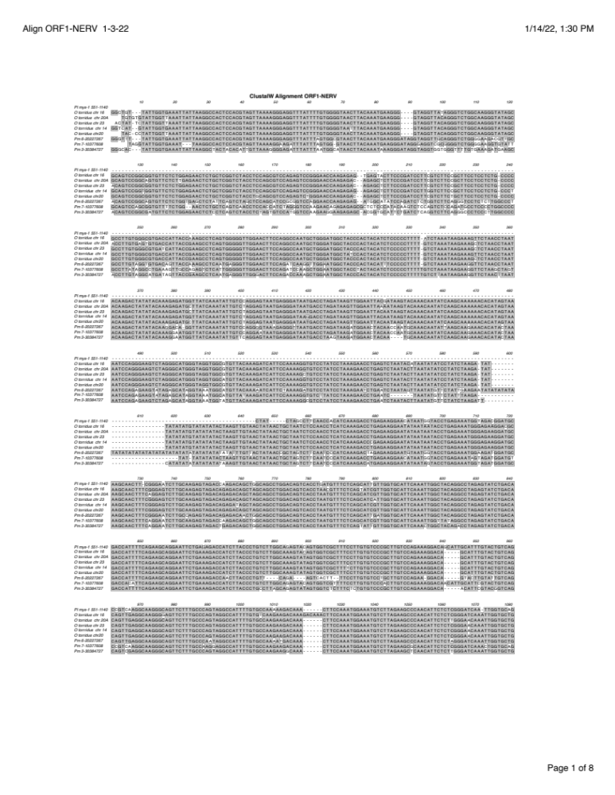

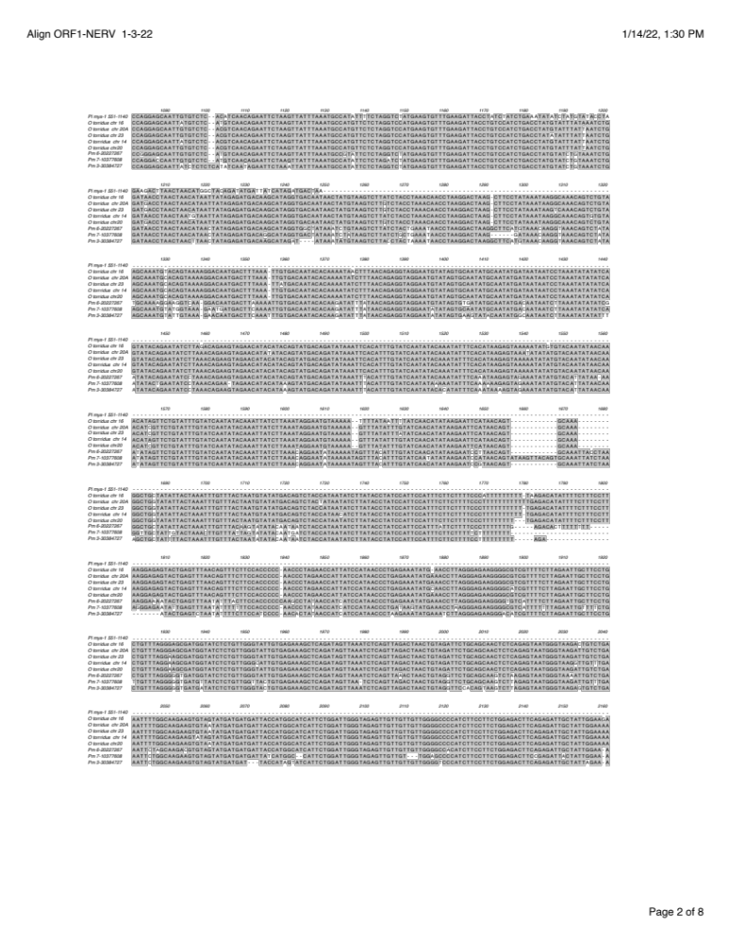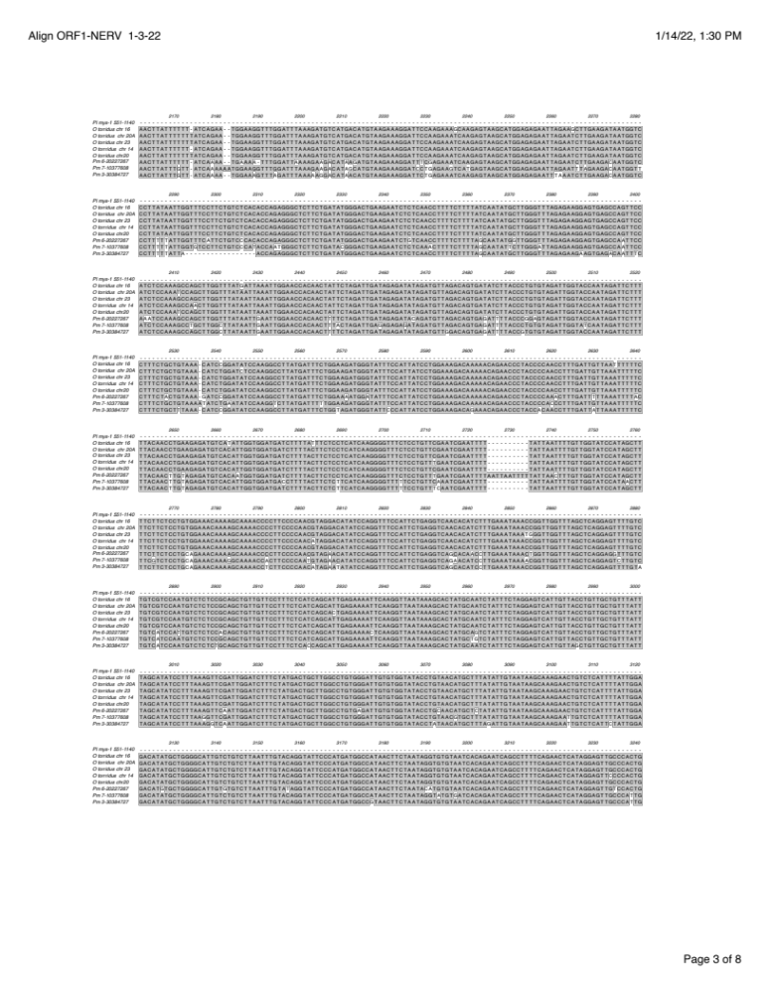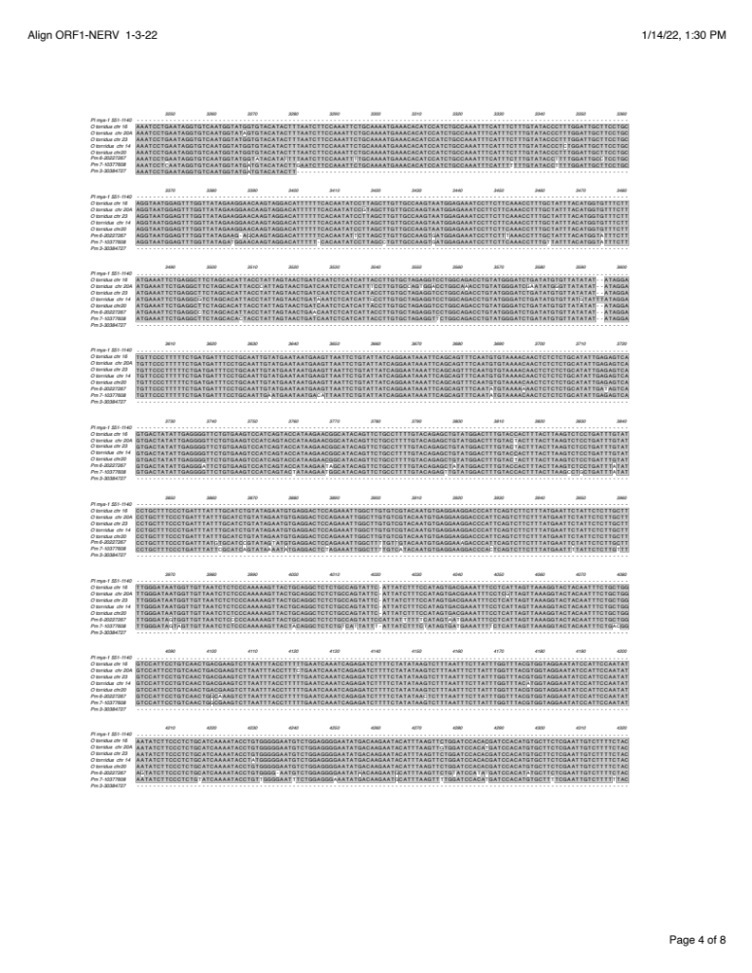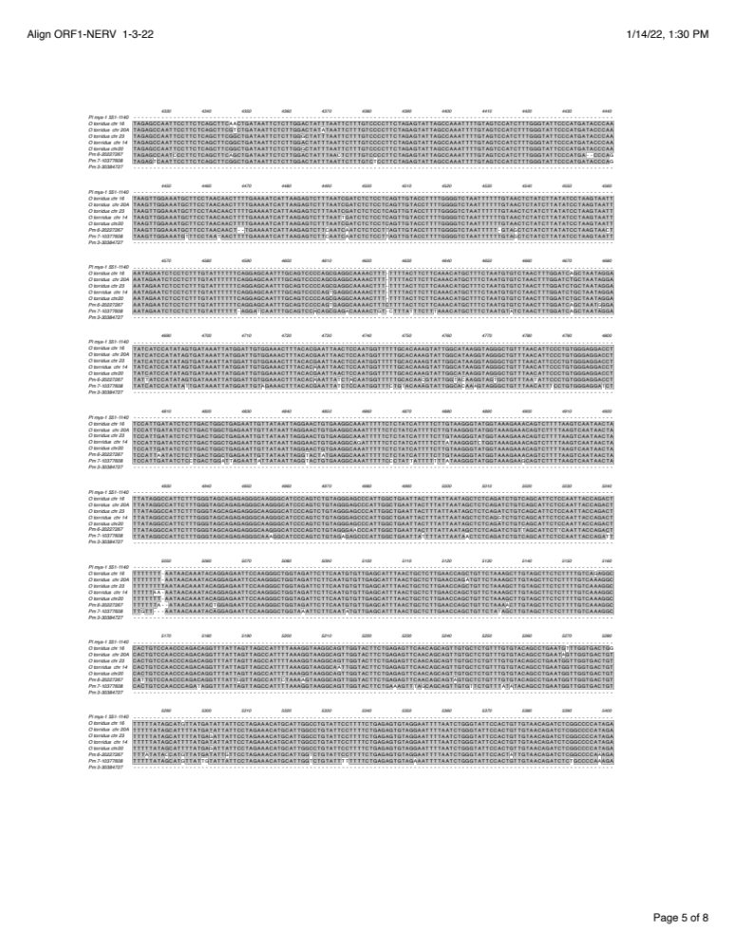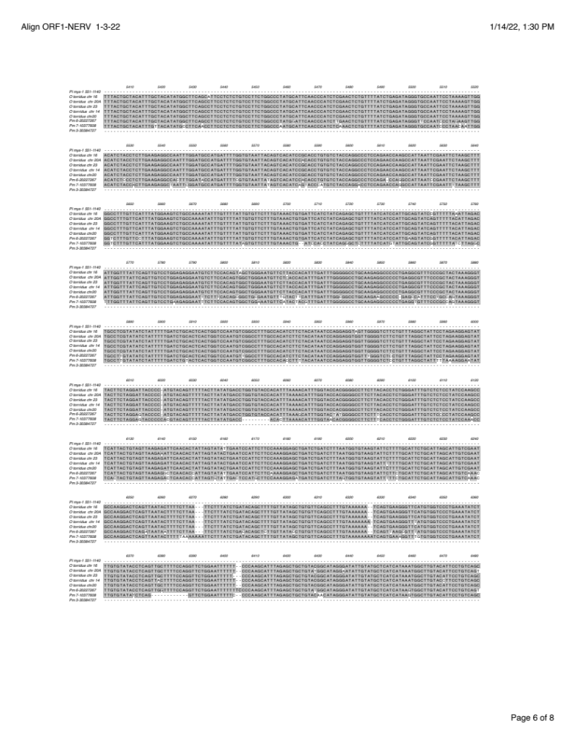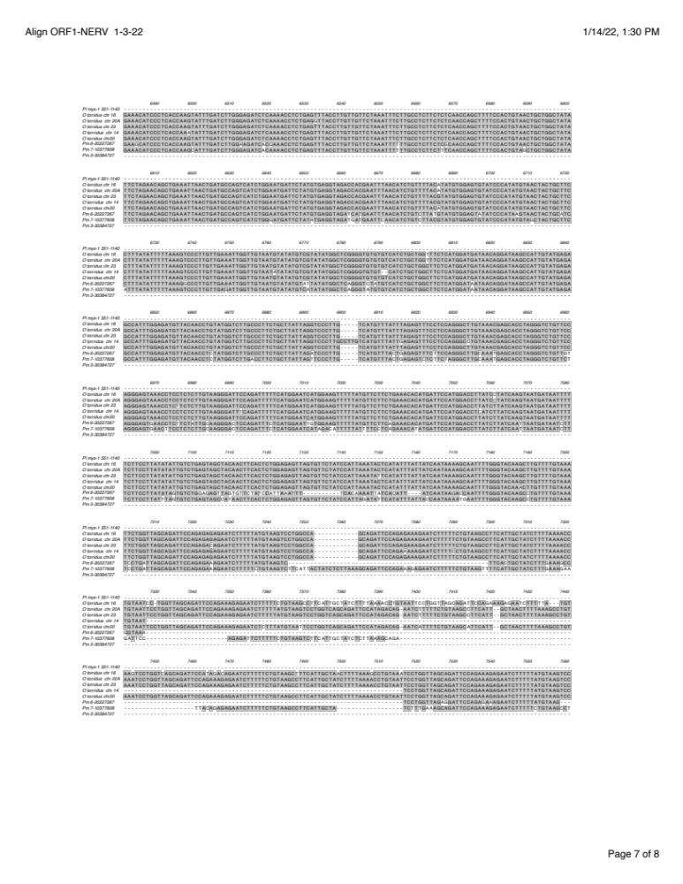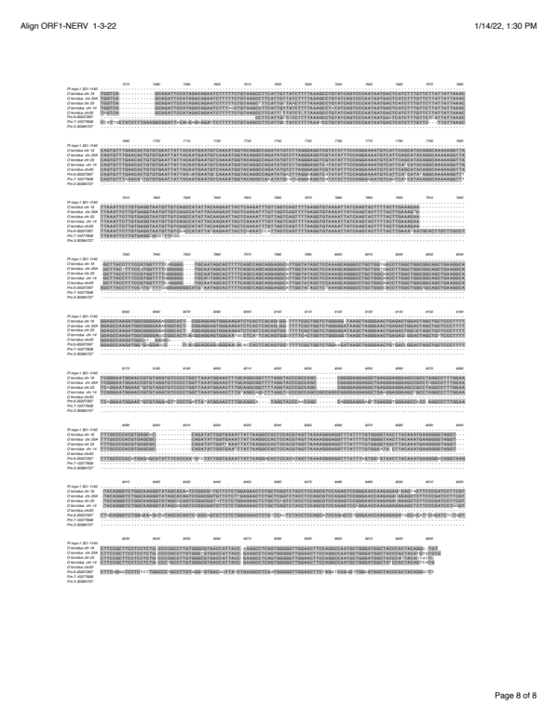
Fig. S6. Alignment of mORF1 sequences with the ORF1 region of mys-1 from P. leucopus. Shaded regions represent highly conserved sequences. Green boxed in areas indicate FDRs.

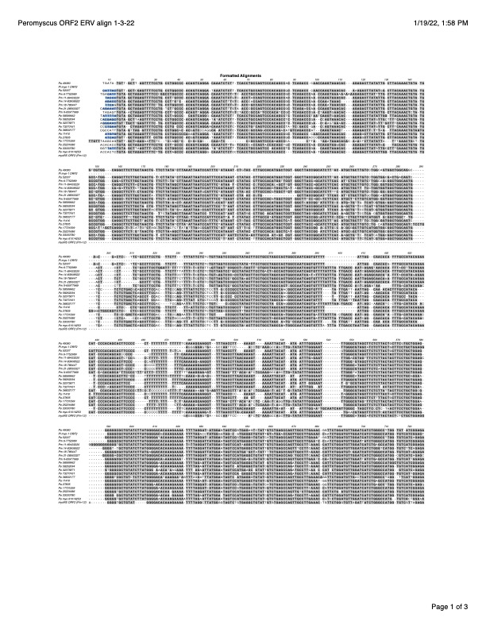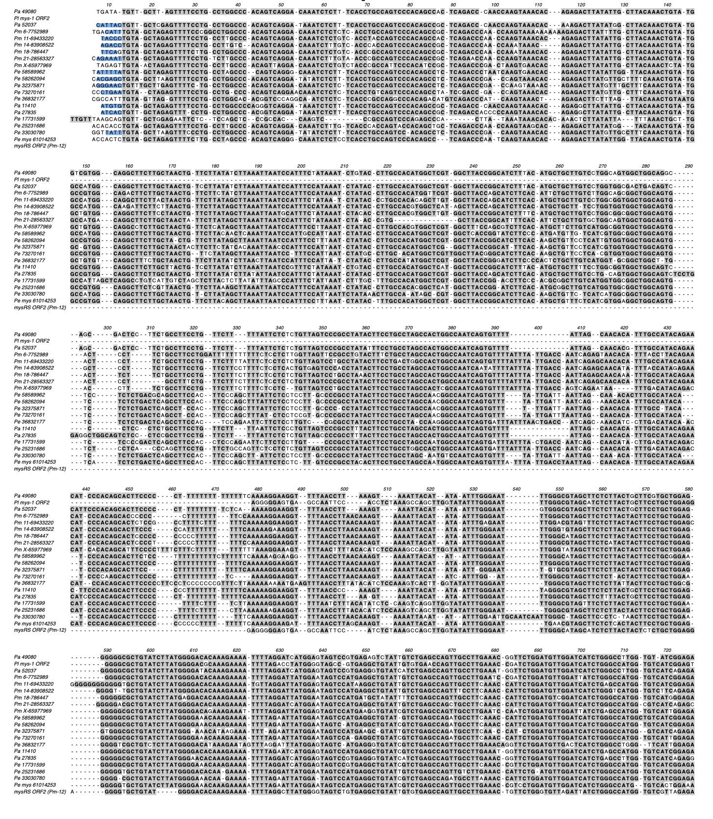
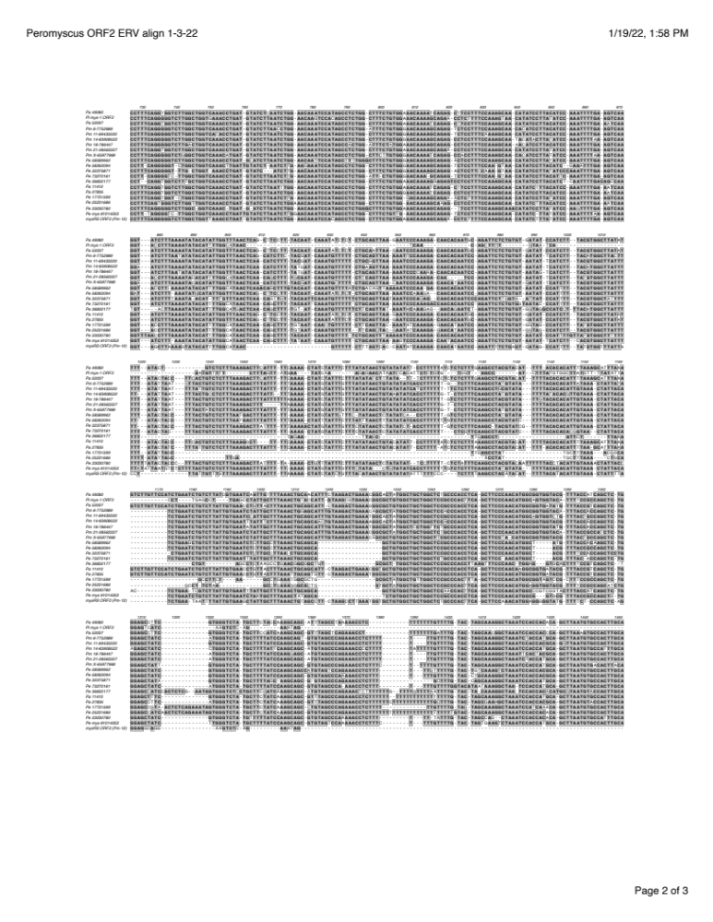

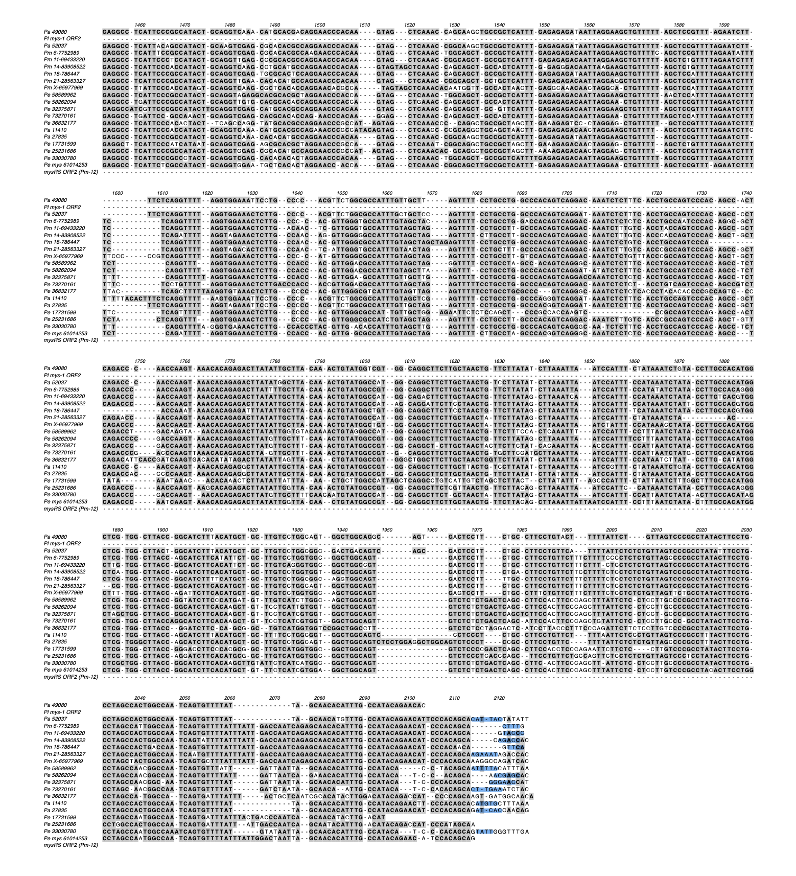

Fig. S7. ClustalW alignment of ORF2-NERV sequences of Peromyscus with ORF2 from P. lecuopus mys-1 and P. maniculatus mysRS. Exact or nearly exact flanking direct repeats are highlighted in blue. Conserved sequences are shaded.

