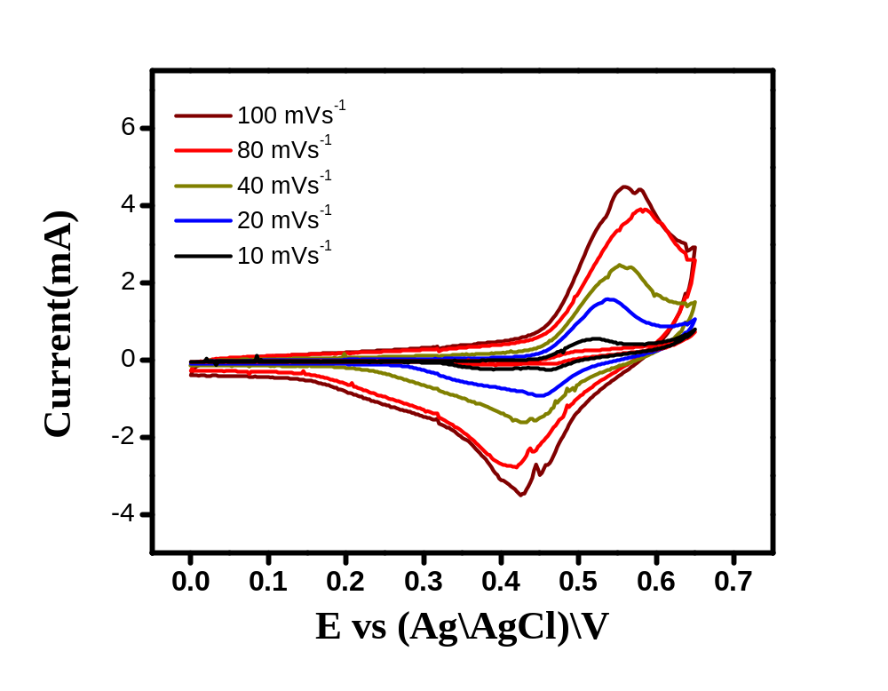

Fig. 1 (a) CV of Ag-MnWO₄ materials at different scan rates.

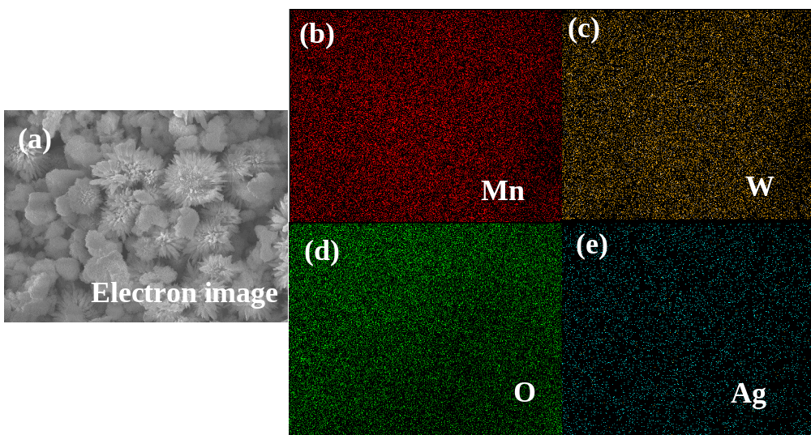
Fig. 2(a) SEM images of Ag-MnWO₄ microflowers, corresponding to elemental mapping of the elements; (b) Mn, (c) W, and (d) O and Ag respectively.

