Supplementary Figures for Exploring the microbiome of oral epithelial dysplasia as a predictor of malignant progression
Robyn J. Wright^{1*}; Michelle E. Pewarchuk²; Erin A. Marshall²; Benjamin Murrary¹, Miriam P. Rosin^{3,4}; Denise M. Laronde^{3.5}; Lewei Zhang^{5,6}; Wan L. Lam²; Morgan G.I. Langille^{1,7}; Leigha D. Rock^{1,7,8,9,10}
¹Department of Pharmacology, Dalhousie University, Halifax, Canada.
²Department of Integrative Oncology, British Columbia Cancer Research Centre, Vancouver, Canada.
³Department of Cancer Control Research, British Columbia Cancer Research Centre, Vancouver, Canada.
⁴Department of Biomedical Physiology and Kinesiology, Simon Fraser University, Burnaby, Canada.
⁵Faculty of Dentistry, University of British Columbia, Vancouver, Canada.
⁶Oral Biopsy Service, Vancouver General Hospital, Vancouver, Canada
⁷Beatrice Hunter Cancer Research Institute, Halifax, Canada.
⁸Faculty of Dentistry, Dalhousie University, Halifax, Canada.
⁹Department of Pathology, Faculty of Medicine, Dalhousie University, Halifax, Canada.
¹⁰Department of Anatomical Pathology, QEII Hospital, Nova Scotia Health, Halifax, Canada.
* Correspondence:
Robyn Wright, PhD
Robyn.Wright@dal.ca

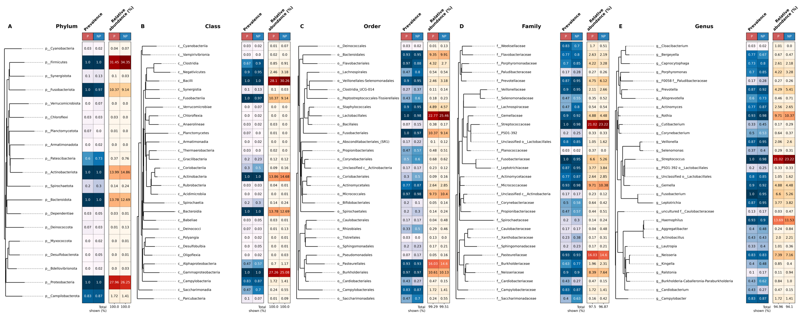
Supp. Figure 1. Mean prevalence and abundance of taxa at the Phylum (A), Class (B), Order (C), Family (D), or Genus (E) levels. Heatmaps show mean prevalence (blue scale; left) and abundance (red scale; right) of taxa in progressor (P) and non-progressor (NP) samples while phylogenetic trees are shown to the left of each set of heatmaps. Numbers below the relative abundance heatmap indicate the relative abundance accounted for in this plot. Only the top 30 most abundant taxa are shown for each phylogenetic level.

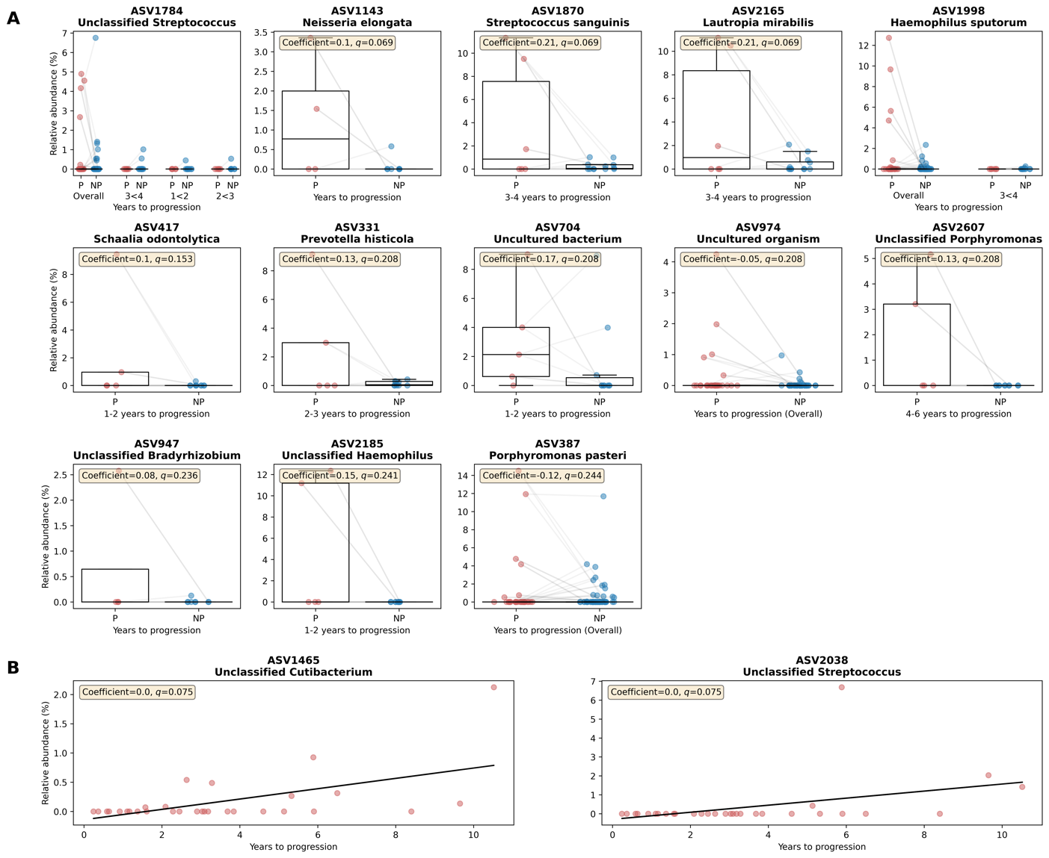
Supplementary Figure 2. ASVs that were identified as significantly differentially abundant by MaAsLin2 tests. (A) shows ASVs that were significantly differentially abundant between Ps and NPs when Ps were grouped to time to progression, with the group that was significant being noted in the x-label. Each sample is shown as an individual point and boxes show the median, upper and lower quartiles while whiskers show the range of the data (1.5 times the interquartile range). Lines between points indicate matched Ps/NPs. (B) shows ASVs that were significantly differentially abundant with time to progression for Ps only. Each point is an individual sample and black lines are lines of best fit calculated using the Python package numpy.

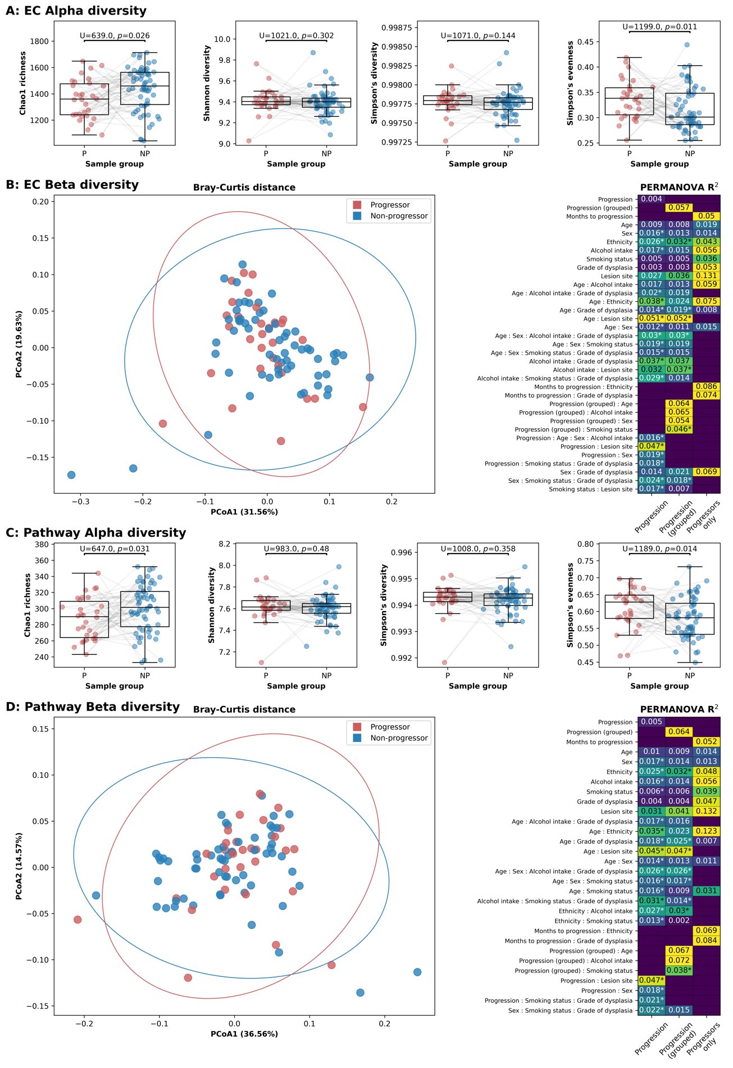
Supplementary Figure 3. Diversity of sample PICRUSt2 profiles. (A) and (B) show data for functional profiles at the Enzyme Commission (EC) number level and (C) and (D) show functional profiles at the MetaCyc Metabolic pathway level. (A) and (C) Functional diversity within the microbial communities of 30 progressing (P) and 60 non-progressing (NP) oral epithelial dysplasia (OED) samples using four different alpha-diversity metrics: Chao1 richness, Shannon diversity, Simpson’s diversity, and Simpson’s evenness. U and p-values in (A) and (C) were determined by Mann-Whitney U tests and lines indicate matched Ps and NPs. Lines between points indicate matched Ps/NPs and boxes show the median, upper and lower quartiles while whiskers show the range of the data (1.5 times the interquartile range). (B) and (D) Principal Coordinates Analysis (PCoA) and PERMANOVA tests using Bray-Curtis distance. Ellipses show the confidence interval (3 standard deviations) for each group and the values shown on each axis label indicate the proportion of sample variation accounted for by that axis. The heatmaps in (B) and (D) show PERMANOVA R² values for all separate variables that were added to the models as well as all interactions between variables with an R² $≥$ 0.05 and/or with p $≤$ 0.05 (denoted with an asterisk). The columns show PERMANOVA tests for Progression (P/NP), Progression (grouped; NP and P grouped to <1, 1-2, 2-3, 3-4, 4-6 or 6+ years for time to progression) and Progressors only with the specific follow-up time.

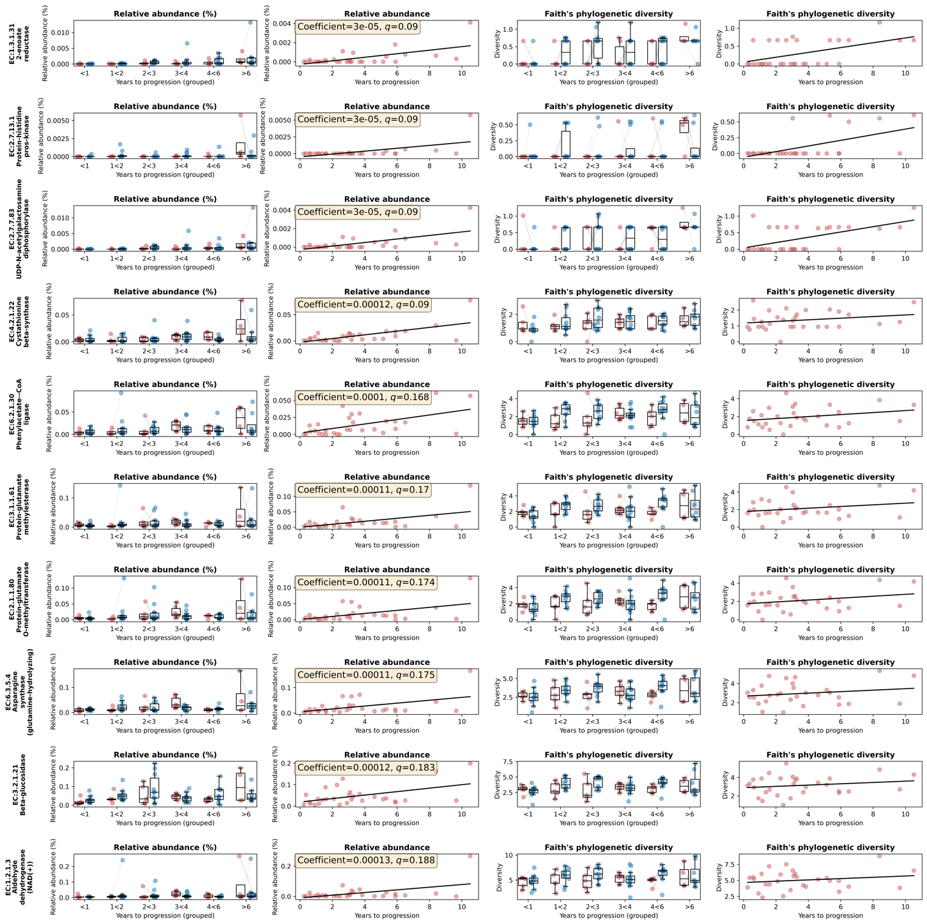
Supplementary Figure 4. Abundance and contributional diversity for the top 10 EC numbers (predicted by PICRUSt2) that were identified as differentially abundant with time to progression (Ps only) by MaAsLin2. Contributional diversity refers to the diversity of the ASVs that possess that enzyme (EC number). Each row shows information for one enzyme (EC number). The first and second columns show relative abundance for the enzyme while the third and fourth columns show Faith’s phylogenetic diversity of the ASVs that possess that enzyme. The first and third columns show all samples split to Ps (red, left) and NPs (blue, right), with each point representing a single sample, lines between points indicate matched Ps/NPs and boxes show the median, upper and lower quartiles while whiskers show the range of the data (1.5 times the interquartile range). The second and fourth columns show relative abundance or Faith’s phylogenetic diversity, respectively, plotted against time to progression for Ps only. Each point is an individual sample and black lines are lines of best fit calculated using the Python package numpy.

