¹H spectrum of thiocinnamamide I

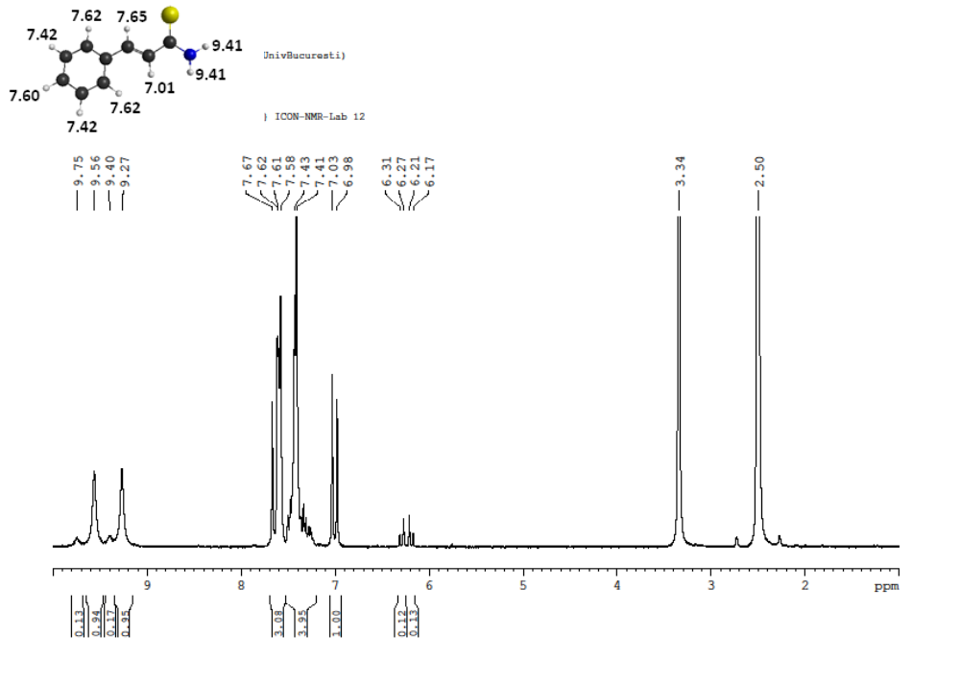
Figure S1. ¹H-NMR spectrum of (E)-3-phenylprop-2-enethioamide (I)
¹³C spectrum of thiocinnamamide I

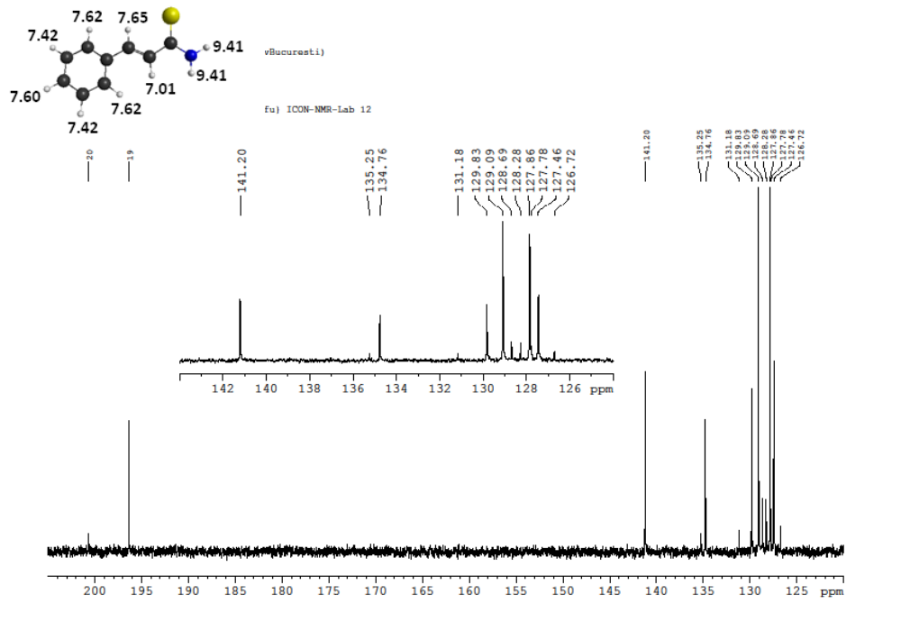
Figure S2. ¹³C-NMR spectrum of (E)-3-phenylprop-2-enethioamide (I)

COSY (¹H, ¹H) spectrum of thiocinnamamide I

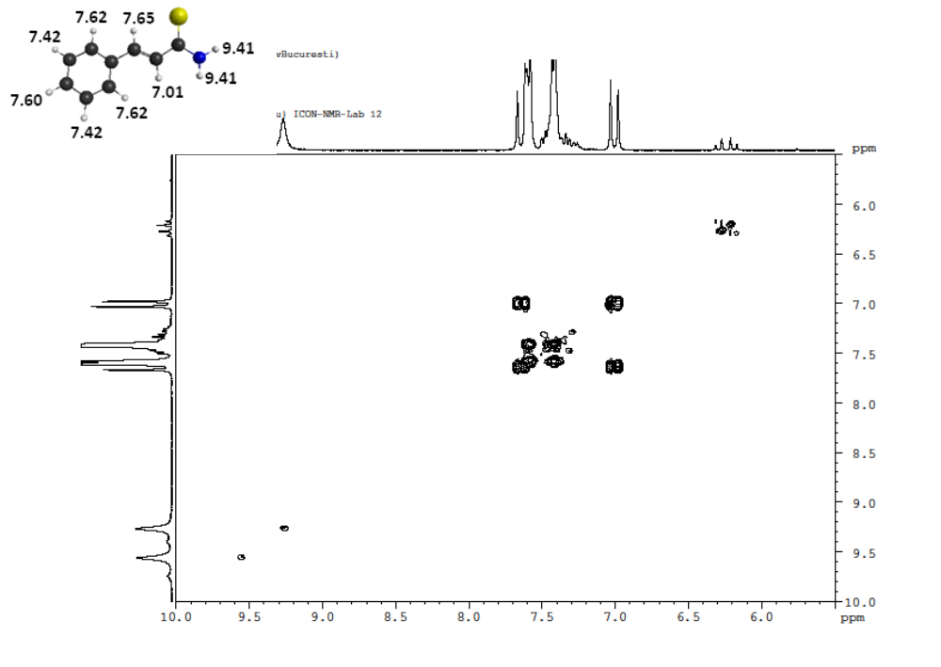
Figure S3. COSY (¹H, ¹H) spectrum of (E)-3-phenylprop-2-enethioamide (I)
HMQC (¹³C, ¹H) spectrum of thiocinnamamide I
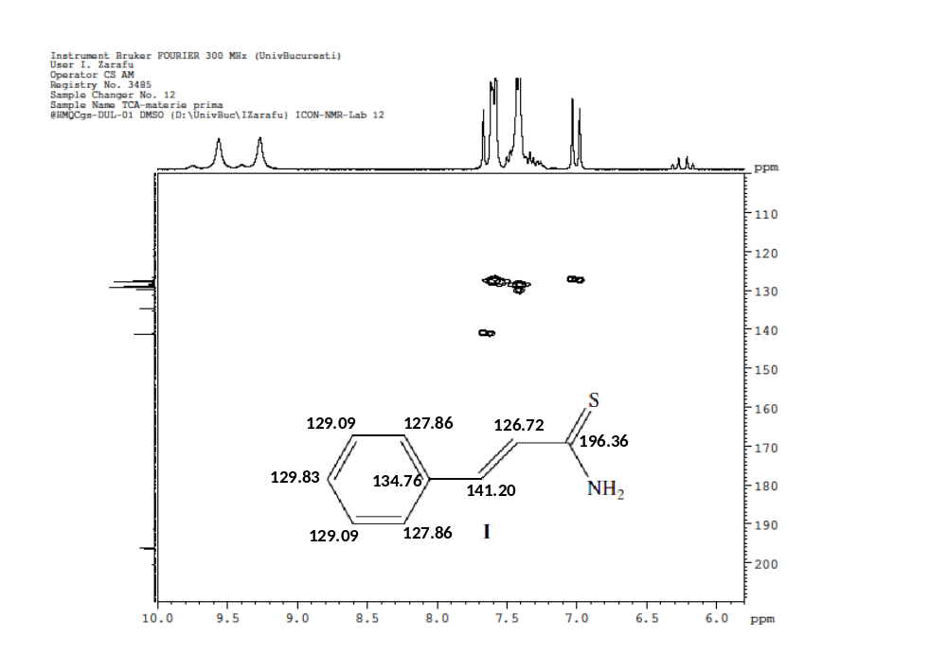
Figure S4. HMQC (¹³C, ¹H) spectrum of (E)-3-phenylprop-2-enethioamide (I)

¹H NMR spectrum of 3-(furan-2-yl)prop-2-enethioamide IV
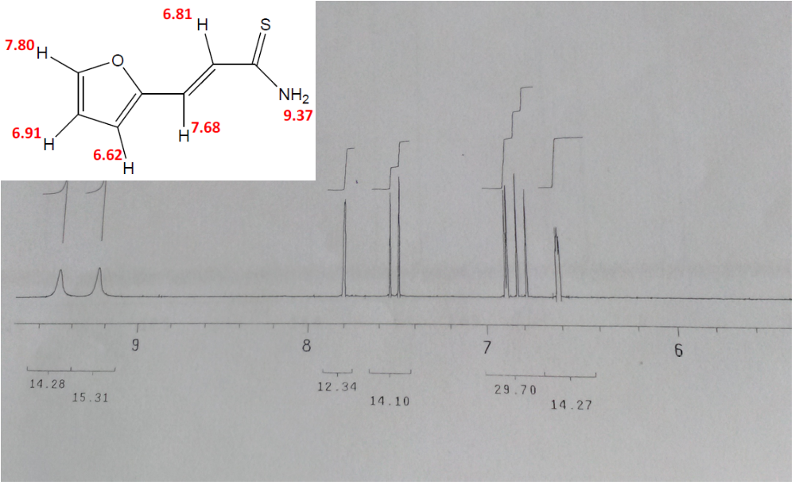
Figure S5. ¹H NMR spectrum of 3-(furan-2-yl)prop-2-enethioamide (IV)

