Supplementary material
Title: Associations of perinatal metals and other element exposures with longitudinal child behavior in the New Hampshire Birth Cohort Study
Authors: Julia A. Bauer, Megan E. Romano, Brian Jackson, David Bellinger, Susan Korrick, Margaret R. Karagas

Contents
Table S1: Limits of detection for toenail metals used in analyses (As, Cu, Mn, Pb, Se and Zn).
Table S2: Adjusted associations of 6-week infant toenail metals and change in BASC composite score from 3 to 5 years of age among all participants, boys and girls from multivariable linear regression models.
Table S3. Adjusted associations of 6-week infant toenail metals and relative change in BASC composite score from 3 to 5 years of age among all participants, boys and girls from multivariable linear regression models.
Table S4. Sensitivity analysis assessing results from adjusted associations of 6-week infant toenail metals and change in BASC composite scores from 3 to 5 years of age after removing influential points.
Figure S1: Correlations (rho) between 6-week infant toenail metals of New Hampshire Birth Cohort participants (n=268).
Figure S2: Adjusted associations of 6-week infant toenail metals and BASC composite score assessed at 3 years, 5 years, and the score change from 3 to 5 years of age among all participants from multivariable linear regression models.
Figure S3: Adjusted associations of 6-week infant toenail metals and BASC composite score assessed at 3 years of age among all participants, boys and girls from multivariable linear regression models.
Figure S4: Adjusted associations of 6-week infant toenail metals and BASC composite score assessed at 5 years of age among all participants, boys and girls from multivariable linear regression models.
Figure S5: Adjusted associations of 6-week infant toenail metals and relative score change in BASC composite score change from 3 to 5 years of age among all participants, boys and girls from multivariable linear regression.
Figure S6: Adjusted associations of 6-week infant toenail metals and change in BASC composite t-score from 3 to 5 years of age among all participants from multivariable linear regression models.
Figure S7: Adjusted associations of 6-week infant toenail metals and change in BASC composite score from 3 to 5 years of age among all participants from multivariable linear regression models adjusting for either age at 3- and 5- year assessments individually or change in age between assessment.

Table S1. Limits of detection for toenail metals used in analyses (As, Cu, Mn, Pb, Se and Zn).
Element | Study participants (n=268)
Element | Detection limit (µg/g) | % Above the LOD | % Detectable Below the LOD
As | 0.01 | 78.4% | 4.8%
Cu | 0.2 | 93.6% | 1.1%
Mn | 0.05 | 98.1% | 1.1%
Pb | 0.01 | 95.5% | 1.1%
Se | 0.02 | 98.1% | 0.3%
Zn | 5.0 | 98.8% | 0.7%

Table S3. Adjusted associations of 6-week infant toenail metals and change in BASC composite score from 3 to 5 years of age among all participants, boys and girls from multivariable linear regression models.
All participants |  |  |  | Among boys |  | Among girls
BSI
Metal | Β (95%CI) | p-value | p-value for metal*sex interaction | Β (95%CI) | p-value | Β (95%CI) | p-value
As | 2.17 (-0.53, 4.87) | 0.12 | 0.81 | 2.50 (-1.60, 6.60) | 0.23 | 1.84 (-1.84, 5.53) | 0.33
Cu | -3.88 (-7.12, -0.64) | 0.02 | 0.03 | -6.39 (-10.85, -1.93) | 0.01 | 1.22 (-3.83, 6.26) | 0.64
Mn | -2.79 (-6.57, 0.98) | 0.15 | 0.22 | -4.86 (-11.06, 1.33) | 0.13 | -0.37 (-5.30, 4.57) | 0.88
Pb | 0.47 (-2.59, 3.53) | 0.77 | 0.008 | 4.25 (-0.53, 9.02) | 0.08 | -3.86 (-7.90, 0.17) | 0.06
Se | 1.91 (-1.23, 5.05) | 0.24 | 0.27 | 3.10 (-1.84, 8.04) | 0.22 | 0.08 (-3.99, 4.14) | 0.97
Zn | 1.99 (-2.87, 6.85) | 0.42 | 0.66 | -0.55 (-9.08, 7.98) | 0.90 | 1.69 (-4.36, 7.74) | 0.59
Externalizing Problems
As | -0.59 (-2.15, 0.98) | 0.46 | 0.36 | -1.16 (-3.57, 1.25) | 0.35 | 0.29 (-1.75, 2.33) | 0.78
Cu | -2.20 (-4.07, -0.33) | 0.02 | 0.03 | -3.62 (-6.25, -1.00) | 0.01 | 1.00 (-1.77, 3.77) | 0.48
Mn | -1.29 (-3.49, 0.91) | 0.25 | 0.35 | -2.28 (-5.90, 1.33) | 0.22 | 0.17 (-2.54, 2.89) | 0.90
Pb | 0.07 (-1.71, 1.85) | 0.94 | 0.007 | 1.81 (-1.00, 4.62) | 0.21 | -2.66 (-4.88, -0.43) | 0.02
Se | 1.62 (-0.20, 3.45) | 0.08 | 0.81 | 1.32 (-1.59, 4.23) | 0.37 | 1.31 (-0.93, 3.56) | 0.25
Zn | 3.42 (0.60, 6.25) | 0.02 | 0.33 | 5.21 (0.24, 10.19) | 0.04 | 1.49 (1.85, 4.84) | 0.38
Internalizing Problems
As | 1.45 (-0.23, 3.12) | 0.09 | 0.89 | 1.50 (-0.88, 3.88) | 0.22 | 1.70 (-0.78, 4.17) | 0.18
Cu | -1.24 (-3.24, 0.76) | 0.22 | 0.11 | -2.30 (-4.88, 0.29) | 0.08 | 1.26 (-2.10, 4.62) | 0.46
Mn | 0.09 (-2.26, 2.44) | 0.94 | 0.06 | -2.17 (-5.73, 1.39) | 0.24 | 2.27 (-1.02, 5.57) | 0.18
Pb | -0.66 (-2.57, 1.25) | 0.50 | 0.03 | 1.06 (-1.71, 3.83) | 0.46 | -2.86 (-5.57, -0.16) | 0.04
Se | 0.71 (-1.25, 2.66) | 0.48 | 0.16 | 1.68 (-1.19, 4.55) | 0.25 | -0.80 (-3.52, 1.93) | 0.57
Zn | -0.64 (-3.66, 2.38) | 0.68 | 0.83 | -0.52 (-5.42, 4.38) | 0.84 | -1.53 (-5.59, 2.53) | 0.46
Adjusted for child sex, maternal education, married status, maternal smoking during pregnancy, maternal IQ, maternal healthy eating index, change in age at assessment

Table S4. Adjusted associations of 6-week infant toenail metals and relative change in BASC composite score from 3 to 5 years of age among all participants, boys and girls from multivariable linear regression models.
All participants |  |  |  | Among boys |  | Among girls
Behavioral Symptoms Index
Metal | Β (95%CI) | p-value | p-value for metal*sex interaction | Β (95%CI) | p-value | Β (95%CI) | p-value
As | 0.008 (-0.002, 0.017) | 0.105 | 0.99 | 0.008 (-0.006, 0.022) | 0.27 | 0.007 (-0.006, 0.020) | 0.30
Cu | -0.014 (-0.026, -0.003) | 0.015 | 0.04 | -0.023 (-0.038, -0.008) | 0.004 | 0.003 (-0.016, 0.021) | 0.77
Mn | -0.010 (-0.023, 0.004) | 0.164 | 0.17 | -0.018 (-0.039, 0.003) | 0.10 | 0.000 (-0.018, 0.018) | 0.98
Pb | 0.002 (-0.009, 0.013) | 0.750 | 0.01 | 0.015 (-0.001, 0.032) | 0.07 | -0.013 (-0.028, 0.002) | 0.09
Se | 0.007 (-0.004, 0.018) | 0.235 | 0.21 | 0.013 (-0.004, 0.029) | 0.15 | -0.001 (-0.016, 0.014) | 0.90
Zn | 0.007 (-0.010, 0.024) | 0.418 | 0.56 | -0.004 (-0.033, 0.025) | 0.78 | 0.007 (-0.015, 0.030) | 0.51
Externalizing problems
 | Β (95%CI) | p-value |  | Β (95%CI) | p-value | Β (95%CI) | p-value
As | -0.008 (-0.025, 0.009) | 0.375 | 0.53 | -0.012 (-0.037, 0.014) | 0.36 | -0.003 (-0.027, 0.021) | 0.81
Cu | -0.023 (-0.043, -0.002) | 0.033 | 0.08 | -0.034 (-0.062, -0.006) | 0.02 | 0.006 (-0.027, 0.039) | 0.73
Mn | -0.008 (-0.033, 0.016) | 0.495 | 0.17 | -0.025 (-0.063, 0.013) | 0.21 | 0.012 (-0.021, 0.044) | 0.49
Pb | 0.001 (-0.019, 0.020) | 0.940 | 0.02 | 0.019 (-0.011, 0.049) | 0.21 | -0.026 (-0.052, 0.001) | 0.06
Se | 0.012 (-0.008, 0.032) | 0.226 | 0.93 | 0.010 (-0.021, 0.040) | 0.53 | 0.010 (-0.017, 0.037) | 0.48
Zn | 0.036 (0.005, 0.067) | 0.023 | 0.34 | 0.053 (0.001, 0.106) | 0.05 | 0.018 (-0.022, 0.058) | 0.38
Internalizing problems
 | Β (95%CI) | p-value |  | Β (95%CI) | p-value | Β (95%CI) | p-value
As | 0.011 (0.001, 0.023) | 0.060 | 0.53 | 0.008 (-0.008, 0.025) | 0.32 | 0.014 (-0.003, 0.032) | 0.11
Cu | -0.009 (-0.023, 0.005) | 0.230 | 0.11 | -0.016 (-0.034, 0.002) | 0.08 | 0.008 (-0.016, 0.032) | 0.50
Mn | 0.001 (-0.016, 0.017) | 0.934 | 0.10 | -0.012 (-0.037, 0.012) | 0.33 | 0.016 (-0.008, 0.039) | 0.19
Pb | -0.005 (-0.019, 0.008) | 0.445 | 0.03 | 0.006 (-0.013, 0.026) | 0.52 | -0.020 (-0.039, -0.001) | 0.04
Se | 0.006 (-0.007, 0.020) | 0.364 | 0.19 | 0.014 (-0.006, 0.034) | 0.17 | -0.004 (-0.024, 0.015) | 0.68
Zn | -0.005 (-0.026, 0.017) | 0.673 | 0.81 | -0.004 (-0.038, 0.030) | 0.81 | -0.011 (-0.040, 0.018) | 0.46
Adjusted for child sex, maternal education, married status, maternal smoking during pregnancy, maternal IQ, maternal healthy eating index

Table S5. Sensitivity analysis assessing results from adjusted associations of 6-week infant toenail metals and change in BASC composite scores from 3 to 5 years of age after removing influential points.
 |  | Original data set (n=268)ª | Influential points removed (n=252)^{b}
Behavioral Symptoms Index
Metal | β (95%CI) |  | β (95%CI)
As | 2.04 (-0.69, 4.78) |  | 1.94 (-0.50, 4.39)
Cu | -3.59 (-6.85, -0.33) |  | -2.51 (-5.59, 0.57)
Mn | -2.54 (-6.39, 1.32) |  | -2.76 (-6.12, 0.60)
Pb | 0.38 (-2.73, 3.50) |  | 0.31 (-2.46, 3.08)
Se | 1.92 (-1.28, 5.11) |  | 1.23 (-1.67, 4.09)
Zn | 1.75 (-3.19, 6.70) |  | 1.51 (-6.06, 3.04)
Externalizing problems score
As | -0.60 (-2.17, 0.98) |  | -0.57 (-2.13, 0.98)
Cu | -2.12 (-3.99, -0.25) |  | -0.38 (-2.34, 1.58)
Mn | -1.24 (-3.45, 0.98) |  | -0.75 (-2.89, 1.38)
Pb | 0.03 (-1.76, 1.83) |  | -0.61 (-2.37, 1.15)
Se | 1.60 (-0.23, 3.44) |  | 0.80 (-1.01, 2.63)
Zn | 3.38 (0.55, 6.23) |  | 1.53 (-1.37, 4.42)
Internalizing problems
As | 1.42 (-0.26, 3.10) |  | 1.45 (-0.23, 3.13)
Cu | -1.18 (-3.18, 0.83) |  | -1.02 (-3.13, 1.09)
Mn | 0.15 (-2.23, 2.52) |  | -0.32 (-2.62, 1.98)
Pb | -0.69 (-2.61, 1.23) |  | -0.72 (-2.62, 1.98)
Se | 0.71 (-1.26, 2.68) |  | 0.94 (-1.03, 2.90)
Zn | -0.69 (-3.73, 2.36) |  | -1.78 (-4.90, 1.34)
ª single dataset with maternal IQ imputed
^{b} dataset ª with influential points removed

Figure S1. Correlations (rho) between 6-week infant toenail metal concentrations of New Hampshire Birth Cohort participants (n=268).
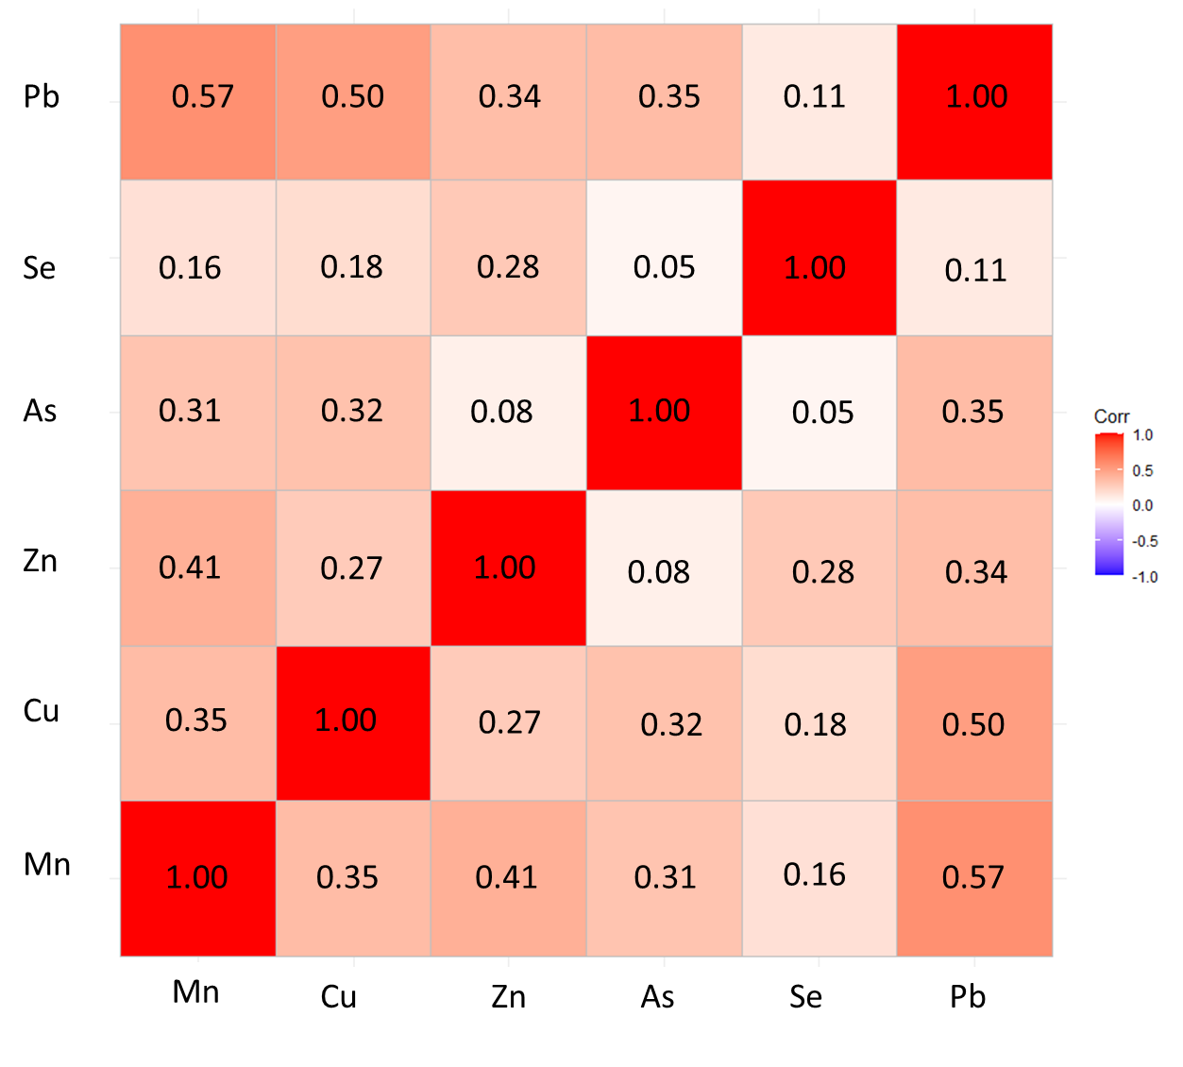

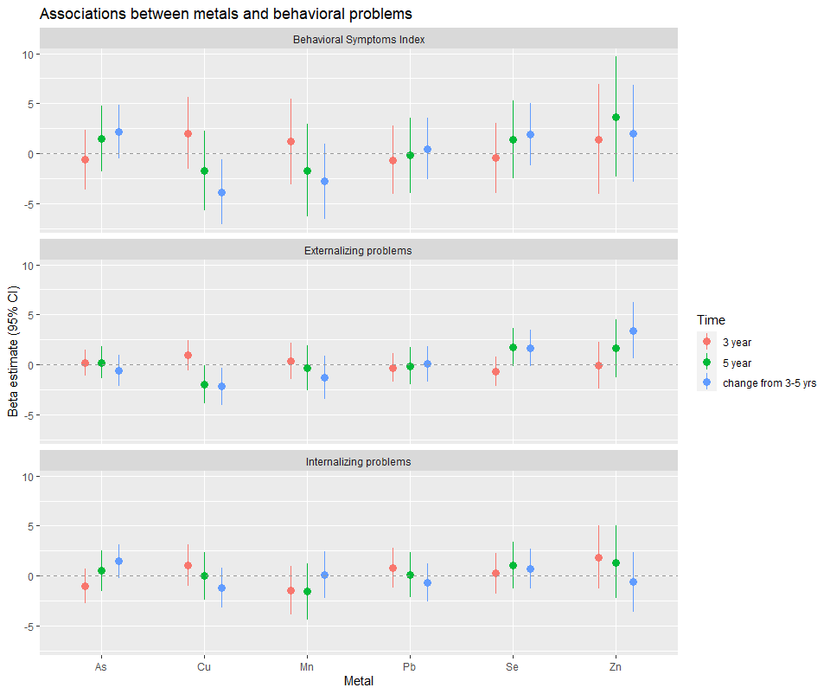
Figure S2. Adjusted associations of 6-week infant toenail metals and BASC composite score assessed at 3 years, 5 years, and the score change from 3 to 5 years of age among all participants from multivariable linear regression models.

Figure S3. Adjusted associations of 6-week infant toenail metals and BASC composite score assessed at 3 years of age among all participants, boys and girls from multivariable linear regression models.

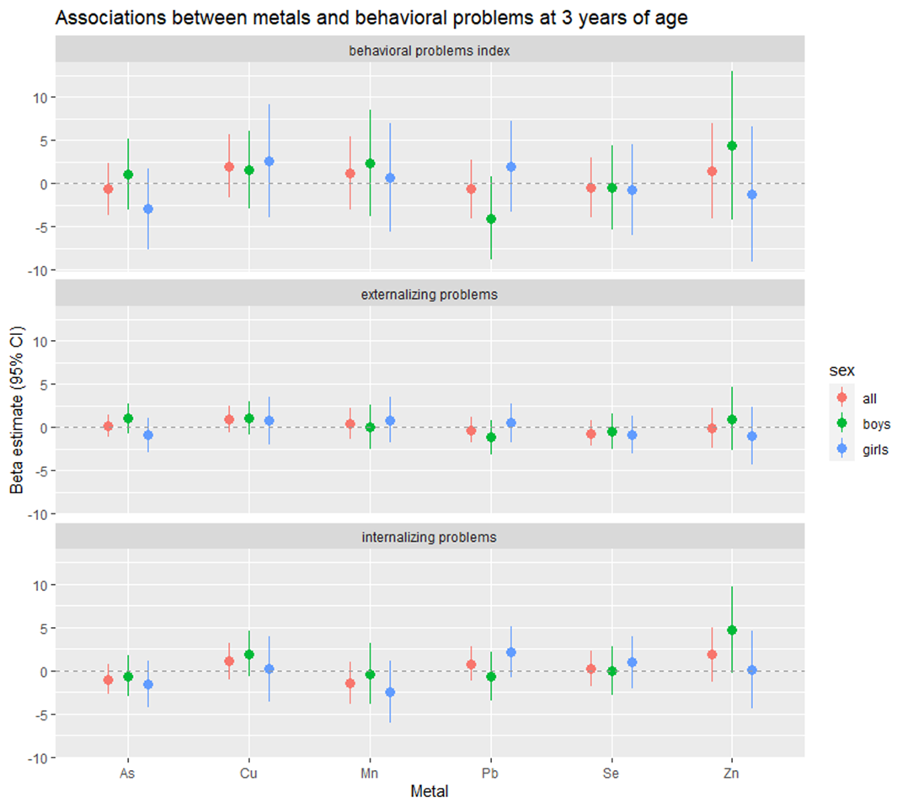
Figure S3. Adjusted associations of 6-week infant toenail metals and BASC composite score assessed at 3 years of age among all participants, boys and girls from multivariable regression models.

Figure S4. Adjusted associations of 6-week infant toenail metals and BASC composite score assessed at 5 years of age among all participants, boys and girls from multivariable linear regression models.
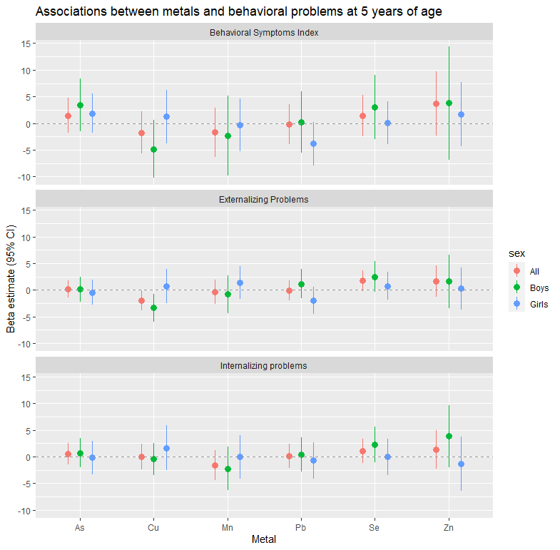

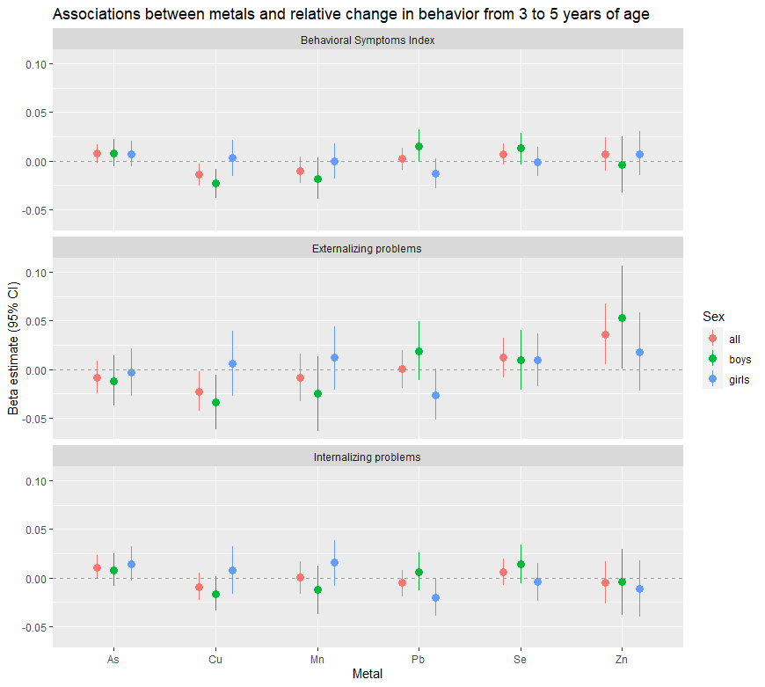
Figure S5. Adjusted associations of 6-week infant toenail metals and relative score change in BASC composite score change from 3 to 5 years of age among all participants, boys and girls from multivariable linear regression.
*
*
*
*

* p<0.05 for sex-metal interaction term.

* p<0.05 for sex-metal interaction term.

Figure S6. Adjusted associations of 6-week infant toenail metals and score change in BASC composite t-score change from 3 to 5 years of age among all participants, boys and girls from multivariable linear regression.
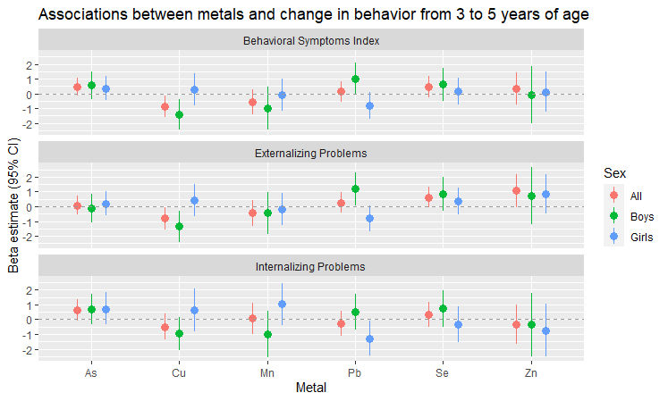

Figure S6: Adjusted associations of 6-week infant toenail metals and change in BASC composite score from 3 to 5 years of age among all participants from multivariable linear regression models adjusting for either age at 3- and 5- year assessments individually or change in age between assessment.
