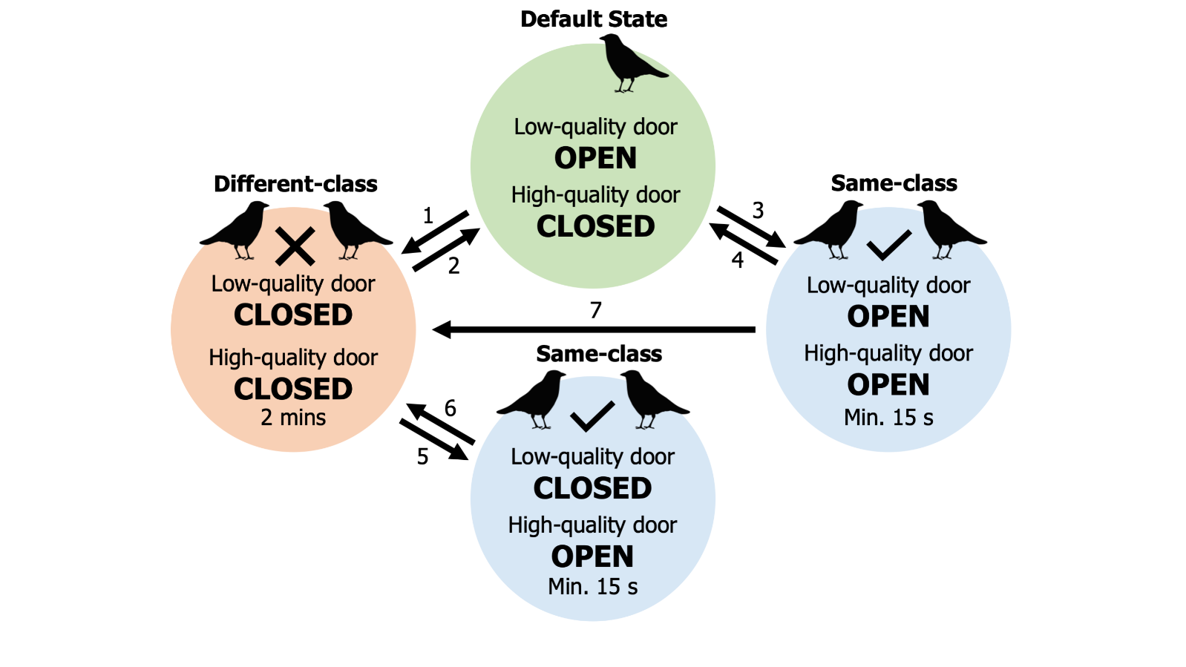
Extended Data Figures
Extended Data Figure 1 | Illustration of the state transitions of the dual-feeder task. The dual-feeder task had four different states and seven state transitions could occur. When the task was unoccupied or only occupied by solo foragers, it reverted to the default task state, in which access to the low-quality reward was granted but the high-quality reward was inaccessible (green circle). An unsuccessful association by a dyad triggered a period of feeder inactivity (1), during which neither type of reward was accessible (pink circle). At the end of this ‘lockout’ period, the task returned to its default state (2). A successful dyadic interaction that occurred during a period when a lockout was not in effect resulted in access to both the high- and low-quality rewards (3). The end of a successful event during a non-lockout period resulted in a return to the default task state (4). A successful dyadic interaction that occurred during a lockout period triggered override of the lockout condition and access to the high-quality reward only (5). A successful dyadic interaction that ended before the completion of a lockout period caused the task to revert to the lockout state (6). Finally, an unsuccessful association event that immediately followed a successful event resulted in a direct transition to a lockout period, bypassing the default task state (7).

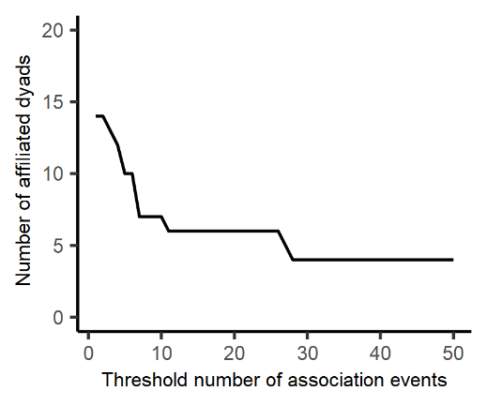
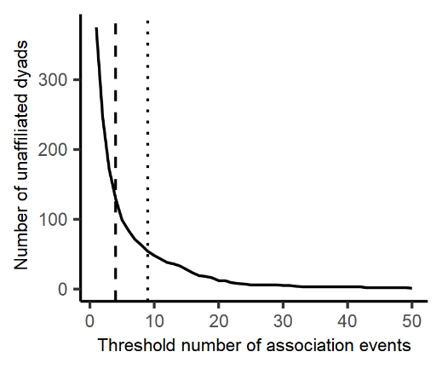
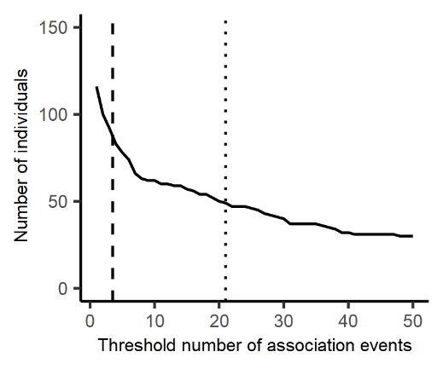
Extended Data Figure 2 | Distribution of overall task experience amongst individuals and dyads. Illustration of the number of (a) individuals, (b) unaffiliated dyads and (c) affiliated dyads that participated in greater than the specified number of association events. Vertical lines indicate the number of association events that at least 100 (dashed line) or 50 (dotted line) individuals or dyads participated in.
a
b
c

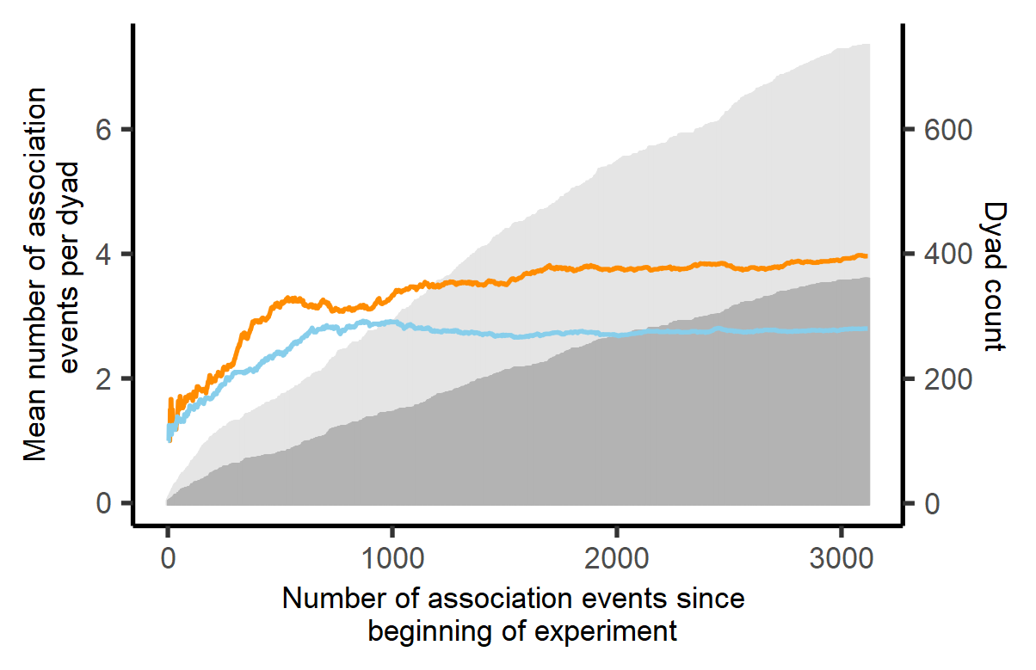
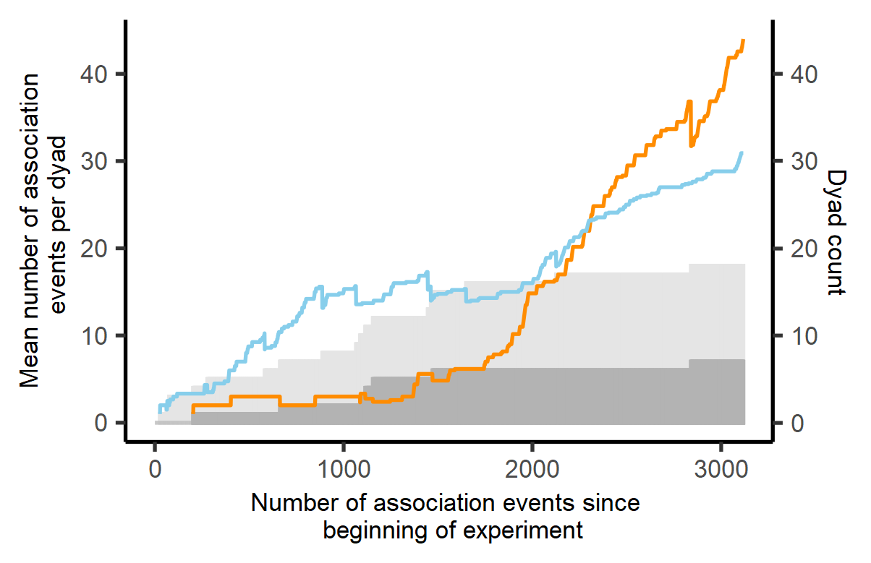
Extended Data Figure 3 | Change in quantity and activity of different dyad types as the experiment progressed. The mean number of events per dyad during each period of the experiment is displayed for same- (orange line) and different-class (blue line) (a) non-affiliate and (b) affiliate dyads. The number of same-class dyads (dark grey shading) is also shown alongside the combined number of same- and different-class dyads (light grey shading). Different-class affiliate dyads and both types of non-affiliate dyad were first observed shortly after the start of the experiment, but same-class affiliate dyads were only observed after approximately 200 association events had taken place. For affiliate dyads, the balance of events per dyad across same-class and different-class dyads shifted as the experiment progressed, indicating an increase in activity within same-class affiliate dyads during the last third of the experimental period. However, due to a greater number of different-class (11) as compared to same-class (7) affiliate dyads, this increase in within-dyad activity did not translate into an overall difference in likelihood of observation (308 observations of same-class affiliate dyads, 340 observations of different-class affiliate dyads). In contrast, same-class and different-class non-affiliate dyads displayed close to equal activity through the first approximately 10% of the experiment (300 events: 60 same-class non-affiliate dyads, 69 different-class non-affiliate dyads, 140 same-class observations, 144 different-class observations), but same-class activity exceeded different-class activity across the remainder of the experiment (2817 events: 333 same-class non-affiliate dyads, 339 different-class non-affiliate dyads, 1279 same-class observations, 906 different-class observations).

a
b
Non-affiliates
Affiliates

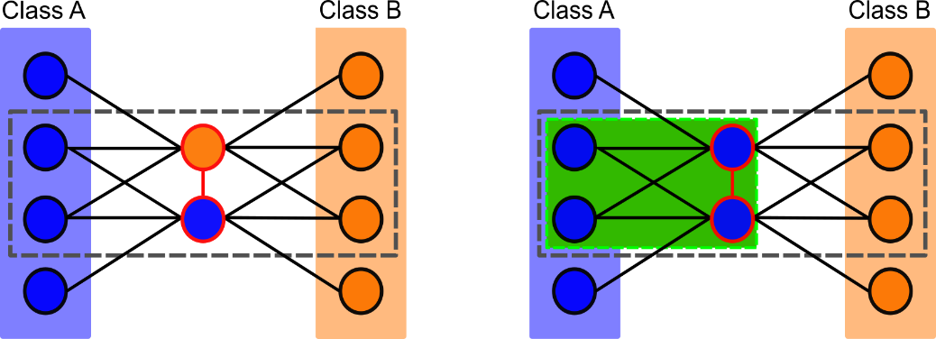
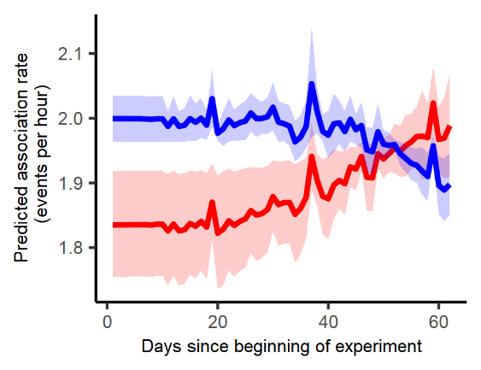
Extended Data Figure 4 | Convergence in the social neighbourhoods of compatible task participants over the duration of the experiment. When individuals retain ties with compatible group members and sever ties with those that are incompatible, then compatible individuals will increasingly share common social partners, resulting in formation of self-sustaining clusters of compatible group members within a social network⁵⁻⁸. (a) For a dyad (red outline) in which the two members belonged to different treatment classes (i. or ii.), selecting an individual from within the subset of all task participants with which both members of the dyad have associated (grey dashed box) yields a triad in which only two of the three individuals belong to the same class. (b) When both members of a dyad belong to the same class, another subset can be defined which contains participants that have associated with both members of a dyad and belong to the same treatment class as them both (green box). If associations occur according to a random process, same-class-only triads should be observed less frequently than mixed-composition triads (Supplementary Notes: 1. Expected triad composition in experimental networks and Extended Data Fig. 8). By summing over all triads in each subset, statistics can be calculated that indicate both a baseline likelihood of observing dyads that share common associates of any class, and the likelihood of observing same-class-only groupings (Supplementary Notes: 2. Triadic closure statistics in Eventnet 0.5.2). (c) The relationship between the class composition of a dyad’s common associates and the dyad’s predicted rate of future association changed as the experiment progressed. Dyads for whom all three of their common associates belonged to the same class as both dyad members (red) became more likely to be observed (though the magnitude of the effect was small). The opposite trend in predicted association rate was apparent for dyads for whom none of their three common associates belonged to the same class as the two dyad members (blue). Median predicted incidence rate (solid line) and 95% prediction interval (shading) are displayed (for further details see Supplementary Methods: 6. Visualization of REM output).

a
b

c
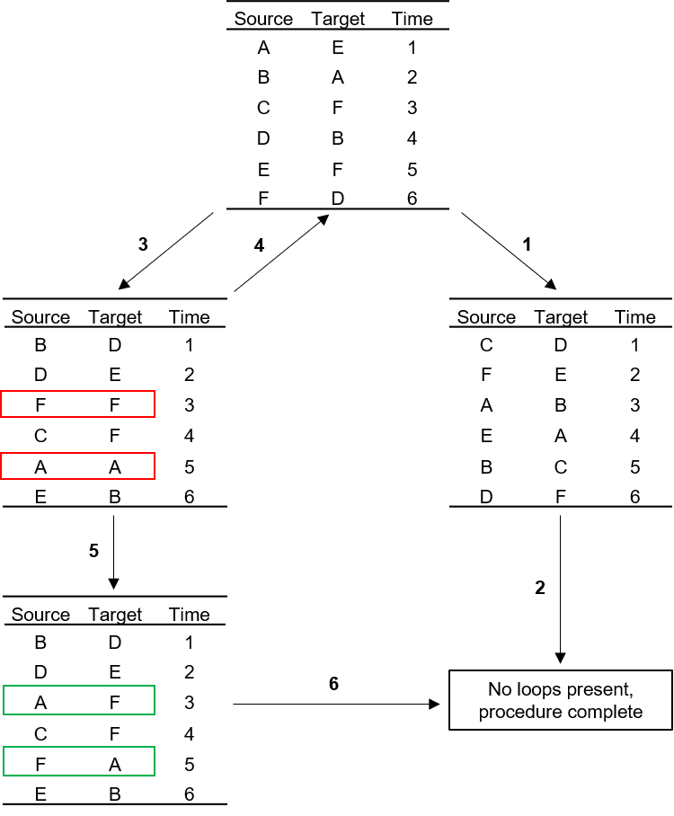
Extended Data Figure 5 | An example of a permutation procedure composed of label shuffling and pairwise label swaps as applied to a REM dataset. For each subset of the unpermuted data (Top Table), the ID labels from each event (Source and Target) are randomized in an unconstrained, unsupervised fashion (random shuffle). In this example, the Source and Target columns are randomized independently (i.e., without mixing of ‘source’ and ‘target’ labels). Unconstrained randomization can generate a dataset in which all events contain valid combinations of source and target labels (1), such that the randomization of a given subset of the data is completed without pairwise label-swapping (2). Alternatively, a permuted dataset that contains invalid source-target label combinations (red boxes) can be generated (3). In this experiment, individuals could not associate with themselves, so these ‘loop’ instances must be removed. If the number of attempts at generating a valid permuted dataset from the current subset has not reached a certain threshold (see Supplementary Methods: Validation of permutation procedure and Extended Data Fig. 7 for details of threshold selection), and a dataset without loops has not been generated, then randomization via unconstrained shuffling of labels is repeated (4). If the randomization limit is reached without a valid dataset having been generated, then the most recent generated dataset is examined to locate invalid instances and labels are swapped between these instances in a pairwise fashion (5) to produce valid events from loops (green boxes). Once all invalid instances have been removed from this permuted dataset, the procedure is complete for the current subset (6).
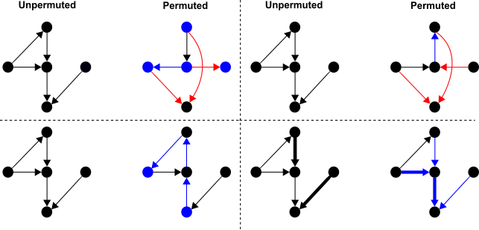
Extended Data Figure 6 | Illustration of the four ways that data-stream permutation can be applied to non-bipartite REM datasets. In each case, the initial unpermuted network is displayed, accompanied by the result of applying the given type of permutation to the REM dataset. Node (circle) and edge (arrow) colours signify change in the properties of existing nodes or edges (blue) or creation of new nodes or edges (red) caused by the permutation procedure. Source and target labels can be randomized non-independently (a), such that a permuted event can contain any combination of the available ‘source’ or ‘target’ (see ‘Glossary of common REM terms’ in Supplementary Tables) labels observed within the given sampling period. Non-independent source and target label randomization can generate new edges, alter the direction of existing edges and alter node properties (each node’s total number of events is preserved, but the balance of events as source or target can change). Source and target labels can be randomized independently (b), whereby source labels can only be exchanged with other source labels and target labels can only be exchanged with target labels. This process preserves node properties, as each individual’s activity as both a source and as a target, rather than just overall activity, remains fixed. Pairwise swaps of source labels with their corresponding target labels only randomizes edge direction and does not create or delete edges, so preserving all observed dyadic interactions (c), but altering node properties (number of events as source versus target). Similarly, for weighted REM data, edge weights can be randomized without altering the underlying network structure (d), so edge weights are permuted without the procedure creating or deleting edges, altering edge direction, or altering node properties.

d
b
c
a

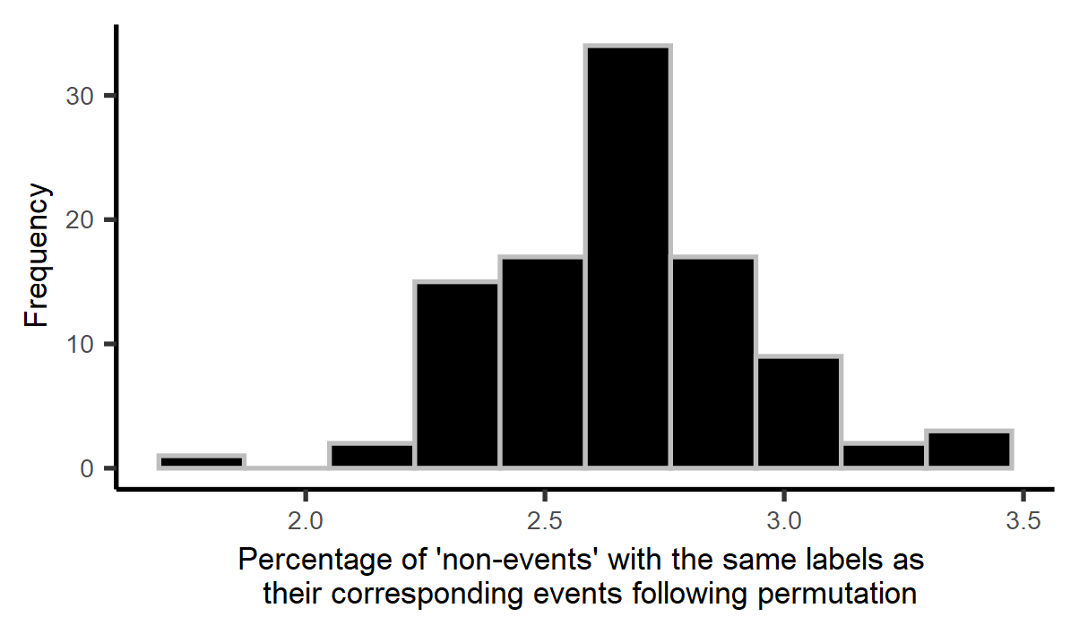
Extended Data Figure 7 | Permutation procedure diagnostics. Histogram of the percentage of REM ‘non-events’ (see ‘Glossary of common REM terms’ in Supplementary Tables), generated from non-independent permutation of source and target labels, that have both the same source and target labels as their corresponding observed events in the dataset (a). The distribution contains the percentage values for 100 permuted datasets and shows the extent to which the permuted datasets were likely to remain unchanged from the original, unpermuted data. The limit of the number of attempted randomizations applied to each subset of the data affects the percentage of the data that can be randomized without using an additional procedure, such as pairwise swaps, to remove loops (b). The minimum and maximum percentage of randomization success (i.e., the number of subsets successfully randomized, without resorting to the use of swaps, divided by the total number of subsets), as calculated from 100 permuted datasets, is displayed for a range of subset randomization limits.

a
b
Maximum number of randomizations | Minimum % | Maximum %
1 | 9.6 | 24.1
10 | 30.1 | 49.4
100 | 60.2 | 72.3
1000 | 77.1 | 86.7
10000 | 86.7 | 95.2
100000 | 92.8 | 96.4

A
A
A
B
B
B
B
A
A
B
B
A
A
B
A
B
A
B
A
A
B
A
B
B
Extended Data Figure 8 | The eight triad configurations that can be formed between individuals that belong to two distinct classes (A & B). When each tie within a triad is formed in turn, the interaction of two individuals that belong to the same class and have both previously interacted with a common third member of the same class results in the formation of same-class-only triads, of which there are two forms (AAA & BBB). Six other mixed composition triads, in which only one of the three ties is between members of the same class, can also be observed if order of tie formation within the triad is accounted for.

a | Source | Target | Time |  | b | Source | Target | Time
 | A | B | t1 |  |  | B | A | t1
 | B | A | t2 |  |  | A | B | t2
c | Source | Target | Time |  | d | Source | Target | Time
 | A | B | t1 |  |  | A | B | t1
 | B | D | t2 |  |  | C | D | t2
 | C | A | t3 |  |  | B | A | t3

Extended Data Figure 9 | The impact of constraining label swaps on the generation of permuted datasets. By utilizing serial swaps of either source or target labels (with other source or target labels respectively), constrained such that events containing the same source and target label cannot be generated by the procedure (i.e., loops not allowed), applying a single swap to the original data (a) cannot generate certain valid permutations of the data (b). Similarly, the probability of transitioning between different permutations of the data is not equal. Following a swap, the number of potential future swaps can differ from the number of possible swaps at the prior stage of the procedure. For example, prior to any swaps occurring two valid swaps are available in a dataset (c: pre-swap, valid swaps - Source ‘A’ with Source ‘B’ or Target ‘D’ with Target ‘A’), but following a particular swap (Source ‘C’ with Source ‘B’) four valid swaps are now possible in the next iteration of the procedure (d: post-swap, valid swaps - Source ‘A’ with Source ‘C’, Source ‘C’ with Source ‘B’, Target ‘B’ with Target ‘D’ and Target ‘D’ with Target ‘A’).

