Supplementary material for Plant and Soil

Soil properties and plant species can predict population health and potential introduction sites of the endangered orchid Cypripedium calceolus

Olivia Rusconi¹*, Théo Steiner¹, Claire Le Bayon¹ and Sergio Rasmann¹*

¹ Institute of biology, University of Neuchâtel, Rue Emile-Argand 11, 2000 Neuchâtel.

* correspondence - OR: olivia.rusconi@unine.ch; SR: sergio.rasmann@unine.ch, phone: +41 332 718 23 37

Table S1. Multivariate analysis of variance (MANOVA) results table for all plant functional traits measured across 34 C. calceolus populations.
Responsevariable | Factor | Df | Pillai | Fnum/Fden | Pr(>F)
All_traits | Pop_size | 1 | 0.3066 | 10/212 | <0.001 | ***
 | Site | 32 | 3.2981 | 320/2210 | <0.001 | ***
 | Residuals | 221
 |  | Df | SumSq | F | Pr(>F)
Plant size | Pop_size | 1 | 2079.2 | 27.22 | <0.001 | ***
 | Site | 32 | 10833.7 | 4.43 | <0.001 | ***
 | Residuals | 221 | 16880.2
Nb of Flower | Pop_size | 1 | 303.6 | 12.72 | <0.001 | ***
 | Site | 32 | 2728.9 | 3.57 | <0.001 | ***
 | Residuals | 221 | 5275.4
Nb of fruits | Pop_size | 1 | 7.06 | 2.45 | 0.12
 | Site | 32 | 213.13 | 2.31 | 0.00 | ***
 | Residuals | 221 | 637.55
Fruit volume | Pop_size | 1 | 462777 | 1.38 | 0.24
 | Site | 32 | 35980689 | 3.36 | <0.001 | ***
 | Residuals | 221 | 74011715
Nb of stems | Pop_size | 1 | 1951.9 | 28.15 | <0.001 | ***
 | Site | 32 | 14595.7 | 6.58 | <0.001 | ***
 | Residuals | 221 | 15323.2
Nb of leaves | Pop_size | 1 | 4.202 | 5.93 | 0.02 | *
 | Site | 32 | 79.452 | 3.50 | <0.001 | ***
 | Residuals | 221 | 156.683
Leaf area | Pop_size | 1 | 11048 | 18.80 | <0.001 | ***
 | Site | 32 | 86449 | 4.60 | <0.001 | ***
 | Residuals | 221 | 129845
SPAD | Pop_size | 1 | 40.9 | 1.87 | 0.17
 | Site | 32 | 2356.8 | 3.36 | <0.001 | ***
 | Residuals | 221 | 4848
SLA | Pop_size | 1 | 0.04262 | 19.04 | <0.001 | ***
 | Site | 32 | 0.78676 | 10.98 | <0.001 | ***
 | Residuals | 221 | 0.4948
Area patch | Pop_size | 1 | 21941923 | 22.38 | <0.001 | ***
 | Site | 32 | 132072274 | 4.21 | <0.001 | ***
 | Residuals | 221 | 216707442
Signif. codes: 0 ‘***’ 0.001 ‘**’ 0.01 ‘*’ 0.05 ‘.’ 0.1 ‘ ’ 1

Table S2. Phylogenetic signal type of analyses to detect potential association between dendrogram branch length (as shown in Figure 3) and trait values across 34 populations of C. calceolus. Signals are calculated both with K and lambda statistics. The associated p-values indicate potential deviation from null values, if p < 0.05.

Variable | K | P (K) | Lambda (λ) | P (λ)
Patch area | 0.59 | 0.11 | 0.00 | 1.00
Plant height | 0.56 | 0.20 | 0.05 | 0.71
Nb stems | 0.56 | 0.25 | 0.00 | 1.00
Nb leaves | 0.55 | 0.22 | 0.04 | 0.75
Leaf area | 0.56 | 0.20 | 0.14 | 0.27
SPAD | 0.58 | 0.13 | 0.00 | 1.00
SLA | 0.56 | 0.19 | 0.00 | 1.00
Nb flowers | 0.56 | 0.19 | 0.00 | 1.00
Nb fruits | 0.48 | 0.70 | 0.00 | 1.00
Fruit size | 0.49 | 0.62 | 0.00 | 1.00

Table S3. Multivariate analysis of variance (MANOVA) results table for all soil physico-chemical properties measured across 34 C. calceolus populations.
Response variable | Factor | Df | Pillai | Fnum/Fden | Pr(>F)
All_traits | Pop_size | 1 | 0.68 | 10/60 | <0.001 | ***
 | Site | 32 | 3.67 | 320/690 | <0.001 | ***
 | Residuals | 69
 |  | Df | SumSq | F-value | Pf(>F)
HR | Pop_size | 1 | 10.7 | 0.55 | 0.462
 | Site | 32 | 2370.3 | 3.79 | <0.001 | ***
 | Residuals | 69 | 1349.8
SOM | Pop_size | 1 | 294.4 | 6.17 | 0.015 | *
 | Site | 32 | 19554.6 | 12.81 | <0.001 | ***
 | Residuals | 69 | 3292
CaCO3 | Pop_size | 1 | 1722 | 21.76 | <0.001 | ***
 | Site | 32 | 45210 | 17.85 | <0.001 | ***
 | Residuals | 69 | 5461
pH | Pop_size | 1 | 0.1631 | 2.40 | 0.126
 | Site | 32 | 16.3437 | 7.52 | <0.001 | ***
 | Residuals | 69 | 4.6879
P | Pop_size | 1 | 16.5 | 0.59 | 0.444
 | Site | 32 | 8121.7 | 9.14 | <0.001 | ***
 | Residuals | 69 | 1916.4
CEC | Pop_size | 1 | 1024.4 | 13.19 | 0.001 | ***
 | Site | 32 | 15773.2 | 6.34 | <0.001 | ***
 | Residuals | 69 | 5360.7
Ntot | Pop_size | 1 | 0.0133 | 0.40 | 0.531
 | Site | 32 | 10.5278 | 9.84 | <0.001 | ***
 | Residuals | 69 | 2.306
CN | Pop_size | 1 | 78 | 0.22 | 0.642
 | Site | 32 | 37225 | 3.27 | <0.001 | ***
 | Residuals | 69 | 24526
NO3 | Pop_size | 1 | 1.88 | 0.34 | 0.560
 | Site | 32 | 719.12 | 4.10 | <0.001 | ***
 | Residuals | 69 | 378.13
Corg | Pop_size | 1 | 96.846 | 7.5121 | 0.008 | **
 | Site | 32 | 128.293 | 9.9514 | <0.001 | ***
 | Residuals | 69 | 12.892
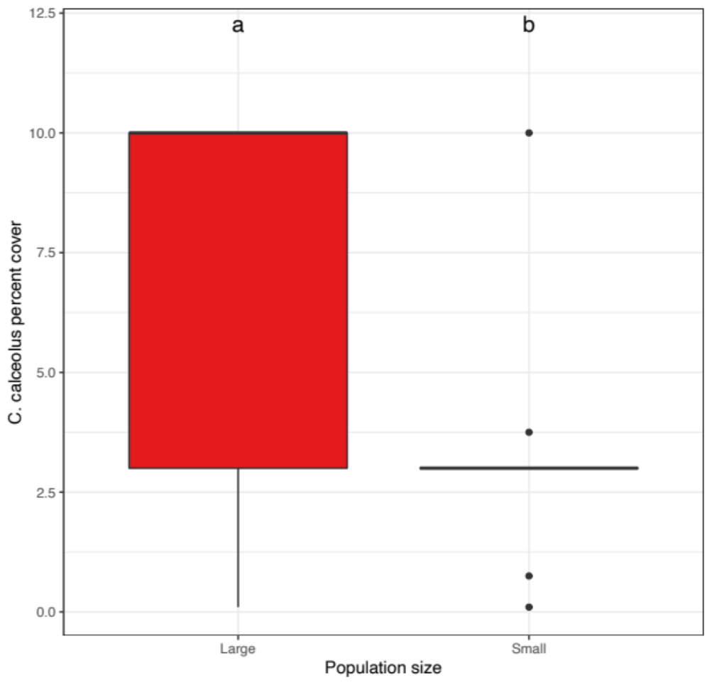

Figure S1. Average percent cover of C. calceolus populations in the surveyed vegetation patches according to the factorial discrimination of population size (Small = blue boxplots, and Large = red boxplots). Letters above boxplots indicate significant differences (glm with quasipoisson distributin, t_{1,29} = -3.202, p = 0.003).

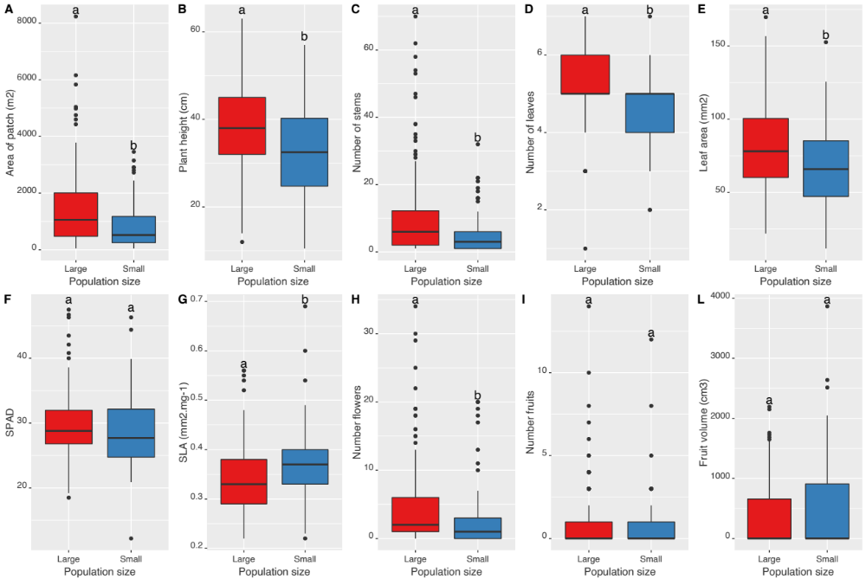

Figure S2. C. calceolus population functional traits. Shown are average trait values distributions for A) individual patch area (approximated to a ellipse) B) plant height, C) Number of stems per patch, D) Number of leaves per plant, E) Leaf area, F) Chlorophyll content (SPAD), G) Specific leaf area (SLA), H) Number of flowers per plant, I) Number of fruits per plant, L) Fruit volume (approximated to a cylinder) for small (blue boxplots; < 10 individuals), and large (red boxplots, > 100 individuals) populations. Different letters above boxplots show significant differences (p < 0.05) based on the multivariate analysis of variance as shown in Table S1.

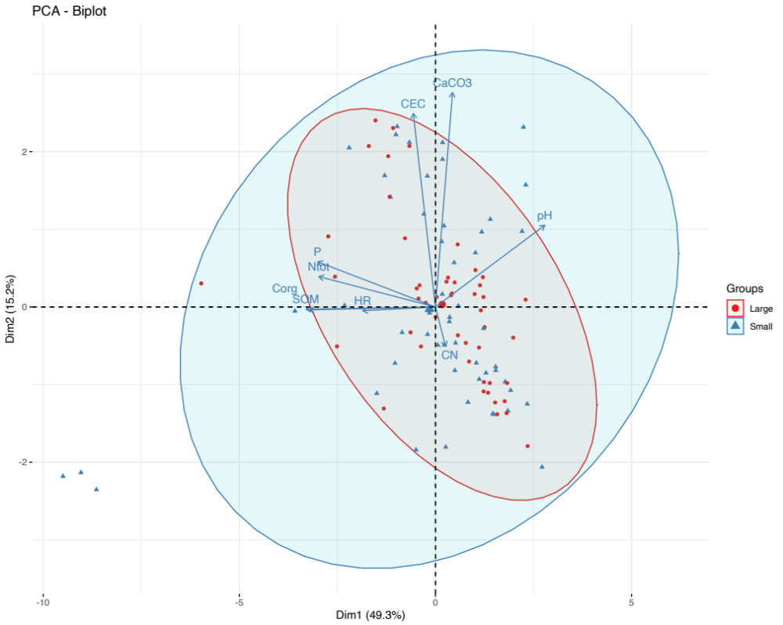
Figure S3. Principal component analysis (PCA) of ten soil physico-chemical traits describing the soils form of the 34 different C. calceolus populations. Ellipses show the 95% confidence intervals characterizing small (blue area; < 10 individuals), and large (red areas, > 20 individuals) populations. Soil traits included: soil relative humidity, pH, total soil organic matter content, CaCO₃, Total N, total C, G) carbon-to-nitrogen ratio (CN), cation exchange capacity (CEC), total phosphorous (P), and total nitrates (NO₃).

Supplementary data D1. Soil profiles of 34 Cypripedium calceolus populations. In each C. calceolus population, we dug a soil profile until bedrock or parental material, and we separated soil profiles in organic, organo-mineral and mineral horizons according to each homogenous zone observed. We identified each horizon and classified both the soils and humus forms (Baize and Girard 2009; IUSS Working Group 2015; Zanella et al. 2018). The humus and soil horizons were named according to the Référentiel pédologique (Baize and Girard 2009), and the World Reference Base for Soil Resources (WRB) (IUSS Working Group 2015) (see glossary of soil terms at the end of the document. Finally, vegetation types were also identified and classified according to Delarze et al. (2015).

Glossary for humus forms and soil horizons according to (Zanella et al. 2018) with (IUSS Working Group 2015) equivalent.

Horizon name | Definition | WRB
nOL and vOL | The OL horizon is characterized by the accumulation of mainly leaves/needles, twigs and woody materials, most of the original plant organs being easily discernible to the naked eye. The humic component amounts to less than 10% by volume; recognizable remains 90% and more, up to 100% in non-decomposed litter. Suffixes characterize neither fragmented nor transformed/discolored leaves and/or needles (nOL), and slightly altered, discolored, bleached, softened up, glued, matted, skeletonized, sometimes only slightly fragmented leaves and/or needles (vOL) | O
BryoOL | OL horizon with Bryo characteristics defined as an horizon with “byophytes or arbuscular lichens or small stonecrop plants totally covering the soil and forming a stratified carpet or cushion with living (green) parts overgrowing a layer of dead stems and leaves | O
OF | The OF horizon is characterized by the accumulation of partly decomposed litter, mainly from transformed leaves/needles, twigs and woody materials, but without any entire plant organ. The proportion of humic component is 10% to 70% by volume. Depending on humus form, decomposition is mainly accomplished by soil fauna (OFzo) or cellulose–lignin decomposing fungi (OFnoz). Slow decomposition is revealed by a partly decomposed matted layer, permeated by hyphae | O
OH | The OH horizon is characterized by an accumulation of zoogenically transformed material, i.e. black, gray-brown, brown, reddish-brown well-decomposed litter, mainly comprised of aged animal droppings. A large part of the original structures and materials are not discernible, the humic component amounting to more than 70% by volume. The OH horizon differs from the OF horizon by a more advanced transformation (fragmentation, humification, ...) due to the action of soil organisms | O

Soil horizons and layers according to (Baize and Girard 2009) with (IUSS Working Group 2015) equivalent.

Horizon name | Definition | WRB
A | A horizon presents a mix of organic and mineral material and is situated under holorganic horizons. | A
Aca | Aca is an A horizon with cold HCl effervescence. | A
Acaho | Acaho is an Aca horizon that is humus-rich. | A
Aci | Aci is an Aca horizon which has been decarbonated. Aci is thus not carbonated in fine soil or or only occasionally or locally. | A
Ado | Ado is an A horizon which is made up of hard dolomitic rocks. | A
Adoy | Adoy is an A horizon which is made up of hard dolomitic rocks and contains gypsum. | A
Agca | Agca is an Aca horizon with cold HCl effervescence and with redoxic properties.
Cca | C horizon is a depth mineral horizon. Its components have undergone, throughout their mass, significant fragmentation and/or some geochemical alteration. Cca is calcareous C horizon. | C
Cdo | Cdo is an C horizon which is made up of hard dolomitic rocks. | C
Mca | M layer is formed by continuous, loose or soft rocks, not or slightly fragmented, with possibly locally or partially altered micro-cracks. This layer are coherent, but easy to work with tools. Mca is calcareous M layer. | -
S | S horizon is a structural horizon. It is an alteration horizon. Process such as alteration of primary minerals, release of iron oxyhydroxides, decarbonation take place in that horizon. | B
Sca | Sca is calcareous S horizon. | B
Sdo | Sdo is an S horizon which is made up of hard dolomitic rocks. | B
Sdoy | Sdoy is an S horizon which is made up of hard dolomitic rocks and contains gypsum. | B
Sgca | Sgca is an Sca horizon with cold HCl effervescence and with redoxic properties. | B

Soil classification
Soil name (Référentiel pédologique, 2009) |  |  | CALCOSOL colluvial, issu d'éboulis calcaires
Soil name (WRB, 2015) |  |  | Calcaric Cambisol (Colluvic)
Humus form (Zanella et al., 2018) |  |  | Eumull
Horizon sequence (Référentiel pédologique, 2009) |  |  | [OL]-OF-BryoOL / Aca / Sca-Aca / Sca-[Aca]
Site name |  |  | AG1
Station parameters
Location | Ramsel Hang | 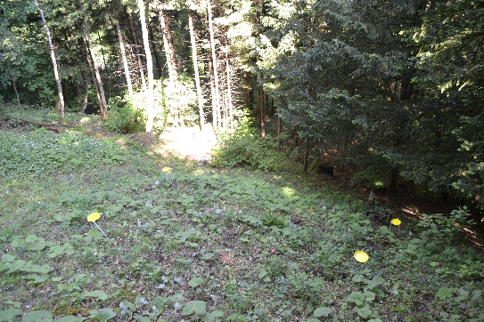
Year of sampling | 2018
Altitude | 501 m
Slope | 40°
Aspect | 330°
Topography | Steep slope
Geology | Calcareous scree
Vegetation type | Galio-Fagenion
Soil profile
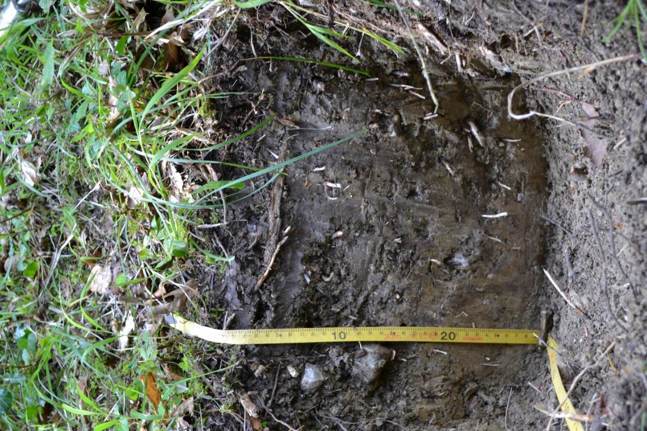

Soil classification
Soil name (Référentiel pédologique, 2009) |  |  | CALCOSOL issu de molasse
Soil name (WRB, 2015) |  |  | Calcaric Cambisol
Humus form (Zanella et al., 2018) |  |  | Eumull
Horizon sequence (Référentiel pédologique, 2009) |  |  | [OL]-BryoOL / Aca / Aca-Sca / Sca
Site name |  |  | AG2
Station parameters
Location | Erli/Bööndler | 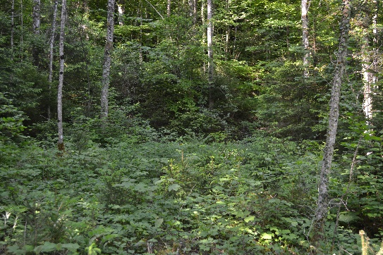
Year of sampling | 2018
Altitude | 600 m
Slope | 8°
Aspect | 0°
Topography | Light north-facing slope
Geology | Molasse
Vegetation type | Galio-Fagenion
Soil profile
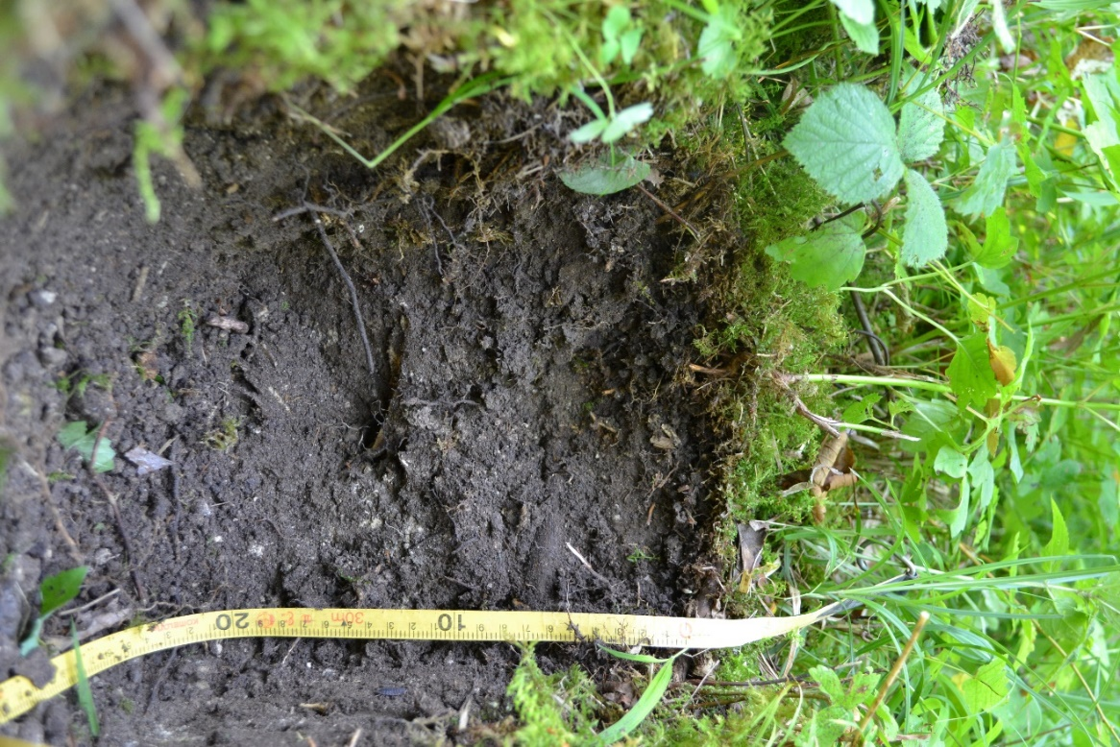

Soil classification
Soil name (Référentiel pédologique, 2009) |  |  | CALCOSOL issu de molasse
Soil name (WRB, 2015) |  |  | Calcaric Cambisol
Humus form (Zanella et al., 2018) |  |  | Eumull
Horizon sequence (Référentiel pédologique, 2009) |  |  | [OL] / BryoOL-OF-Aca / Aca / Sca1 / Sca2
Site name |  |  | AG3
Station parameters
Location | Grashalde | 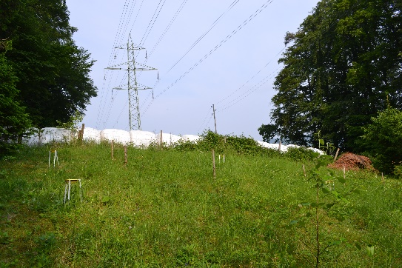
Year of sampling | 2018
Altitude | 450 m
Slope | 10°
Aspect | 47°
Topography | Light slope
Geology | Molasse
Vegetation type | Cephalanthero-Fagenion
Soil profile
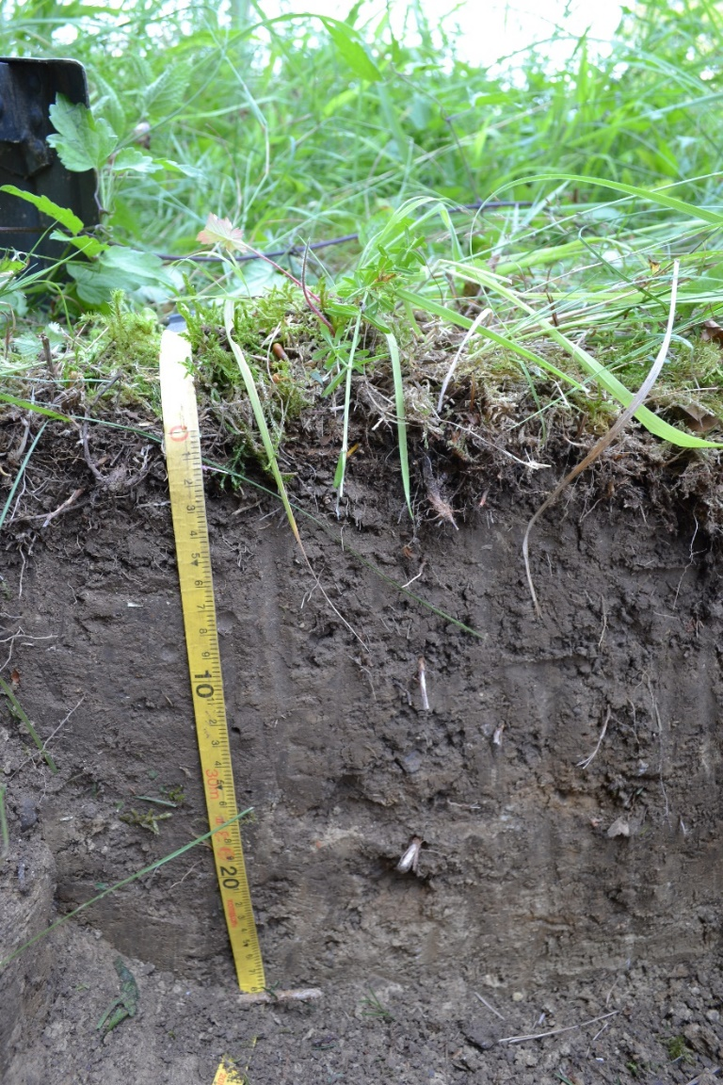

Soil classification
Soil name (Référentiel pédologique, 2009) |  |  | CALCOSOL issu de molasse
Soil name (WRB, 2015) |  |  | Calcaric Cambisol
Humus form (Zanella et al., 2018) |  |  | Eumull
Horizon sequence (Référentiel pédologique, 2009) |  |  | [nOL-vOL] / Aca-Sca / Aca-Sca&Cca
Site name |  |  | AG4
Station parameters
Location | Rotebüel | 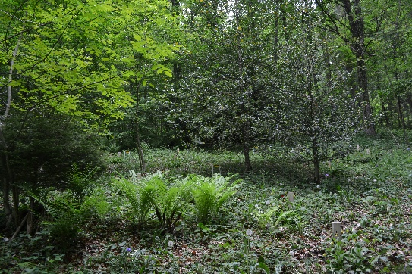
Year of sampling | 2018
Altitude | 467 m
Slope | 10°
Aspect | 180°
Topography | Light slope
Geology | Molasse
Vegetation type | Galio-Fagenion
Soil profile
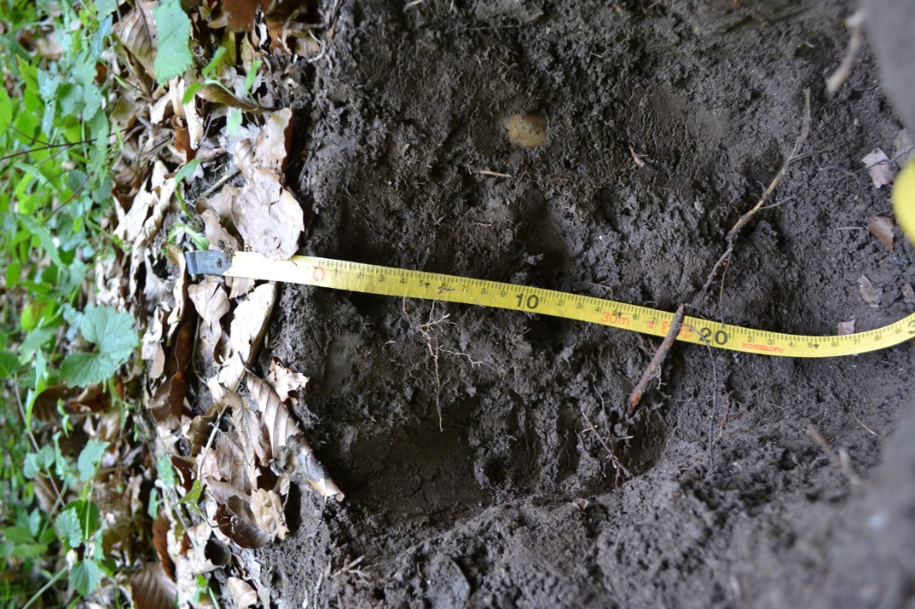

Soil classification
Soil name (Référentiel pédologique, 2009) |  |  | CALCOSOL colluvial, issu d'éboulis calcaires
Soil name (WRB, 2015) |  |  | Calcaric Cambisol (Colluvic)
Humus form (Zanella et al., 2018) |  |  | Eumull
Horizon sequence (Référentiel pédologique, 2009) |  |  | [OL]-OF-BryoOL / Aca-Sca / Mca-[Aca-Sca]
Site name |  |  | AG5
Station parameters
Location | Risi | 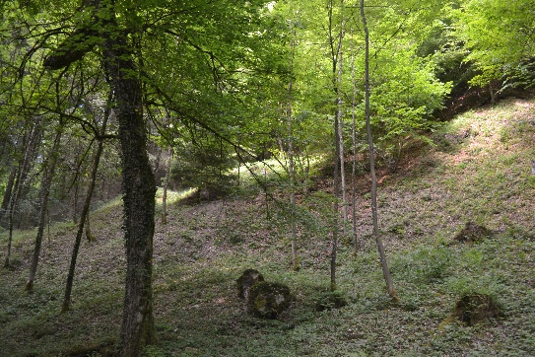
Years of sampling | 2016 and 2018
Altitude | 564 m
Slope | 40°
Aspect | 90°
Topography | Steep slope
Geology | Calcareous scree
Vegetation type | Galio-Fagenion
Soil profile
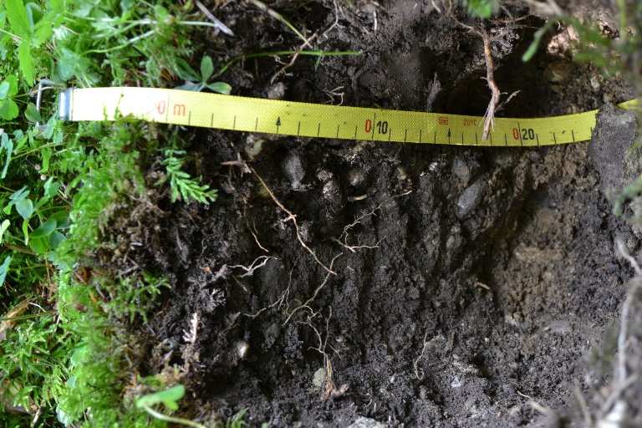

Soil classification
Soil name (Référentiel pédologique, 2009) |  |  | CALCOSOL issu de molasse
Soil name (WRB, 2015) |  |  | Calcaric Cambisol
Humus form (Zanella et al., 2018) |  |  | Mesomull
Horizon sequence (Référentiel pédologique, 2009) |  |  | nOL-BryoOL / Aca / Sca / Sca-Mca / Mca
Site name |  |  | BE1
Station parameters
Location | Chatzestiel | 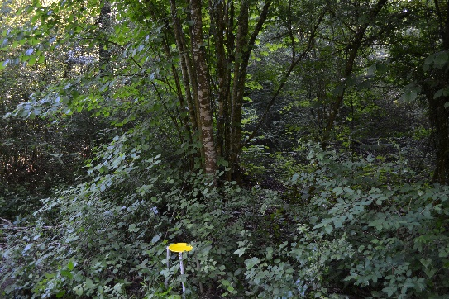
Year of sampling | 2018
Altitude | 440 m
Slope | 0°
Aspect | 0°
Topography | Edge of a forest road, flat
Geology | Molasse
Vegetation type | Cephalanthero-Fagenion
Soil profile
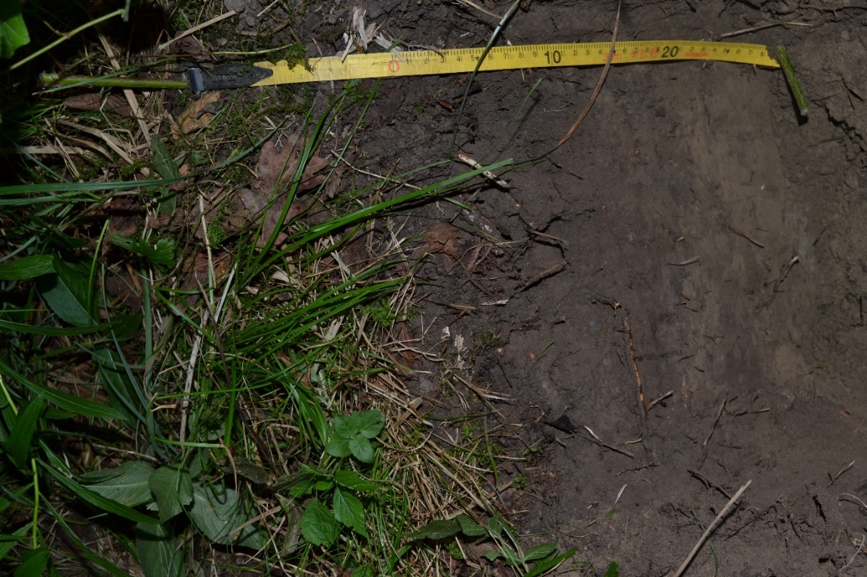

Soil classification
Soil name (Référentiel pédologique, 2009) |  |  | CALCOSOL issu de calcaires du Portlandien
Soil name (WRB, 2015) |  |  | Calcaric Cambisol
Humus form (Zanella et al., 2018) |  |  | Dysmull
Horizon sequence (Référentiel pédologique, 2009) |  |  | nOL-vOL / OF-[Aca] / Aca-[OF] / Aca-Sca / Cca
Site name |  |  | BE2
Station parameters
Location | La Neuveville | 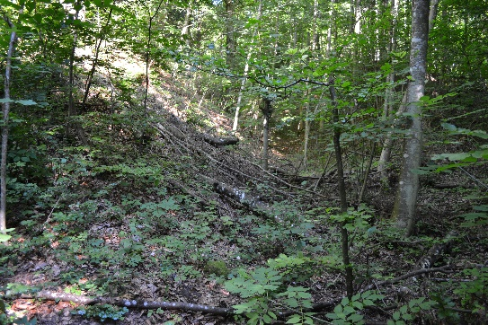
Year of sampling | 2016 and 2021
Altitude | 606 m
Slope | 5°
Aspect | 68°
Topography | Concave bottom of slope
Geology | Portlandian limestone
Vegetation type | Cephalanthero-Fagenion
Soil profile
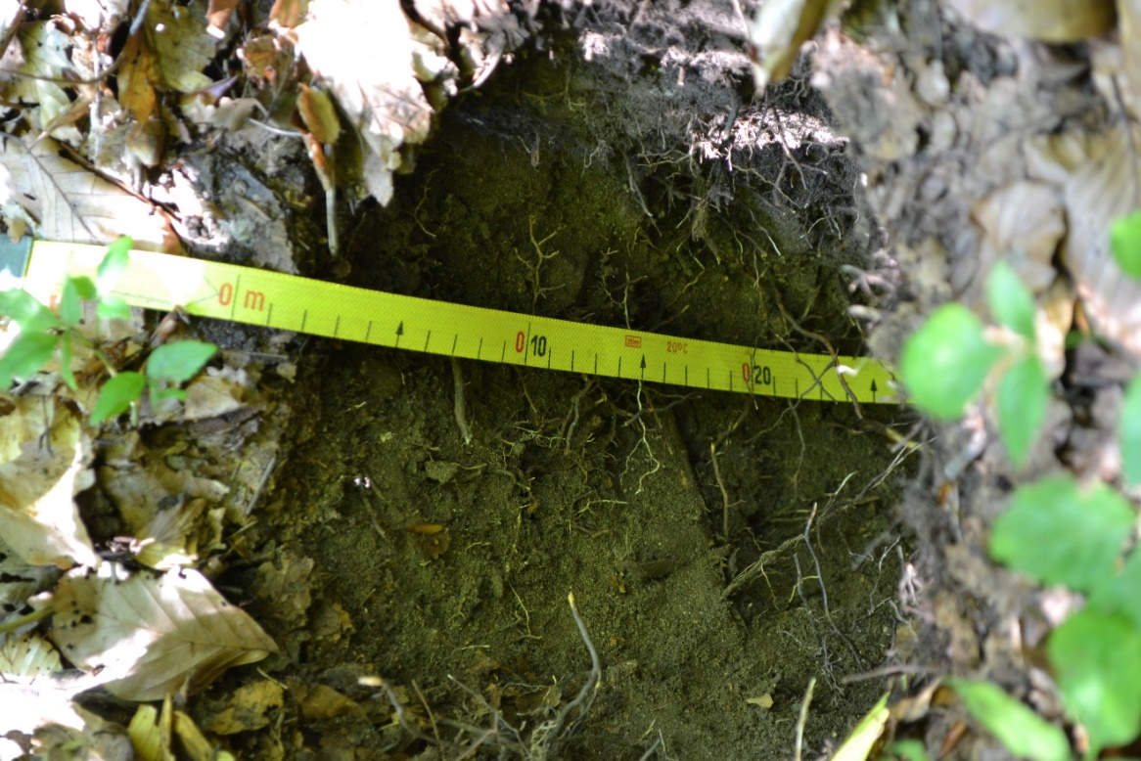

Soil classification
Soil name (Référentiel pédologique, 2009) |  | CALCOSOL colluvial, issu d’éboulis calcaires
Soil name (WRB, 2015) |  | Calcaric Cambisol (Colluvic)
Humus form (Zanella et al., 2018) |  | Mesomull
Horizon sequence (Référentiel pédologique, 2009) |  | nOL-OF / Aca / Sca / Sca-Cca
Site name |  | BE3
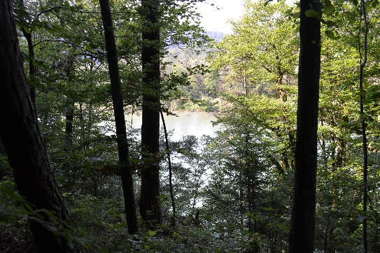
Station parameters
Location | Schlosshubel
Year of sampling | 2016 and 2018
Altitude | 500 m
Slope | 45°
Aspect | 220°
Topography | Steep slope under a molasse cliff
Geology | Molasse and calcareous scree
Vegetation type | Cephalanthero-Fagenion
Soil profile
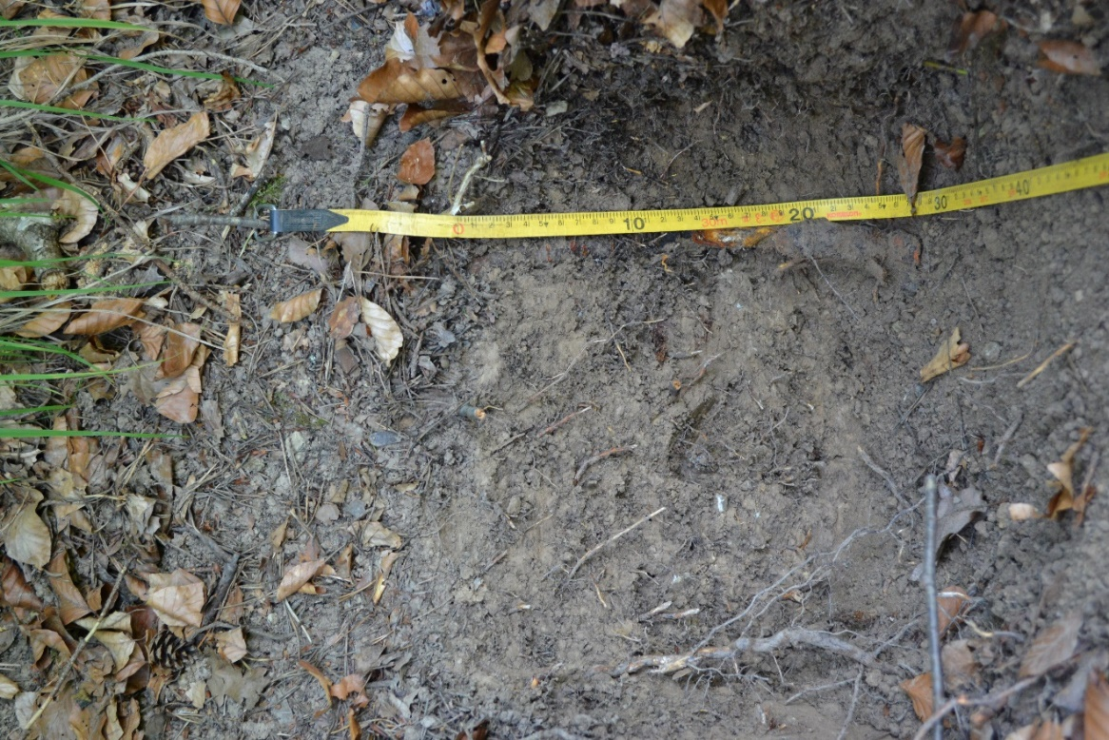

Soil classification
Soil name (Référentiel pédologique, 2009) |  |  | CALCOSOL colluvial, issu d’éboulis calcaires
Soil name (WRB, 2015) |  |  | Calcaric Cambisol (Colluvic)
Humus form (Zanella et al., 2018) |  |  | Oligomull
Horizon sequence (Référentiel pédologique, 2009) |  |  | OL / OF-Aca / Aca-Sca / Sca1 / Sca2
Site name |  |  | BE4
Station parameters
Location | Schwändiwald | 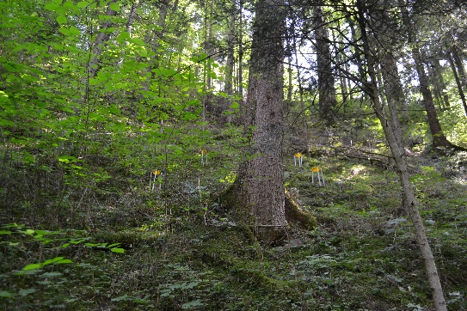
Year of sampling | 2018
Altitude | 870 m
Slope | 35°
Aspect | 220°
Topography | Steep slope
Geology | Calcareous scree
Vegetation type | Lonicero-Fagenion
Soil profile
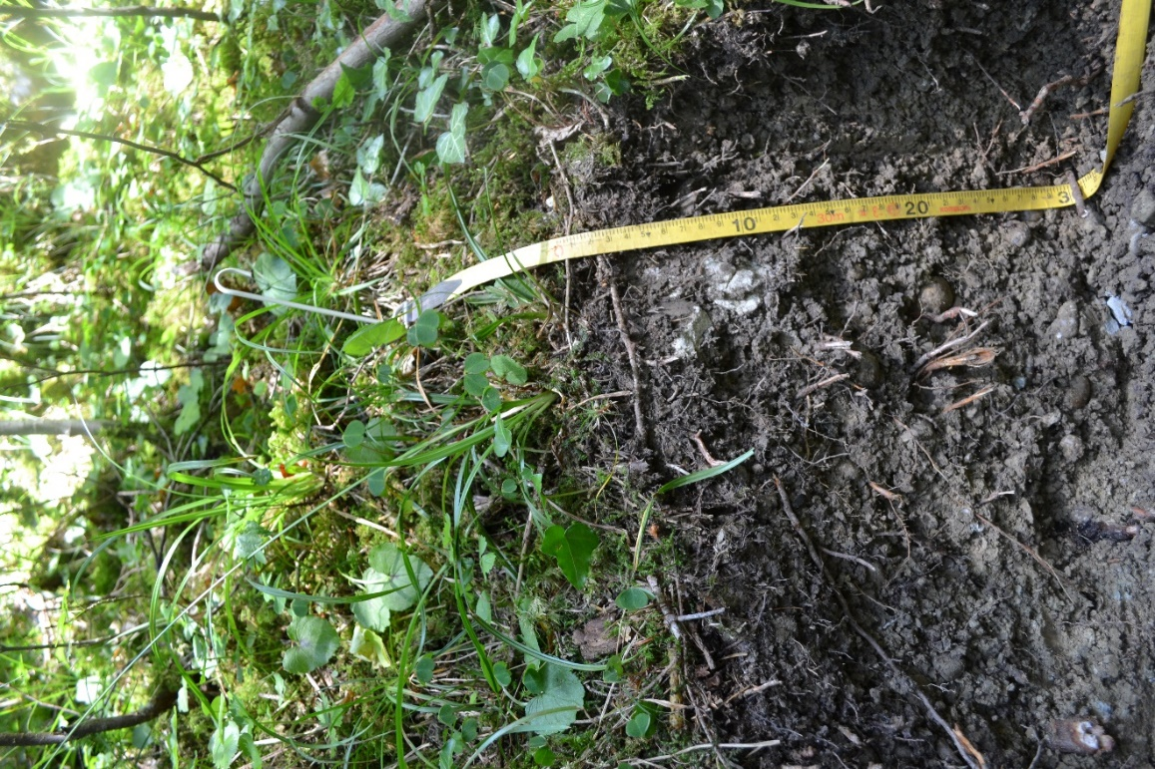

Soil classification
Soil name (Référentiel pédologique, 2009) |  |  | CALCOSOL issu de molasse
Soil name (WRB, 2015) |  |  | Calcaric Cambisol
Humus form (Zanella et al., 2018) |  |  | Oligomull
Horizon sequence (Référentiel pédologique, 2009) |  |  | OL / BryoOL-OF-Aca / Aca / Aca-Sca-Cca
Site name |  |  | BE5
Station parameters
Location | Zapfenmoos | 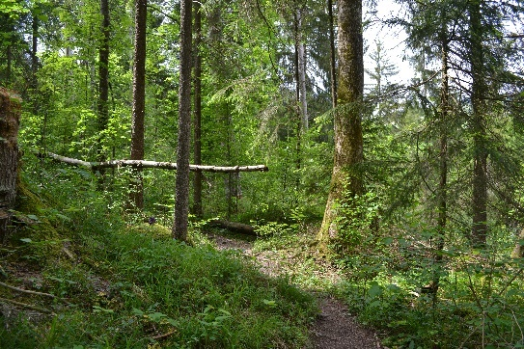
Year of sampling | 2018
Altitude | 780 m
Slope | 15°
Aspect | 0°
Topography | Light slope
Geology | Molasse
Vegetation type | Lonicero-Fagenion
Soil profile
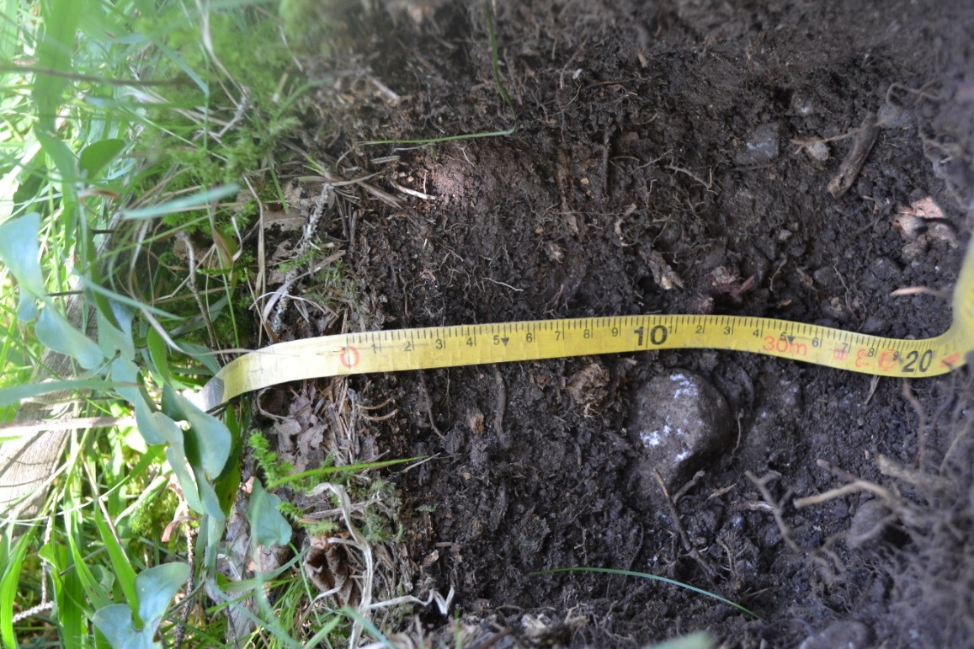

Soil classification
Soil name (Référentiel pédologique, 2009) |  |  | CALCOSOL colluvial, issu d’éboulis calcaires
Soil name (WRB, 2015) |  |  | Calcaric Cambisol (Colluvic)
Humus form (Zanella et al., 2018) |  |  | Oligomull
Horizon sequence (Référentiel pédologique, 2009) |  |  | OL / OF-Aca / Aca-Sca / Cca
Site name |  |  | BE6
Station parameters
Location | Sahlenweidli | 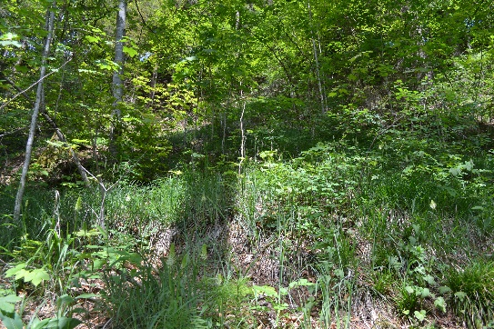
Year of sampling | 2018
Altitude | 915 m
Slope | 40°
Aspect | 160°
Topography | Steep slope
Geology | Calcareous scree
Vegetation type | Lonicero-Fagenion
Soil profile
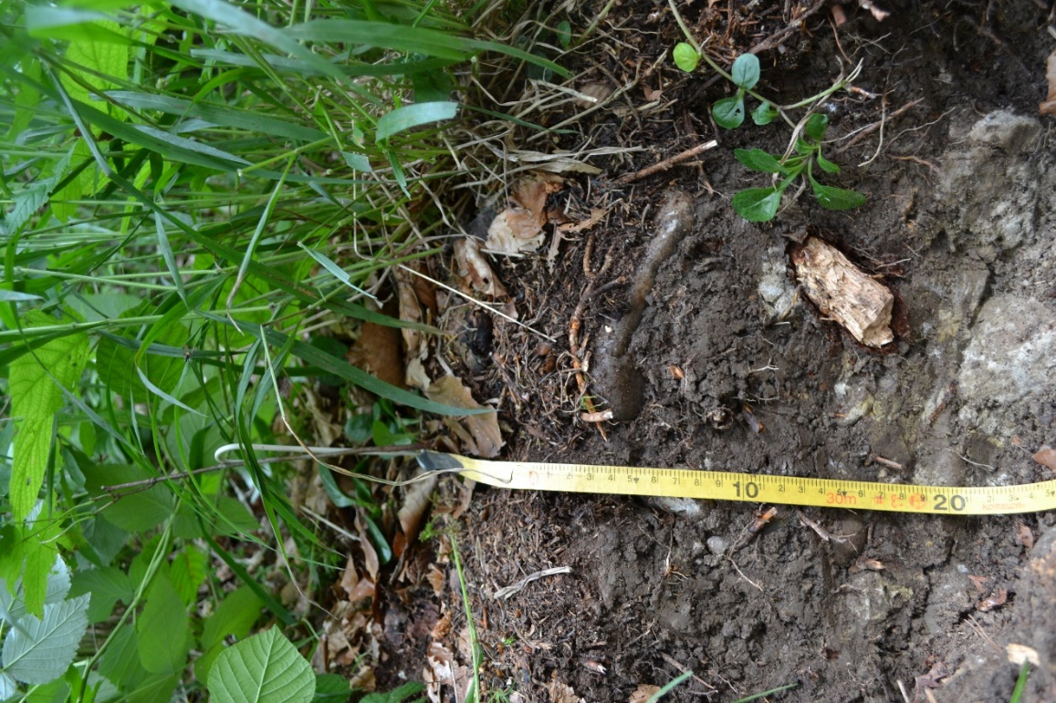

Soil classification
Soil name (Référentiel pédologique, 2009) |  |  | CALCOSOL à horizon A hémiorganique, colluvial, issu d’éboulis calcaires
Soil name (WRB, 2015) |  |  | Calcaric Cambisol (Colluvic, Humic)
Humus form (Zanella et al., 2018) |  |  | Mesomull
Horizon sequence (Référentiel pédologique, 2009) |  |  | OL / Acaho / Acaho-Sca-Cca / Sca-Cca
Site name |  |  | BE7
Station parameters
Location | Gasterntal | 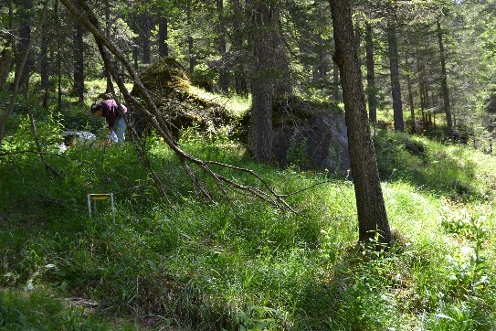
Year of sampling | 2018
Altitude | 1540 m
Slope | 17°
Aspect | 230°
Topography | Slope with flat areas
Geology | Calcareous scree
Vegetation type | Vaccinio-Piceion
Soil profile
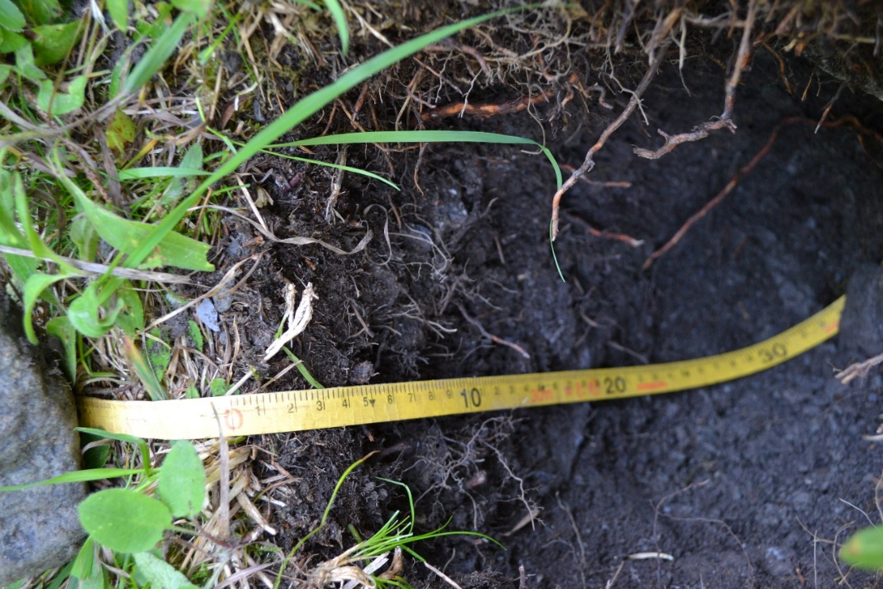

Soil classification
Soil name (Référentiel pédologique, 2009) |  |  | RENDOSOL colluvial, issu d’éboulis calcaires
Soil name (WRB, 2015) |  |  | Rendzic Calcaric Leptosol (Colluvic)
Humus form (Zanella et al., 2018) |  |  | Hemimoder
Horizon sequence (Référentiel pédologique, 2009) |  |  | vOL-nOL-BryoOL / OF-[OH] / Acaho-Cca
Site name |  |  | BL1
Station parameters
Location | Langenbruck | 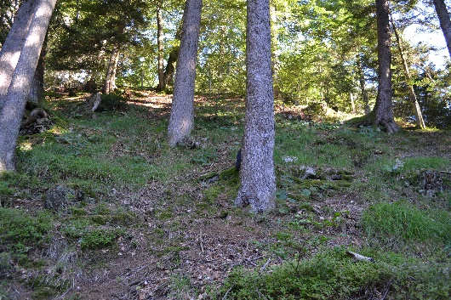
Year of sampling | 2016 and 2021
Altitude | 933 m
Slope | 35°
Aspect | 156°
Topography | Steep slope
Geology | Calcareous scree
Vegetation type | Abieti-Fagenion
Soil profile
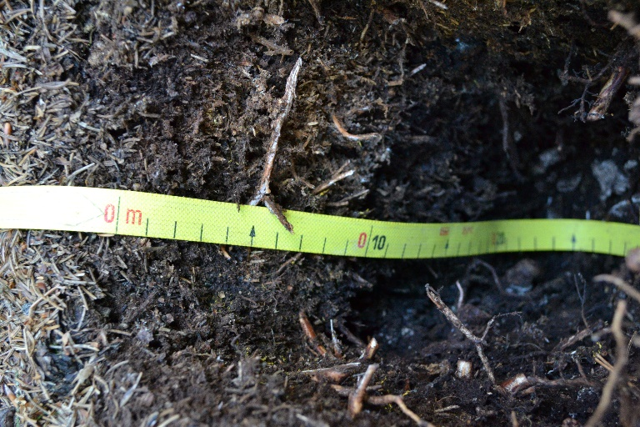

Soil classification
Soil name (Référentiel pédologique, 2009) |  |  | DOLOMITOSOL
Soil name (WRB, 2015) |  |  | Dolomitic Cambisol
Humus form (Zanella et al., 2018) |  |  | Oligomull
Horizon sequence (Référentiel pédologique, 2009) |  |  | nOL-vOL / Ado1 / Ado2 / Sdo
Site name |  |  | GR1
Station parameters
Location | Schmitten | 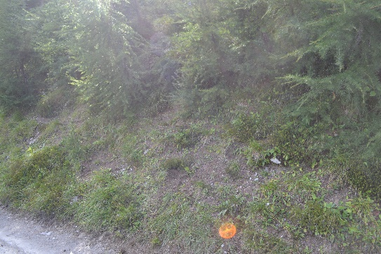
Year of sampling | 2019 and 2021
Altitude | 1927 m
Slope | 10°
Aspect | 88°
Topography | Light slope, edge of a forest road
Geology | Dolomite
Vegetation type | Erico-Pinion unicinatae
Soil profile
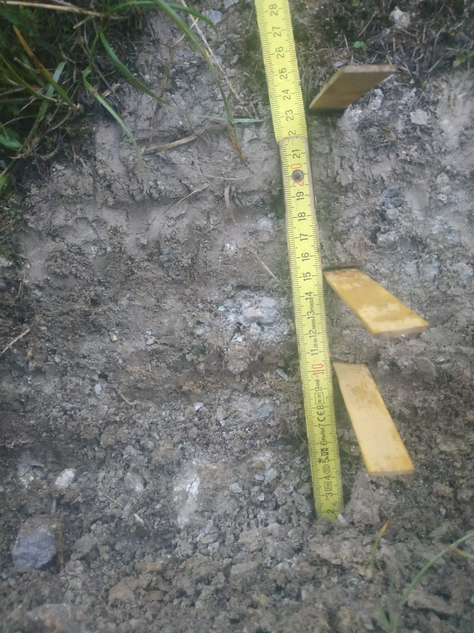

Soil classification
Soil name (Référentiel pédologique, 2009) |  | DOLOMITOSOL à horizons gypsiques
Soil name (WRB, 2015) |  | Gypsiric Dolomitic Cambisol
Humus form (Zanella et al., 2018) |  | Dysmull
Horizon sequence (Référentiel pédologique, 2009) |  | [nOL]-[vOL]-OF / Adoy / Cdo1 / Cdo2 / Cdo3
Site name |  | GR2
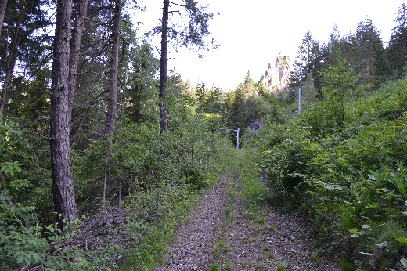
Station parameters
Location | Filisur (Bim Schloss)
Year of sampling | 2019
Altitude | 1128 m
Slope | 32°
Aspect | 253°
Topography | Steep slope between a forest road and railroad
Geology | Dolomite
Vegetation type | Cephalanthero-Fagenion
Soil profile
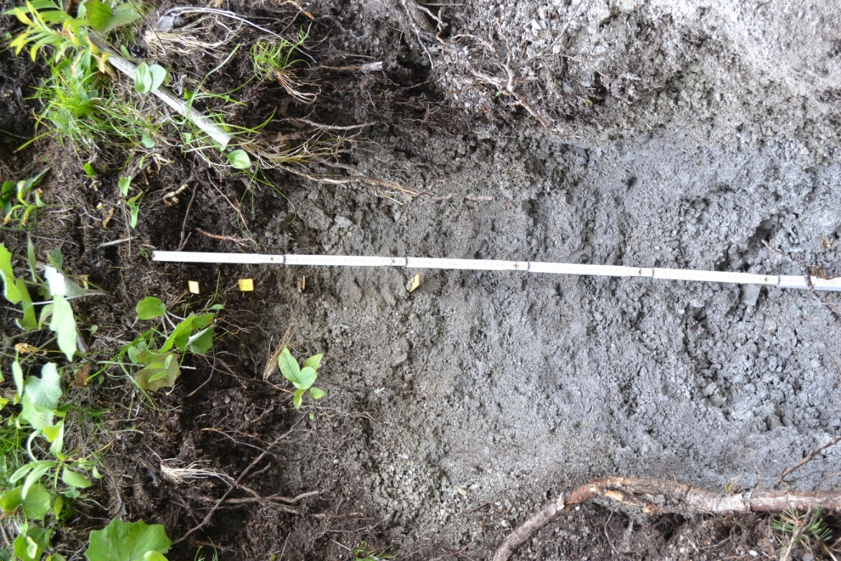

Soil classification
Soil name (Référentiel pédologique, 2009) |  |  | DOLOMITOSOL à horizons gypsiques
Soil name (WRB, 2015) |  |  | Gypsiric Dolomitic Cambisol
Humus form (Zanella et al., 2018) |  |  | Eumull
Horizon sequence (Référentiel pédologique, 2009) |  |  | nOL / Adoy / Sdoy
Site name |  |  | GR3
Station parameters
Location | Lenzerheide | 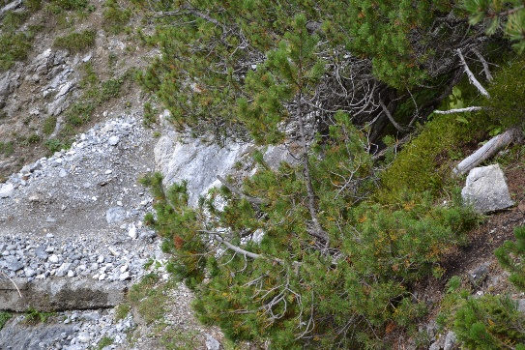
Year of sampling | 2019 and 2021
Altitude | 1922 m
Slope | 35°
Aspect | 218°
Topography | Steep slope, scree
Geology | Dolomite
Vegetation type | Erico-Pinion sylvestris
Soil profile
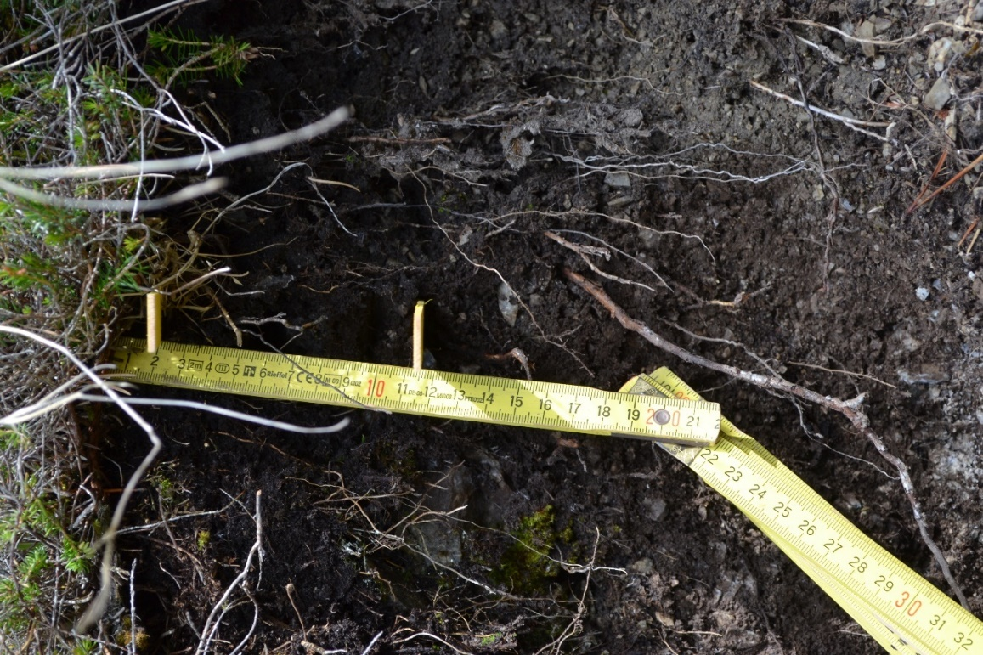

Soil classification
Soil name (Référentiel pédologique, 2009) |  |  | CALCOSOL à horizon A hémiorganique
Soil name (WRB, 2015) |  |  | Calcaric Cambisol (Humic)
Humus form (Zanella et al., 2018) |  |  | Pachyamphi
Horizon sequence (Référentiel pédologique, 2009) |  |  | vOL-nOL / BryoOL-OF-OH / Acaho / Sca
Site name |  |  | GR4
Station parameters
Location | Bonaduz | 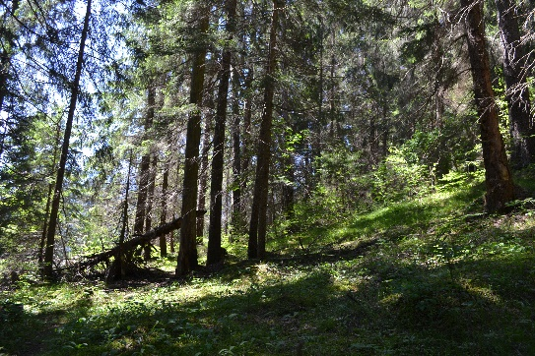
Year of sampling | 2019
Altitude | 880 m
Slope | 30°
Aspect | 94°
Topography | Slopes and flat areas
Geology | Mixed moraine
Vegetation type | Cephalanthero-Fagenion
Soil profile
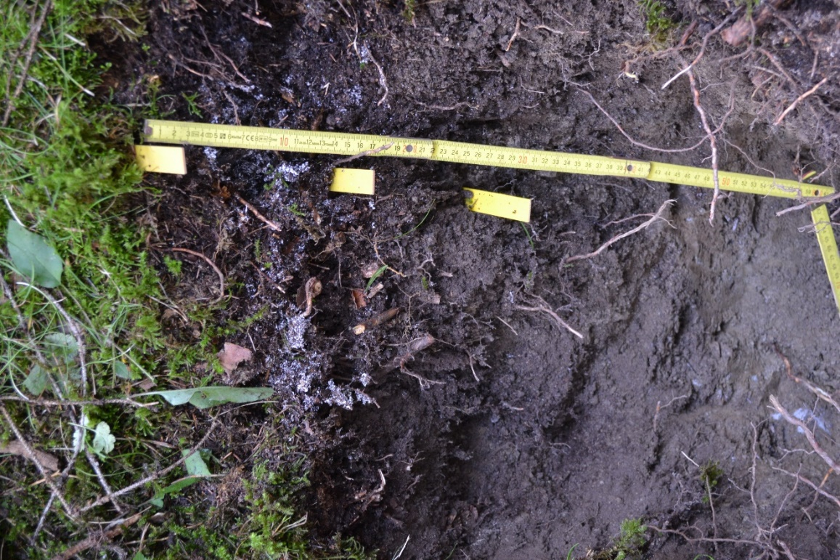

Soil classification
Soil name (Référentiel pédologique, 2009) |  |  | DOLOMITOSOL à horizons gypsiques
Soil name (WRB, 2015) |  |  | Gypsiric Dolomitic Cambisol
Humus form (Zanella et al., 2018) |  |  | Rhizoamphi
Horizon sequence (Référentiel pédologique, 2009) |  |  | nOL-[vOL] / OF-[OH] / Adoy / Adoy-Sdoy
Site name |  |  | GR5
Station parameters
Location | Bergün | 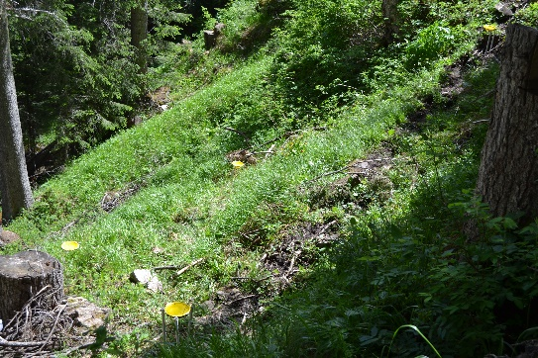
Year of sampling | 2019
Altitude | 1700 m
Slope | 38°
Aspect | 350°
Topography | Steep slope and edge of a road
Geology | NA
Vegetation type | Vaccinio-Piceion
Soil profile
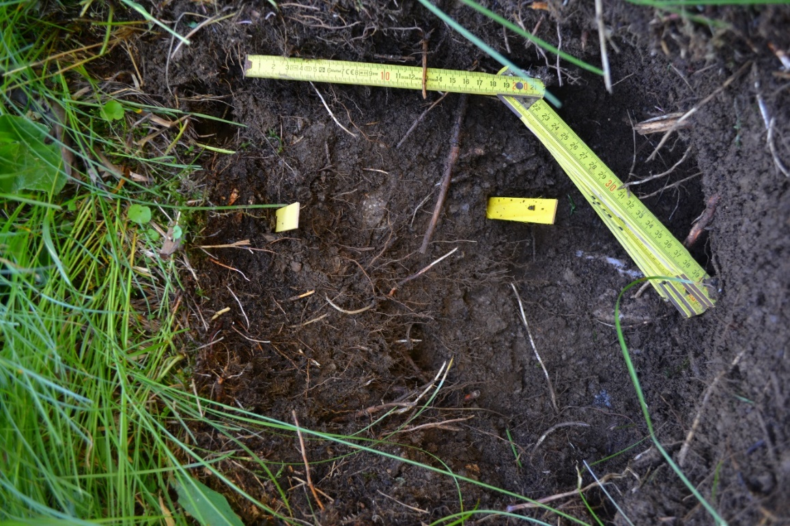

Soil classification
Soil name (Référentiel pédologique, 2009) |  |  | DOLOMITOSOL
Soil name (WRB, 2015) |  |  | Dolomitic Cambisol
Humus form (Zanella et al., 2018) |  |  | Mesomull
Horizon sequence (Référentiel pédologique, 2009) |  |  | OF / Ado / Ado-Sdo / Sdo
Site name |  |  | GR6
Station parameters
Location | Zernez | 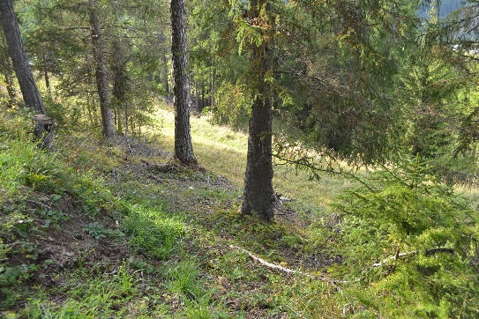
Year of sampling | 2019 and 2021
Altitude | 1526 m
Slope | 15°
Aspect | 340°
Topography | Light slope, edge of a forest road
Geology | NA
Vegetation type | Vaccinio-Piceion
Soil profile
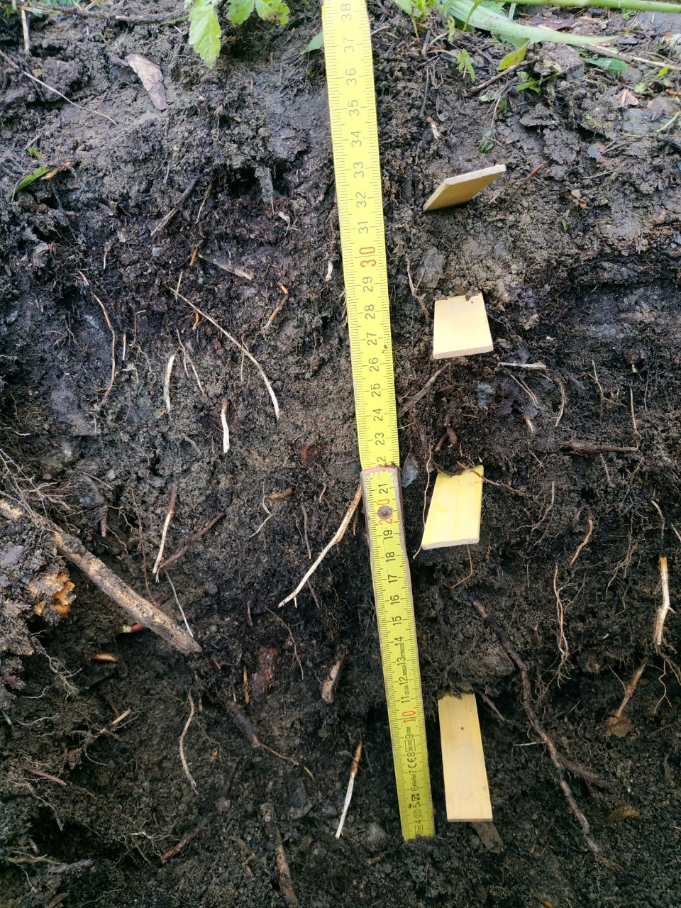

Soil classification
Soil name (Référentiel pédologique, 2009) |  |  | CALCOSOL hypocalcaire, colluvial, issu d’éboulis calcaires
Soil name (WRB, 2015) |  |  | Calcaric Cambisol (Colluvic)
Humus form (Zanella et al., 2018) |  |  | Oligomull
Horizon sequence (Référentiel pédologique, 2009) |  |  | [nOL]-[vOL] / S*-OF / [OF]-Aca / Aca-Sca / Dca
Site name |  |  | GR7
Station parameters
Location | Ruina Belfort | 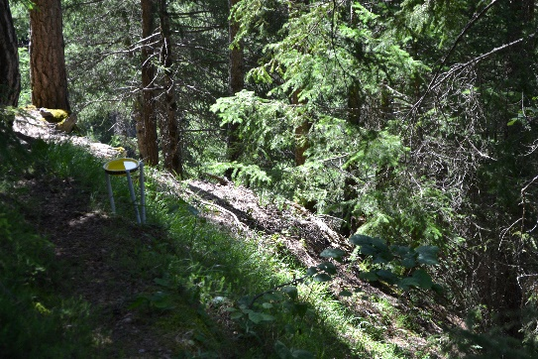
Year of sampling | 2019 and 2021
Altitude | 1153 m
Slope | 35°
Aspect | 205°
Topography | Very steep slope
Geology | Calcareous scree
Vegetation type | Erico-Pinion sylvestris
Soil profile
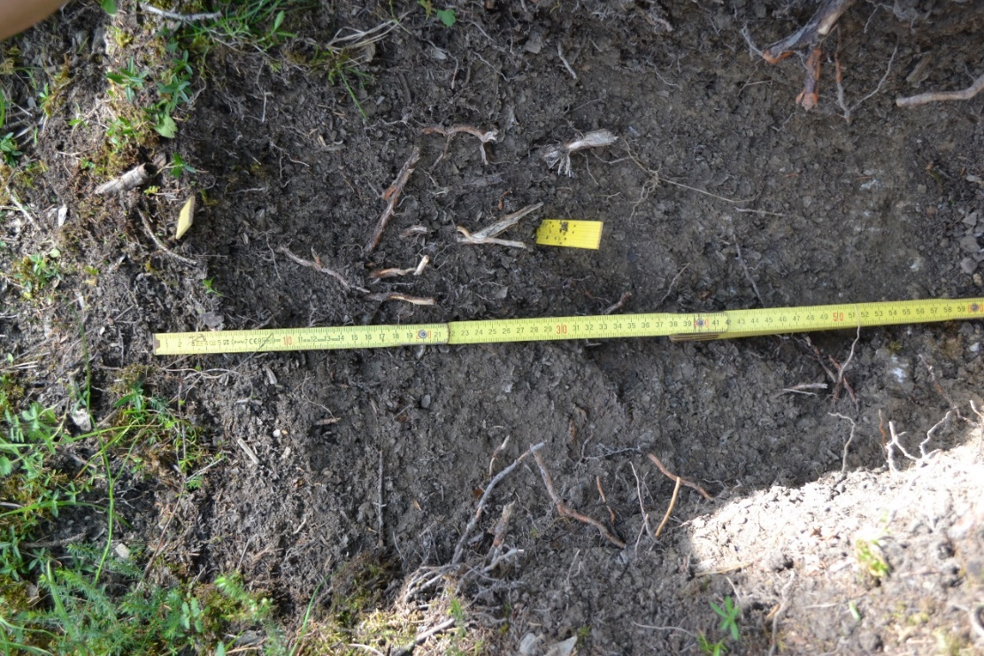

Soil classification
Soil name (Référentiel pédologique, 2009) |  |  | CALCOSOL colluvial, leptique, issu d’éboulis calcaires
Soil name (WRB, 2015) |  |  | Calcaric Cambisol (Colluvic)
Humus form (Zanella et al., 2018) |  |  | Dysmoder
Horizon sequence (Référentiel pédologique, 2009) |  |  | [BryoOL]-[vOL]-[nOL] / OF-OH / Aca / Cca-[Sca]
Site name |  |  | NE1
Station parameters
Location | Creux-du-Van | 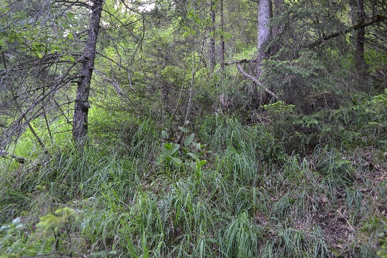
Year of sampling | 2016 and 2018
Altitude | 1166 m
Slope | 45°
Aspect | 295°
Topography | Steep slope
Geology | Calcareous scree
Vegetation type | Lonicero-Fagenion
Soil profile
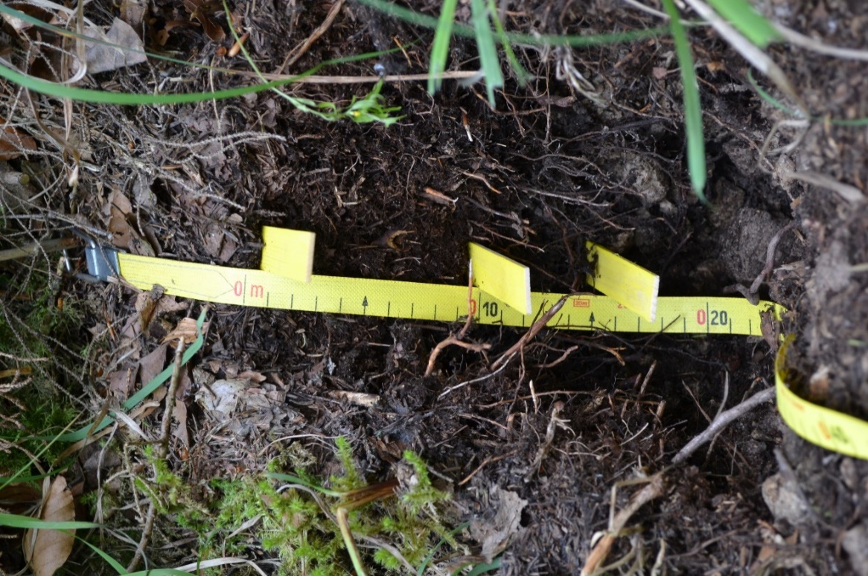

Soil classification
Soil name (Référentiel pédologique, 2009) |  |  | RENDOSOL colluvial, issu d’éboulis calcaires
Soil name (WRB, 2015) |  |  | Rendzic Calcaric Leptosol (Colluvic)
Humus form (Zanella et al., 2018) |  |  | Dysmoder
Horizon sequence (Référentiel pédologique, 2009) |  |  | vOL-BryOL / OF-OH / Aca / Dca-[Aca]
Site name |  |  | NE2
Station parameters
Location | Creux-du-Van | 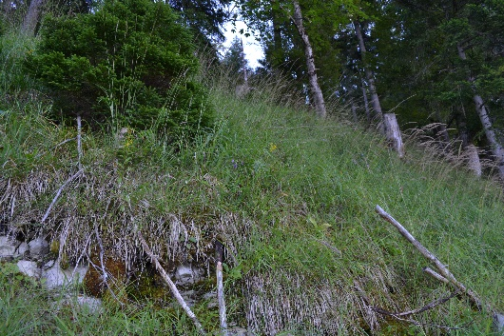
Year of sampling | 2016 and 2021
Altitude | 1187 m
Slope | 55°
Aspect | 336°
Topography | Steep slope with a rocky break
Geology | Calcareous scree
Vegetation type | Abieti-Fagenion
Soil profile
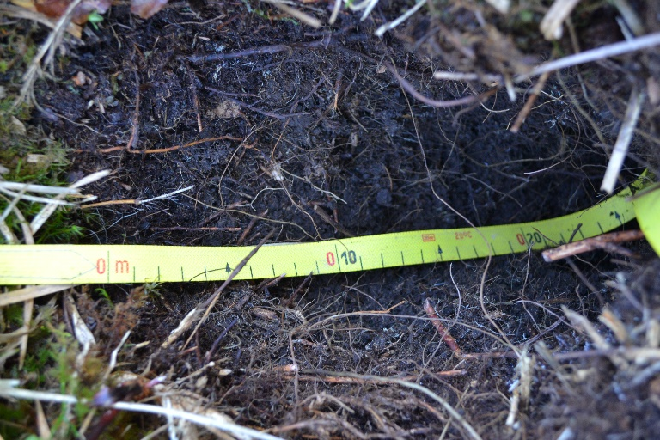

Soil classification
Soil name (Référentiel pédologique, 2009) |  |  | DOLOMITOSOL
Soil name (WRB, 2015) |  |  | Dolomitic Cambisol
Humus form (Zanella et al., 2018) |  |  | Oligomull
Horizon sequence (Référentiel pédologique, 2009) |  |  | nOL / OF / Ado
Site name |  |  | TI1
Station parameters
Location | Airolo | 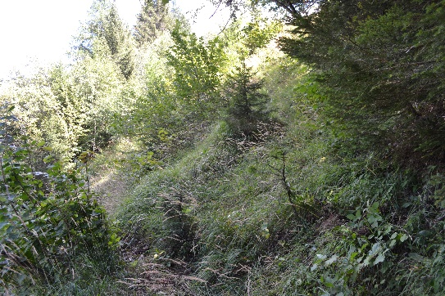
Year of sampling | 2019 and 2021
Altitude | 1276 m
Slope | 20°
Aspect | 326°
Topography | North-facing slope
Geology | NA
Vegetation type | Sambuco-Salicion
Soil profile
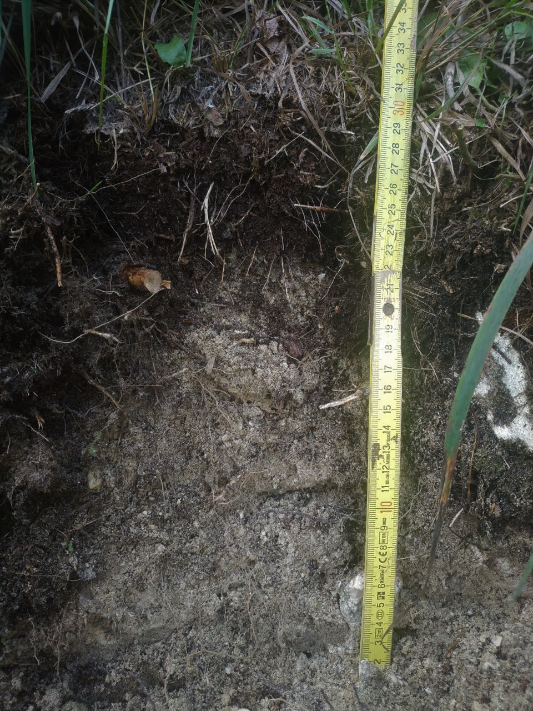

Soil classification
Soil name (Référentiel pédologique, 2009) |  |  | DOLOMITOSOL
Soil name (WRB, 2015) |  |  | Dolomitic Cambisol
Humus form (Zanella et al., 2018) |  |  | Mesomull
Horizon sequence (Référentiel pédologique, 2009) |  |  | vOL / Ado / Ado-Sdo / Sdo1 / Sdo2
Site name |  |  | TI2
Station parameters
Location | Bedretto | 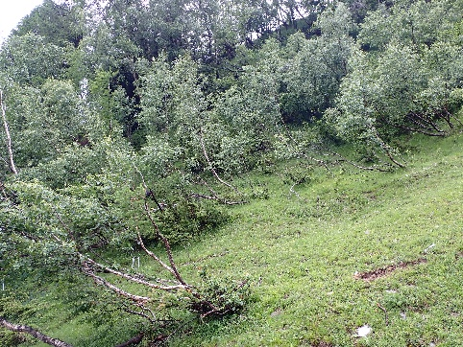
Year of sampling | 2019 and 2021
Altitude | 1495 m
Slope | 45°
Aspect | 80°
Topography | Landslide cone
Geology | Dolomite
Vegetation type | Vaccinio-Piceion
Soil profile
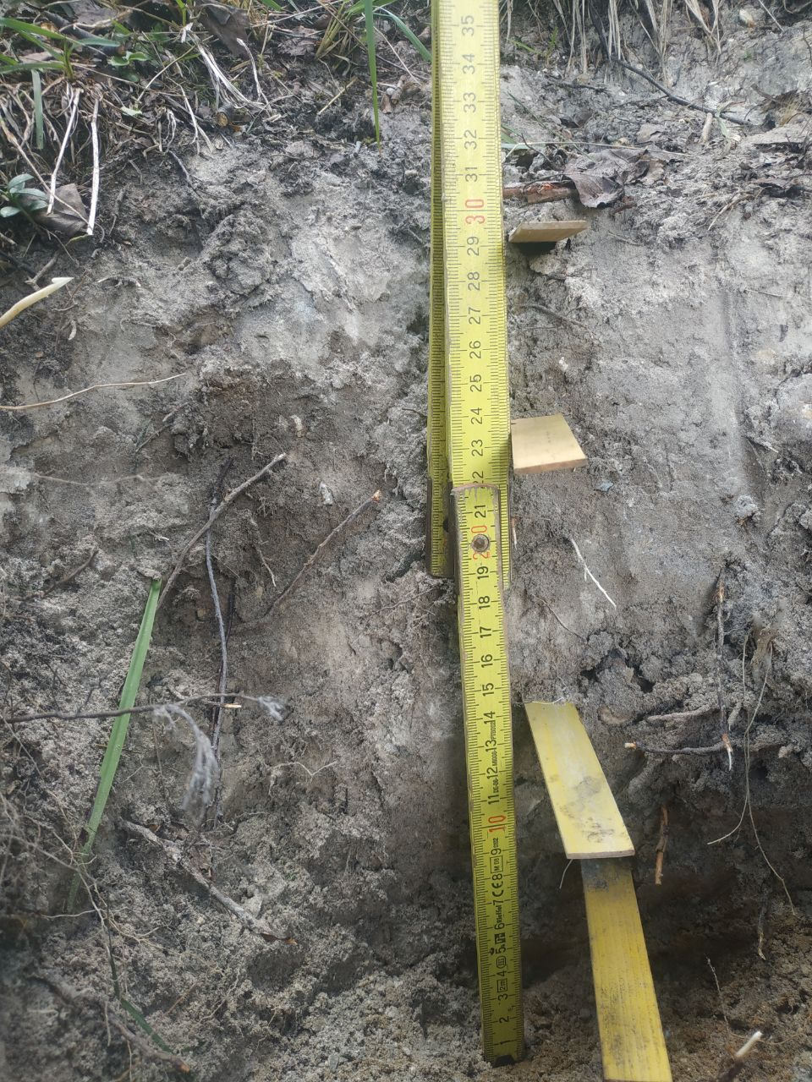

Soil classification
Soil name (Référentiel pédologique, 2009) |  |  | CALCOSOL colluvial, issu d’éboulis calcaires
Soil name (WRB, 2015) |  |  | Calcaric Cambisol (Colluvic)
Humus form (Zanella et al., 2018) |  |  | Oligomull
Horizon sequence (Référentiel pédologique, 2009) |  |  | OL / OF-Aca / Aca-OF / Sca
Site name |  |  | VD1
Station parameters
Location | Moulin d’Assens | 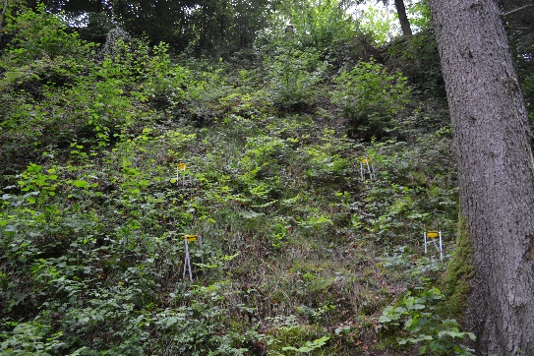
Year of sampling | 2018
Altitude | 658 m
Slope | 40°
Aspect | 290°
Topography | Steep slope above a forest path
Geology | Calcareous scree
Vegetation type | Galio-Fagenion
Soil profile
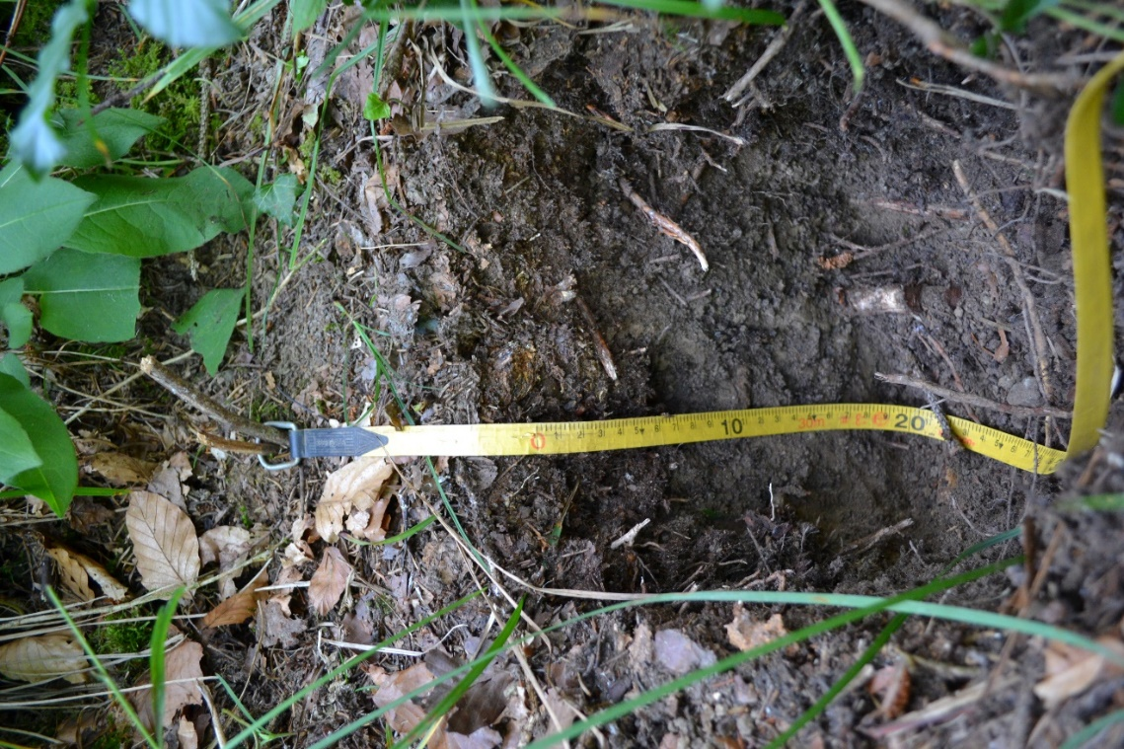

Soil classification
Soil name (Référentiel pédologique, 2009) |  |  | RENDOSOL issu de molasse
Soil name (WRB, 2015) |  |  | Calcaric Cambisol (Humic)
Humus form (Zanella et al., 2018) |  |  | Mesomull
Horizon sequence (Référentiel pédologique, 2009) |  |  | OL / Acaho1 / Acaho2 / Mca
Site name |  |  | VD2
Station parameters
Location | Grande Côte de Baumont | 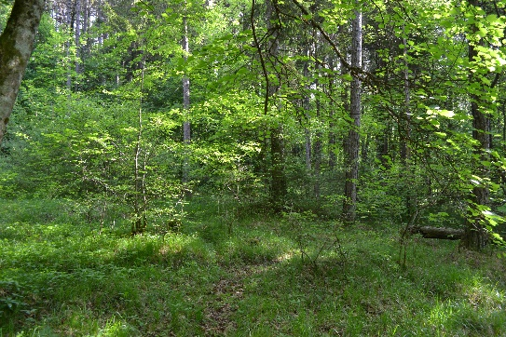
Year of sampling | 2016 and 2018
Altitude | 669 m
Slope | 7°
Aspect | 110°
Topography | Slight slope
Geology | Molasse
Vegetation type | Molinio-Pinion
Soil profile
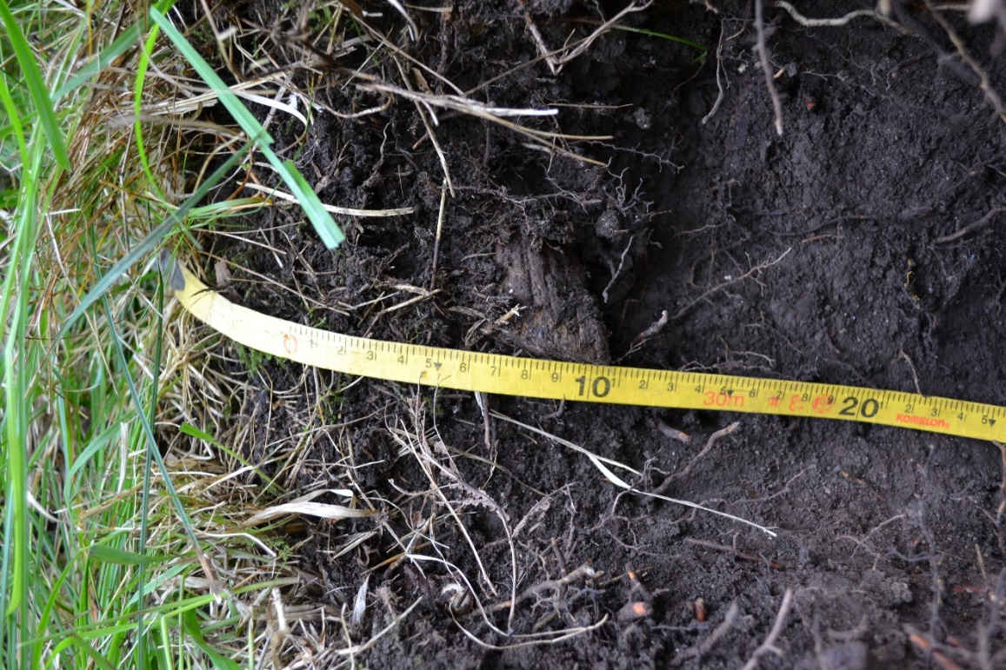

Soil classification
Soil name (Référentiel pédologique, 2009) |  |  | CALCOSOL issu de Molasse
Soil name (WRB, 2015) |  |  | Calcaric Cambisol
Humus form (Zanella et al., 2018) |  |  | Mesomull
Horizon sequence (Référentiel pédologique, 2009) |  |  | OL / Aca-Sca / Sca-Aca
Site name |  |  | VD3
Station parameters
Location | Vallon de la Veveyse | 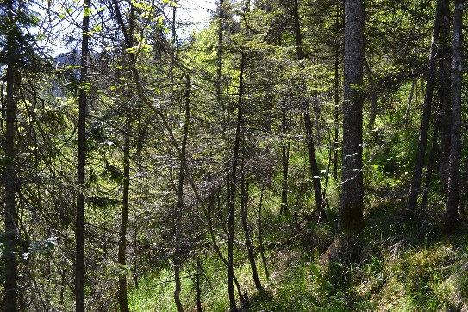
Year of sampling | 2018
Altitude | 994 m
Slope | 50°
Aspect | 90°
Topography | Slope up a river
Geology | Molasse
Vegetation type | Abieti-Fagenion
Soil profile
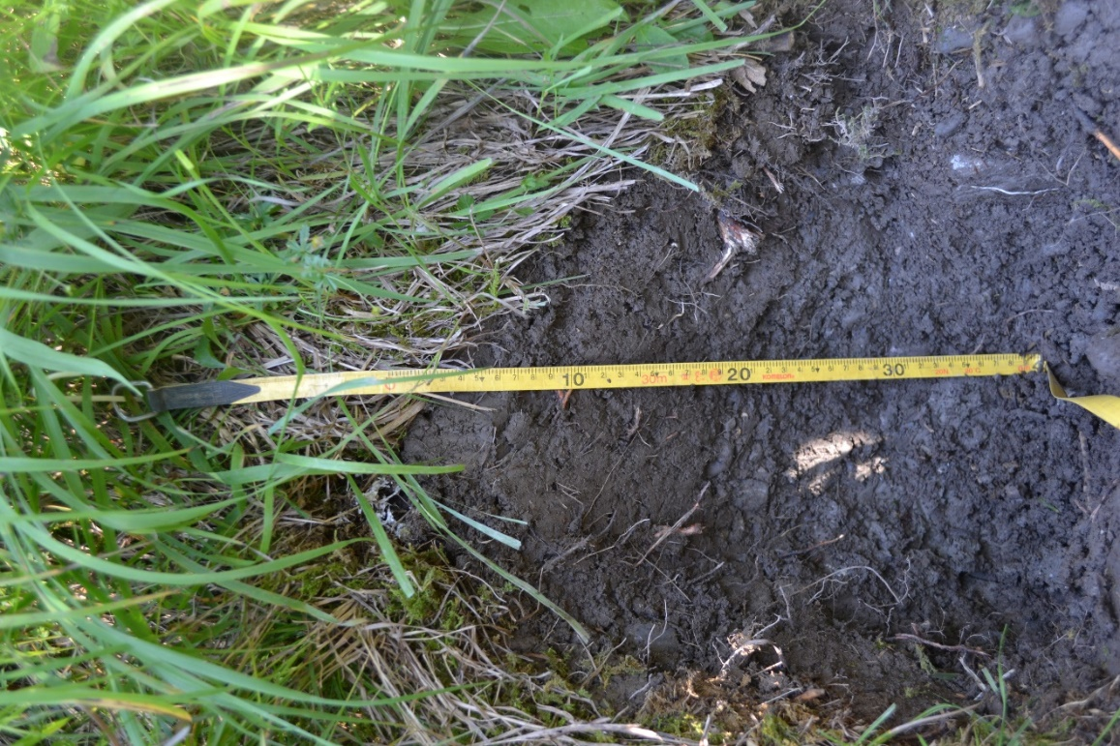

Soil classification
Soil name (Référentiel pédologique, 2009) |  |  | CALCOSOL décarbonaté en surface
Soil name (WRB, 2015) |  |  | Calcaric Cambisol
Humus form (Zanella et al., 2018) |  |  | Oligomull
Horizon sequence (Référentiel pédologique, 2009) |  |  | OL / OF-Aci / Aci / Aca-Cca / Sca
Site name |  |  | VD4
Station parameters
Location | Saint-George | 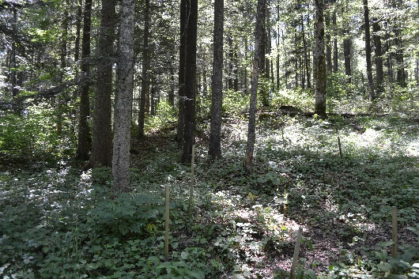
Year of sampling | 2016 and 2018
Altitude | 1122 m
Slope | 15°
Aspect | 15°
Topography | Slope
Geology | NA
Vegetation type | Abieti-Fagenion
Soil profile
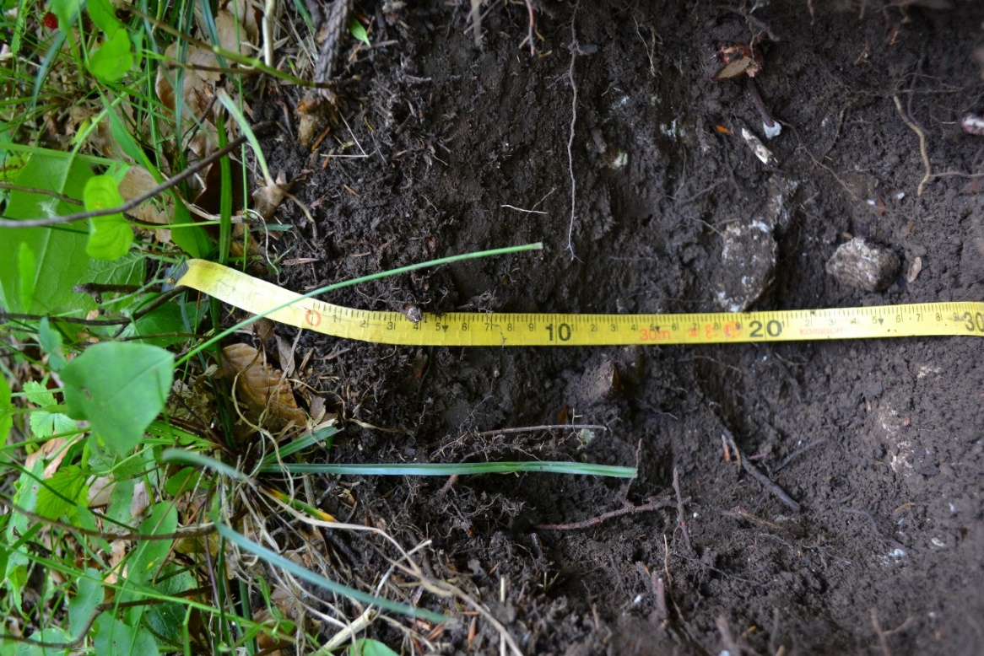

Soil classification
Soil name (Référentiel pédologique, 2009) |  |  | RENDOSOL pachique issu de molasse
Soil name (WRB, 2015) |  |  | Rendzic Calcaric Leptosol
Humus form (Zanella et al., 2018) |  |  | Hemimoder
Horizon sequence (Référentiel pédologique, 2009) |  |  | BryoOL-vOL / OL-[BryoOL] / OF-[OH]-[vOL]-[BryoOL] / Aca
Site name |  |  | VD5
Station parameters
Location | Fey | 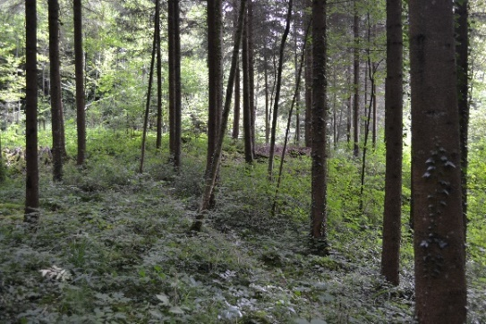
Year of sampling | 2016 and 2021
Altitude | 621 m
Slope | 5°
Aspect | 136°
Topography | Slight slope below a molasse cliff
Geology | Molasse
Vegetation type | Galio-Fagenion
Soil profile
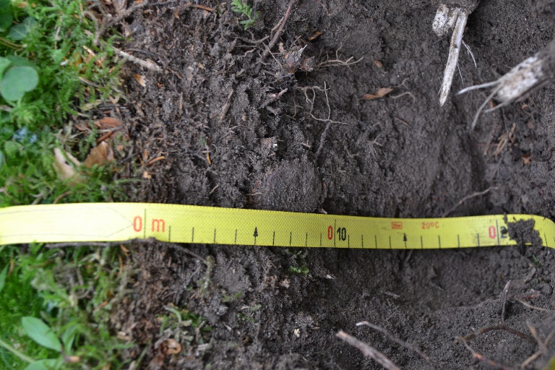

Soil classification
Soil name (Référentiel pédologique, 2009) |  |  | CALCOSOL leptique
Soil name (WRB, 2015) |  |  | Leptic Calcaric Cambisol
Humus form (Zanella et al., 2018) |  |  | Dysmull
Horizon sequence (Référentiel pédologique, 2009) |  |  | nOL-[vOL] / OF / [OF]-Aca / Sca1 / Sca2
Site name |  |  | VS1
Station parameters
Location | Sion | 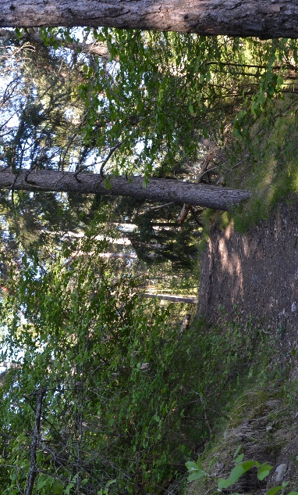
Year of sampling | 2019
Altitude | 731 m
Slope | 28°
Aspect | 14°
Topography | Edge of a forest path
Geology | NA
Vegetation type | Cephalanthero-Fagenion
Soil profile
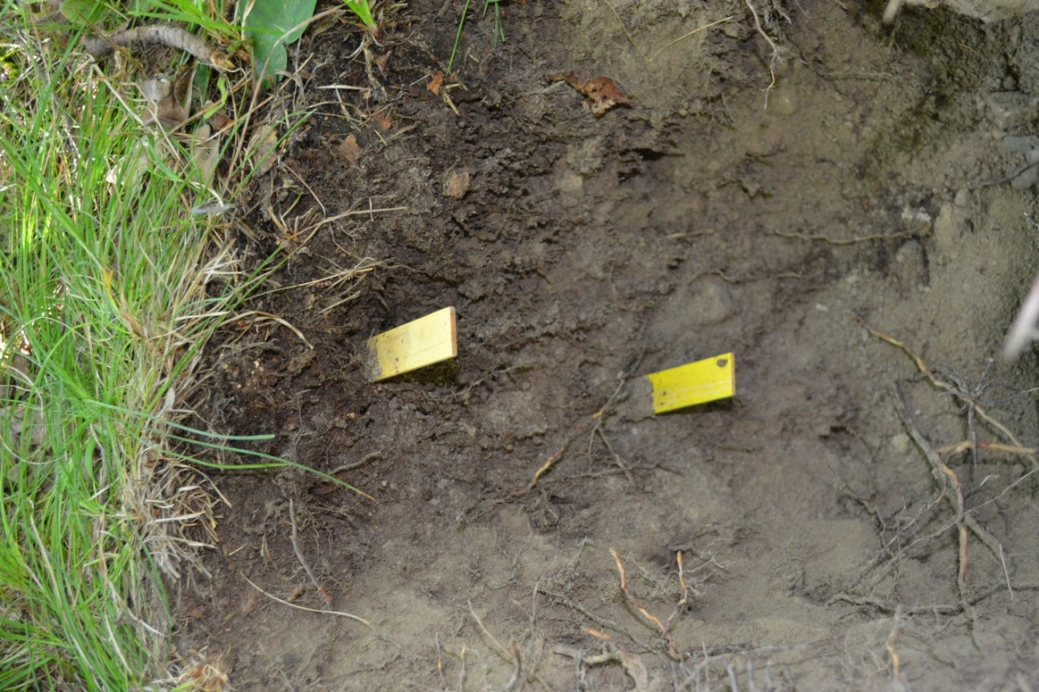

Soil classification
Soil name (Référentiel pédologique, 2009) |  |  | CALCOSOL rédoxique
Soil name (WRB, 2015) |  |  | Stagnic Calcaric Cambisol
Humus form (Zanella et al., 2018) |  |  | Dysmoder
Horizon sequence (Référentiel pédologique, 2009) |  |  | vOL / OF-OH / Agca / Agca-Sgca
Site name |  |  | VS2
Station parameters
Location | L’Ermitage | 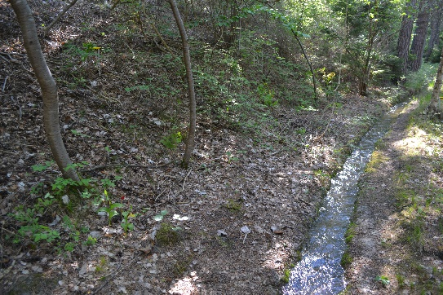
Year of sampling | 2019
Altitude | 571 m
Slope | 17°
Aspect | 217°
Topography | Next to a water chanel (bisse)
Geology | NA
Vegetation type | Cephalanthero-Fagenion
Soil profile
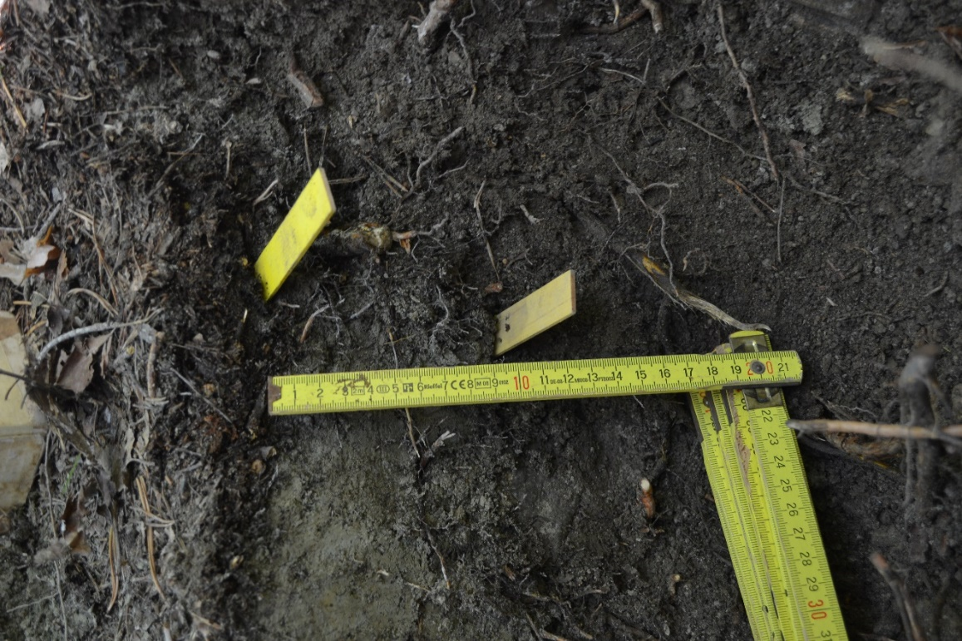

Soil classification
Soil name (Référentiel pédologique, 2009) |  |  | CALCOSOL
Soil name (WRB, 2015) |  |  | Calcaric Cambisol
Humus form (Zanella et al., 2018) |  |  | Hemimoder
Horizon sequence (Référentiel pédologique, 2009) |  |  | [nOL]-vOL / S*-OF-[OH] / Aca-Sca / Dca
Site name |  |  | VS3
Station parameters
Location | Forêt de Sierre | 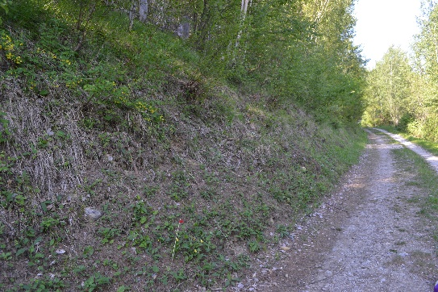
Year of sampling | 2019
Altitude | 1075 m
Slope | 31°
Aspect | 354°
Topography | Edge of a forest road
Geology | NA
Vegetation type | Abieti-Piceion
Soil profile
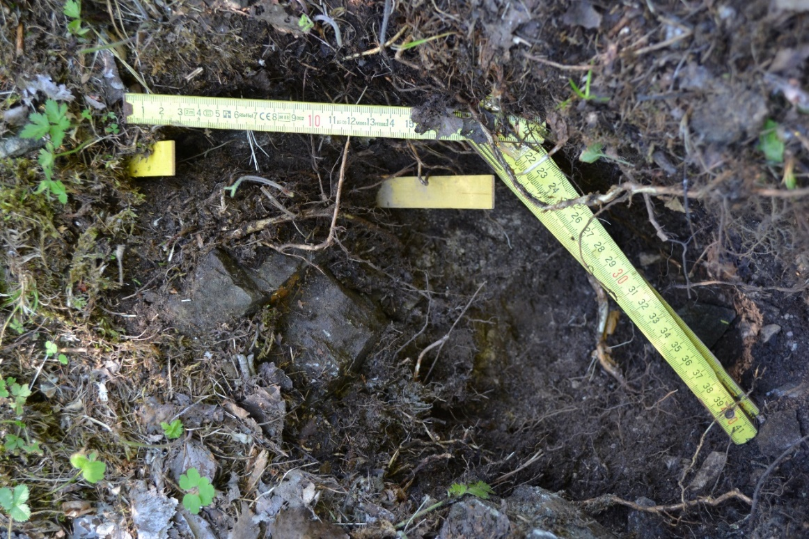

Soil classification
Soil name (Référentiel pédologique, 2009) |  |  | RENDOSOL colluvial, issu d’éboulis calcaires
Soil name (WRB, 2015) |  |  | Calcaric Leptosol (Colluvic)
Humus form (Zanella et al., 2018) |  |  | Dysmull
Horizon sequence (Référentiel pédologique, 2009) |  |  | [nOL]-vOL / OF / Aca1 / Aca2 / Dca
Site name |  |  | VS4
Station parameters
Location | Niouc | 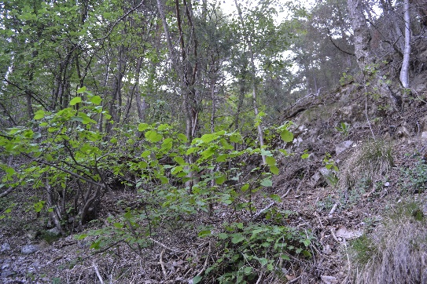
Year of sampling | 2019
Altitude | 1040 m
Slope | 30°
Aspect | 278°
Topography | Bottom of a steep slope
Geology | Calcareous scree
Vegetation type | Cephalanthero-Fagenion
Soil profile
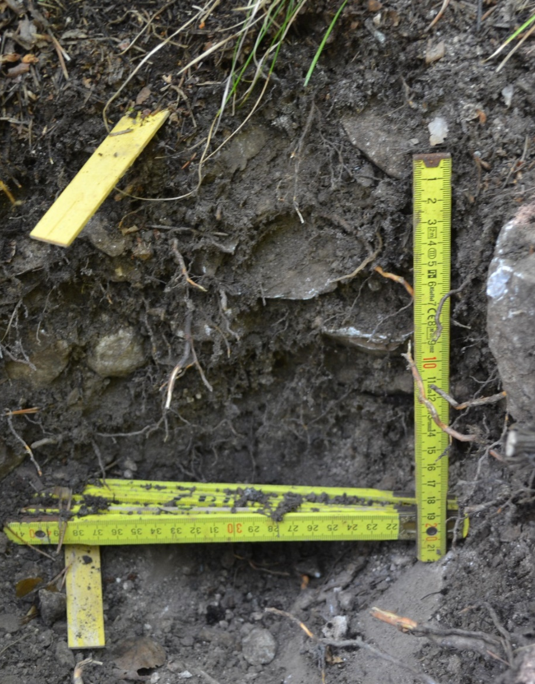

Soil classification
Soil name (Référentiel pédologique, 2009) |  |  | CALCOSOL
Soil name (WRB, 2015) |  |  | Calcaric Cambisol
Humus form (Zanella et al., 2018) |  |  | Oligomull
Horizon sequence (Référentiel pédologique, 2009) |  |  | nOL-[vOL] / S*-OF / Aca / Sca
Site name |  |  | VS5
Station parameters
Location | Les Diablerets | 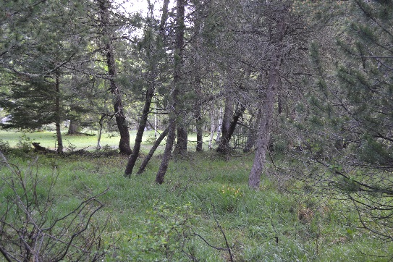
Year of sampling | 2019
Altitude | 1450 m
Slope | 6°
Aspect | 190°
Topography | Flat area
Geology | NA
Vegetation type | Erico-Pinion unicinatae
Soil profile
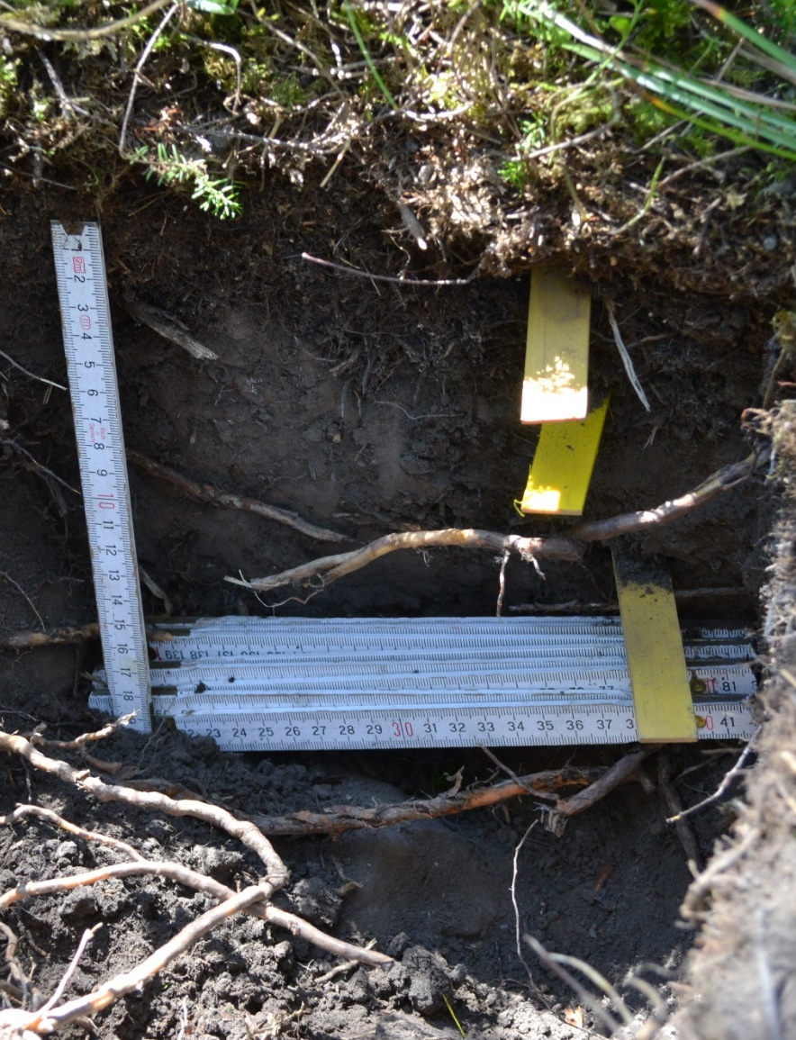

References

Baize D, Girard M-C (2009) Référentiel pédologique 2008. Editions Quae, Versaille , France.
Delarze R, Gonseth Y, Eggenberg S, Vust M (2015) Guide des milieux naturels de Suisse: écologie, menaces, espèces caractéristiques. Rossolis, Bussigny, Switzerland.
IUSS Working Group W (2015) World reference base for soil resources 2014, update 2015. World Soil Resources Report 106.
Zanella A, Ponge J-F, Jabiol B, Sartori G, Kolb E, Le Bayon R-C, Gobat J-M, Aubert M, De Waal R, Van Delft B (2018) Humusica 1, article 5: Terrestrial humus systems and forms—Keys of classification of humus systems and forms. Applied Soil Ecology 122: 75-86.

