Supplementary Information Files for

Exploring the Effects of Potentization by Electron Microscopy, Raman Spectroscopy and AI Algorithms
Camelia Berghian-Grosan^{1,}*, Drosos Kourounis², Alin Sebastian Porav¹, Ilknur Dag^{3,4}, Kursad Osman Ay³, and George Vithoulkas^{5,}*

¹National Institute for Research and Development of Isotopic and Molecular Technologies; Cluj-Napoca 400293, Romania.
²NEPLAN AG, CH-8700 Küsnacht (ZH), Switzerland
³Eskisehir Osmangazi University, Central Research Laboratory Application and Research Center, Eskisehir 26480, Turkey.
⁴Eskisehir Osmangazi University, Vocational Health Services High School, Eskisehir 26480, Turkey.
⁵University of the Aegean; Mytilene 81100, Greece.

Correspondence to: camelia.grosan@itim-cj.ro and george@vithoulkas.com

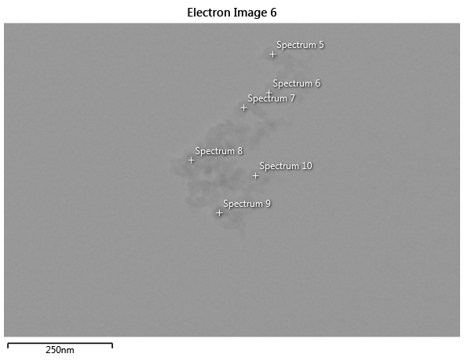
E-AUR 6C
A
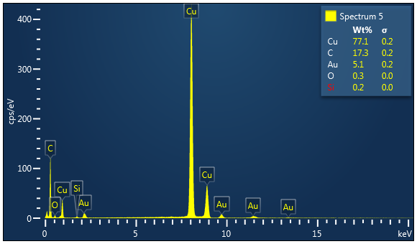
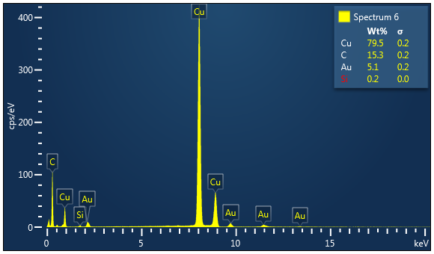
B
C

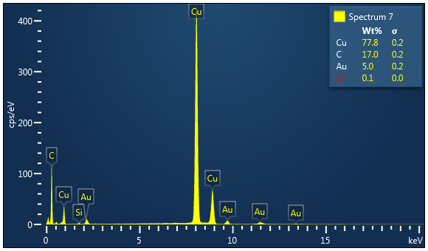
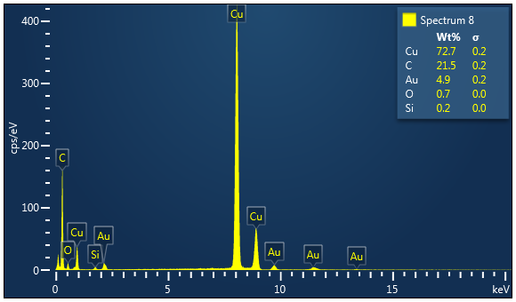
D
E

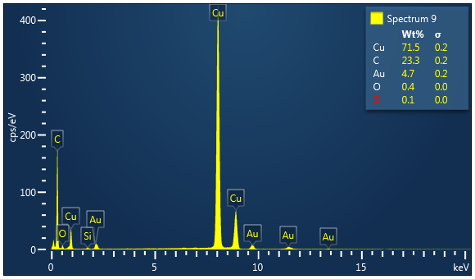
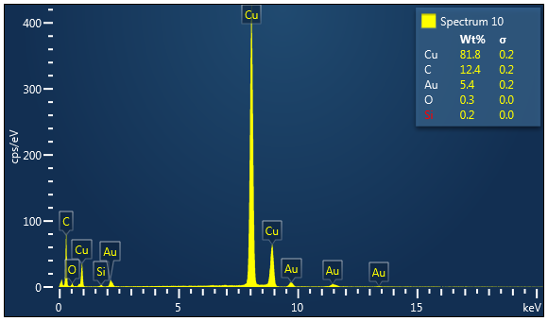
Fig. S1. (A) TEM image recorded for E- AUR 6C samples and (B-G) the EDX spectra obtained for the investigated points indicated in the TEM figure
F
G

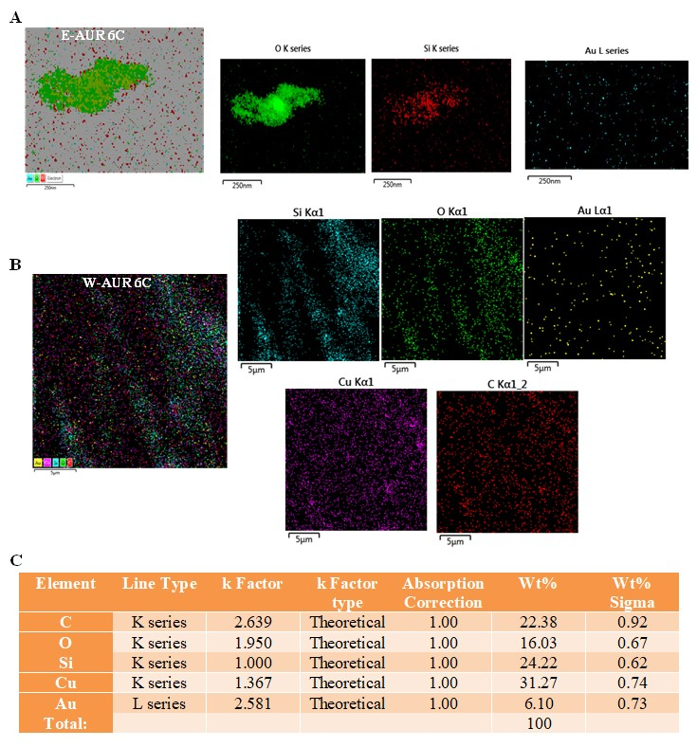
Fig. S2. TEM-EDX data for 6C potency of AUR. (A) TEM mapping for Aurum metallicum samples recorded in Romania - E-AUR 6C and (B) Turkey - W-AUR 6C; (C) EDX data obtained for W-AUR 6C.
E-AUR 6C
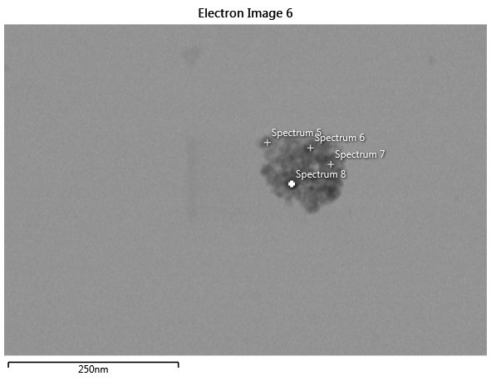
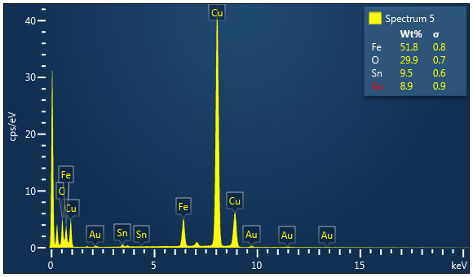
E-AUR 30C
A
B

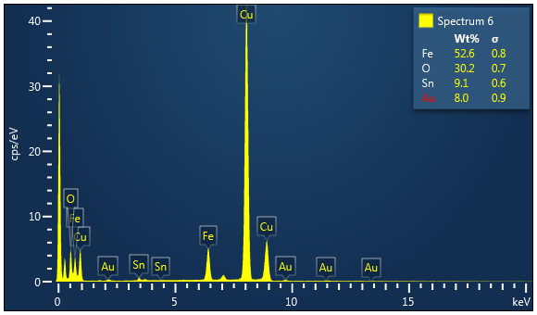
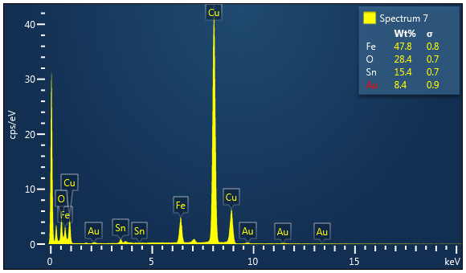
C
D

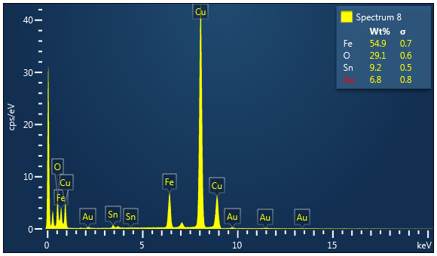
E

Fig. S3. (A) TEM image recorded for E- AUR 30C samples and (B-E) the EDX spectra obtained for the investigated points indicated in the TEM figure
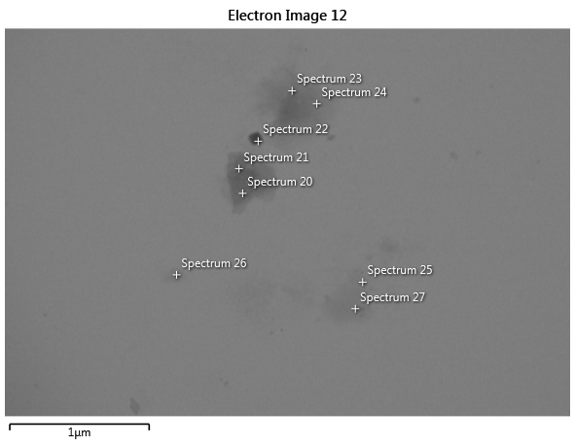
A
E-AUR 30C

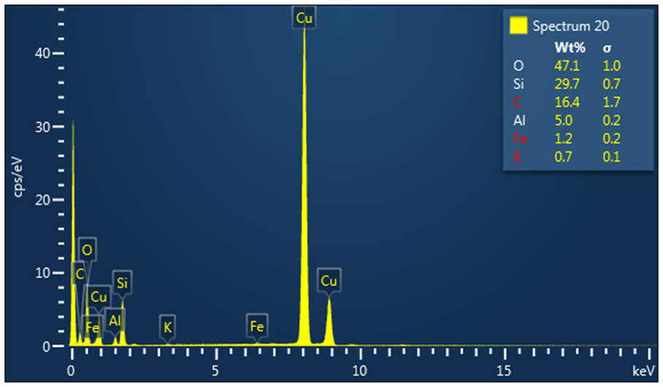
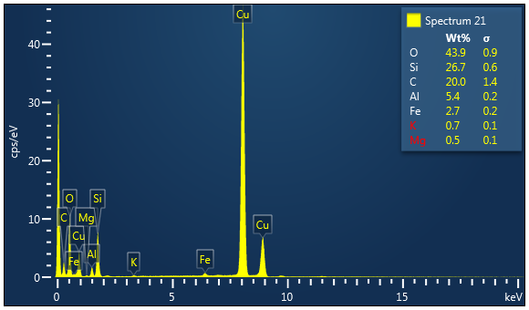
B
C

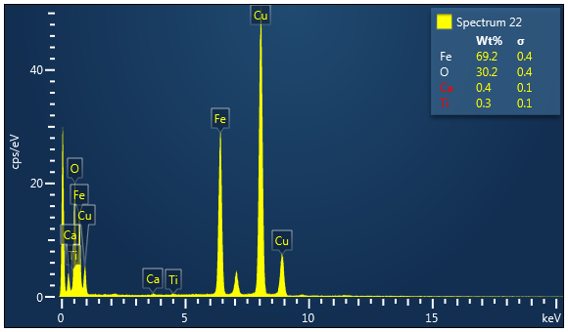
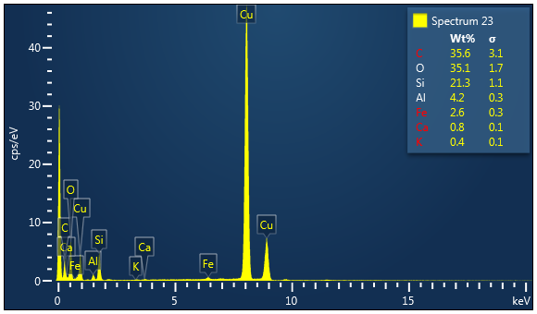
D
E

F

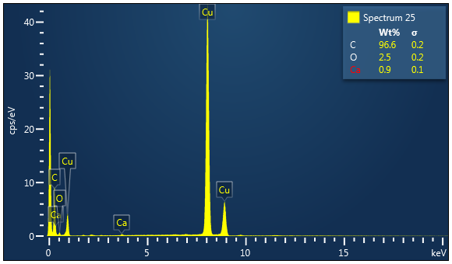
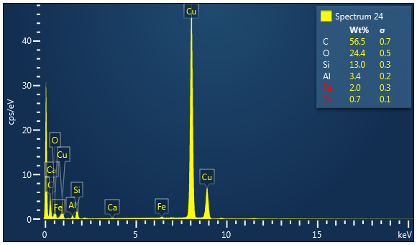
G
F

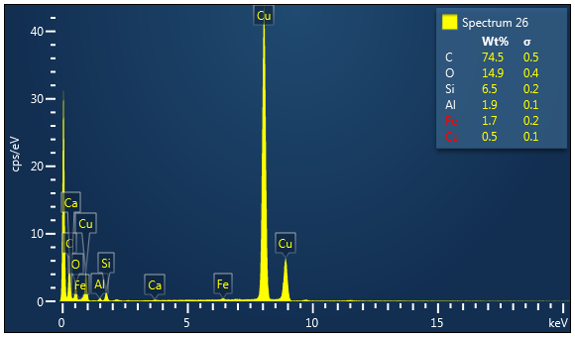
H

Fig. S4. (A) TEM image recorded for E- AUR 30C samples and (B-H) the EDX spectra obtained for the investigated points indicated in the TEM figure

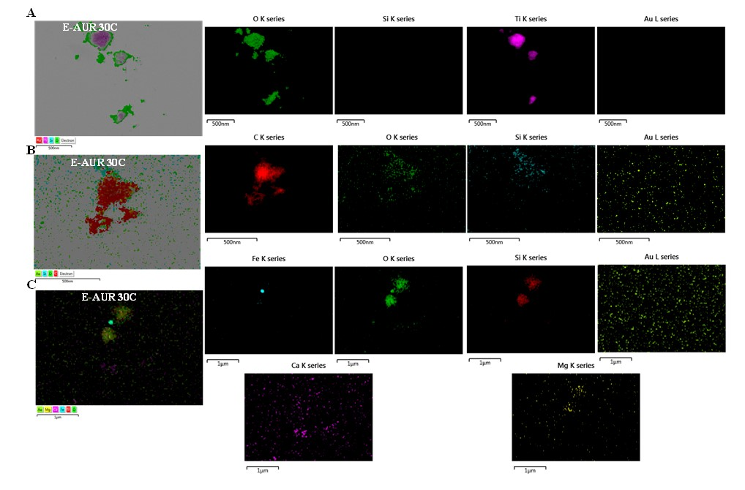
Fig. S5. TEM mapping for 30C potency of AUR. (A-C) Different images of Aurum metallicum samples recorded in Romania - E-AUR 30C

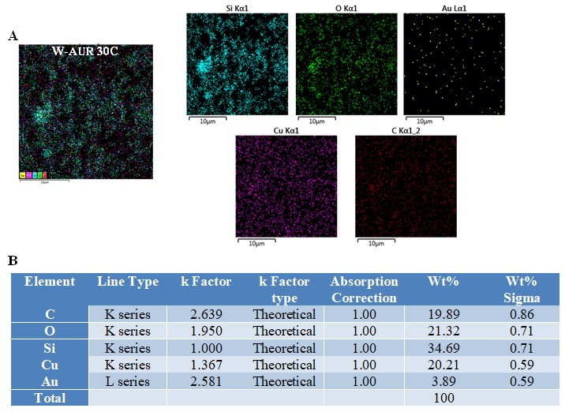
Fig. S6. TEM-EDX data for 30C potency of AUR. (A) TEM mapping of Aurum metallicum samples recorded in Turkey - W-AUR 30C; (B) EDX data obtained for W-AUR 30C.

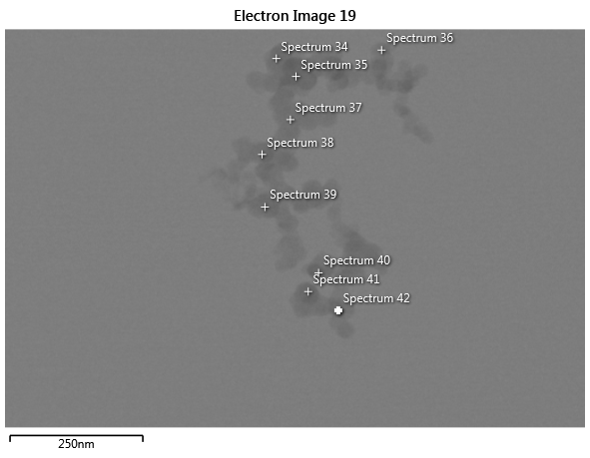
A
E-AUR 200C

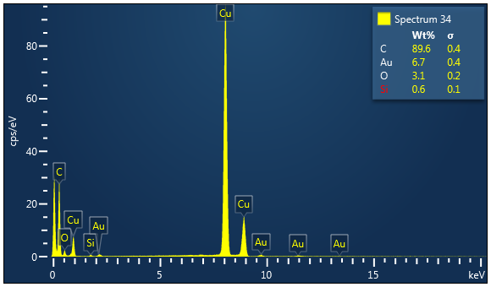
B

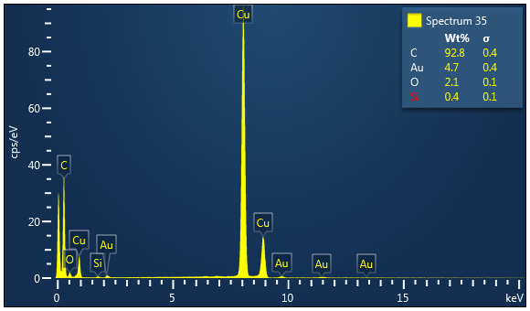
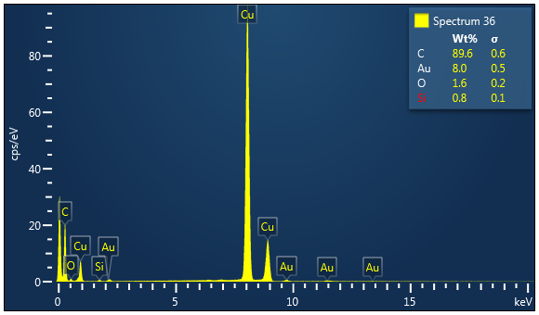
C
D

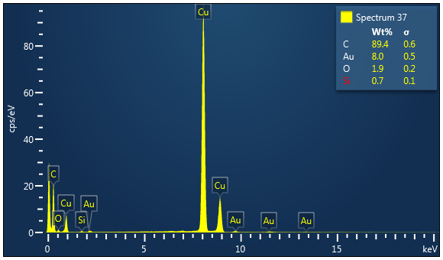
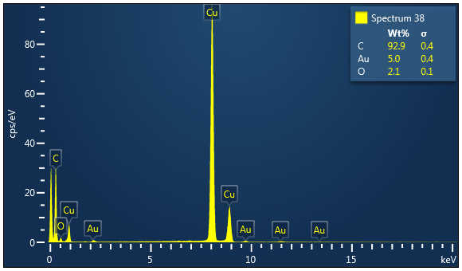
E
F

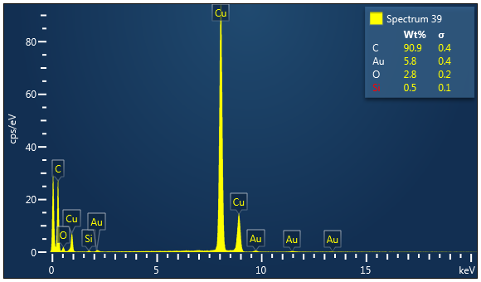
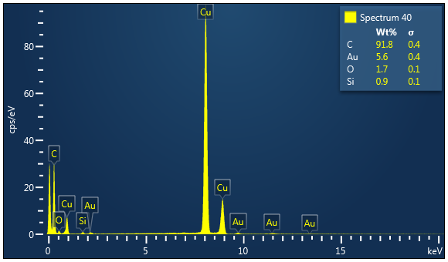
G
H

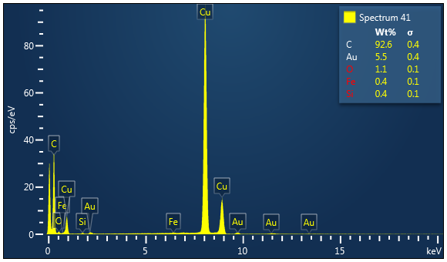
I

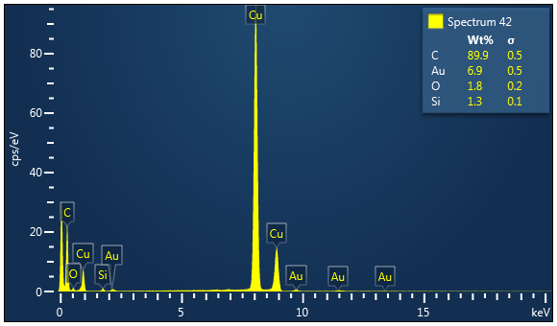
J

Fig. S7. (A) TEM image recorded for E- AUR 200C samples and (B-J) the EDX spectra obtained for the investigated points indicated in the TEM figure

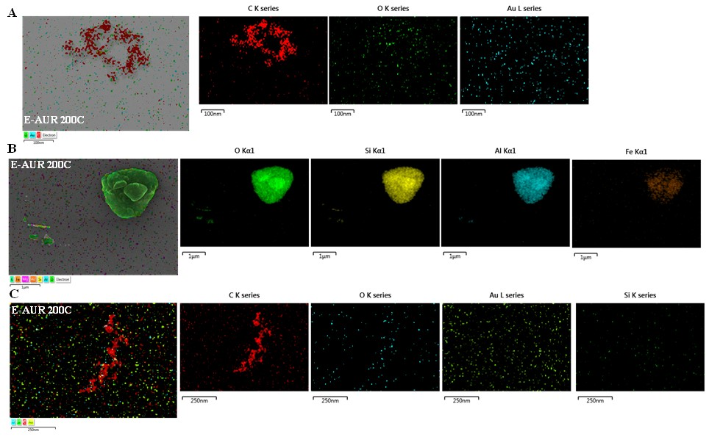
Fig. S8. TEM mapping for 200C potency of AUR. (A-C) Different Aurum metallicum samples recorded in Romania, E-AurMet 200C
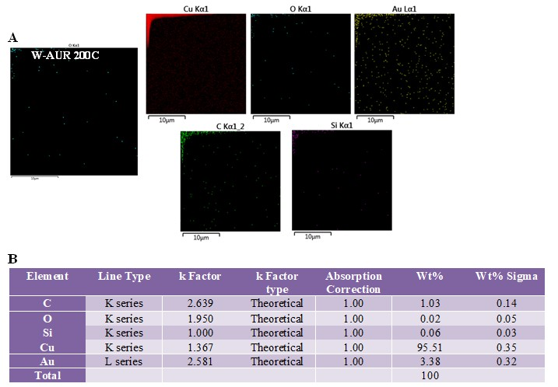
Fig. S9. TEM-EDX data for 200C potency of AUR (A) TEM mapping Aurum metallicum samples recorded in Turkey - W-AUR 200C; (B) EDX data obtained for W-AUR 200C.

Fig. S10. Raman spectra recorded for the three batches of the PW and different levels of potentization (6C, 30C, 200C) – 514.5 nm laser excitation.
Fig. S11. Raman spectra recorded for the three batches of the UW and different levels of potentization (6C, 30C, 200C) – 514.5 nm laser excitation.

Fig. S12. Raman spectra recorded for the three batches of different levels of potentization (6C, 30C, 200C) of Aurum metallicum (AUR) – 514.5 nm laser excitation.

