Supplementary Materials: The effectiveness of conversational AI services on Covid-19 vaccine confidence and acceptance in Thailand, Hong Kong, and Singapore
Kristi Yoonsup Lee MPH, Saudamini Vishwanath Dabak MA, Vivian Hanxiao Kong PhD, Minah Park PhD, Shirley L. L. Kwok BS, Madison Silzle BS, Chayapat Rachatan BA, Alex Cook PhD, Aly Passanante MSc, Ed Pertwee PhD, Zhengdong Wu BS, Javier A. Elkin PhD, Heidi J. Larson PhD, Eric H.Y. Lau PhD, Kathy Leung PhD, Joseph T. Wu PhD, Leesa Lin PhD¹

Appendix 2. Chatbots
1. Hong Kong and Singapore D24H Chatbot link https://wa.me/85267444704?text=hi

2. Thailand ChatSure link https://www.facebook.com/socialmarketingth
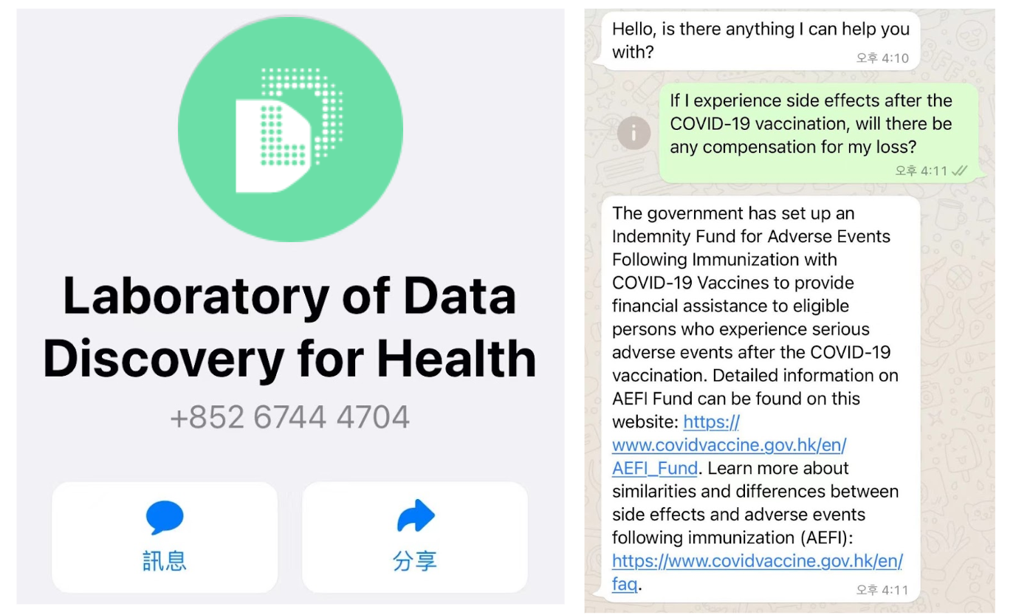
3. Screenshot Images of D24H Chatbot for Hong Kong and Singapore

4. Screenshot Image of ChatSure for Thailand

4. Screenshot Images of ChatSure for Thailand
