The effectiveness of conversational AI service (chatbot) utilization on vaccine confidence

Study protocol number: JTW VCF 01 Version 3
November 28, 2021

Principal Investigator:

Prof. Joseph T. Wu
Professor
School of Public Health
LKS Faculty of Medicine
The University of Hong Kong

Co-Principal Investigator:

Dr Leesa Lin
Assistant Professor
London School of Hygiene and Tropical Medicine

Investigators:

Dr. Kathy Leung
Assistant Professor
School of Public Health
LKS Faculty of Medicine
The University of Hong Kong

Dr. Vivian Kong
Postdoctoral Researcher
School of Public Health
LKS Faculty of Medicine
The University of Hong Kong

Ms. Kristi Lee
Research Assistant
School of Public Health
LKS Faculty of Medicine
The University of Hong Kong

Summary

The primary objective of this intervention is to develop and evaluate a conversational AI service (chatbot) on WeChat and WhatsApp, as an AI‐interface for users to obtain accurate and personalized vaccine information and to assess the veracity of vaccine information in Hong Kong. The key features include:

- Infodemic management – the chatbot is engaged through natural conversation in channels already used by most smartphone users in the region and addresses misinformation through responses about fake news, latest developments, and rumor reporting.

- Vaccine confidence booster and booking service – conversation content will be designed to persuade vaccine hesitant users to take a vaccine and provides links to local vaccination booking websites for success of conversion tracking.

We will focus on subcommunities that have shown the greatest COVID‐19 vaccine hesitancy and low uptake in in Hong Kong (China). We will employ randomized controlled trials (RCTs) and the RE-AIM framework [1,2] for formative, impact, and process evaluation of the intervention. The chatbot will be supported with data from 1) social listening analytics for monitoring local real time discourses in the digital space on COVID‐19 vaccine hesitancy and misinformation, and 2) formative, baseline, and endpoint evaluation, which will generate evidence for development, and improvement/refinement.

Table of Contents
1. Background of research 4
2. Study objectives 4
3. Study design 5
4. Selection and withdrawal of subjects 5
5. Safety assessment 10
6. Outcome measurements and statistical analysis 10
7. Ethical issues 10
8. Data and record handling 10
9. Financing and insurance 10
10. Publication policy 10
11. References 11

1. Background of research
The current suboptimal uptake of COVID‐19 vaccines across Hong Kong has starkly shown that vaccine hesitancy is a key impediment to the control of Vaccine‐preventable diseases (VPDs) despite unprecedented advances in medical technologies. It highlights the tremendous challenges in overcoming vaccine hesitancy in the context of a world‐devastating pandemic and resurgences fueled by the Delta variant. In response to the imminent crisis, this intervention aims to utilize a conversational AI service to combat misinformation (including fake news, rumors, and conspiracy theories) on COVID‐19 vaccines, identify potential reasons for hesitancy for COVID‐19 vaccines, and increase COVID‐19 vaccine uptake with a focus on the communities that have shown persistent hesitancy after vaccine rollout.

Our research has shown that vaccine hesitancy emerges and spreads in many populations for a myriad of complex reasons: complacency against the threat of VPDs, lack of confidence in vaccine safety and effectiveness, distrust in health authorities or political leadership, inconvenient access to vaccine information and vaccines, and exposure to vaccine misinformation aimed at generating confusion and conflicts [4‐7]. The specific root causes of vaccine hesitancy are highly diverse among different individuals and vary across time, locations and demographics [7].

The proposed multi‐pronged intervention aims to improve vaccine confidence as well as detect and mitigate the emergence and spread of vaccine hesitancy and misinformation. It comprises social media listening, big data analytics, AI technologies, crowdsourcing, infectious disease epidemiology, vaccinology, fact‐checking, and personalized responses to vaccine queries for building vaccine confidence. Evidence for effectiveness of the different components of our proposed solution is well‐documented in the scientific literature [8,9]. The novel solution will be supported and facilitated with traditional research methods that will help us derive strong evidence to better understand each person’s reasons for vaccine hesitancy. The key innovation will be to generate a science‐driven automated conversation that can convert vaccine hesitant individuals into vaccinated ones. This can in turn be translated into similar programs in other parts of the world and build general confidence and uptake in vaccines in the region.

We will focus on subcommunities that have shown high levels of COVID‐19 vaccine hesitancy and low uptake in Hong Kong. The target population is individuals aged 70 or above who show the highest levels of vaccine hesitancy, with the lowest vaccine uptake Hong Kong (93% unvaccinated as of early September 2021 [13]). We will target both seniors and their guardians, usually their children in the age demographic 40‐70. The chatbot will be implemented in both widely used instant messaging applications, i.e., WeChat and WhatsApp, with about 6.2 million users in Hong Kong [10,11], representing 83% of the population.

2. Study objectives
The primary objective of this intervention is to develop and evaluate a conversational AI service (chatbot) as an AI‐interface for users to obtain accurate and personalized vaccine information and assess the veracity of vaccine information that they receive.

The proposed chatbot has two main features:

- Infodemic management – the chatbot is engaged through natural conversation in channels already used by most smartphone users in the region and addresses misinformation through responses about fake news and conspiracy, latest developments, and rumor reporting.

- Vaccine confidence booster and booking service – conversation content will be designed to persuade vaccine hesitant users to take a vaccine and provides links to local vaccination booking websites for conversion tracking.

The chatbot (Figure 1) will be supported with data from 1) social listening and social network analysis from monitoring local discourses in the digital space (e.g. Facebook, Twitter) and acquire situational awareness of COVID‐19 vaccine sentiments around confidence and misinformation in the target population, 2) formative interviews with existing COVID‐19 chatbot developers, users, and stakeholders, 3) baseline assessment on target population, which will
generate crowdsourced data on misinformation, rumors, and reasons/examples for hesitancy and behavioral change, and 4) endpoint assessment data on intervention evaluation and chatbot engagement.

These data will allow us to a) tailor chatbot content to local target communities, and b) refine the chatbot for scale‐up in the next phase. In both the short and longer term, the chatbot will also serve as a crowdsourcing platform for early detection of emergence of vaccine hesitancy, and vaccine misinformation and rumors.
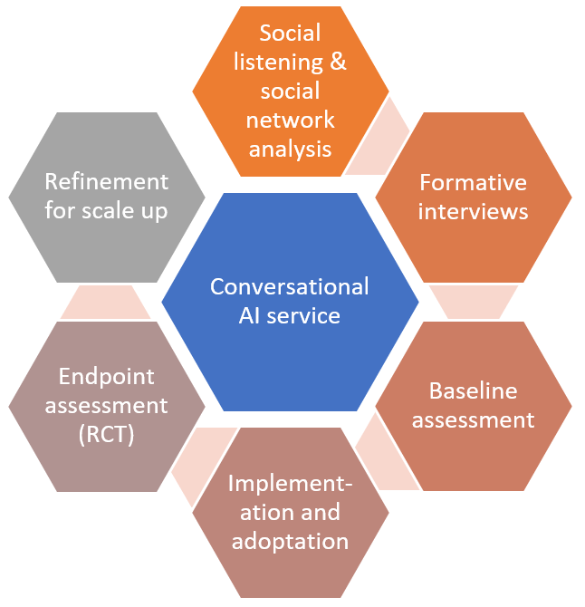

Figure 1. Chatbot development and evaluation

In addition to monitoring and assessing COVID‐19 vaccine confidence and information needs in real time, the proposed intervention can support long‐term mitigation of vaccine hesitancy by proactively immunizing the global community against vaccine misinformation ‐ an innovative “pre‐bunking” approach from inoculation theory (e.g. Get bad news [16]).

3. Study design

Methods
Hypothesis

We hypothesize a conversational AI service (chatbot) has a positive impact on Covid‐19 vaccine confidence and vaccination status. A Theory of Change is attached.

Chatbot design

The geographic focus will be about Hong Kong. Intervention technical development: initial data for chatbot development will be derived from existing validated chatbots (i.e. World Health Organization (WHO) Facebook Messenger [17] and Japanese Line Corowa‐Kun [3], interviews with stakeholders, social media analytics and social network analysis, and baseline assessment questionnaires. These data will help identify: (i) the most pressing concerns and questions individuals have about vaccines; (ii) factors that influence hesitancy against different vaccines in different populations; (iii) existing misinformation and rumors about COVID‐19 vaccines. The dialogues/messages will be tailored to the local context and will need to be translated into local languages (i.e. Chinese, and English).

Social network analysis, Natural Language Processing (NLP) and Deep Learning will be employed to analyze social media and crowdsourced data. We will automatically detect rumors and misinformation as they emerge, or re‐emerge, using a mix of traditional techniques (e.g. Latent Dirichlet Allocation (LDA)) and state‐of‐the‐art language modelling architectures. Neural networks based on attentive mechanisms will be used to elicit the main determinants of the vaccine hesitancy among users. Users will be then clustered according to their characteristics to identify targeted groups.

HKU will lead a promotional campaign to boost service uptake. The roles/responsibilities are specified in the Project Schedule. To massively scale the service outreach and impact, we will develop automated fact‐checking algorithms and AI chatbots on WeChat/WhatsApp so that anyone with an internet connection can access our knowledge base at any time. The algorithms will auto‐engineer a search for the reliability of the statements against trustable references (e.g. WHO, U.S. Centers for Disease Control and Prevention (CDC), Ministry of Health, etc.).

Intervention evaluation with a randomized controlled trial (RCT)

The Chatbot will be evaluated by randomized controlled trials (RCTs), complemented with the RE‐AIM Framework (reach, efficacy, adoption, implementation, and maintenance [1,2], see Figure 3 for details).

We will focus on Hong Kong residents that have shown considerable COVID-19 vaccine hesitancy and low uptake. Participants will be recruited by random digit dialing to meet the target quota by age and sex. Participants will then be randomly assigned to the intervention group and the control group.

For both intervention and control groups, surveys will be given out to the study participants asking questions about their demographics, including age, sex, educational level, employment status and household income levels. Participants will then answer questions regarding COVID-19 vaccine confidence, including the effectiveness and safety of vaccines, the system that delivers them, and the motivations of the policymakers who decided on the needed vaccines. Participants will also be asked about COVID-19 vaccine acceptance, including the intention to receive COVID-19 vaccines, encourage others to take COVID-19 vaccines, make plans to receive COVID-19 vaccines, and receive at least one dose of COVID-19 vaccines.

The intervention group will then be asked to use the chatbot developed by the research team for one week. The chatbot is developed under the RE-AIM framework for formative, impact, and process evaluation of the intervention. The control group will be asked not to use any chatbot related to vaccination in the same week. Both intervention and control groups will then be asked to complete the same questionnaire they take before.

Schedule

The baseline survey will be performed before the campaign is initiated in November 2021; the post‐intervention survey will be conducted one week after chatbot use in December 2021.

Using a questionnaire as the evaluation tool

A self‐administered questionnaire will be employed including four sections:

- Socio‐demographic characteristics of the participants.
- COVID‐19 vaccine confidence: Vaccine Confidence IndexTM (VCI) [18] will be used. We will also measure confidence on a) the effectiveness and safety of vaccines; b) the system that delivers them, and c) the motivations of the policymakers who decided on the needed vaccines.), following the World Health Organization’s definition of vaccine confidence [19].
- Covid‐19 vaccine acceptance: measured according to intention to receive Covid‐19 vaccines, encourage others to take Covid‐19 vaccines, make plans to receive Covid‐19 vaccines, and receive at least one dose of Covid‐19 vaccines.
- Risk perceptions, emotions, and opinions about Covid‐19 vaccines and rollout. Covid‐19 vaccine uptake clicks on links to local vaccination booking websites.

Sample size

In Hong Kong, we aim to achieve a sample size of 500 participants: 250 in the intervention group (chatbot users), 250 in the control group. Participants will be randomly assigned to either group.

Study population and data collection

Details of the target population are described in the Background section. We have an exclusion criterion that respondents must be aged at least 18 years old, unvaccinated, and must be living in participating countries. The inclusion criteria for participants is 'being COVID vaccine-hesitant' and the expected effect size used for calculation was: 15%. Data will be collected via online panels or telephone surveys by Premise in participating countries.

Data analysis

Using a self‐administered questionnaire before and after the intervention (chatbot use), we will measure the association of the chatbot use on COVID-19 vaccine confidence and acceptance measured by Vaccine Confidence Index (VCI) and cite the paper (de Figueiredo et al, The Lancet 2020, https://doi.org/10.1016/S0140-6736(20)31558-0), controlling for socio‐demographic variables including gender, age, educational level, household income, hometown, and region.

We will employ χ² and t‐test to examine the changes between pre‐ and post‐ intervention. By pooling pre‐ and post‐intervention survey data, we will use multivariate regression models to evaluate the association of the chatbot use on Covid‐19 vaccines confidence and acceptance, controlling for socio‐demographic variables including gender, age, educational level, household income, hometown, and region.

Process evaluation (Figure 2) will be performed using data from chatbot use monitoring, social media analysis, and a post‐campaign survey with chatbot partners (e.g., local LINE office), users, and stakeholders (e.g., government officials) where sociodemographic characteristics and opinions/views of the chatbot and promotional campaign will be gathered.

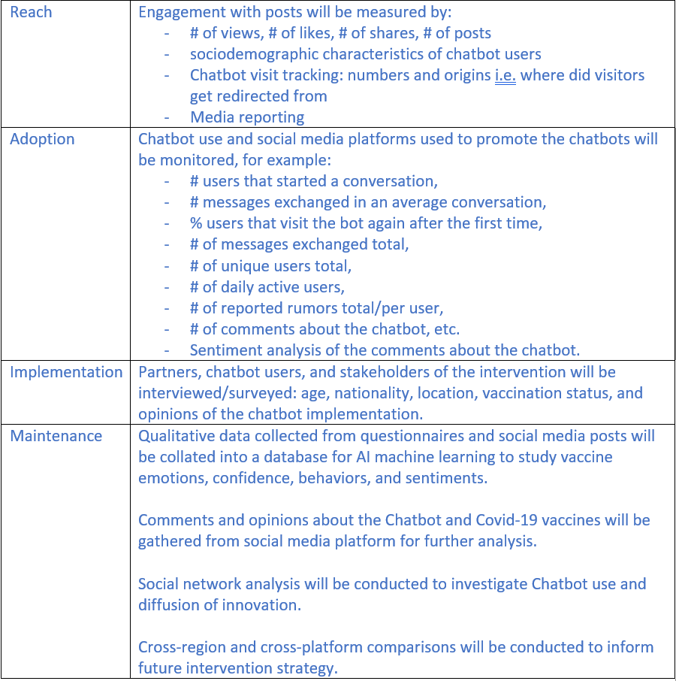

Figure 2. RE‐AIM framework for process evaluation

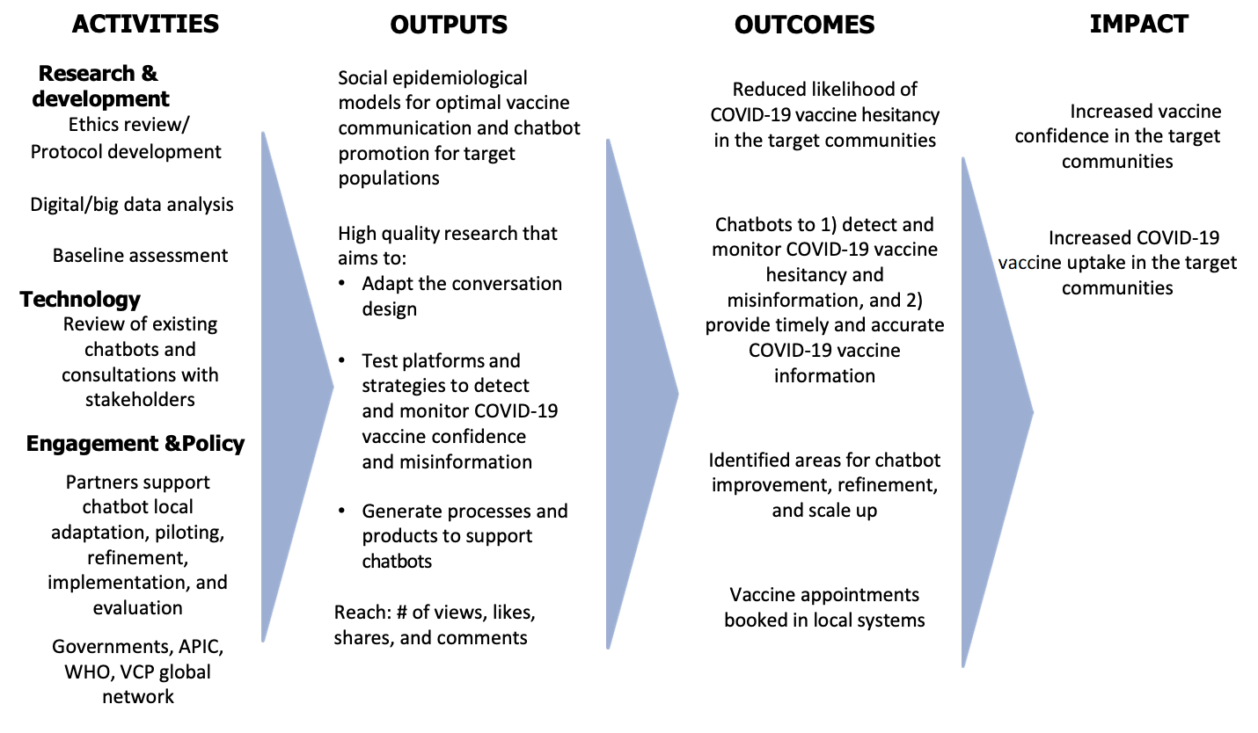

Figure 3. COVID-19 VACCINE CHATBOT: THEORY OF CHANGE

4. Selection and withdrawal of subjects
We will recruit subjects who are HK adult residents.

Inclusion criteria:
Unvaccinated Hong Kong residents (English or Chinese users) who are at least 18 years old or at least 18 years old with unvaccinated senior parents aged 70 or above or children aged below 18

Exclusion criteria:
We do not have any exclusion criterion, but participants should meet the inclusion criteria above.

5. Safety assessment
The study will not cause potential physically, mental, or financial damage to the study subjects.

6. Outcome measurements and statistical analysis
See details in study design.

7. Ethical issues
We will collect socio‐demographic characteristics of the participants, and also information will be collected about: Covid‐19 vaccine confidence; Covid‐19 vaccine acceptance; risk perceptions, emotions, and opinions about Covid‐19 vaccines and rollout.

Participants who are at least 18 years old will provide consent forms for themselves. Participants with unvaccinated senior parents aged 70 or above will provide consent forms with signatures of both participants and elderly parents. Participants with unvaccinated children aged below 18 will provide consent forms on their children’s behalf.

Identifiers of respondents, including name, telephone number and address, will only be collected for the ease of giving supermarket coupons as our appreciation of completed survey, which will be kept confidential and will not be used in the data analysis and result presentation. Identifiers of respondents' contacts will not be collected.

8. Data Handling and Record Keeping
All data will be anonymized when entered an electronic database and stored in the School of Public Health, HKU. All data are accessible to only individuals related to this study.

Anonymized data relevant to study will be kept permanently, including socio‐demographic characteristics of the participants, and information will be collected about: Covid‐19 vaccine confidence; Covid‐19 vaccine acceptance; risk perceptions, emotions, and opinions about Covid‐19 vaccines and rollout in the survey. None of the respondents’ personal information will be revealed in any subsequent research output. The P.I. and the designated researchers will be responsible for data safekeeping.

Personal identifiers, including respondents' name, telephone number and address will be kept confidentially for five years after the study ends. These personal data will be kept confidentially in a separate file accessible only to the research team.

9. Financing and insurance
The study is currently funded by Vaccine Confidence Fund (VCF).

10. Publication policy
The results of this study will be published in international peer-reviewed journals and presented in international conferences.

11. References
1. Glasgow RE, Vogt TM, Boles SM. Evaluating the public health impact of health promotion interventions: the RE‐AIM framework. Am J Public Health 1999; 89(9): 1322‐7.
2. Gaglio B, Shoup JA, Glasgow RE. The RE‐AIM framework: a systematic review of use over time. Am J Public Health 2013; 103(6): e38‐46.
3. Kobayashi T, Nishina Y, Tomoi H, et al. Corowa‐kun: Impact of a COVID‐19 vaccine information chatbot on vaccine hesitancy, Japan 2021. medRxiv 2021: 2021.05.26.21257854.
4. de Figueiredo A, Simas C, Karafillakis E, Paterson P, Larson HJ. Mapping global trends in vaccine confidence and investigating barriers to vaccine uptake: a large‐scale retrospective temporal modelling study. Lancet 2020; 396(10255): 898‐908.
5. Larson HJ, Smith DM, Paterson P, et al. Measuring vaccine confidence: analysis of data obtained by a media surveillance system used to analyse public concerns about vaccines. Lancet Infect Dis 2013; 13(7): 606‐13. 6. Hou Z, Tong Y, Du F, et al. Assessing COVID‐19 Vaccine Hesitancy, Confidence, and Public Engagement: A Global Social Listening Study. J Med Internet Res 2021; 23(6): e27632.
7. Wang Q, Yang L, Jin H, Lin L. Vaccination against COVID‐19: A systematic review and meta‐analysis of acceptability and its predictors. Prev Med 2021; 150: 106694.
8. Zhang J, Featherstone JD, Calabrese C, Wojcieszak M. Effects of fact‐checking social media vaccine misinformation on attitudes toward vaccines. Prev Med 2021; 145: 106408.
9. Altay S, Hacquin A‐S, Chevallier C, Mercier H. Information Delivered by a Chatbot Has a Positive Impact on COVID‐19 Vaccines Attitudes and Intentions. Preprint: https://psyarxivcom/eb2gt/ 2021.
10. Thomala LL. Penetration rate of leading social networks in Hong Kong as of 3rd quarter 2020 (Link: https://www.statista.com/statistics/412500/hk‐social‐network‐penetration/, last accessed on August 1, 2021). Statista; 2020.
11. Kemp S. Digital 2021: Hong Kong (Link: https://datareportal.com/reports/digital‐2021‐hong‐kong, last accessed on August 1, 2021). Data Reportal; 2021.
12. Müller J. Social network penetration in Singapore Q3 2020 (Link: https://www.statista.com/statistics/284466/singapore‐social‐network‐penetration/, last accessed on August 1, 2021). Statista; 2020.
13. Huang C. Hong Kong faces uphill task to vaccinate its seniors against Covid‐19 (Link: https://www.straitstimes.com/asia/east‐asia/hong‐kongs‐uphill‐push‐to‐vaccinate‐its‐seniors‐against‐covid‐19, last accessed on August 1, 2021). The Straits Times. 2021.
14. Steve. Lexicon. The LINE Phenomenon in Thailand – By the Numbers (Link: https://lexiconthai.com/blog/the‐line‐phenomenon‐in‐thailand‐by‐the‐numbers/, last accessed on August 1, 2021), 2020.
15. Agency T. Line in Thailand Internet Population (Link: https://www.twfdigital.com/blog/2020/04/line‐user‐ stat‐in‐thailand‐2020/, last accessed on August 1, 2021), 2020.
16. Get bad news (Link: https://www.getbadnews.com/#intro, last accessed on August 1, 2021). 2021.
17. Elkin J. WHO launches a chatbot on Facebook Messenger to combat COVID‐19 misinformation. (Link: https://www.who.int/news‐room/feature‐stories/detail/who‐launches‐a‐chatbot‐powered‐facebook‐ messenger‐to‐combat‐covid‐19‐misinformation, last accessed: August 1, 2021). 2020.
18. Larson HJ, Schulz WS, Tucker JD, Smith DM. Measuring vaccine confidence: introducing a global vaccine confidence index. PLoS Curr 2015; 7.
19. SAGE. Report of the SAGE Working Group on Vaccine Hesitancy (Link: https://www.who.int/immunization/sage/meetings/2014/october/1_Report_WORKING_GROUP_vaccine_hesita ncy_final.pdf, last accessed on August 1, 2021), 2014.

