Supplementary Materials: The effectiveness of conversational AI services on Covid-19 vaccine confidence and acceptance in Thailand, Hong Kong, and Singapore
Kristi Yoonsup Lee MPH, Saudamini Vishwanath Dabak MA, Vivian Hanxiao Kong PhD, Minah Park PhD, Shirley L. L. Kwok BS, Madison Silzle BS, Chayapat Rachatan BA, Alex Cook PhD, Aly Passanante MSc, Ed Pertwee PhD, Zhengdong Wu BS, Javier A. Elkin PhD, Heidi J. Larson PhD, Eric H.Y. Lau PhD, Kathy Leung PhD, Joseph T. Wu PhD, Leesa Lin PhD¹

Appendix 1. Supplementary Tables and Figures
Table S1. Baseline characteristics of control and intervention groups for the senior group in Thailand and Hong Kong.
 | Thailand |  |  |  | Hong Kong
 | Control (n = 73) | Intervention (n = 59) | Overall (n = 132) | P Value | Control (n = 106) | Intervention (n = 82) | Overall (n = 188) | P Value
Respondent’s ethnicity |  |  |  | 0·04 |  |  |  | 0·39
Chinese | 0 (0%) | 0 (0%) | 0 (0%) |  | 69 (66%) | 44 (54%) | 113 (60%)
Filipino | 0 (0%) | 0 (0%) | 0 (0%) |  | 25 (24%) | 24 (29%) | 49 (26%)
Indonesian | 0 (0%) | 0 (0%) | 0 (0%) |  | 6 (5·7%) | 7 (8·5%) | 13 (7·0%)
Thai | 62 (85%) | 57 (97%) | 119 (90%) |  | 0 (0%) | 0 (0%) | 0 (0%)
Other/Prefer not to answer | 11 (15%) | 2 (3·4%) | 13 (9·8%) |  | 5 (4·8%) | 7 (8·5%) | 12 (6·4%)
Missing | 0 | 0 | 0 |  | 1 | 0 | 1
Respondent’s gender |  |  |  | 0·11 |  |  |  | 0·36
Female | 36 (49%) | 38 (64%) | 74 (56%) |  | 63 (59%) | 53 (65%) | 116 (62%)
Male | 37 (51%) | 21 (36%) | 58 (44%) |  | 42 (40%) | 26 (32%) | 68 (36%)
Other | 0 (0%) | 0 (0%) | 0 (0%) |  | 1 (0·9%) | 3 (3·7%) | 4 (2·1%)
Respondent’s age |  |  |  | 0·27 |  |  |  | 0·37
35 and under | 43 (59%) | 41 (69%) | 84 (64%) |  | 41 (39%) | 37 (46%) | 78 (42%)
Over 35 | 30 (41%) | 18 (31%) | 48 (36%) |  | 65 (61%) | 44 (54%) | 109 (58%)
Missing | 0 | 0 | 0 |  | 0 | 1 | 1
Respondent’s education level |  |  |  | 0·86 |  |  |  | 0·18
Below college level | 35 (48%) | 31 (53%) | 66 (50%) |  | 54 (51%) | 32 (39%) | 86 (46%)
College or above | 34 (47%) | 28 (47%) | 62 (47%) |  | 50 (47%) | 46 (56%) | 96 (51%)
Other | 4 (5·5%) | 0 (0%) | 4 (3·0%) |  | 2 (1·9%) | 4 (4·9%) | 6 (3·2%)
Respondent’s employment status |  |  |  | 0·17 |  |  |  | 0·14
Unemployed/Economically inactive | 22 (31%) | 12 (20%) | 34 (26%) |  | 26 (25%) | 28 (36%) | 54 (30%)
Employed | 48 (69%) | 47 (80%) | 95 (74%) |  | 77 (75%) | 49 (64%) | 126 (70%)
Missing | 3 | 0 | 3 |  | 3 | 5 | 8
Is the respondent working in a healthcare setting? |  |  |  | 0·012 |  |  |  | 0·12
Yes | 19 (26%) | 5 (8·5%) | 24 (18%) |  | 9 (8·5%) | 2 (2·4%) | 11 (5·9%)
No | 54 (74%) | 54 (92%) | 108 (82%) |  | 97 (92%) | 80 (98%) | 177 (94%)
Family income |  |  |  | NA |  |  |  | 0·95
Under 30K HKD | NA | NA | NA |  | 64 (60%) | 49 (60%) | 113 (60%)
30-59K HKD | NA | NA | NA |  | 16 (15%) | 14 (17%) | 30 (16%)
60K HKD or above | NA | NA | NA |  | 16 (15%) | 12 (15%) | 28 (15%)
Other | NA | NA | NA |  | 10 (9·4%) | 7 (8·5%) | 17 (9·0%)
Financial situation |  |  |  | 1 |  |  |  | NA
Low | 13 (18%) | 11 (19%) | 24 (18%) |  | NA | NA | NA
Middle | 25 (34%) | 20 (34%) | 45 (34%) |  | NA | NA | NA
High | 30 (41%) | 24 (41%) | 54 (41%) |  | NA | NA | NA
Other | 5 (6·8%) | 4 (6·8%) | 9 (6·8%) |  | NA | NA | NA
Geographical location |  |  |  | 0·48 |  |  |  | NA
Urban | 27 (37%) | 26 (44%) | 53 (40%) |  | NA | NA | NA
Non-urban | 46 (63%) | 33 (56%) | 79 (60%) |  | NA | NA | NA
Senior’s gender |  |  |  | 0·49 |  |  |  | 0·77
Female | 40 (55%) | 36 (61%) | 76 (58%) |  | 59 (56%) | 48 (59%) | 107 (57%)
Male | 33 (45%) | 23 (39%) | 56 (42%) |  | 47 (44%) | 34 (41%) | 81 (43%)
Senior’s age |  |  |  | 0·67 |  |  |  | 0·51
60 to 80 | 57 (78%) | 48 (81%) | 105 (80%) |  | 80 (75%) | 58 (71%) | 138 (73%)
over 80 | 16 (22%) | 11 (19%) | 27 (20%) |  | 26 (25%) | 24 (29%) | 50 (27%)
* Values are numbers (percentages) of participants unless stated otherwise.

Table S2. Baseline characteristics of control and intervention groups for the child groups in Thailand, Hong Kong, and Singapore.
 | Thailand |  |  |  | Hong Kong |  |  |  | Singapore
 | Control (n = 65) | Intervention (n = 69) | Overall (n = 134) | P Value | Control (n = 109) | Intervention (n = 90) | Overall (n = 199) | P Value | Control (n = 50) | Intervention (n = 45) | Overall (n = 95) | P Value
Respondent’s ethnicity |  |  |  | 0·17 |  |  |  |  |  |  |  | 0·16
Chinese | 0 (0%) | 0 (0%) | 0 (0%) |  | 41 (38%) | 46 (51%) | 87 (44%) | 0·18 | 21 (42%) | 23 (51%) | 44 (46%)
Indian | 0 (0%) | 0 (0%) | 0 (0%) |  | 0 (0%) | 0 (0%) | 0 (0%) |  | 2 (4·0%) | 5 (11%) | 7 (7·4%)
Malay | 0 (0%) | 0 (0%) | 0 (0%) |  | 0 (0%) | 0 (0%) | 0 (0%) |  | 9 (18%) | 5 (11%) | 14 (15%)
Filipino | 0 (0%) | 0 (0%) | 0 (0%) |  | 52 (48%) | 33 (37%) | 85 (43%) |  | 16 (32%) | 7 (16%) | 23 (24%)
Indonesian | 0 (0%) | 0 (0%) | 0 (0%) |  | 10 (9·2%) | 8 (8·9%) | 18 (9·0%) |  | 0 (0%) | 0 (0%) | 0 (0%)
Thai | 63 (97%) | 62 (90%) | 125 (93%) |  | 0 (0%) | 0 (0%) | 0 (0%) |  | 0 (0%) | 0 (0%) | 0 (0%)
Other/Prefer not to answer | 2 (3·1%) | 7 (10%) | 9 (6·7%) |  | 6 (5·5%) | 3 (3·3%) | 9 (4·5%) |  | 2 (4·0%) | 5 (11%) | 7 (7·4%)
Respondent’s gender |  |  |  | 0·29 |  |  |  | 0·11 |  |  |  | 0·84
Female | 44 (68%) | 40 (58%) | 84 (63%) |  | 84 (77%) | 60 (67%) | 144 (72%) |  | 24 (48%) | 21 (47%) | 45 (47%)
Male | 21 (32%) | 29 (42%) | 50 (37%) |  | 24 (22%) | 29 (32%) | 53 (27%) |  | 25 (50%) | 24 (53%) | 49 (52%)
Other/Prefer not to answer | 0 (0%) | 0 (0%) | 0 (0%) |  | 1 (0·9%) | 1 (1·1%) | 2 (1·0%) |  | 1 (2·0%) | 0 (0%) | 1 (1·1%)
Respondent’s age |  |  |  | 0·1 |  |  |  | 0·67 |  |  |  | 0·99
35 and under | 49 (75%) | 42 (61%) | 91 (68%) |  | 56 (51%) | 49 (55%) | 105 (53%) |  | 21 (42%) | 19 (42%) | 40 (42%)
Over 35 years old | 16 (25%) | 27 (39%) | 43 (32%) |  | 53 (49%) | 40 (45%) | 93 (47%) |  | 29 (58%) | 26 (58%) | 55 (58%)
Missing | 0 | 0 | 0 |  | 0 | 1 | 1 |  | 0 | 0 | 0
Respondent’s education level |  |  |  | 0·86 |  |  |  | 0·002 |  |  |  | 0·15
Below college level | 32 (49%) | 34 (49%) | 66 (49%) |  | 65 (60%) | 34 (38%) | 99 (50%) |  | 22 (44%) | 27 (60%) | 49 (52%)
College level or above | 30 (46%) | 34 (49%) | 64 (48%) |  | 40 (37%) | 53 (59%) | 93 (47%) |  | 27 (54%) | 18 (40%) | 45 (47%)
Other/Prefer not to answer | 3 (4·6%) | 1 (1·4%) | 4 (3·0%) |  | 4 (3·7%) | 3 (3·3%) | 7 (3·5%) |  | 1 (2·0%) | 0 (0%) | 1 (1·1%)
Respondent’s employment status |  |  |  | 0·12 |  |  |  | 0·003 |  |  |  | 1
Unemployed/Economically inactive | 16 (25%) | 9 (13%) | 25 (19%) |  | 48 (46%) | 22 (25%) | 70 (36%) |  | 8 (16%) | 7 (16%) | 15 (16%)
Employed | 49 (75%) | 59 (87%) | 108 (81%) |  | 56 (54%) | 67 (75%) | 123 (64%) |  | 42 (84%) | 38 (84%) | 80 (84%)
Missing | 0 | 1 | 1 |  | 5 | 1 | 6 |  | 0 | 0 | 0
Is the respondent working in a healthcare setting? |  |  |  | 0·2 |  |  |  | 0·52 |  |  |  | 0·27
Yes | 11 (17%) | 6 (8·7%) | 17 (13%) |  | 7 (6·4%) | 3 (3·3%) | 10 (5·0%) |  | 10 (20%) | 5 (11%) | 15 (16%)
No | 54 (83%) | 63 (91%) | 117 (87%) |  | 102 (94%) | 87 (97%) | 189 (95%) |  | 40 (80%) | 40 (89%) | 80 (84%)
Family income |  |  |  | NA |  |  |  | 0·002 |  |  |  | NA
Under 30K HKD | NA | NA | NA |  | 79 (72%) | 48 (53%) | 127 (64%) |  | NA | NA | NA
30-59K HKD | NA | NA | NA |  | 13 (12%) | 16 (18%) | 29 (15%) |  | NA | NA | NA
60K HKD or above | NA | NA | NA |  | 8 (7·3%) | 21 (23%) | 29 (15%) |  | NA | NA | NA
Other/Prefer not to answer | NA | NA | NA |  | 9 (8·3%) | 5 (5·6%) | 14 (7·0%) |  | NA | NA | NA
Housing |  |  |  | NA |  |  |  | NA |  |  |  | 1
HDB | NA | NA | NA |  | NA | NA | NA |  | 34 (68%) | 31 (69%) | 65 (68%)
Non-HDB | NA | NA | NA |  | NA | NA | NA |  | 16 (32%) | 14 (31%) | 30 (32%)
Financial situation |  |  |  | 0·47 |  |  |  | NA |  |  |  | NA
Low | 17 (26%) | 12 (17%) | 29 (22%) |  | NA | NA | NA |  | NA | NA | NA
Middle | 17 (26%) | 22 (32%) | 39 (29%) |  | NA | NA | NA |  | NA | NA | NA
High | 28 (43%) | 31 (45%) | 59 (44%) |  | NA | NA | NA |  | NA | NA | NA
Other/Prefer not to answer | 3 (4·6%) | 4 (5·8%) | 7 (5·2%) |  | NA | NA | NA |  | NA | NA | NA
Geographical location |  |  |  | 0·86 |  |  |  | NA |  |  |  | NA
Urban | 24 (37%) | 27 (39%) | 51 (38%) |  | NA | NA | NA |  | NA | NA | NA
Non-urban | 41 (63%) | 42 (61%) | 83 (62%) |  | NA | NA | NA |  | NA | NA | NA
Child’s gender |  |  |  | 0·16 |  |  |  | 0·38 |  |  |  | 0·51
Female | 34 (52%) | 30 (43%) | 64 (48%) |  | 42 (39%) | 44 (49%) | 86 (43%) |  | 15 (30%) | 18 (40%) | 33 (35%)
Male | 25 (38%) | 38 (55%) | 63 (47%) |  | 57 (52%) | 45 (50%) | 102 (51%) |  | 30 (60%) | 26 (58%) | 56 (59%)
Other/Prefer not to answer | 6 (9·2%) | 1 (1·4%) | 7 (5·2%) |  | 10 (9·2%) | 1 (1·1%) | 11 (5·5%) |  | 5 (10%) | 1 (2·2%) | 6 (6·3%)
* Values are numbers (percentages) of participants unless stated otherwise.

Table S3. Secondary outcome variables for child groups in Thailand, Hong Kong, and Singapore
 | Thailand |  |  | Hong Kong* |  |  | Singapore*
 | Control  (n = 65) | Intervention  (n = 69) | P Value† | Control  (n = 47) | Intervention  (n = 49) | P Value† | Control  (n = 34) | Intervention  (n = 38) | P Value†
My child does not need to be vaccinated |  |  | 0·006 |  |  | 0·55 |  |  | 0·77
Deteriorated | 21 (32%) | 9 (13%) |  | 10 (21%) | 9 (18%) |  | 6 (18%) | 5 (13%)
No change | 22 (34%) | 40 (58%) |  | 25 (53%) | 22 (45%) |  | 15 (44%) | 20 (53%)
Improved | 22 (34%) | 20 (29%) |  | 12 (26%) | 18 (37%) |  | 13 (38%) | 13 (34%)
My child might get COVID-19 |  |  | 0·34 |  |  | 0·62 |  |  | 0·015
Deteriorated | 17 (26%) | 12 (17%) |  | 11 (23%) | 8 (16%) |  | 11 (32%) | 3 (7·9%)
No change | 24 (37%) | 33 (48%) |  | 24 (51%) | 29 (59%) |  | 15 (44%) | 17 (45%)
Improved | 24 (37%) | 24 (35%) |  | 12 (26%) | 12 (24%) |  | 8 (24%) | 18 (47%)
COVID-19 is a serious disease |  |  | 0·008 |  |  | 0·30 |  |  | 0·65
Deteriorated | 16 (25%) | 5 (7·2%) |  | 9 (19%) | 8 (16%) |  | 6 (18%) | 5 (13%)
No change | 29 (45%) | 46 (67%) |  | 26 (55%) | 34 (69%) |  | 19 (56%) | 19 (50%)
Improved | 20 (31%) | 18 (26%) |  | 12 (26%) | 7 (14%) |  | 9 (26%) | 14 (37%)
I will be less anxious if my child is vaccinated |  |  | 0·59 |  |  | 0·18 |  |  | 0·74
Deteriorated | 8 (12%) | 5 (7·2%) |  | 9 (19%) | 5 (10%) |  | 8 (24%) | 6 (16%)
No change | 33 (51%) | 35 (51%) |  | 24 (51%) | 34 (69%) |  | 21 (62%) | 26 (68%)
Improved | 24 (37%) | 29 (42%) |  | 14 (30%) | 10 (20%) |  | 5 (15%) | 6 (16%)
Vaccination of children can control the spread of COVID-19 |  |  | 0·87 |  |  | 0·073 |  |  | 1
Deteriorated | 12 (18%) | 10 (14%) |  | 13 (28%) | 5 (10%) |  | 6 (18%) | 7 (18%)
No change | 34 (52%) | 38 (55%) |  | 23 (49%) | 33 (67%) |  | 19 (56%) | 22 (58%)
Improved | 19 (29%) | 21 (30%) |  | 11 (23%) | 11 (22%) |  | 9 (26%) | 9 (24%)
My child will get vaccinated if many others are vaccinated |  |  | 0·59 |  |  | 0·33 |  |  | 0·85
Deteriorated | 9 (14%) | 6 (8·7%) |  | 10 (21%) | 6 (12%) |  | 5 (15%) | 8 (21%)
No change | 37 (57%) | 39 (57%) |  | 23 (49%) | 31 (63%) |  | 19 (56%) | 20 (53%)
Improved | 19 (29%) | 24 (35%) |  | 14 (30%) | 12 (24%) |  | 10 (29%) | 10 (26%)
My child will get vaccinated if there is a vaccine mandate |  |  | 0·19 |  |  | 0·60 |  |  | 0·94
Deteriorated | 10 (15%) | 4 (5·8%) |  | 9 (19%) | 7 (14%) |  | 6 (18%) | 5 (13%)
No change | 33 (51%) | 42 (61%) |  | 26 (55%) | 25 (51%) |  | 19 (56%) | 23 (61%)
Improved | 22 (34%) | 23 (33%) |  | 12 (26%) | 17 (35%) |  | 9 (26%) | 10 (26%)
I think COVID-19 vaccination should be mandatory |  |  | 0·56 |  |  | 0·088 |  |  | 0·60
Deteriorated | 12 (18%) | 9 (13%) |  | 9 (19%) | 3 (6·1%) |  | 2 (5·9%) | 5 (13%)
No change | 34 (52%) | 35 (51%) |  | 26 (55%) | 36 (73%) |  | 21 (62%) | 23 (61%)
Improved | 19 (29%) | 25 (36%) |  | 12 (26%) | 10 (20%) |  | 11 (32%) | 10 (26%)
It is easy to find information about COVID-19 vaccines |  |  | 0·11 |  |  | 0·52 |  |  | NA
Deteriorated | 11 (17%) | 4 (5·8%) |  | 13 (28%) | 9 (18%) |  | NA | NA
No change | 37 (57%) | 42 (61%) |  | 23 (49%) | 25 (51%) |  | NA | NA
Improved | 17 (26%) | 23 (33%) |  | 11 (23%) | 15 (31%) |  | NA | NA
COVID-19 vaccines cause genetic change |  |  | NA |  |  | 0·031 |  |  | 0·26
Deteriorated | NA | NA |  | 4 (8·5%) | 5 (10%) |  | 6 (18%) | 3 (7·9%)
No change | NA | NA |  | 28 (60%) | 39 (80%) |  | 20 (59%) | 29 (76%)
Improved | NA | NA |  | 15 (32%) | 5 (10%) |  | 8 (24%) | 6 (16%)
COVID-19 vaccines cause death |  |  | 0·39 |  |  | 0·94 |  |  | 0·52
Deteriorated | 10 (15%) | 7 (10%) |  | 4 (8·5%) | 3 (6·1%) |  | 3 (8·8%) | 4 (11%)
No change | 35 (54%) | 45 (65%) |  | 33 (70%) | 36 (73%) |  | 24 (71%) | 30 (79%)
Improved | 20 (31%) | 17 (25%) |  | 10 (21%) | 10 (20%) |  | 7 (21%) | 4 (11%)
COVID-19 vaccines cause infertility |  |  | 0·022 |  |  | 0·11 |  |  | 0·52
Deteriorated | 16 (25%) | 5 (7·2%) |  | 8 (17%) | 6 (12%) |  | 3 (8·8%) | 3 (7·9%)
No change | 34 (52%) | 46 (67%) |  | 25 (53%) | 36 (73%) |  | 27 (79%) | 27 (71%)
Improved | 15 (23%) | 18 (26%) |  | 14 (30%) | 7 (14%) |  | 4 (12%) | 8 (21%)
COVID-19 vaccines cause infection |  |  | NA |  |  | 0·16 |  |  | 0·40
Deteriorated | NA | NA |  | 5 (11%) | 8 (16%) |  | 7 (21%) | 5 (13%)
No change | NA | NA |  | 29 (62%) | 35 (71%) |  | 23 (68%) | 31 (82%)
Improved | NA | NA |  | 13 (28%) | 6 (12%) |  | 4 (12%) | 2 (5·3%)
COVID-19 vaccines were approved without completing clinical trials |  |  | 0·67 |  |  | 0·74 |  |  | 0·24
Deteriorated | 10 (15%) | 10 (14%) |  | 4 (8·5%) | 7 (14%) |  | 2 (5·9%) | 4 (11%)
No change | 37 (57%) | 44 (64%) |  | 33 (70%) | 32 (65%) |  | 27 (79%) | 23 (61%)
Improved | 18 (28%) | 15 (22%) |  | 10 (21%) | 10 (20%) |  | 5 (15%) | 11 (29%)
Safety of COVID-19 vaccines has not been confirmed |  |  | NA |  |  | NA |  |  | 0·19
Deteriorated | NA | NA |  | NA | NA |  | 3 (8·8%) | 8 (21%)
No change | NA | NA |  | NA | NA |  | 25 (74%) | 20 (53%)
Improved | NA | NA |  | NA | NA |  | 6 (18%) | 10 (26%)
† Tested using Fisher’s exact test. Values are numbers (percentages) of participants unless stated otherwise.
* Filipino and Indonesian sub-communities were excluded.

Table S4. Secondary outcome variables for senior groups in Thailand, Hong Kong, and Singapore
 | Thailand |  |  | Hong Kong*
 | Control  (n = 73) | Intervention  (n = 59) | P Value† | Control  (n = 75) | Intervention  (n = 51) | P Value†
My family member does not need to be vaccinated |  |  | 0·72 |  |  | 0·34
Deteriorated | 27 (37%) | 18 (31%) |  | 16 (21%) | 13 (25%)
No change | 26 (36%) | 22 (37%) |  | 32 (43%) | 26 (51%)
Improved | 20 (27%) | 19 (32%) |  | 27 (36%) | 12 (24%)
My family member might get COVID-19 |  |  | 0·48 |  |  | 0·95
Deteriorated | 12 (16%) | 14 (24%) |  | 24 (32%) | 17 (33%)
No change | 26 (36%) | 22 (37%) |  | 30 (40%) | 21 (41%)
Improved | 35 (48%) | 23 (39%) |  | 21 (28%) | 13 (25%)
COVID-19 is a serious disease |  |  | 0·093 |  |  | 0·14
Deteriorated | 17 (23%) | 10 (17%) |  | 25 (33%) | 9 (18%)
No change | 28 (38%) | 34 (58%) |  | 37 (49%) | 33 (65%)
Improved | 28 (38%) | 15 (25%) |  | 13 (17%) | 9 (18%)
I will be less anxious if my family member is vaccinated |  |  | 0·85 |  |  | 0·73
Deteriorated | 17 (23%) | 12 (20%) |  | 16 (21%) | 9 (18%)
No change | 34 (47%) | 27 (46%) |  | 43 (57%) | 28 (55%)
Improved | 22 (30%) | 20 (34%) |  | 16 (21%) | 14 (27%)
Vaccination of elderly can control the spread of COVID-19 |  |  | 0·91 |  |  | 0·44
Deteriorated | 11 (15%) | 7 (12%) |  | 19 (25%) | 8 (16%)
No change | 38 (52%) | 32 (54%) |  | 40 (53%) | 31 (61%)
Improved | 24 (33%) | 20 (34%) |  | 16 (21%) | 12 (24%)
My family member will get vaccinated if many others are vaccinated |  |  | 0·82 |  |  | 0·19
Deteriorated | 14 (19%) | 12 (20%) |  | 24 (32%) | 9 (18%)
No change | 38 (52%) | 33 (56%) |  | 39 (52%) | 31 (61%)
Improved | 21 (29%) | 14 (24%) |  | 12 (16%) | 11 (22%)
My family member will get vaccinated if there is a vaccine mandate |  |  | 0·036 |  |  | 0·56
Deteriorated | 9 (12%) | 18 (31%) |  | 7 (9·3%) | 8 (16%)
No change | 37 (51%) | 25 (42%) |  | 48 (64%) | 29 (57%)
Improved | 27 (37%) | 16 (27%) |  | 20 (27%) | 14 (27%)
I think COVID-19 vaccination should be mandatory |  |  | 0·57 |  |  | 0·72
Deteriorated | 12 (16%) | 14 (24%) |  | 18 (24%) | 10 (20%)
No change | 37 (51%) | 29 (49%) |  | 37 (49%) | 29 (57%)
Improved | 24 (33%) | 16 (27%) |  | 20 (27%) | 12 (24%)
It is easy to find information about COVID-19 vaccines |  |  | 0·86 |  |  | 0·65
Deteriorated | 12 (16%) | 10 (17%) |  | 11 (15%) | 10 (20%)
No change | 39 (53%) | 34 (58%) |  | 41 (55%) | 24 (47%)
Improved | 22 (30%) | 15 (25%) |  | 23 (31%) | 17 (33%)
COVID-19 vaccines cause genetic change |  |  | NA |  |  | 0·079
Deteriorated | NA | NA |  | 10 (13%) | 4 (7·8%)
No change | NA | NA |  | 48 (64%) | 42 (82%)
Improved | NA | NA |  | 17 (23%) | 5 (9·8%)
COVID-19 vaccines cause death |  |  | 0·92 |  |  | 0·45
Deteriorated | 6 (8·2%) | 4 (6·8%) |  | 10 (13%) | 8 (16%)
No change | 53 (73%) | 42 (71%) |  | 48 (64%) | 36 (71%)
Improved | 14 (19%) | 13 (22%) |  | 17 (23%) | 7 (14%)
COVID-19 vaccines cause infertility |  |  | 0·51 |  |  | 0·80
Deteriorated | 16 (22%) | 8 (14%) |  | 13 (17%) | 11 (22%)
No change | 48 (66%) | 43 (73%) |  | 41 (55%) | 28 (55%)
Improved | 9 (12%) | 8 (14%) |  | 21 (28%) | 12 (24%)
COVID-19 vaccines cause infection |  |  | NA |  |  | 0·69
Deteriorated | NA | NA |  | 7 (9·3%) | 5 (9·8%)
No change | NA | NA |  | 53 (71%) | 39 (76%)
Improved | NA | NA |  | 15 (20%) | 7 (14%)
COVID-19 vaccines were approved without completing clinical trials |  |  | 0·026 |  |  | 0·11
Deteriorated | 13 (18%) | 2 (3·4%) |  | 10 (13%) | 6 (12%)
No change | 47 (64%) | 42 (71%) |  | 42 (56%) | 37 (73%)
Improved | 13 (18%) | 15 (25%) |  | 23 (31%) | 8 (16%)
† Tested using Fisher’s exact test. Values are numbers (percentages) of participants unless stated otherwise.
* Filipino and Indonesian sub-communities were excluded.

Table S5. Minimum renumeration amount for participants in each study group
 | Hong Kong | Singapore | Thailand
Control group | 54·20 HKD | 9·40 SGD | 91 THB
Intervention group | 77·30 HKD | 13·35 SGD | 129 THB

Table S6. RE-AIM framework chatbot evaluation
 |  |  | Chatbot users in study locations
 | Definition* | Metrics used | Hong Kong | Singapore | Thailand
Reach | "The absolute number, proportion, and representativeness of individuals who participate in a given intervention or program." | the total number of unique chatbot users | 144 | 40 | 41 (Study participants)  1454 (Public users)
Reach |  | the mean numbers of messages exchanged | 15 | 12 | 6.7% (Study participants)  4.8% (Public users)
Effectiveness | "The impact of an intervention on important outcomes" | changes in vaccine confidence | Discussed in the result section
Effectiveness | "The impact of an intervention on important outcomes" | changes in vaccine acceptance | Discussed in the result section
Adoption | "The absolute number, proportion, and representativeness of settings and intervention agents who initiate a program" | the proportion of users who reported that they would use chatbots again "I intend to user chatbot again" | 107/147 (73%) | 31/38 (82%) | 103/119 (87%)
Adoption |  | the proportion of users who reported that they would recommend our chatbots to family and friends "I intend to recommend to family/friends" | 101/147 (69%) | 30/38 (79%) | 95/119 (80%)
Implementation | " The intervention agents' fidelity to and adaptations of an intervention and associated implementation strategies, including consistency of delivery as intended and the time and costs" | congruence between the planned and actual implementation of the chatbots in terms of the time and cost of chatbot development | For the course of the chatbot development period from October 2021 to January 2022, the actual cost of the chatbot development and implementation and operational cost was HKD$257,441 for Hong Kong and Singapore and $16,666 THB (Free of charge for the implementation, and approximately 16,666 THB for operational costs) for Thailand, averages of 1,392HKD and 11THB per unique users, respectively. The chatbots were developed and updated according to the plan. However, during the study period, the chatbot in Thailand, ChatSure, was temporarily unavailable while Facebook reviewed ChatSure’s app credentials and use cases for the integration such as Facebook login, like and share buttons.
Maintenance | "The extent to which a program or policy becomes institutionalized or part of the routine organizational practices and policies" | the long-term potential of the chatbots. | Although Hong Kong and Singapore have newly developed a D²4H chatbot for the closed trial participants, ChatSure in Thailand has been a part of the Thai government's vaccination campaign initiative to address COVID-19-related concerns and questions. The content available on ChatSure may be expanded to other public health topics in the future. The D24H chatbot is under re-imagination and will be expanded to cover other vaccines such as HPV vaccines and potentially as a supplemental measure to existing vaccination campaigns.
* Kwan BM, McGinnes HL, Ory MG, et al. RE-AIM in the Real World: Use of the RE-AIM Framework for Program Planning and Evaluation in Clinical and Community Settings. Frontiers in Public Health 2019;7 doi: 10.3389/fpubh.2019.00345

Figure S1. Percentage of fully vaccinated population (two doses) and cumulative COVID-19 cases per million in Thailand, Hong Kong, and Singapore from January 2022 to June 2022.
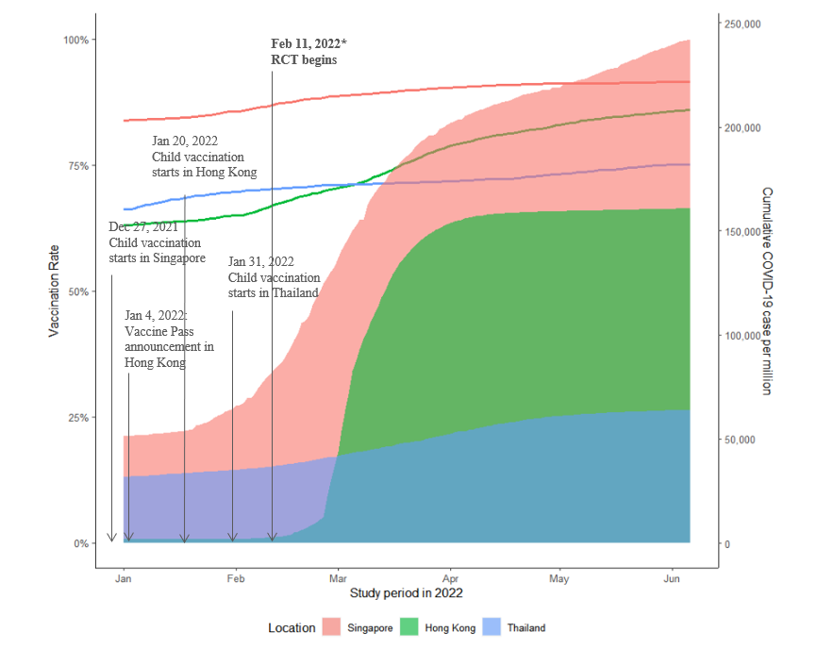
Figure S2. Sensitivity analysis for vaccine confidence and acceptance measures with and without Filipino and Indonesian subgroup.
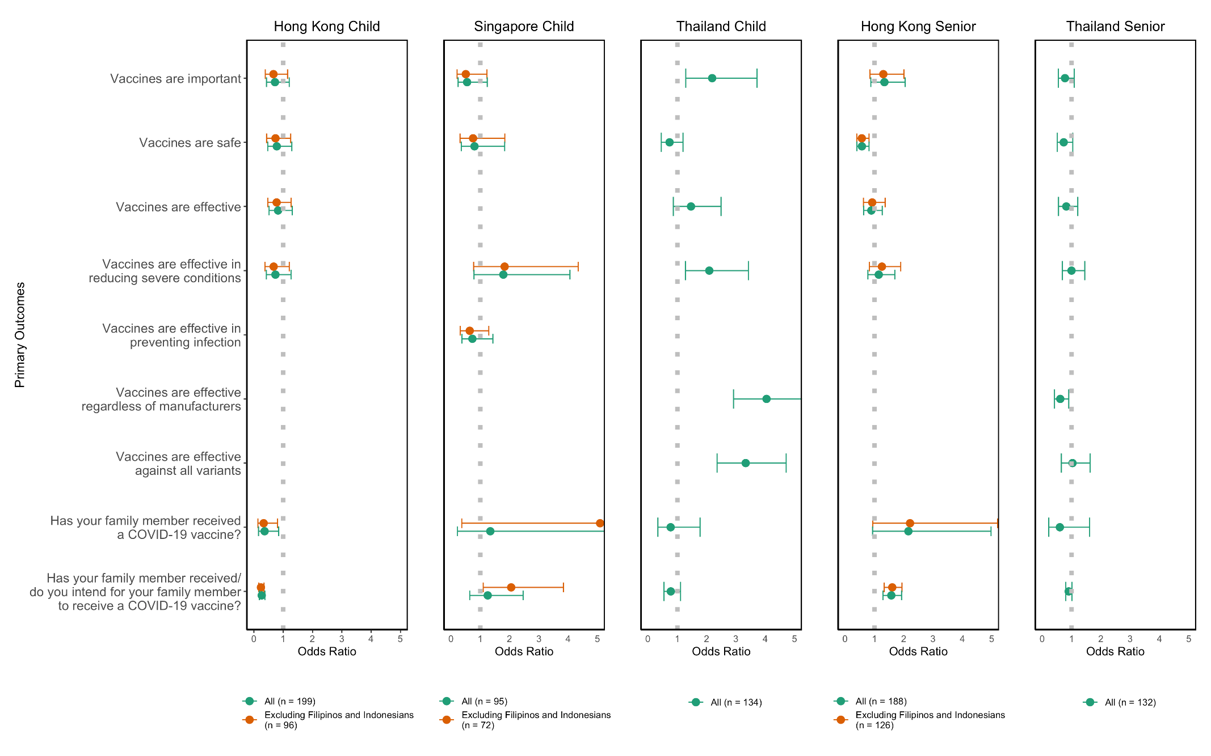
*Values indicate odds ratios; values above 1 indicate that chatbot intervention was more likely to lead to an improvement in the above indices in comparison to control group with no chatbot intervention, values below 1 indicate that chatbot intervention was less likely to lead to an improvement in the indices. Bars indicate 95% confidence interval calculated with the profile likelihood method. Rows left empty in each study group are variables not covered in the corresponding study group.

Figure S3. Sensitivity analysis for secondary outcomes with and without Filipino and Indonesian subgroup.
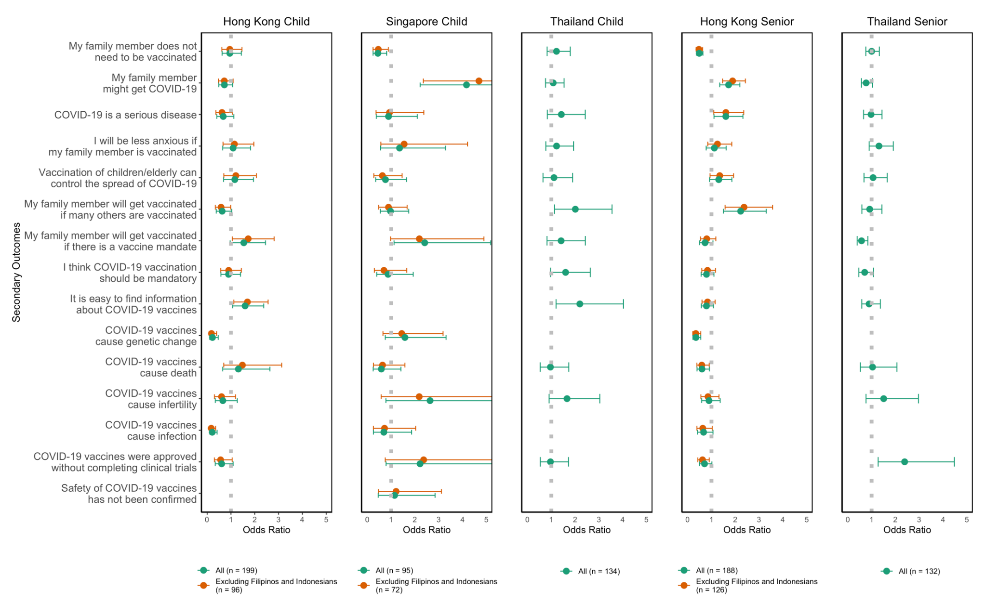
* Values indicate odds ratios; values above 1 indicate that chatbot intervention was more likely to lead to an improvement in the above indices in comparison to control group with no chatbot intervention, values below 1 indicate that chatbot intervention was less likely to lead to an improvement in the indices. Bars indicate 95% confidence interval calculated with the profile likelihood method.

Figure S4. Word cloud of English keywords from participant interactions with chatbots in Hong Kong and Singapore.
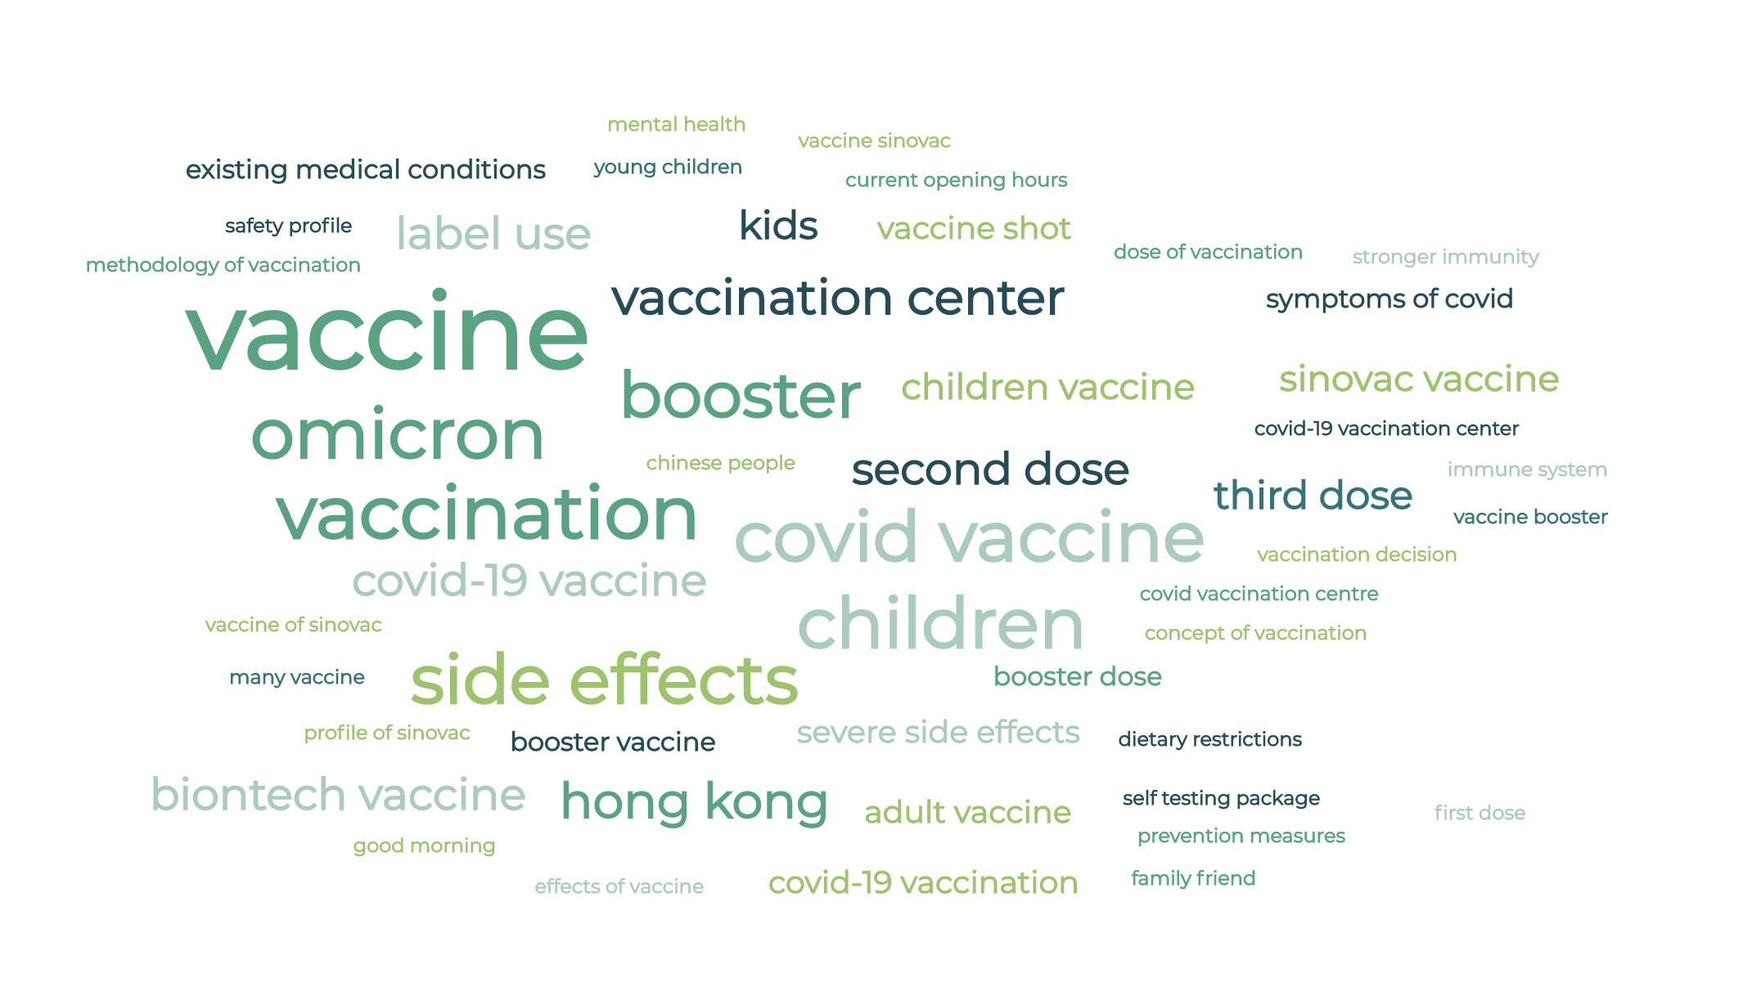
Figure S5. Word cloud of Chinese keywords from participant interactions with chatbots in Hong Kong and Singapore.


Figure S6. Word cloud of Chinese key phrases from participant interactions with chatbots in Hong Kong and Singapore.


Figure S7. Word cloud of Thai key phrases (with English translation) from Thai participant interactions with ChatSure.


