Supplentary Information
Supplentary Methods
Food and protein consumption
Historical data on China’s population, grain and animal production were obtained from Chinese National Statistics between 1961 and 2018, including the Compilation of China Agricultural Statistics and Statistical Bulletin on National Economic and Social Development. Plant food and animal food (meat, eggs and milk) consumption were calculated based on the net plant food supply (production + import - export), considering approximately 20% of total food supply as food wastes^{1,2}. The mean daily protein intake per capita was calculated as the sum of protein from all plant and animal food products, excluding those used for animal feeds (50% of plant products). Annual N intake per capita (kg N capita⁻¹ yr⁻¹) was estimated by multiplying daily protein intake (g capita⁻¹ day⁻¹) with the protein N content (16%) and 365 days in one year:
Annual N intake = Daily protein consumption × 0.16 × 365 × 0.001 (1)
The ratio of animal protein to total (plant+animal) protein was calculated as:
Animal protein ratio = Animal protein intake / total (plant+animal) protein intake (2)

N saving potentials
We analyzed N saving potentials for China’s crop production based on three approaches. First, we focused on the replacement of chemical N fertilizer with an increasing proportion of recycled manure. This is based on setting an equal nutrient value for N from chemical fertilizer and manure in the long-term^{3,4}. We analyzed N saving potentials from technical innovations using the so-called 4R strategy⁵, i.e. the use of improved fertilizer products (Right N products), that are applied at the Right amount, the Right time and to the Right place. To realize the 4R strategy, we used balanced fertilization (Right amount) for saving N as the second step. Then we adopted integrated approaches (the other 3Rs) for further optimizing N inputs as the third step. The basis for the calculations is as follows:

(1) N fertilizer replacement at 80% manure recycling. Based on Bai et al.⁶ and Kang et al.⁷, only 20% of the N intake by livestock is excreted onto grazed land. This implies that 80% of manure can be recycled. Available recycled manure N to croplands was estimated at 9.8 Tg N yr⁻¹ assuming a recycling efficiency of 80%, while current manure N input was estimated at 5.6 Tg N yr⁻¹ in 2018 (Table S3). Thus 80% recycling of N in manure would lead to an additional saving of 4.2 Tg N yr⁻¹ (plus already recycled 5.6 Tg N yr⁻¹), being approximately equal to 34% of fertilizer N in 2018.
(2) Balanced N fertilization. This approach implies that the N requirement of crops is balanced by all N inputs, including the input of non-N fertilizer sources, i.e. manure, deposition and irrigation, thus allowing a lower N fertilizer input. Considering a similar NUE for all N sources, China’s average NUE was 45% in 2018. Xia et al.⁸ suggest that an overall decrease of N fertilizer by 1/3 is possible, implying a total NUE of 63% is achievable.
(3) Integrated approaches. Integrated approaches refer to integrated soil-crop system management, including the 4R technologies (right rate, right type, right place and right time of fertilizer application), optimised irrigation scheme, improved soil and crop management based on 80% manure recycling and balanced N fertilization. This can result in an overall increase in NUE to 73%, which is slightly higher than the expected NUE in Europe in 2050.

Cost savings
The proposed changes in N management will lead to direct and indirect beneficial economic effects. Direct beneficial effects include the reduced costs of N fertilizer. Based on the costs of urea of about 300-500 Euro per ton and an N content of 46%, we calculated N fertilizer costs as 0.6-1.0 Euro per kg N with an uncertainty of 50% considering the price differences for different types of fertilizers. The indirect benefits from reduced heath costs and an improved environment were based on the willingness to pay (WTP) in the EU27⁹, corrected for the ratio of gross domestic product (GDP) per capita in China to the GDP per capita in EU27. The WTP for China was derived from the corrected values from the EU due to various N losses to air and water given in Table S5.

Uncertainties
The estimated country totals for N inputs, N uptake and N losses to air and water are all prone to uncertainties. In line with Kros et al.¹⁰, who performed an uncertainty assessment of N inputs and N outputs for the EU27, we used three levels of uncertainties for the coefficient of variation (CV) including a low (0.10), moderate (0.25) and high (0.50) uncertainty. We used a Monte Carlo analysis to assign the ranges in N emissions, leaching and runoff, i.e. 20% for NH₃ emissions, and 30% for N₂O and NO_{x} emissions and 30% for N leaching plus runoff. These uncertainties are based on the most conservative assumptions for the EU27, considering a higher uncertainty in input data for China as compared to the EU27. The results showed that N balances in maize, wheat and rice systems fit a normal distribution (Fig. S5). These uncertainties are expected to be systematic rather than random, and therefore do not affect conclusions based on temporal comparisons.
Table S1 │ Estimated N inputs from fertilizer, manure, fixation, deposition, and irrigation, plus crop N uptake and NUE.
Types of N inputs | Total N fluxes (Tg N yr⁻¹)
Types of N inputs | 1961 | 1980 | 2000 | 2018
N from fertilizer | 0.6 (0.4-0.7) | 12.3 (9.8-14.7) | 22.4 (17.9-26.9） | 28.6 (22.9-34.3)
N from manure | 2.8 (2.2-3.3) | 9.30 (7.4-11.2) | 11.2 (8.9-13.4) | 12.3 (9.8-14.7)
- Recycled | 2.5 (2.1-3.1) | 7.0 (5.6-8.4) | 5.8 (4.6-6.9) | 5.6 (4.5-6.7)
- Non-recycled | 0.2 (0.1-0.30) | 2.2 (1.8-2.7) | 5.4 (4.3-6.4) | 6.7 (5.3-8.0)
N from environment | 0.9 (0.7-1.1) | 3.1 (2.9-4.4) | 5.6 (4.9-7.4) | 7.1 (6.2-9.4)
- N fixation | 0.2 (0.1-0.3) | 0.5 (0.3-0.7) | 0.5 (0.3-0.8) | 0.6 (0.4-0.9)
- N deposition | 0.8 (0.6-1.0) | 2.5 (2.0-3.0) | 4.9 (3.8-5.8) | 6.2 (5.0-7.5)
- N irrigation | 0.01 (0.01-0.02) | 0.1 (0.05-0.2) | 0.2 (0.1-0.40) | 0.3 (0.1-0.5)
Total N input | 4.2 (4.0-4.4) | 24.6 (20.1-30.2) | 39.2 (31.8-47.7) | 48.0 (39.0-58.5)
Crop N uptake | 3.0 (2.7-4.1) | 11.6 (9.5-14.2) | 17.6 (14.3-21.4) | 21.6 (17.5-26.3)
NUE (%) | 70 (68-73) | 47 (45-49) | 45 (43-47) | 46 (43-48)
NH₃ emissions | 0.4 (0.3-0.5) | 3.2 (2.6-3.9) | 5.9 (4.7-7.1) | 7.2 (5.8-8.7)
N leaching and runoff | 0.4 (0.3-0.5) | 3.2 (2.6-3.9) | 5.1 (4.1-6.2) | 6.2 (5.1-7.6)
NO, N₂O and N₂ emissions | 0.5 (0.4-0.7) | 6.7 (5.4-8.1) | 10.6 (8.6-12.9) | 13.0 (10.5-15.8)

Table S2 │ Leaching rates from precipitation and irrigation to croplands in China based on the water balance in seven major watersheds, according to Li and Huang¹¹.
Watershed | Total land (M ha) | Cropland (M ha) | Precipitation (10⁹ m³ yr⁻¹) | Irrigation (10⁹ m³ yr⁻¹) | P_{leaching} (10⁹ m³ yr⁻¹) | I_{leaching}  (10⁹ m³ yr⁻¹) | T_{leaching} total (10⁹ m³ yr⁻¹) | T_{leaching}  (mm yr⁻¹)
Songleng River | 107 | 20 | 70  (56-84) | 36  (29-43) | 1.6  (1.2-1.9) | 0.8  (0.6-0.9) | 2.4  (1.92-2.88) | 12  (9.6-14.4)
Hai River | 32 | 11 | 78  (62-93) | 27  (21-32) | 3.5  (2.8-4.2) | 1.2  (0.9-1.4) | 4.7  (3.76-5.64) | 45  (36.0-54.0)
Huai River | 29 | 12 | 101  (80 -121) | 32  (25-38) | 18.2  (14.5-21.8) | 5.7  (4.5-6.8) | 23.9  (19.1-28.6) | 199  (159-238)
Yellow River | 82 | 13 | 36  (28-43) | 42  (33-50) | 1.9  (1.5-2.2) | 2.2  (1.7-2.6) | 4.1  (3.2-4.9) | 31  (24.8-37.2)
Yangtze River | 180 | 25 | 345  (276-414) | 79  (63-94) | 78  (62-93) | 17.8  (14.2-21.3) | 95.5  (76.4-114.6) | 388  (310-465)
Qiantang- Min Rivers | 17 | 5.2 | 121  (96-145) | 48  (38-57) | 24  (19-28) | 9.4  (7.5-11.2) | 32.9  (26.3-39.4) | 633  (506-759)
Pearl River | 58 | 4.8 | 745  (596-894) | 16  (12-19) | 21  (16-25) | 4.5  (3.6-5.4) | 26  (20.8-31.2) | 534  (427-640)
Seven River Watersheds | 505 | 90 | 825  (660-990) | 279  (223-334) | 148  (118-177) | 42  (33.6-50.4) | 189  (151-226) | 210  (168-252)

Table S3│Improved N inputs from N fertilizer replacement by 80% manure recycling, balanced N fertilization and integrated soil-crop system management in China.
Type of N inputs | Total fluxes in 2018 (Tg N yr⁻¹) | N fluxes by improved management  (Tg N yr⁻¹)
 |  | 80% manure recycling | Balanced N fertilization | Integrated approaches
N fertilizer | 28.6 (22.9-34.3) | 24.4 (21.2-31.8) | 16.3 (14.2-20.3) | 13.0 (9.2-13.7)
N manure | 12.3 (9.8-14.7) | 12.3 (9.8-14.7) | 12.3 (9.8-14.7) | 12.3 (9.8-14.7)
- Recycled | 5.6 (4.5-6.7) | 9.8 (8.8-11.2) | 9.8 (8.8-11.2) | 9.8 (8.8-11.2)
- Not recycled | 6.7 (5.3-8.0) | 2.5 (2.1-3.1) | 2.5 (2.1-3.1) | 2.5 (2.1-3.1)
N environment | 7.1 (6.2-9.4) | 6.8 (6.2-8.4) | 6.3 (5.1-7.5) | 5.8 (5.0-7.0)
- N fixation | 0.6 (0.4-0.9) | 0.6 (0.4-0.9) | 0.6 (0.4-0.9) | 0.6 (0.4-0.9)
- N_{r} deposition | 6.2 (5.0-7.5) | 5.9 (4.5-7.0) | 5.4 (4.5-6.2) | 4.9 (3.9-5.8)
- N irrigation | 0.3 (0.1-0.5) | 0.3 (0.1-0.5) | 0.3 (0.1-0.5) | 0.3 (0.1-0.5)
Total N input | 48.0 (39.0-58.5) | 43.5 (38.3-52.5) | 34.9 (31.6-37.8) | 31.1 (23.6-35.4)

Table S4 │ N_{r} losses and their reductions achieved by manure recycling, plus balanced N fertilization and plus integrated approaches based on soil-crop system management in China.
Type of N_{r} fluxes | Total N fluxes in 2018 (Tg N yr⁻¹) | N loss reductions by improved management (Tg N yr⁻¹)
 |  | 80% manure recycling | Balanced N fertilization | Integrated approaches
NH₃ emission | 7.2 (5.8-8.7) | 6.5 (6.1-7.1) | 5.2 (4.6-6.9) | 4.7 (3.9-5.9)
N₂O emission | 1.0 (0.8-1.2) | 0.9 (0.7-1.1) | 0.7 (0.5-0.8) | 0.6 (0.4-0.7)
NO_{x} emission | 0.6 (0.4-0.7) | 0.5 (0.4-0.6) | 0.4 (0.3-0.5) | 0.4 (0.3-0.5)
N leaching & runoff | 6.2 (5.1-7.6) | 5.7 (4.9-7.4) | 4.5 (4.0-6.0) | 4.0 (3.4-5.1)
Reduction in NH₃ emission | - | 0.7 (0.6-0.9) | 2.0 (1.7-2.5) | 2.5 (2.1-3.1)
Reduction in N₂O emission | - | 0.1 (0.08-0.12) | 0.3 (0.2-0.4) | 0.4 (0.3-0.5)
Reduction in NO_{x} emission | - | 0.1 (0.08-0.12) | 0.2 (0.1-0.3) | 0.2 (0.1-0.3)
Reduction in N leaching & runoff | - | 0.5 (0.4-0.7) | 1.7 (1.4-2.2) | 2.2 (2.0-2.5)

Table S5 │ Cost-benefit analyses resulting from improving N management.
Type of N fluxes | Costs based on WTP  (€ kg⁻¹ N) | N fluxes in 2018  (Tg N yr⁻¹) | Total cost (Billion Euro) | Reduced costs (Billion €)
 |  |  |  | Manure replacement | Balanced fertilization | Integrated approaches
N fertilizer | 0.8  (0.6-1.0) | 28.6 (22.9-34.3) | 22.9  (18.3-34.3) | 3.4 (2.5-4.2) | 9.8  (7.4-12.3) | 12.5  (9.4-15.6)
NH₃ to air | 4  (2-6) | 7.2  (5.8-8.7) | 28.8 (11.6-52.2) | 2.8 (1.2-1.9) | 8.0  (6.6-9.9) | 10.0 (9.5-14.2)
N₂O to air | 2  (1-3) | 1.0  (0.8-1.2) | 2.0  (0.8-3.6) | 0.2 (0.1-0.4) | 0.6  (0.4-0.7) | 0.8  (0.6-0.9)
NO_{x} to air | 4  (2-6) | 0.6  (0.4-0.7) | 2.4  (0.8-4.2) | 0.3 (0.2-0.4) | 0.8  (0.6-0.9) | 0.8  (0.6-0.9)
N_{r} to water | 3  (1-5) | 6.2  (5.1-7.6) | 18.6  (15.3-38.0) | 1.5 (1.2-2.3) | 5.1  (4.4-6.7) | 6.3  (3.1-9.2)
Total | - | - | 74.7 (68.0-93.0) | 8.2  (6.6-9.9) | 24.3 (21.9-28.8) | 30.4 (28.5-35.8)
The indirect costs are based on Willingness To Pay (WTP) in the EU27, adjusted by dividing this by a factor of 5 according to the ratio of mean per capita GDP in China (approx. 6100 Euro yr⁻¹) to mean per capita GDP in EU27 (30600 Euro yr⁻¹). The total costs and reduced costs in Billion Euro are average values. The uncertainty range given per unit costs was applied to these costs.

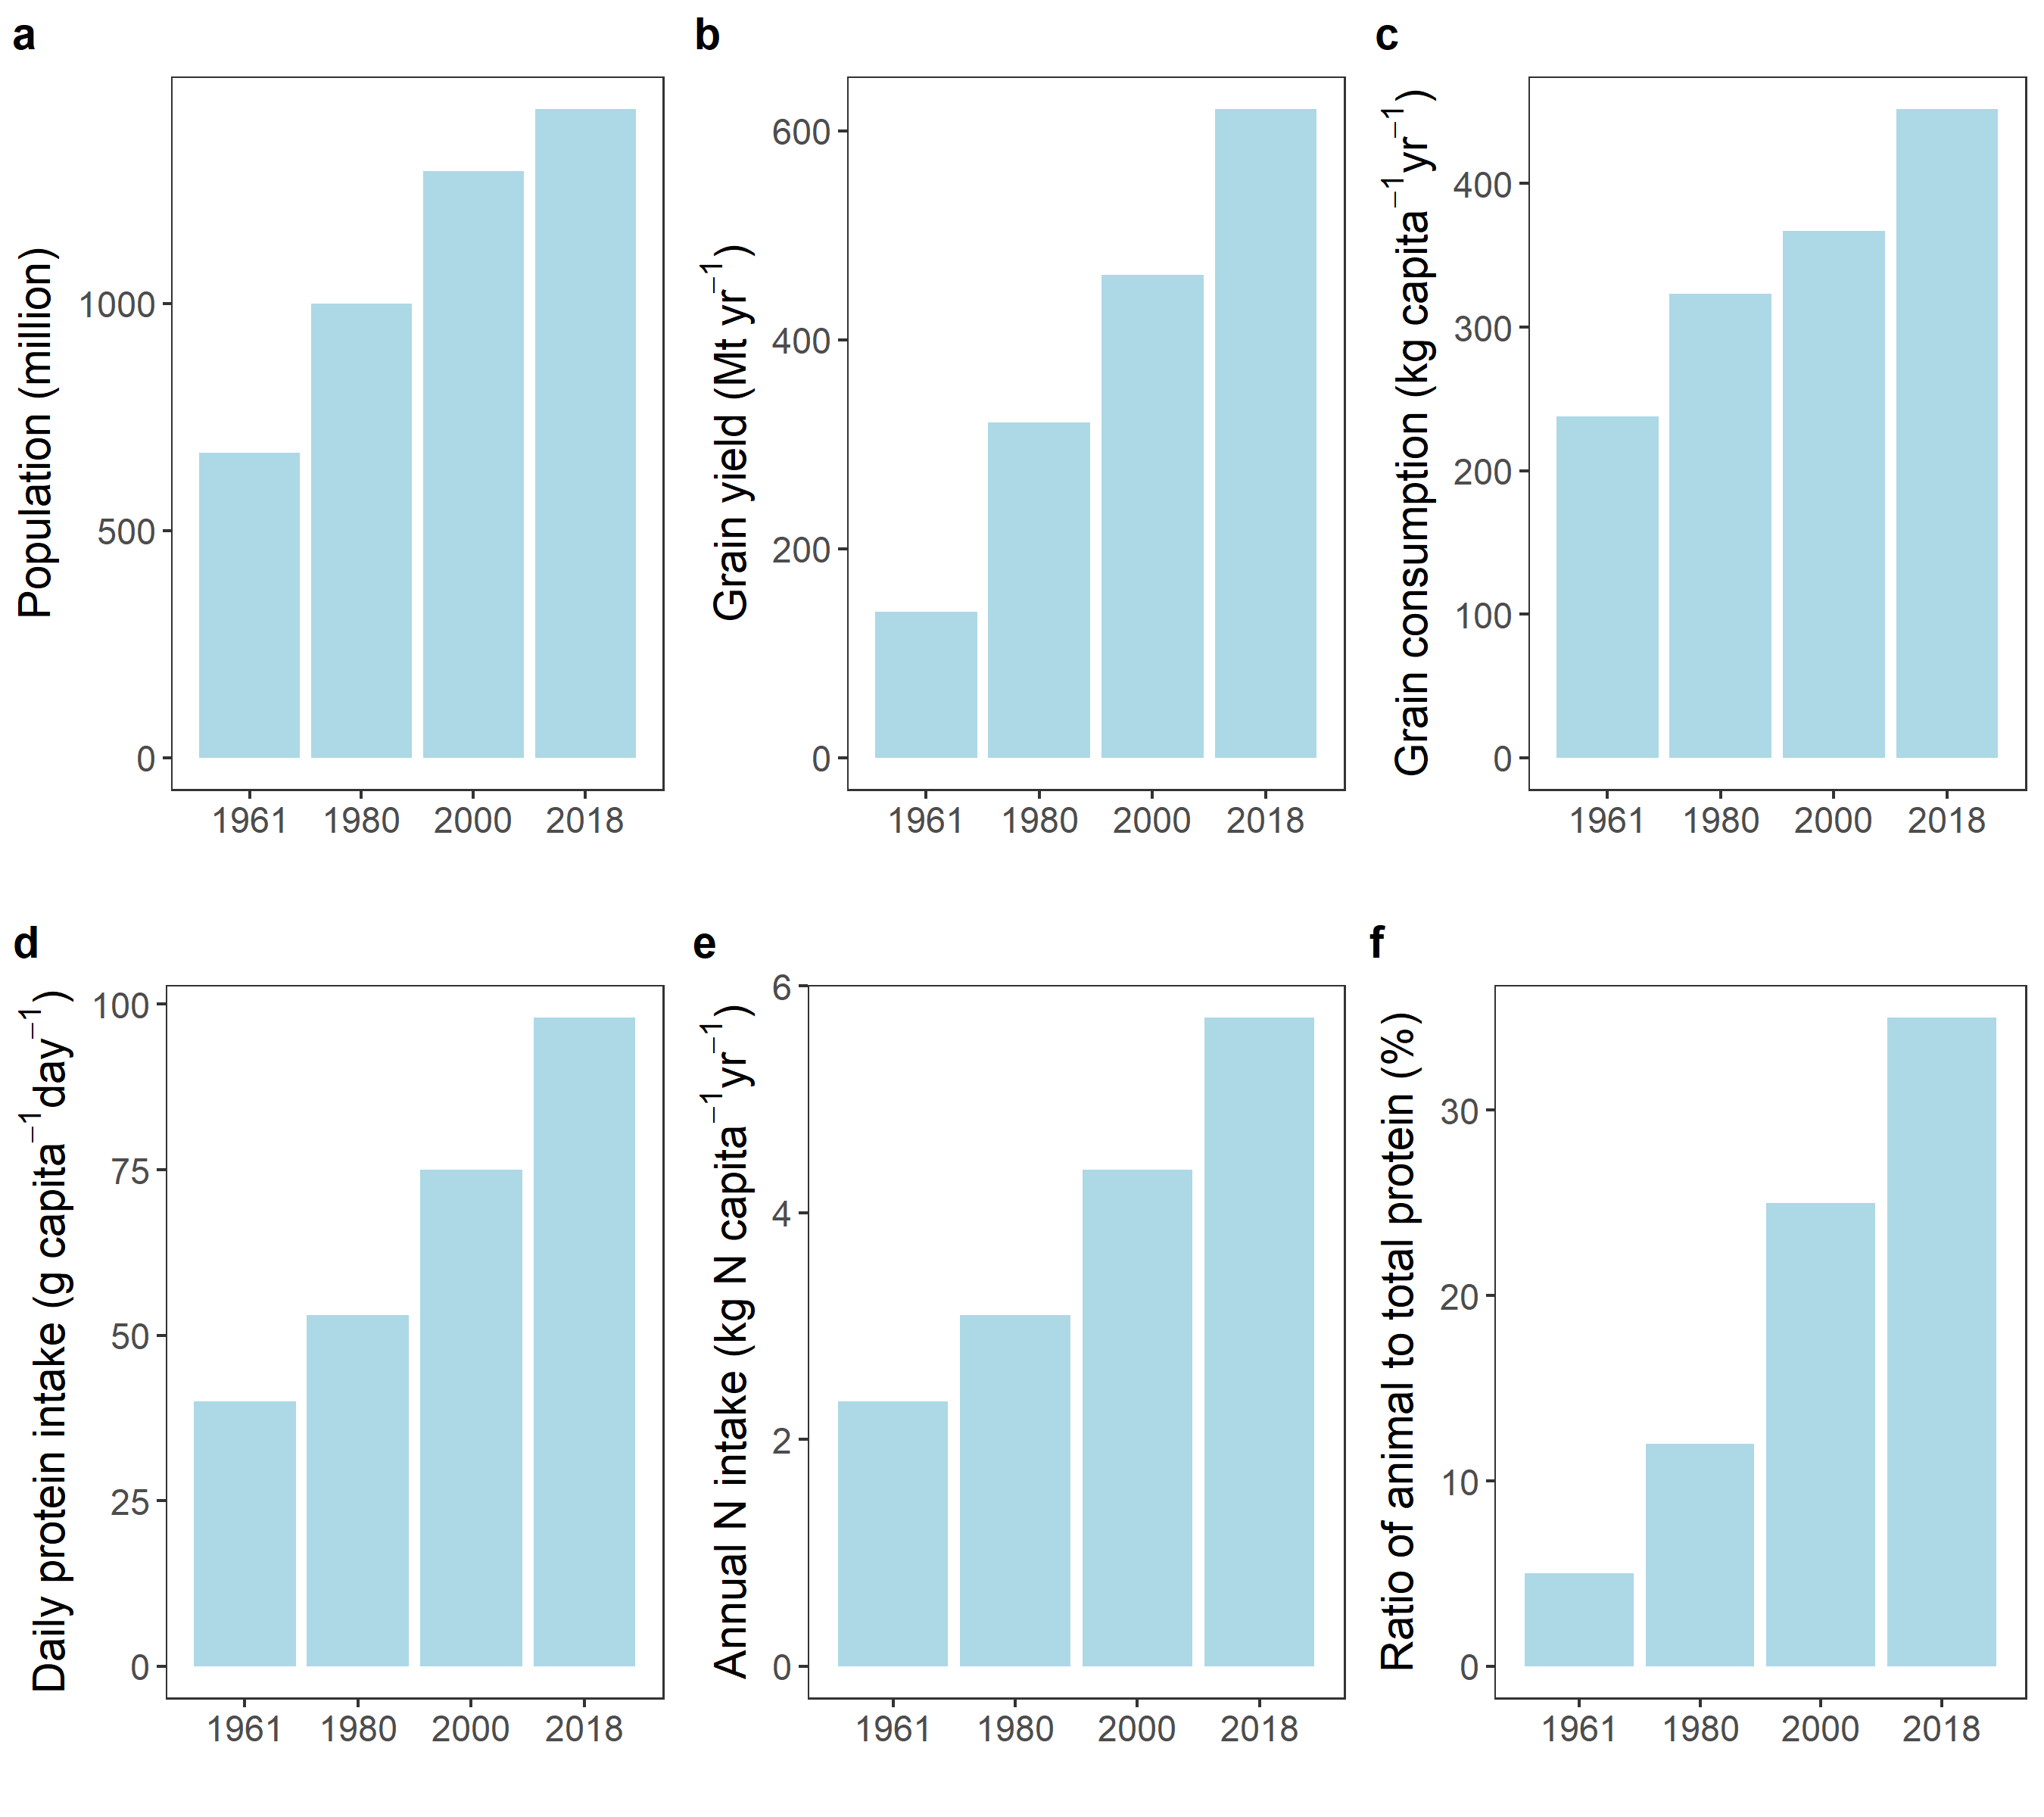
Figure S1│Changes in the population, grain yield, grain consumption, daily protein intake, annual N intake and the ratio of animal protein to total (animal + plant) protein.

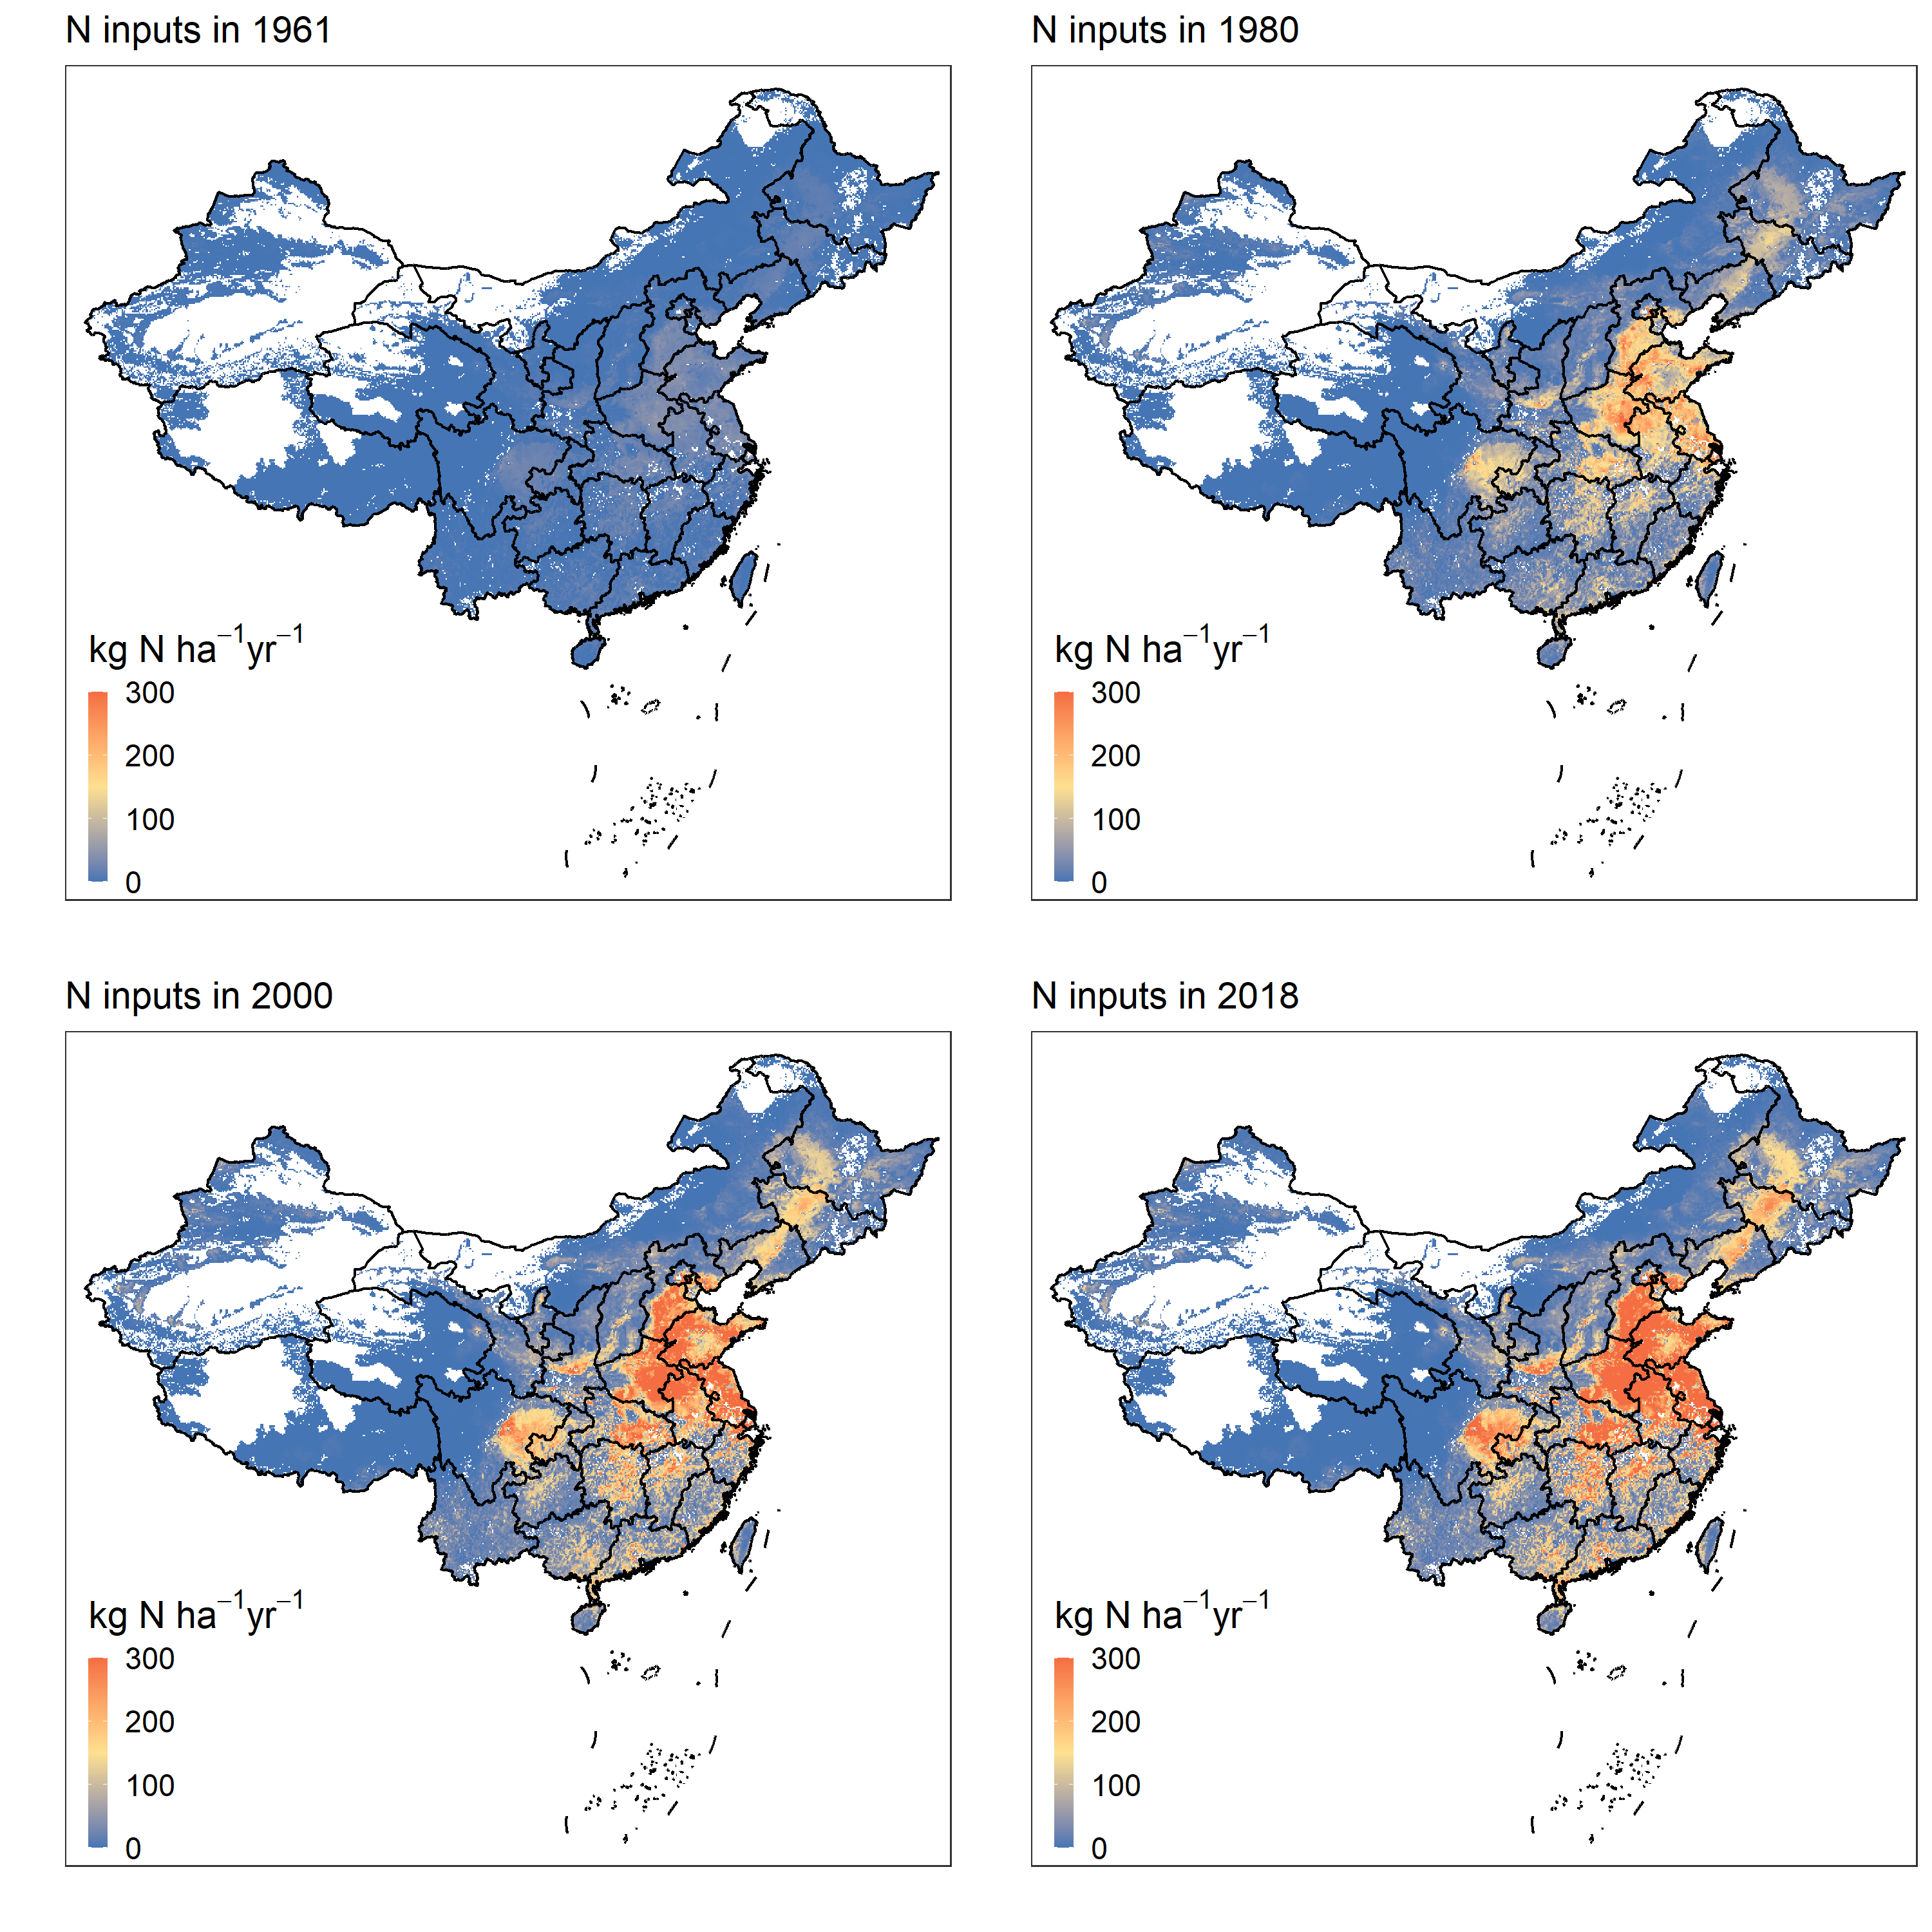
Figure S2 │ Spatial distribution of total N inputs including N fertilizer, manure and environment (N deposition, irrigation and N fixation) in China in 1961, 1980, 2000 and 2018.

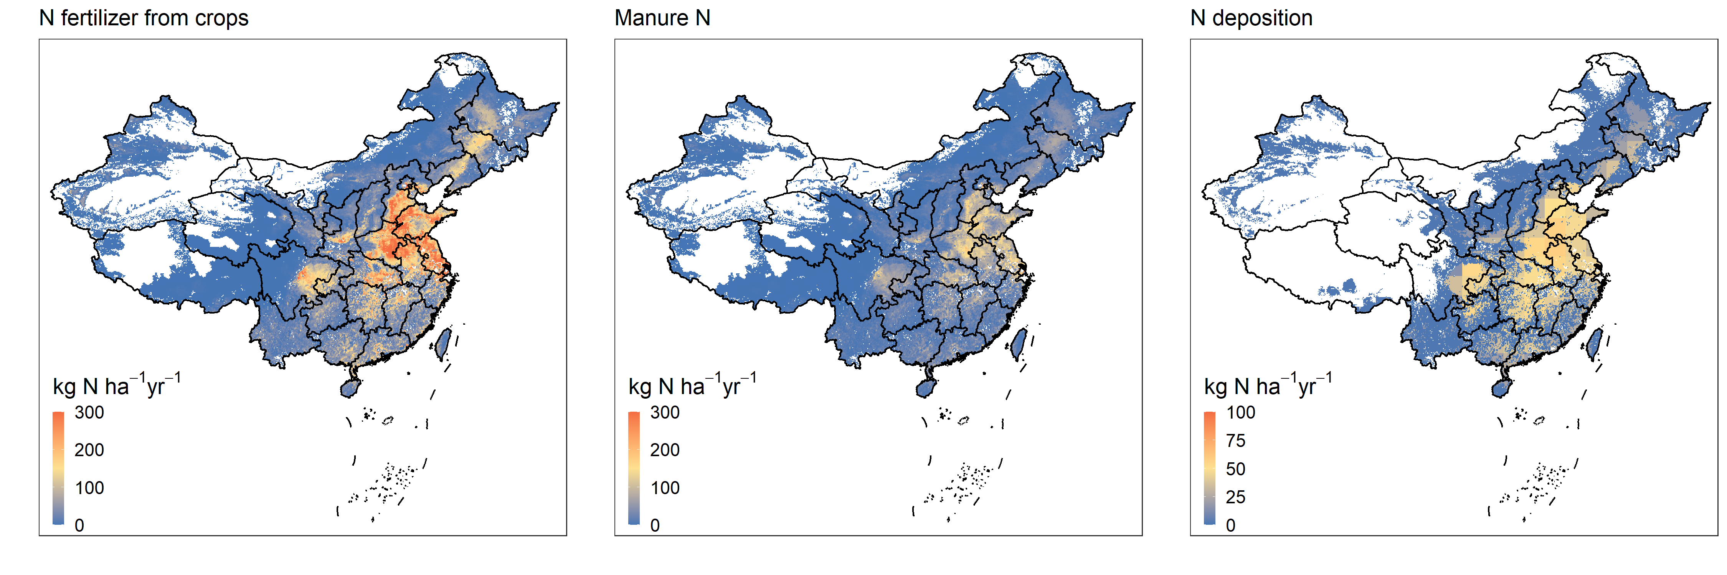
Figure S3│ Spatial distribution of N fertilizer, manure and environment (N deposition, irrigation and N fixation) inputs in China in 2010.

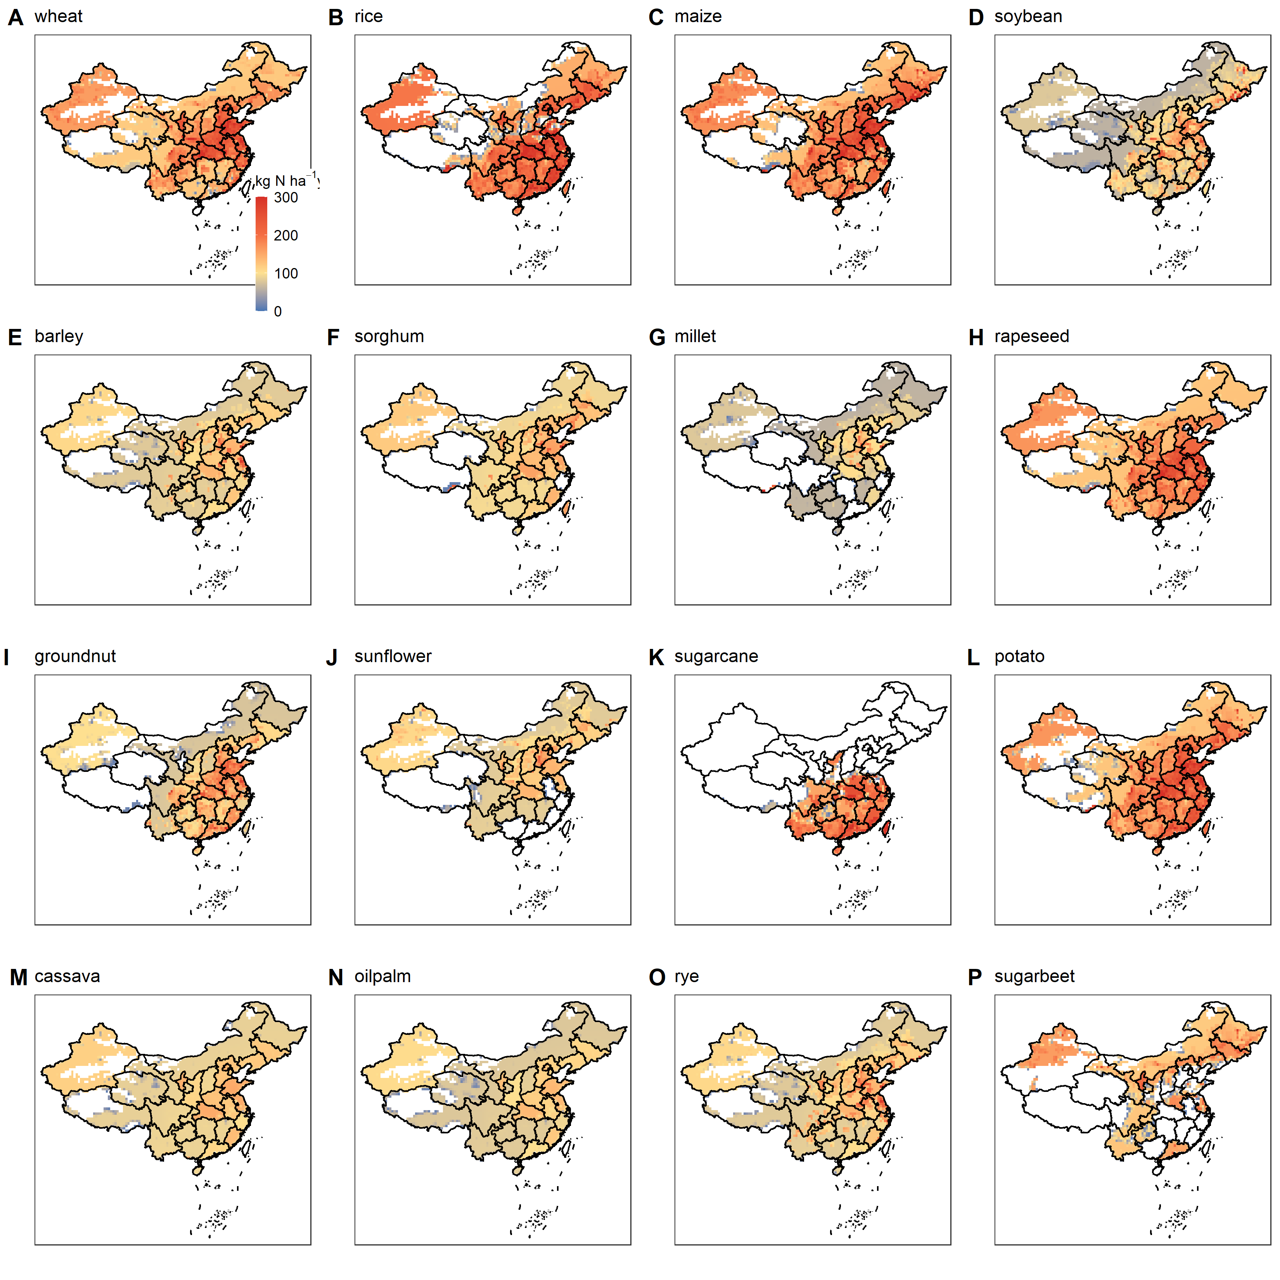
Figure S4│ Spatial distribution of N fertilizer inputs for 16 major crops in China.

Figure S5│Distribution and uncertainty ranges of the N balance for wheat (a), rice (b), maize (c) and vegetables (d), based on a Monte Carlo analysis by sampling 1000 times.

References
- Erisman, J.W., et al. How a century of ammonia synthesis changed the world. Nat. Geosci. 1, 636-639 (2008).
- Foyer, C. H., et al. Neglecting legumes has compromised human health and sustainable food production. Nat. Plants 2, 16112 (2016).
- Duan, Y. et al. Long-term evaluation of manure application on maize yield and nitrogen use efficiency in China. Soil Sci. Soc. Am. J. 75, 1562-1573 (2011).
- Li, H. et al. Chemical fertilizers could be completely replaced by manure to maintain high maize yield and soil organic carbon (SOC) when SOC reaches a threshold in the Northeast China Plain. J. Integr. Agric. 16, 937-946 (2017).
- Bruulsema, T. In Proceedings of the North Central Extension-Industry Soil Fertility Conference. Volume 25. Des Moines, IA (2009).
- Bai, Z., et al. Nitrogen, phosphorus, and potassium flows through the manure management chain in China. Environ. Sci. Technol. 50, 13409-13418 (2016).
- Kang, Y., et al. High-resolution ammonia emissions inventories in China from 1980 to 2012. Atmos. Chem. Phys. 16, 2043-2058 (2016).
- Xia, L. et al. Can knowledge‐based N management produce more staple grain with lower greenhouse gas emission and reactive nitrogen pollution? A meta‐analysis. Glob. Chang. Biol. 23, 1917-1925 (2017).
- Van Grinsven, H.J.M. et al. Costs and benefits of nitrogen for Europe and implications for mitigation. Environ. Sci. Technol. 47, 3571-3579 (2013).
- Kros, H., et al. Uncertainties in model predictions of nitrogen fluxes from agro-ecosystems in Europe. Biogeosciences 9, 4573–4588 (2012).
- Li, B. & Huang, F. Trends in China's agricultural water use during recent decade using the green and blue water approach. Adv. Water Sci. 21, 575-583 (2010).

References for contribution of each N output
- Bhandari, M., et al. Response of winter wheat yield and soil N₂O emission to nitrogen fertilizer reduction and nitrapyrin application in North China Plain. Communications in Soil Science and Plant Analysis. 51, 554-565 (2020).
- Qing, C. & Wen, X.F. Fate of fertilizer nitrogen in soil-plant system under irrigating condition 1. Effect of nitrogen level. Acta Agriculturae Nucleatae Sinica. 2, 97-102 (1997).
- Chen X., et al. Effects of postponing N application on the yield, apparent N recovery and N absorption of winter wheat. Journal of Plant Nutrition and Fertilizer. 3, 450-455 (2008).
- Chen, X., et al. Synchronizing N supply from soil and fertilizer and nitrogen demand of winter wheat by an improved Nmin method. Nutrient Cycling in Agroecosystems. 74, 91-98 (2006).
- Dang, T.H., et al. Relationship between soil nitrate, nitrogen balance and utilization in rainfed land. Plant Nutrition and Fertilizer Science. 3, 573-577 (2009).
- Gao, Y.J., et al. Effects of mulch, N fertilizer, and plant density on wheat yield, wheat nitrogen uptake, and residual soil nitrate in a dryland area of China. Nutrient Cycling in Agroecosystems. 85, 109-121 (2009).
- Guo, T.C., et al. Utilization and Balance of Nitrogen and Proper Application Amount of Nitrogen Fertilizer in Winter Wheat in High-Yielding Regions. The Crop Journal. 5, 886-892 (2008).
- Huang, S.W., et al. Effect of the regionalized balanced fertilization technique on nitrogen fertilizer utilization efficiency and soil nutrient balance. Soil Fertilizer. 6, 3-7 (2002).
- Ji, Y.Z., et al. Impact of different nitrogen application on nitrogen movement and gaseous loss of winter wheat fields. Soil and Water Conservation. 3, 113-118 (2010).
- Jie, X.L., et al. Studies on use efficicency of N fertilizer in wheat field with different soil fertility and soil texture. Acta Agronomy Sinica. 6, 884-888 (1998).
- Ju, X.T., et al. Study on Effect of nitrogen fertilizer and nitrogen balance in winter wheat and summer maize rotation system. Scientia Agricultura Sinica. 11, 1361-1368 (2002).
- Li, B.Q., et al. Effects of wheat yield and nitrogen use efficiency of nitrogen application in Chao Soil region. Henan Chemical. 27, 38-40 (2010).
- Li, Q.Q. Effects of LIMUS, a urease inhibitor, on ammonia reduction, crop yield and nitrogen utilization in China. China Agricultural University. (2014).
- Li, J.M., et al. Studies on the soil nitrate content and nitrogen balance in winter wheat plants under limited irrigation condition. Acta Agriculturae Boreali-Sinica. 2, 51-55 (2003).
- Li, S., et al. Effects of swine slurry application on ammonia emission, nitrogen utilization and apparent balance of a winter wheat-summer maize rotation system. Chinese Journal of Eco-Agriculture. 27, 1502-1514 (2019).
- Liao, X.Y. Effects of optimal nitrogen management system in winter wheat-summer maize rotation in North China Plain. Hunan Agricultural University. (2001).
- Gu, L.M., et al. Lysimeter study of nitrogen losses and nitrogen use efficiency of Northern Chinese wheat. Field Crops Research. 188, 82-95 (2016).
- Liu, X.Y., et al. Effects of different N rates on fate of N fertilizer and balance of soil N of winter wheat. Journal of Plant Nutrition and Fertilizer Science. 2, 296-303 (2010).
- Liu, X.J., et al. Effects of reduced nitrogen application on nitrogen utilization and balance in winter wheat-summer maize cropping system. Journal of Applied Ecology. 15, 58-462 (2004).
- Lv. F.L., et al. Agronomic and environmental effects of combined application of organic and inorganic fertilizers in winter wheat/summer maize rotation system. Journal of Northwest A&F University. (2019).
- Ma, X.H., et al. Effect of irrigation regimes on water consumption characteristics and nitrogen distribution in wheat at different nitrogen applications. Acta Ecologica Sinica. 30, 1955-1965 (2010).
- Sha, Z.P., et al. Nitrogen stabilizers mitigate reactive N and greenhouse gas emissions from an arable soil in North China Plain: Field and laboratory investigation. Journal of Cleaner Production. 258, 121025 (2020).
- Shen, X.L., et al. Effects of nitrogen rate on nitrogen uptake and utilization of winter wheat and residual nitrate in soil under straw mulch. Journal of Northwest A&F University. 31, 1-14 (2003).
- Shi, Y., et al. Effects of nitrogen fertilizer rate and ratio of base and topdressing on yield of wheat, content of soil nitrate and nitrogen balance. Acta Ecologica Sinica. 11, 3661-3669 (2006).
- Tong, Y.A., et al. Effect of N rates on N uptake, transformation and the yield of winter wheat. Journal of Plant Nutrition and Fertilizer Science. 1, 64-69 (2007).
- Wang, D., et al. Physiological and ecological basis of effects of nitrogen application rate on soil nitrogen change and wheat yield and quality. Shandong Agricultural University. (2005).
- Wang, L. Effects of nitrogen fertilizer and winter wheat varieties on NH₃ exchange between canopy and atmosphere. Northwest A&F University. (2019).
- Wang, Q., et al. Effects of irrigation and nitrogen application rates on nitrate nitrogen distribution and fertilizer nitrogen loss, wheat yield and nitrogen uptake on a recently reclaimed sandy farmland. Acta Ecologica Sinica. 5, 2148-2159 (2008).
- Wang, X.Y., et al. Interactive effects of irrigation and nitrogen fertilizer on nitrogen fertilizer recovery and nitrate-N movement across soil profile in a winter wheat field. Acta Ecologica Sinica. 2, 685-694 (2008).
- Wang, X., et al. Soil nitrogen balance in a winter wheat/summer maize rotation system on the Loess Plateau. Journal of Plant Nutrition and Fertilizer science. 6, 759-764 (2006).
- Wang, X.B., et al. Soil ammonia volatilization in winter wheat/summer maize rotation system under optimized fertilization in North China. Journal of Plant Nutrition and Fertilizer Science. 2, 344-351 (2009).
- Wang, X.G., et al. Effects of fertilizer N, P on wheat yield and nutrients uptake characters in dryland of Loess Plateau. Journal of Northwest A&F University. 2, 138-142 (2007).
- Wei, J.L., et al. Effects of different nitrogen management strategies on wheat yield and nitrogen use efficiency. Shandong Agricultural Sciences. 9, 53-59 (2010).
- Wu, J.X. Study on soil nitrogen supply capacity in winter wheat/summer maize rotation system. China Agricultural University. (2003).
- Xia, L.K., et al. Effects of different nitrogen application periods on dry matter accumulation and nitrogen utilization of summer maize. Journal of Maize Science. 5, 138-140,144 (2009).
- Liu, X.J., et al. Nitrogen dynamics and budgets in a winter wheat–maize cropping system in the North China Plain. Field Crops Research. 83, 111-124 (2003).
- Yang, Y., et al. Effects of conservation tillage practices on ammonia emissions from Loess Plateau rain-fed winter wheat fields. Atmospheric Environment. 104, 59-68 (2015).
- Zhang, A.P., et al. Effect of N rates on yield of spring wheat, fertilizer N recovery and N balance. Chinese Agricultural Science Bulletin. 17, 137-142 (2009).
- Zhang, X., et al. Effects of nitrogen ratio of base fertilizer and topdressing on uptake, utilization of nitrogen and yield in winter wheat. Acta Agriculturae Boreali-Sinica. 25, 193-197 (2010).
- Zhang, Y.X., et al. Effects of nitrogen rate on nitrogen uptake and utilization of winter wheat and residual nitrate in soil under straw mulch. Agricultural Research in the Arid Areas. 27, 189-193 (2009).
- Zhao, J.Y. & Yu, Z.W. Effects of nitrogen rate on nitrogen fertilizer use of winter wheat and content of soil nitrate-N under different fertility condition. Acta Ecologica Sinica. 26, 815-822 (2006).
- Zhao, R.F., et al. Study on nitrogen optimized management at different growing stage of winter wheat based on nutrient balance and soil test. Chinese Agricultural Science Bulletin. 11, 211-225 (2005).
- Zhao, S.C., et al. Response of winter wheat to different nitrogen managements in North Central China. Journal of Plant Nutrition and Fertilizers. 17, 517-524 (2011).
- Zhao, P. & Chen, F. Effects of straw mulching plus nitrogen fertilizer on nitrogen efficiency and grain yield in winter wheat. Acta Agronomy Sinica. 34, 1014-1018 (2008).
- Zheng, F.X., et al. Effects of combined application of manure and chemical fertilizers on ammonia volatilization loss and yield of winter wheat. Journal of Plant Nutrition and Fertilizers. 23, 567-577(2017).
- Zhong, Q., et al. Analysis of environmental endurance of winter wheat/summer maize rotation system to nitrogen in North China Plain. Journal of Plant Nutrition and Fertilizers. 12, 285-293 (2006).
- Ding, X.Q. Ammonia volatilization from nitrogen fertilization in winter wheat-summer maize rotation system in the north China Plain. China Agricultural University. (2005).
- Bhandari, M., et al. Response of winter wheat yield and soil N₂O emission to nitrogen fertilizer reduction and nitrapyrin application in North China Plain. Communications in Soil Science and Plant Analysis. 51, 554-565 (2020).
- Cai, G.X., et al. Nitrogen losses from fertilizers applied to maize, wheat and rice in the North China Plain. Nutrient Cycling in Agroecosystems. 63, 187-195 (2002).
- Li, C.Q., et al. Effects of Limus, a urease inhibitor, on ammonia reduction, crop yield and nitrogen utilization in China. China Agricultural University. (2014).
- Li, G.T., et al. Method for measurement of ammonia volatilization from large area field by Bowen ratio system. Journal of China Agricultural University. 5, 56-62 (2001).
- Li, S., et al. Effects of swine slurry application on ammonia emission, nitrogen utilization and apparent balance of a winter wheat-summer maize rotation system. Chinese Journal of Eco-Agriculture. 10, 1502-1514 (2019).
- Gu, L.M., et al. Lysimeter study of nitrogen losses and nitrogen use efficiency of Northern Chinese wheat. Field Crops Research. 188, 82-95 (2016).
- Ma, Y.L., et al. Effects of N fertilization rates on the NH3 volatilization and N₂O emissions from the wheat-maize rotation system in North China Plain. Journal of Ecology and Environment. 2, 225-230 (2012).
- Sha, Z.P., et al. Nitrogen stabilizers mitigate reactive N and greenhouse gas emissions from an arable soil in North China Plain: Field and laboratory investigation. Journal of Cleaner Production. 258, 121025 (2020).
- Li, T.Y., et al. Exploring optimal nitrogen management practices within site-specific ecological and socioeconomic conditions. Journal of Cleaner Production. 241, 118295 (2019).
- Wei, W., et al. Biochar effects on crop yields and nitrogen loss depending on fertilization. Science of the Total Environment. 702, 134423 (2020).
- Xia, W.J., et al. Characteristics of nitrogen cycling in rice-wheat rotation under optimal nitrogen application. Chinese Academy of Agricultural Sciences. (2011).
- Zhang, Y.M., et al. Ammonia volatilization and denitrification losses from an irrigated maize-wheat rotation field in the North China Plain. Pedosphere. 4, 533-540 (2004).
- Zheng, F.X., et al. Effects of combined application of manure and chemical fertilizers on ammonia volatilization loss and yield of winter wheat. Plant Nutrition and Fertilizer Science. 3, 567-577 (2017).
- Bhandari, M.H., et al. Response of winter wheat yield and soil N₂O emission to nitrogen fertilizer reduction and nitrapyrin application in North China Plain. Communications in Soil Science and Plant Analysis. 4, 554-565 (2020).
- Wu, D., et al. Potential dual effect of nitrification inhibitor 3,4-dimethylpyrazole phosphate on nitrifier denitrification in the mitigation of peak N₂O emission events in North China Plain cropping systems. Soil Biology and Biochemistry. 121, 147-153 (2018).
- Cui, F., et al. Annual emissions of nitrous oxide and nitric oxide from a wheat-maize cropping system on a silt loam calcareous soil in the North China Plain. Soil Biology and Biochemistry. 48, 10-19 (2012).
- Han, X., et al. Effects of reduced nitrogen fertilization and biochar application on CO₂ and N₂O emissions from a summer maize-winter wheat rotation field in north China. Agricultural Science & Technology. 12, 2800-2808 (2016).
- Li, B.Y., et al. Effect of nitrogen fertilizer on N₂O emissions from winter wheat field in the Loess Plateau. Journal of Northwest A&F University. 5, 50-58 (2018).
- Li, Y.Q., et al. Effect of different manures combined with chemical fertilizer on yields of crops and gaseous N loss in farmland. Journal of Plant Nutrition and Fertilizer Science. 11, 1835-1846 (2019).
- Liang, D.L. Study on nitrogen loss of nitrous oxide in loess soil and its influencing factors. Northwest A&F University. (2003).
- Liang, G.Q., et al. Effect of optimized nitrogen application on N₂O emission from paddy field under wheat-rice rotation system. Journal of Plant Nutrition and Fertilizer Science. 2, 304-311 (2010).
- Lv, F.L. Agronomic and environmental effects of combined application of organic and inorganic fertilizers in winter wheat/summer maize rotation system. Northwest A&F University. (2019).
- Wang, X.B., et al. Effect of optimized nitrogen application on denitrification losses and N₂O emissions from soil in winter wheat/summer corn rotation system in North China. Journal of Plant Nutrition and Fertilizer Science. 1, 49-54 (2009).
- Wen, W., et al. Study on annual nitrogen efficient utilization of spring wheat-silage maize. Shihezi University. (2019).
- Hu, X.K., et al. Greenhouse gas emissions from a wheat-maize double cropping system with different nitrogen fertilization regimes. Environmental Pollution. 176, 198-207 (2013).
- Xu, H., et al. Effects of soil texture on N₂O emission from wheat and cotton fields. Agro-Environment Protection. 1, 1-3 (2000).
- Dong, Y., et al. Nitrous oxide emissions from cultivated soils in the North China Plain. Tellus. 53, 1-9 (2001).
- Yang, Y., et al. Evaluation of N₂O emission from rainfed wheat field in northwest agricultural land in China. Environmental Science and Pollution Research International. 27, 43466-43479 (2020).
- Yao, Z.S., et al. Straw return reduces yield-scaled N₂O plus NO emissions from annual winter wheat-based cropping systems in the North China Plain. Science of the Total Environment. 590-591, 174-185 (2017).
- Zhou, Y.Z., et al. The influence of straw returning on N₂O emissions from a maize-wheat field in the North China Plain. Science of the Total Environment. 584-585, 935-941 (2017).
- Zeng, J.H., et al. Estimation of soil N₂O flux and total amount during wheat-maize rotation. Environmental Science. 1, 32-35 (1995).
- Zhang, Y.M. Study on nitrogen cycling and balance in winter wheat-summer maize rotation farmland in front plain of Taihang Mountain, North China. China Agricultural University. (2005).
- Zhao, J.B., et al. Study on N₂O emission and its influencing factors in wheat field under conservation tillage. Journal of China Agricultural University. 3, 196-200 (2008).
- Chen, S., et al. Water leakage and nitrate leaching characteristics in the winter wheat-summer maize rotation system in the North China Plain under different irrigation and fertilization management practices. Water. 2, 141 (2017).
- Li, X.X., et al. Study on nitrate leaching under wheat and maize cropping system in North China. Water. 6, 7-10 (2006).
- Gu, L.M., et al. Lysimeter study of nitrogen losses and nitrogen use efficiency of Northern Chinese wheat. Field Crops Research. 188, 82-95 (2016).
- Luo, W.H., et al. Effects of water saving and nitrogen reduction on soil nitrate distribution and water and nitrogen use efficiency of winter wheat. Acta Agronomica Sinica. 6, 924-936 (2020).
- Xiao, X.H. Quantitative evaluation of water and nitrogen balance in irrigated farmland under winter wheat-summer maize rotation. China Agricultural University. (2004).
- Zheng, W.K., et al. Developing water and nitrogen budgets of a wheat-maize rotation system using auto-weighing lysimeters: Effects of blended application of controlled-release and un-coated urea. Environmental Pollution. 263, 114383 (2020).
- Zhu, A., et al. Water balance and nitrate leaching losses under intensive crop production with Ochric Aquic Cambosols in North China Plain. Environment International International. 6, 904-912 (2005).

