Supporting Information
for
A dihydropyridine derivative as a highly selective fluorometric probe for quantification of Au³⁺ residue in the gold nanoparticle solution
Waroton Paisuwanª, Mongkol Sukwattanasinitt^{b}, Mamoru Tobisu^{c,d}, Anawat Ajavakom^{b,}*

ªDepartment of Chemistry, Faculty of Science, Chulalongkorn University, Phyathai Road, Pathumwan, Bangkok 10330, Thailand
^{b}Nanotec-CU Center of Excellence on Food and Agriculture, Department of Chemistry, Faculty of Science, Chulalongkorn University, Phyathai Road, Pathumwan, Bangkok 10330, Thailand
^{c}Department of Applied Chemistry, Graduate School of Engineering, Osaka University, Suita, Osaka 565-0871
^{d}Innovative Catalysis Science Division, Institute for Open and Transdisciplinary Research Initiatives (ICS-OTRI), Osaka University, Suita, Osaka 565-0871, Japan

TABLE OF CONTENTS  (c) | PAGE
S1. ¹H NMR spectra of DHP in acetone-d₆ | 2
S2. ¹H NMR spectra of DHP-OH in acetone-d₆ | 2
S3. ¹³C NMR spectra of DHP in acetone-d₆¹H | 3
S4. ¹³C NMR spectra of DHP-OH in acetone-d₆ | 3
S5. HRMS spectra of DHP | 4
S6. HRMS spectra of DHP-OH | 4
S7. IR spectra of DHP | 5
S8. IR spectra of DHP-OH | 5
S9. Molar absorptivity of DHP and DHP-OH | 6
S10. Fluorescence quantum efficiency of DHP and DHP-OH | 7
S11. Fluorescence response of DHP and [DHP+Au³⁺] in various pHs | 8
S12. Fluorescence response of DHP-OH and [DHP-OH+Au³⁺] in various pHs | 8
S13. Time dependent fluorescence quenching profile in Tris-HCl pH 6.0 for 60 minutes | 9
S14. Comparison of fluorescent probes for Au³⁺ detection | 9-10
S15. Absorption spectra of DHP-OH, Au³⁺, and the mixture of DHP-OH and Au³⁺ in Tris-HCl pH 6.0. | 10
S16. ¹³C NMR spectra of [DHP-OH+Au³⁺] | 11
S17. HRMS spectra of [DHP-OH+Au³⁺] | 11
S18. Absorption and morphology of AuNPs | 12

S1. ¹H NMR spectra of DHP in acetone-d₆
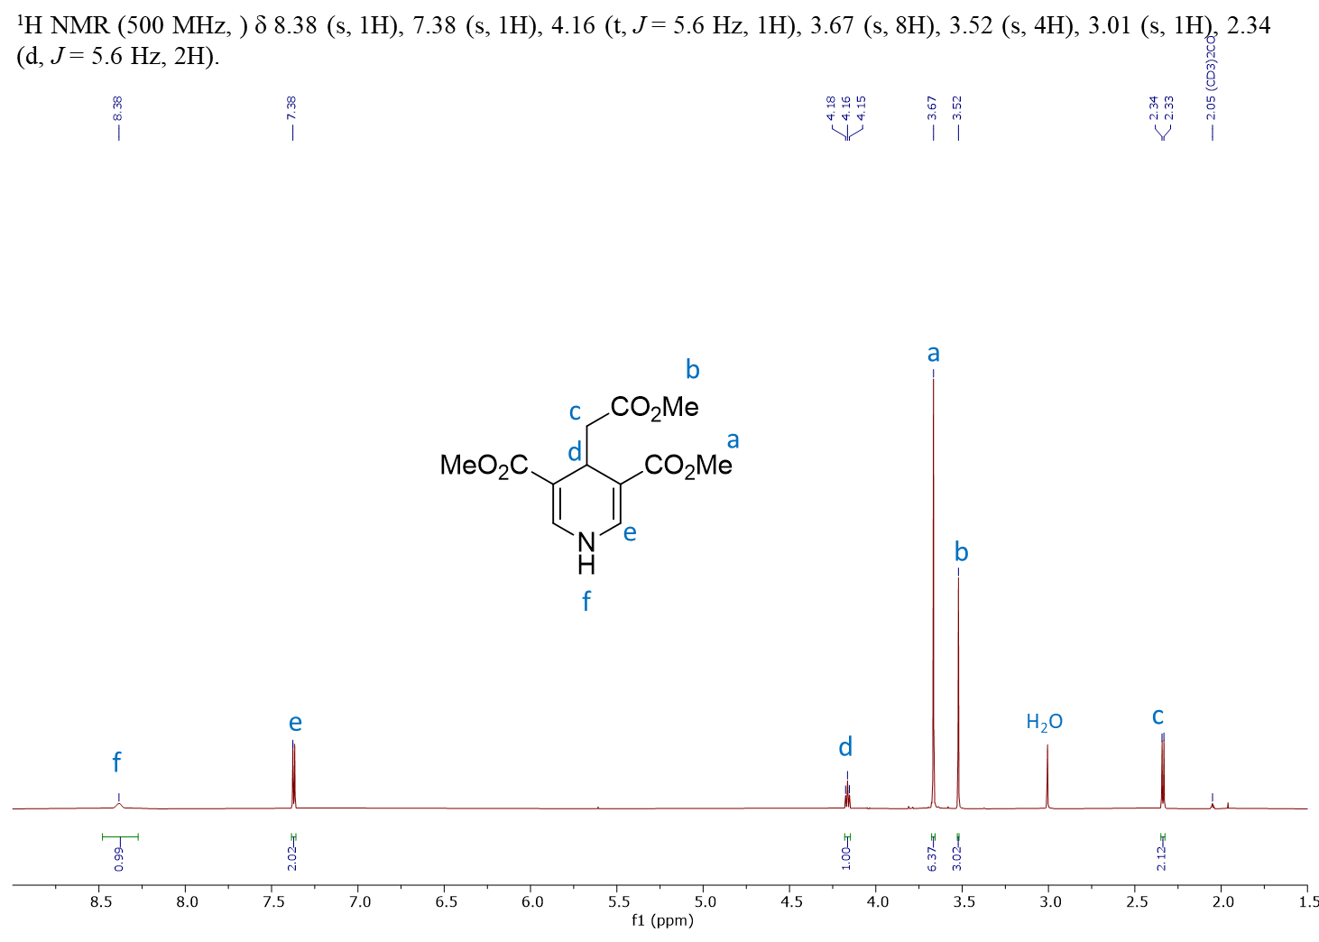
S2. ¹H NMR spectra of DHP-OH in acetone-d₆
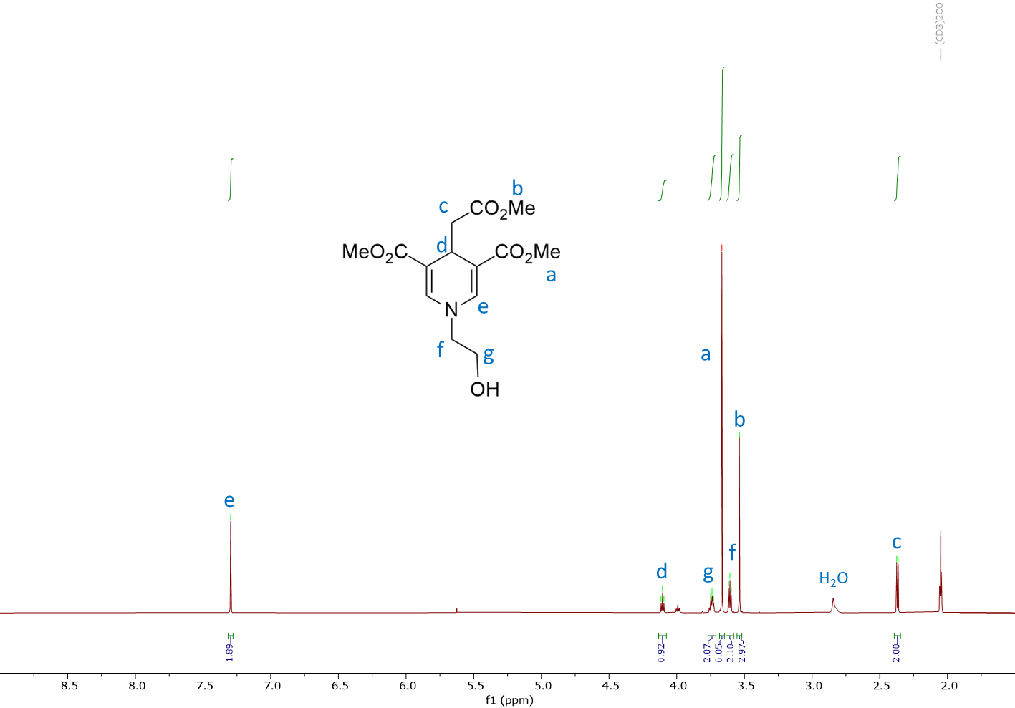
S3. ¹³C NMR spectra of DHP in acetone-d₆
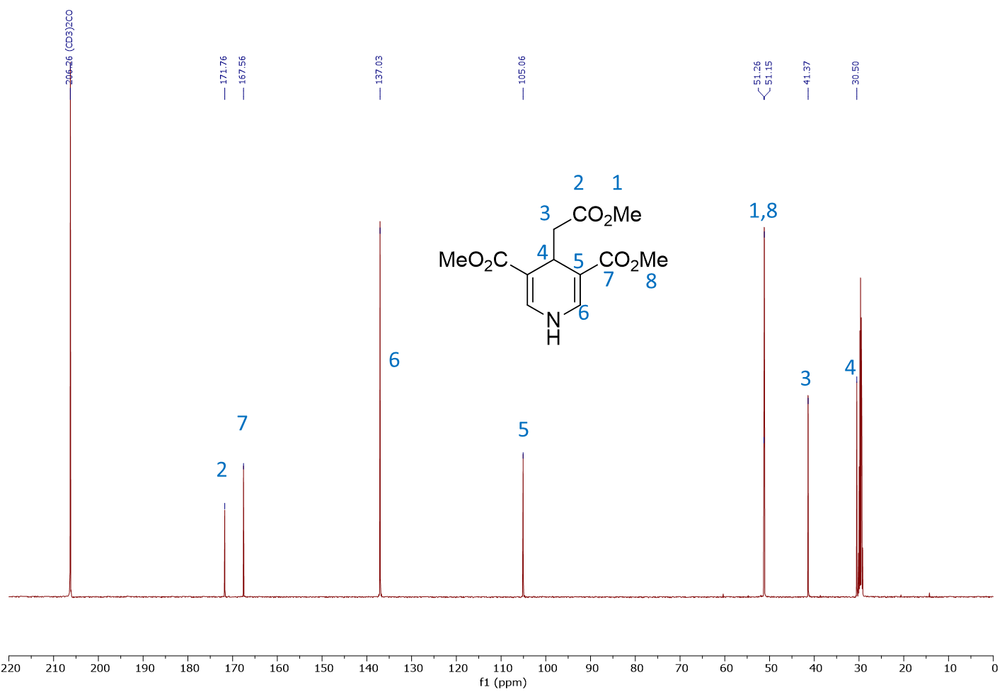
S4. ¹³C NMR spectra of DHP-OH in acetone-d₆
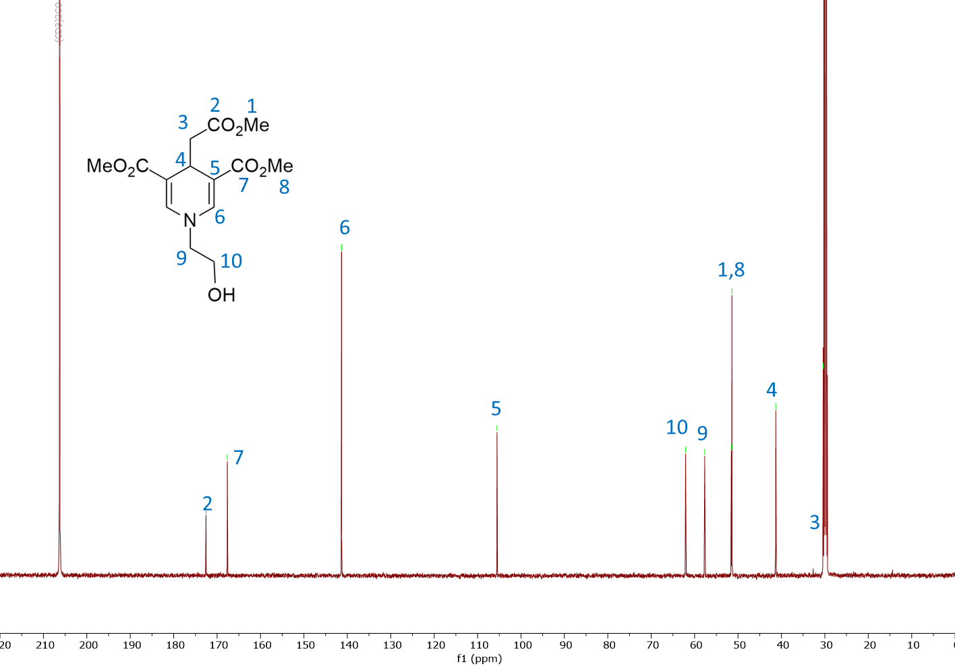
S5. HRMS spectra of DHP
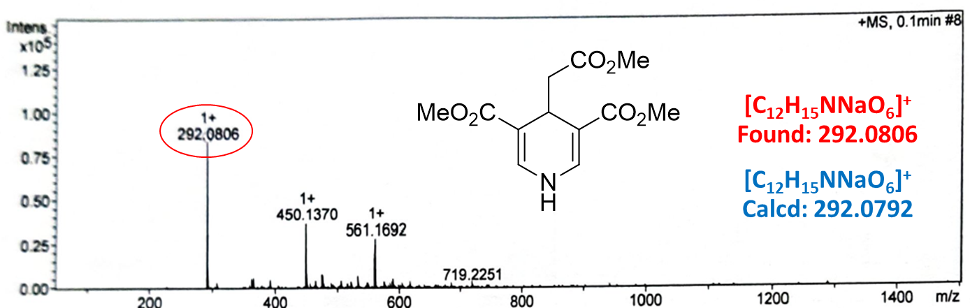

S6. HRMS spectra of DHP-OH
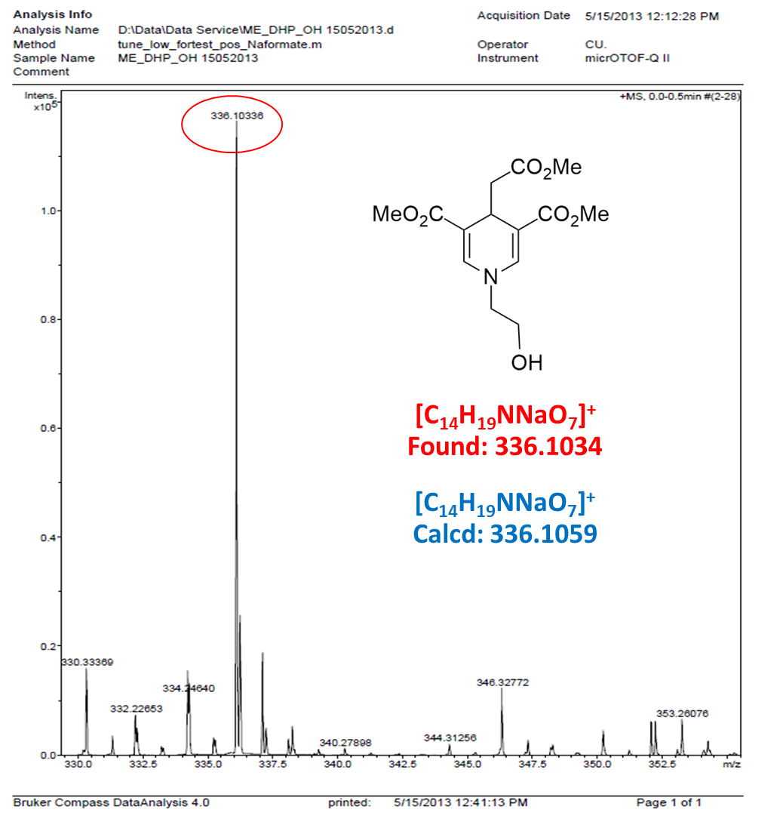

S7. IR spectra of DHP
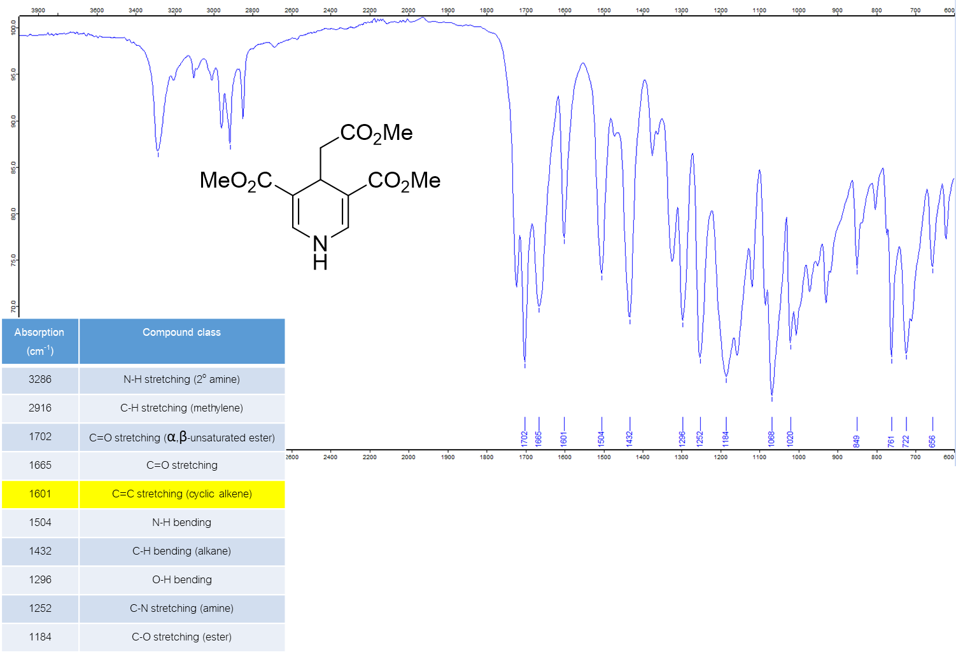

S8. IR spectra of DHP-OH
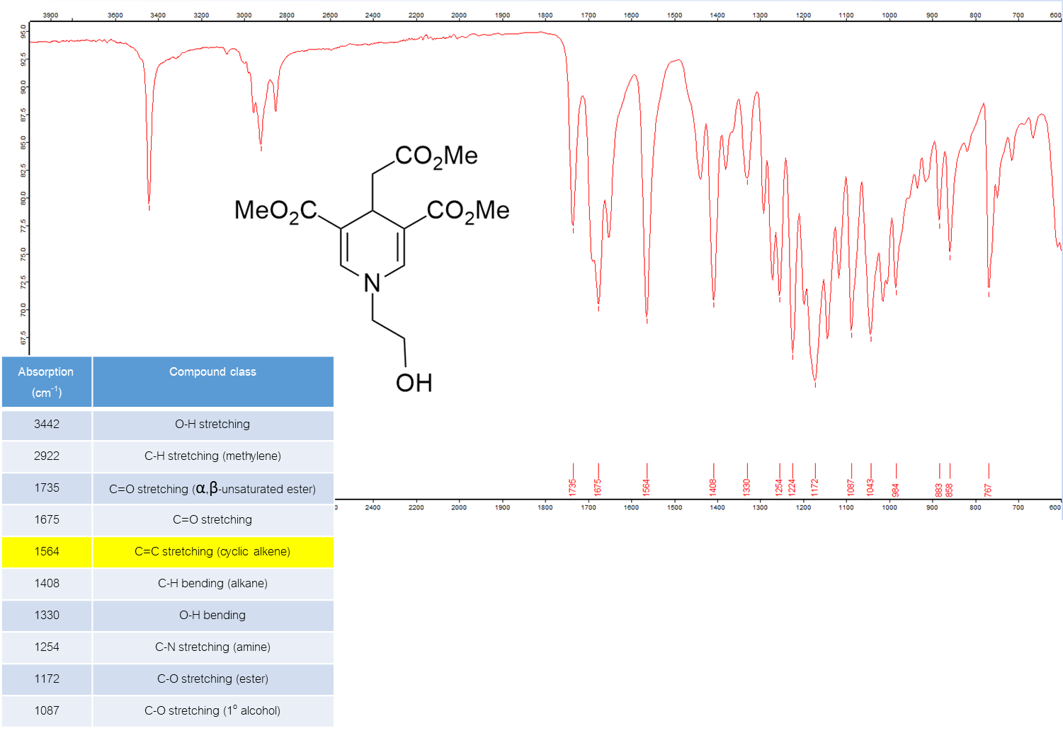
S9. Molar absorptivity of DHP and DHP-OH
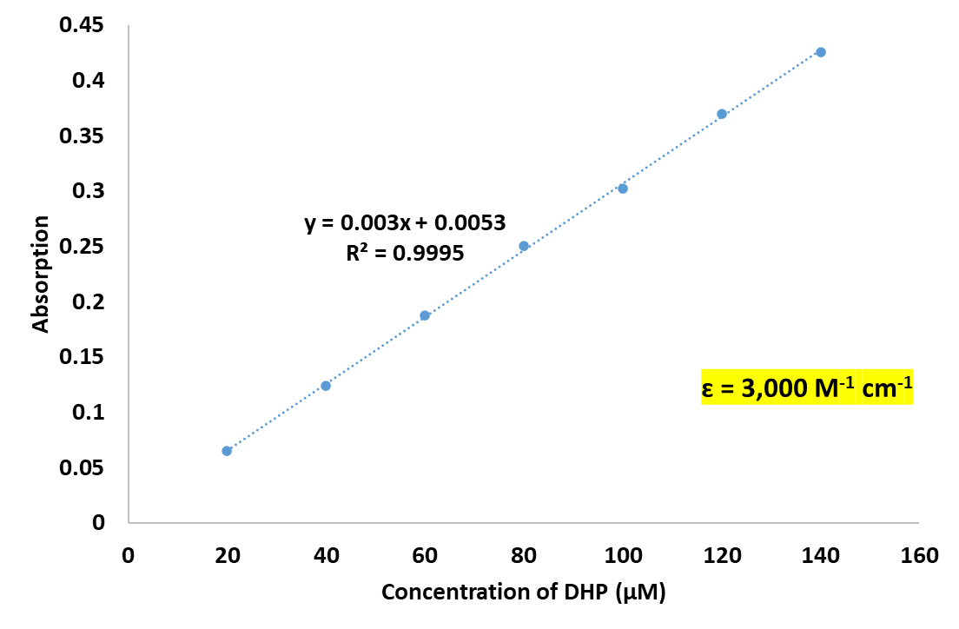
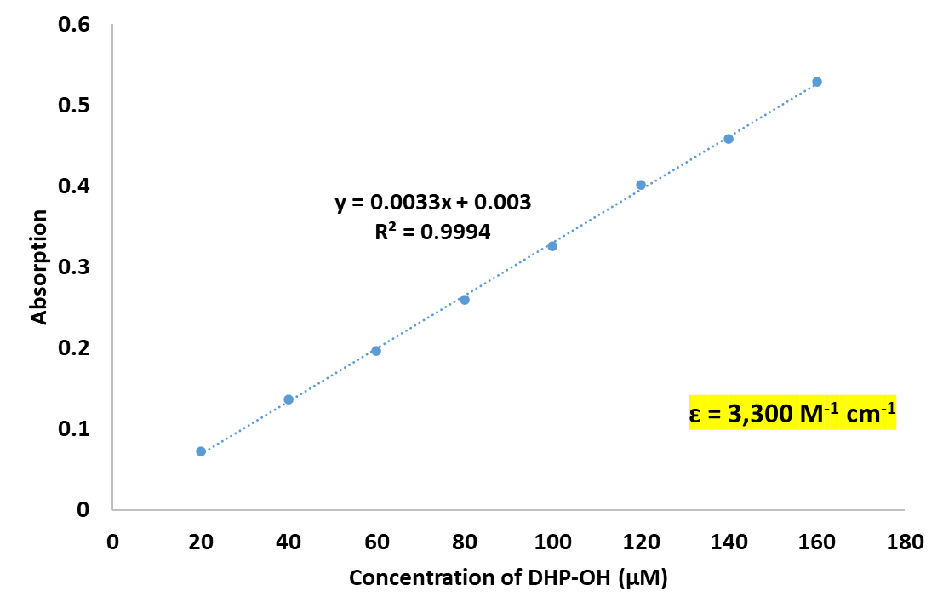

S10. Fluorescence quantum efficiency of DHP and DHP-OH
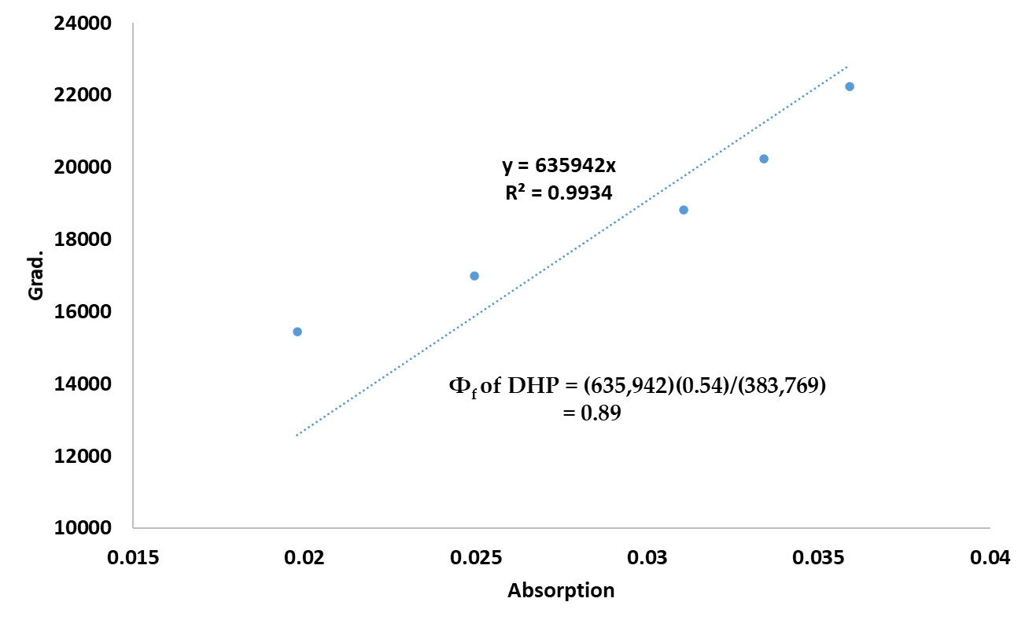
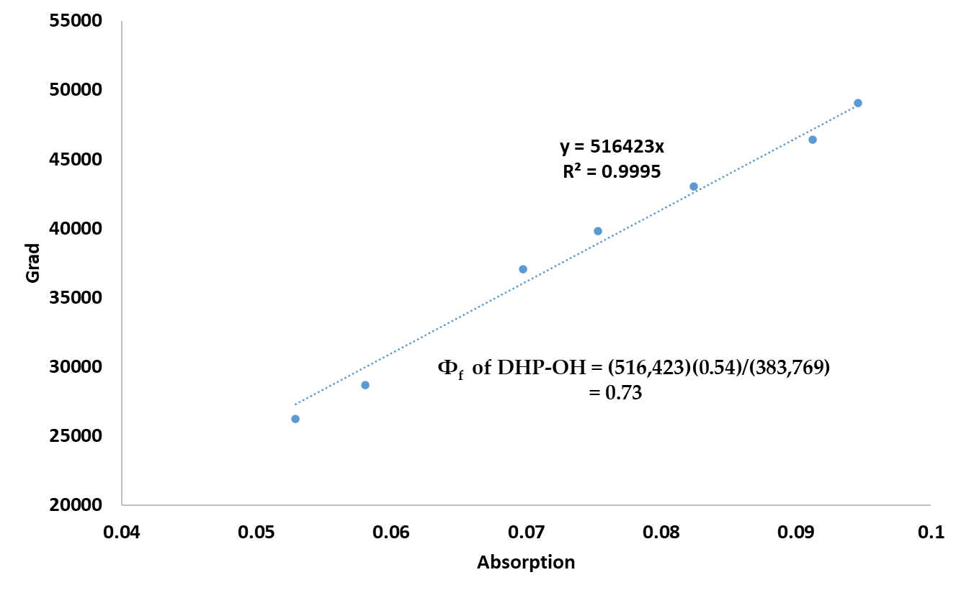

S11. Fluorescence response of DHP and [DHP+Au³⁺] in various pHs
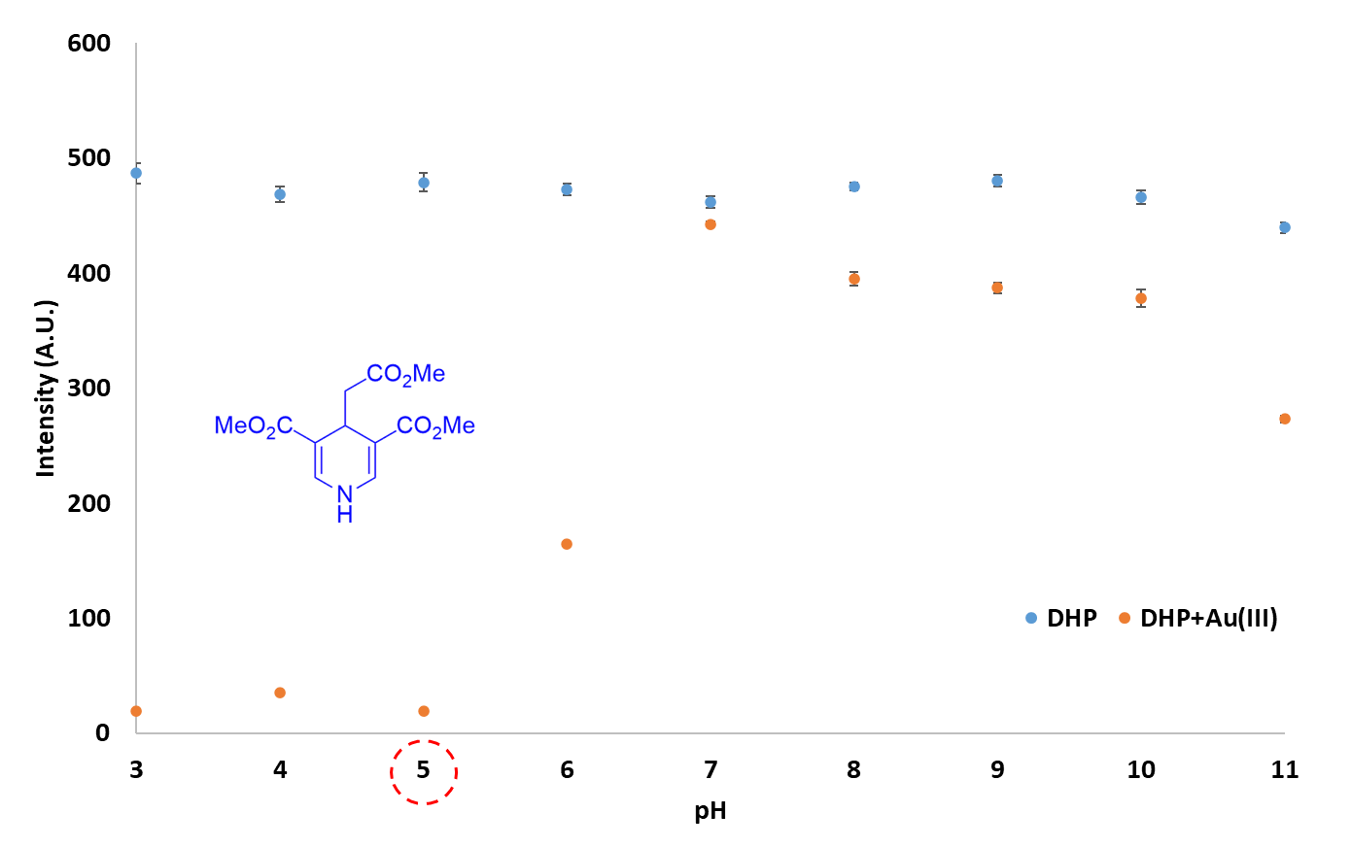

S12. Fluorescence response of DHP-OH and [DHP-OH+Au³⁺] in various pHs
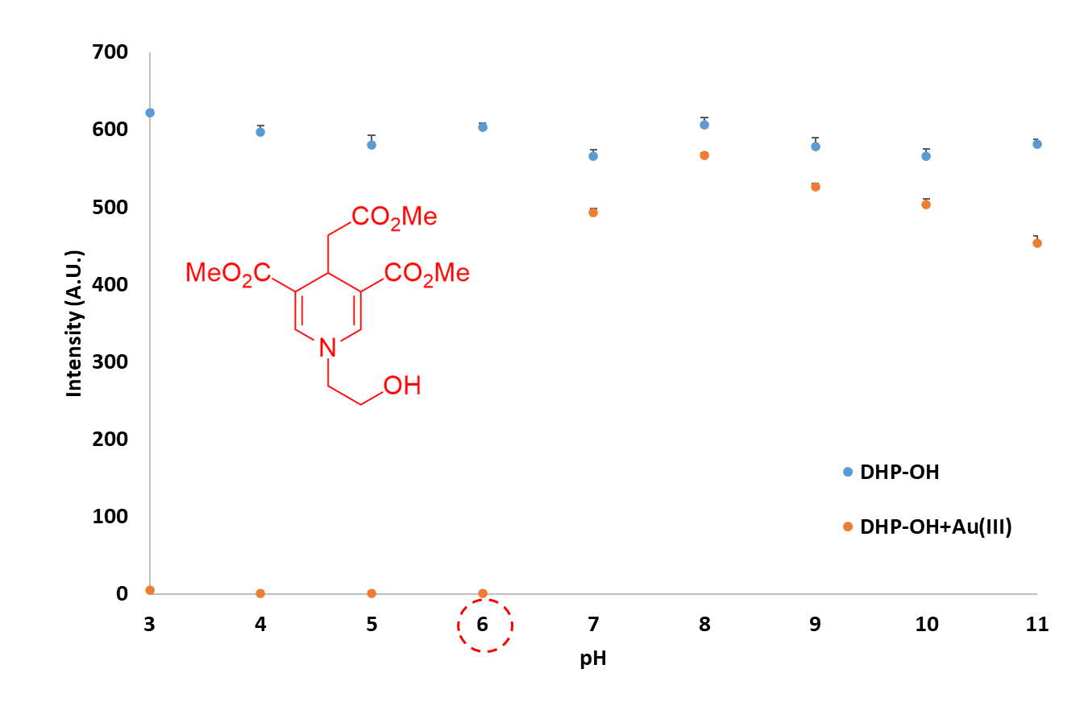

S13. Time dependent fluorescence quenching profile in Tris-HCl pH 6.0 for 60 minutes
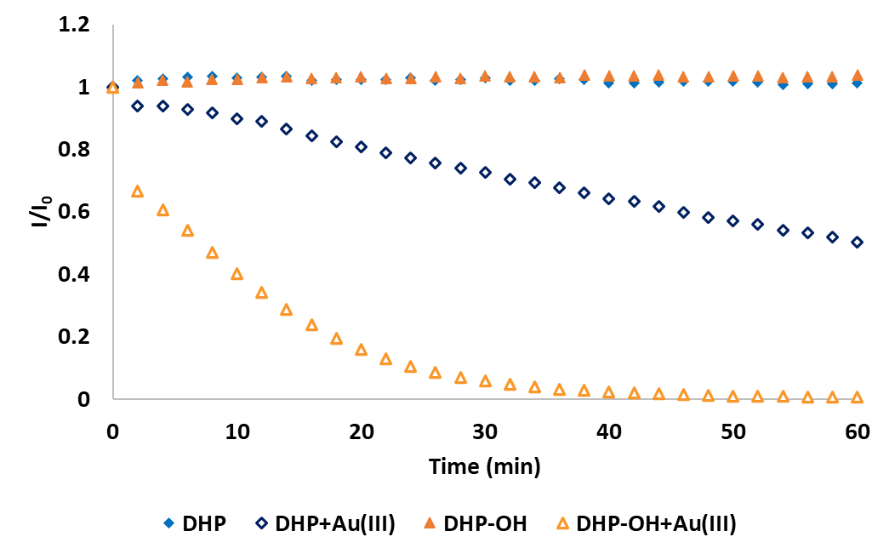

S14. Comparison of fluorescent probes for Au³⁺ detection
Entry | Fluorescent Probe | Synthetic step | LOD (nM) | Fluorescent Mode | Solvent (v/v) | Application | References
1 | 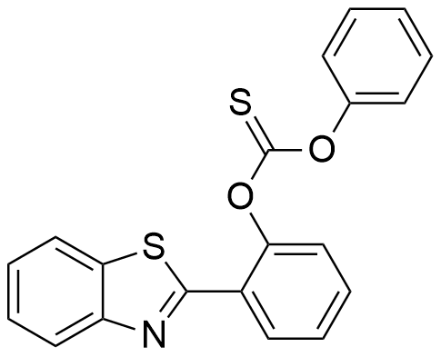 | 1 | 48 | Turn on | DMSO/ H₂O (1/1) | Synthetic waste water | Dyes and Pigments, 2019, 164,  14-19.
2 | 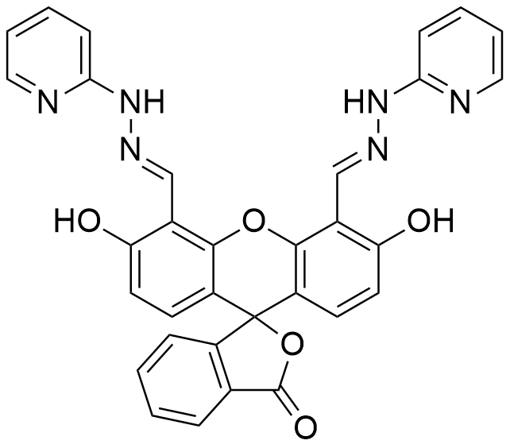 | 1 | 70 | Turn on | HEPES  (pH 7.4) | Cell imaging | Sensors and Actuators B, 2015, 209,  1005-1010.
3 | 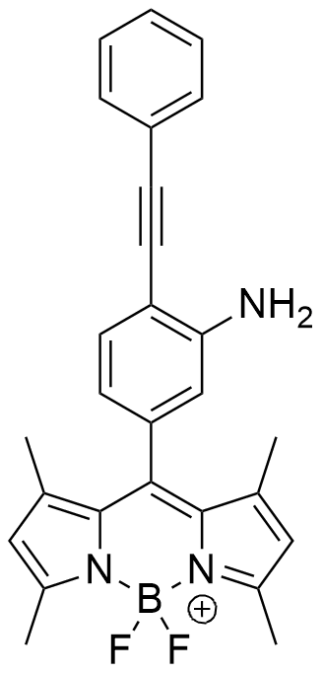 | 3 | 100 | Turn on | EtOH/  PBS (1/1,  pH 7.4) | Human blood, serum and cell imaging | Sensors and Actuators B, 2016, 226,  364-369.
4 | 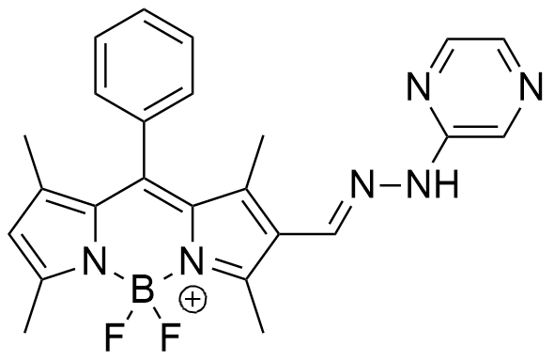 | 1 | 60 | Turn on | PBS/  EtOH  (7:3,  pH 7.0) | Cell imaging | Biosensors and Bioelectronics, 2016, 77, 812-817.
5 | 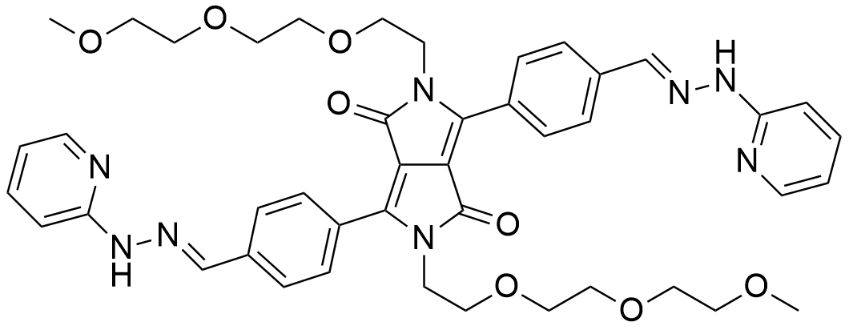 | 4 | 15 | Turn on and ratiometric | EtOH/  PBS (1/1,  pH 7.4) | Cell imaging | Biosensors and Bioelectronics, 2016, 80, 288-293.
6 | 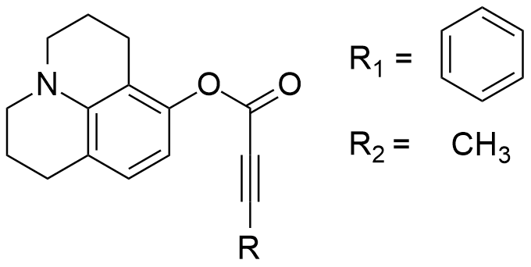 | 1 | R₁=100  R₂=120 | Turn on | EtOH/  HEPES (1/1,  pH 7.4) | Cell imaging | Biosensors and Bioelectronics, 2016, 86, 939-943.
7 | 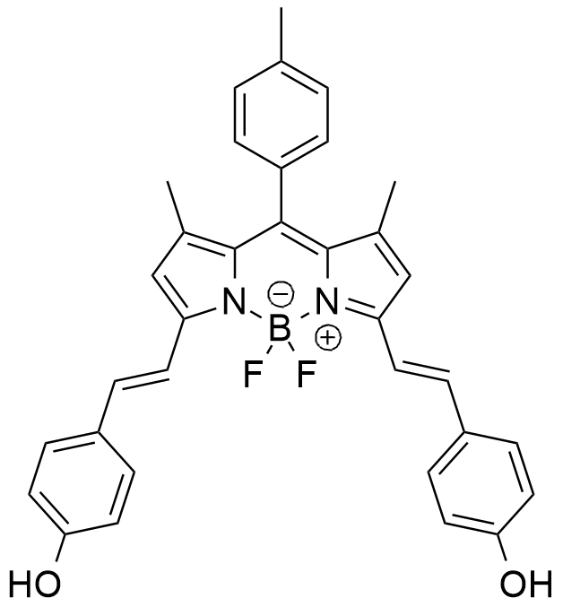 | 1 | 9.4 | Turn on | MeOH/  H₂O  (8:2) | Tap water  and  cell imaging | Dyes and Pigments, 2021, 191,  109341.
8 | 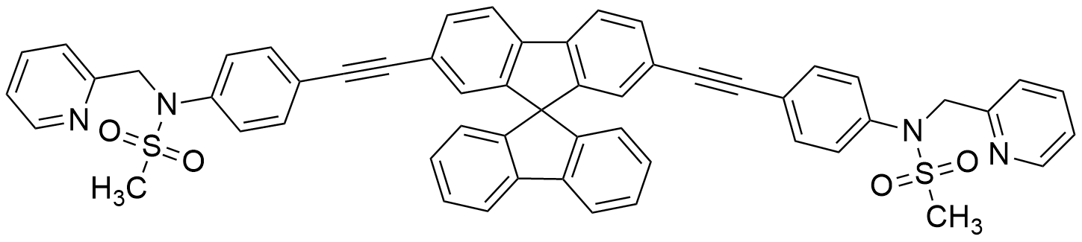 | 2 | 9.8 | Turn off | DMSO/NaCl-HCl  (1/99,  pH 2.0) | Drinking,  rain, tap,  pond, and  river water | Journal of Photochemistry and Photobiology A: Chemistry, 2020, 112823,
9 | 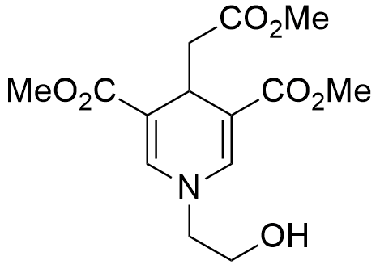 | 1 | 167  (32.8 ppb) | Turn off | Tris-HCl pH 6.0 | Strip test,  Real water samples, and Au³⁺ residue in AuNPs solution | This work

S15. Absorption spectra of DHP-OH, Au³⁺, and the mixture of DHP-OH and Au³⁺ in Tris-HCl pH 6.0.

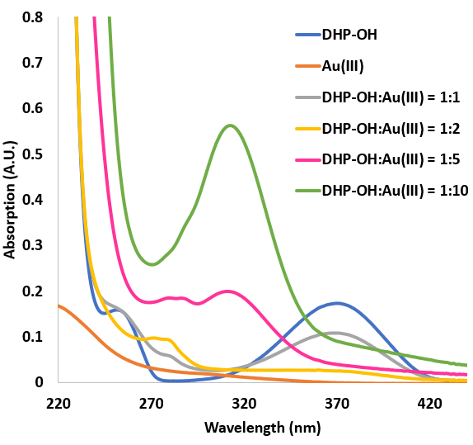

S16. ¹³C NMR spectra of [DHP-OH+Au³⁺]
1-(2-hydroxyethyl)-4-(2-methoxy-2-oxoethyl)-3,5-bis(methoxycarbonyl)pyridin-1-ium (Oxidized product): ¹³C NMR (125 MHz, D₂O:DMSO-d₆ (99:1, v/v)) δ (ppm): 171.29, 163.23, 155.09, 148.76, 131.93, 64.03, 59.87, 54.11, 53.16, 37.99.
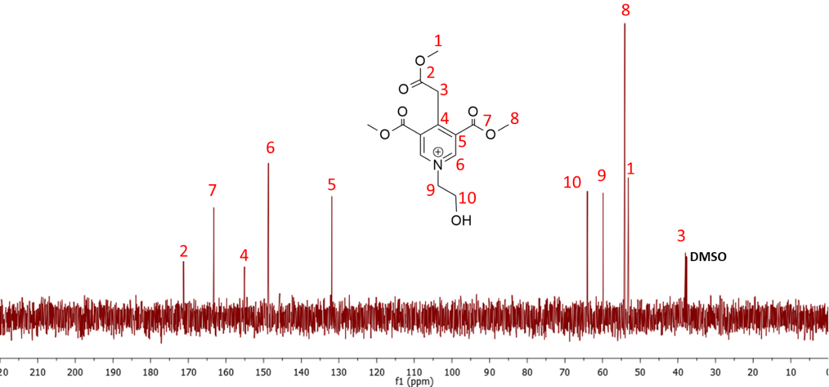

S17. HRMS spectra of [DHP-OH+Au³⁺]
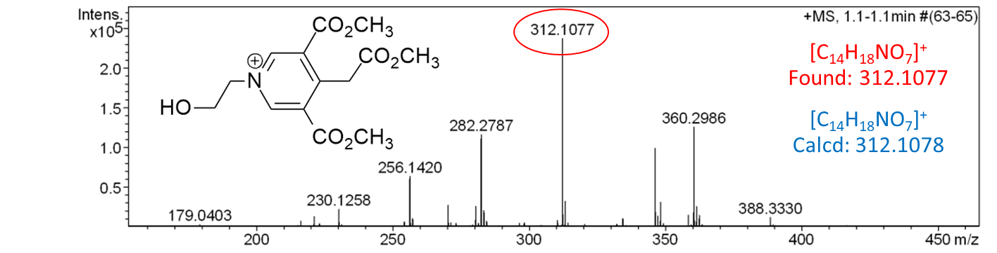

S18. Absorption and morphology of AuNPs
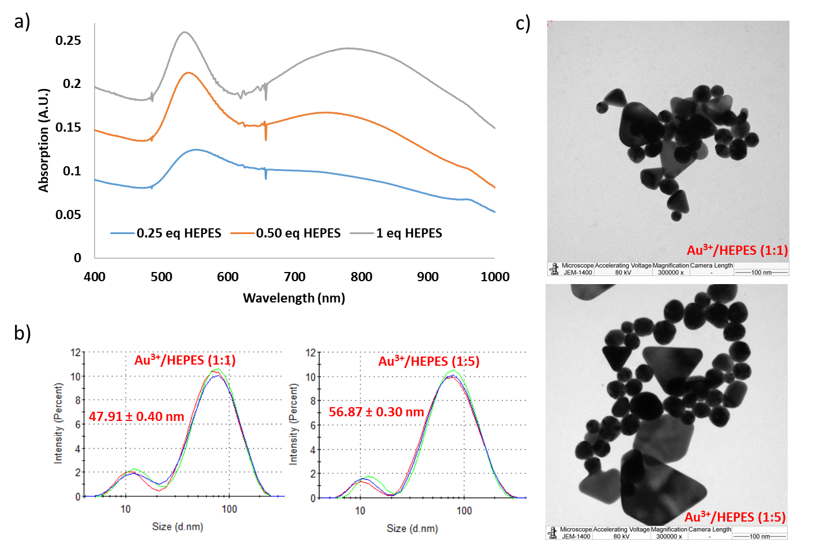
a) absorption spectra, b) DLS spectra, and c) TEM images of the Au³⁺/HEPES solution at the molar ratio of 1:1 and 1:5.

