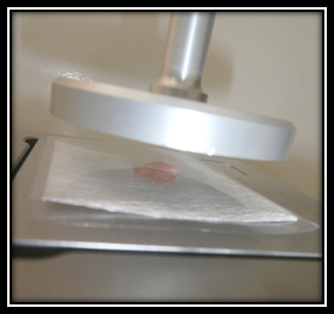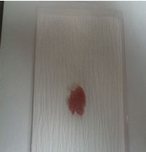
A

B

Supplementary Figure S1a: Briefly, 20 g of the LD samples were ground for 30 seconds, then, approximately 0.3 g of the sample were placed on a Walkman No.5 filter paper and a compression force of 2.5 Kg was applied for 5 minutes.

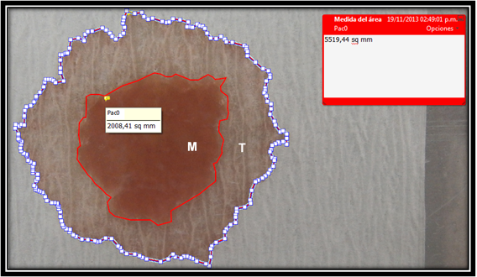
Supplementary Figure S1b: Then, the paper was removed, revealing two areas, one formed by the pressed meat (M) and the second corresponding to the water released by the meat (T)

