Supporting information

Design and Applications of a Promising Powerful Colorimetric Sensor for glutathione detection based on Mesoporous Silica Nanoparticle loaded by Copper

Morvarid Aghayanª, Ali Mahmoudi^{a,*}, Mohammad Reza Sazegarª, khodadad Nazari^{b}, Alireza Jahanafarinª, Omid Nazariª, Forogh Adhami^{c}, Zeynab Poorhasanª, Parisa Hamidiª, Batoul Sadat Shafaeiª

ªDept. of Chemistry, Faculty of science, Islamic Azad University, North Tehran Branch, Tehran, Iran
^{b}Future Bioenergy Solutions Inc., North Vancouver, BC, V7P3P9, Canada
^{c.}Dep. of chemistry, Faculty of science, Islamic Azad University, Yadegar-e-Imam Khomeini (RAH), Shahre Rey Branch, Tehran, Iran.

* Corresponding Authors
E-mail: mahmoudiali.ac@gmail.com
Tel.: +98 9123377127

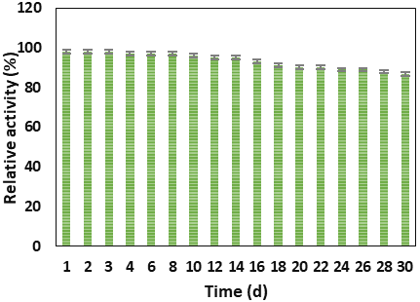
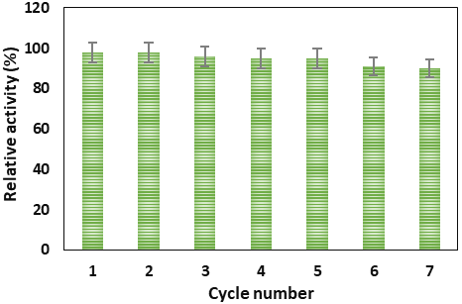
A
B

Fig. S1 (A) long-term stability and (b) recyclability of catalytic activity of Cu-MSN, respectively.

(1)

Table S1. Comparison of Kinetic parameters of Cu-MSN and other peroxidase-mimics
 | Enzyme mimics |  | k_{m}(mM) |  | V_{max}(mM.S⁻¹) |  | k_{cat}(S⁻¹) |  | k_{cat}/k_{m}(mM⁻¹.S⁻¹) |  |  |  | References
TMB | Cu-MSN |  | 0.1009 |  | 4.5×10⁻⁵ |  | 1.4×10⁻¹ |  |  | 1.72 | This work
TMB | HRP |  | 0.434 |  | 1×10⁻⁴ |  | 4×10³ |  |  | 9.21×10³ | [32]
TMB | Porous CuO |  | 0.14 |  | 1.45×10⁻⁵ |  | 2.12×10⁻⁶ |  |  | 1.5×10⁻⁵ | [33]
TMB | PtPd NPs |  | 1.78 |  | 3.46×10⁻⁴ |  | 1.42×10⁻² |  |  | 7.9×10⁻³ | [34]
TMB | Fe-MSN |  | 0.407 |  | 7.6×10⁻⁵ |  | 4.6×10⁻³ |  |  | 1.13×10⁻² | [35]
TMB | Ag nanowire |  | 108 |  | 2.84×10⁻⁶ |  | 6.35×10⁻⁵ |  |  | 5.87×10⁻³ | [36]
H₂O₂ | Cu-MSN |  | 0.0226 |  | 6.5×10⁻⁵ |  | 2×10⁻¹ |  |  | 1.08×10¹ | This work
H₂O₂ | HRP |  | 3.70 |  | 8.71×10⁻⁵ |  | 4×10³ |  |  | 9.4×10² | [32]
H₂O₂ | PtPd NPs |  | 0.053 |  | 9.26×10⁻⁵ |  | 3.6×10⁻³ |  |  | 6.7×10⁻² | [34]
H₂O₂ | Fe-MSN |  | 0.01 |  | 4.33×10⁻⁵ |  | 2.9×10⁻³ |  |  | 2.6×10⁻¹ | [35]
ABTS | Cu-MSN | 0.0854 |  | 2.9 ×10⁻⁴ |  | 9.2 |  |  |  | 1.07×10² |  | This work
ABTS | Pd@Fe₂O₃ | 0.049 |  | 1.02 ×10⁻⁴ |  | 7.5 ×10⁻² |  |  |  | 0.15×10¹ |  | [37]
ABTS | HRPª | 0.472 |  | 55 ×10⁻⁵ |  | 4.8 ×10³ |  |  |  | 1.01×10⁴ |  | [38]
ABTS | AuNPs | 0.033 |  | 8.1 ×10⁻⁶ |  | 5.67 |  |  |  | - |  | [38]
ABTS | Co-MSN | 0.07 |  | 33 ×10⁻⁵ |  | 1.62 ×10⁻² |  |  |  | 2.22 ×10⁻¹ |  | [39]
ABTS | Zn-CuO NPs | 0.01 |  | 2.87×10⁻⁵ |  | - |  |  |  | - |  | [40]
H₂O₂ | Cu-MSN | 0.0885 |  | 1.5×10¹ |  | 4.96×10² |  |  |  | 4.72×10³ |  | This work
H₂O₂ | Pd@Fe₂O₃ | 0.254 |  | 1.28×10⁻⁴ |  | 9.4×10⁻² |  |  |  | 3.7×10⁻¹ |  | [37]
H₂O₂ | Co-MSN | 0.34 |  | 13.2×10⁻⁵ |  | - |  |  |  | - |  | [39]
H₂O₂ | Zn-CuO | 0.071 |  | 0.3×10⁻⁵ |  | - |  | - |  |  |  | [40]
^{an} HRP: Horseradish peroxidase

(2)

Table S2. Detection of GSH amount in diverse human serum samples
Samples | Added (µM) | Found (µM) | Recovery (%) | RSD(%)
1 | 1 | 0.996±0.018 | 99.6 | 2.2
1 | 10 | 9.982±0.018 | 99.8 | 0.18
1 | 30 | 29.93±0.051 | 99.7 | 0.2
2 | 1 | 0.99±0.014 | 99 | 1.41
2 | 10 | 9.986±0.092 | 99.8 | 0.32
2 | 30 | 29.95±0.091 | 99.8 | 0.31
3 | 1 | 0.973±0.03 | 97.3 | 3.08
3 | 10 | 9.996±0.057 | 99.9 | 0.78
3 | 30 | 29.93±0.087 | 99.7 | 0.3

(3)

