Supplement

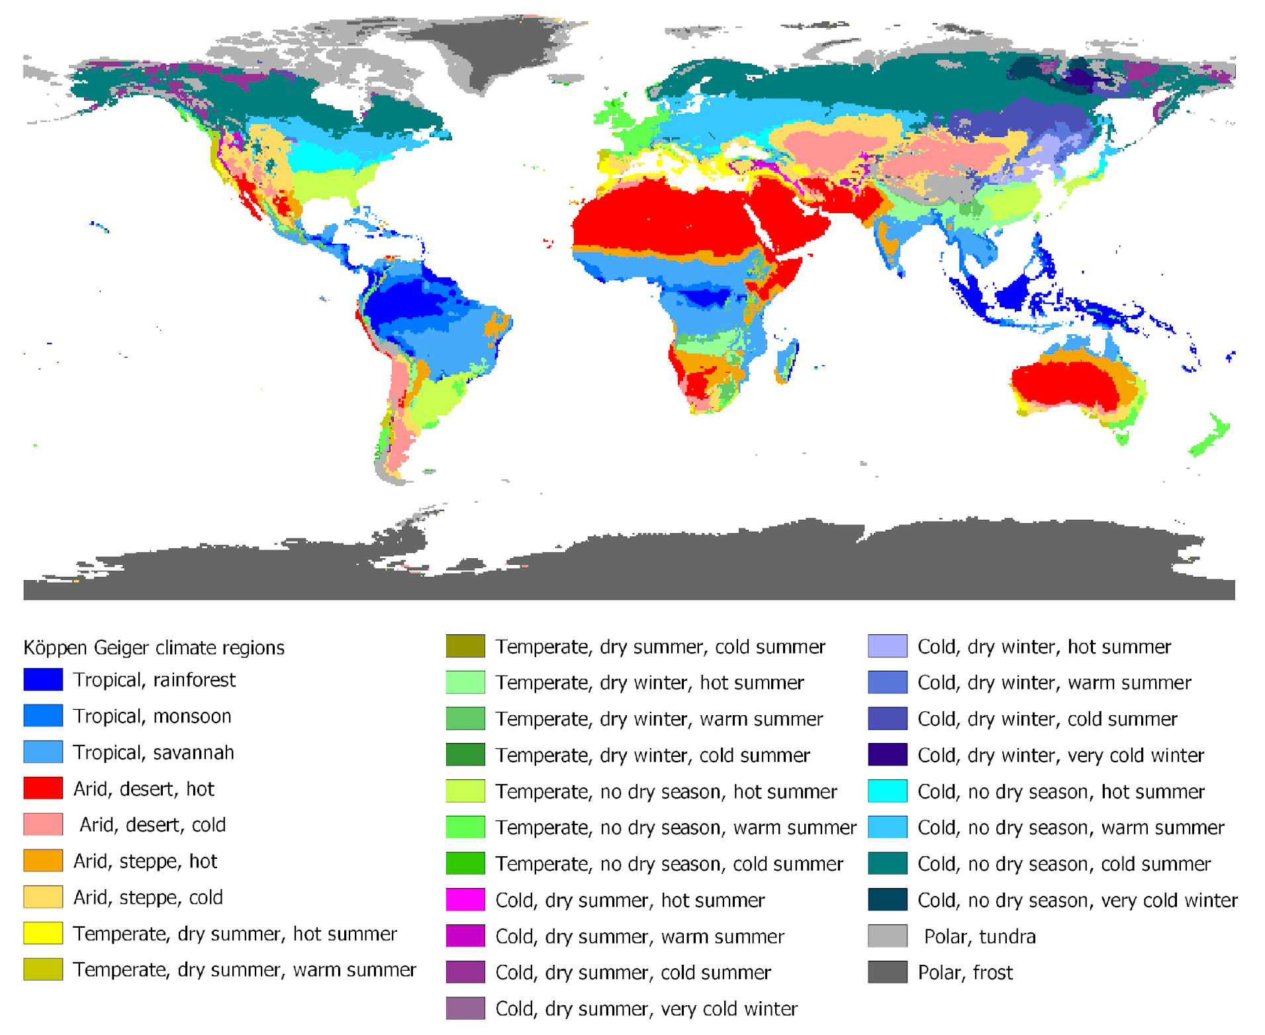
Figure S1: Map of the distribution of climatic zones based on the Köppen-Geiger classification for the period 1980-2016 (adapted from ⁴⁵).

Figure S2: Distribution of changes in a) temperature, b) precipitation and c) water balance between 1901-1920 and the reference period 2001-2020.

