Supplementary Material 1
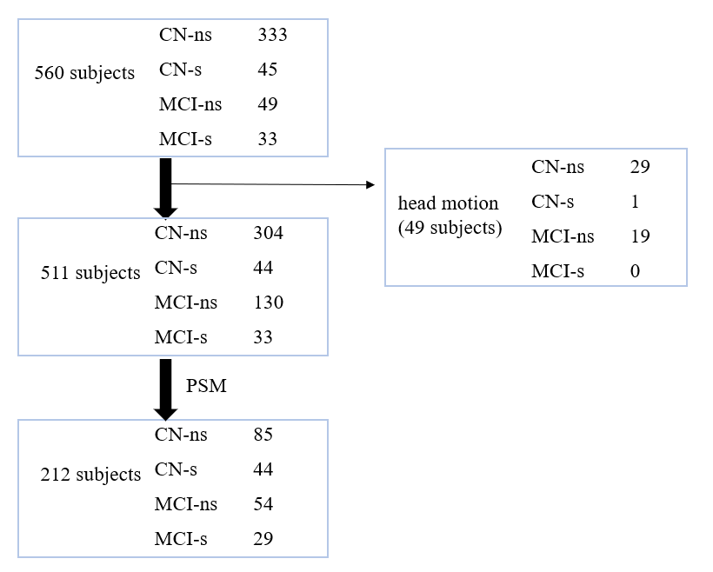
Figure 1. The screening processes of smoking subjects from the ADNI database before December 21st, 2020
We excluded 49 subjects due to head motion. Finally, 85 non-smoking CN, 44 smoking CN, 54 non-smoking MCI, and 29 smoking MCI entered subsequent analyses.
Abbreviations: CN: cognitive normal, MCI: mild cognitive impairment, ns: non-smoking, s: smoking, PSM: propensity score matching

Supplementary Material 2
Table 1. Standardized difference (d) before and after PSM in CN and MCI
 | Standardized difference (d) in CN |  |  | Standardized difference (d) in MCI
 | Before PSM | After PSM |  | Before PSM | After PSM
Age | 0.374 | -0.039 |  | 0.302 | 0.103
Male | 0.247 | -0.157 |  | 0.137 | -0.033
Education | -0.231 | -0.139 |  | -0.384 | -0.061
Abbreviations: PSM: propensity score matching, CN: cognitive normal, MCI: mild cognitive impairment

Supplementary Material 3
Table 2. Brain areas with significant LPI FC difference among non-smoking CN, smoking CN, non-smoking MCI and smoking MCI
Cluster size | Brain region | Peak MNI coordinates |  |  | peak-value
Cluster size | Brain region | x | y | z | peak-value
left posterior insula
102 | left precuneus | 0 | -57 | 21 | 15.82
37 | left cingulate gyrus | -3 | 12 | 45 | 12.94
Abbreviation: LPI: left posterior insula, FC: functional connectivity, CN: cognitive normal, MCI: mild cognitive impairment, MNI, Montreal Neurological Institute; X Y Z coordinates of the primary peak locations in the MNI space.
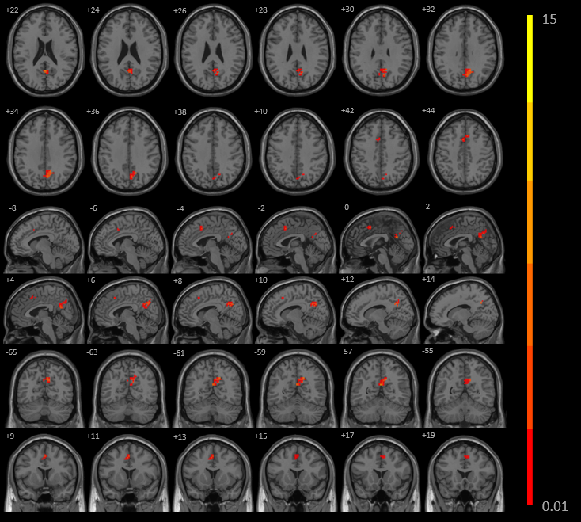
Figure 2. The significant interaction effects (smoking × cognitive state) identified between the LPI with LP and LCG among non-smoking CN, smoking CN, non-smoking MCI and smoking MCI
The figure shows the difference in the LPI FC after adjustment for age, sex, education, and gray matter volume in non-smoking CN, smoking CN, non-smoking MCI and smoking MCI after-PSM subjects. The four groups have significant interaction between left PI and left precuneus and cingulate gyrus (GRF corrected, p < 0.01 at height and p < 0.05 at cluster level).
Abbreviation: LPI: left posterior insula, LP: left precuneus, LCG: left cingulate gyrus, CN: cognitive normal, MCI: mild cognitive impairment
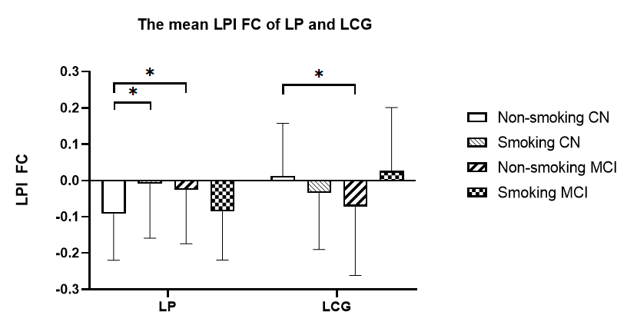
Figure 3. The mean LPI FC of the LP and LCG of the non-smoking CN, smoking CN, non-smoking MCI and smoking MCI
The figure shows the mean LPI FC of the LP and LCG L of the non-smoking CN, smoking CN, non-smoking MCI, and smoking MCI throughout the whole subjects. LPI FC with LP in the non-smoking CN was significantly lower than those in the smoking CN and non-smoking MCI (p < 0.05, Bonferroni correction). LPI FC with LCG in the non-smoking CN was significantly higher than in the non-smoking MCI (p < 0.05, Bonferroni correction).
Abbreviation: LPI: left posterior insula, FC: functional connectivity, LP: left precuneus, LCG: left cingulate gyrus, HC: healthy controls, MCI: mild cognitive impairment, * p < 0.05, Bonferroni correction.

Supplementary Material 4
Table 3. Demographic characteristics and neuropsychological scales of the 511 subjects
 | Non-smoking HC (n=304) | Smoking HC (n=44) | Non-smoking MCI (n=130) | Smoking MCI (n=33) | F/χ² Value | p-Value
Age | 72.98±7.25 | 75.83±7.64 | 74.33±7.87 | 76.61±7.54 | 4.09 | 0.007^{b}
Education | 16.88±2.33 | 16.27±92.60 | 16.71±2.54 | 15.79±2.40 | 2.56 | 0.05
Sex (F/M) | 183/121 | 21/23 | 56/74 | 12/21 | 15.62 | 0.001
MMSE | 29.14±1.08 | 29.25±0.81 | 28.33±1.62 | 27.70±1.76 | 22.97 | < 0.001^{abcd}
Visuo-spatial
CDT | 4.76±0.52 | 4.61±0.62 | 4.44±0.91 | 4.49±0.94 | 7.78 | < 0.001ª
Memory
IST | 14.64±3.61 | 15.23±3.36 | 10.62±4.30 | 11.64±4.76 | 38.55 | < 0.001^{abcd}
DST | 13.53±3.80 | 14.21±3.62 | 8.59±4.37 | 9.61±4.59 | 54.97 | < 0.001^{abcd}
AVLT | 46.97±10.10 | 45.11±10.99 | 37.45±10.34 | 37.70±11.37 | 27.12 | < 0.001^{abcd}
Language
SVF | 21.68±5.12 | 21.32±5.87 | 19.02±5.07 | 18.67±5.23 | 10.08 | < 0.001^{ab}
Attention
TMT-A | 31.30±9.51 | 29.84±6.70 | 36.15±13.05 | 37.76±12.91 | 9.96 | < 0.001^{abcd}
Execution
TMT-B | 74.85±34.90 | 70.50±27.24 | 96.23±51.98 | 110.39±64.58 | 14.21 | < 0.001^{abcd}
Data are presented as mean ± standard deviation. CN: cognitive normal, MCI: mild cognitive impairment, F: female, M: male, MMSE: Mini-Mental State Examination, CDT: clock drawing test, IST: immediate story retell, DST: delayed story retell, AVLT: auditory verbal learning test, SVF: semantic verbal fluency, TMT-A: Trail-Making Test, Part A, TMT-B: Trail-Making Test, Part B.
^{a-d} Post hoc paired comparison further revealed the source of ANOVA difference respectively (p < 0.05, after Bonferroni corrected) (ª non-smoking CN vs non-smoking MCI, ^{b} non-smoking CN vs smoking MCI, ^{c} smoking CN vs non-smoking MCI, ^{d} smoking CN vs smoking MCI).

Table 4. Brain areas with significant insula FC difference among non-smoking CN, smoking CN, non-smoking MCI and smoking MCI in 511 subjects
Cluster size | Brain region | Peak MNI coordinates |  |  | peak-value
Cluster size | Brain region | x | y | z | peak-value
right anterior insula
216 | right inferior parietal lobule | 51 | -45 | 21 | 28.57
60 | left middle temporal gyrus | -54 | -51 | 21 | 19.32
left anterior insula
45 | left angular gyrus | -57 | -60 | 27 | 15.12
right posterior insula
21 | right middle occipital gyri | 36 | -90 | 18 | 14.96
left posterior insula
18 | left temporal pole | -21 | 9 | -27 | 18.36
Abbreviation: FC: functional connectivity, CN: cognitive normal, MCI: mild cognitive impairment, MNI, Montreal Neurological Institute; X Y Z coordinates the primary peak locations in the MNI space.

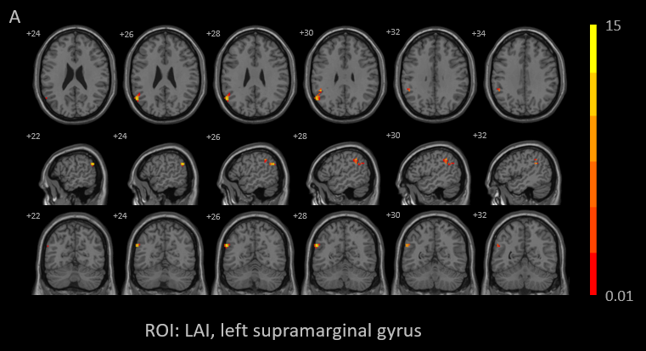
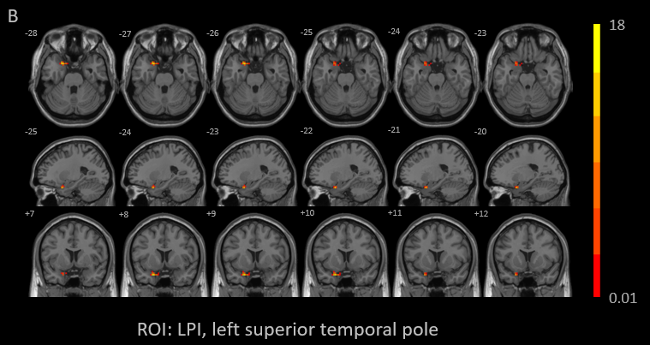
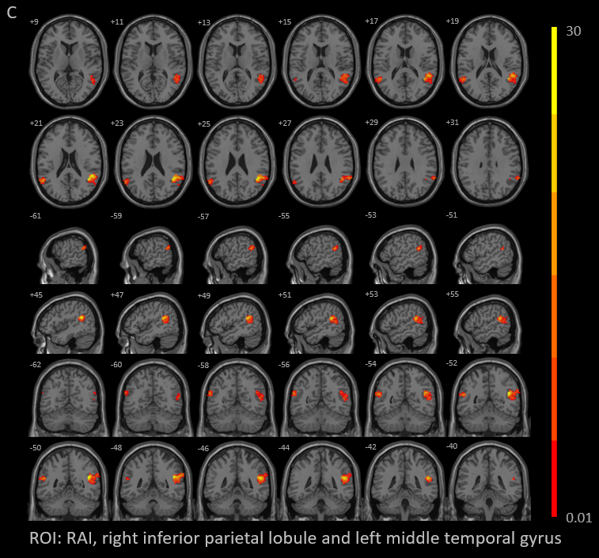
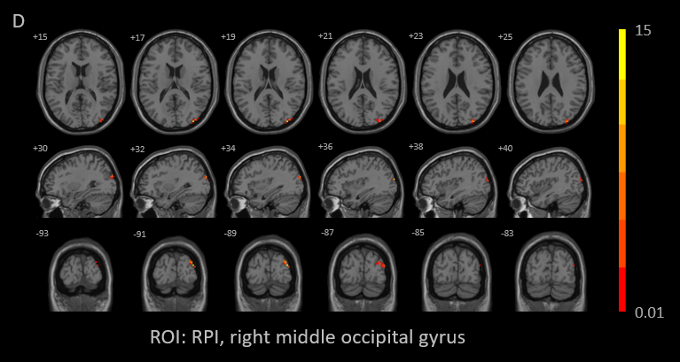
Figure 4. The significant interaction effects (smoking × cognitive state) identified among non-smoking CN, smoking CN, non-smoking MCI and smoking MCI in 511 subjects
The figure A-D respectively shows the difference in the insula FC among non-smoking CN, smoking CN, non-smoking MCI and smoking MCI in whole subjects. After correction for age, sex, education, and gray matter volume, we identified regions where the FC to the insula were significantly altered: A) between the LAI and left supramarginal gyrus (p < 0.01, cluster level < 0.05, GRF corrected); B) between the LPI and left superior temporal pole (p < 0.01, cluster level < 0.05, GRF corrected); C) between the RAI and right inferior parietal lobule and left middle temporal gyrus (p < 0.01, cluster level < 0.05, GRF corrected); D) between the RPI and right middle occipital gyrus (p < 0.01, cluster level < 0.05, GRF corrected)
Abbreviation: ROI: region-of-interest, LAI: left anterior insula, LPI: left posterior insula, RAI: right anterior insula, RPI: right posterior insula, CN: cognitive normal, MCI: mild cognitive impairment,

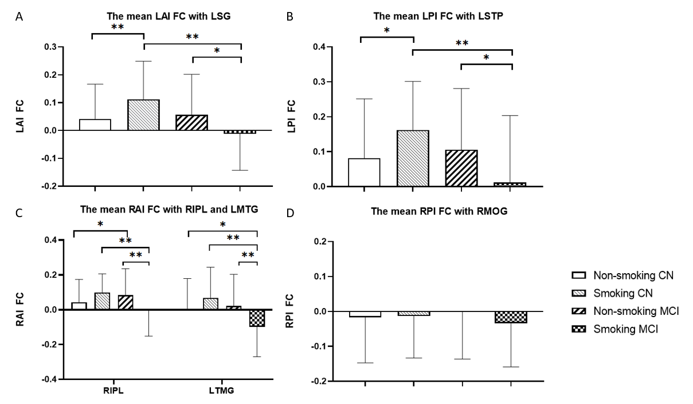
Figure 5. The mean insula FC of non-smoking CN, smoking CN, non-smoking MCI and smoking MCI
The figure A-D respectively shows the mean insula FC of non-smoking CN, smoking CN, non-smoking MCI and smoking MCI. A) and B) LAI-LSG FC and LPI-LSTP FC in the smoking MCI were significantly lower than those in the smoking CN (p < 0.01, Bonferroni correction) and non-smoking MCI (p < 0.05, Bonferroni correction). And insula FC in smoking CN were higher than that in the non-smoking CN both during LAI-LSG (p < 0.01, Bonferroni correction) and LPI-LSTP (p < 0.05, Bonferroni correction). C) RAI-RIPL FC in the non-smoking CN was significantly higher than that in the non-smoking MCI (p < 0.05, Bonferroni correction). RAI-LMTG in the non-smoking CN was significantly higher than that in the smoking MCI (p < 0.05, Bonferroni correction). And RAI-RIPL FC and RAI-LMTG FC in the smoking MCI were significantly lower than those in the smoking CN and non-smoking MCI (p < 0.01, Bonferroni correction).
Abbreviation: LAI: left anterior insula, FC: functional connectivity, LSG: left supramarginal gyrus, LPI: left posterior insula, LSTP: left superior temporal pole, RAI: right anterior insula, RIPL: right inferior parietal lobule, LMTG: left middle temporal gyrus, RPI: right posterior insula, RMOG: right middle occipital gyrus, CN: cognitive normal, MCI: mild cognitive impairment
* p < 0.05, Bonferroni correction, ** p < 0.01, Bonferroni correction

Supplementary Material 5
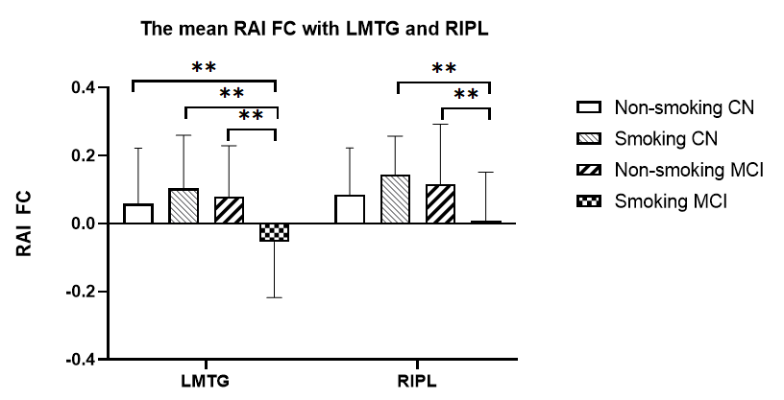
Figure 6. The mean RAI FC of the LMTG and RIPL of non-smoking CN group, smoking CN group, non-smoking MCI group and smoking MCI group
The figure shows the mean RAI FC of the LMTG and RIPL of non-smoking CN, smoking CN, non-smoking MCI and smoking MCI. RAI FC with LMTG in the non-smoking CN, smoking CN, and non-smoking MCI were significantly higher than that in the smoking MCI (p < 0.01, Bonferroni correction). RAI FC with RIPL in the smoking CN and non-smoking MCI were significantly higher than that in the smoking MCI (p < 0.01, Bonferroni correction).
Abbreviation: RAI: right anterior insula, FC: functional connectivity, LMTG: left middle temporal gyrus, RIPL: right inferior parietal lobule, CN: cognitive normal, MCI: mild cognitive impairment.
** p < 0.01, Bonferroni correction.

Supplementary Material 6
Table 5. Correlations between insula FC and neuropsychological scores
 | left middle temporal gyrus |  |  |  | right inferior parietal lobule
 | Non-smokers | Smokers | CN | MCI | Non-smokers | Smokers | CN | MCI
MMSE | -0.003 (0.97) | 0.11 (0.36) | -0.03 (0.79) | -0.09 (0.43) | -0.07 (0.41) | 0.29 (0.02 ª) | 0.03 (0.72) | -0.05 (0.66)
Visuo-spatial
CDT | -0.03 (0.76) | 0.02 (0.86) | -0.04 (0.66) | 0.004 (0.98) | -0.07 (0.41) | -0.08 (0.50) | -0.09 (0.31) | -0.14 (0.20)
Memory
IST | -0.11 (0.19) | 0.23 (0.05) | 0.05 (0.61) | -0.20 (0.08) | -0.16 (0.06) | 0.23 (0.05) | -0.05 (0.58) | -0.15 (0.19)
DST | -0.11 (0.18) | 0.20 (0.09) | -0.01 (0.92) | -0.24 (0.03 ª) | -0.19 (0.03 ª) | 0.30 (0.01 ª) | -0.07 (0.43) | -0.26 (0.02 ª)
AVLT | 0.01 (0.92) | 0.17 (0.16) | 0.14 (0.12) | -0.22 (0.049 ª) | -0.12 (0.18) | 0.26 (0.03 ª) | 0.004 (0.96) | -0.11 (0.33)
Language
SVF | -0.07 (0.41) | 0.23 (0.06) | 0.08 (0.39) | -0.05 (0.66) | -0.10 (0.24) | 0.26 (0.03 ª) | 0.012 (0.90) | -0.02 (0.87)
Attention
TMT-A | -0.02 (0.83) | -0.16 (0.18) | -0.07 (0.47) | -0.02 (0.86) | 0.02 (0.82) | -0.35 (0.003 ^{ab}) | -0.13 (0.16) | -0.05 (0.65)
Execution
TMT-B | -0.04 (0.67) | -0.22 (0.06) | -0.087 (0.34) | -0.09 (0.41) | 0.13 (0.15) | -0.45 (< 0.001 ^{ab}) | 0.02 (0.79) | -0.17 (0.13)
Abbreviation: FC: functional connectivity, CN: cognitive normal, MCI: mild cognitive impairment, MMSE: Mini-Mental State Examination, CDT: clock drawing test, IST: immediate story retell, DST: delayed story retell, AVLT: auditory verbal learning test, SVF: semantic verbal fluency, TMT-A: Trail-Making Test, Part A, TMT-B: Trail-Making Test, Part B.
ª p < 0.05, uncorrected, ^{b} p < 0.05/8, Bonferroni corrected.

