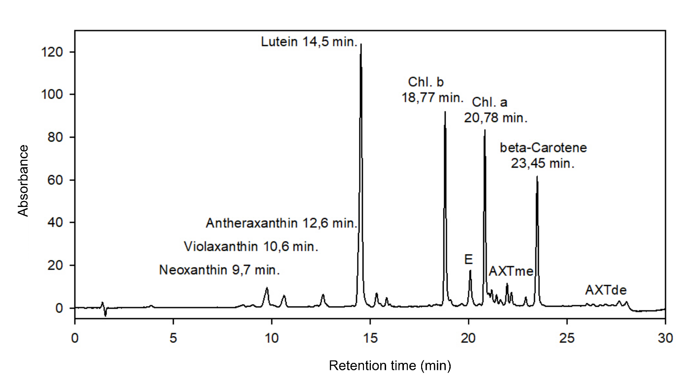
Supplementary Figure S4. HPLC analysis of Bracteacoccus bullatus CCALA 1120 at 450 nm (AXTme - astaxanthin monoesters, AXTde - astaxanthin diesters).

