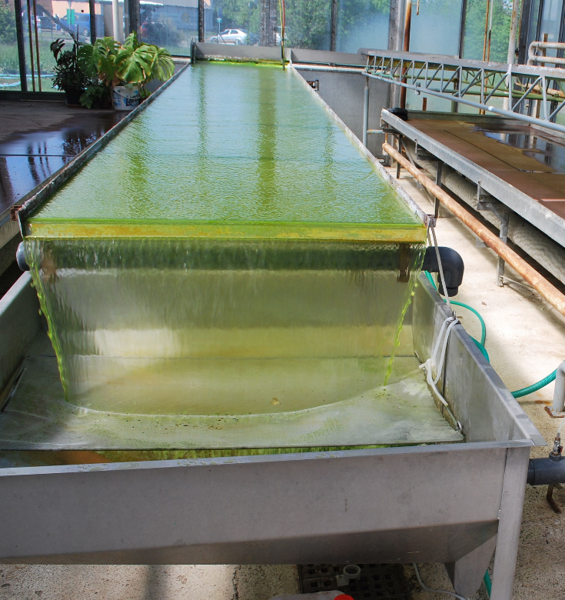
Supplementary Figure S1. Pilot-plant cultivation unit (a platform in a greenhouse) with Bracteacoccus bullatus CCALA 1120, area 12 m², volume 150 L, height of the suspension layer is about 10 mm.

