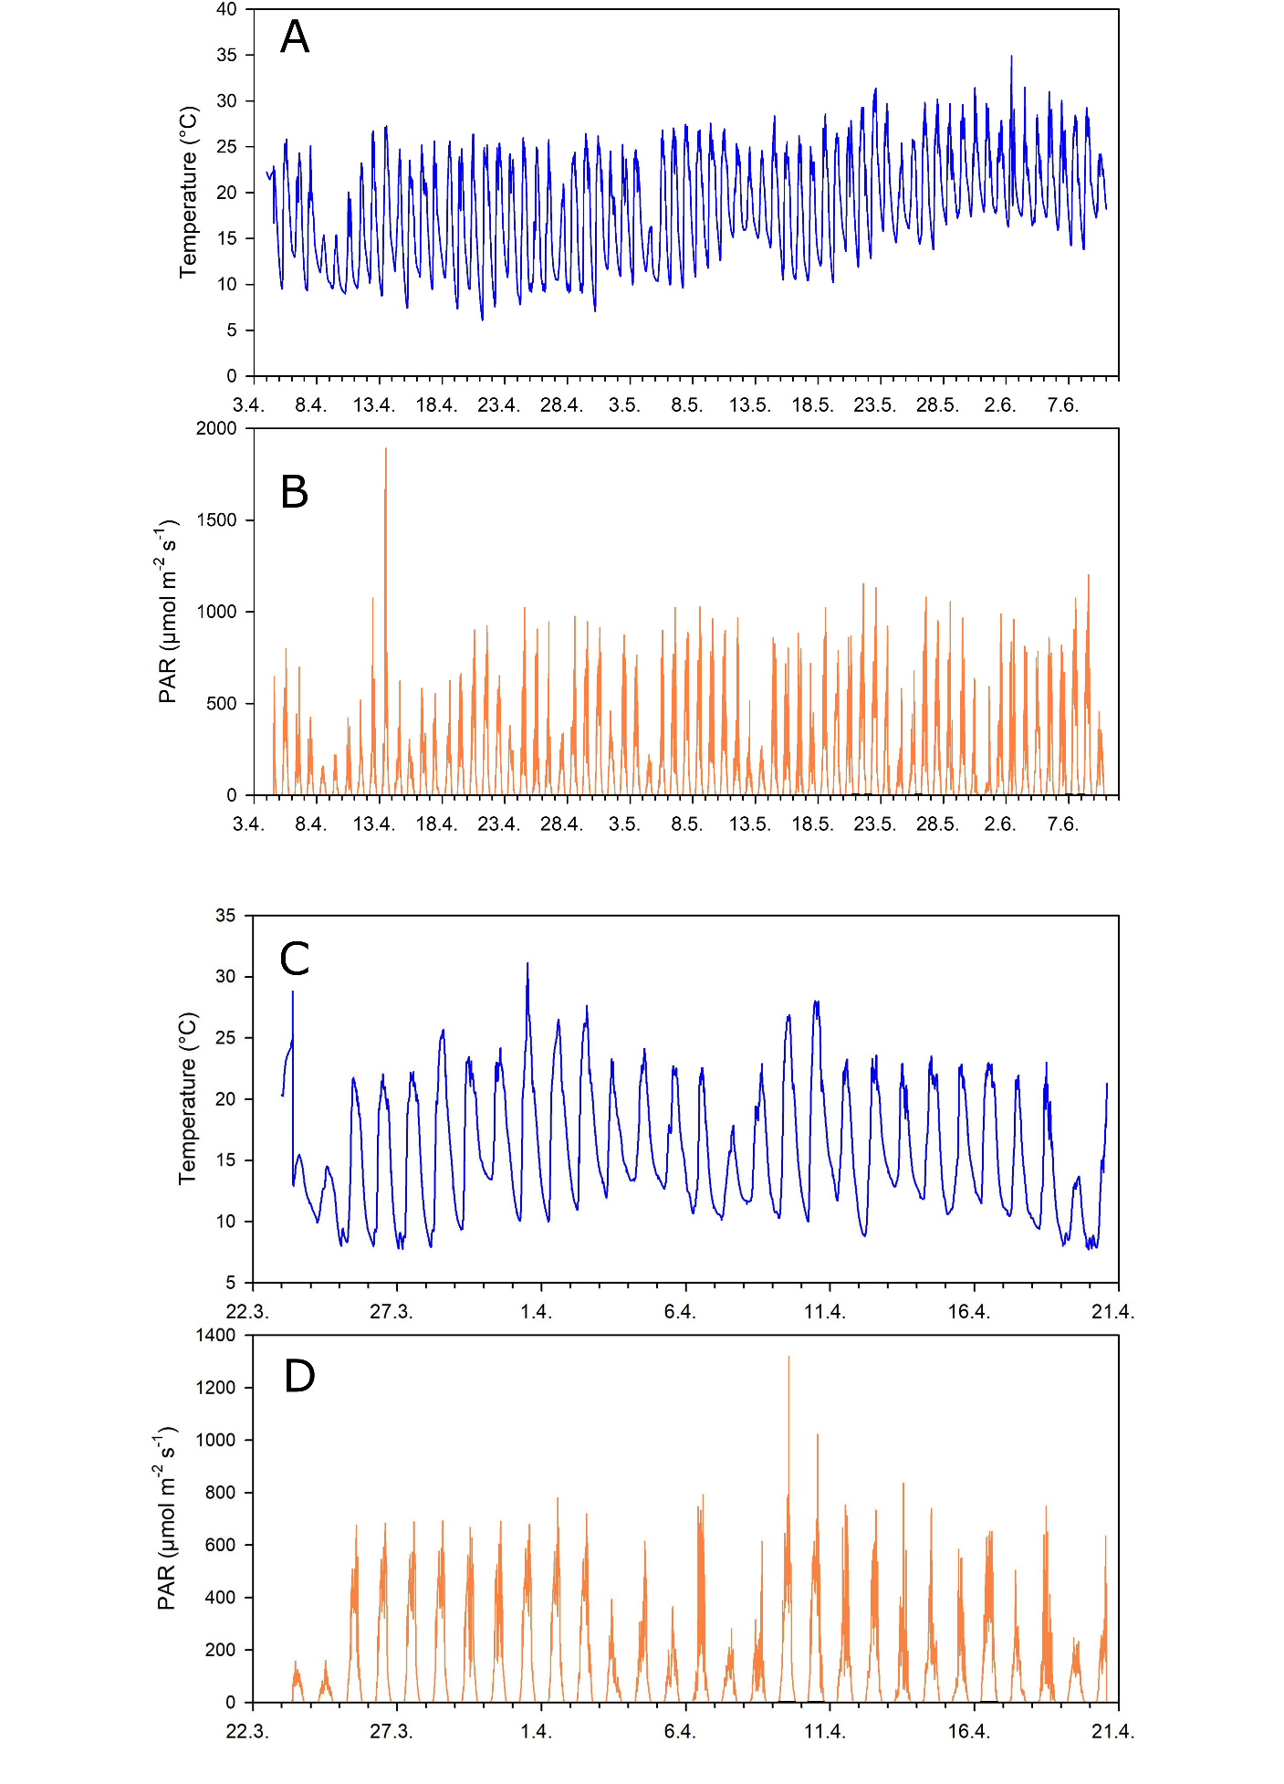
Supplementary Figure S3. Time course of (A, C) the temperature of the culture medium, (B, D) the PAR intensity in outdoor cultivation (greenhouse) on a platform. (A, B) The first cultivation April 4 – June 9 2016. (C, D) The second cultivation, March 23 – May 1 2017. A statistical summary of the data is included in Supplementary Table S2.

