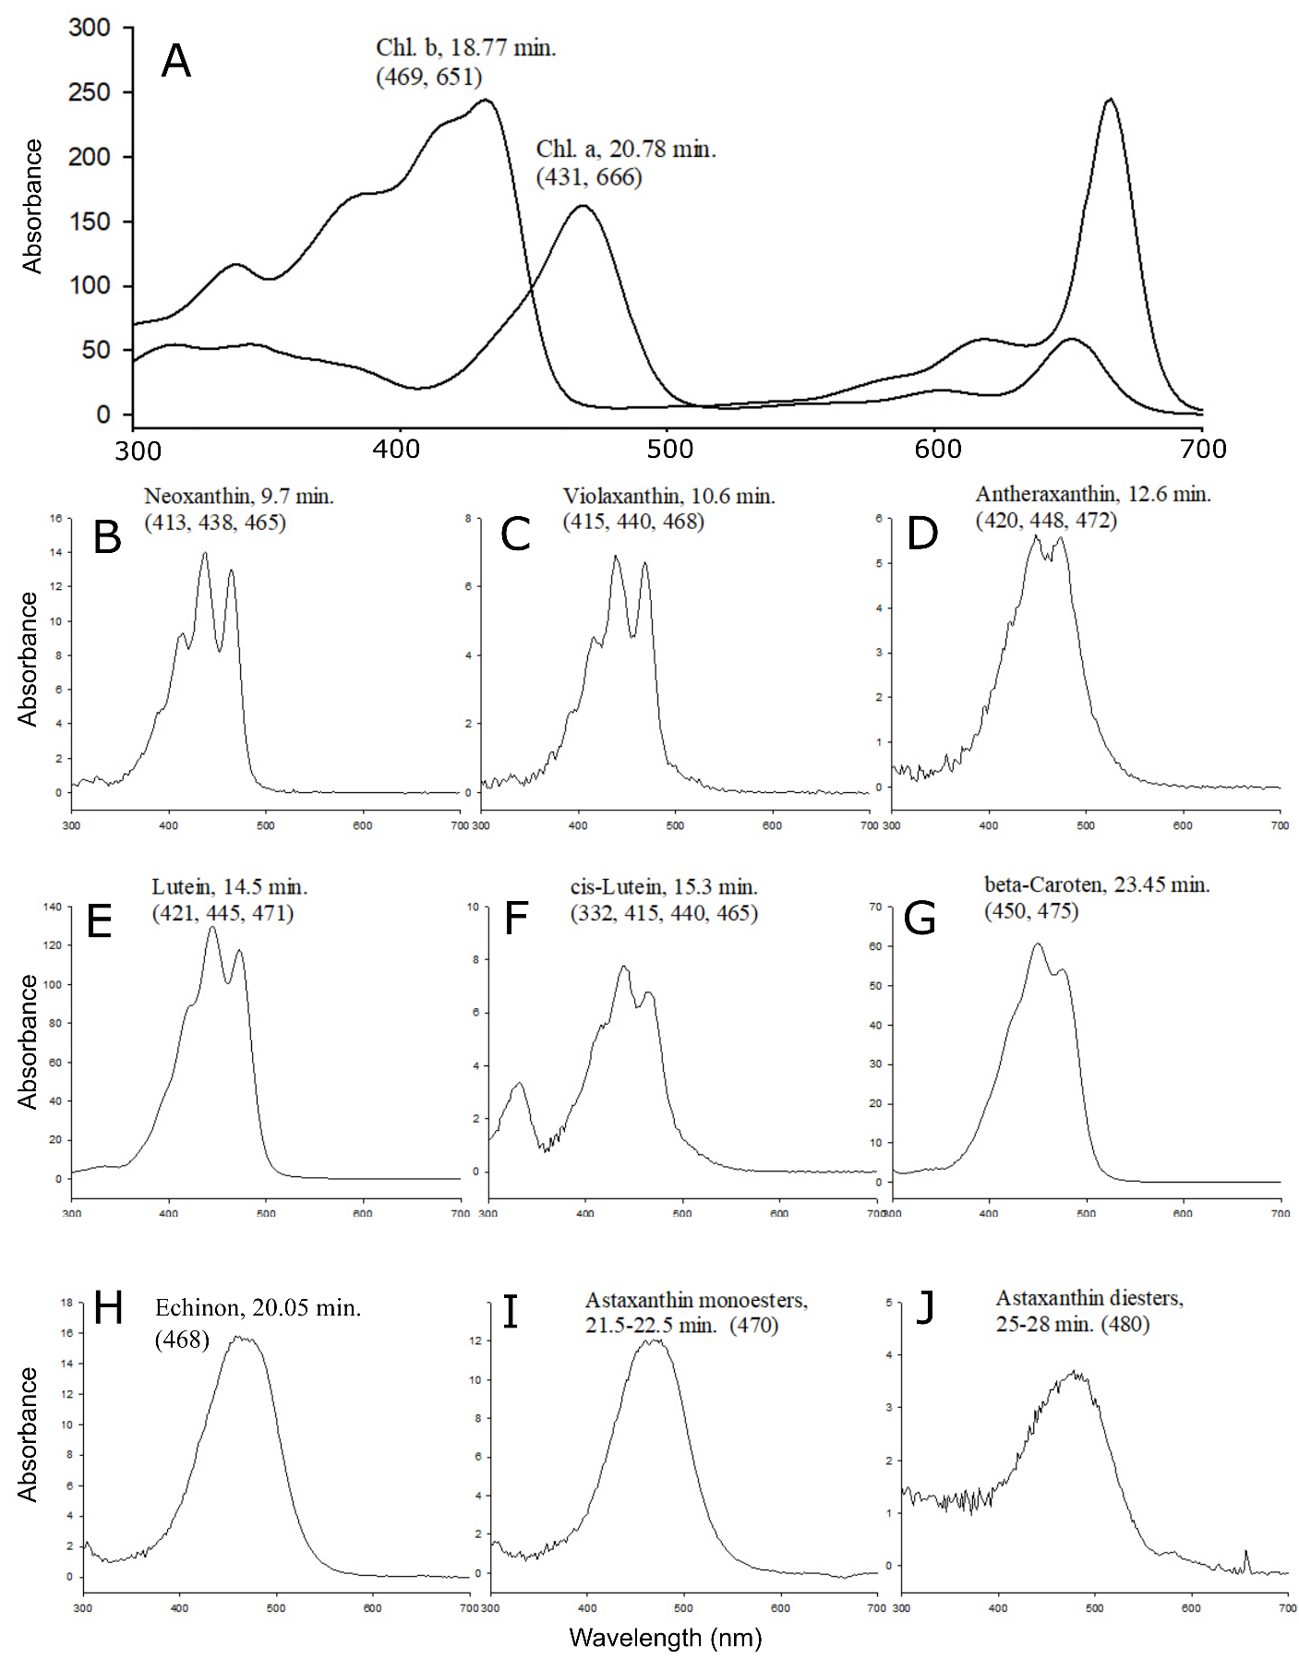
Supplementary Figure S5. Pigment spectra of Bracteacoccus bullatus CCALA 1120. (A) Chlorophyll a and b spectra. (B-D) Primary carotenoid pigments spectra. (E-I) Secondary carotenoid pigments spectra (astaxanthin monoester and diesters are marked as ATXme and ATXde, respectively, in the chromatogram shown in Supplementary Figure S4).

