AMB Express
Transcriptomic and enzymatic characteristics analysis reveals the roles of glutamate dehydrogenase in nitrogen metabolism of Corynebacterium glutamicum
Fanglan Ge¹*, Jingkun Sun^{1,2}*, Yao Ren¹, Jiao Li¹, Sen Yang¹, Wei Li¹**
College of life Sciences, Sichuan Normal University, Chengdu, 610068, P. R. China¹
Pingdingshan university, Pingdingshan, 467000, P. R. China ²
**These authors contributed equally to this work.
**Corresponding author, Wei Li, liwei001@sicnu.edu.cn

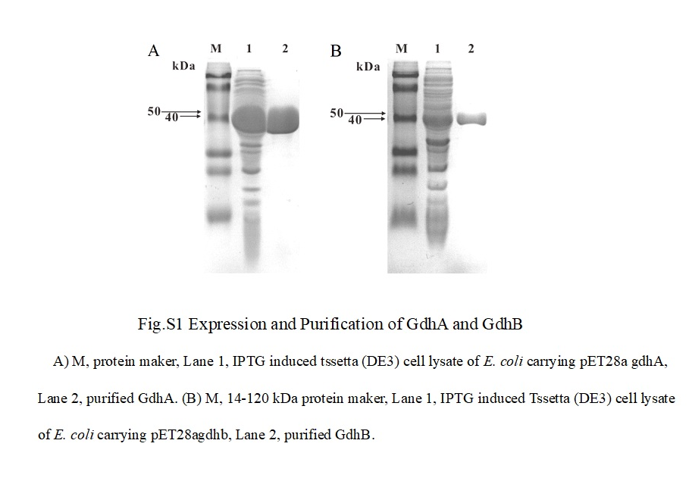

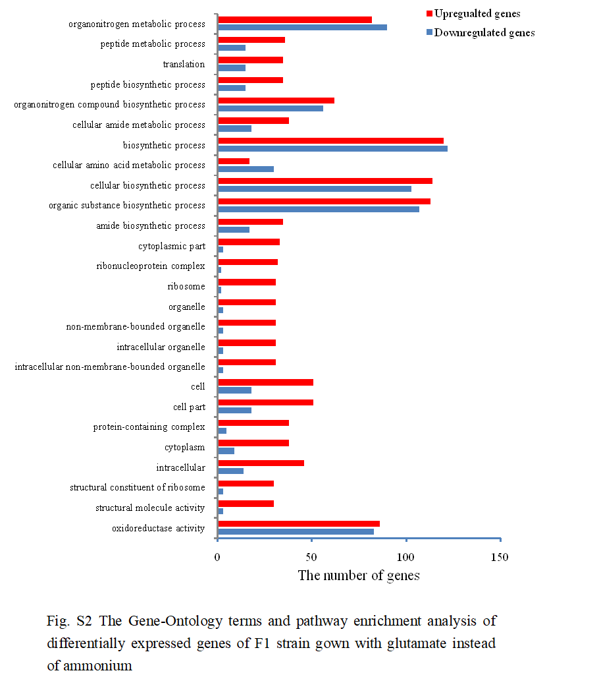

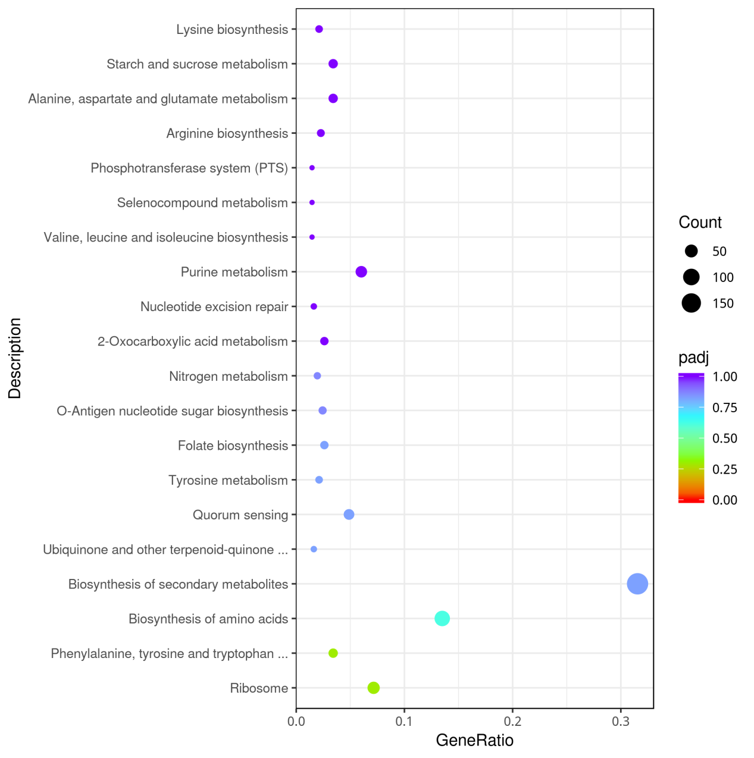

Fig.S3 The KEGG pathway analysis of differentially expressed genes of F1 strain gown with glutamate instead of ammonium

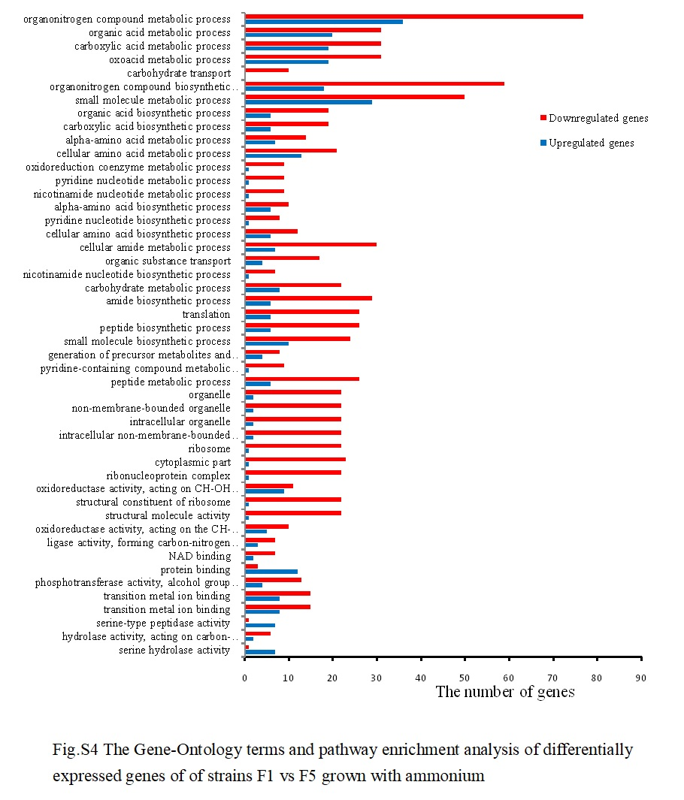

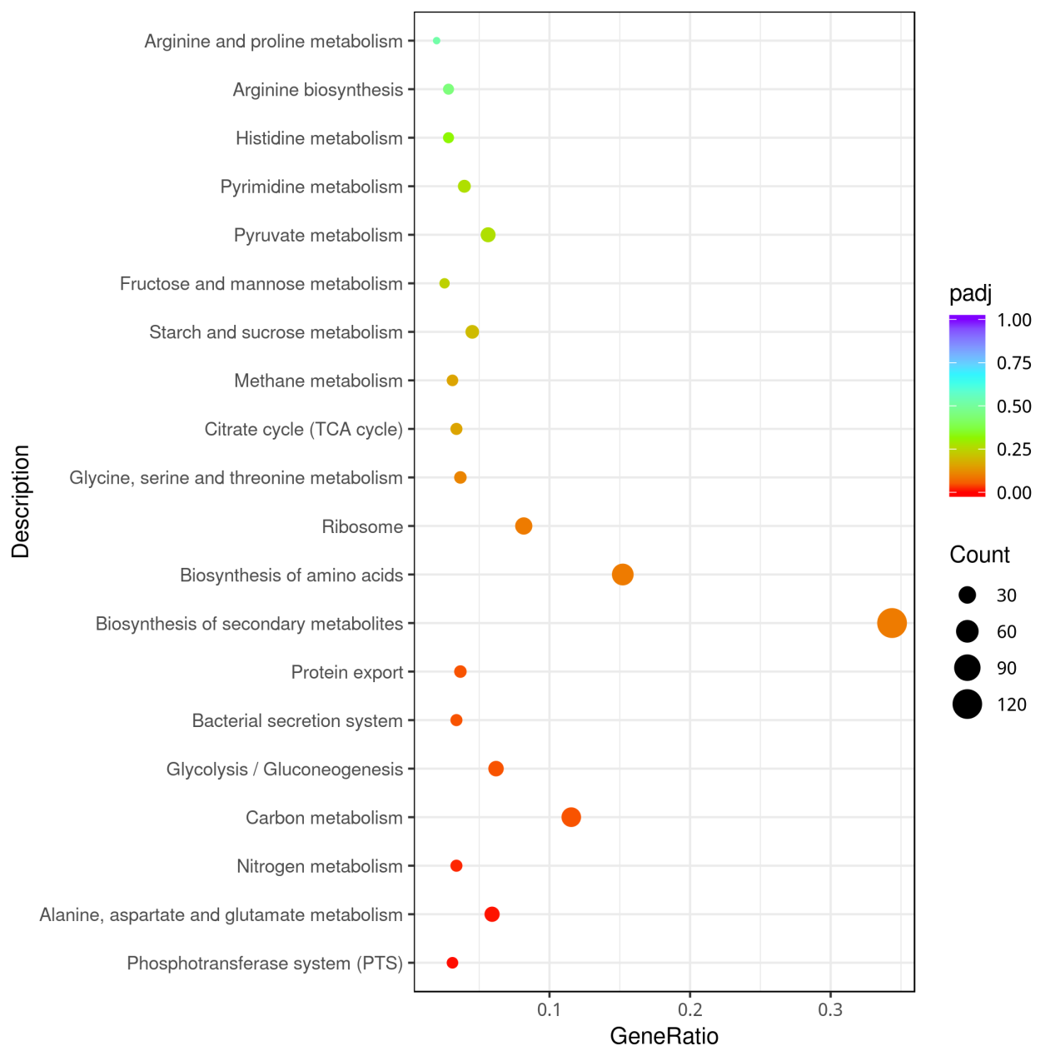

Fig.S5 The KEGG pathway analysis of differentially expressed genes of strains F5 vs F1 grown with ammonium

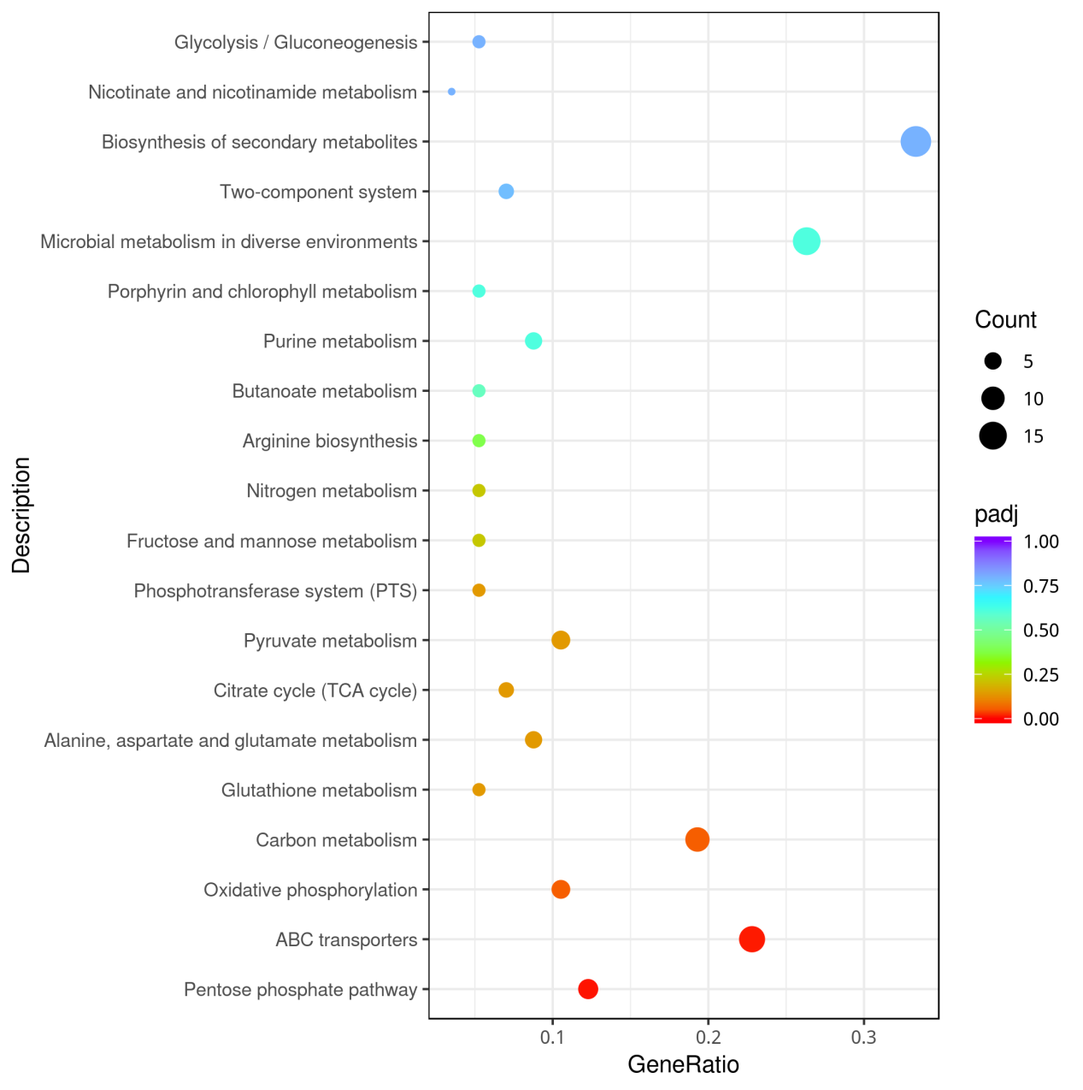

Table S1 The primers are designed in this paper
Primer name | Sequence(5'-3')
gdhA F | CGACATATGACAGTTGATGAGCAGGTCTCTAAC
gdhA R | CATGAATTCTTAGATGACGCCCTGTGCCAG
gdhB F | CAGCATATGTTCGAGCTAATCGACGACTGG
gdhB R | CACGAATTCTGTGTTATCGGCGAACCATACCTCTG
gdhB-up F | CTGGGATCCACTTGGCGCACACACTCTCCTTGC
gdhB-up R | ACTGTCGACTGTCGATGACAAGTACGCCACGCATCC
gdhB-dw F | ATGGTCGACACCTCTGAATCTGACCTGACCAGC
gdhB-dwR | GTCAAGCTTAGTCATCATTGGAGGCATGGTCGCGC
gltBup-F | ACTCCCGGGCCGGAGCAGGTCTTTGATGGCAGTTG
gltBup-R | TGCTCTAGACCATCGCCAGTGTTCTTCTCTGCACC
gltBdown-F | TGCTCTAGACCACGGTTGTGAGTACATGACTGGC
gltBdown-R | GACAAGCTTGACTGATTCTGCACCTTGGCGCAGTG
CheckgdhB F | ACTGCGCTTGCCCTGATCTGTGGCG
Chec gdhB R | TCTGGCGCGCATAGCTGCAAGAACT
CheckgltB F | AAGCATCATCGTTTGGGGTTGGAGG
CheckgltB R | GCTCATCAGCCCATGTCAGATCGTC
Note: The underlined parts in the table are restriction sites.

Table S2 RNA-Sequencing read mapping. L-glutamate (LG) and ammonium sulfate (S) correspond to two different conditions: 50 mL minimal medium plus with 150 mM ammonium sulfate, 70mMl L-glutamate, respectively.

Sample name | Total reads | Total mapped | Multiple mapped | Uniquely mapped
F_LG1 | 7458972 | 7346926 (98.5%) | 136194 (1.83%) | 7210732 (96.67%)
F_LG2 | 7655750 | 7520441 (98.23%) | 148897 (1.94%) | 7371544 (96.29%)
F_LG3 | 7527264 | 7411139 (98.46%) | 143210 (1.9%) | 7267929 (96.55%)
FQAB_S1 | 8477954 | 8396661 (99.04%) | 162301 (1.91%) | 8234360 (97.13%)
FQAB_S2 | 7591890 | 7511266 (98.94%) | 138713 (1.83%) | 7372553 (97.11%)
FQAB_S3 | 7638924 | 7557299 (98.93%) | 161206 (2.11%) | 7396093 (96.82%)
FQB_S1 | 8652742 | 8564639 (98.98%) | 153348 (1.77%) | 8411291 (97.21%)
FQB_S2 | 7788252 | 7704029 (98.92%) | 152998 (1.96%) | 7551031 (96.95%)
FQB_S3 | 7395054 | 7312795 (98.89%) | 143773 (1.94%) | 7169022 (96.94%)
F_S1 | 8208712 | 8129097 (99.03%) | 150269 (1.83%) | 7978828 (97.2%)
F_S2 | 8190028 | 8098446 (98.88%) | 152294 (1.86%) | 7946152 (97.02%)
F_S3 | 7583692 | 7494193 (98.82%) | 164006 (2.16%) | 7330187 (96.66%)

Note: F_LG1、F_LG2、F_LG3 refer to three biological repetitions of the C.glutamicum strain F343 grown with glutamate; F_S1、F_S2、F_S3 refer to the C.glutamicum strain F343 grown with ammonium; FQB_S1、FQB_S2、FQB_S3 are the strain gdhB deletion mutants grown with ammonium; FQAB_S1、FQAB_S2、FQAB_S3 are the strain gdhAgdhB double deletion mutants grown with ammonium;

Table S3 The differentially expressed genes involved in metabolism by comparative transcriptomic analysis of strains F3 vs F1

Gene ID | Gene name | Annotaion | FQB_S  RPKM | F_S  RPKM | Log2FoldChange
Genes in the pentose phosphate pathway
C629_RS12390 | gnk | gluconokinase | 47.94 | 17.962 | 1.41
C629_RS08140 | gndA | 6-phosphogluconate dehydrogenase | 8857.94 | 6237.22 | 0.51
C629_RS08735 | zwf | glucose-6-phosphate 1-dehydrogenase | 1063.92 | 590.12 | 0.85
C629_RS08725 | tkt | transketolase | 3175.62 | 2082.42 | 0.61
C629_RS11985 | rpi | ribose 5-phosphate isomerase B | 1124.01 | 544.87 | 1.04
C629_RS07705 | rbsK1 | ribokinase | 432.404 | 187.91 | 1.20
Genes involved in the oxidative phosphorylation
C629_RS06615 | cydA | cytochrome oxidase subunit I | 869.57 | 318.77 | 1.45
C629_RS06610 | cydB | cytochrome oxidase subunit II | 405.76 | 142.92 | 1.51
C629_RS08720 | ctaB | heme o synthase | 346.99 | 148.83 | 1.22
C629_RS08705 | ctaA | heme a synthase | 1140.85 | 621.15 | 0.88
C629_RS02270 | sdhA | succinate dehydrogenase A | 1173.06 | 768.89 | 0.61
C629_RS02275 | sdhB | succinate dehydrogenase B | 523.31 | 302.97 | 0.79
Genes involved in heavy metal resistance
C629_RS00610 | - | multicopper oxidase | 0 | 112.12 | -9.28
C629_RS00615 | - | metal-binding protein | 0 | 61.75 | -8.42
C629_RS00620 | - | response regulator factor | 0 | 422.46 | -11.20
C629_RS00625 | - | histidine kinase | 0 | 322.52 | -10.81
C629_RS00630 | - | heavy-metal-associated domain-containing protein | 0 | 69.14 | -8.59
C629_RS00635 | - | copper-translocating P-type ATPase | 0 | 695.34 | -10.95
C629_RS00640 | - | YdhK family protein | 0 | 273.72 | -10.57
C629_RS00645 | - | Lrp ligand binding domain-containing protein | 0 | 12.12 | -6.077
C629_RS00655 | - | hypothetical protein | 0 | 21.048 | -6.87
C629_RS00665 | - | hypothetical protein | 0 | 42.94 | -7.90
C629_RS00670 | - | recombinase family protein | 0 | 74.42 | -8.69
C629_RS00675 | - | metalloregulator ArsR transcription factor | 0 | 102.99 | -9.16
C629_RS00680 | - | cadmium resistance transporter | 0 | 149.33 | -9.709
C629_RS00685 | merA | mercury(II) reductase | 0 | 76.17 | -8.73
C629_RS00690 | - | heavy metal-responsive transcriptional regulator | 0 | 62.84 | -8.45
C629_RS00700 | - | helix-turn-helix transcriptional regulator | 0 | 412.70 | -11.16
C629_RS00705 | - | aldo/keto reductase | 0 | 325.62 | -10.82
C629_RS00710 | - | hypothetical protein | 0 | 169.55 | -9.88
C629_RS00715 | - | AAA family ATPase | 0 | 29.42 | -7.35
C629_RS00720 | mcrC | 5-methylcytosine-specific restriction endonuclease | 0 | 34.28 | -7.57

