SUPPLEMENTARY INFORMATION
Table S1. Partial least square (PLS) accuracy measured as correlation between observed and predicted values (ρ), and normalized Root Mean Squared Error (NRMSE) with their respective standard errors (SE) for genomic prediction of 40mm or less tuber weight considering single trait PLS (ST-PLS)- and multi-trait PLS (MT-PLS) for each location within each year and across environments considering five-fold random cross-validations (5FCV) and leaving one environment out (LOEO). The largest ρ in bold font.
Environ ^{z} |  | ρ |  | S.E. | NRMSE | S.E. | ρ | S.E. | NRMSE | S.E.
 |  |  | ST-PLS |  |  |  | MT-PLS
5FCV | H20 | 0.8016 |  | 0.0316 | 0.7458 | 0.0983 | 0.7629 | 0.0338 | 0.7471 | 0.0719
5FCV | H21 | 0.6421 |  | 0.0496 | 1.0508 | 0.0615 | 0.6088 | 0.0342 | 1.0706 | 0.0501
5FCV | M20 | 0.7010 |  | 0.0427 | 0.7160 | 0.0437 | 0.7045 | 0.0525 | 0.7101 | 0.0531
5FCV | M21 | 0.7125 |  | 0.0258 | 0.8263 | 0.0377 | 0.7422 | 0.0110 | 0.7872 | 0.0389
5FCV | U20 | 0.6589 |  | 0.0278 | 0.7763 | 0.0152 | 0.6512 | 0.0149 | 0.7855 | 0.0228
5FCV | U21 | 0.5878 |  | 0.0386 | 0.8045 | 0.0261 | 0.6073 | 0.0443 | 0.7984 | 0.0339
5FCV | Across | 0.7697 |  | 0.0067 | 0.6427 | 0.0100 | 0.7820 | 0.0109 | 0.6321 | 0.0181
LOEO | H20 | 0.7509 |  | − | 0.9255 | − | 0.7653 | − | 0.8612 | −
LOEO | H21 | 0.6103 |  | − | 2.1682 | − | 0.5988 | − | 2.1032 | −
LOEO | M20 | 0.7014 |  | − | 0.7401 | − | 0.7218 | − | 0.7341 | −
LOEO | M21 | 0.7064 |  | − | 1.6436 | − | 0.743 | − | 1.6645 | −
LOEO | U20 | 0.6773 |  | − | 1.1035 | − | 0.6700 | − | 1.1202 | −
LOEO | U21 | 0.6096 |  | − | 1.2049 | − | 0.6612 | − | 1.1952 | −
LOEO | Across | 0.6760 |  | 0.0230 | 1.2976 | 0.2140 | 0.6933 | 0.0251 | 1.2797 | 0.2107
^{z} H = Helgegården, M = Mosslunda, U = Umeå; 20 = Year 2020, 21 = Year 2021, Global = across six environments

Table S2. Partial least square (PLS) accuracy measured as correlation between observed and predicted values (ρ), and normalized Root Mean Squared Error (NRMSE) with their respective standard errors (SE) for genomic prediction of 40−50mm of tuber weight considering single trait PLS (ST-PLS)- and multi-trait PLS (MT-PLS) for each location within each year and across environments considering five-fold random cross-validations (5FCV) and leaving one environment out (LOEO). The largest ρ in bold font.
Environ ^{z} |  | ρ |  | S.E. | NRMSE | S.E. | ρ | S.E. | NRMSE | S.E.
 |  |  | ST-PLS |  |  |  | MT-PLS
5FCV | H20 | 0.6008 |  | 0.0854 | 0.7915 | 0.0533 | 0.6710 | 0.0253 | 0.7569 | 0.0205
5FCV | H21 | 0.5008 |  | 0.0300 | 0.8922 | 0.0247 | 0.5135 | 0.0524 | 0.9035 | 0.0392
5FCV | M20 | 0.5085 |  | 0.0513 | 0.8879 | 0.0492 | 0.4504 | 0.0462 | 0.9078 | 0.0317
5FCV | M21 | 0.5521 |  | 0.0560 | 0.8382 | 0.0360 | 0.5328 | 0.0602 | 0.8574 | 0.0495
5FCV | U20 | 0.3969 |  | 0.0310 | 0.9490 | 0.0165 | 0.4730 | 0.0255 | 0.8973 | 0.0196
5FCV | U21 | 0.3488 |  | 0.0631 | 0.9580 | 0.0370 | 0.4268 | 0.0587 | 0.9137 | 0.0395
5FCV | Across | 0.6098 |  | 0.0146 | 0.8017 | 0.0096 | 0.6387 | 0.0055 | 0.7804 | 0.0066
LOEO | H20 | 0.5327 |  | − | 0.8935 | − | 0.5088 | − | 0.9082 | −
LOEO | H21 | 0.3973 |  | − | 1.3075 | − | 0.3316 | − | 1.3394 | −
LOEO | M20 | 0.5460 |  | − | 0.8421 | − | 0.5514 | − | 0.8356 | −
LOEO | M21 | 0.6028 |  | − | 1.1614 | − | 0.5992 | − | 1.1556 | −
LOEO | U20 | 0.3191 |  | − | 1.0716 | − | 0.3586 | − | 1.0432 | −
LOEO | U21 | 0.2490 |  | − | 1.1900 | − | 0.3163 | − | 1.1606 | −
LOEO | Across | 0.4412 |  | 0.0575 | 1.0777 | 0.0735 | 0.4443 | 0.0504 | 1.0738 | 0.0752
^{z} H = Helgegården, M = Mosslunda, U = Umeå; 20 = Year 2020, 21 = Year 2021, Global = across six environments

Table S3. Partial least square (PLS) accuracy measured as correlation between observed and predicted values (ρ), and normalized Root Mean Squared Error (NRMSE) with their respective standard errors (SE) for genomic prediction of 50−60mm of tuber weight considering single trait PLS (ST-PLS)- and multi-trait PLS (MT-PLS) for each location within each year and across environments considering five-fold random cross-validations (5FCV) and leaving one environment out (LOEO). The largest ρ in bold font.
Environ ^{z} |  | ρ |  | S.E. | NRMSE | S.E. | ρ | S.E. | NRMSE | S.E.
 |  |  | ST-PLS |  |  |  | MT-PLS
5FCV | H20 | 0.5665 |  | 0.0579 | 0.8309 | 0.0452 | 0.5916 | 0.0778 | 0.8015 | 0.0491
5FCV | H21 | 0.1370 |  | 0.0746 | 1.0514 | 0.0331 | 0.3015 | 0.0300 | 0.9934 | 0.0362
5FCV | M20 | 0.5194 |  | 0.0440 | 0.8526 | 0.0222 | 0.5310 | 0.0284 | 0.8514 | 0.0180
5FCV | M21 | 0.5450 |  | 0.0527 | 0.8612 | 0.0490 | 0.6160 | 0.0471 | 0.8021 | 0.0495
5FCV | U20 | 0.5648 |  | 0.0484 | 0.8524 | 0.0416 | 0.5978 | 0.0499 | 0.8209 | 0.0455
5FCV | U21 | 0.5303 |  | 0.0367 | 0.8855 | 0.0390 | 0.5351 | 0.0345 | 0.8884 | 0.0266
5FCV | Across | 0.6455 |  | 0.0073 | 0.7754 | 0.0088 | 0.6887 | 0.0109 | 0.7334 | 0.0127
LOEO | H20 | 0.6489 |  | − | 1.1860 |  | 0.6691 |  | 1.1876 | −
LOEO | H21 | - 0.1437 |  | − | 1.4793 | − | - 0.0624 | − | 1.4475 | −
LOEO | M20 | 0.4349 |  | − | 0.9074 | − | 0.5043 | − | 0.8719 | −
LOEO | M21 | 0.5822 |  | − | 0.9196 | − | 0.6054 | − | 0.8958 | −
LOEO | U20 | 0.5271 |  | − | 1.2528 | − | 0.5134 | − | 1.2626 | −
LOEO | U21 | 0.4964 |  | − | 1.2338 | − | 0.4908 | − | 1.2180 | −
LOEO | Across | 0.4243 |  | 0.1174 | 1.1631 | 0.0891 | 0.4534 | 0.1070 | 1.1472 | 0.0911
^{z} H = Helgegården, M = Mosslunda, U = Umeå; 20 = Year 2020, 21 = Year 2021, Global = across six environments

Table S4. Partial least square (PLS) accuracy measured as correlation between observed and predicted values (ρ), and normalized Root Mean Squared Error (NRMSE) with their respective standard errors (SE) for genomic prediction of higher than 60mm of tuber weight considering single trait PLS (ST-PLS)- and multi-trait PLS (MT-PLS) for each location within each year and across environments considering five-fold random cross-validations (5FCV) and leaving one environment out (LOEO). The largest ρ in bold font.
Environ ^{z} |  | ρ |  | S.E. | NRMSE | S.E. | ρ | S.E. | NRMSE | S.E.
 |  |  | ST-PLS |  |  |  | MT-PLS
5FCV | H20 | 0.7964 |  | 0.0247 | 0.6062 | 0.0323 | 0.8167 | 0.0218 | 0.5892 | 0.0319
5FCV | H21 | 0.6783 |  | 0.0303 | 0.7585 | 0.0242 | 0.6673 | 0.0308 | 0.7548 | 0.0223
5FCV | M20 | 0.6463 |  | 0.0566 | 0.7503 | 0.0491 | 0.6795 | 0.0413 | 0.7287 | 0.0366
5FCV | M21 | 0.7388 |  | 0.0083 | 0.7013 | 0.0118 | 0.7422 | 0.0098 | 0.6892 | 0.0096
5FCV | U20 | 0.6727 |  | 0.0427 | 1.2380 | 0.0671 | 0.6507 | 0.0441 | 1.1034 | 0.0882
5FCV | U21 | 0.4962 |  | 0.0725 | 1.5174 | 0.1629 | 0.5103 | 0.0615 | 1.3637 | 0.1609
5FCV | Across | 0.7985 |  | 0.0141 | 0.6100 | 0.0169 | 0.8142 | 0.0111 | 0.5876 | 0.0123
LOEO  LOEO | H20 | 0.7938 |  | − | 0.6496 | − | 0.8205 | − | 0.6436 | −
LOEO  LOEO | H21 | 0.6310 |  | − | 1.5324 | − | 0.6370 | − | 1.5324 | −
LOEO  LOEO | M20 | 0.6503 |  | − | 0.7933 | − | 0.6626 | − | 0.7901 | −
LOEO  LOEO | M21 | 0.7661 |  | − | 0.8432 | − | 0.7997 | − | 0.8006 | −
LOEO  LOEO | U20 | 0.6814 |  | − | 2.8190 | − | 0.6973 | − | 2.7634 | −
LOEO  LOEO | U21 | 0.5124 |  | − | 2.9855 | − | 0.5639 | − | 2.9119 | −
LOEO  LOEO | Across | 0.6725 |  | 0.0414 | 1.6038 | 0.4296 | 0.6968 | 0.0401 | 1.5737 | 0.4197

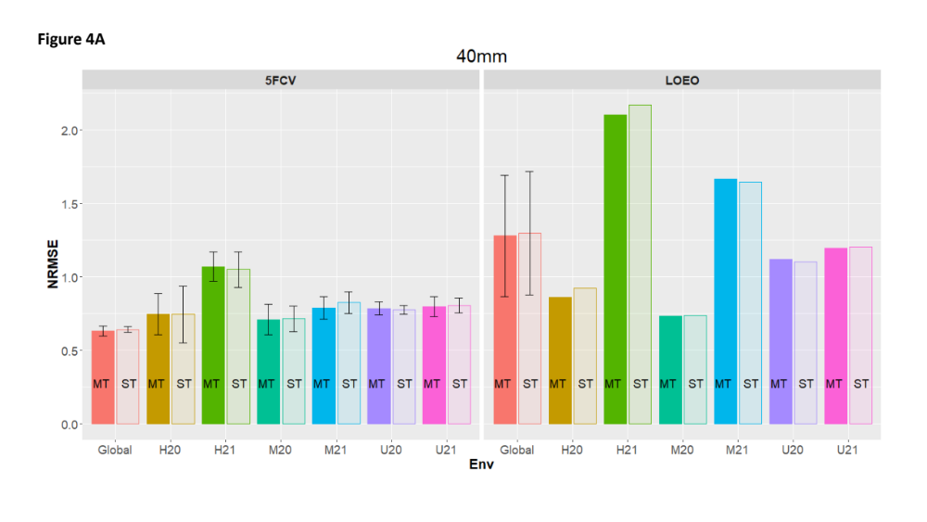
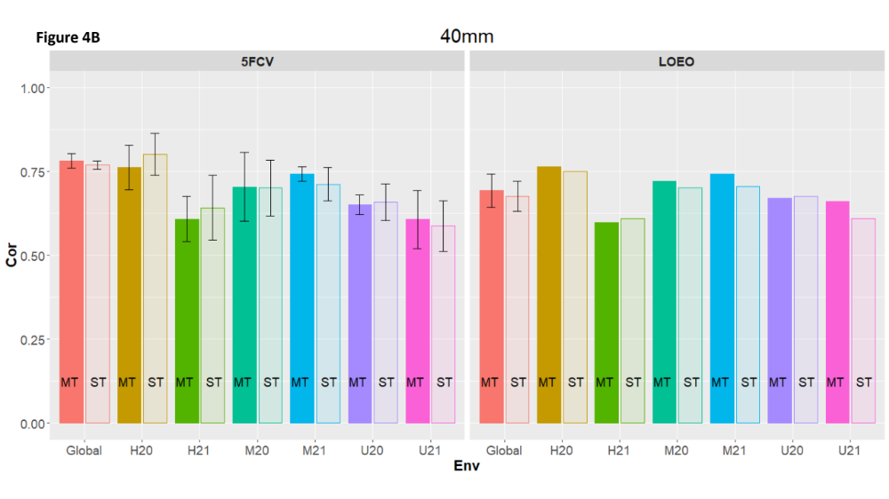
Figure S1. Weight of tubers below 40 mm. Above: Correlation (Cor) between observed and predicted values for multi-trait (MT) and single trait (ST) for 5 fold cross-validation (5FCV) and leave-one-environment-out (LOEO) for each location-year combination (H = Helgegården, M = Mosslunda, U = Umeå; 20 = Year 2020, 21 = Year 2021, Global = across six environments). Below: Normalized Root Mean Squared Error (NRMSE) for MT and ST for 5FCV and LOEO for each location-year combination (H = Helgegården, M = Mosslunda, U = Umeå; 20 = Year 2020, 21 = Year 2021, Global = across six environments)
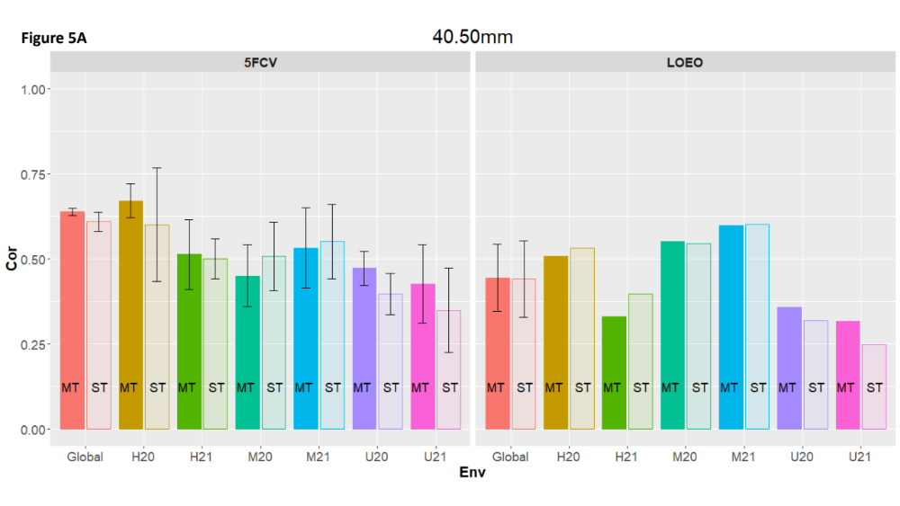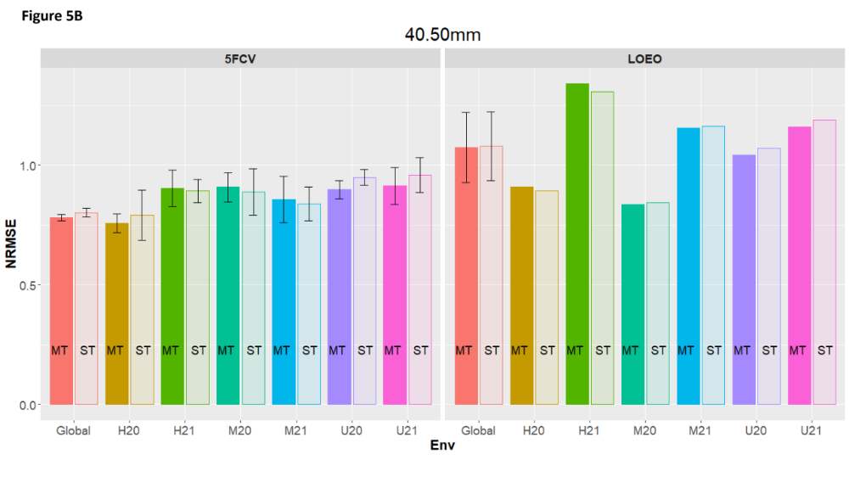
Figure S2. Weight of tubers between 40 and 50 mm. Above: Correlation (Cor) between observed and predicted values for multi-trait (MT) and single trait (ST) for 5 fold cross-validation (5FCV) and leave-one-environment-out (LOEO) for each location-year combination (H = Helgegården, M = Mosslunda, U = Umeå; 20 = Year 2020, 21 = Year 2021, Global = across six environments). Below: Normalized Root Mean Squared Error (NRMSE) for MT and ST for 5FCV and LOEO for each location-year combination (H = Helgegården, M = Mosslunda, U = Umeå; 20 = Year 2020, 21 = Year 2021, Global = across six environments)
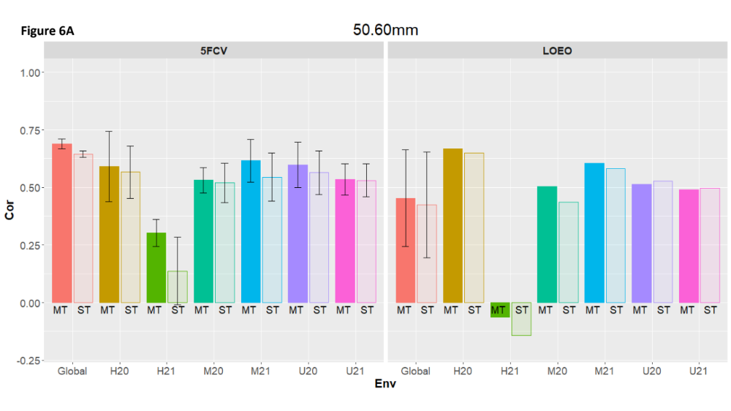
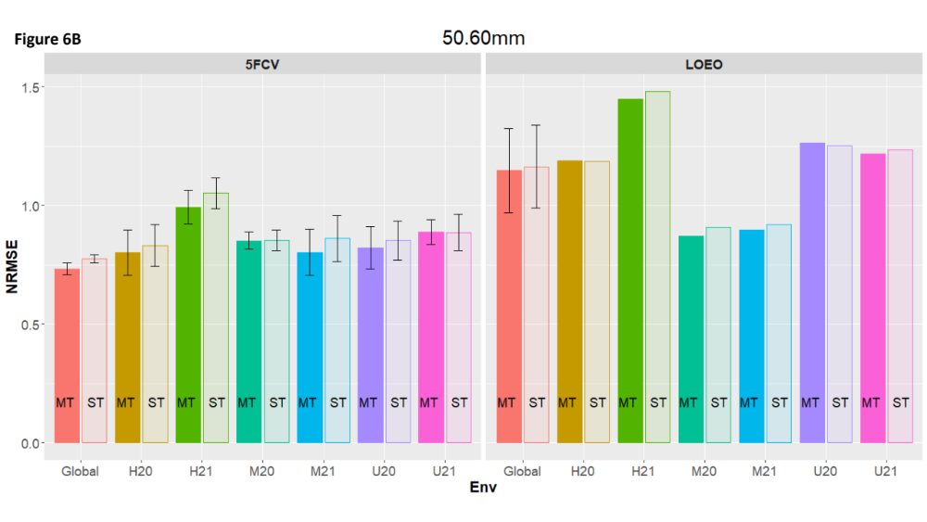
Figure S3. Weight of tubers between 50 and 60 mm. Above: Correlation (Cor) between observed and predicted values for multi-trait (MT) and single trait (ST) for 5 fold cross-validation (5FCV) and leave-one-environment-out (LOEO) for each location-year combination (H = Helgegården, M = Mosslunda, U = Umeå; 20 = Year 2020, 21 = Year 2021, Global = across six environments). Below: Normalized Root Mean Squared Error (NRMSE) for MT and ST for 5FCV and LOEO for each location-year combination (H = Helgegården, M = Mosslunda, U = Umeå; 20 = Year 2020, 21 = Year 2021, Global = across six environments.)
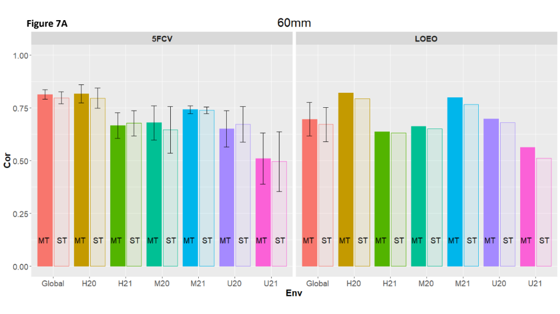
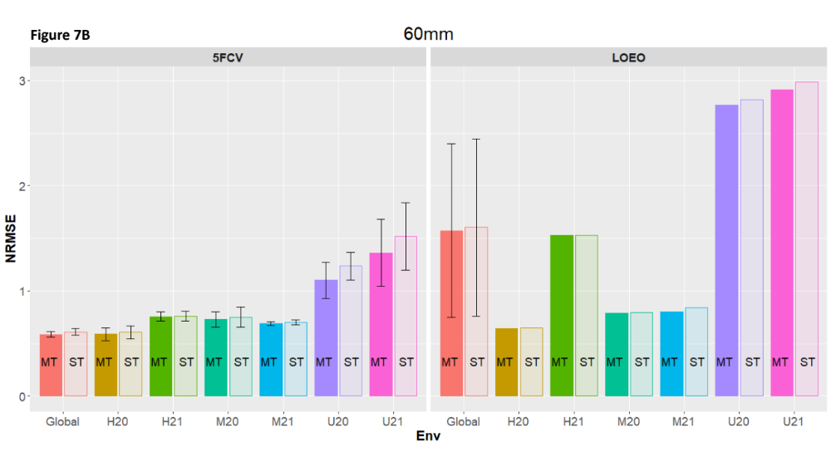Figure S4. Weight of tubers above 60 mm. Above: Correlation (Cor) between observed and predicted values for multi-trait (MT) and single trait (ST) for 5 fold cross-validation (5FCV) and leave-one-environment-out (LOEO) for each location-year combination (H = Helgegården, M = Mosslunda, U = Umeå; 20 = Year 2020, 21 = Year 2021, Global = across six environments). Below: Normalized Root Mean Squared Error (NRMSE) for MT and ST for 5FCV and LOEO for each location-year combination (H = Helgegården, M = Mosslunda, U = Umeå; 20 = Year 2020, 21 = Year 2021, Global = across six environments)

