Table S1
Estimates from Sensitivity Analyses [53]
df = 97
 | Simple Slopes |  |  | Simple Intercepts
ADHD Behaviors
 | Unst. b | z | p | Unst. b | z | p
Low Effortful Control (-1SD) | 0.28 (.12) | 2.36 | .019 | 1.48 (.16) | 9.07 | < .0001
Mean Effortful Control (x̅) | 0.06 (.11) | 0.53 | .595 | 1.28 (.12) | 10.45 | < .0001
High Effortful Control (+1SD) | -0.16 (.17) | -0.97 | .332 | 1.07 (.16) | 6.88 | < .0001
Internalizing Behaviors
 | Unst. b | z | p | Unst. b | z | p
Low Household Chaos (-1SD) | -0.38 (.18) | 2.13 | .033 | 1.24 (.19) | 6.59 | < .0001
Mean Household Chaos (x̅) | -0.13 (.13) | 1.04 | .299 | 1.50 (.15) | 10.12 | < .0001
High Household Chaos (+1SD) | 0.11 (.17) | 0.65 | .516 | 1.76 (.19) | 9.39 | < .0001

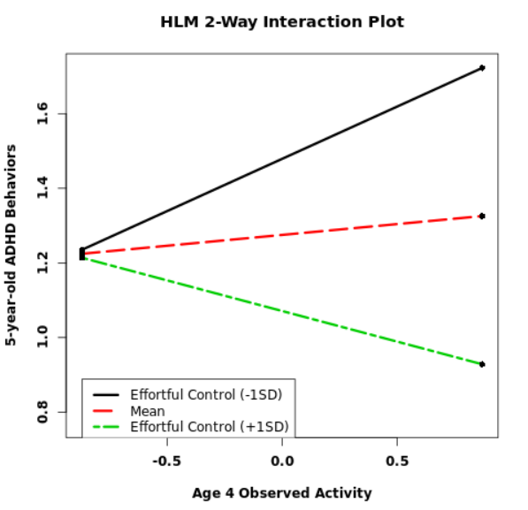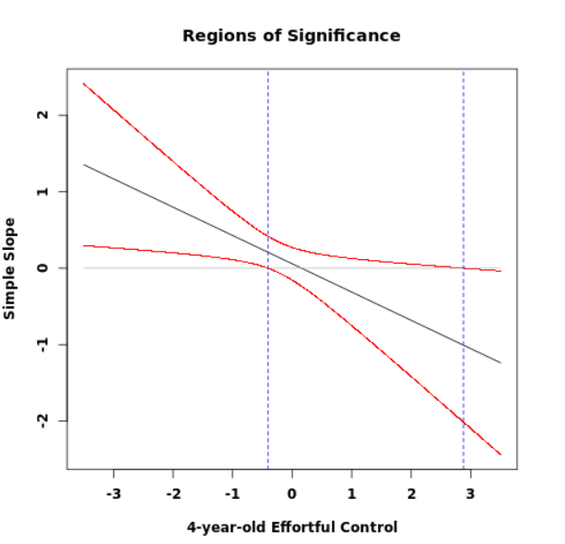
Figure S1. Simple slopes and regions of significance plots from the sensitivity analysis [53], indicating that 5-year-old ADHD behaviors significantly varied as a function of age 4 observed activity for children with 4-year-old temperamental effortful control scores *outside* the confidence bands (CBQec = -0.41 > z > 2.88 – i.e., approximately -1SD and lower and nearly +3SD and greater).

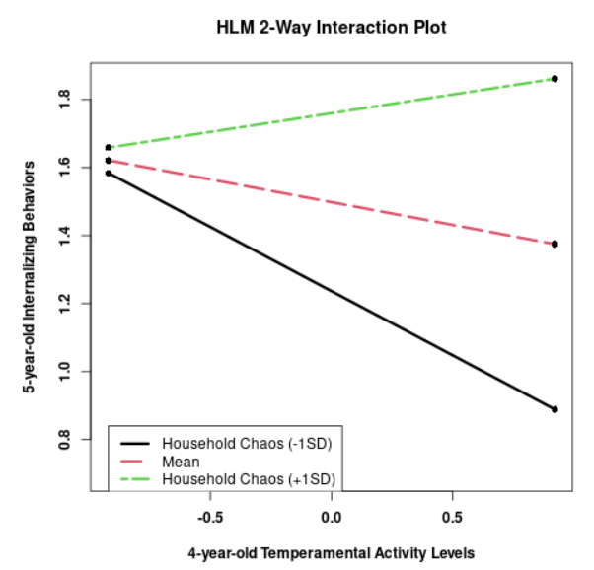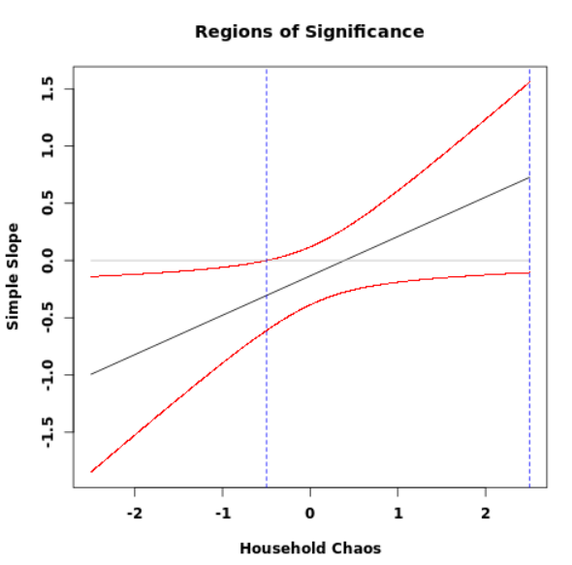
Figure S2. Simple slopes and regions of significance plots from the sensitivity analysis [53], indicating that 5-year-old internalizing behaviors significantly varied as a function of 4-year-old temperamental activity levels for children with household chaos scores *outside* the confidence bands (CHAOS = z < -0.50 – i.e., approximately -1SD below the mean and lower).

