Supplementary Information
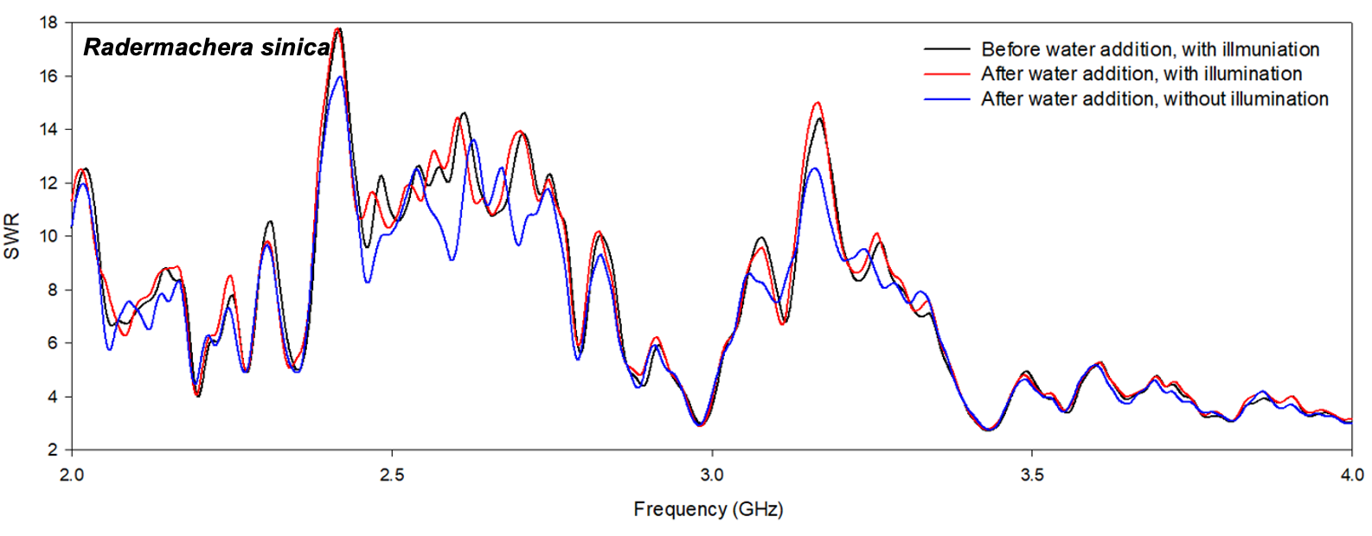
Fig. S1 Standing wave ratio (SWR) changes for the experimental plant Radermachera sinica. SWR measurement of the coil sensor was performed using a network analyzer under various experimental conditions, and the frequency was measured at 2.0–4.0 GHz (p < 0.01).

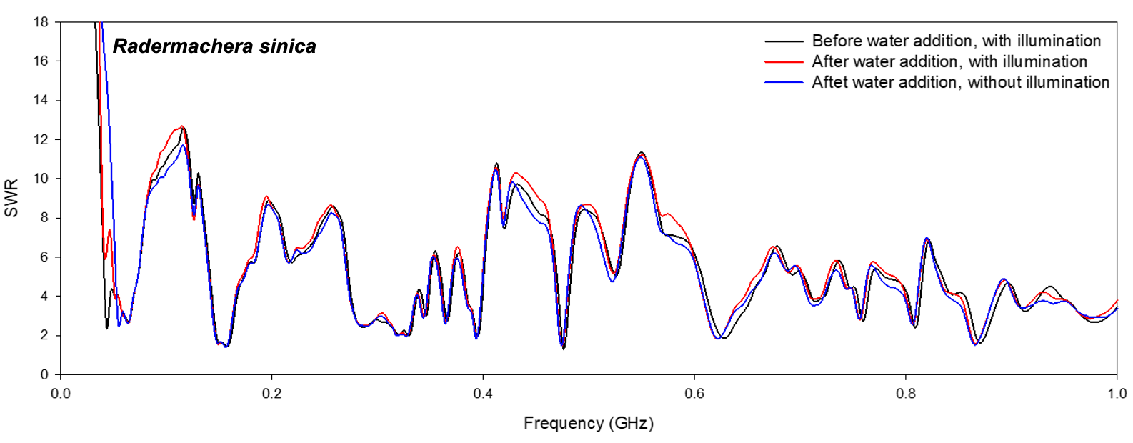
Fig. S2 Standing wave ratio (SWR) changes for the experimental plant Radermachera sinica. SWR measurement of the coil sensor was performed using a network analyzer under various experimental conditions, and the frequency was measured at 0.0–1.0 GHz (p < 0.05).

