ELECTRONIC SUPPLENTARY INFORMATION
Novel ionic liquid 4,4ʹ-trimethylenedipiperidine phosphate catalysed greener and efficient synthesis of dihydro pyrano[2,3-c] pyrazole
Sagar Tanpure^{a,b}, Abhijeet Mulikª, Mohan Rajmaneª, Shamrao Lawande^{b}*
ª Department of Chemistry, Sadguru Gadage Maharaj College, Karad-415124, M.S., India.
^{b} Department of Chemistry Shri Chhatrapati Shivaji College, Shrigonda 413701, M.S., India
Sr. No. | CONTENTS | Page No.
1. | General Experimental | 3
2. | Preparation of Ionic Liquid & Typical procedure for one pot synthesis of pyranopyrazole derivatives | 3
3. | Figure S5 & S6 Mass Analysis spectra of new Ionic Liquid in positive & negative ion mode | 4
4. | Figure S7. IR spectrum of 6‑Amino-5‑cyano‑3‑methyl‑4‑ (4‑chlorophenyl) -1, 4‑dihydropyrano [2, 3-c] pyrazole (5b) | 4
5. | Figure S8. ¹H NMR of 6‑Amino-5‑cyano‑3‑methyl‑4‑ (4‑chlorophenyl) -1, 4‑dihydropyrano [2, 3-c] pyrazole (5b) | 5
6. | Figure S9. ¹³C NMR spectrum of 6‑Amino-5‑cyano‑3‑methyl‑4‑ (4‑chlorophenyl) -1, 4‑dihydropyrano [2, 3-c] pyrazole (5b) | 5
7. | Figure S10. IR spectrum of 6‑Amino-5‑cyano‑3‑methyl‑4‑ (3-nitrophenyl) -1, 4‑dihydropyrano [2, 3-c] pyrazole (5c) | 6
8. | Figure S11. ¹H NMR of 6‑Amino-5‑cyano‑3‑methyl‑4‑ (3-nitrophenyl) -1, 4‑dihydropyrano [2, 3-c] pyrazole (5c) | 5
9. | Figure S12. ¹³C NMR spectrum of 6‑Amino-5‑cyano‑3‑methyl‑4‑ (3-nitrophenyl) -1, 4‑dihydropyrano [2, 3-c] pyrazole (5c) | 6
10. | Figure S13. IR spectrum of 6‑Amino-5‑cyano‑3‑methyl‑4‑ (4‑hydroxyphenyl) -1, 4‑dihydropyrano [2, 3-c] pyrazole (5d) | 6
11. | Figure S14. ¹H NMR of 6‑Amino-5‑cyano‑3‑methyl‑4‑ (4‑hydroxyphenyl) -1, 4‑dihydropyrano [2, 3-c] pyrazole (5d) | 7
12. | Figure S15. ¹³C NMR spectrum of 6‑Amino-5‑cyano‑3‑methyl‑4‑ (4‑hydroxyphenyl) -1, 4‑dihydropyrano [2, 3-c] pyrazole (5d) | 8
13. | Figure S16. IR spectrum of 6‑Amino-5‑cyano‑3‑methyl‑4‑ (4‑methoxyphenyl) -1, 4‑dihydropyrano [2, 3-c] pyrazole (5e) | 8
14. | Figure S17. ¹H NMR of 6‑Amino-5‑cyano‑3‑methyl‑4‑ (4‑methoxyphenyl) -1, 4‑dihydropyrano [2, 3-c] pyrazole (5e) | 11
15. | Figure S18. ¹³C NMR spectrum of 6‑Amino-5‑cyano‑3‑methyl‑4‑ (4‑methoxyphenyl) -1, 4‑dihydropyrano [2, 3-c] pyrazole (5e) | 12

General Experimental
Aldehyde, malono nitrile, ethyl acetoacetate and hydrazine hydrate were obtained from Sigma-Aldrich and used without further purification. Melting points were measured in open glass capillary method and are uncorrected. The progress of reaction was monitored on TLC, silica gel-coated aluminium sheets. The Fourier Transformer Infrared (FTIR) spectrum was recorded on lambda FTIR-7600 spectrometer. The NMR spectra of pure products were recorded on Brucker 400 MHz by using DMSO-d₆ solvent with TMS as an internal standard.
Preparation of Ionic Liquid
A round-bottom flask (100 mL) was charged filled with solution of 4, 4ʹ-trimethylenedipiperidine (TMDP) (8.1 mmol) in dry dichloromethane (50 mL) and was stirred in an ice bath. Then, phosphoric acid (85% w/w 1 mL 1.84 g) was added dropwise to this mixture over a period of 30 min. at 0 ºC. After completion of addition, the reaction mixture was removed from ice bath and the flask was immersed in heating mental and fitted with reflux condenser for 24 h. The white precipitated ionic liquid was washed with diethyl ether (3 x 10 mL) and dried under vacuum to give white solid as [H₂-TMDP] [HPO₄] in 96% yield. The structure of catalyst was analysed by FTIR, ¹HNMR, ¹³CNMR and MS.
Typical procedure for one pot synthesis of pyranopyrazole derivatives
A mixture of hydrazine hydrate 80% (1 mmol) 1, ethyl acetoacetate (1 mmol) 2, diverse aromatic aldehyde (1 mmol) 3, malononitrile (1 mmol) 4 and Bronsted acidic ionic liquid [H₂-TMDP] [HPO₄] (10 mg) was taken in round-bottom flask (25 mL) and stirred in EtOH:H₂O (1:1 v/v, 6 ml) at room temperature for appropriate time. The progress of reaction monitored by TLC (n-hexane/ethyl acetate 7:3). After the successful completion reaction, add 5 mL H₂O. The [H₂-TMDP] [HPO₄] was soluble in water and crude products were extracted with ethyl acetate. The resulting solid product purified from hot ethanol. The recrystallized product characterized by FTIR, ¹H-NMR and ¹³C-NMR techniques. The aqueous layer was evaporated under reduced pressure to recover the ionic liquid. The crude ionic liquid was reused after thermal treatment under vacuum at 55°C for 3 hours.

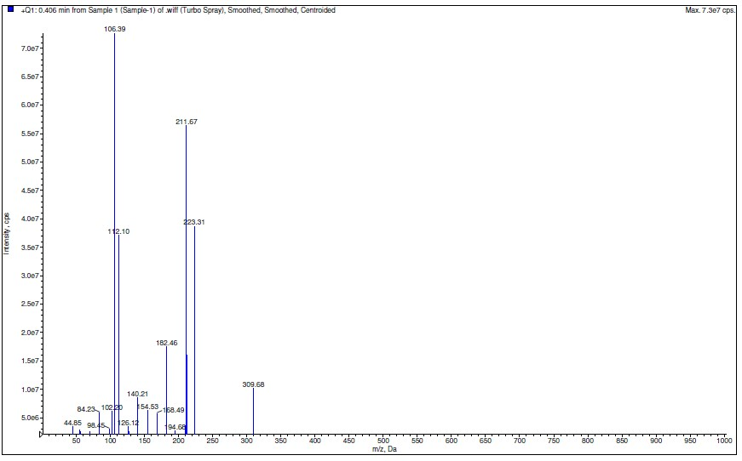
Figure S1. Mass Analysis spectra of new Ionic Liquid in positive ion mode
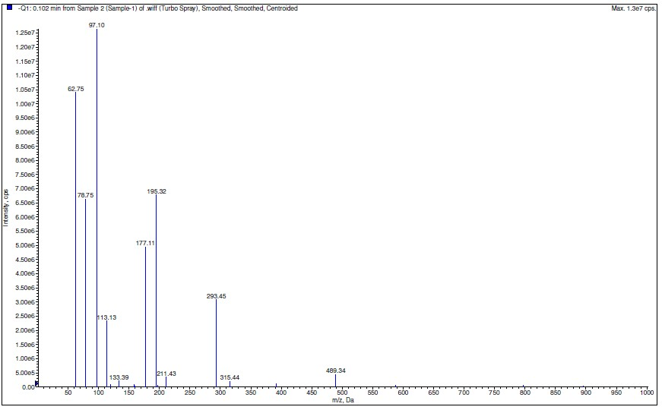
Figure S2. Mass Analysis spectra of new Ionic Liquid in negative ion mode

FT-IR, ¹H NMR and ¹³C NMR copies of the Derivatives of pyranopyrazoles (The NMR spectra were recorded in 400 MHz Bruker instrument and DMSO-d₆ was used as NMR solvent).
6‑Amino-5‑cyano‑3‑methyl‑4‑ (4‑chlorophenyl) -1, 4‑dihydropyrano [2, 3-c] pyrazole (5b) Off-white solid, M.P. 232-–235 °C.,
IR ‾ν_{max} (KBr) cm⁻¹: 3189 (NH₂), 3400 (–NH–), 2928 (Aromatic), 2900 (–CH₃), 2211 (–CN), 1488 (–NH–), 1058 (Ar–Cl), 815 (Para-Cl).¹H NMR—(400 MHz, DMSO d₆)—δ ppm 11.89 (1H,s), 7.88-7.93 (2H, m, J = 11.2 Hz), 7.21 (2H, m, J = 11.2 Hz), 6.50 (2H, s), 4.49 (1H, s),1.75 (3H, s). ¹³C NMR—(100 MHz, DMSO d₆)—δ ppm 161.20, 155.05, 143.0, 136.44, 132.07, 129.41, 128.64, 121.03, 97.25, 57.70, 36.18, 10.11.
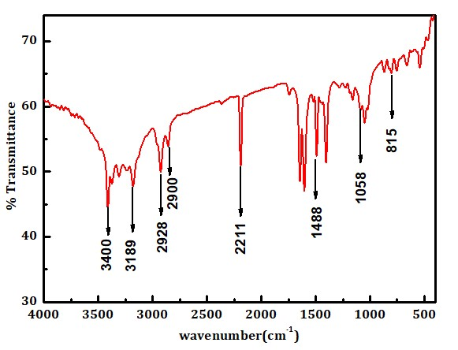
Figure S3. FT-IR spectra of (5b)

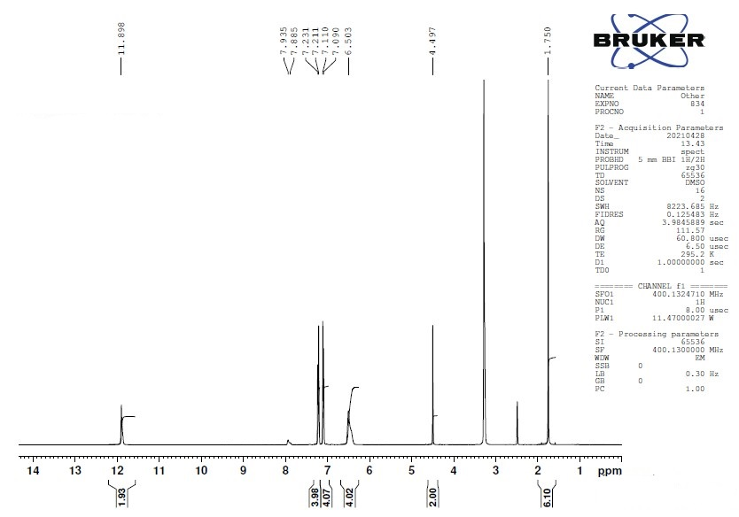
Figure S4. ¹H-NMR spectra of (5b)

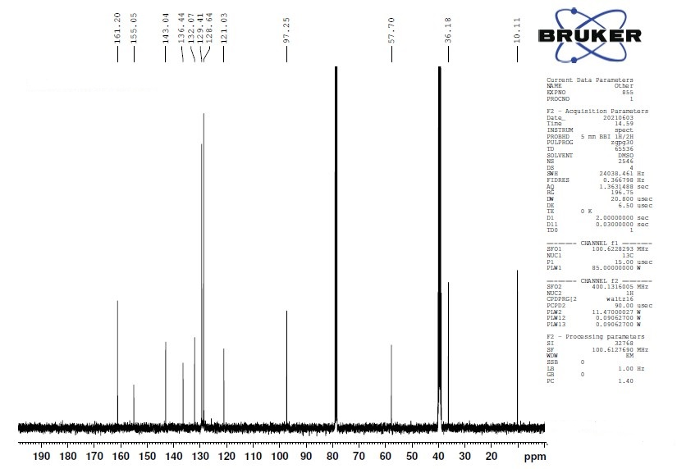
Figure S5. ¹³C-NMR spectra of (5b)

6‑Amino-5‑cyano‑3‑methyl‑4‑ (3-nitrophenyl) -1, 4‑dihydropyrano [2, 3-c] pyrazole (5c)
Off-white solid, M.P. 193–196 °C
IR‾ν max (KBr) cm⁻¹: 3410 (NH2), 3298 (–NH–), 3138 (Aromatic), 2914 (–CH3), 2181 (–CN), 1590 (–NH–), 1035 (Ar–NO2).¹H NMR—(400 MHz, DMSO d₆)—δ ppm 12.04 (1H,s), 8.04 (2H, m, J = 11.2 Hz), 7.51-7.59 (2H, m, J = 11.2 Hz), 6.76 (2H, s), 4.72 (1H, s), 1.77 (3H, s). ¹³C NMR—(100 MHz, DMSO d₆)—δ ppm 161.43, 155.04, 148.2, 146.50, 136.58, 134.4, 130.0, 122.2, 96.6, 36.46, 10.13
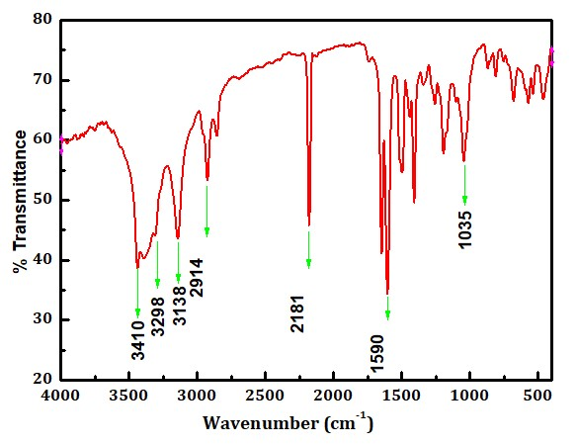
Figure S6. FTIR spectra of (5c)

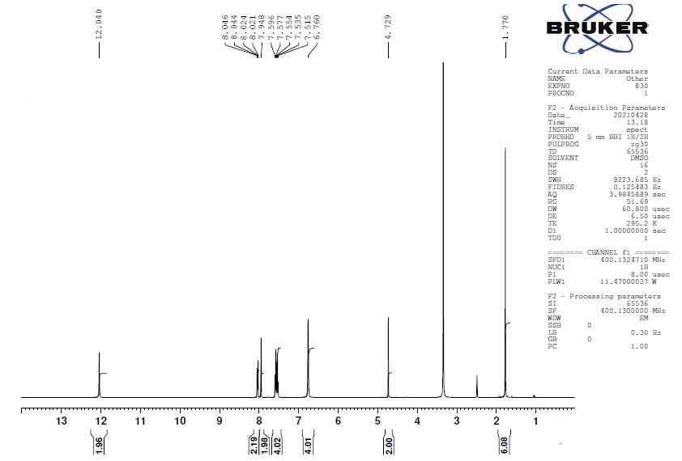
Figure S7. ¹H-NMR spectra of (5c)
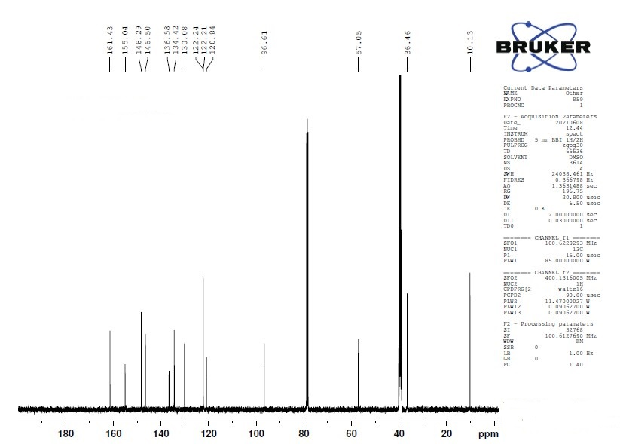Figure S8. ¹³C-NMR spectra of (5c)

6‑Amino-5‑cyano‑3‑methyl‑4‑ (4‑hydroxyphenyl) -1, 4‑dihydropyrano [2, 3-c] pyrazole (5d)
Cream solid, M.P. 210-–212 °C
IR‾ν max (KBr) cm⁻¹: 3280 (NH₂), 3110 (Aromatic), 2928 (–CH₃), 2181 (–CN), 1485 (–NH–), 1021 (Ar–OH).¹H NMR—(400 MHz, DMSO d₆)—δ ppm 11.88 (1H,s),9.09 (1H,s) 8.08 (2H, m, J = 11.2 Hz), 6.91-6.65 (2H, m, J = 11.2 Hz), 6.52 (2H, s), 4.39 (1H, s), 1.75 (3H, s). ¹³C NMR—(100 MHz, DMSO d₆)—δ ppm 160.9, 156.1, 136.3, 128.7, 121.3, 115.4, 98.2, 35.91, 10.1

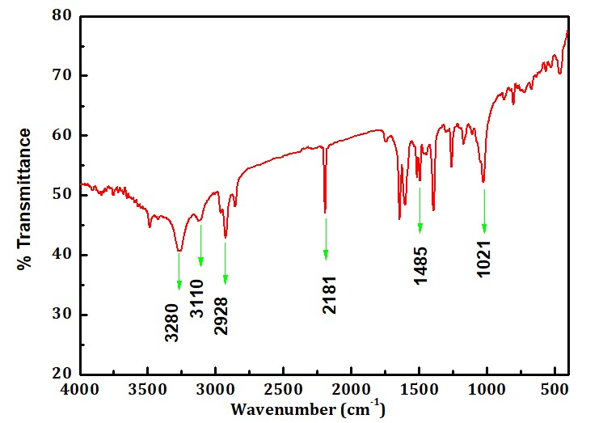
Figure S9. FTIR spectra of (5d)

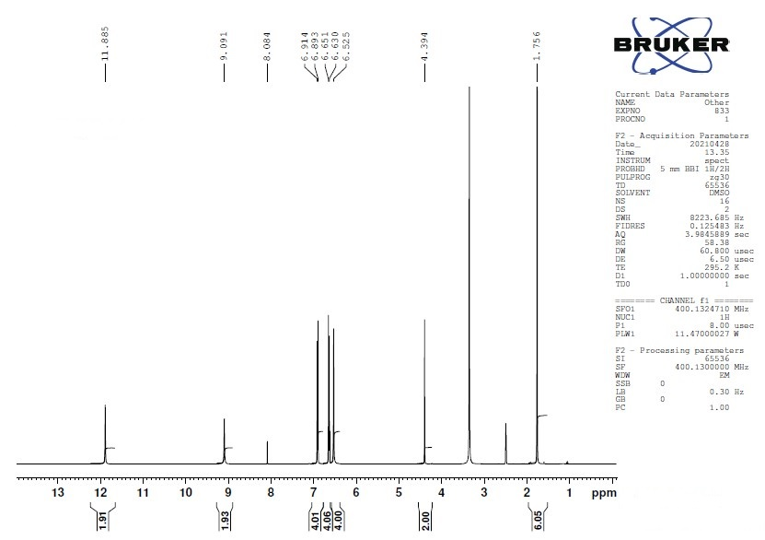
Figure S10. ¹H-NMR spectra of (5d)
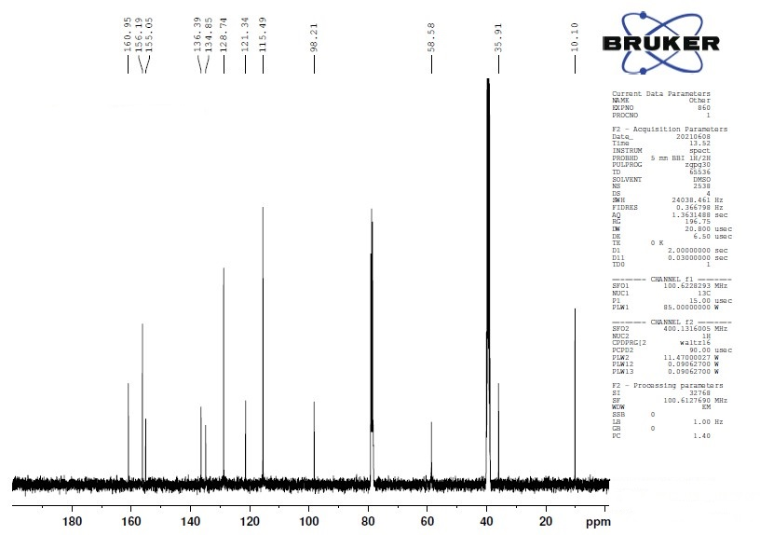
Figure S11. ¹³C-NMR spectra of (5d)

6‑Amino-5‑cyano‑3‑methyl‑4‑ (4‑methoxyphenyl) -1, 4‑dihydropyrano [2, 3-c] pyrazole (5e)
Off-white solid, M.P. 210–212 °C
IR‾ν max (KBr) cm⁻¹: 3392 (NH₂), 3284 (–NH–), 2931 (–CH₃), 2195 (–CN), 1507 (–NH–), 811 (Ar–OMe).¹H NMR—(400 MHz, DMSO d₆)—δ ppm 11.87 (1H,s), 8.02 (2H, m, J = 11.2 Hz), 7.01-7.03 (2H, m, J = 11.2 Hz), 6.75 (2H, s), 4.44 (1H, s), 3.69 (3H, s, OMe)1.74 (3H, s). ¹³C NMR—(100 MHz, DMSO d₆)—δ ppm 161.0, 155.0, 148.8, 136.9, 121.2, 111.7, 97.8 56.3, 10.1
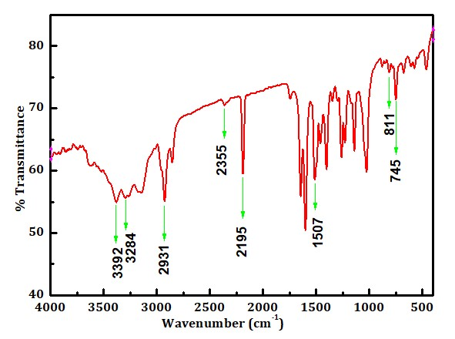
Figure S12. FTIR spectra of (5e)

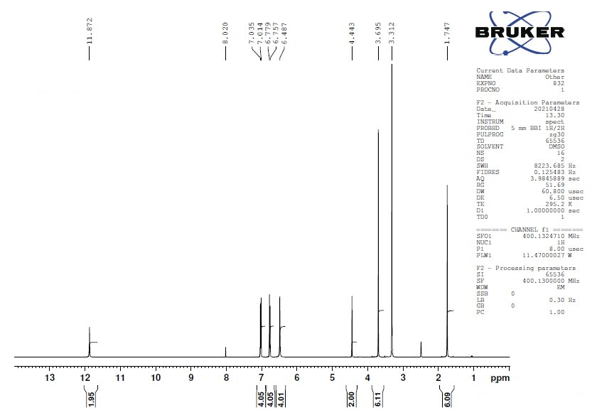
Figure S13. ¹H-NMR spectra of (5e)
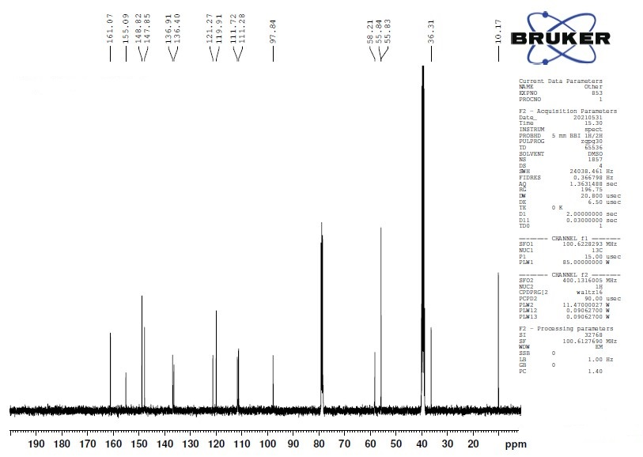
Figure S14. ¹³C-NMR spectra of (5e)

Some representative compounds are described below
1) 6‑Amino-5‑cyano‑3‑methyl‑4‑ phenyl -1, 4‑dihydropyrano [2, 3-c] pyrazole (5a)
Off-white solid M.P. 242-244 °C
IR‾ν max (KBr) cm⁻¹: 3373 (NH₂), 3317 (–NH–), 3171 (Aromatic), 2995 (–CH₃), 2195 (–CN), 1401(–NH), 745 (Ar–H) ¹H NMR-(400 MHz, DMSO d₆)- δ ppm :12.00 (1H, s), 7.30 (2H, t, J = 7.56), 7.22 (3H, m, J = 7.28 and 11.24), 6.71 (2H, s), 4.50 (1H, s),1.79 (3H, s). ¹³C NMR—(100 MHz, DMSO d₆)—δ ppm 161.35, 155.26, 144.93, 136.04, 128.91, 127.94, 127.20, 121.24, 98.13, 57.71, 36.73, 10.20.

2) 6‑Amino-5‑cyano‑3‑methyl‑4‑ (3, 4‑dimethoxyphenyl)-1, 4‑dihydropyrano [2, 3-c] pyrazole (5f)
Light Off-white solid M.P. 188-192 °C.
IR‾ν max (KBr) cm⁻¹: 3432, 3391 (NH₂), 3316 (–NH–), 3069, 3017 (Aromatic), 2922 (–CH₃), 2593 (–OCH₃), 2207 (–CN), 1487 (–NH–), 772 (meta), 805 (para). ¹H NMR—(400 MHz, DMSO d₆)—δ ppm 11.13 (s, 1H, NH), 1.78 (s, 3H, CH3), 3.72-3.69 (s, 6H, OCH3), 4.46 (s, 1H, 4H), 6.57 (s, 2H, NH2), 6.78 (s, 2H, Ar–H), ¹³C NMR—(100 MHz, DMSO d₆)—δ ppm 160.95, 154.67,153.13, 152.76, 140.07, 136.07, 135.73, 120.87, 105.50, 104.49, 97.28, 59.91, 56.84, 55.74, 36.46, 9.91.

3) 6‑Amino-5‑cyano‑3‑methyl‑4‑ (4‑fluorophenyl) -1, 4‑dihydropyrano [2, 3-c] pyrazole (5i)
Light-yellow solid M.P. 215-217 °C
IR‾ν max (KBr) cm⁻¹: 3415, 3385(NH2) 3041 (Aromatic), 2915(-CH3), 2220(–CN), 1475(–NH–) 700(Para-F).¹H NMR (400 MHz, DMSO-d₆) δ ppm: 12.15 (s, 1H, NH), 1.78 (s, 3H, CH3), 4.68 (s, 1H, CH), 7.04 (s, 2H, NH2), 7.25 (d, J = 8.1Hz, 2H, Ar-H), 7.43 (d, J = 8.0 Hz, 2H, Ar-H) ¹³C NMR (100 MHz, DMSO-d₆): δ 162.1, 157.2, 144.6, 135.2, 131.2, 129.6, 122.2, 116.3, 111.6, 57.2, 35.6, 10.8.

