Supplementary material for “North-West Europe hottest summer temperatures rising much faster than the mean”

Matthew Patterson^{1.}
1. Atmospheric, Oceanic and Planetary Physics, University of Oxford, Parks Road, OX1 3PU, UK

Contents
S1 – A table of CMIP6 models used in this study
Figures S1-S3

Table S1: A table of CMIP6 models used in this study

Model | Institute | Ensemble member
ACCESS-ESM1-5 | CSIRO | r1i1p1f1
ACCESS-CM2 | CSIRO-ARCCSS | r1i1p1f1
AWI-CM-1-1-MR | AWI | r1i1p1f1
BCC-CSM2-MR | BCC | r1i1p1f1
CAMS-CSM1-0 | CAMS | r1i1p1f1
CanESM5 | CCCma | r1i1p1f1
CNRM-CM6-1 | CNRM | r1i1p1f2
CNRM-CM6-1-HR | CNRM | r1i1p1f2
CNRM-ESM2-1 | CNRM | r1i1p1f2
EC-Earth3 | EC-Earth-Consortium | r1i1p1f1
FGOALS-g3 | CAS | r1i1p1f1
GFDL-ESM4 | NOAA-GFDL | r1i1p1f1
HadGEM3-GC31-LL | MOHC | r1i1p1f3
HadGEM3-GC31-MM | MOHC | r1i1p1f3
INM-CM4-8 | INM | r1i1p1f1
INM-CM5-0 | INM | r1i1p1f1
IPSL-CM6A-LR | IPSL | r1i1p1f1
MIROC6 | MIROC | r1i1p1f1
MIROC-ES2L | MIROC | r1i1p1f2
MPI-ESM1-2-LR | MPI-M | r1i1p1f1
MRI-ESM2-0 | MRI | r1i1p1f1
NorESM2-LM | NCC | r1i1p1f1
NorESM2-MM | NCC | r1i1p1f1
UKESM1-0-LL | MOHC | r1i1p1f2

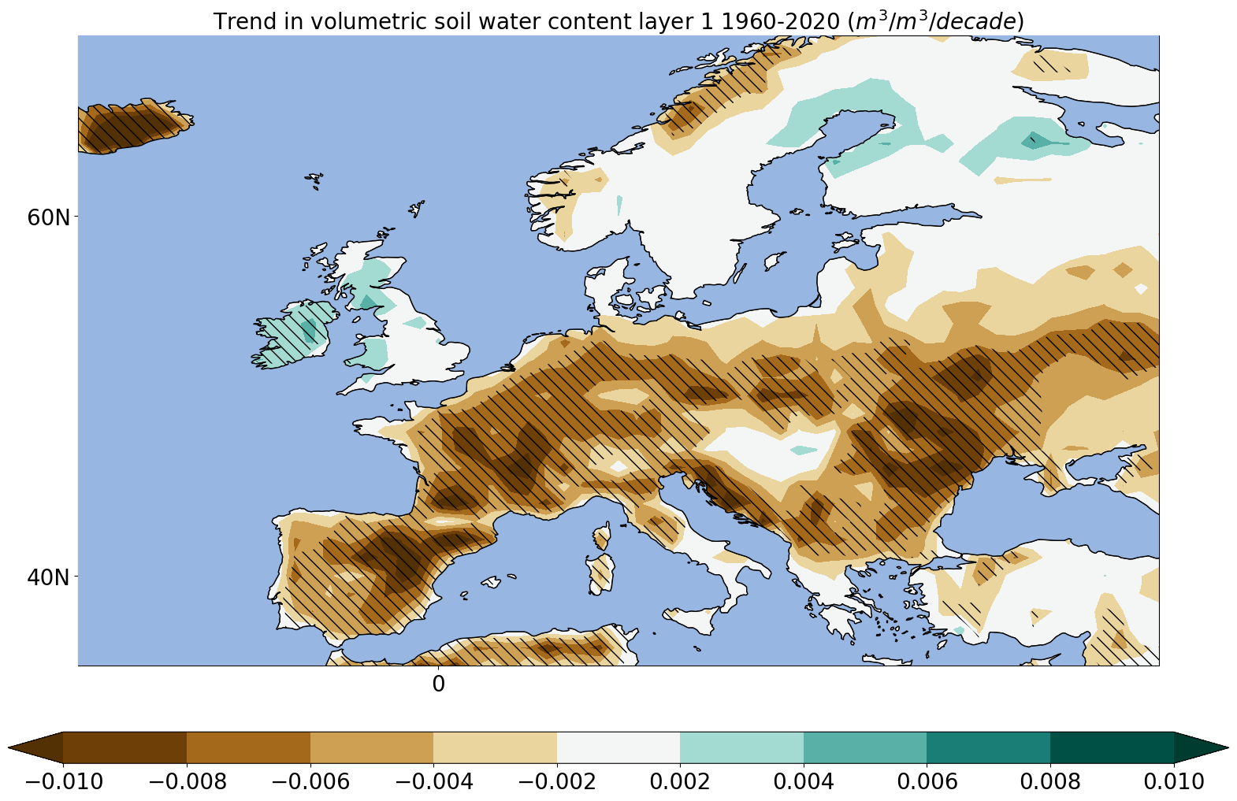
Figure S1: The trend in volumetric soil water content in the top layer of soil, i.e. the top 7cm, in JJA over the period 1960-2021 using monthly-mean ERA5 data (units of m³/m³/decade).

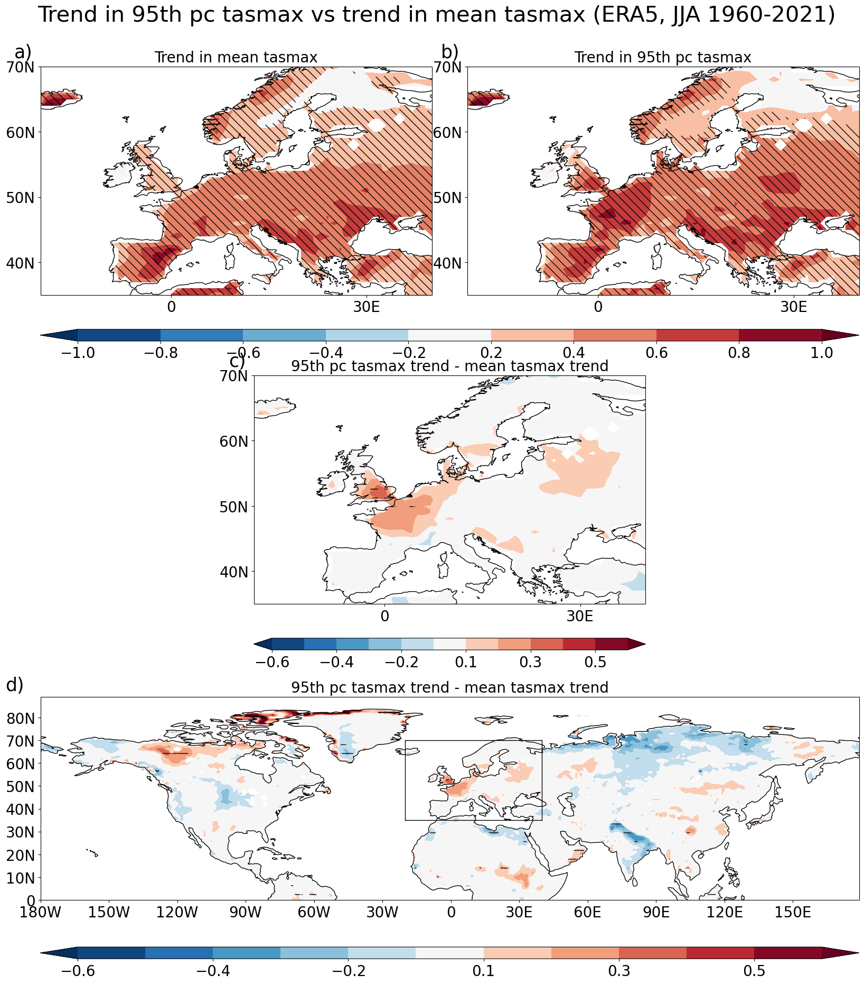
Figure S2: The same as figure 1 of the main manuscript, but for the 95th percentile of summer (JJA) days.
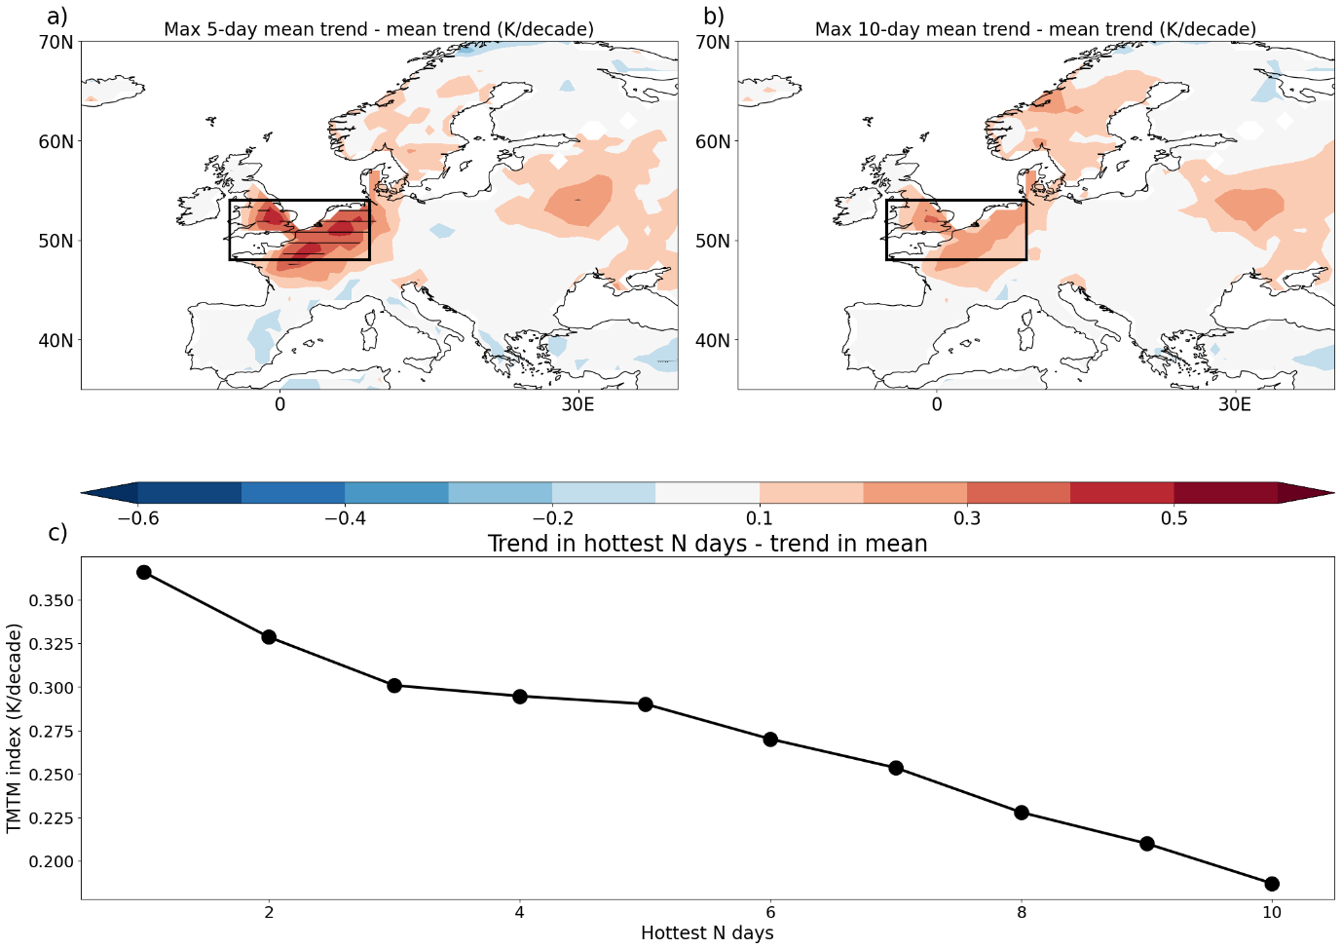
Figure S3: Trends in a) maximum 5-day mean tasmax and b) maximum 10-day mean tasmax minus the trend in JJA-mean tasmax. c) the discrepancy between the maximum N-day mean tasmax and the JJA-mean tasmax for N between 1 and 10, calculated as a mean over the boxed in region in a) and b) (i.e. the TMTM index).

