Supplementary Materials part 1

Table S1. Brain datasets used in the study
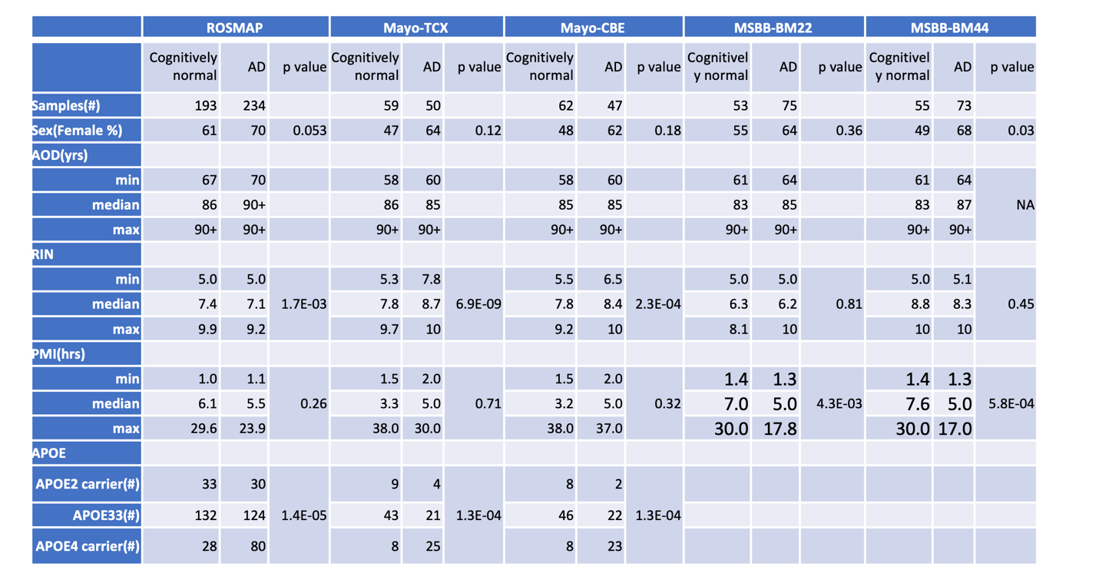

For the ROSMAP study, we had individuals with a final consensus cognitive diagnosis(Schneider, Arvanitakis et al. 2007) of ‘no cognitive impairment’ as cognitive normal groups, and individuals with a final consensus cognitive diagnosis of “AD: Alzheimer’s dementia and NO other cause of CI(NINCDS PROB AD)” or “AD: Alzheimer’s dementia and another cause of CI(NINCDS POSS AD)” as AD groups. For the Mayo study(Allen, Wang et al. 2018), subjects with definite diagnosis of AD according to the National Institute of Neurological and Communicative Disorders and Stroke and the Alzheimer’s Disease and Related Disorders Association (NINCDS-ADRDA) criteria(McKhann, Drachman et al. 1984) and had Braak neurofibrillary tangle (NFT) stage of ≥4.0. Subjects without any brain pathology aging phenotypes were classified in the “Normal” groups. For MSBB, subjects were classified by the Neuropathology Category as measured by CERAD values (1:“Normal”; 2: “AD”).
Note:
- For MSBB cohort, 36% of samples do not have APOE information. Thus, APOE is not included in the analysis.
- AOD(yrs) information for individuals over 90 are labeled with ‘90+’

Table S2. Coefficients of determination(R²)
between MT-ND1 and other mtDNA-encoded genes

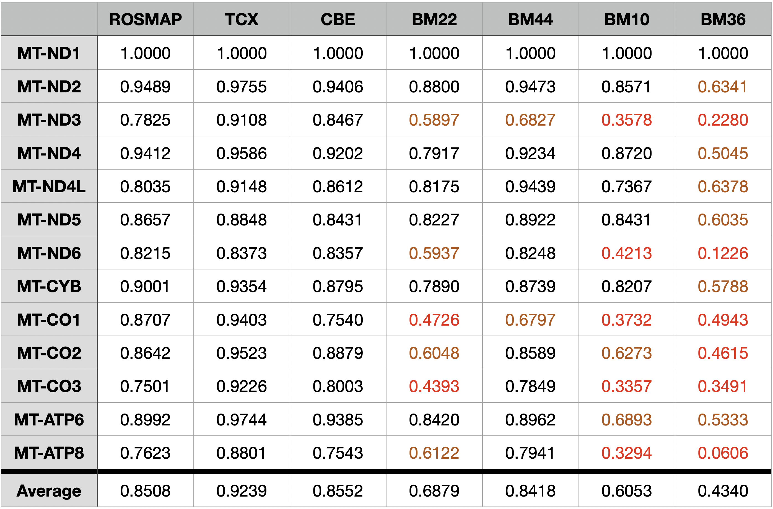

The R² below 0.5 are colored in red, and R² between 0.5 and 0.7 are colored in brown.

Figure S1

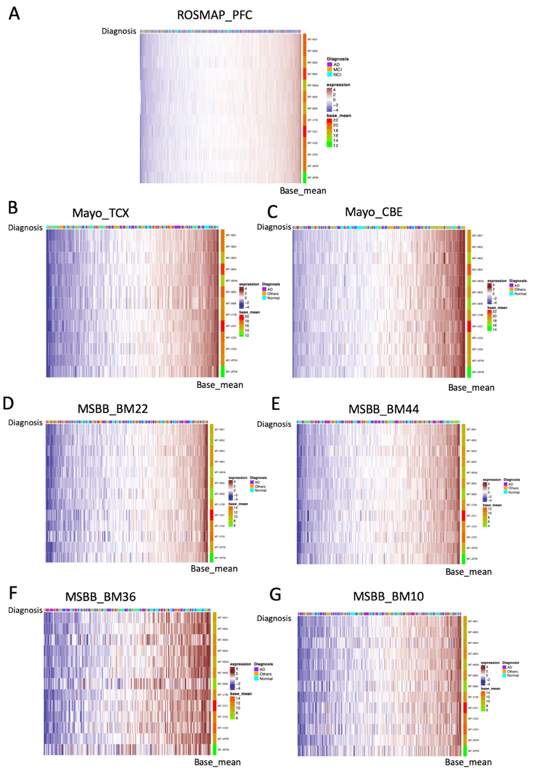
Figure S1. Heatmap of the scaled expressions of mtDNA-encoded genes from ROSMAP, Mayo and MSBB datasets. For each dataset, the disease diagnosis and base mean expression of each gene are annotated on the top and right-side of the heatmap, respectively.

Figure S2

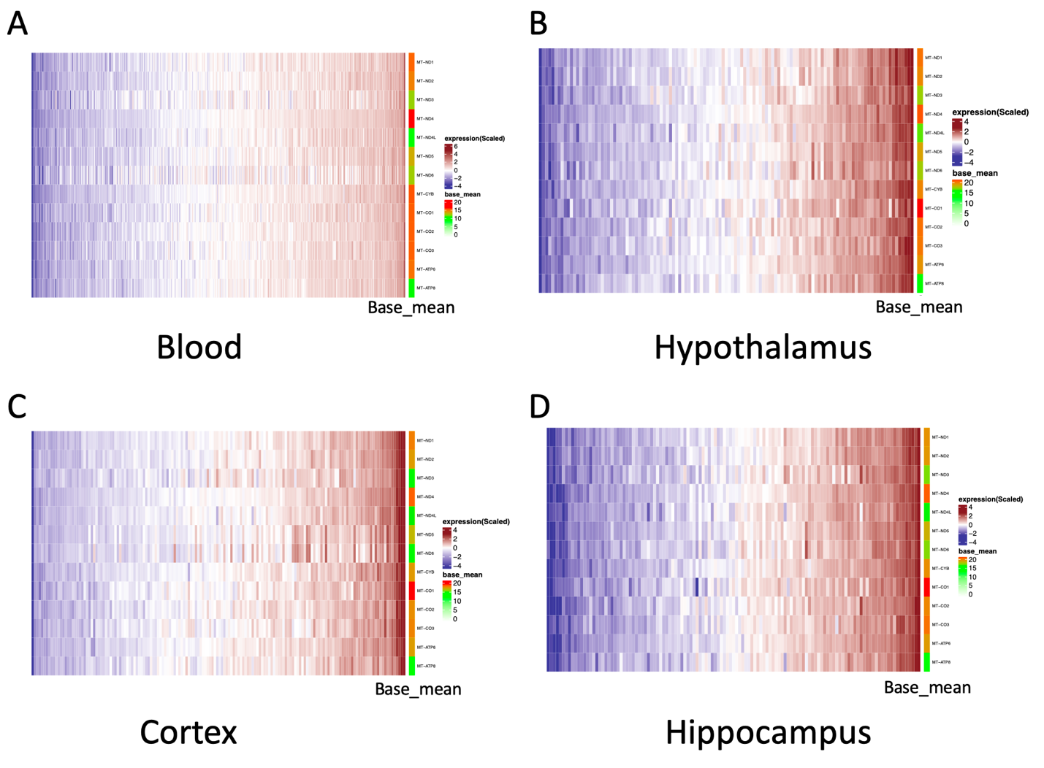
Figure S2. Heatmap of the scaled expressions of mtDNA-encoded genes from GTEx datasets.

Figure S3

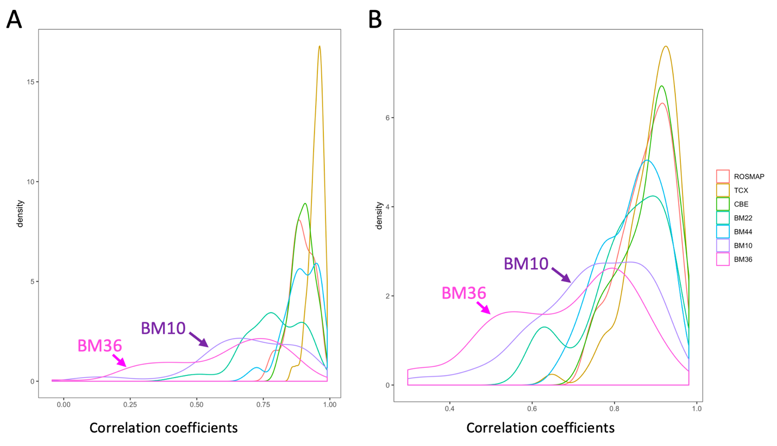
Figure S3. Distributions of the Pearson correlation coefficients between mtDNA-encoded genes in cognitively normal and AD brains from ROSMAP, TCX, CBE, BM22, BM44, BM10 and BM36 datasets.

Figure S4

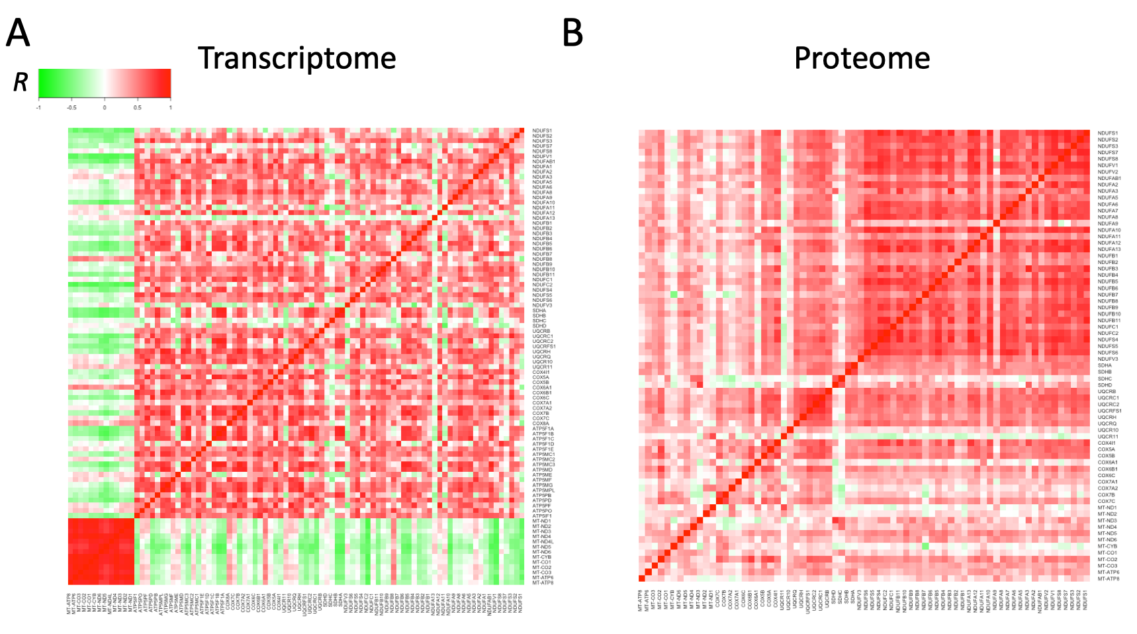

Figure S4. Heatmap of the Pearson correlation coefficients between OXPHOS genes in Alzheimer’s in ROSMAP transcriptome dataset.

Figure S5

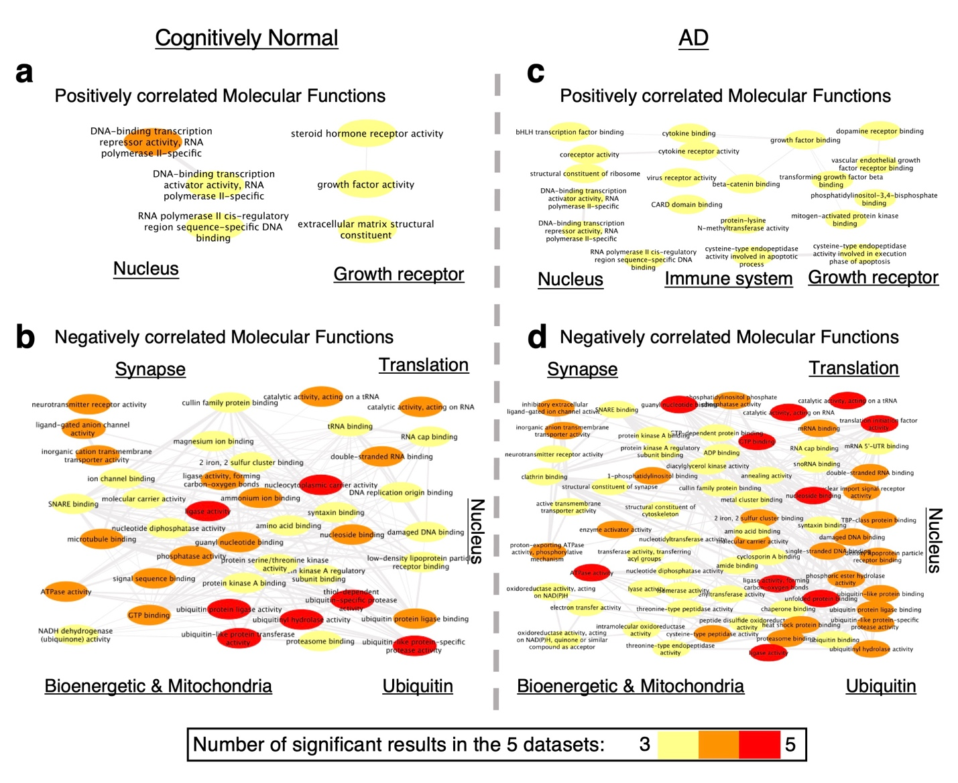

Figure S5. Co-regulation of GO:MF with MT-ND1 in cognitively normal and AD brains summarized from ROSMAP, Mayo (TCX, CBE), and MSBB ( BM22, BM44) data sets.

Figure S6

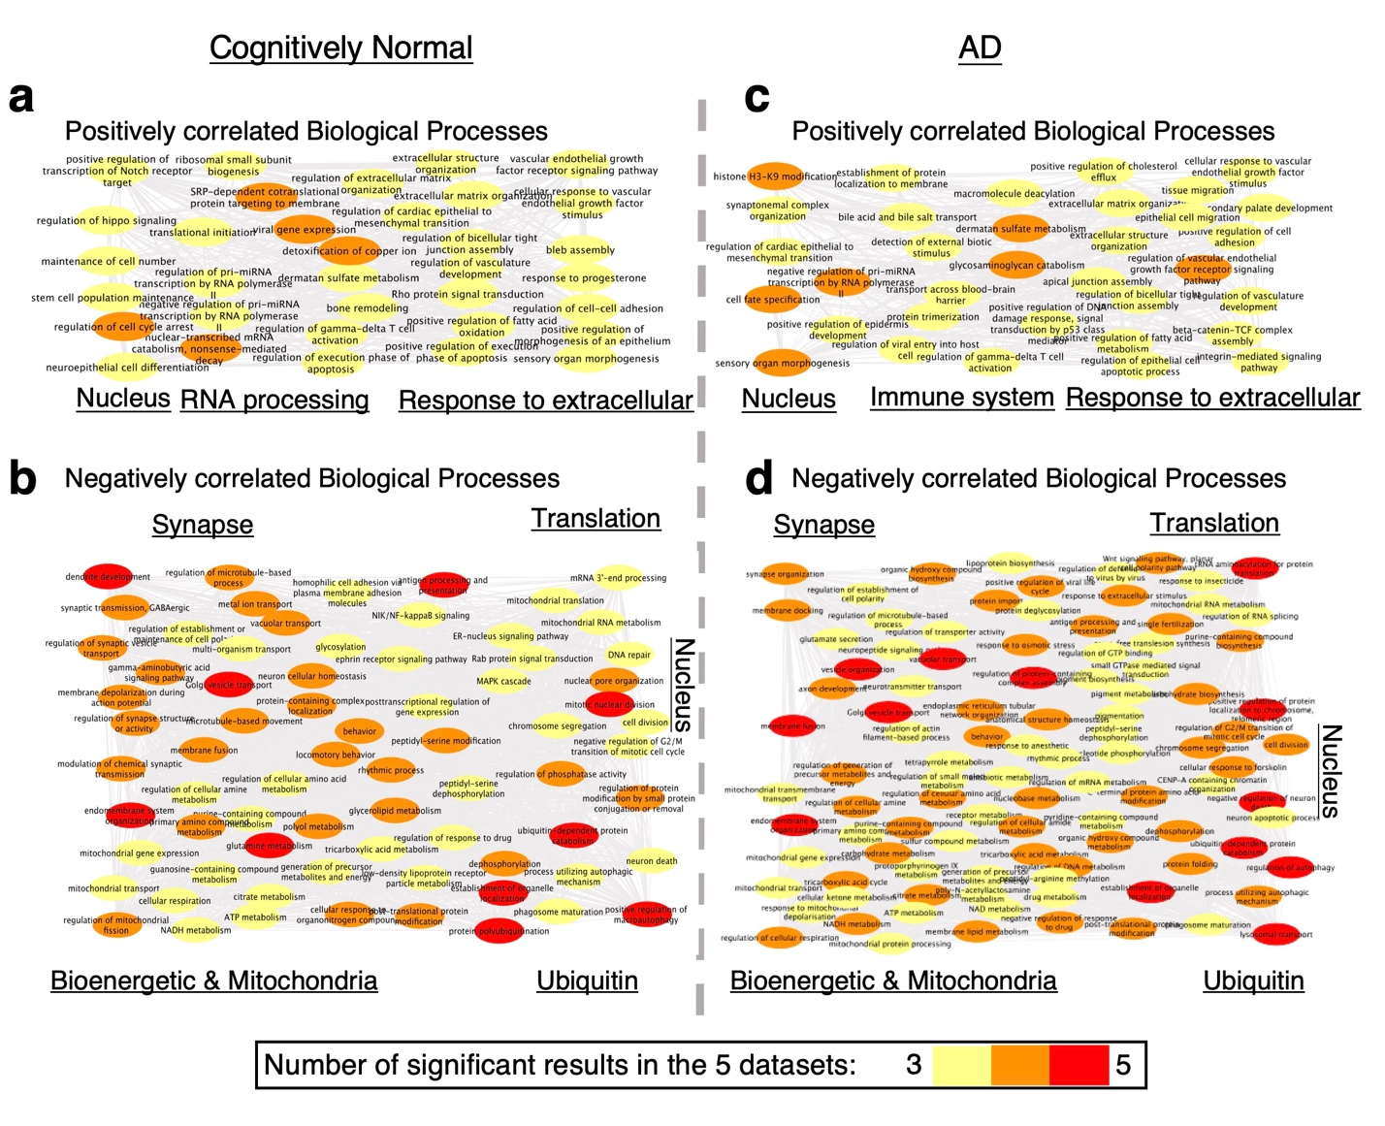
Figure S6. Co-regulation of GO:BP with MT-ND1 in cognitively normal and AD brains summarized from ROSMAP, Mayo (TCX, CBE), and MSBB ( BM22, BM44) data sets.

Figure S7

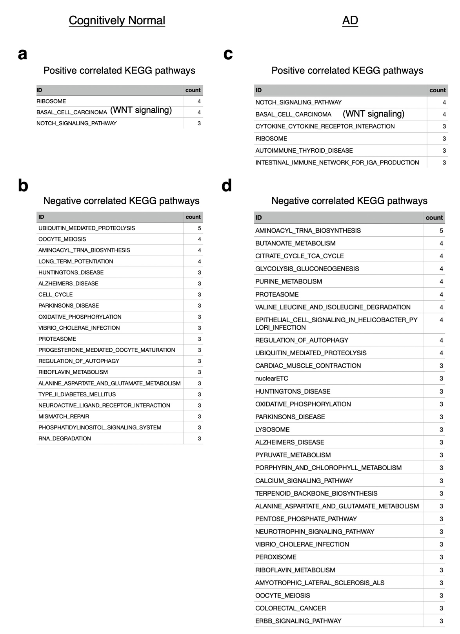
Figure S7. Co-regulation of KEGG pathways with MT-ND1 in cognitively normal and AD brains summarized from ROSMAP, Mayo (TCX, CBE), and MSBB ( BM22, BM44) data sets.

Figure S8

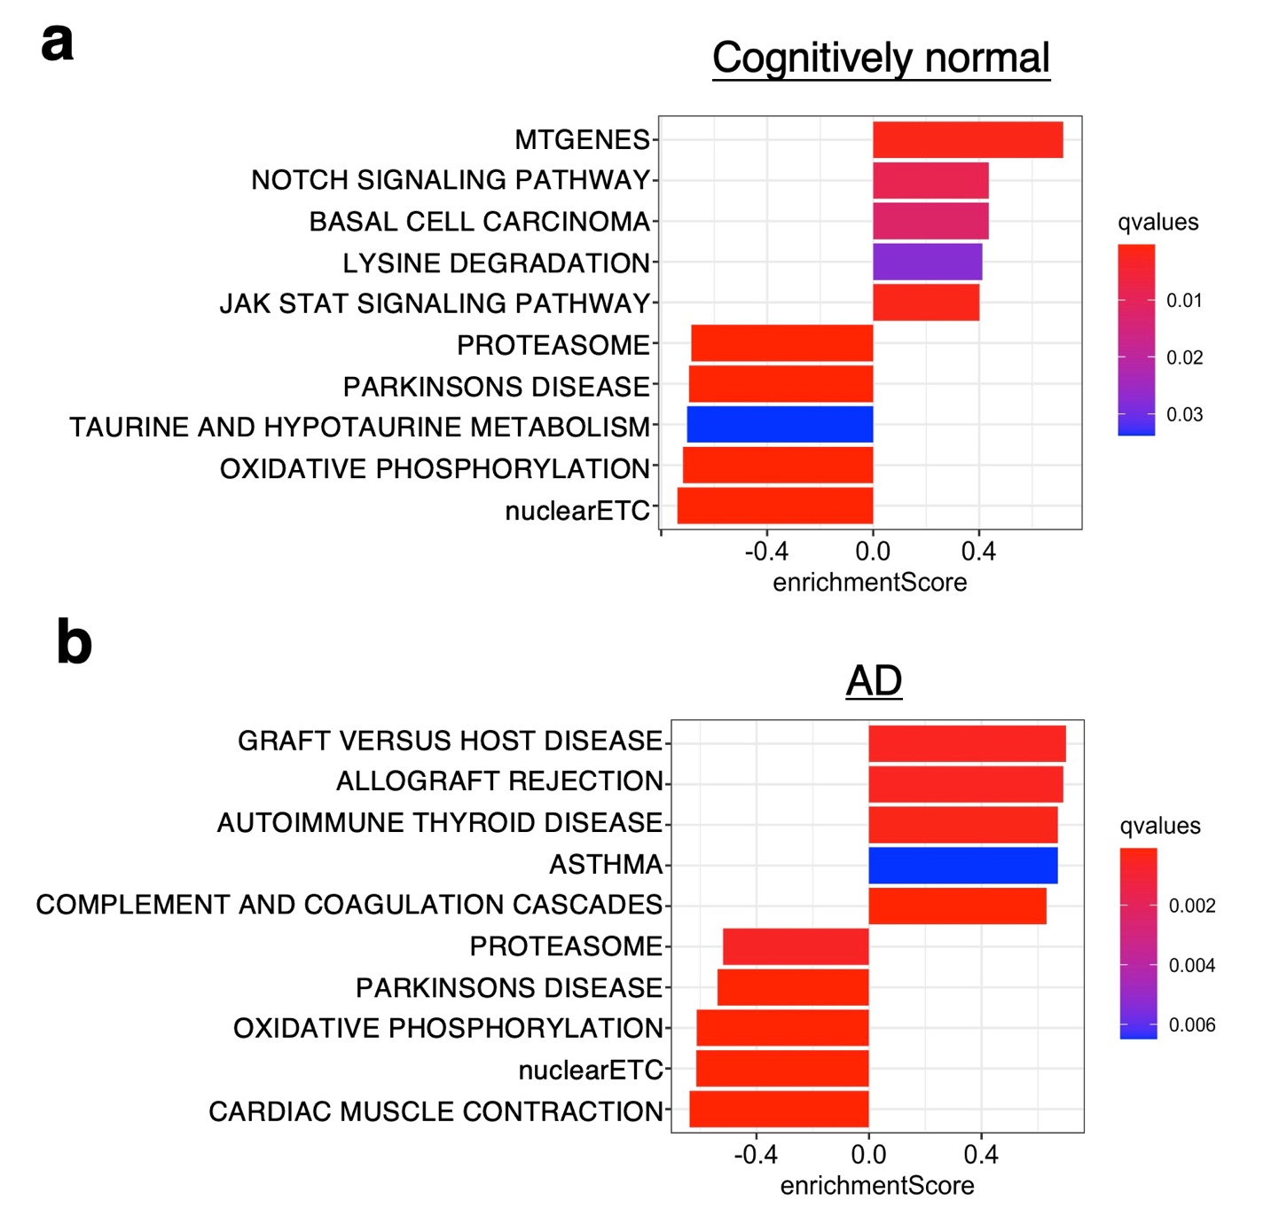
Figure S8. Transcriptome level pathway associations with β-Amyloid in cognitively normal and AD brains in ROSMAP cohort using GSEA analysis.

Figure S9

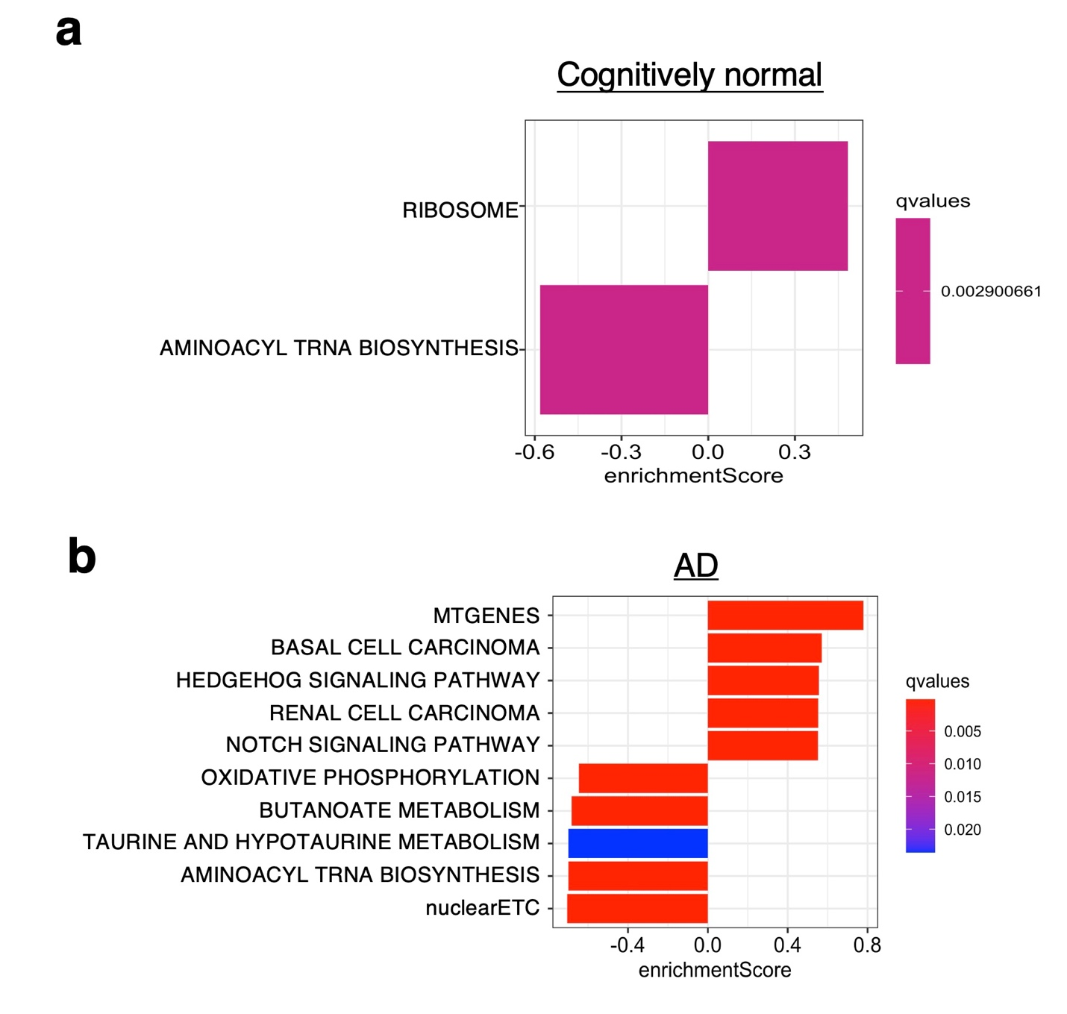
Figure S9. Transcriptome level pathway associations with NFT in cognitively normal and AD brains in ROSMAP cohort using GSEA analysis.

Figure S10

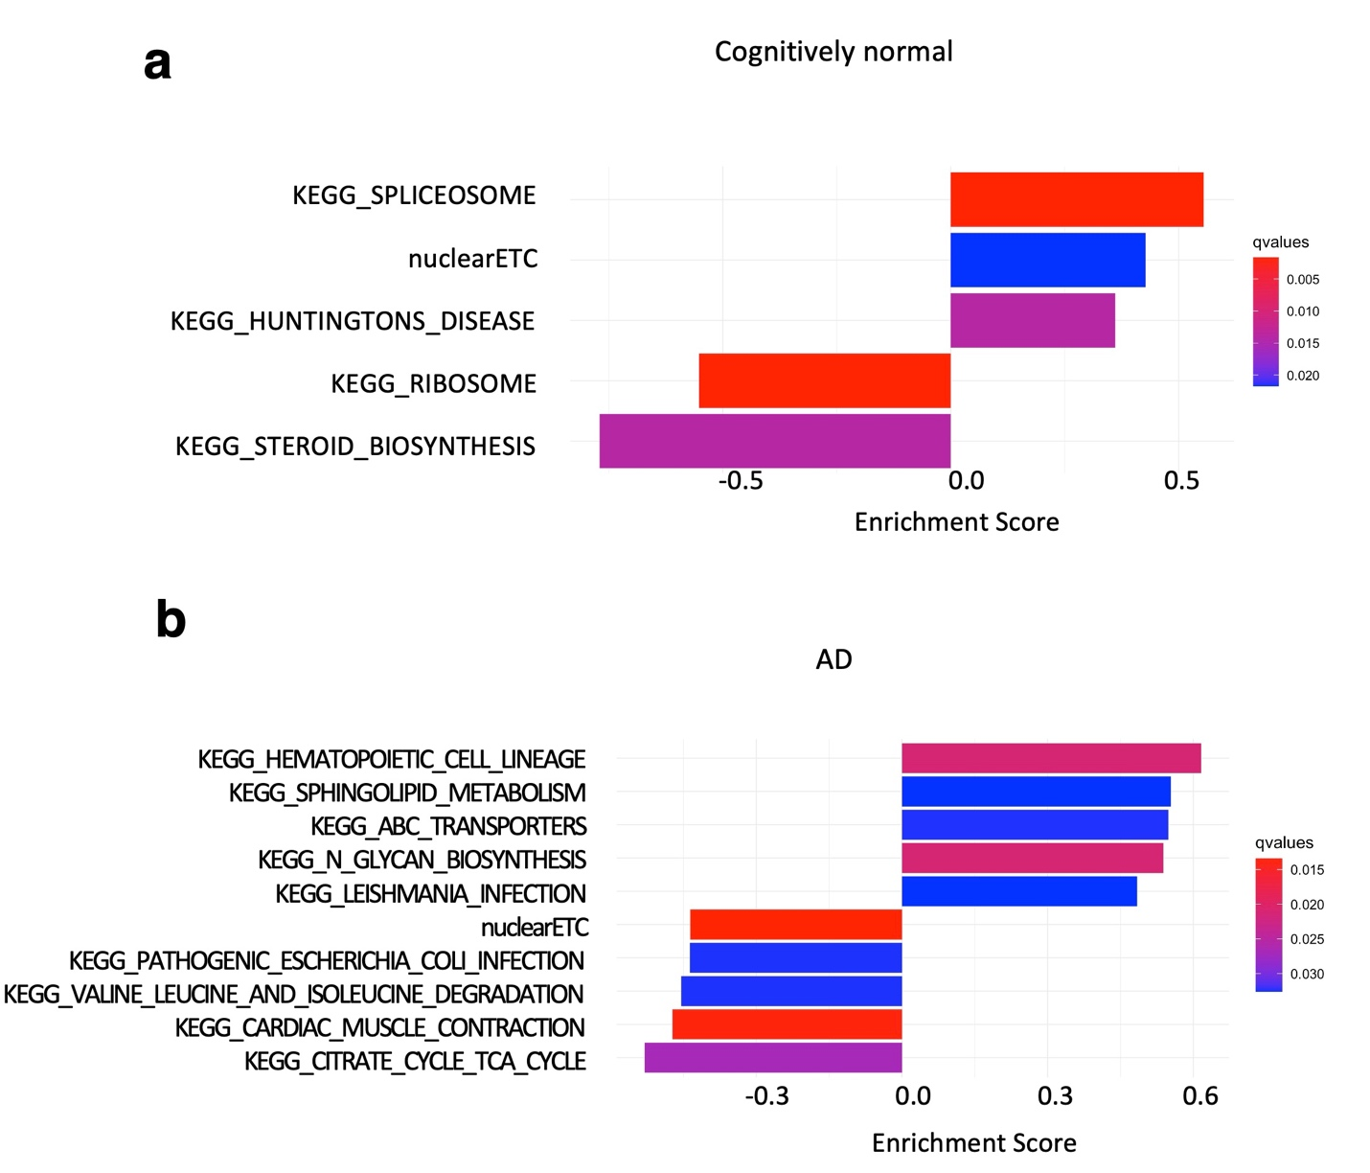
Figure S10. Proteome level pathway associations between total tau and in cognitively normal and AD brains in ROSMAP cohort using GSEA analysis.
Figure S11
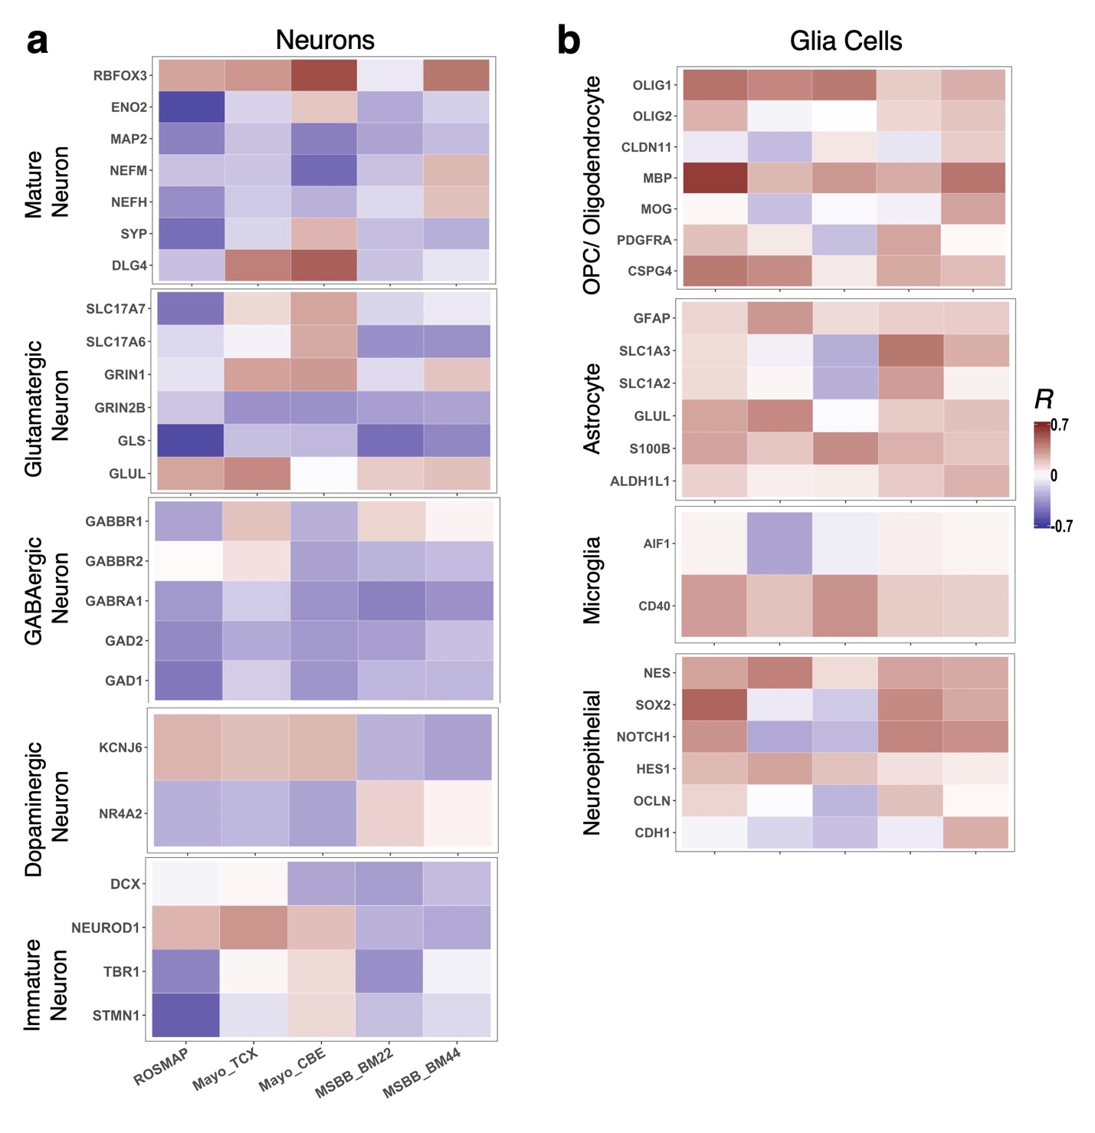
Figure S11. Co-expression of brain cell markers with MT-ND1 in cognitively normal brains.

Figure S12
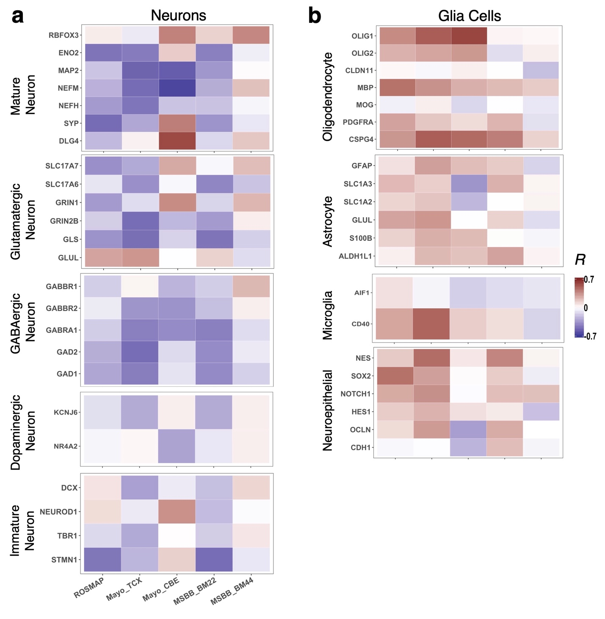
Figure S12. Co-expression of brain cell markers with MT-ND1 in AD brains.

Figure S13
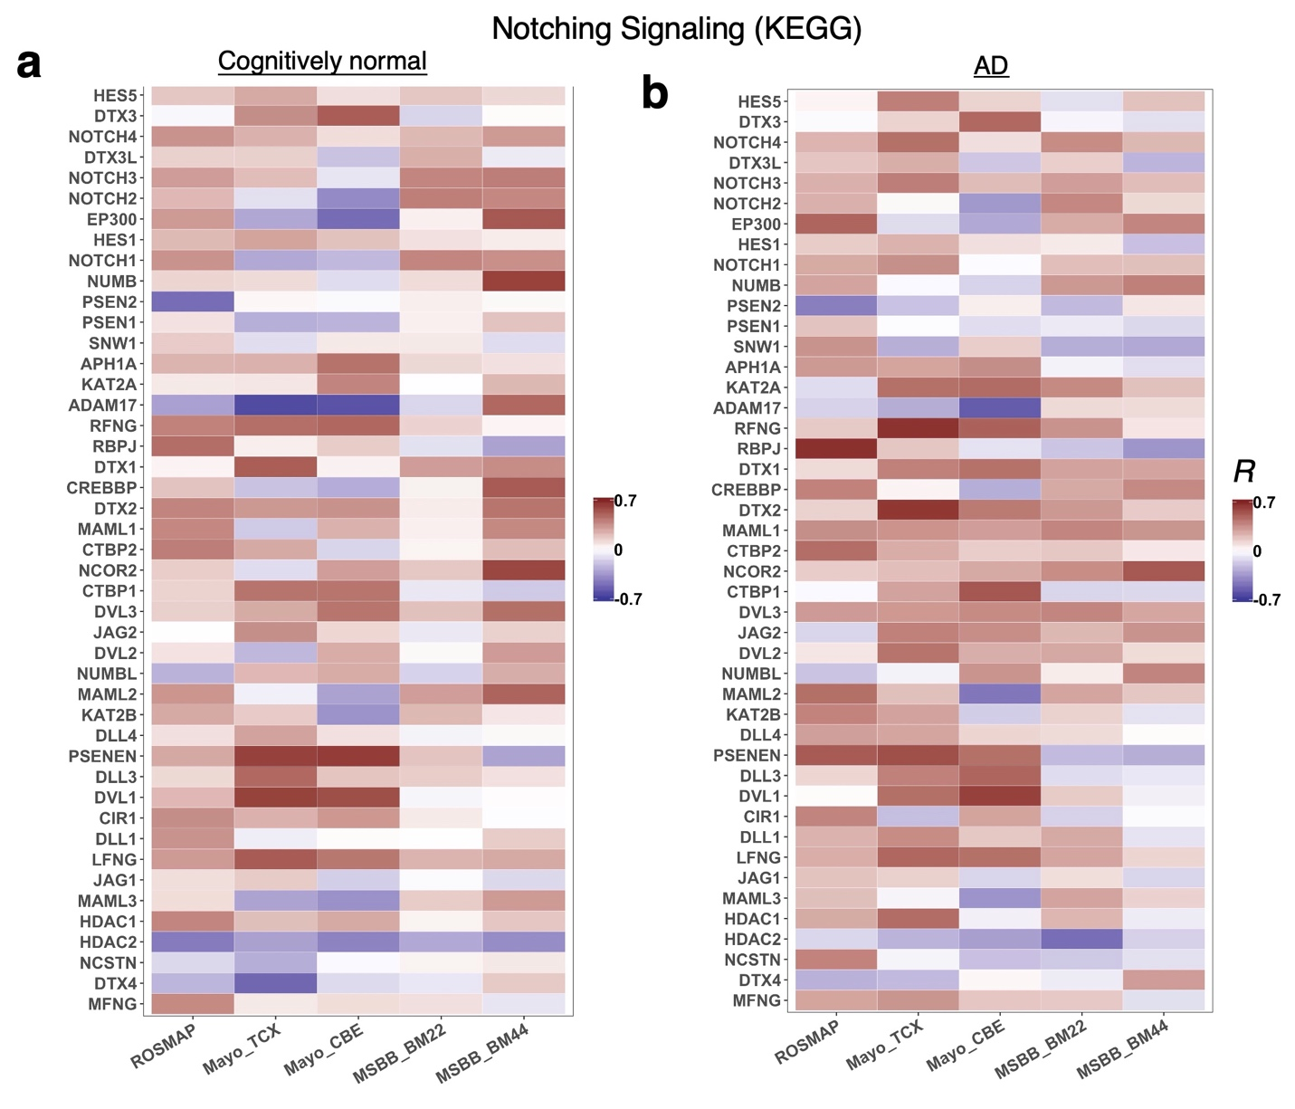
Figure S13. Heatmap of the correlation coefficients between MT-ND1 and genes in Notch signaling pathway in cognitively normal and AD brains.

References:

Allen, M., et al. (2018). "Conserved brain myelination networks are altered in Alzheimer's and other neurodegenerative diseases." Alzheimer's & Dementia 14(3): 352-366.
Abstract Introduction Comparative transcriptome analyses in Alzheimer's disease (AD) and other neurodegenerative proteinopathies can uncover both shared and distinct disease pathways. Methods We analyzed 940 brain transcriptomes including patients with AD, progressive supranuclear palsy (PSP; a primary tauopathy), and control subjects. Results We identified transcriptional coexpression networks implicated in myelination, which were lower in PSP temporal cortex (TCX) compared with AD. Some of these associations were retained even after adjustments for brain cell population changes. These TCX myelination network structures were preserved in cerebellum but they were not differentially expressed in cerebellum between AD and PSP. Myelination networks were downregulated in both AD and PSP, when compared with control TCX samples. Discussion Downregulation of myelination networks may underlie both PSP and AD pathophysiology, but may be more pronounced in PSP. These data also highlight conservation of transcriptional networks across brain regions and the influence of cell type changes on these networks.

McKhann, G., et al. (1984). "Clinical diagnosis of Alzheimer's disease: report of the NINCDS-ADRDA Work Group under the auspices of Department of Health and Human Services Task Force on Alzheimer's Disease." Neurology 34(7): 939-944.
Clinical criteria for the diagnosis of Alzheimer's disease include insidious onset and progressive impairment of memory and other cognitive functions. There are no motor, sensory, or coordination deficits early in the disease. The diagnosis cannot be determined by laboratory tests. These tests are important primarily in identifying other possible causes of dementia that must be excluded before the diagnosis of Alzheimer's disease may be made with confidence. Neuropsychological tests provide confirmatory evidence of the diagnosis of dementia and help to assess the course and response to therapy. The criteria proposed are intended to serve as a guide for the diagnosis of probable, possible, and definite Alzheimer's disease; these criteria will be revised as more definitive information become available.

Schneider, J. A., et al. (2007). "Mixed brain pathologies account for most dementia cases in community-dwelling older persons." Neurology 69(24): 2197-2204.
Objective: To examine the spectrum of neuropathology in persons from the Rush Memory and Aging Project, a longitudinal community-based clinical-pathologic cohort study. Methods: The study includes older persons who agreed to annual clinical evaluation and brain donation. We examined the neuropathologic diagnoses, including Alzheimer disease (AD) (NIA-Reagan Criteria), cerebral infarctions, and Parkinson disease/Lewy body disease (PD/LBD), in the first 141 autopsies. We calculated the frequency of each diagnosis alone and mixed diagnoses. We used logistic regression to compare one to multiple diagnoses on the odds of dementia. Results: Twenty persons (14.2%) had no acute or chronic brain abnormalities. The most common chronic neuropathologic diagnoses were AD (n = 80), cerebral infarctions (n = 52), and PD/LBD (n = 24). In persons with dementia (n = 50), 38.0% (n = 19) had AD and infarcts, 30.0% (n = 15) had pure AD, and 12% each had vascular dementia (n = 6) and AD with PD/LBD (n = 6). In those without dementia (n = 91), 28.6% (n = 26) had no chronic diagnostic abnormalities, 24.2% (n = 22) had pure AD, and 17.6% (n = 16) had infarctions. In persons with dementia, over 50% had multiple diagnoses (AD, PD/LBD, or infarcts), whereas, in persons without dementia, over 80% had one or no diagnosis. After accounting for age, persons with multiple diagnoses were almost three times (OR = 2.8; 95% CI = 1.2, 6.7) more likely to exhibit dementia compared to those with one pathologic diagnosis. Conclusion: The majority of community-dwelling older persons have brain pathology. Those with dementia most often have multiple brain pathologies, which greatly increases the odds of dementia.

