Supplementary Materials

ZIF-8-doped Au/PEDOT nanocomposite as an effective electrochemical sensing platform for simultaneous detection of catechin and sunset yellow in tea beverage

Junhong Li¹, Hui Huang², Lu Deng¹, Shuqian Xie¹, Jingkun Xu^{1,3, *}, Ruirui Yue^{2, *}, Xuemin Duan¹
¹ College of Pharmacy, Jiangxi Science and Technology Normal University, Nanchang 330013, P.R. China
² College of Life Science, Jiangxi Science and Technology Normal University, Nanchang 330013, P.R. China
³ Jiangxi Key Laboratory of Flexible Electronics, Jiangxi Science and Technology Normal University, Nanchang 330013, P.R. China
* Corresponding authors: xujingkun1971@yeah.net (J. Xu), yueruirui2014@yeah.net (R. Yue).

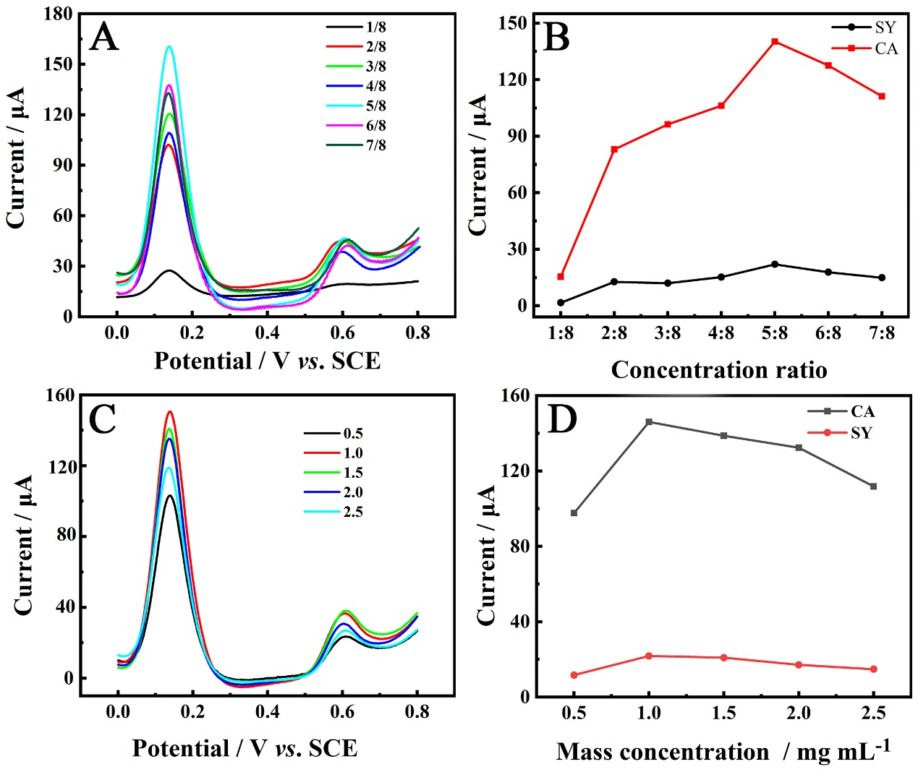

Fig. S1. DPV response of Au/PEDOT/ZIF-8 to 50 μM CA and 25 μM SY in PBS (pH = 7.5) with the effects of (A) different molar ratios of HAuCl₄/EDOT. (B) The relationship of the oxidation peak currents versus the molar ratio of HAuCl₄/EDOT in (A). (C) DPV response of Au/PEDOT/ZIF-8 to 50 μM CA and 25 μM SY in PBS (pH = 7.5) with the effect of the mass concentration of ZIF-8. (D) The relationship of the oxidation peak currents versus the mass concentration of ZIF-8 in (C).

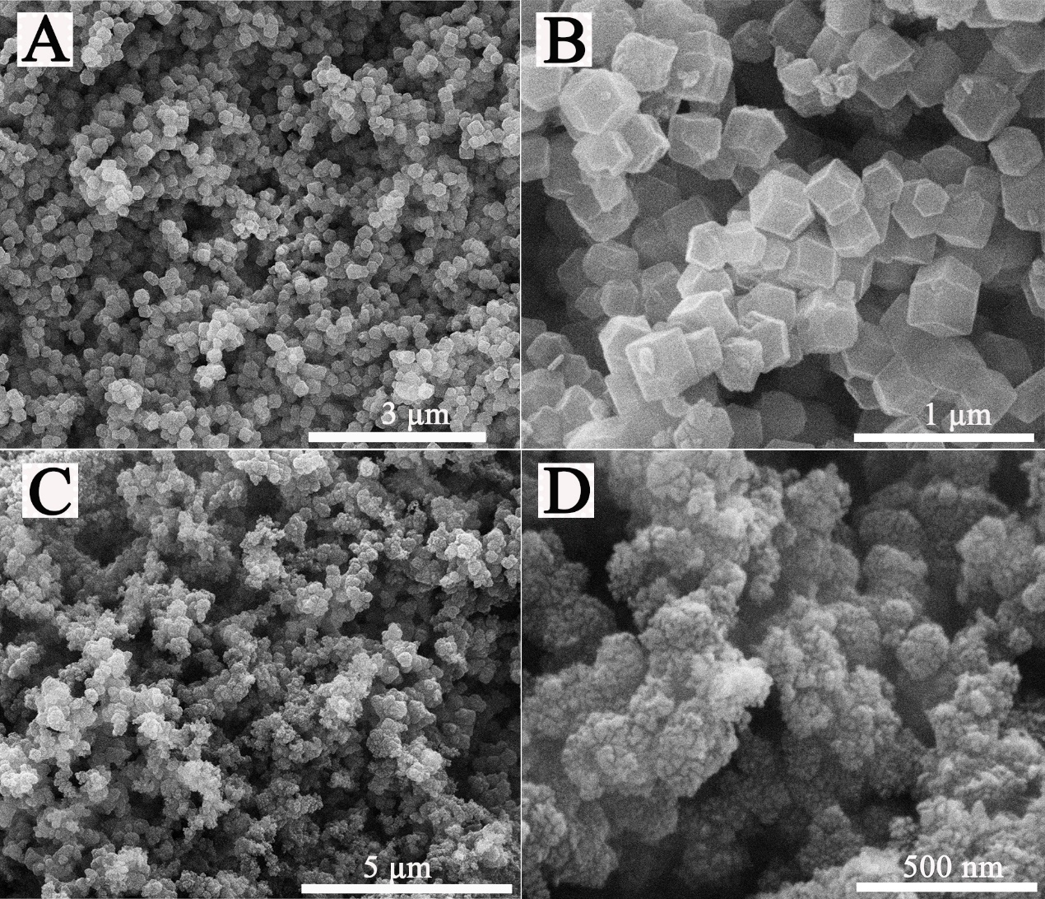

Fig. S2. (A, B) SEM images of the ZIF-8, and (C, D) SEM images of the Au/PEODT.

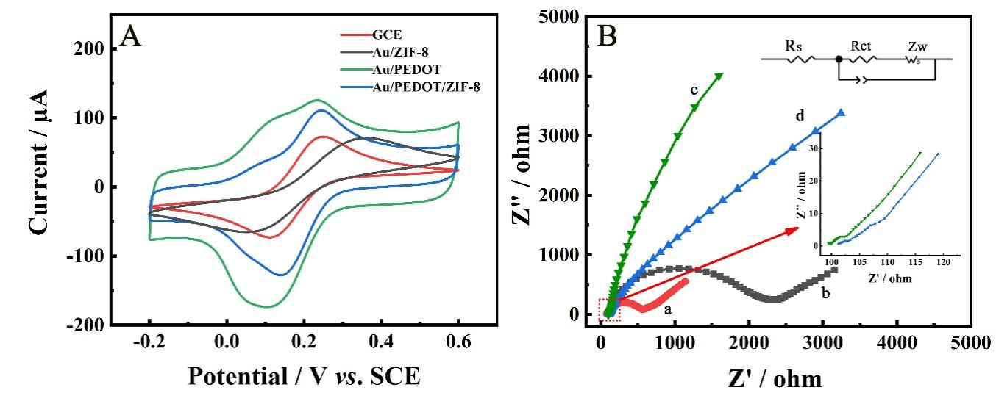

Fig. S3. (A) CV response and (B) Nyquist diagrams of EIS of (a) the bare GCE, (b) Au/ZIF-8/GCE, (c) Au/PEDOT/GCE, and (d) Au/PEDOT/ZIF-8/GCE in 5.0 mM [Fe(CN)₆]^{3-/4-} solution containing 0.1 M KCl.

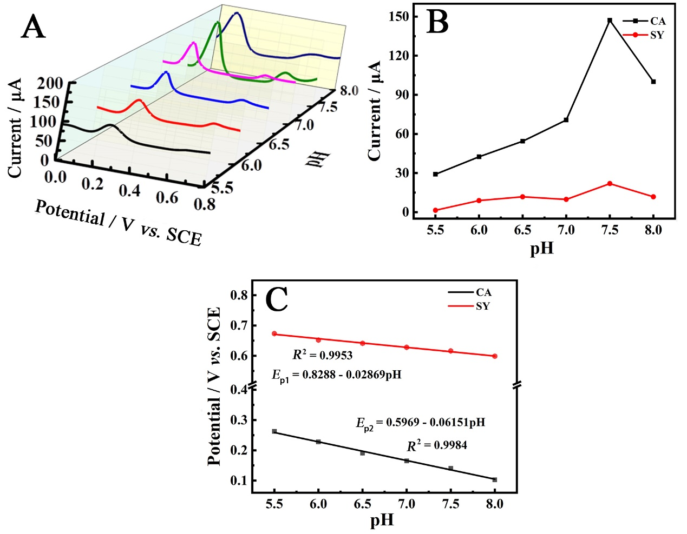
Fig. S4. (A) DPV responses to CA and SY at Au/PEDOT/ZIF-8/GCE with different pHs in phosphate buffer, (B, C) the corresponding relationship of the oxidation peak currents versus the pH and the linear fitting curves of the peak potential versus the pH in (A), respectively.

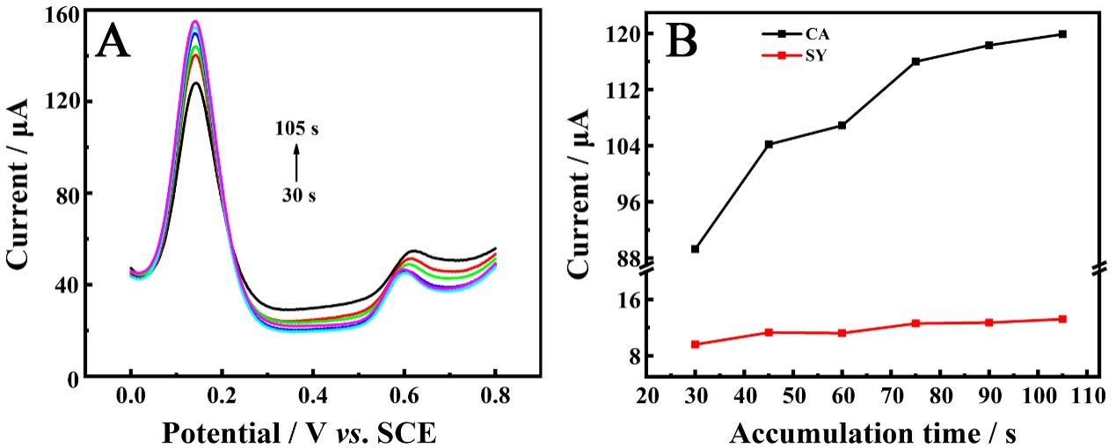

Fig. S5. (A) DPV responses of Au/PEDOT/ZIF-8 under different accumulation time (from 30 to 105 s) to 50 μM CA and 25 μM SY in PBS (pH = 7.5). (B) The relationship of the oxidation peak currents versus the accumulation time in (A).

1. Electrochemical parameter calculation
To better study the electrochemical performance of this sensor, the relative electroactive surface area, and the electron transfer coefficient of Au/PEDOT/ZIF-8/GCE were calculated. By using the CV method, scan in the 0.1 M KCl solution containing 5.0 mM [Fe(CN)₆]^{3- /4-} at different scan rates ranging from 25 to 225 mV s⁻¹, as shown in Fig. S6A. Redox current is obtained in Fig. S6B. The linear relationship as follows: Ip = 7.1255+14.7616 V^{1/2}, R² = 0.9993 for CA and Ip = 9.5016 - 18.4371 V^{1/2}, R² = 0.9991 for SY, which suggest that the electrochemical system follows the diffusion control mechanism. The electrically active surface area was calculated by the Randles-Sevcik equation:
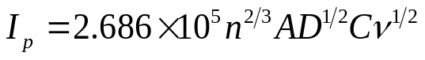 (1)
Among them, Ip (A) represents the peak current, n (n = 1) is the number of electrons transferred in the [Fe(CN)₆]^{3-/4-} redox process, and A is the electrochemical active area of the sensor, [Fe(CN)₆]^{3-/4-} diffusion coefficient and concentration are represented by D (cm² s⁻¹) and C (mol cm⁻³), ν is the scan rate (V s⁻¹). Therefore, n = 1, C = 5×10⁻⁶ mol cm⁻³, D = 0.67×10⁻⁵ cm² s⁻¹. Therefore, based on the slope of Ip vs. ν^{1/2}, the average electroactive surface area of Au/PEDOT/ZIF-8/GCE was calculated to be 0.142 cm², which is 1.54 times of the bare electrode area (0.092 cm²). The above results indicate that the Au/PEDOT/ZIF-8 nanocomposite possesses the highest electrochemical active surface area, which will be beneficial for improving its electrocatalytic performance for CA and SY oxidation.
Fig. S7A shown the CV plots for 50 µM CA and 25 µM SY with different scanning rates, in 0.1 M PBS solution with pH = 7.5 and the equation of linear regression for CA are E_{p} = 0.0804 + 0.02156 Inν, R² = 0.9982(Fig. S7B) and this result indicates that the sensing system follows the surface control mechanism. The value of α was calculated with the following equation (Aikens, 1983):
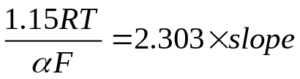 (2)
where R represents the gas constant (R = 8.314 J K^{-1·}mol⁻¹), T is room temperature (T = 298 k) and F is the Faraday constant (F = 96485 C·mol⁻¹). The slope was obtained from Fig. S7B. The α values of CA were calculated to be 0.595. The value of the electron transfer number (n) can be obtained by the Laviron equation (Gligor & Ungureşan, 2010):
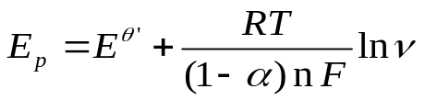 (3)
E^{θ'} represents the formal redox potential. The values of n for CA were calculated to be 2.94 (approximately equal to 3). indicating that the electrochemical oxidization reaction on Au/PEDOT/ZIF-8/GCE is a three-electron transfer process for CA.
As shown in Fig. S7D, show the CV plots for 25 µM SY with different scanning rates. In this CV diagram, SY has only one oxidation peak at about 0.65V. So the number of electrons transferred at the electrooxidation of SY at the surface was calculated by evaluating the variation of potential peaks concerning the Naperian logarithm of the scan rate (lnν) by Eq. (4) (Bard, 1980):
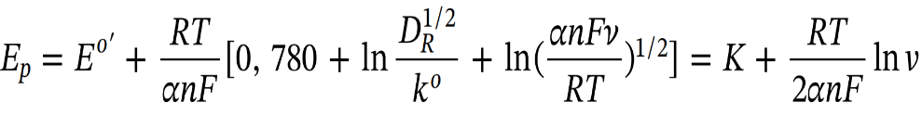 (4)
where Eº΄, the formal reduction potential, D_{R}, the diffusion coefficient, kº, the rate constant of the electrochemical reaction, and α, the transfer coefficient. The rest of the symbols have their usual meaning. The equation of linear regression for SY are E_{p} = 0.6135 + 0.01184Inν, R² = 0.9990 (Fig. S7E). Based on Eq. (4) and for α = 0.5(Laviron, 1979), the value of n for SY was calculated to be 2.17 (approximately equal to 2).

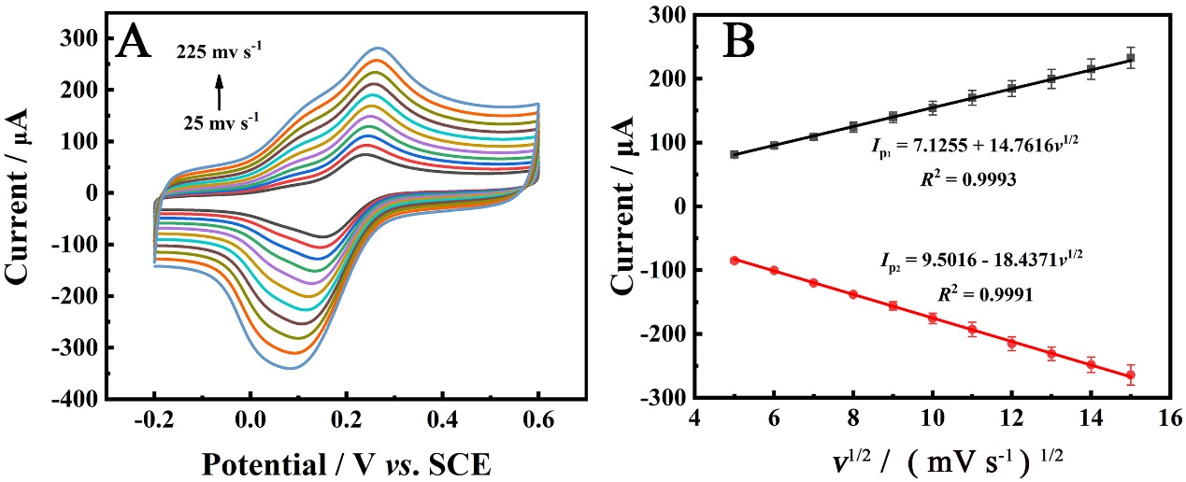

Fig. S6. (A) CVs of Au/PEDOT/ZIF-8 at different scan rates in 5.0 mM [Fe(CN)₆]^{3-/4-} containing 0.1 M KCl. (B) The linear fitting curves of peak currents versus square root of scan rates (n = 3) in (A).

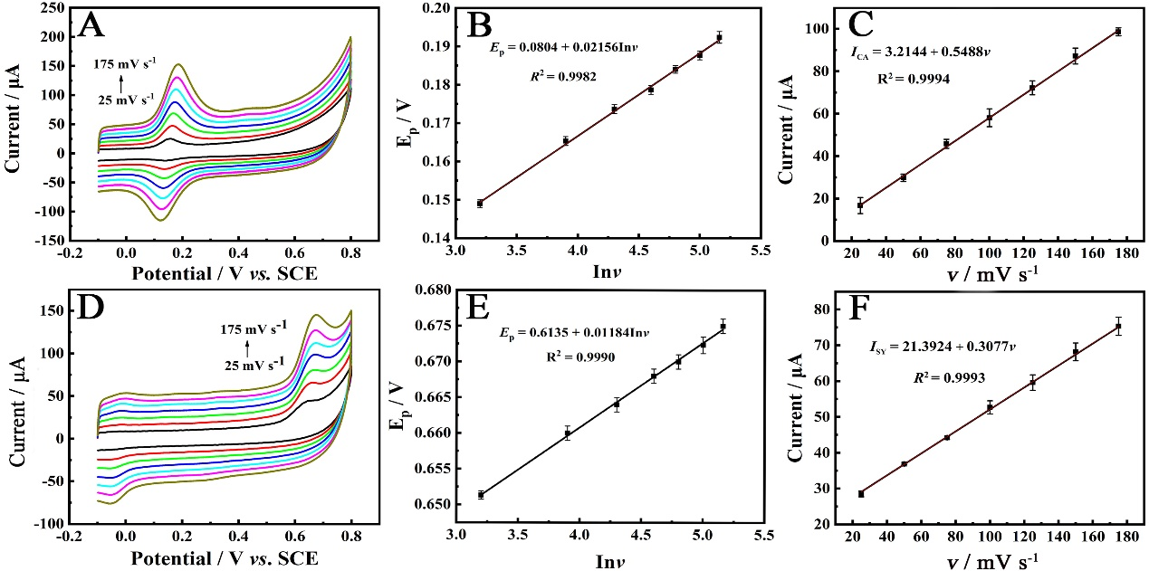

Fig. S7. (A) CVs of Au/PEDOT/ZIF-8 at different scan rates to 50 µM CA in PBS (pH = 7.5). (B) The corresponding linear fitting curve of the peak potential versus the Napierian logarithm of scan rate and (C) the linear fitting curve of the oxidation peak currents versus the scan rate in (A), respectively. (D) CVs of Au/PEDOT/ZIF-8 at different scan rates to 25 µM SY in PBS (pH = 7.5). (E) The corresponding linear fitting curve of the peak potential versus the Napierian logarithm of scan rate and (F) the linear fitting curve of the oxidation peak currents versus the scan rate in (D), respectively.

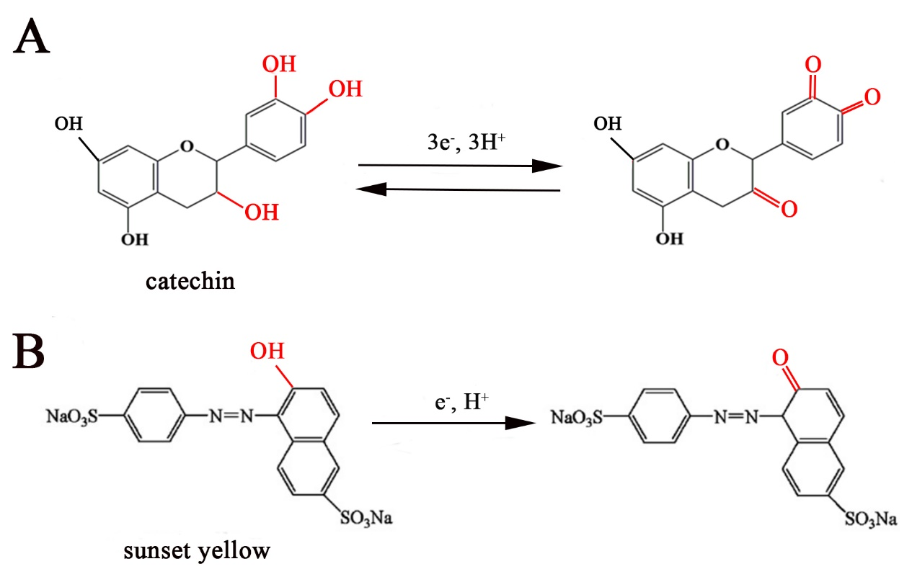

Fig. S8. The schematic diagram of the electrooxidation mechanism of (A) CA and (B) SY on the surface of Au/PEDOT/ZIF-8/GCE.

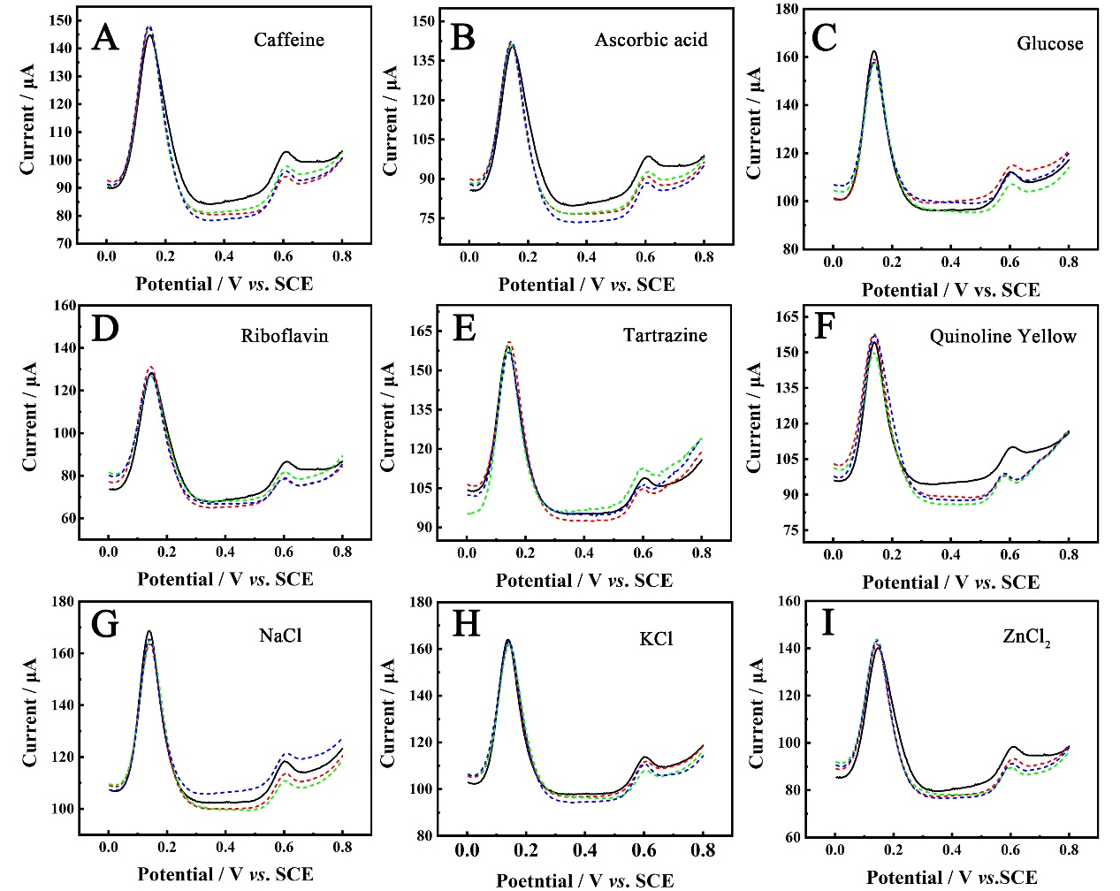

Fig. S9 DPV curves of interference responses to 20 μM CA and 20 μM SY containing caffeine, ascorbic acid, glucose, riboflavin, tartrazine, quinoline yellow, NaCl, KCl, and ZnCl₂ (n = 3).

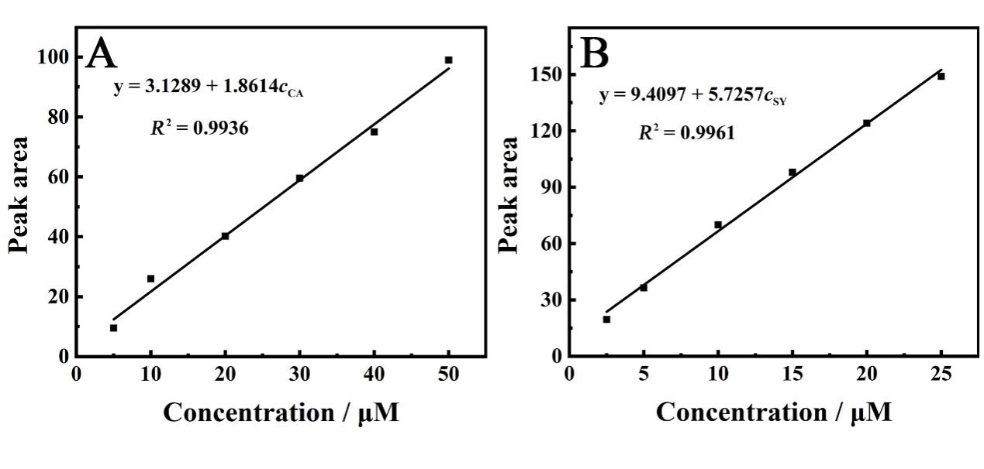
Fig. S10. The linear fitting curve of peak area versus (A) CA and (B) SY concentration under HPLC, respectively
Table S1
Comparison of the main electrochemical sensing performance between Au/PEDOT/ZIF-8/GCE platform and others reported in literature toward CA and SY detection.
Sensing platform | Method | Analytes |  | Linear range (μM) |  | LOD (μM) |  | References
Sensing platform | Method | CA | SY | CA | SY | CA | SY | References
N-Gr/GCE | DPV | √ | / | 1–10, 10–30 | / | 0.088 | / | (Pang et al., 2017)
CS/GCE | DPV | √ | / | 0.1–1.5 | / | 0.013 | / | (Senocak et al., 2019)
diode array detector (DAD) | HPLC | √ | / | 6.9–34.45 | / | 0.18 | / | (Sheikh et al., 2016)
Ni(II) complex–SAM-Au electrod | SWV | √ | / | 3.31–25.1 | / | 0.826 | / | (Moccelini et al., 2009)
CHIT/CaONPs/MWCNTs/AuE | DPV | / | √ | / | 1.99–22.11 | / | 1.77 | (Rovina et al., 2016)
BDDE | MPA–FIA | / | √ | / | 1–50 | / | 0.8 | (Medeiros et al., 2012)
CoC/CPE | DPV | / | √ | / | 0.12−3 | / | 0.9 | (Penagos-Llanos et al., 2019)
GC/WS2/DNPs/GCE | DPV | / | √ | / | 0.3−3.0 | / | 0.86 | (Blanco et al., 2020)
Au/PEDOT/  ZIF-8/GCE | DPV | √ | √ | 0.3-1.0  1.0-50.0 | 3.0-25.0 | 0.1 | 1 | This work

References
Aikens, D. A. (1983). Electrochemical methods, fundamentals and applications. Journal of Chemical Education, 60(1), A25. https://doi.org/10.1021/ed060pA25.1
Bard, A. J. F. L. R. (1980). Electrochemical methods : fundamentals and applications. Wiley.
Blanco, E., Hristova, L., Martinez-Moro, R., Vazquez, L., Ellis, G. J., Sanchez, L., del Pozo, M., Petit-Dominguez, M. D., Casero, E., & Quintana, C. (2020). A 2D tungsten disulphide/diamond nanoparticles hybrid for an electrochemical sensor development towards the simultaneous determination of sunset yellow and quinoline yellow. Sensors and Actuators B-Chemical, 324, Article 128731. https://doi.org/10.1016/j.snb.2020.128731
Gligor, D. M., & Ungureşan, M. L. (2010). Numerical modelling and simulation of Laviron treatment for poly-phenothiazine derivative-modified glassy carbon electrodes. Journal of Mathematical Chemistry, 47(4), 1476-1482. https://doi.org/10.1007/s10910-009-9629-y
Laviron, E. (1979). General expression of the linear potential sweep voltammogram in the case of diffusionless electrochemical systems. Journal of Electroanalytical Chemistry and Interfacial Electrochemistry, 101(1), 19-28. https://doi.org/https://doi.org/10.1016/S0022-0728(79)80075-3
Medeiros, R. A., Lourencao, B. C., Rocha-Filho, R. C., & Fatibello-Filho, O. (2012). Flow injection simultaneous determination of synthetic colorants in food using multiple pulse amperometric detection with a boron-doped diamond electrode. Talanta, 99, 883-889. https://doi.org/10.1016/j.talanta.2012.07.051
Moccelini, S. K., Fernandes, S. C., de Camargo, T. P., Neves, A., & Vieira, I. C. (2009). Self-assembled monolayer of nickel(II) complex and thiol on gold electrode for the determination of catechin. Talanta, 78(3), 1063-1068. https://doi.org/10.1016/j.talanta.2009.01.038
Pang, J., Wu, X., Li, A., Liu, X., & Li, M. (2017). Detection of catechin in Chinese green teas at N-doped carbon-modified electrode. Ionics, 23(7), 1889-1895. https://doi.org/10.1007/s11581-017-2006-0
Penagos-Llanos, J., Garcia-Beltran, O., Calderon, J. A., Hurtado-Murillo, J. J., Nagles, E., & Hurtado, J. J. (2019). Simultaneous determination of tartrazine, sunset yellow and allura red in foods using a new cobalt-decorated carbon paste electrode. Journal of Electroanalytical Chemistry, 852, Article 113517. https://doi.org/10.1016/j.jelechem.2019.113517
Rovina, K., Siddiquee, S., & Shaarani, S. M. (2016). Highly sensitive determination of sunset yellow FCF (E110) in food products based on Chitosan/Nanoparticles/MWCNTs with modified gold electrode. IOP Conference Series: Earth and Environmental Science. https://doi.org/10.1088/1755-1315/36/1/012023
Senocak, A., Basova, T., Demirbas, E., & Durmus, M. (2019). Direct and Fast Electrochemical Determination of Catechin in Tea Extracts using SWCNT-Subphthalocyanine Hybrid Material. Electroanalysis, 31(9), 1697-1707. https://doi.org/10.1002/elan.201900214
Sheikh, Z. A., Siddiqui, Z. A., Naveed, S., & Usmanghani, K. (2016). Quantitative Determination of Catechin as Chemical Marker in Pediatric Polyherbal Syrup by HPLC/DAD. Journal of Chromatographic Science, 54(8), 1324-1327. https://doi.org/10.1093/chromsci/bmw078

