Supplementary Information for

Cost-effective climate mitigation via conservation incentives targeting poverty: Bolsa Verde's impact in Brazilian Amazonia settlements

Sébastien Costedoat*, Alexander Pfaff, Bruno Coutinho, and Michael B. Mascia

To whom correspondence should be addressed. Email: scostedoat@conservation.org

Supplementary Information Text

Treatment Effects.

Fig. S6 displays group-time Average Treatment Effects (ATT) of the effect of Bolsa Verde in Enrolled Settlements of Amazonia on annual tree cover loss in % of tree cover per site in 2000. Group-time ATTs are the ATTs of each group at each time period, where a group is defined by the year when each site contains households is first enrolled in the program (2). The graph provides an overview of the heterogeneity of effects across groups and time-periods (which in turn reflect differences in deforestation risk across groups and across years), and we observe that most post-intervention group-time ATT are most often negative but quite close to zero, although there are most of the time statistically non-significant, except for years 2015 to 2018 of the group enrolled since 2012.

Group-time ATTs can be aggregated into several more aggregated and interpretable treatment effects. Fig. S7 corresponds to the event-study graph for settlements in Amazonia, i.e., an estimation of how the impact of the program has varied as a function of the length of exposure to the program, again considering that not all groups have started enrollment on the same year. We observe that effects are more clearly detected between 3 and 5 years after the initial enrollment in the program, and this can partially reflect both group-effects as well as time-effects. Event study graphs can also be used to visualize whether future enrolled and never-enrolled sites had statistically different tree cover loss in the years preceding the first enrollment in the program. If we do detect statistically significant pre-program differences in outcomes, we can be more confident about the validity of the interpretation of post-intervention differences as a treatment effect (although it does not constitute a sufficient condition to confirm the validity of the untestable Parallel Trend Assumption). Fig. S9 to S11, and S17 to S18 also show the event-study graphs for the other regions of our analysis (and at program scale, respectively for settlements and for protected areas), and they are consistent with the absence of detected effect explained in the main text.

Another aggregated treatment effect of interest is the group-specific treatment effects in enrolled settlements of Amazonia (Fig. S8), i.e., how do treatment effects vary across groups, where a group is defined by the year when each site contains households is first enrolled in the program. These treatment effects provide information about the heterogeneity of effects across groups, notably when the average characteristics of each group vary from one group to another. We note that all group-specific effects are negative. We also note the much wider confidence interval for the group 2013, probably reflecting more heterogeneity in the characteristics of the sites in this group, which may be explained by the fact that the program starts enrolling considerably more households in 2013, and not all of them may have been located in sites with high avoided deforestation potential. We finally note that the group 2012, when BV started expanding, is negative and statistically significant, suggesting that this cohort may have been a key contributor for the overall impact of the program.

Finally, calendar time treatment effects (Fig. S10) correspond to the effects at each post-intervention calendar year, again considering the staggered enrollment into the program. Effects are clearly detectable on the years 2015 and following years. We observe that the effect in calendar year 202 is positive but not statistically significant. Note that in Table 1 of the main manuscript, our main estimate is the cumulative ATT, that is the sum of all calendar time effects between 2011 and 2012, which can be interpreted as the accumulated avoided tree cover loss across the duration of the program, expressed in % of forest cover in 2000.

Specification charts. Figs. S11 to S14 are specification charts (3, 4), i.e., a visualization of the sensitivity of the main estimate (cumulative ATT) to variation in our econometric specifications. Our base models estimate the effect of BV in all enrolled sites of the regions after performing an Inverse Probability Weighting on the Propensity Score estimated with the following confounders: distance to roads, distance to rivers, travelling time to nearest city, topology, forest cover in 2010, forest cover loss 2000-2004, forest cover loss 2004-2007, forest cover loss 2007-2010, Municipal Human Development Index, and in the case of settlements also including the density of registered households in proportion of forest cover in 2010.

In our specification charts, we notably test the influence of changes in matching variables compared to the model we used in the main text (“base model”):
- no matching variables,
- base model but without forest cover loss variables,
- base model but with a single forest cover loss variable 2000-2010,
- base model but with a single forest cover loss variable 2007-2010.

We also test different level of standard error clustering (5) (individual level, municipal level, and no clustering).

We also take a look at the heterogeneity of our findings by exploring the effects in subsamples of the enrolled sites corresponding to
- removing the upper quartile for the distance to roads,
- removing the lower quartile for the forest cover loss 2011-2017, and
- removing the upper quartiles for the size of forest cover in 2010.

We also consider different densities related to the number of enrolled households per forest cover area:
- above 0.5 average enrolled household per hectare of forest in 2010,
- above 1 household, and
- above 5 households.

Finally, we test the robustness of our findings when we remove sites that were no longer enrolled in the program before the end of the program (Following (1), all the other estimates derived from the group-time ATT are calculating without considering the fact that some sites have not been continuously enrolled between the first year of enrollment and the end of the program).

In each graph, our base model is in Orange and alternative models are in Black. On the main model, bright orange interval corresponds to 90% pointwise confidence interval and light orange is 95%. On the other models, black interval is 90% and grey interval is 95%.

In Fig. S11, we observe that the magnitude of our ATT is fairly stable across most specifications for the settlements in Amazonia, except when no matching variables are including, when we do not add any past tree cover loss as matching variables, or for the subgroup of the most densely enrolled sites. It confirms the important selection bias associated with the program: on average, before matching, never-enrolled settlements had a higher, although decreasing, tree cover loss than enrolled settlements, particularly the years before the beginning of the program. In a difference-in-difference estimation, if loss in the control group starts at a higher level but marginally decrease during the treatment period (because of other causes than the treatment) while loss in the intervention remains fairly stable, by difference we may obtain a positive ATT, although this would not reflect a causal impact of the program because we are not making an “apple-to-apple” comparison between similar enrolled and never-enrolled sites. Fig. S8 also further suggest that only considering tree cover loss 2007-2010 as a past loss matching variable would correspond to a slightly higher cumulative ATT than in the base model that use several past tree cover loss periods, while only considering tree cover loss 2000-2010 without separating into different periods would yield a slightly lower ATT, which may be a further indication of how time-varying drivers of deforestation can induce treatment effect heterogeneity.

We note that clustering standard error at the municipal level would make the results not significant at the 95% level, but the result would still be significant at the 90% level. We also observe that removing the enrolled sites the more far away from roads (in our sample of enrolled settlements in Amazonia, it corresponds to sites located more than 34 km away from roads) would make our impact estimate statistically non-significant, indicating that some of the program effect could have been located in sites quite far away from mains roads which may be facing deforestation pressures (e.g., associated with secondary or informal road networks). The forest cover area seems also to be associated with heterogeneity, as removing the largest forest sites slightly reduce the ATT (significant only at 90% level). Considering heterogeneity in forest cover loss 2011-2017, we do not find that removing sites with the lowest loss affect our main findings, which is consistent with the fact that the program may have primarily induced impacts in sites facing moderate to high deforestation.

The subgroups exploring heterogeneity as a function of the enrollment ratio of the program (in minimum number of enrolled households per site forest area) also reveals that the more densely enrolled sites (>=5) are not necessarily more effective, which may be interpreted as an indication that, because the program targeted households mostly based on poverty criteria, poorer households may be living in sites facing less deforestation risk than other sites, reducing the possibility to observe an important impact in these sites. Finally, removing early-leaver sites does not alter the results in enrolled settlements of Amazonia.

Figs. S12 to S14 shows the specification charts for other regions, generally showing an absence of statistically significant impacts. We note however that in the case of settlements outside Amazonia (Fig S14), some of the most densely enrolled subgroups appear to have been associated with more deforestation. This counterintuitive finding could nevertheless be consistent with the fact that on average enrolled settlements outside Amazonia are facing important deforestation risk, while the payments offered by the program was insufficient to address the drivers of deforestation. In this case the estimate would reveal less an effect of the program and more a location bias associated with the enrollment of the program.

Fig. S1. Enrolled BV sites and never-enrolled sites across biomes.
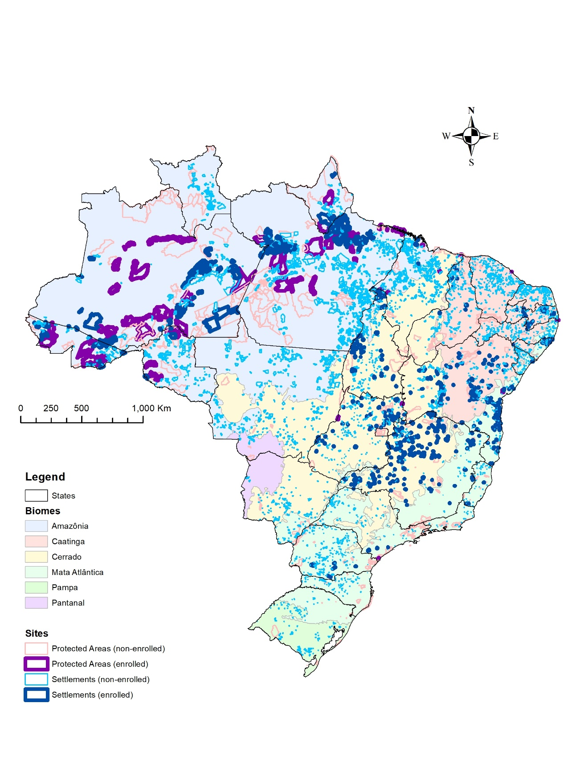

Source: Shapefiles of all federal PA recognized by the Instituto Chico Mendes de Conservação da Biodiversidade, ICMBio, which is the Brazilian Ministry of the Environment’s administrative agency (version of September 2018) as well as the shapefile of all the settlements created by the Instituto Nacional de Colonização e Reforma Agrária, INCRA, which is the Brazilian agency administering land reforms (version of September 2018), and the Ministry of Environment’s publicly available database provided the name of the sites containing enrolled households.

Fig. S2. Evolution of enrolled sites and households across regions.

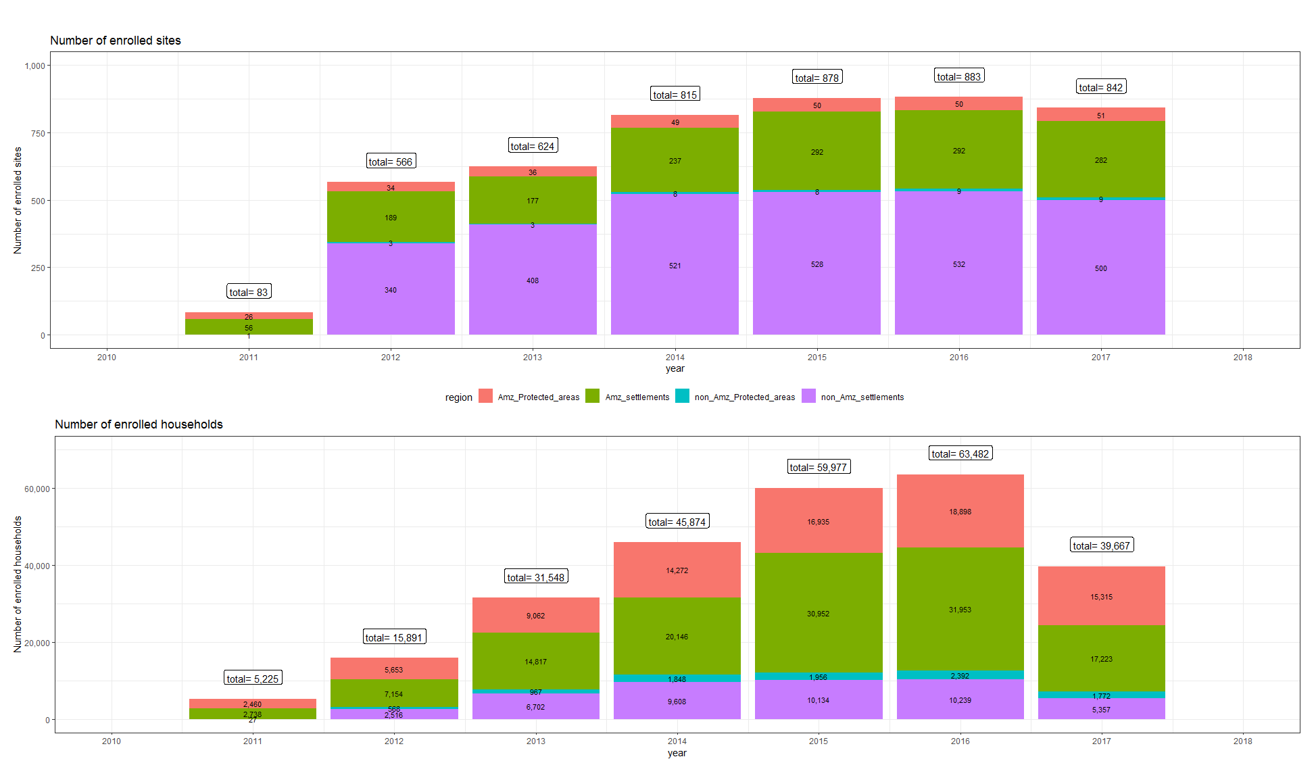

Source: The Ministry of Environment’s publicly available database provided the name of the sites containing enrolled households

Fig. S3. Tree cover and tree cover loss in enrolled sites.

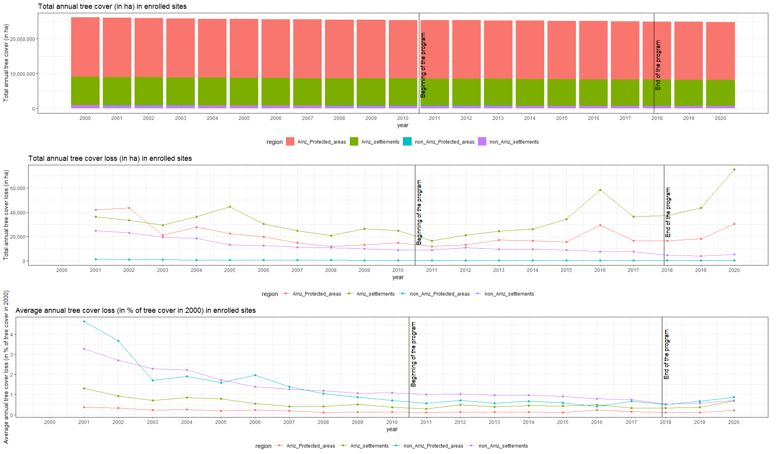

Source: Source: The Ministry of Environment’s publicly available database provided the name of the sites containing enrolled households and MapBiomas version 6.0 .

Fig. S4. Variable distribution across biomes and sites.

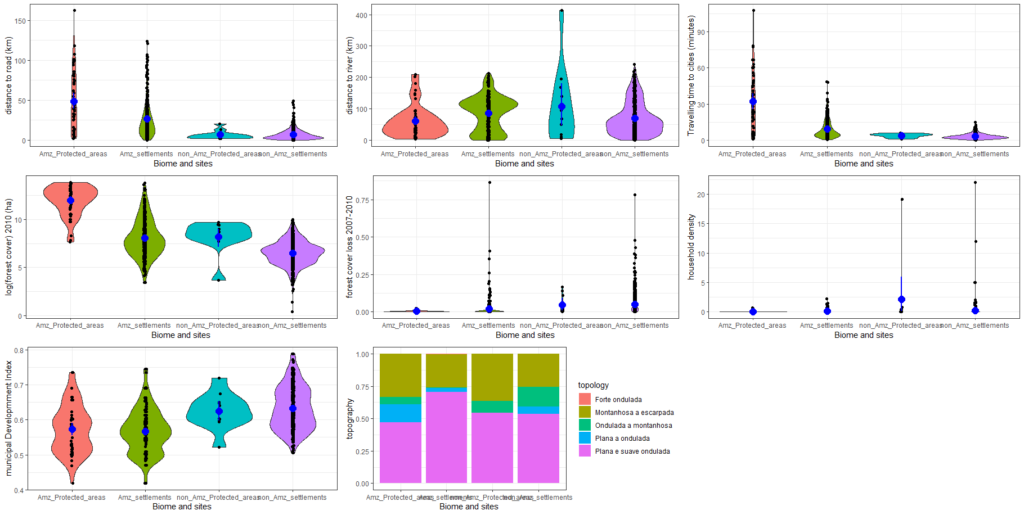

Note: In the violin plot for each continuous variables, each black dot is a single observation point, while the blue dot is the average (and confidence interval) and of each group. In the histogram for the discrete variable (topography), the graph represents the relative frequency of each topographic value across each site.

Fig. S5. Effects of the program on deforestation rate across biomes and sites

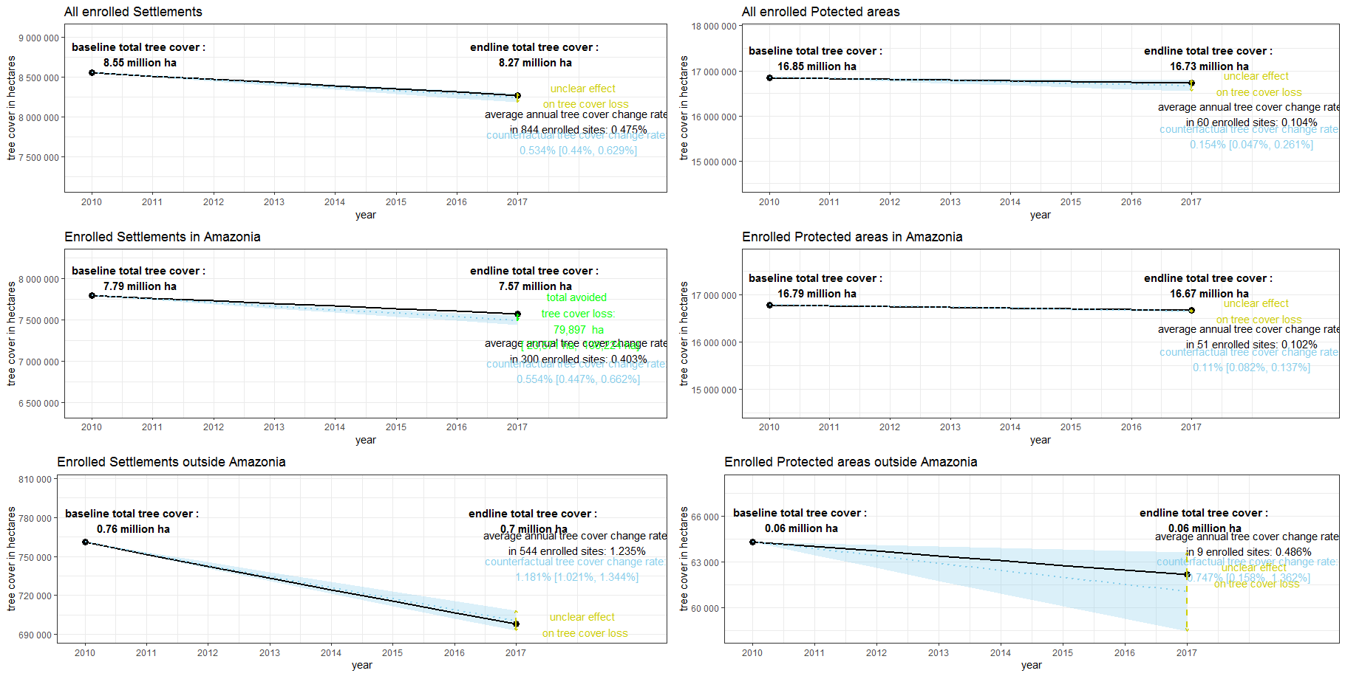
Note: Fig. S5. plots the standardized effect size of the program on annual forest cover rate (1), respectively at program scale for all settlements and all PAs (first row) and then disaggregated for our 4 regions of interest. Standardized effect sizes provide a summary of the impact of the program over the studied period, rearranged as if the forest cove change was uniform across years. The black slope represents the observed average annualized forest cover change in the enrolled sites, while the blue areas represent the estimated counterfactual annualized forest cover change. If the black slope overlaps the blue areas, the difference between the observed and counterfactual rates is statistically non-significant.

Fig. S6. Group-time Average Treatment Effects for enrolled Settlements (2011-2020) in Amazonia (with 95% pointwise confidence intervals)
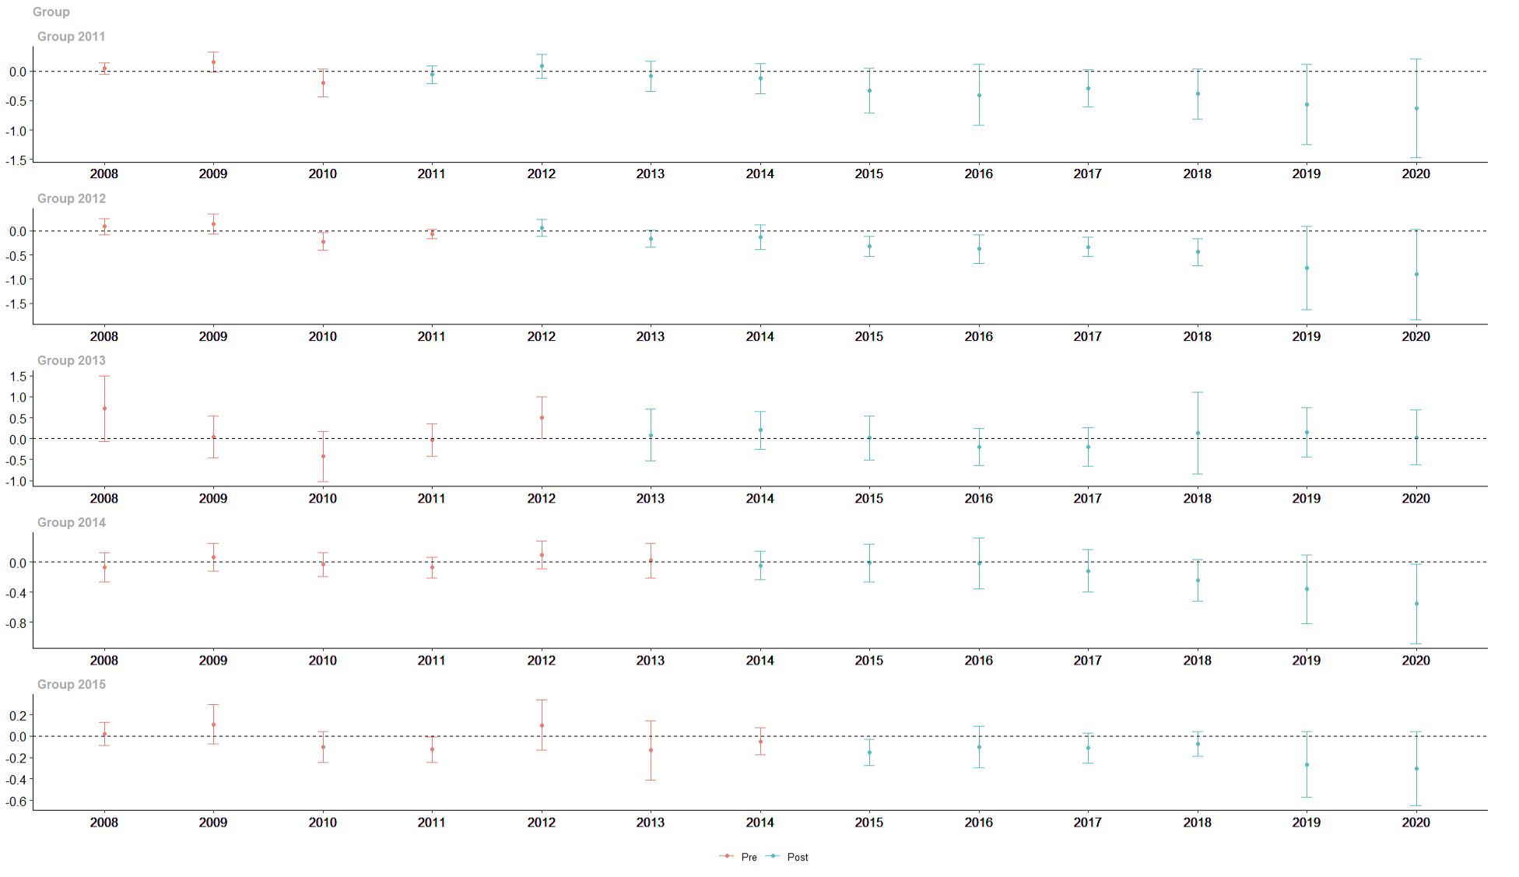
Note: Each group represents the samples characterized by the first year of enrollment into the program. Red bars represent the difference between enrolled and respective controls before the first years of enrollment in the program while blue bars represent the difference after the first year of enrollment in the program. A negative value corresponds to less forest cover loss than in controls, and a positive value corresponds to more forest cover loss than in controls.

Fig. S7. Event-study graph for enrolled Settlements (2011-2017) in Amazonia (with 95% pointwise confidence intervals)

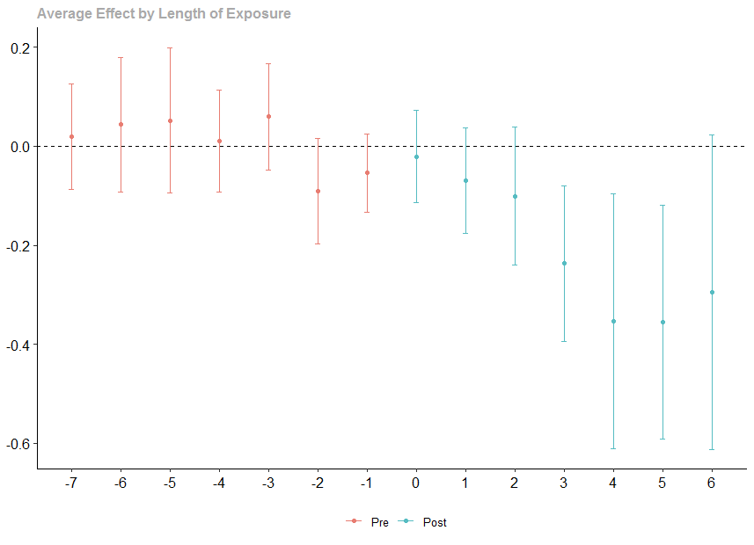
Note: The event-study graph corresponds to the average effect of the program expressed in relative length of exposure to the program, both before and after the first year of enrollment in the program. Red bars represent the difference between enrolled and respective controls before the first years of enrollment in the program while blue bars represent the difference after the first year of enrollment in the program. A negative value corresponds to less forest cover loss than in controls, and a positive value corresponds to more forest cover loss than in controls.

Fig. S8. Group Average Treatment Effects for enrolled Settlements (2011-2017) in Amazonia (with 95% pointwise confidence intervals)
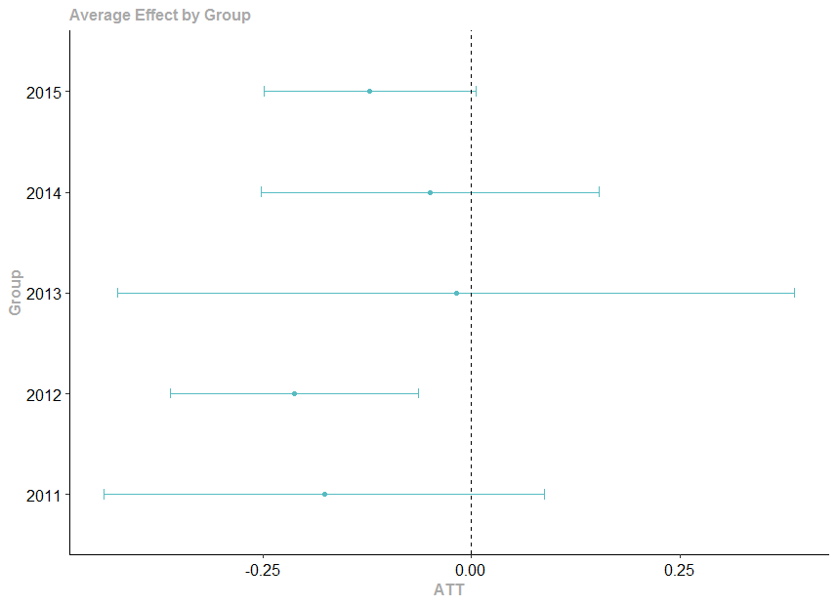
Note:This graph aggregates the group-time ATT from Fig. S6 to obtain an average impact for each group, characterized by the year of first enrollment into the program. A negative value corresponds to less forest cover loss than in controls, and a positive value corresponds to more forest cover loss than in controls.

Fig. S9. Variable distribution across groups in enrolled settlements of Amazonia

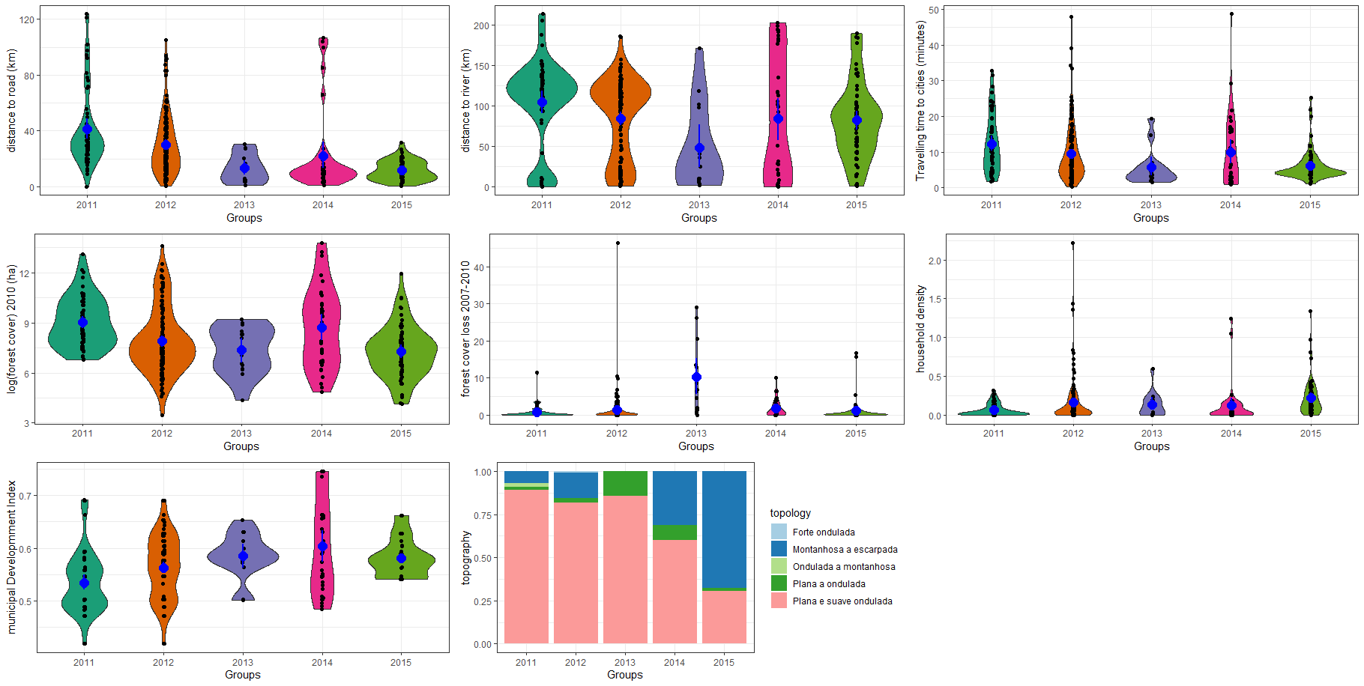

Note:In the violin plot for each continuous variables, each black dot is a single observation point, while the blue dot is the average (and confidence interval) and of each group. In the histogram for the discrete variable (topography), the graph represents the relative frequency of each topographic value across each site.

Fig. S10. Calendar Average Treatment Effects for enrolled Settlements in Amazonia (with 95% pointwise confidence intervals)

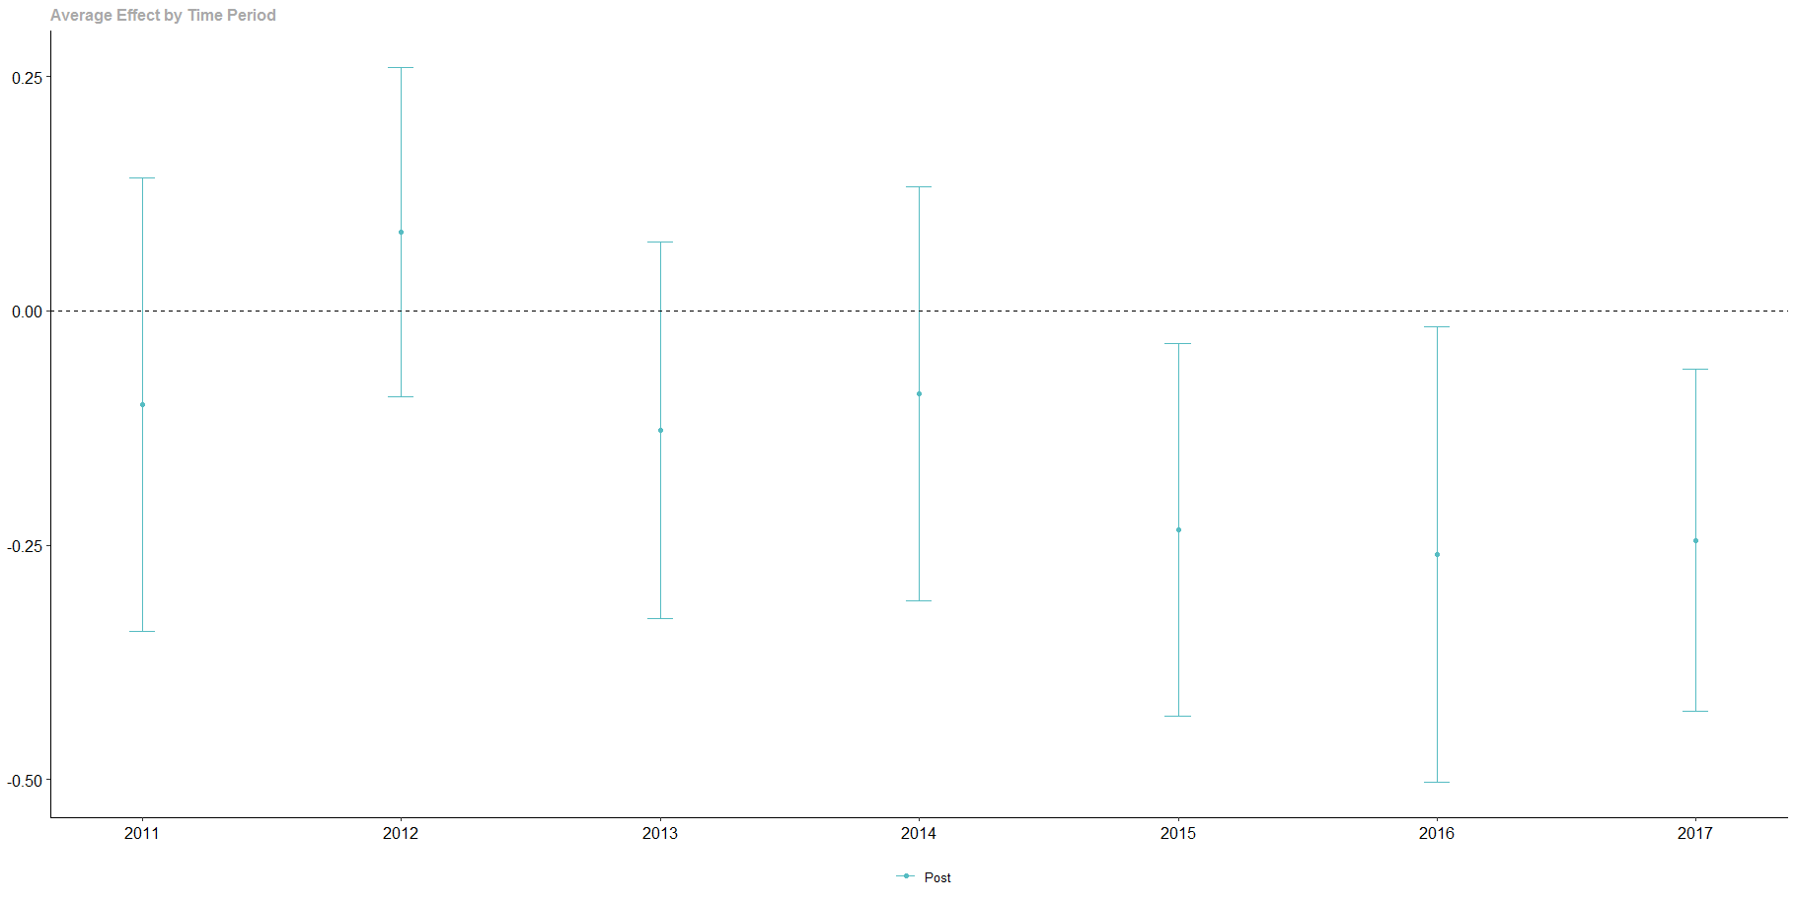
Note:This graph aggregates the group-time ATT from Fig. S6 to obtain an average impact for each calendar year, i.e., combining the effects form different groups that have started enrollment at different points in time. A negative value corresponds to less forest cover loss than in controls, and a positive value corresponds to more forest cover loss than in controls.

Fig. S11. Specification charts for enrolled Settlements in Amazonia (with 90% and 95% pointwise confidence intervals)

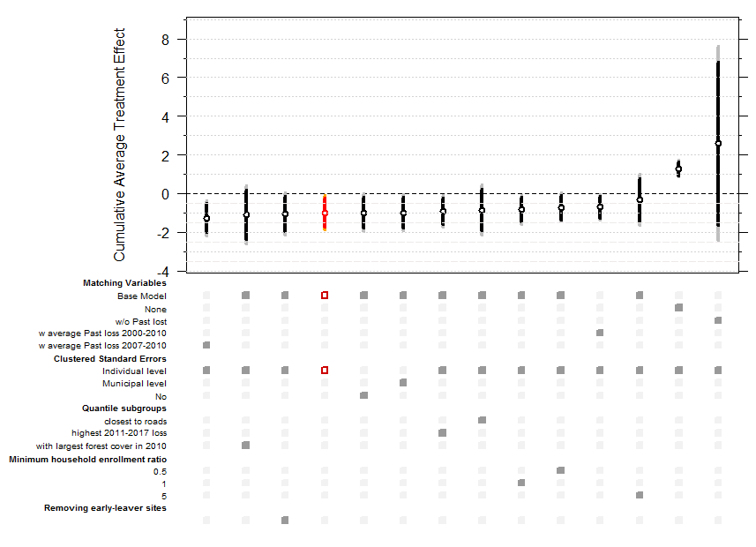

Note:The specification charts asses the sensitive of the main estimates to different changes in matching variables and other parameters and subgroups. The base model is in Orange and alternative models are in Black. On the main model, bright orange interval corresponds to 90% pointwise confidence interval and light orange is 95%. On the other models, black interval is 90% and grey interval is 95%.

Fig. S12. Specification charts for enrolled Protected Areas in Amazonia (with 90% and 95% pointwise confidence interval)

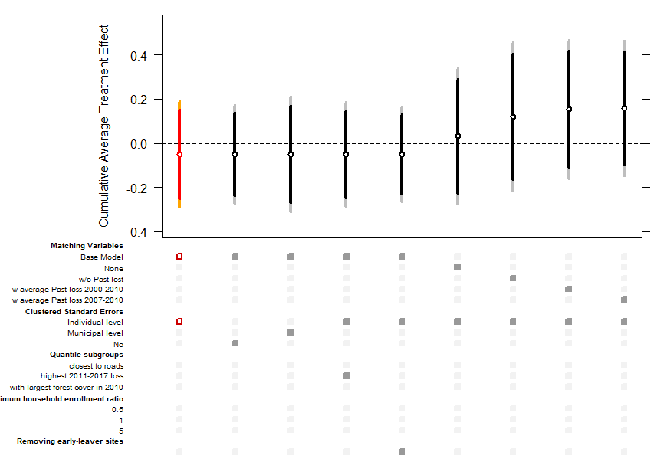

Note:The specification charts asses the sensitive of the main estimates to different changes in matching variables and other parameters and subgroups. The base model is in Orange and alternative models are in Black. On the main model, bright orange interval corresponds to 90% pointwise confidence interval and light orange is 95%. On the other models, black interval is 90% and grey interval is 95%.

Fig. S13. Specification charts for enrolled Protected Areas outside Amazonia (with 90% and 95% pointwise confidence interval)

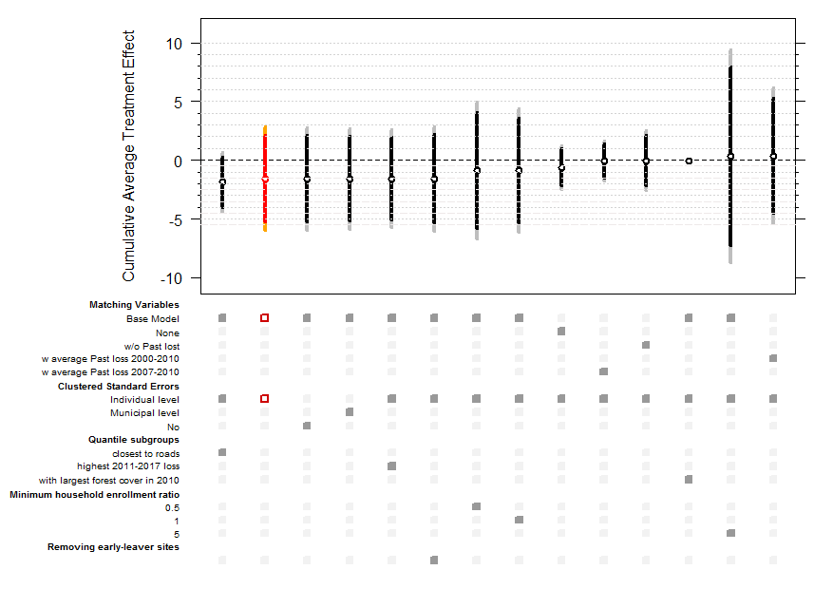

Note: The specification charts asses the sensitive of the main estimates to different changes in matching variables and other parameters and subgroups. The base model is in Orange and alternative models are in Black. On the main model, bright orange interval corresponds to 90% pointwise confidence interval and light orange is 95%. On the other models, black interval is 90% and grey interval is 95%.

Fig. S14. Specification charts for enrolled Settlements outside Amazonia (with 90% and 95% pointwise confidence interval)
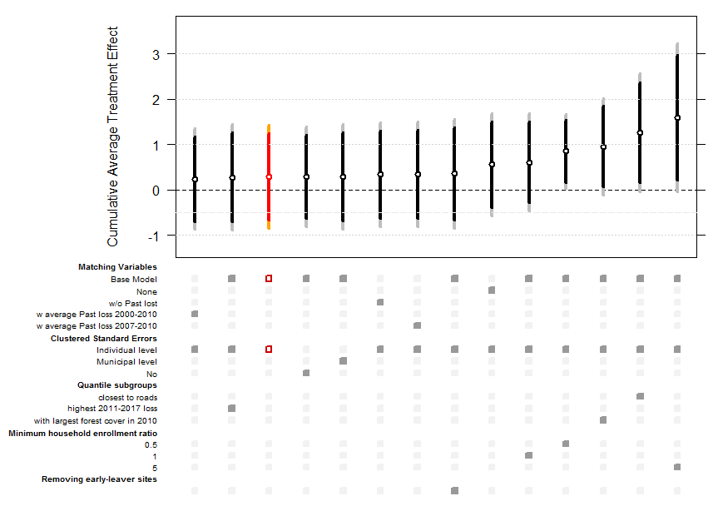

Note:The specification charts asses the sensitive of the main estimates to different changes in matching variables and other parameters and subgroups. The base model is in Orange and alternative models are in Black. On the main model, bright orange interval corresponds to 90% pointwise confidence interval and light orange is 95%. On the other models, black interval is 90% and grey interval is 95%.

Fig. S15. Benefits and costs estimates in enrolled settlements in Amazonia (2.5% discount rate)

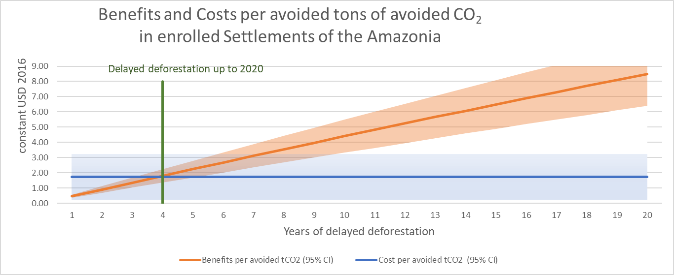

This graph is built using similar assumptions than Fig. 3, but with a discount rate of 2.5% instead of 3% (i.e., putting a higher value on the future than the present). The plots are lines instead of bars, to reflect the fact that in our model the benefits are essentially a function of the years for delayed deforestation, while the average costs are fixed because all the budget of the program in this region has been spent during program implementation. 95% CI are 95% confidence intervals.

Fig. S16. Benefits and costs estimate at program scale (2.5% discount rate)

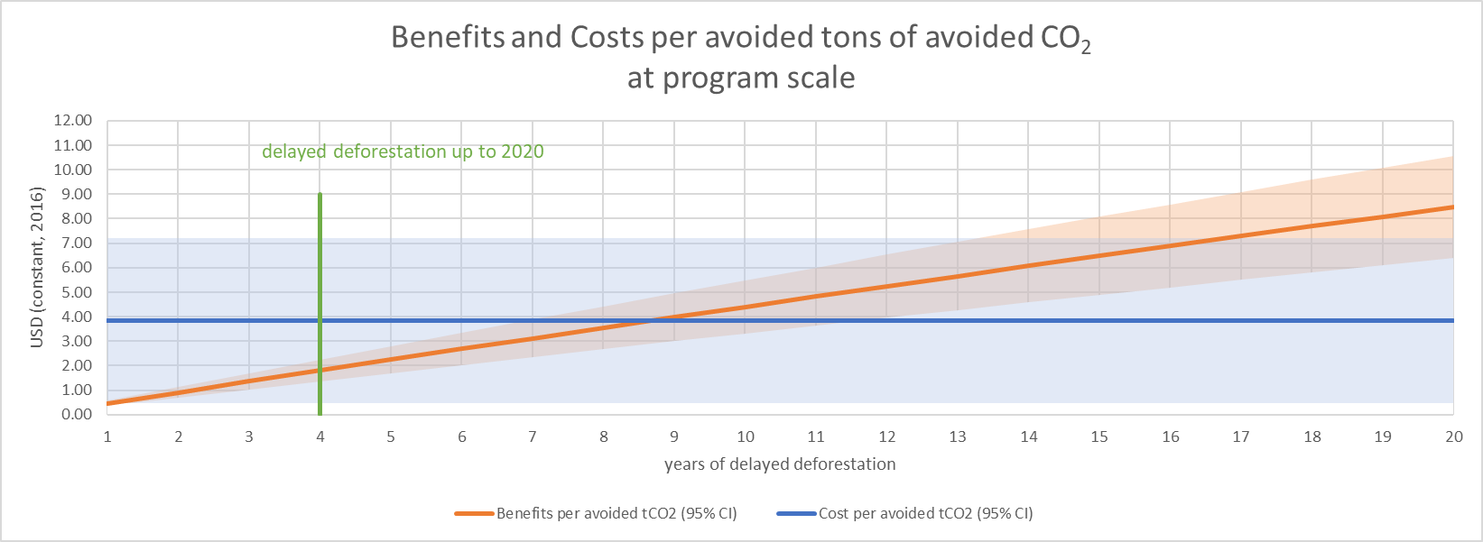

This graph is built using similar assumptions than Fig. S15 but calculate the average costs of the whole program instead of just the costs in the Amazonian Settlements. The plots are lines instead of bars, to reflect the fact that in our model the benefits are essentially a function of the years for delayed deforestation, while the costs are fixed because all the budget of the program has been spent during program implementation. 95% CI are 95% confidence intervals. The benefits curve between Figs S15 and S16 are exactly the same, as they correspond to the average monetized values as a function of years of delayed emissions.

Table S1. Covariate Balance Table for enrolled Settlements in Amazonia
 |  | Before Weighting on the Propensity Score |  |  | After Weighting
 | Type | Control | Treated | Standardized Difference in Means | Control | Treated | Standardized Difference in Means
Propensity Score | Distance | 0.0713 | 0.6168 | 1.8176 | 0.6070 | 0.6168 | 0.0326
Distance to road in km | Contin. | 15.9942 | 26.6237 | 0.4434 | 26.6237 | 26.6237 | 0.0000
Distance to rivers in km | Contin. | 56.9225 | 85.8478 | 0.5297 | 85.8478 | 85.8478 | 0.0000
Travelling time to nearest city (in hours) | Contin. | 7.2252 | 9.1369 | 0.2447 | 9.1369 | 9.1369 | 0.0000
topology_very_undulated | Binary | 0.0030 | 0.0033 | 0.0003 | 0.0033 | 0.0033 | 0.0000
topology_rugged | Binary | 0.2273 | 0.2567 | 0.0293 | 0.2567 | 0.2567 | -0.0000
topology_mountainous | Binary | 0.1487 | 0.0033 | -0.1454 | 0.0033 | 0.0033 | 0.0000
topology_undulated | Binary | 0.0103 | 0.0333 | 0.0231 | 0.0333 | 0.0333 | 0.0000
topology_flat | Binary | 0.6106 | 0.7033 | 0.0927 | 0.7033 | 0.7033 | 0.0000
forest cover in 2010 in ha | Contin. | 6412.9315 | 25963.0422 | 0.2087 | 25963.0422 | 25963.0422 | 0.0000
Forest cover loss 2000-2004 in % of forest cover in 2000 | Contin. | 28.8166 | 3.7824 | -3.5275 | 3.7824 | 3.7824 | -0.0000
Forest cover loss 2004-2007 in % of forest cover in 2000 | Contin. | 12.3819 | 1.7514 | -3.3257 | 1.7514 | 1.7514 | -0.0000
Forest cover loss 2007-2010 in % of forest cover in 2000 | Contin. | 6.9910 | 1.3070 | -2.5591 | 1.3070 | 1.3070 | 0.0000
Household density (in # of registered households / forest cover in 2010 in ha) | Contin. | 0.8007 | 0.1523 | -2.6222 | 0.1523 | 0.1523 | -0.0000
Municipal Human Development Index 2010 | Contin. | 0.6014 | 0.5670 | -0.5483 | 0.5670 | 0.5670 | -0.0000

Effective (Weighted) Sample Size | Control | Treated
Before Weighting | 1654 | 300
After Weighting | 65.87 | 300

Table S2. Covariate Balance Table for enrolled Protected Areas in Amazonia
 |  | Before Weighting on the Propensity Score |  |  | After Weighting
 | Type | Control | Treated | Standardized Difference in Means | Control | Treated | Standardized Difference in Means
Propensity Score | Distance | 0.4878 | 0.8087 | 1.8459 | 0.8021 | 0.8087 | 0.0379
Distance to road in km | Contin. | 42.3146 | 48.7866 | 0.1705 | 36.8362 | 48.7866 | 0.3149
Distance to rivers in km | Contin. | 82.2158 | 60.9555 | -0.4170 | 54.1003 | 60.9555 | 0.1345
Travelling time to nearest city (in hours) | Contin. | 34.6808 | 32.1333 | -0.1041 | 30.3429 | 32.1333 | 0.0731
topology_rugged | Binary | 0.1500 | 0.3333 | 0.1833 | 0.3720 | 0.3333 | -0.0387
topology_mountainous | Binary | 0.3500 | 0.0588 | -0.2912 | 0.0680 | 0.0588 | -0.0092
topology_undulated | Binary | 0.0500 | 0.1373 | 0.0873 | 0.2337 | 0.1373 | -0.0964
topology_Flat | Binary | 0.4500 | 0.4706 | 0.0206 | 0.3263 | 0.4706 | 0.1443
forest cover in 2010 in ha | Contin. | 503263.570 | 329124.30 | -0.5712 | 299088.62 | 329124.30 | 0.0985
Forest cover loss 2000-2004 in % of forest cover in 2000 | Contin. | 1.6900 | 1.1651 | -0.3289 | 0.8184 | 1.1651 | 0.2173
Forest cover loss 2004-2007 in % of forest cover in 2000 | Contin. | 1.1482 | 0.6286 | -0.4813 | 0.5245 | 0.6286 | 0.0964
Forest cover loss 2007-2010 in % of forest cover in 2000 | Contin. | 0.4746 | 0.3820 | -0.1859 | 0.2928 | 0.3820 | 0.1792
Municipal Human Development Index 2010 | Contin. | 0.6052 | 0.5734 | -0.4573 | 0.5705 | 0.5734 | 0.0423
Effective (Weighted) Sample Size | Control | Treated
Before Weighting | 20 | 51
After Weighting | 7.43 | 51

Table S3. Covariate Balance Table for enrolled Protected Areas outside Amazonia
 |  | Before Weighting on the Propensity Score |  |  | After Weighting
 | Type | Control | Treated | Standardized Difference in Means | Control | Treated | Standardized Difference in Means
Propensity Score | Distance | 0.1227 | 0.5500 | 1.0561 | 0.2742 | 0.5500 | 0.6816
Distance to road in km | Contin. | 2.8249 | 7.7125 | 0.8548 | 5.5094 | 7.7125 | 0.3853
Forest cover loss 2000-2004 in % of forest cover in 2000 | Contin. | 3.2055 | 11.9097 | 0.5304 | 3.3963 | 11.9097 | 0.5188
Forest cover loss 2004-2007 in % of forest cover in 2000 | Contin. | 1.7593 | 4.9313 | 0.5282 | 1.8324 | 4.9313 | 0.5161
Forest cover loss 2007-2010 in % of forest cover in 2000 | Contin | 1.7817 | 2.6254 | 0.2481 | 0.9866 | 2.6254 | 0.4819
Effective (Weighted) Sample Size | Control | Treated
Before Weighting | 33 | 9
After Weighting | 12.48 | 9

Table S4. Covariate Balance Table for enrolled Settlements outside Amazonia
 |  | Before Weighting on the Propensity Score |  |  |  | After Weighting
 | Type | Control | Treated | Standardized Difference in Means | Control |  | Treated | Standardized Difference in Means
Propensity Score | Distance | 0.1240 | 0.1900 | 0.7553 | 0.1879 |  | 0.1900 | 0.0237
biome_CAATINGA | Binary | 0.4052 | 0.1930 | -0.2121 | 0.1930 |  | 0.1930 | 0.0000
biome_CERRADO | Binary | 0.3129 | 0.5202 | 0.2074 | 0.5202 |  | 0.5202 | 0.0000
biome_MATA ATLÂNTICA | Binary | 0.2820 | 0.2868 | 0.0048 | 0.2868 |  | 0.2868 | -0.0000
Distance to road in km | Contin. | 6.0461 | 7.0387 | 0.1487 | 7.0387 |  | 7.0387 | 0.0000
Distance to rivers in km | Contin. | 106.5732 | 68.5251 | -0.7455 | 68.5251 |  | 68.5251 | 0.0000
Travelling time to nearest city (in hours) | Contin. | 2.7792 | 3.2323 | 0.2050 | 3.2323 |  | 3.2323 | 0.0000
topology_very_undulated | Binary | 0.0022 | 0.0000 | -0.0022 | 0.0000 |  | 0.0000 | -0.0000
topology_rugged | Binary | 0.3653 | 0.2537 | -0.1116 | 0.2537 |  | 0.2537 | 0.0000
topology_mountainous | Binary | 0.0772 | 0.1526 | 0.0754 | 0.1526 |  | 0.1526 | -0.0000
topology_undulated | Binary | 0.0946 | 0.0551 | -0.0394 | 0.0551 |  | 0.0551 | 0.0000
topology_flat | Binary | 0.4607 | 0.5386 | 0.0779 | 0.5386 |  | 0.5386 | 0.0000
forest cover in 2010 in ha | Contin. | 1268.668 | 1398.8977 | 0.0570 | 1398.897 |  | 1398.897 | 0.0000
Forest cover loss 2000-2004 in % of forest cover in 2000 | Contin. | 13.8306 | 10.4939 | -0.2985 | 10.4939 |  | 10.4939 | -0.0000
Forest cover loss 2004-2007 in % of forest cover in 2000 | Contin. | 5.3022 | 4.3786 | -0.1866 | 4.3786 |  | 4.3786 | 0.0000
Forest cover loss 2007-2010 in % of forest cover in 2000 | Contin. | 3.3664 | 3.3510 | -0.0043 | 3.3510 |  | 3.3510 | 0.0000
Household density (in # of registered households / forest cover in 2010 in ha) | Contin. | 1.3174 | 0.1992 | -0.9953 | 0.1992 |  | 0.1992 | -0.0000
Municipal Human Development Index 2010 | Contin. | 0.6288 | 0.6337 | 0.0803 | 0.6337 |  | 0.6337 | -0.0000
Effective (Weighted) Sample Size | Control | Treated
Before Weighting | 3564 | 544
After Weighting | 2217.12 | 544

Table S5. The total cost of Bolsa Verde in contact USD 2016 (converting all amounts in USD 2016, and further applying a 3 % discount for costs after 2016)

Year | current Brazilian Reais | current USD from CEPAL | in constant USD 2016
2011 | 8,500,000 | 5,081,213 | 5,421,589
2012
2013 | 54,185,274 | 25,131,277 | 25,891,827
2014 | 83,800,112 | 35,614,884 | 36,106,978
2015 | 92,830,525 | 27,902,974 | 28,254,974
2016 | 73,424,347 | 21,030,580 | 21,030,580
2017 | 61,273,533 | 19,199,641 | 18,251,605
2018
 | unadjusted total in Brazilian Reais | unadjusted total in current USD | total sum constant 2016 USD
 | 374,013,791 | 133,960,570 | 134,957,552
Source: Non-contributory Social Protection Programmes Database of the Economic Commission for Latin America and the Caribbean (https://dds.cepal.org/bpsnc/programme?id=60)
References
1. C. Samii, M. Lisiecki, P. Kulkarni, L. Paler, L. Chavis, Effects of payment for environmental services (PES) on deforestation and poverty in low and middle income countries: a systematic review. Campbell Systematic Reviews 10 (2014).
2. B. Callaway, P. H. C. Sant’Anna, Difference-in-Differences with multiple time periods. Journal of Econometrics (2020) https:/doi.org/10.1016/j.jeconom.2020.12.001 (December 18, 2020).
3. S. Desbureaux, Subjective modeling choices and the robustness of impact evaluations in conservation science. Conservation Biology 35, 1621–1626 (2021).
4. A. Ortiz-Bobea, T. R. Ault, C. M. Carrillo, R. G. Chambers, D. B. Lobell, Anthropogenic climate change has slowed global agricultural productivity growth. Nat. Clim. Chang. 11, 306–312 (2021).
5. A. Abadie, S. Athey, G. W. Imbens, J. Wooldridge, “When Should You Adjust Standard Errors for Clustering?” (National Bureau of Economic Research, 2017) https:/doi.org/10.3386/w24003 (January 28, 2022).

